Form Approved
OMB No. 0920-1027
Expiration Date: 08/31/2017

Title of Project Post-Launch Usability Testing for the Division of HIV/AIDS Prevention Website Redesign

Attachment 3
Screenshots for Post-Launch Usability Testing for the Division of HIV/AIDS Prevention Website Redesign

Public reporting burden of this collection of information is estimated to average 1 hour per response, including the time for reviewing instructions, searching existing data sources, gathering and maintaining the data needed, and completing and reviewing the collection of information. An agency may not conduct or sponsor, and a person is not required to respond to a collection of information unless it displays a currently valid OMB control number. Send comments regarding this burden estimate or any other aspect of this collection of information, including suggestions for reducing this burden to CDC/ATSDR Reports Clearance Officer; 1600 Clifton Road NE, MS D-74, Atlanta, Georgia 30333; Attn: OMB-PRA (0920-1027)

Website Homepage and survey beginning
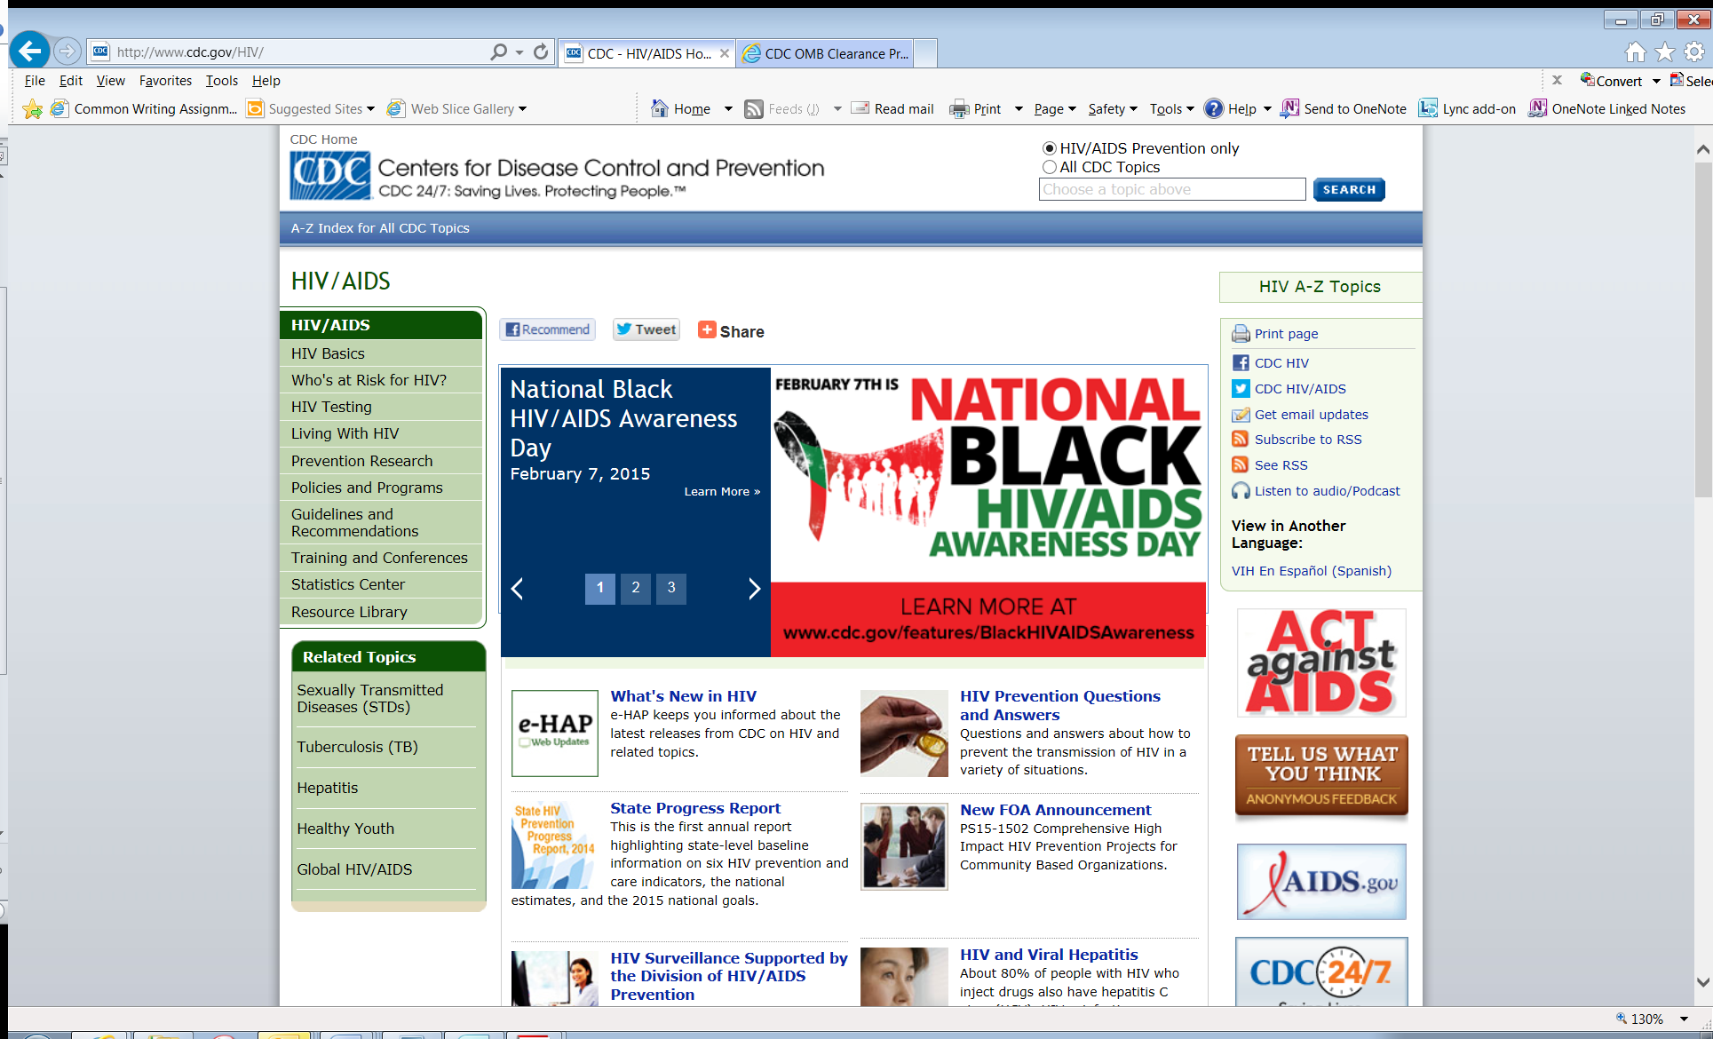

Task 1
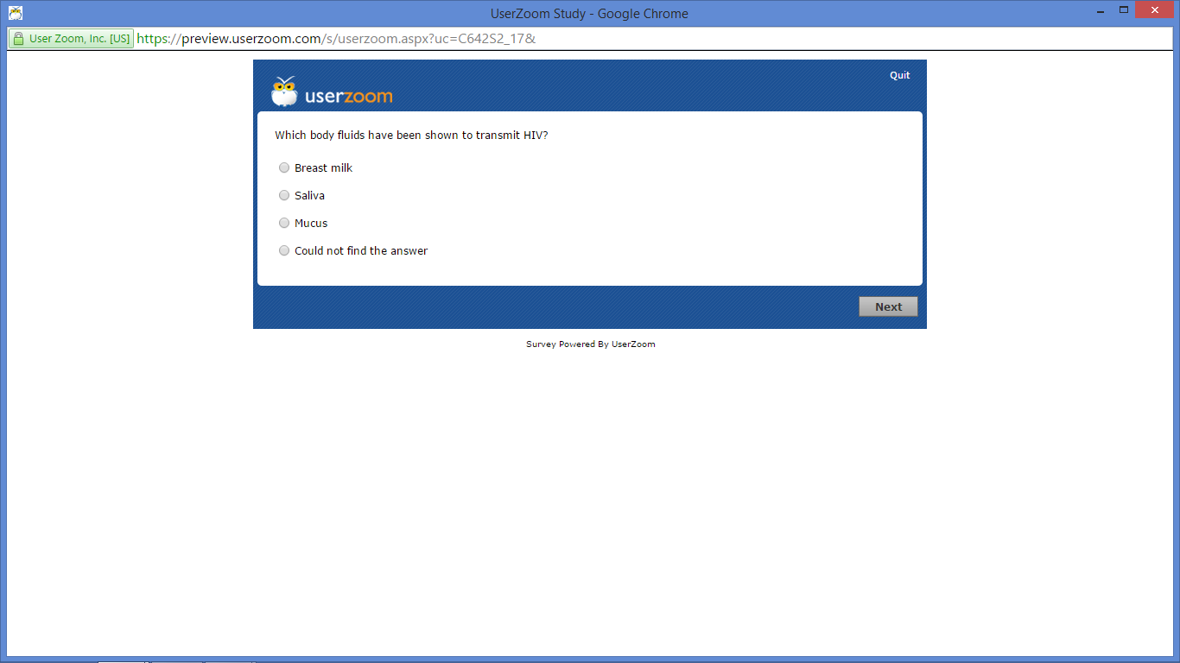

Task 2

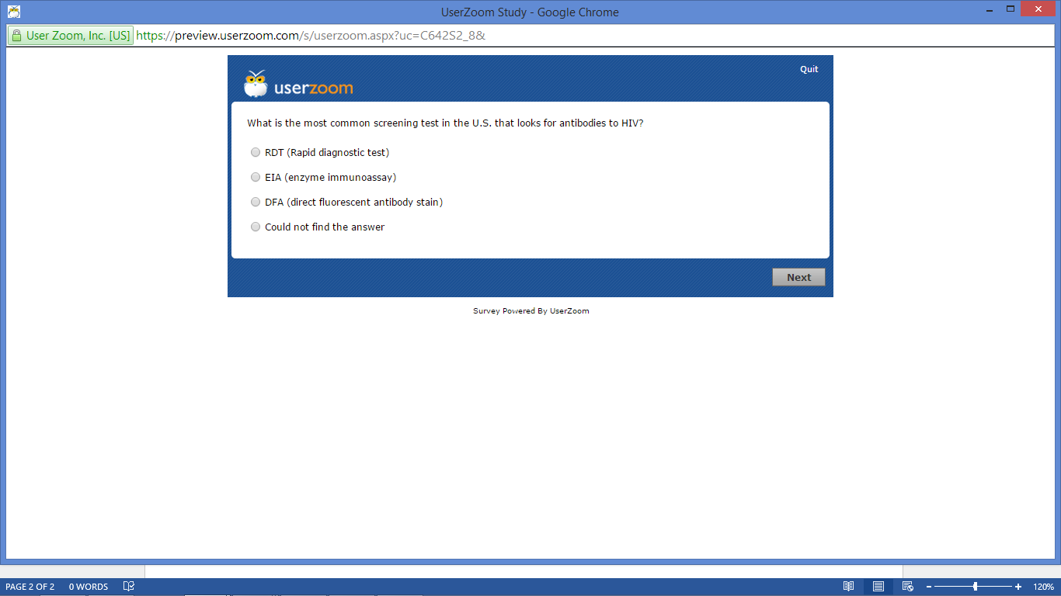

Task 3
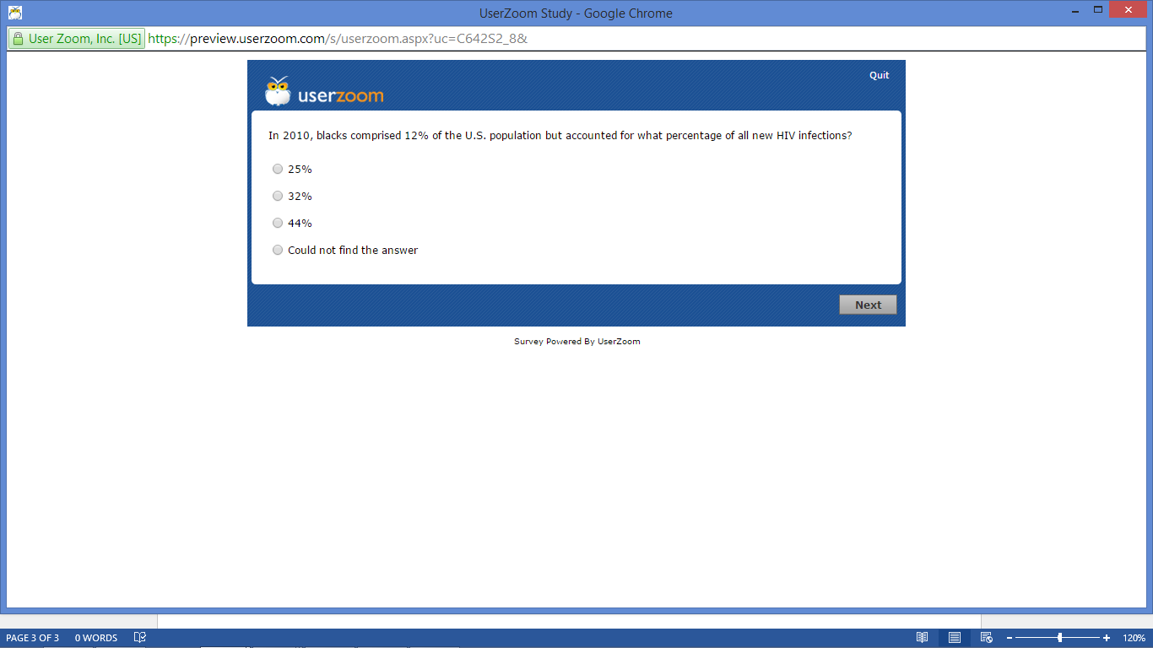
Task 4
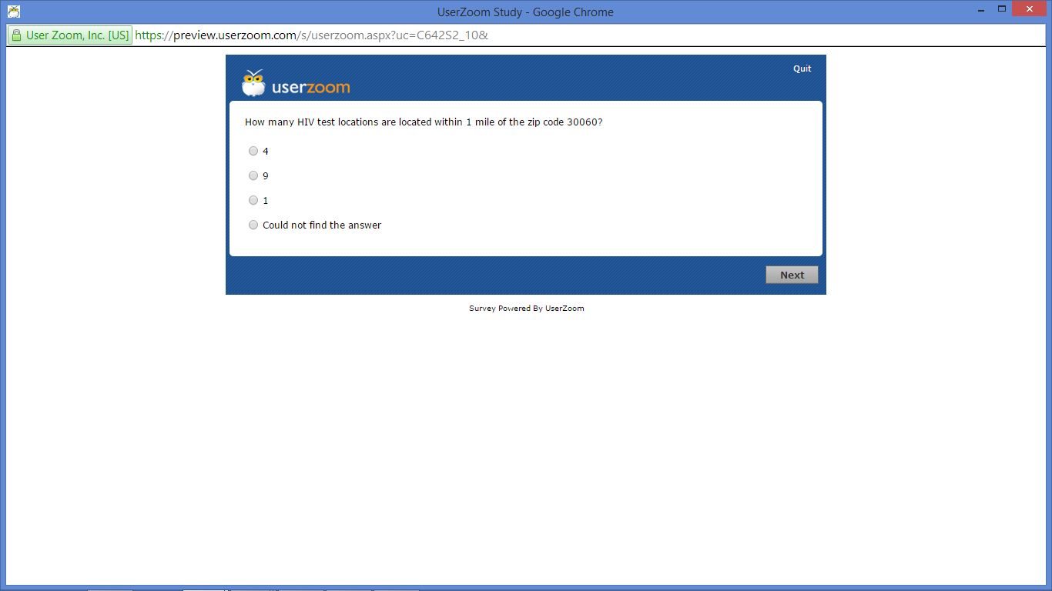

Task 5

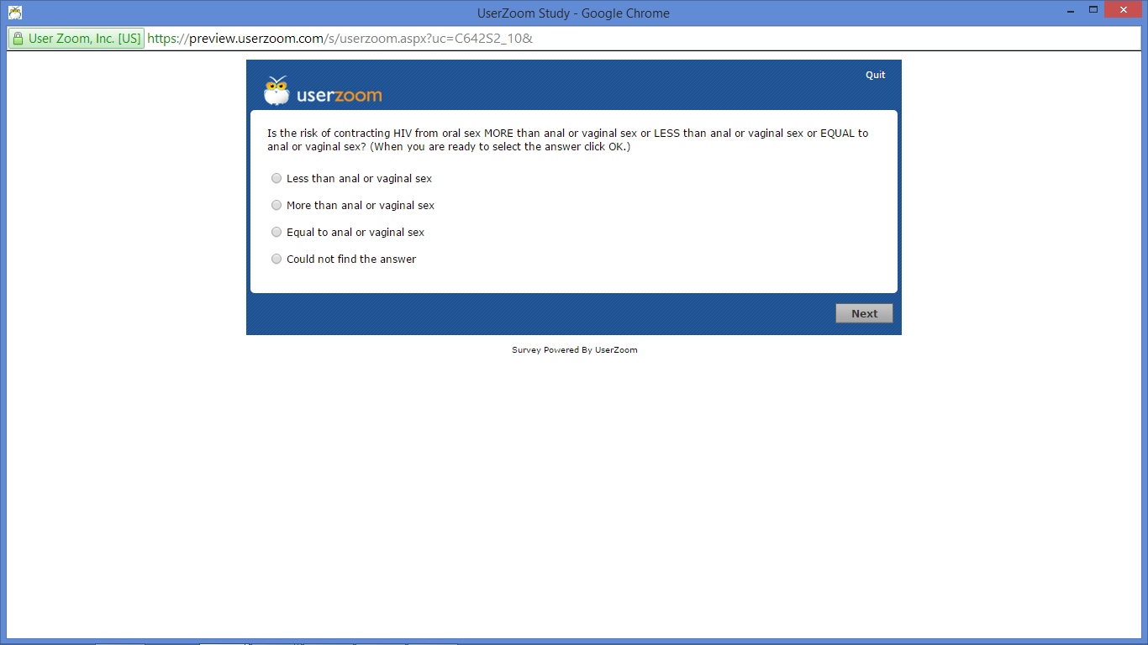

Task 6
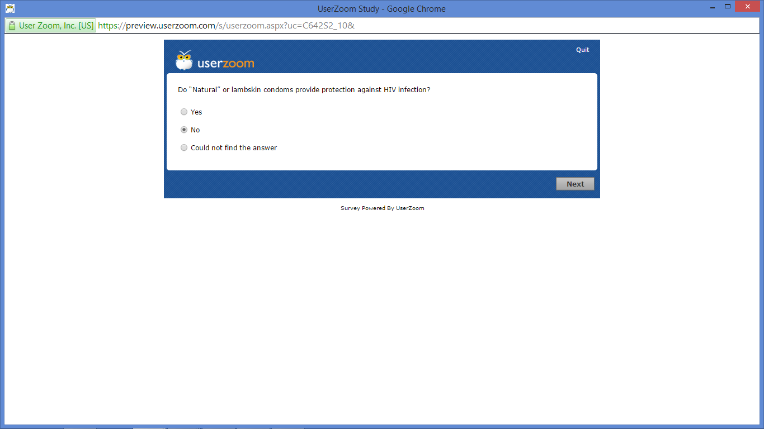

Task 7
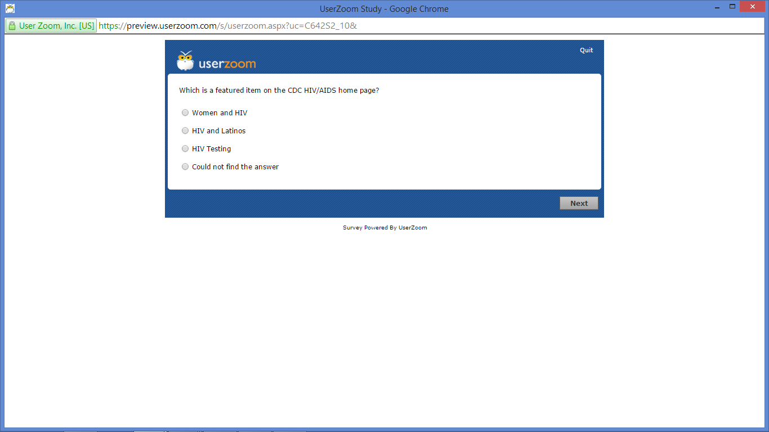

Task 8
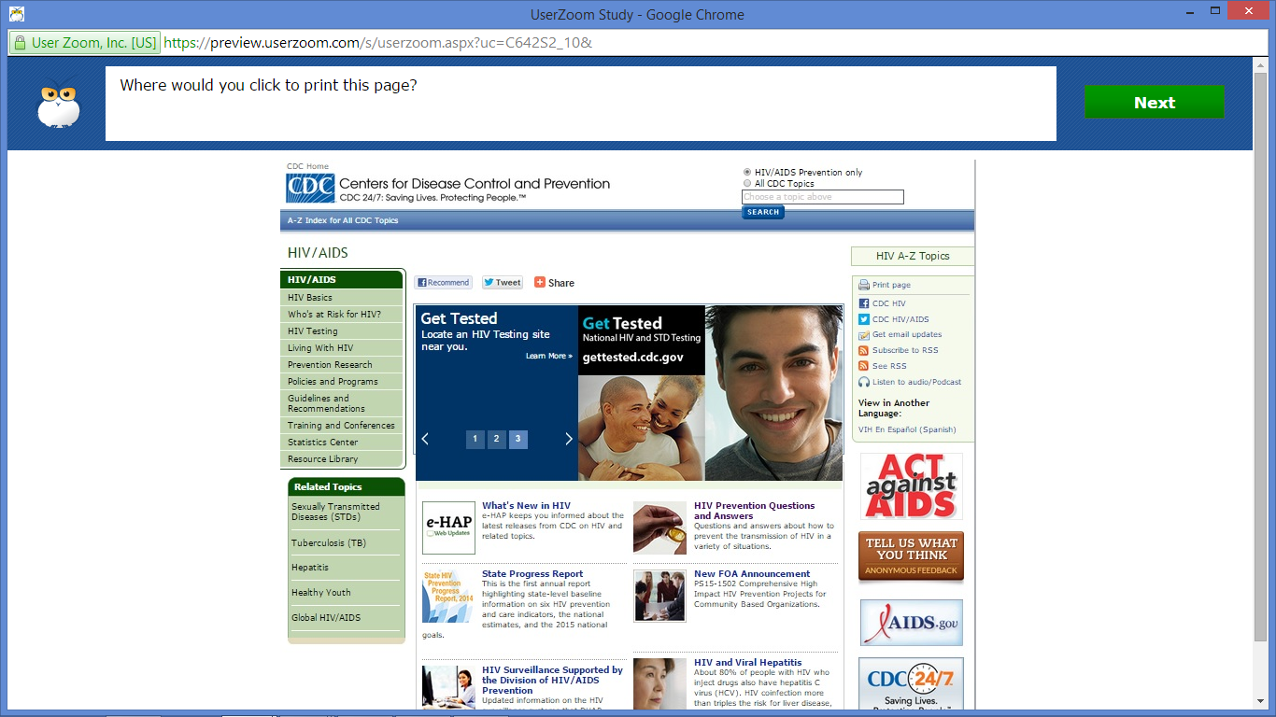

Task 9
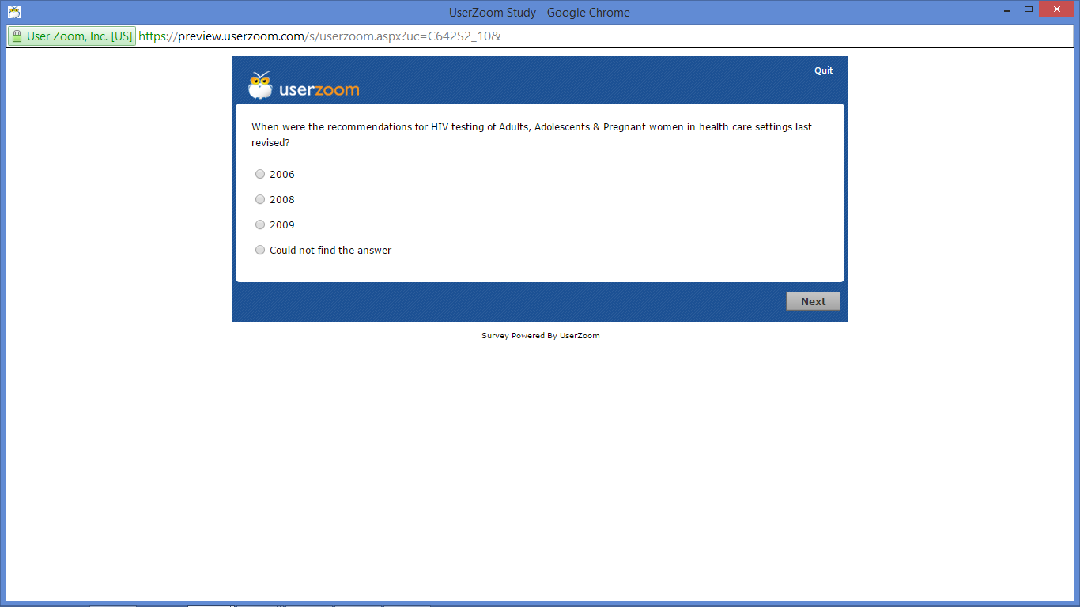

Task 10
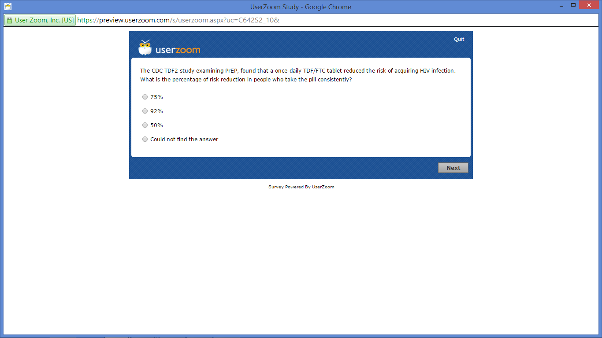

Task 11
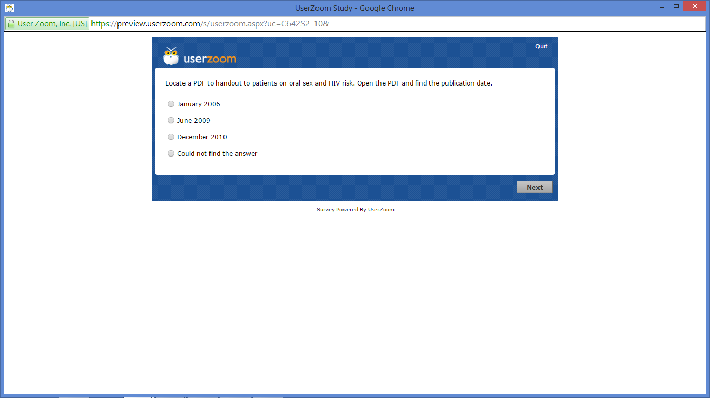

Task 12
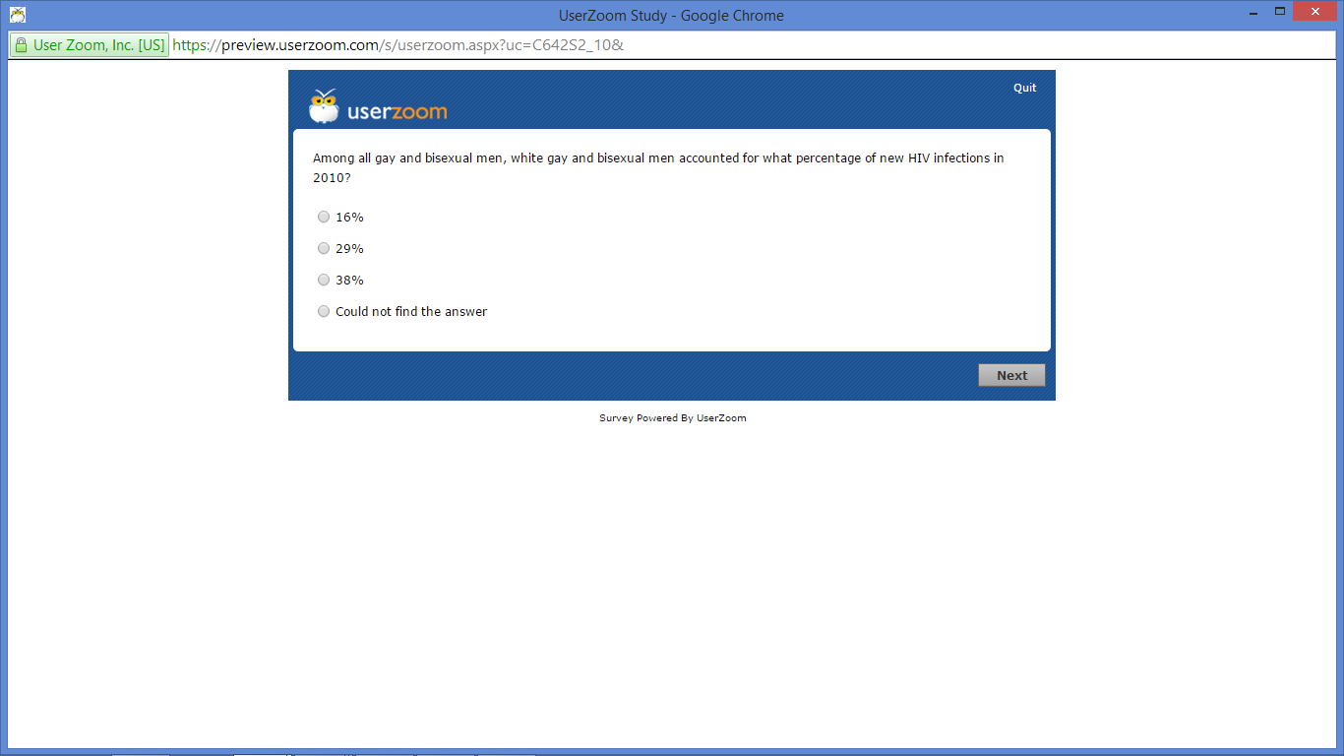

Task 13
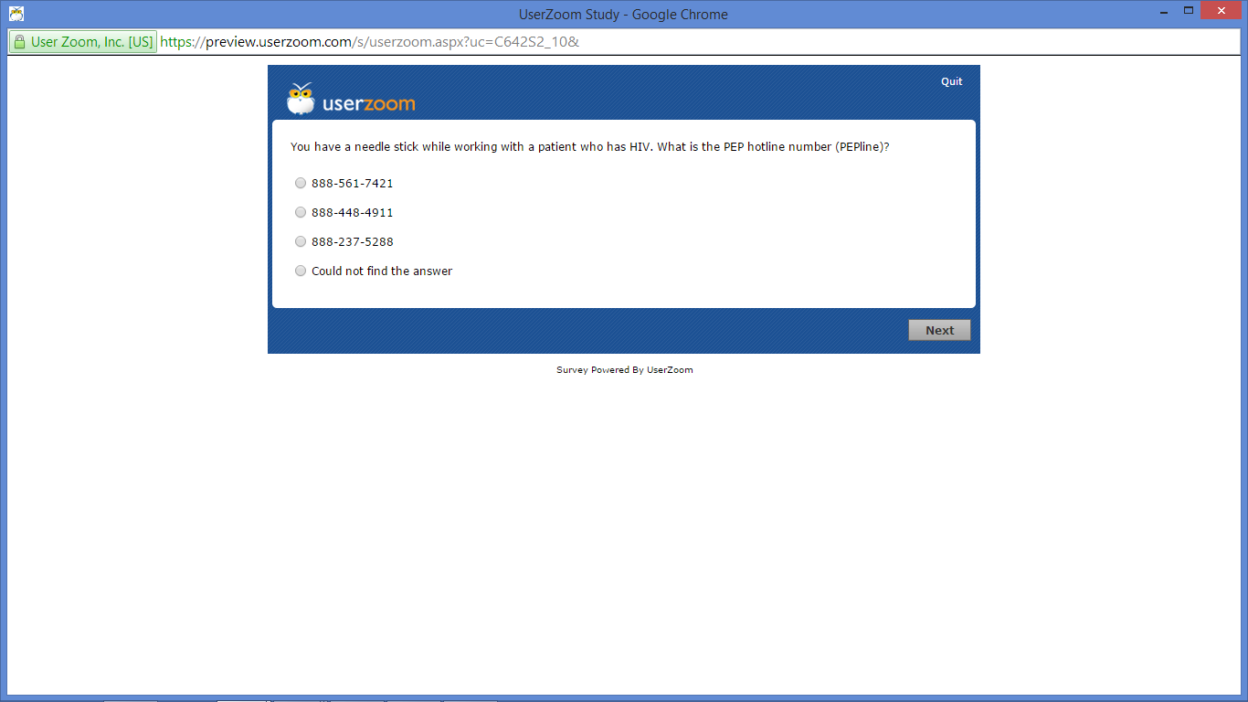

Task 14
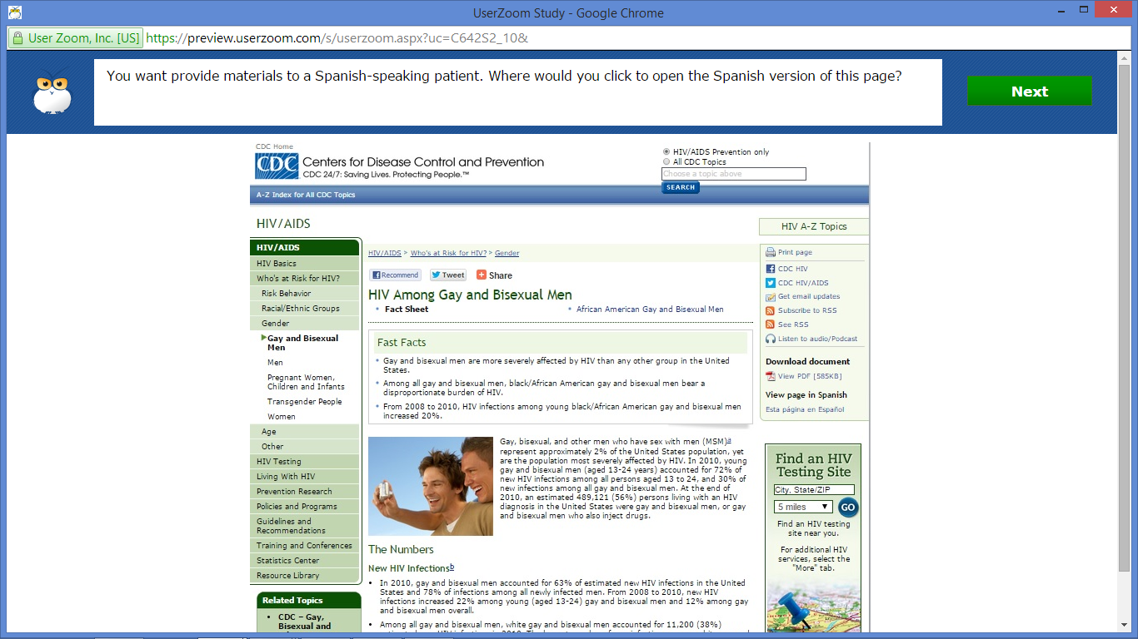

Task 15
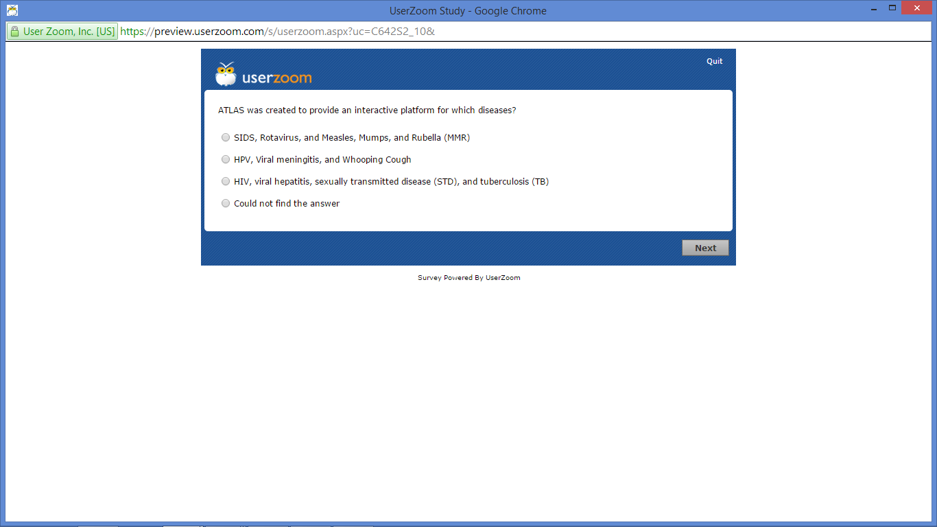

Task 16
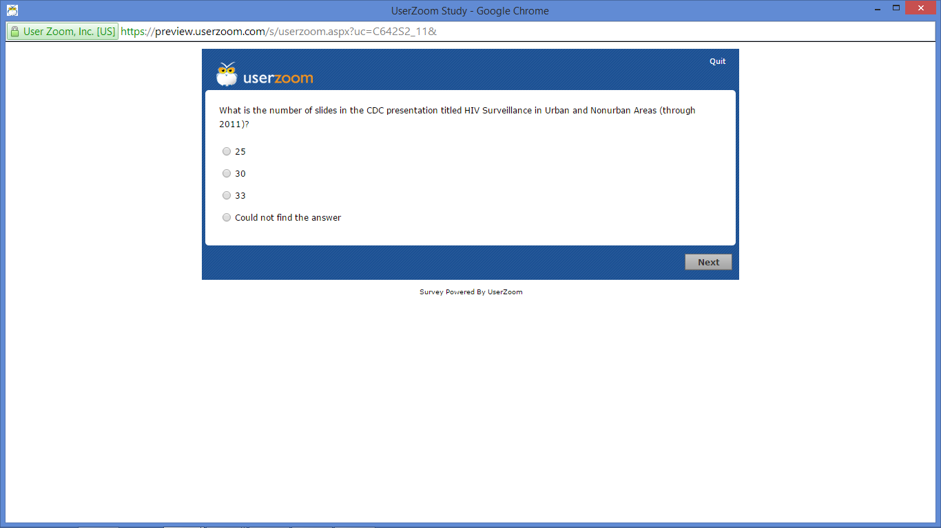

Task 17
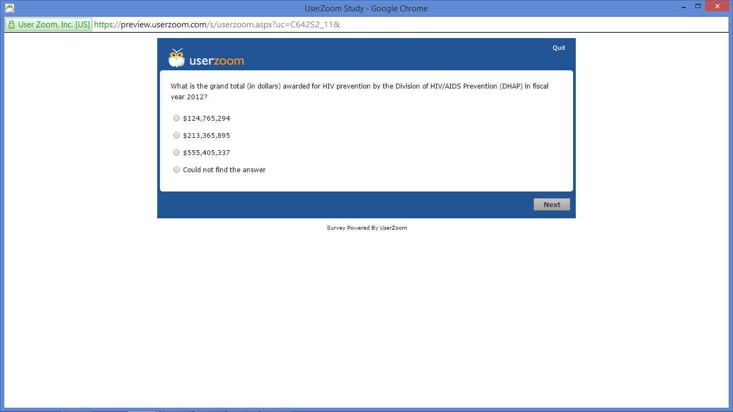

Task 18
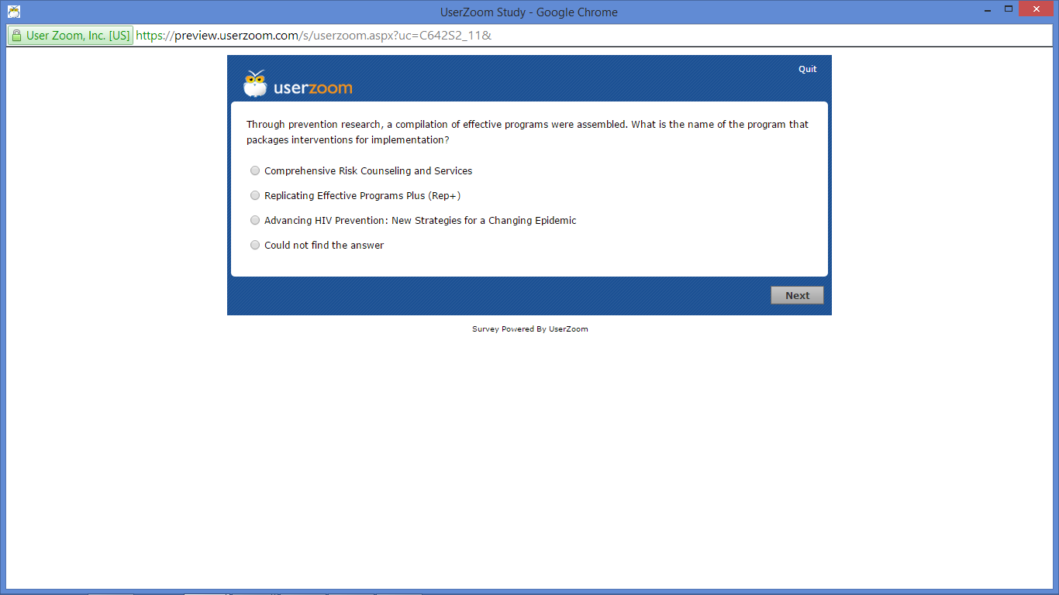

Task 19
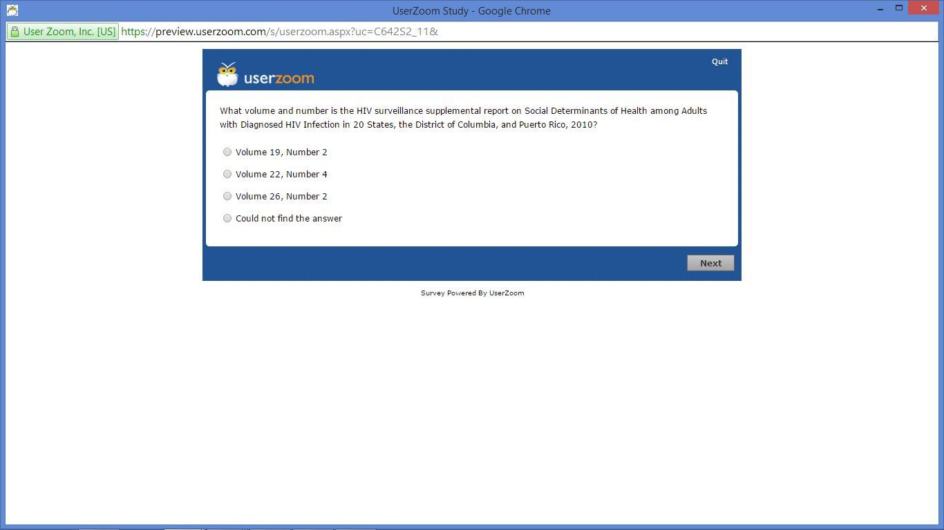

Task 20
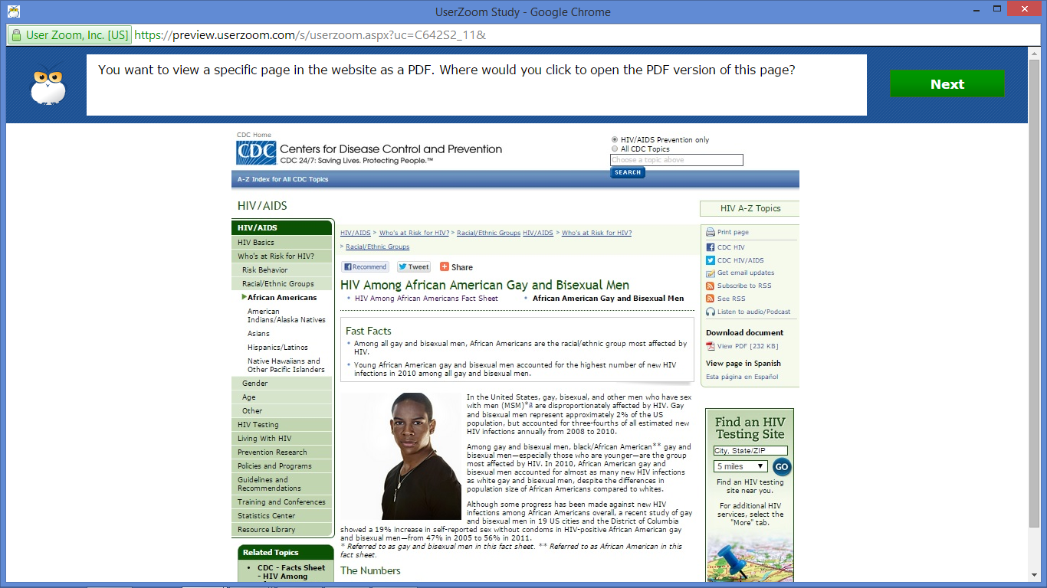

Task 21
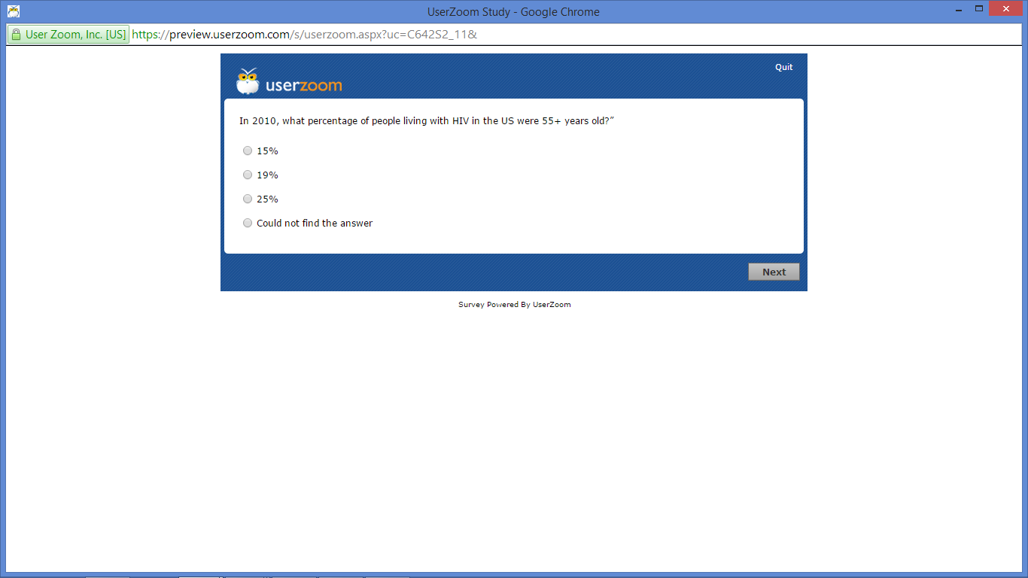

Task 22
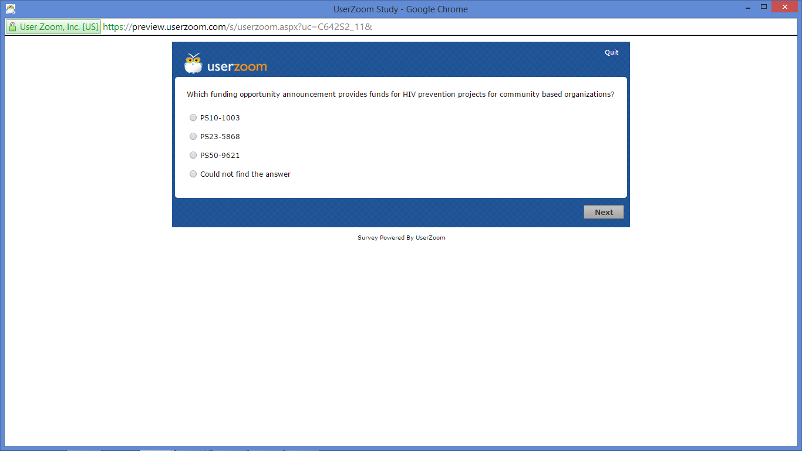

Task 23
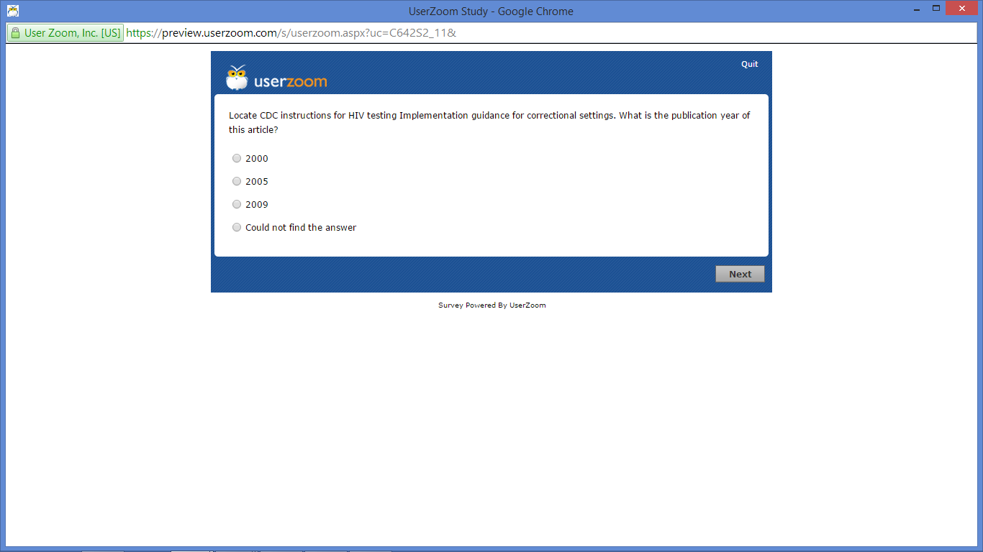

Task 24
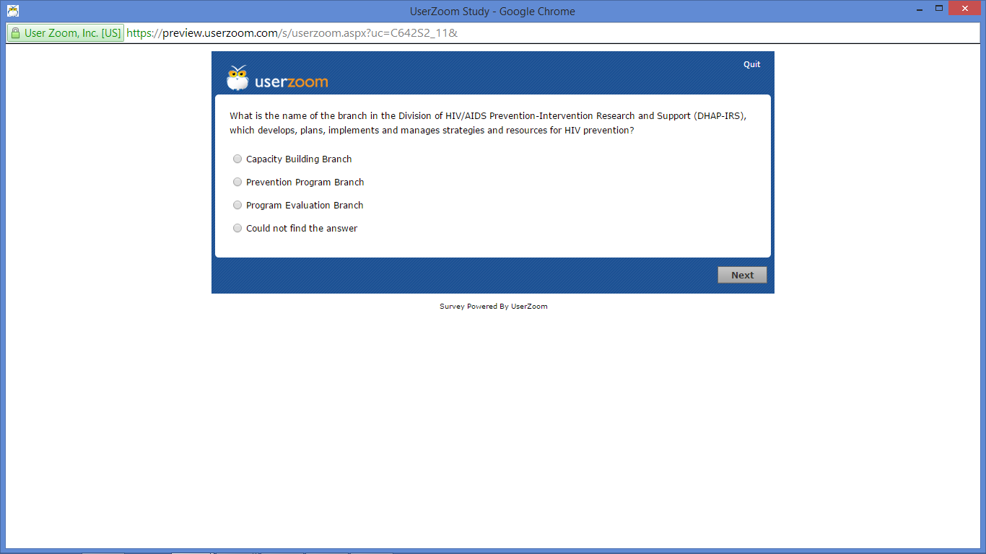

Task 25
