Form Approved

OMB No. 0920-1027

Expiration Date: 08/31/2017

Title of Project: Usability Testing of CDC’s Act Against AIDS (AAA) Website

**Attachment 3**

**Screenshots** forUsability Testing of CDC’s Act Against AIDS (AAA) Website

Public reporting burden of this collection of information is estimated to average 1 hour per response, including the time for reviewing instructions, searching existing data sources, gathering and maintaining the data needed, and completing and reviewing the collection of information. An agency may not conduct or sponsor, and a person is not required to respond to a collection of information unless it displays a currently valid OMB control number. Send comments regarding this burden estimate or any other aspect of this collection of information, including suggestions for reducing this burden to CDC/ATSDR Reports Clearance Officer; 1600 Clifton Road NE, MS D-74, Atlanta, Georgia 30333; Attn: OMB-PRA (0920-1027)

Intercept Page for Online Survey

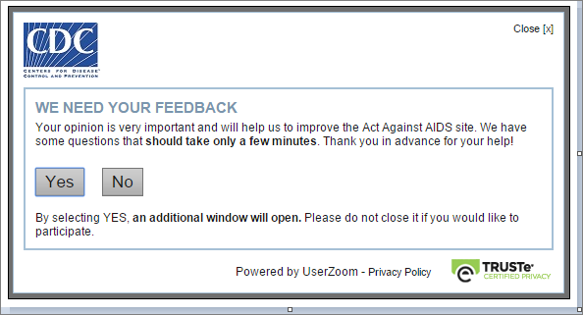

Web site Homepage and survey beginning. Respondents will be asked to execute functions to test the navigation of the website. Instructions for the user/respondent will be located at the bottom of the screen and respondents will simply identify information or follow the instructions.

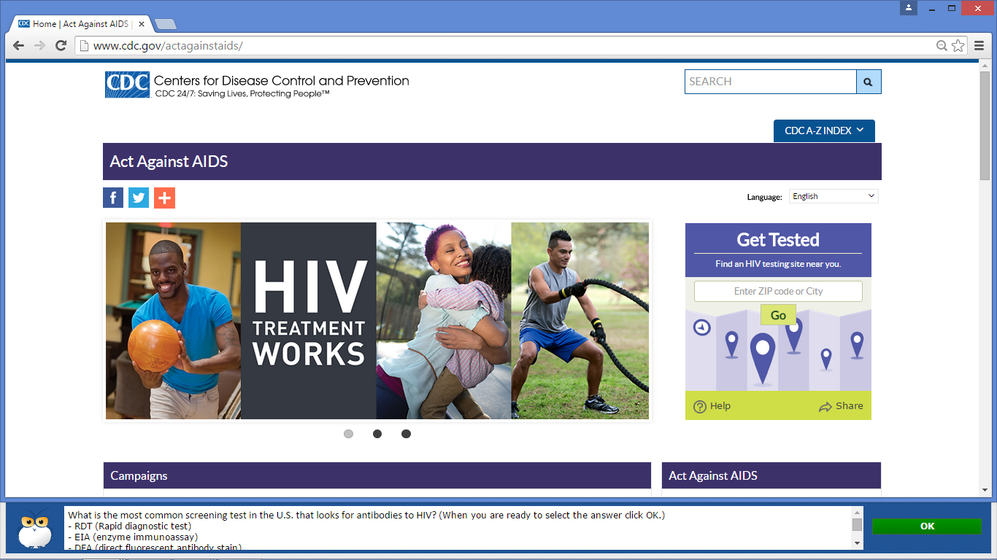

Task 1

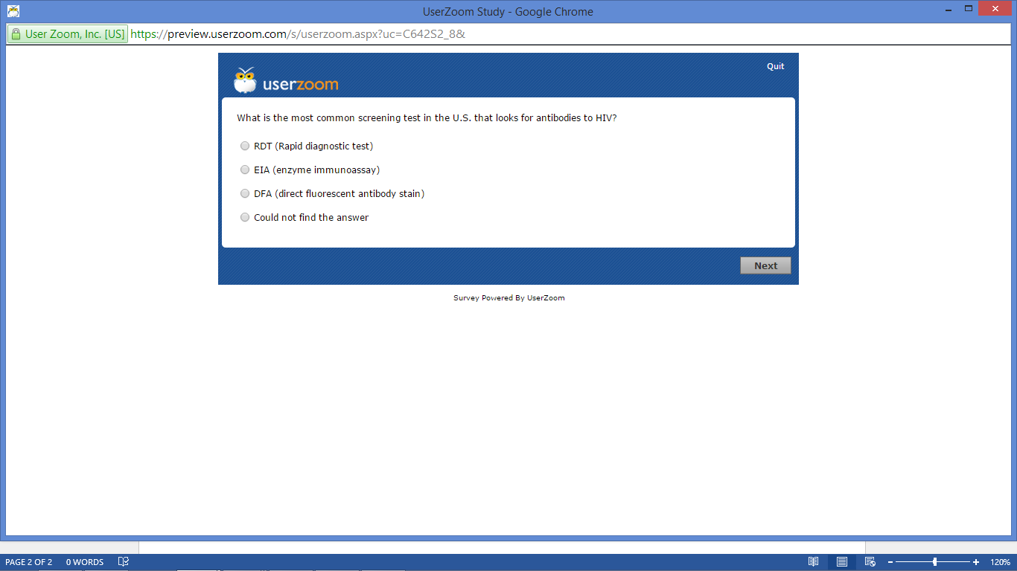

Task 2

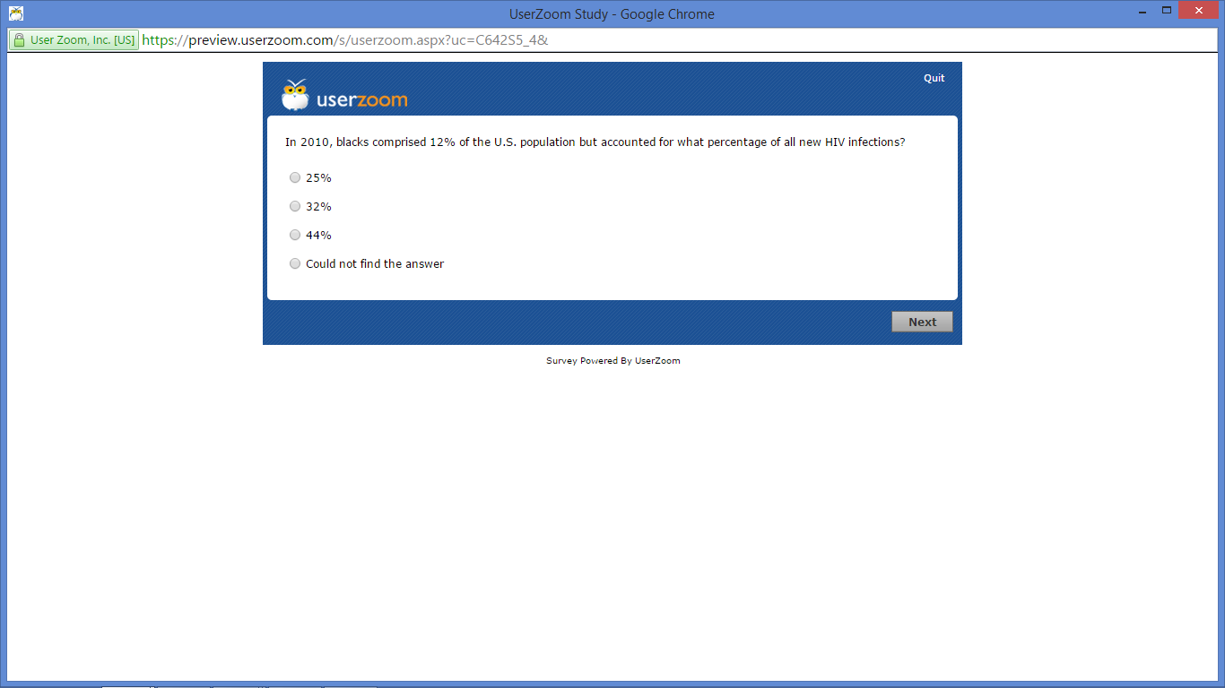

Task 3

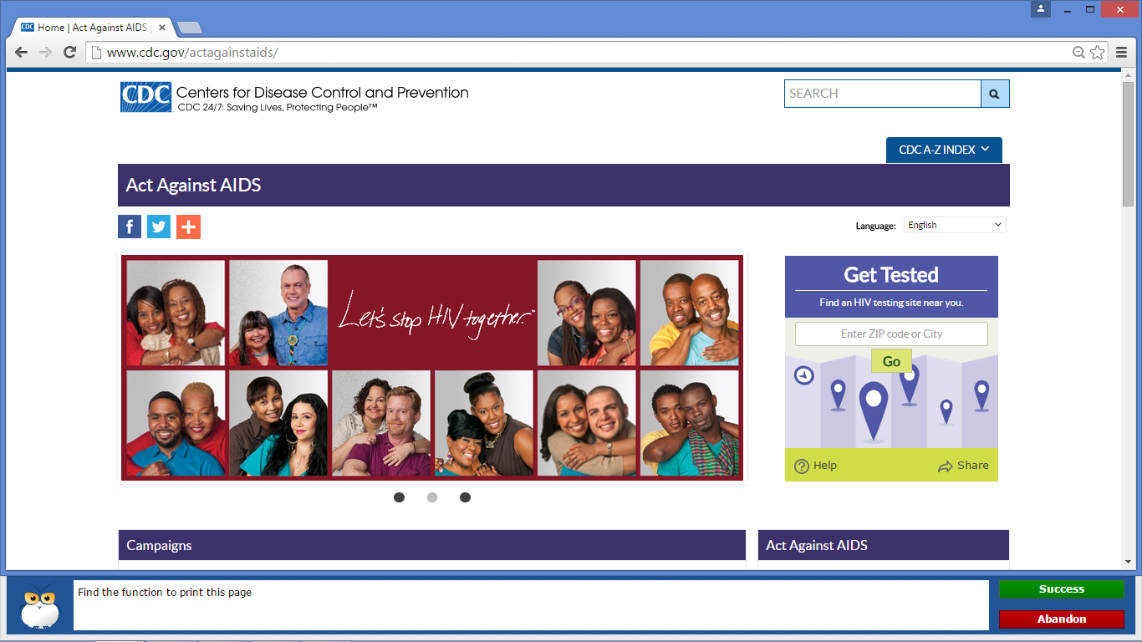

Task 4

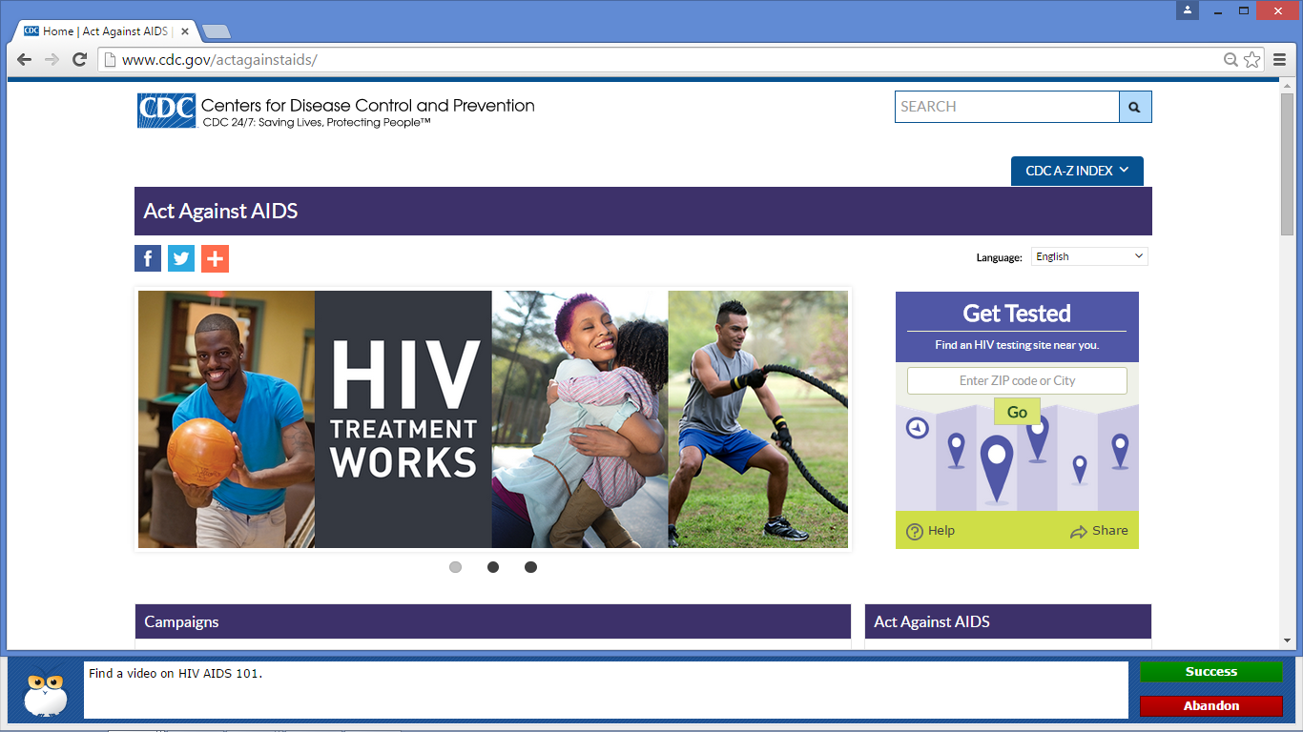

Task 5

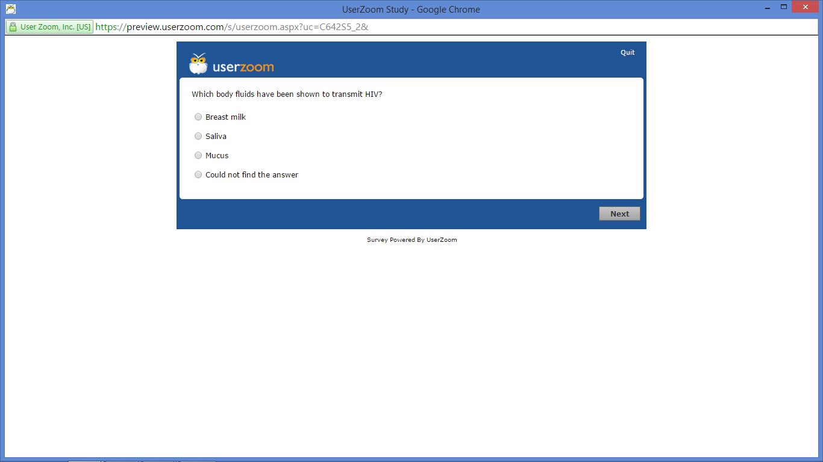

Task 6

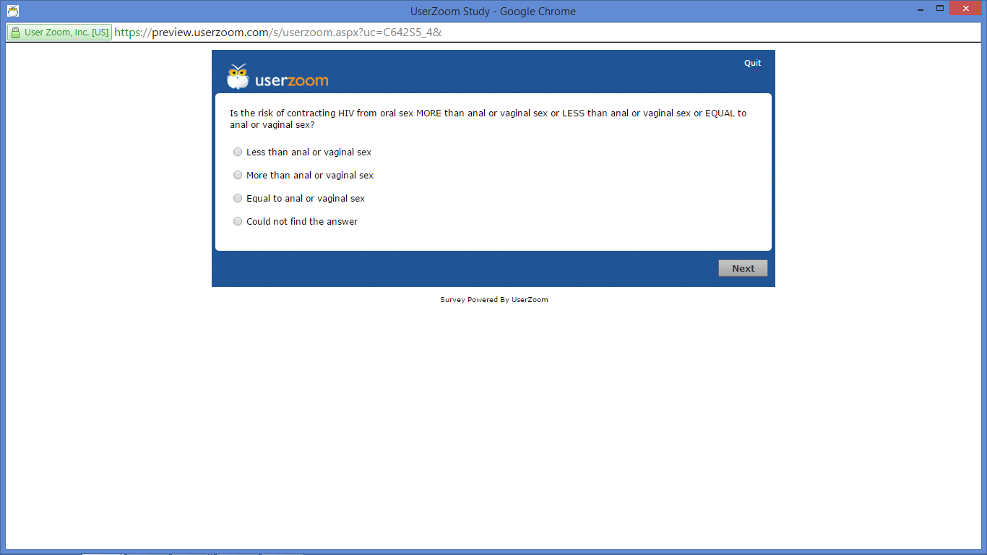

Task 7

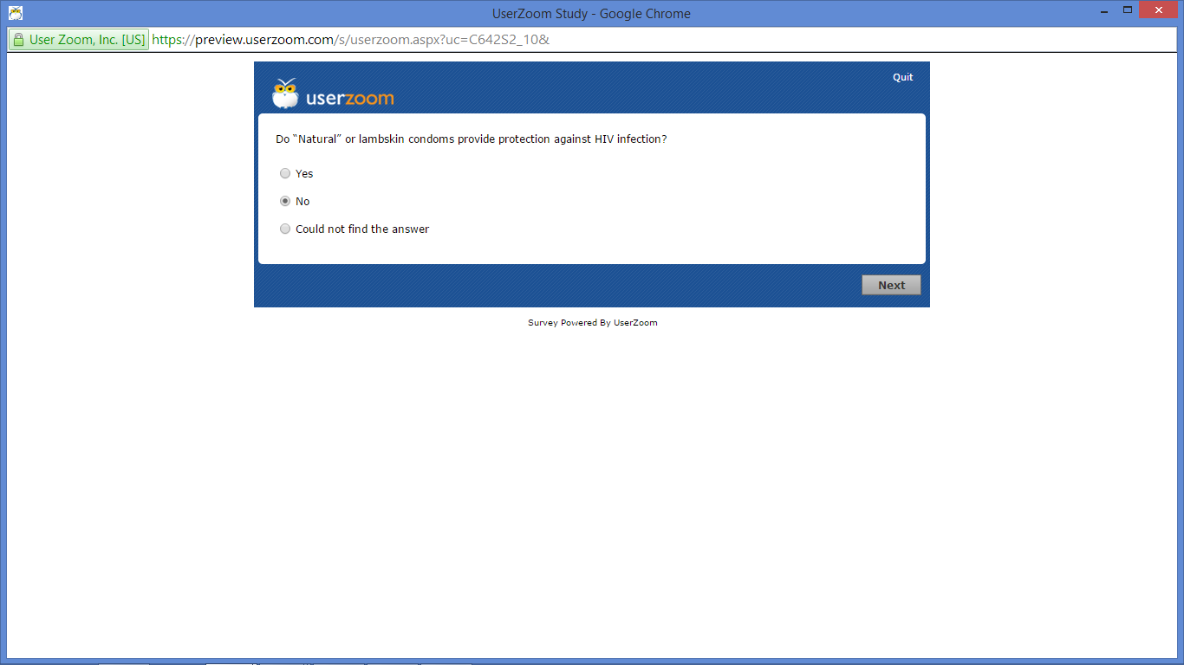

Task 8

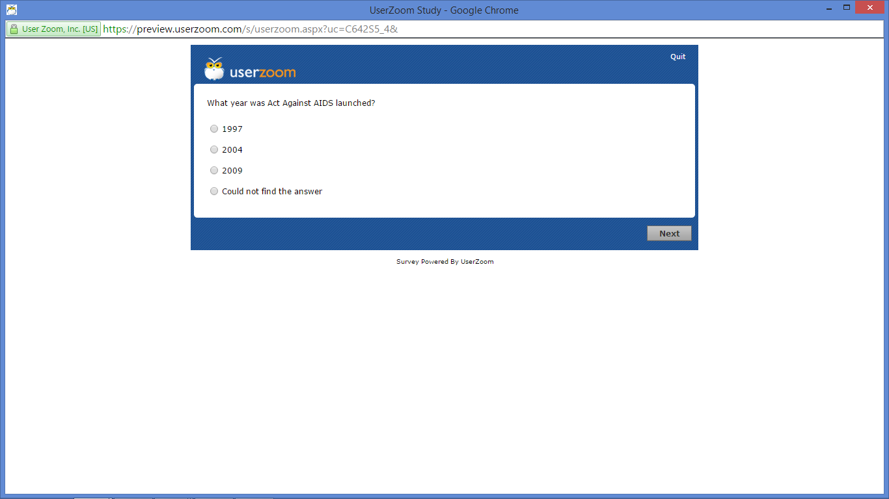

Task 9

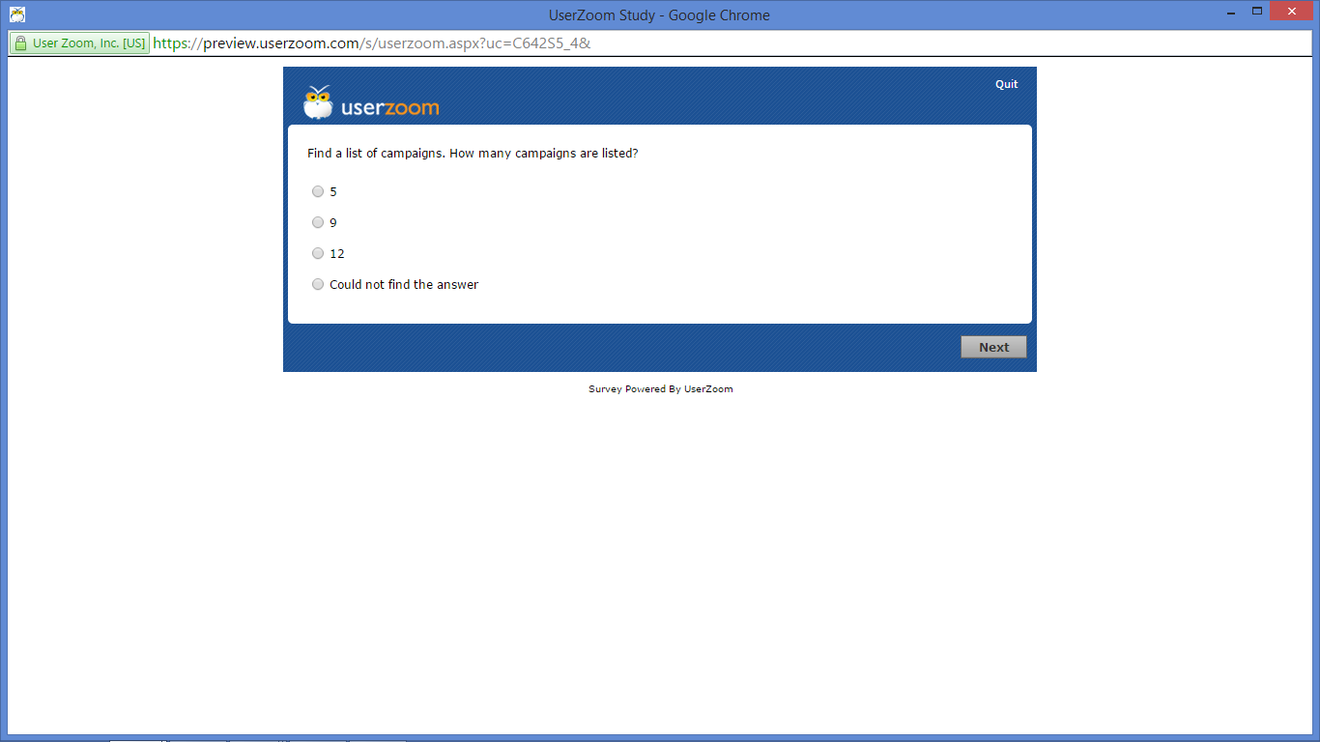

Task 10

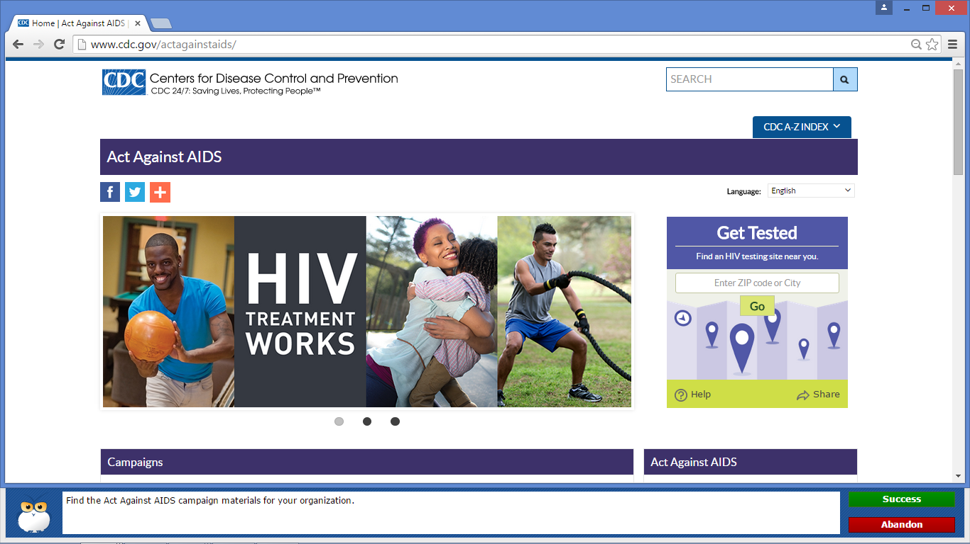

Task 11

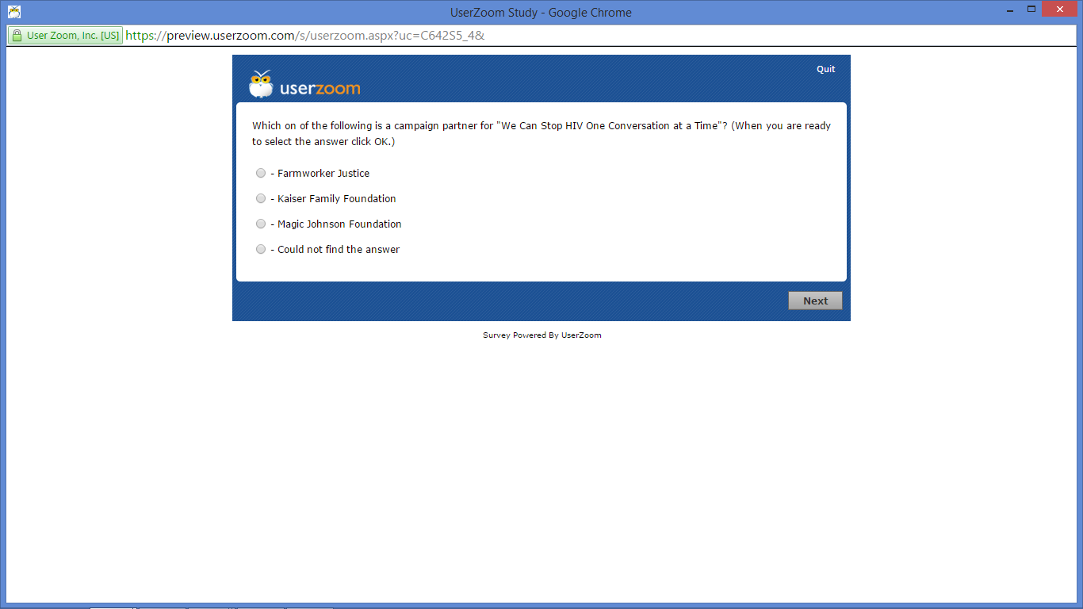

Task 12

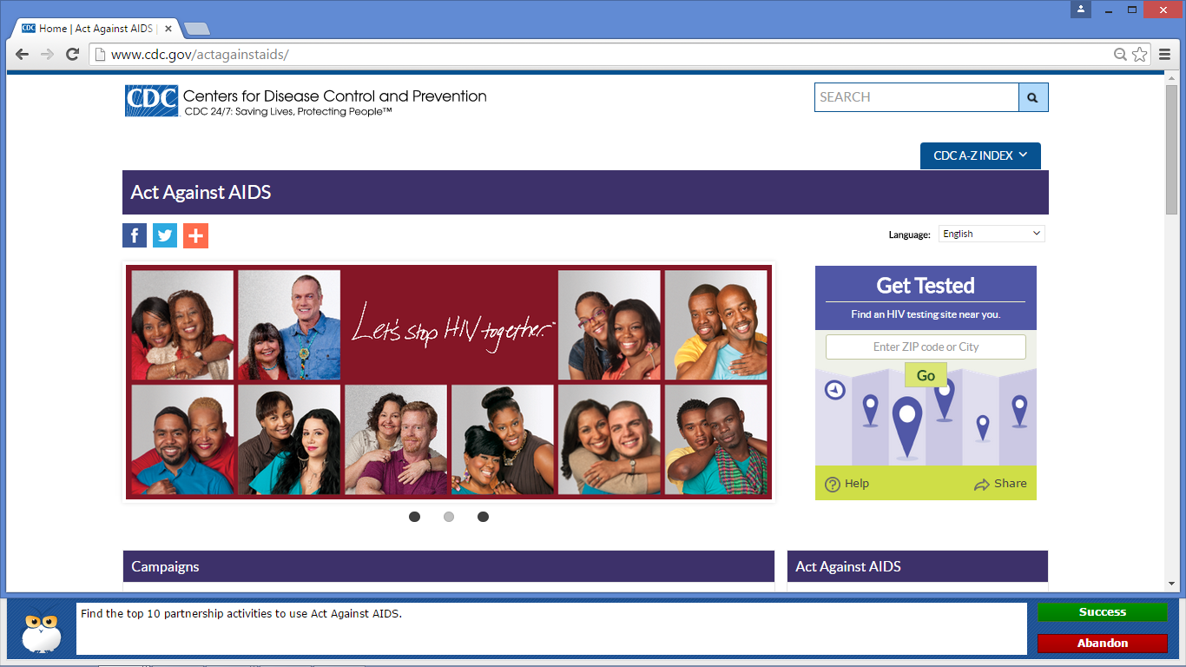

Task 13

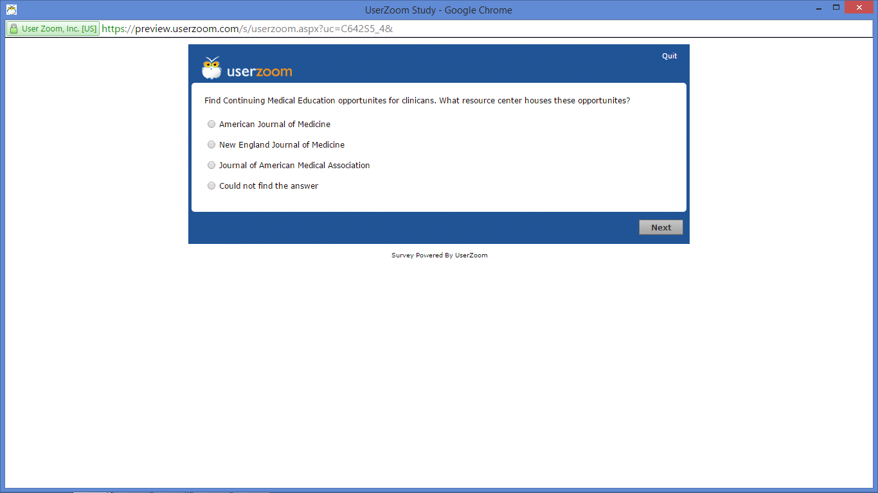

Task 14

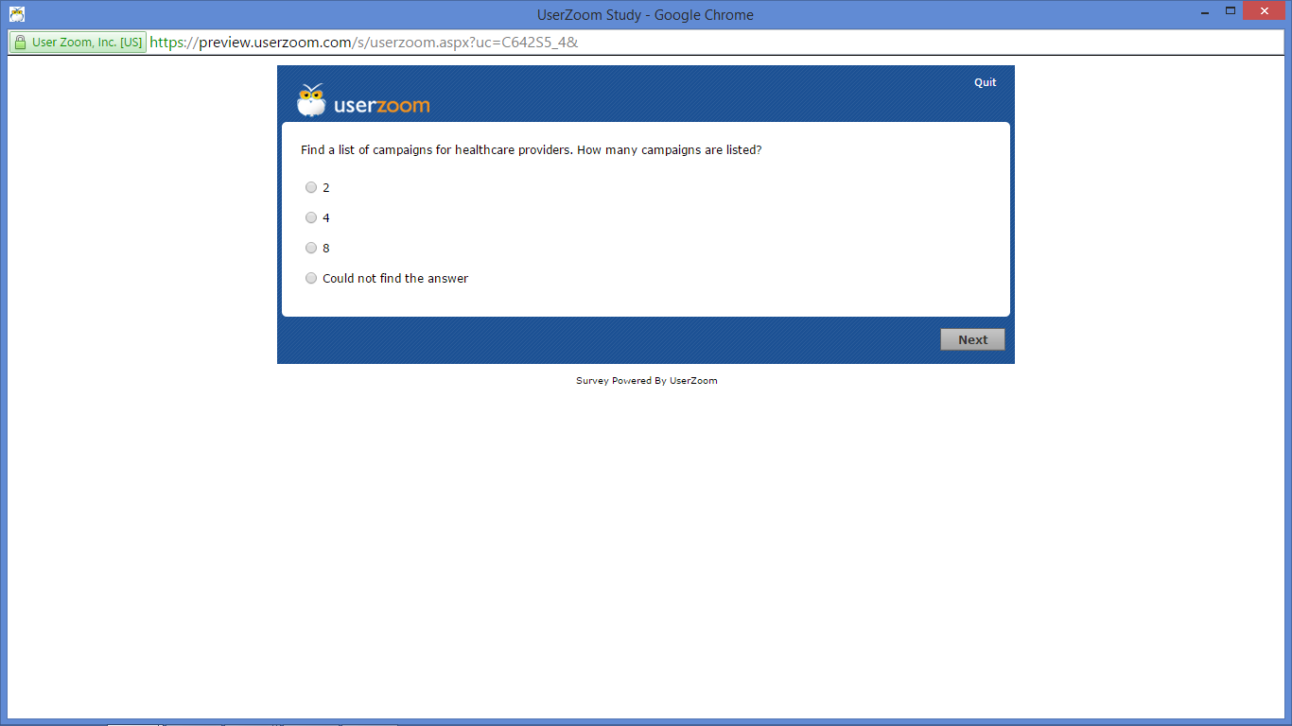

Task 15

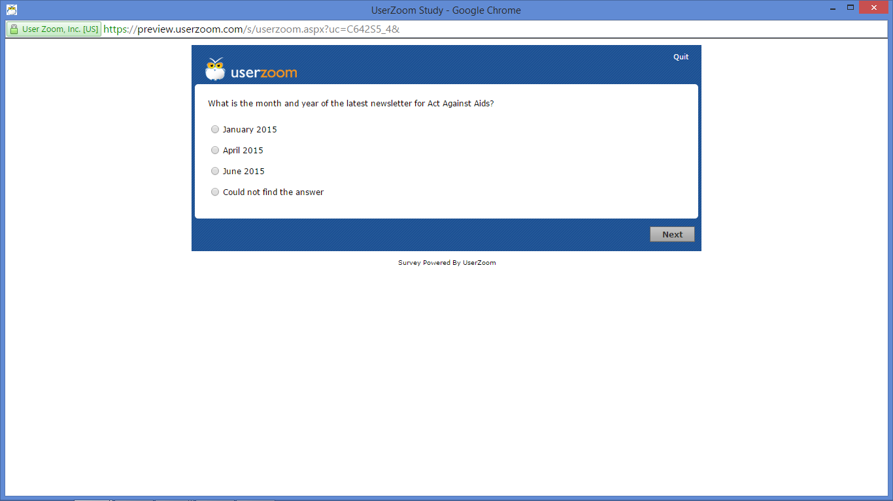

Final Questionnaire: Question 1

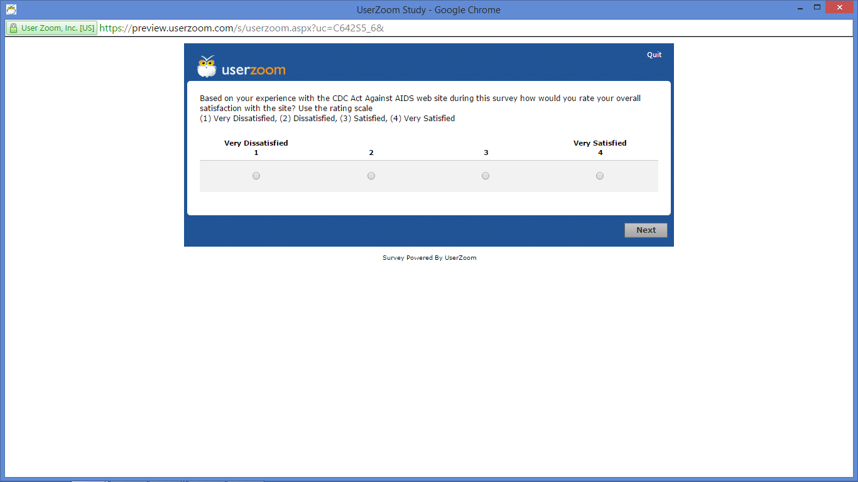

Final Questionnaire: Question 2

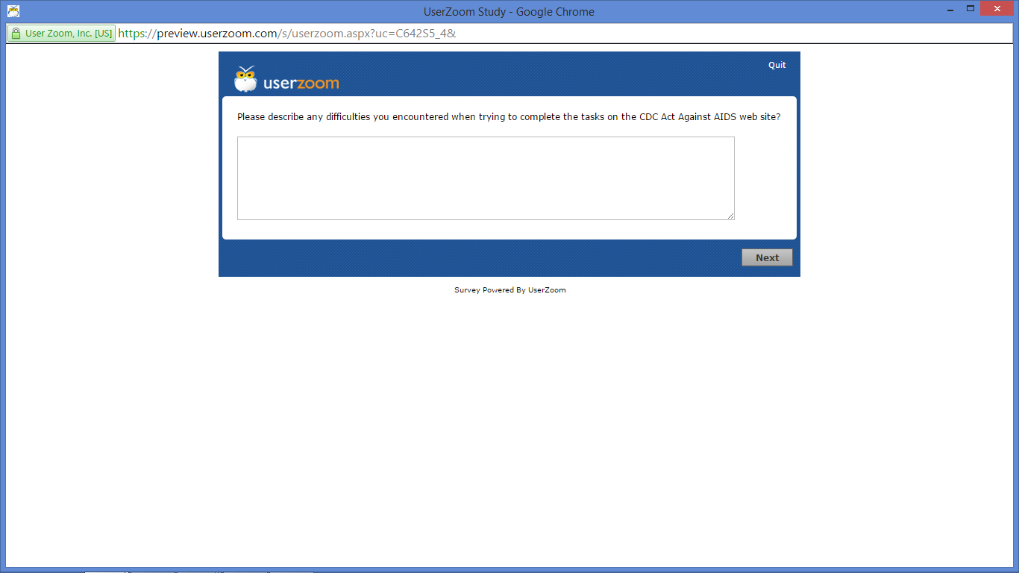

Final Questionnaire: Question 3

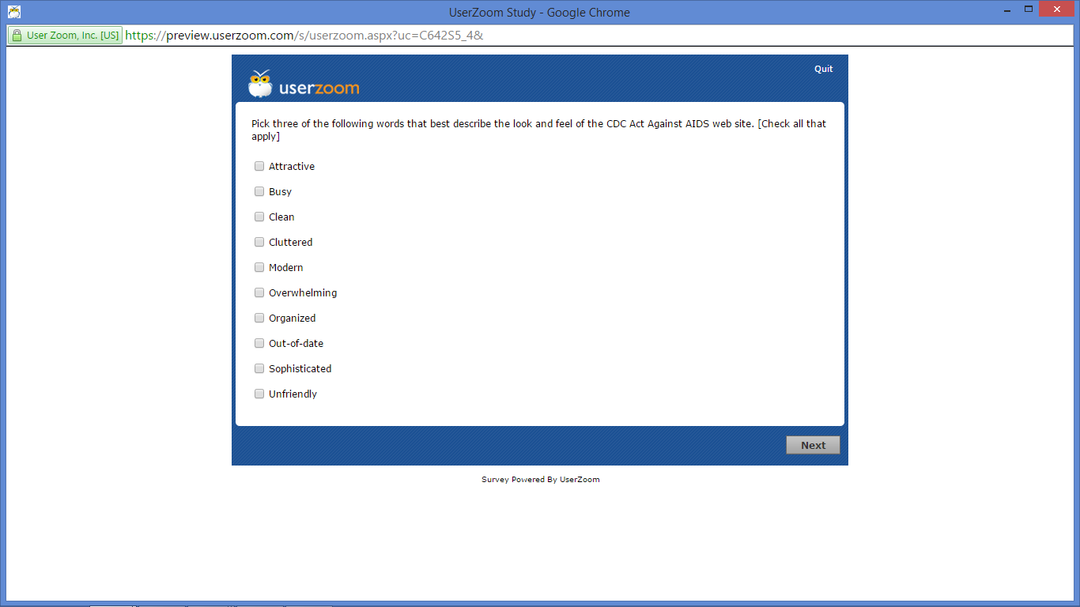

Final Questionnaire: Question 4

