Form Approved
OMB No. 0920-1027
Expiration Date: 08/31/2017

Title of Project: User Insights for NCHHSTP Atlas Website and Tool

Attachment 2
Email Invitation Body for Online Survey User Survey for NCHHSTP Atlas Website and Tool

Dear Colleague,

Do you use data to drive your work in HIV/AIDS, viral hepatitis, TB, or STDs?

We invite you to take a brief survey about the NCHHSTP Atlas tool. Danya International is working with NCHHSTP and wants your feedback to help in their efforts to maximize the Atlas’ usefulness and to better serve your needs. As someone working to improve public health, we value your opinion and feedback about continuous improvements.

Participate Today!

Who?
We are looking for individuals in the public health field who have may have used the NCHHSTP Atlas and tool. The individual may be public health professionals, students, researchers, policy makers, or healthcare providers.

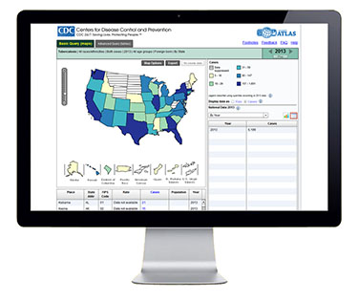
What and How?
Participating is quick and easy. Respond to our 10 minute survey about the NCHHSTP Atlas by clicking on the link below:
[INSERT LINK TO SURVEY]

Questions?
Contact Everett Long at elong@danya.com

Thank you for your participation.

Take our 10 minute survey
about the Atlas today!

