Attachment 5
Analysis Coding Book: NVDRS Variable Names by Data Entry Screens
Screenshots

Contents
Introduction 1
1.0 Demographic Variables 2
1.1 Demographics, Race, and Ethnicity 3
1.2 Place of Residence, Birthplace, Industry, Occupation, and Education 4
2.0 Injury and Death 5
2.1 Injury Locations, Time, and Events 5
2.2 Hospital Codes 6
2.3 Wounds and Death Certificate (Part 1: Underlying Cause of Death & Location of Death) 7
2.3 Wounds and Death Certificate (Part 2: Wounds and Multiple Conditions) 8
3.0 Circumstances 9
3.1 Mental, Health, Substance Abuse, and Other Addiction & Relationship and Life Stressors 9
3.2 Mental, Health, Substance Abuse, and Other Addiction & Relationship and Life Stressors 10
3.3 Manner Specific Circumstances for Homicide and Suicide Deaths 11
3.4 Manner Specific Circumstances for Unintentional Firearm Deaths 12
3.5 Manner Specific Circumstances for Unintentional Firearm Deaths 13
4.0 Weapons 14
5.0 Suspects 15
6.0 Toxicology 16
6.1 Toxicology Specimen Date & Toxicology Findings 16
6.2 Toxicology Summary 17
7.0 Document 18
8.0 Incident 19
8.1 Incident Overview 19
8.2 CME and LE Incident Narratives 20

Introduction
This document displays the screens that abstractors use to enter required data elements. The variable name associated with each data entry field is provided to help users interpret and analyze the data.

Form Approved
OMB No. 0920-0607
Exp. Date: 12/31/2015
Public Reporting burden of this collection of information is estimated at 30 minutes per response, including the time for reviewing instructions, searching existing data sources, gathering and maintaining the data needed, and completing and reviewing the collection of information. An agency may not conduct or sponsor, and a person is not required to respond to a collection of information unless it displays a currently valid OMB control number. Send comments regarding this burden estimate or any other aspect of this collection of information, including suggestions for reducing this burden to CDC/ATSDR Reports Clearance Officer, 1600 Clifton Road NW, MS D-74, Atlanta, GA 30333; Attn: PRA (0920-0607).

1.0 Demographic Variables

1.1 Demographics, Race, and Ethnicity
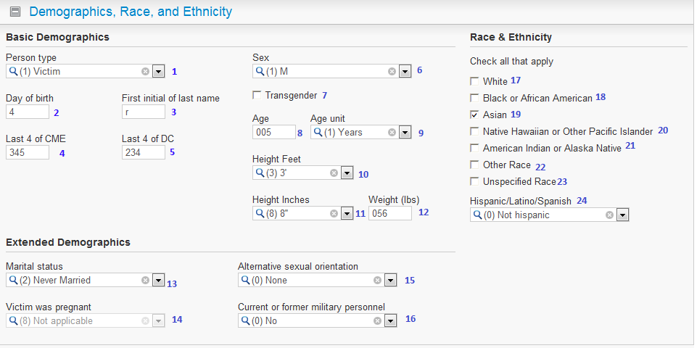
1 | PersonType |  |  | 9 | AgeUnit |  | 17 | RaceWhite
2 | BirthDayofMonth |  |  | 10 | HeightFeet |  | 18 | RaceBlack
3 | LastNameFirstInitial |  |  | 11 | HeightInches |  | 19 | RaceAsian
4 | CMENumberLastFour |  |  | 12 | Weight |  | 20 | RacePacificIslander
5 | DCNumberLastFour |  |  | 13 | MaritalStatus |  | 21 | RaceAmericanIndian
6 | Sex |  |  | 14 | Pregnant |  | 22 | RaceOther
7 | Transgender |  |  | 15 | SexualOrientation |  | 23 | RaceUnspecified
8 | Age |  |  | 16 | Military |  | 24 | Ethnicity

1.2 Place of Residence, Birthplace, Industry, Occupation, and Education
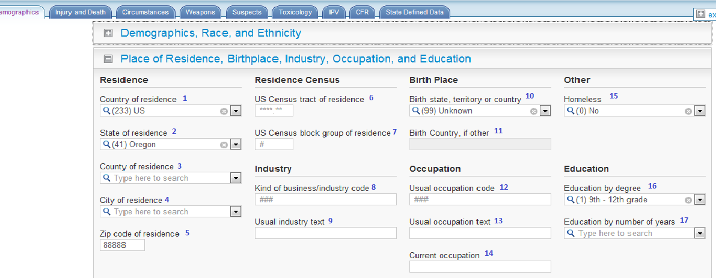
1 | Country |  |  |  |  | 10 | BirthPlace
2 | ResidenceState |  |  |  |  | 11 | BirthCountryOther
3 | ResidenceCounty |  |  |  |  | 12 | UsualOccupation
4 | ResidenceCity |  |  |  |  | 13 | OccupationText
5 | ResidenceZip |  |  |  |  | 14 | OccupationCurrentText
6 | ResidenceCensusTract |  |  |  |  | 15 | Homeless
7 | ResidenceCensusBlock |  |  |  |  | 16 | EducationLevel
8 | Industry |  |  |  |  | 17 | EducationYears
9 | IndustryText

2.0 Injury and Death

2.1 Injury Locations, Time, and Events
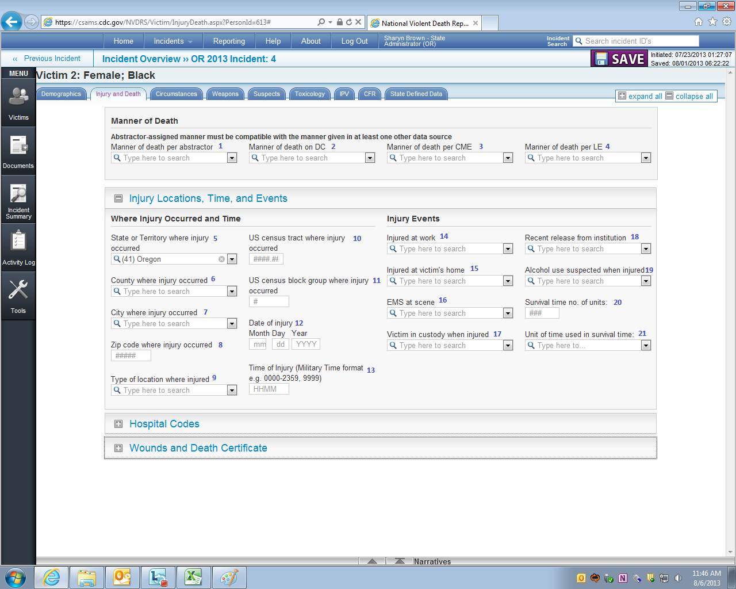
1 | DeathMannerAbstractor |  |  | 9 | InjuryLocationType |  | 17 | VictimInCustody
2 | DeathMannerDC |  |  | 10 | CensusTract |  | 18 | RecentRelease
3 | DeathMannerCME |  |  | 11 | CensusBlock |  | 19 | AlcoholUseSuspected
4 | DeathMannerLE |  |  | 12 | InjuryDate |  | 20 | SurvivalTime
5 | InjuryState |  |  | 13 | InjuryTime |  | 21 | SurvivalTimeUnit
6 | InjuryCounty |  |  | 14 | InjuredAtWork
7 | InjuryCity |  |  | 15 | InjuredAtVictimHome

8 | InjuryZip |  |  | 16 | EMSPresent

2.2 Hospital Codes
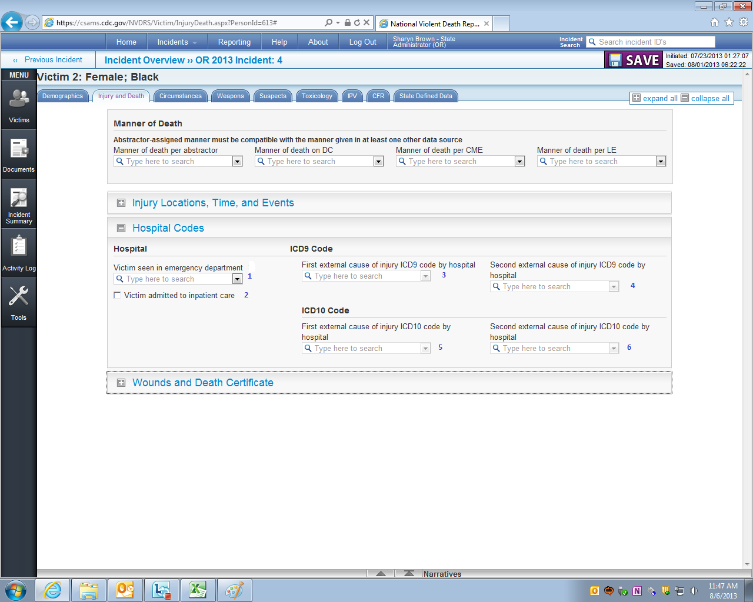
1 | EmergencyDepartment
2 | HospitalAdmit
3 | ExternalCause1ICD9
4 | ExternalCause2ICD9
5 | ExternalCause1ICD10
6 | ExternalCause2ICD10

2.3 Wounds and Death Certificate (Part 1: Underlying Cause of Death & Location of Death)
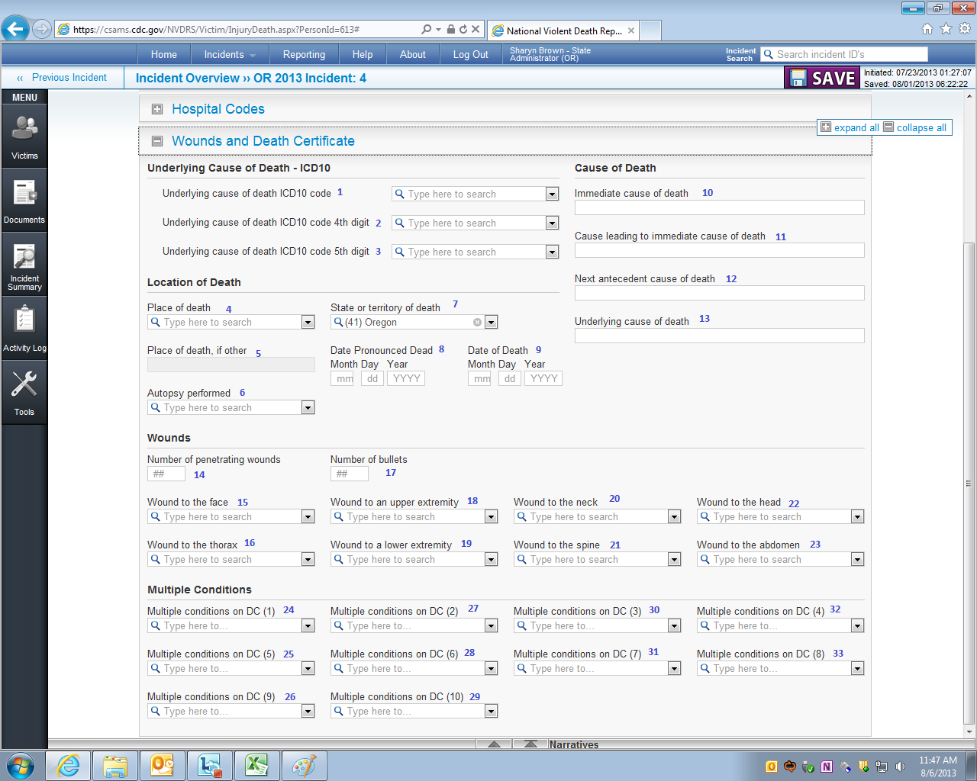
1 | UnderlyingCauseCode | 8 | DatePronouncedDate
2 | UnderlyingCauseCode4thDigit | 9 | DeathDate
3 | UnderlyingCauseCode5thDigit | 10 | DeathCause1
4 | DeathPlace | 11 | DeathCause2
5 | DeathPlaceText | 12 | DeathCause3
6 | AutopsyPerformed | 13 | DeathCause4
7 | DeathState

2.3 Wounds and Death Certificate (Part 2: Wounds and Multiple Conditions)
14 | NumberWounds | 21 | WoundToSpine | 28 | MultiCondition06ICD10
15 | WoundToFace | 22 | WoundToHead | 29 | MultiCondition10ICD10
16 | WoundToThorax | 23 | WoundToAbdomen | 30 | MultiCondition03ICD10
17 | NumberBullets | 24 | MultiCondition01ICD10 | 31 | MultiCondition07ICD10
18 | WoundToUpperExtremity | 25 | MultiCondition05ICD10 | 32 | MultiCondition04ICD10
19 | WoundToLowerExtremity | 26 | MultiCondition09ICD10 | 33 | MultiCondition08ICD10
20 | WoundToNeck | 27 | MultiCondition02ICD10

3.0 Circumstances

3.1 Mental, Health, Substance Abuse, and Other Addiction & Relationship and Life Stressors
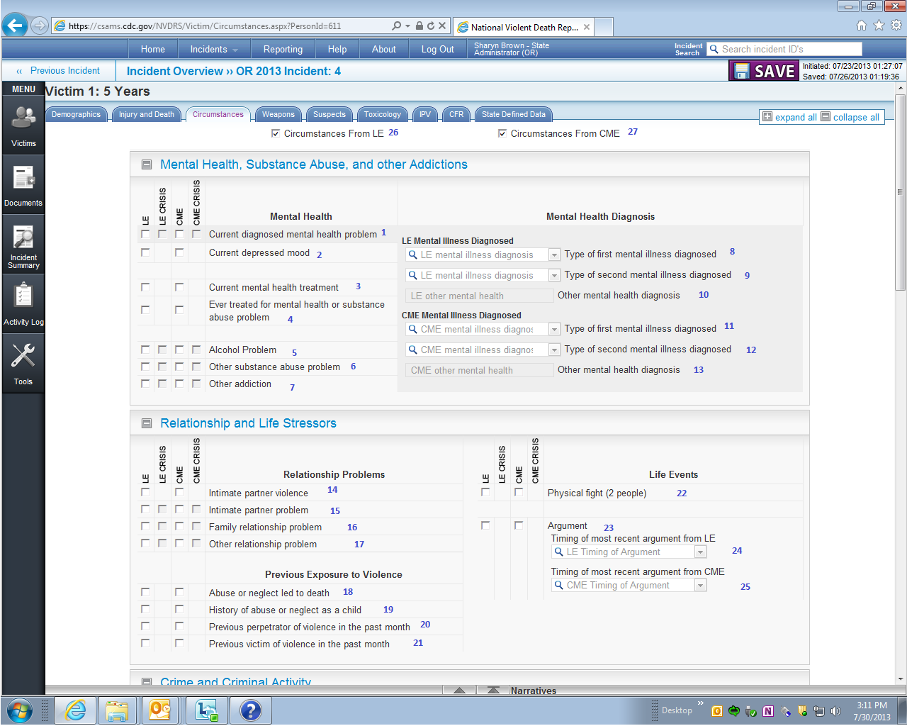
CRISIS VARIABLE NAMES
Whether a circumstance was a crisis (i.e., checking the “LE Crisis” or “CME Crisis” checkbox) is stored in a separate variable from the circumstance in the export file. Specifically, crisis variables will have the word “crisis” inserted between the data source (i.e., LE and CME) and the circumstance name in the variable label variable (e.g., CME_CrisisVariableName, LE_CrisisVariableName). For example, the crisis variables for “Stalking” will be CME_CrisisStalking and LE_CrisisStalking.
CIRCUMSTANCE VARIABLE NAMES BY DATA SOURCE (CME AND LE)
Variables abstracted from both the CME and the LE reports are exported into two variables. If the CME report is the source, the variable name is preceded by “CME_” (e.g., “CME_VariableName”). If the LE report is the source, the variable name is preceded by “LE_” (e.g., “LE_VariableName”). For instance, information on the “Argument” variable will be stored in “CME_Argument” and “LE_Argument”

 |  |  |  |  | 17 | RelationshipProblemOther
  1 | MentalHealthProblem | 9 | LE_MentalHealthDiagnosis2 | 17 | RelationshipProblemOther | 26 LE_CircumstancesKnown
  2 | DepressedMood | 10 | LE_MentalHealthDiagnosisOther | 18 | DeathAbuse | 27 CME_CircumstancesKnown
  3 | MentalIllnessTreatmentCurrent | 11 | CME_MentalHealthDiagnosis1 | 19 | AbusedAsChild
  4 | HistoryMentalIllnessTreatment | 12 | CME_MentalHealthDiagnosis2 | 20 | InterpersonalViolencePerpetrator
  5 | AlcoholProblem | 13 | CME_MentalHealthDiagnosisOther | 21 | InterpersonalViolenceVictim
  6 | SubstanceAbuseOther | 14 | IntimatePartnerViolence | 22 | FightBetweenTwoPeople
  7 | OtherAddiction | 15 | IntimatePartnerProblem | 23 | Argument
  8 | LE_MentalHealthDiagnosis1 | 16 | FamilyStressors | 24 | LE_ArgumentTiming
   |  |  |  | 25 | CME_ArgumentTiming

3.2 Mental, Health, Substance Abuse, and Other Addiction & Relationship and Life Stressors

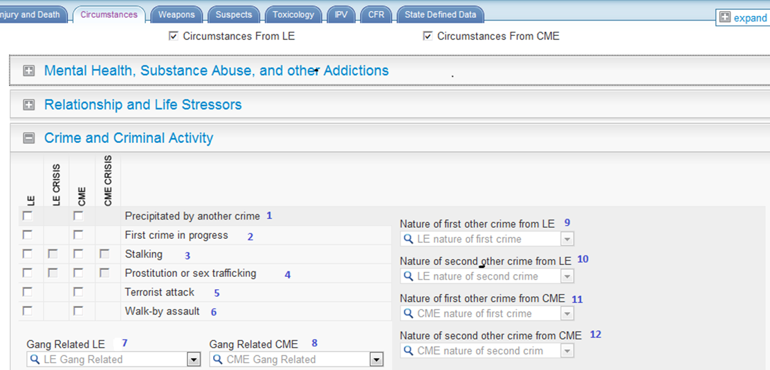
1 | PrecipitatedByOtherCrime | 7 | LE_GangType
2 | OtherCrimeinProgress | 8 | CME_GangType
3 | Stalking | 9 | LE_NatureOtherCrime1
4 | Prostitution | 10 | LE_NatureOtherCrime2
5 | TerroristAttack | 11 | CME_NatureOtherCrime1
6 | WalkByAssault | 12 | CME_NatureOtherCrime2

3.3 Manner Specific Circumstances for Homicide and Suicide Deaths
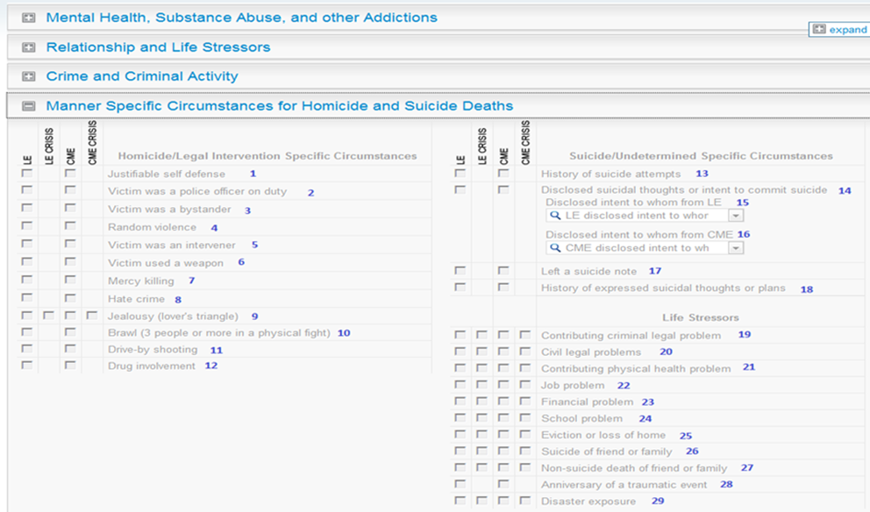
1 | JustifiableSelfDefense | 8 | HateCrime | 15 | LE_DisclosedIntentToWhom | 22 | JobProblem
2 | VictimPoliceOfficeOnDuty | 9 | Jealousy | 16 | CME_DisclosedIntentToWhom | 23 | FinancialProblem
3 | Bystander | 10 | Brawl | 17 | SuicideNote | 24 | SchoolProblem
4 | RandomViolence | 11 | DriveByShooting | 18 | SuicideThoughtHistory | 25 | EvictionorLossofHome
5 | IntervenerAssistingVictim | 12 | DrugInvolvement | 19 | RecentCriminalLegalProblem | 26 | RecentSuicideFriendFamily
6 | VictimUsedWeapon | 13 | SuicideAttemptHistory | 20 | LegalProblemOther | 27 | DeathFriendorFamilyOther
7 | MercyKilling | 14 | SuicideIntentDisclosed | 21 | PhysicalHealthProblem | 28 | TraumaticAnniversary

 |  |  |  |  |  | 29 | DisasterExposure

3.4 Manner Specific Circumstances for Unintentional Firearm Deaths
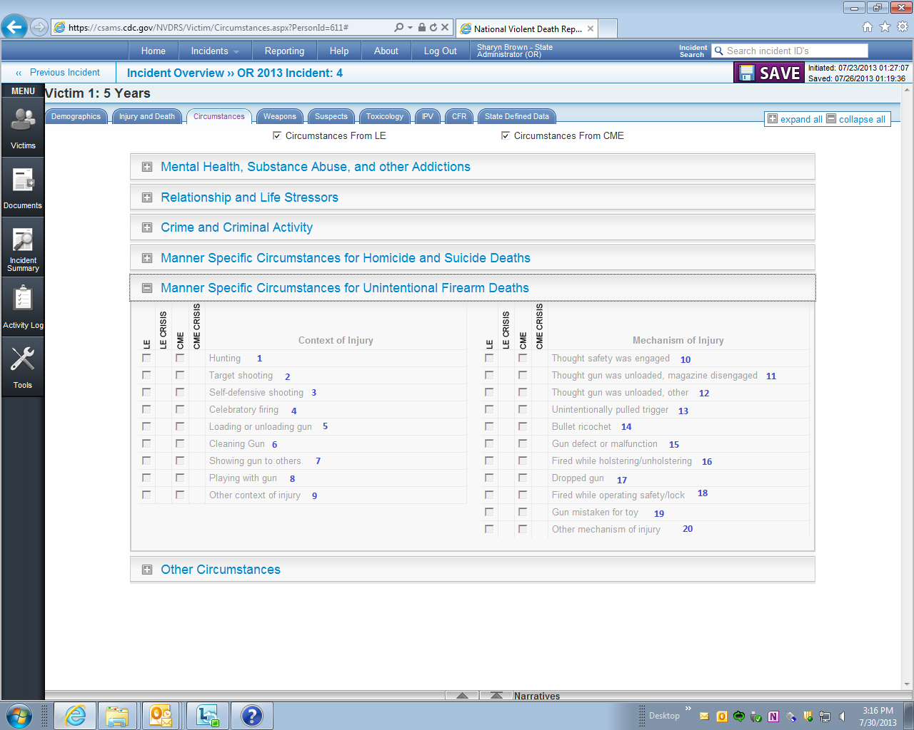
1 | Hunting |  |  |  | 10 | GunThoughtSafetyEngaged
2 | TargetShooting |  |  |  | 11 | GunThoughtUnloadedMagazineDisengaged
3 | SelfDefense |  |  |  | 12 | GunThoughtUnloadedOther
4 | CelebratoryFiring |  |  |  | 13 | GunUnintentionallyPulledTrigger
5 | GunFiredLoadingUnloading |  |  |  | 14 | BulletRicochet
6 | GunCleaning |  |  |  | 15 | GunDefectMalfunction
7 | GunShowing |  |  |  | 16 | GunFiredHolstering
8 | GunPlaying |  |  |  | 17 | GunDropped
9 | OtherContextInjury |  |  |  | 18 | GunFiredOperatingSafetyLock
 |  |  |  |  | 19 | GunThoughtToy

 |  |  |  |  | 20 | OtherMechanismInjury

3.5 Manner Specific Circumstances for Unintentional Firearm Deaths
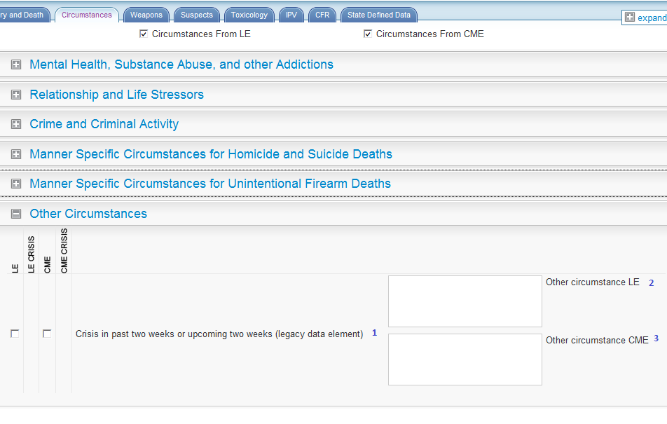
1 | CrisisRecent
2 | LE_CircumstancesOtherText
3 | CME_CircumstancesOtherText

4.0 Weapons
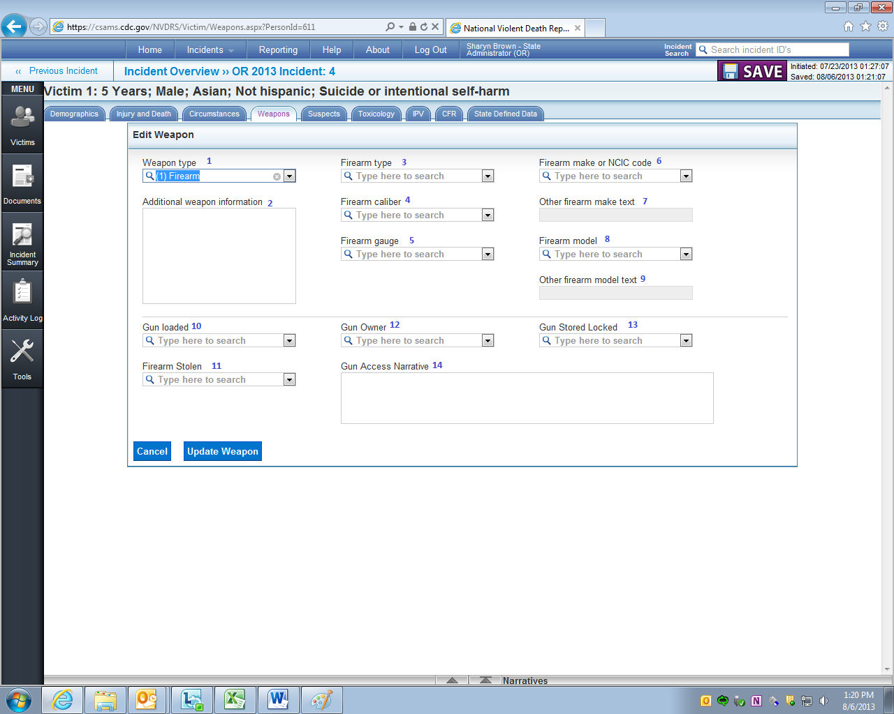
1 | WeaponType |  |  |  | 10 | GunLoaded
2 | WeaponOther |  |  |  | 11 | FirearmStolen
3 | FirearmType |  |  |  | 12 | GunOwner
4 | FirearmCaliber |  |  |  | 13 | GunStoredLocked
5 | FirearmGauge |  |  |  | 14 | YouthGunAccessNarrative
6 | FirearmMake
7 | FirearmMakeText
8 | FirearmModel
9 | FirearmModelText

5.0 Suspects
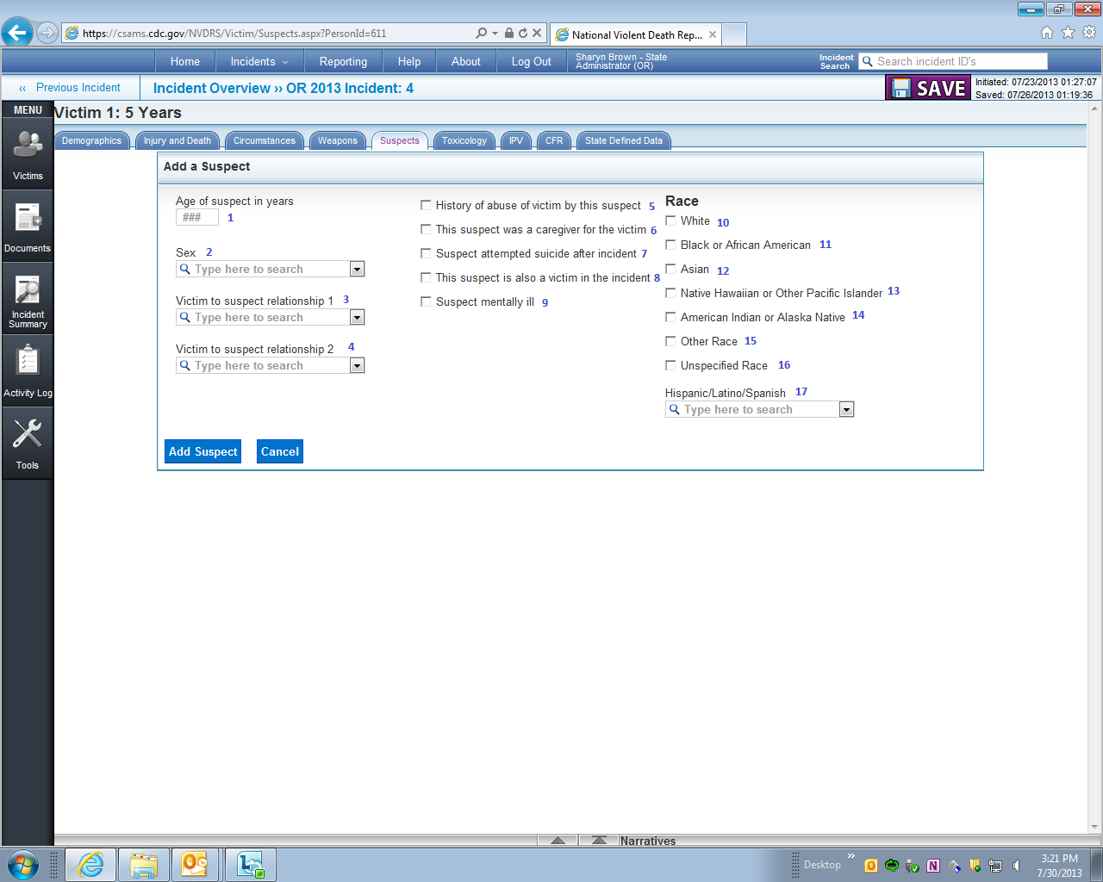
1 | AgeYears |  | 5 | AbuseHistory |  | 10 | RaceWhite
2 | Sex |  | 6 | CareGiver |  | 11 | RaceBlack
3 | VictimSuspectRelationship1 |  | 7 | AttemptedSuicide |  | 12 | RaceAsian
4 | VictimSuspectRelationship2 |  | 8 | SuspectAlsoVictim |  | 13 | RacePacificIslander
 |  |  | 9 | SuspectMentallyIll |  | 14 | RaceAmericanIndian
 |  |  |  |  |  | 15 | RaceOther
 |  |  |  |  |  | 16 | RaceUnspecified

 |  |  |  |  |  | 17 | Ethnicity

6.0 Toxicology

6.1 Toxicology Specimen Date & Toxicology Findings
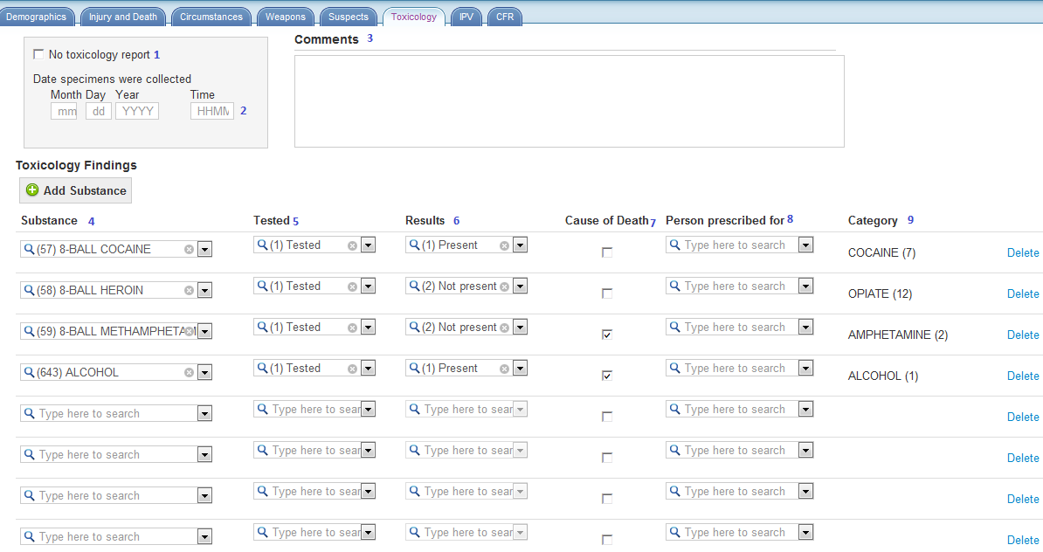
1 | No Toxicology Available |  |  | 7 | SubstanceCausedDeath
2 | SpecimensTime |  |  | 8 | DrugObtainedFor
3 | Comments |  |  | 9 | SubstanceClass
4 | SubstanceName
5 | SubstanceTested
6 | SubstanceResult

6.2 Toxicology Summary
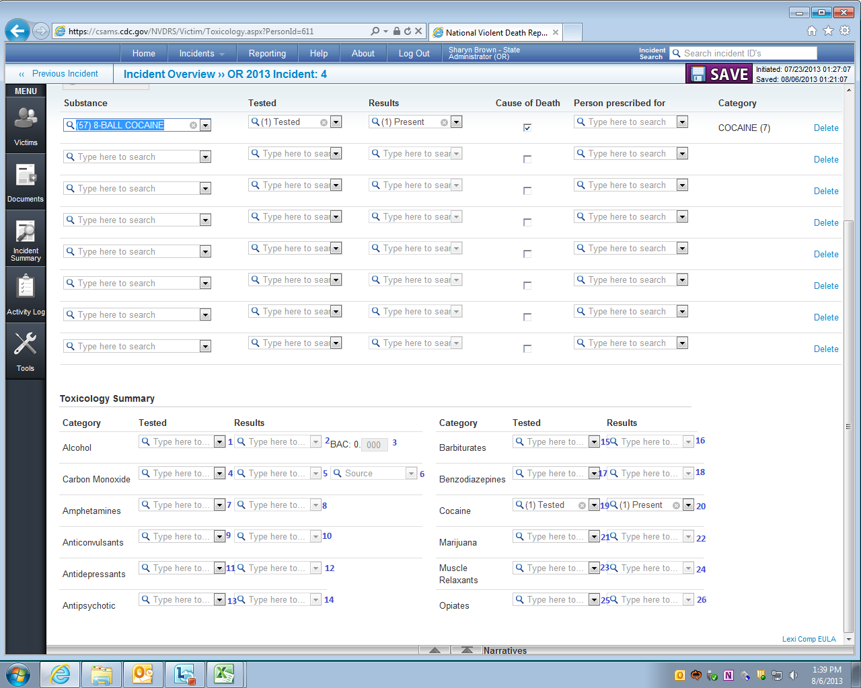
1 AlcoholTested | 9 | AnticonvulsantsTested | 17 | BenzodiazepinesTested | 25 | OpiateTested
2 AlcoholResult | 10 | AnticonvulsantsResult | 18 | BenzodiazepinesResult | 26 | OpiateResult
3 AlcoholLevel | 11 | AntiDepressantTested | 19 | CocaineTested
4 CarbonMonoxideTested | 12 | AntiDepressantResult | 20 | Cocaine test result
5 CarbonMonoxideResult | 13 | AntipsychoticTested | 21 | MarijuanaTested
6 CarbonMonoxideSource | 14 | AntipsychoticResult | 22 | MarijuanaResult
7 AmphetamineTested | 15 | BarbituratesTested | 23 | MuscleRelaxantTested
8 AmphetamineResult | 16 | BarbituratesResult | 24 | MuscleRelaxantResult

7.0 Document
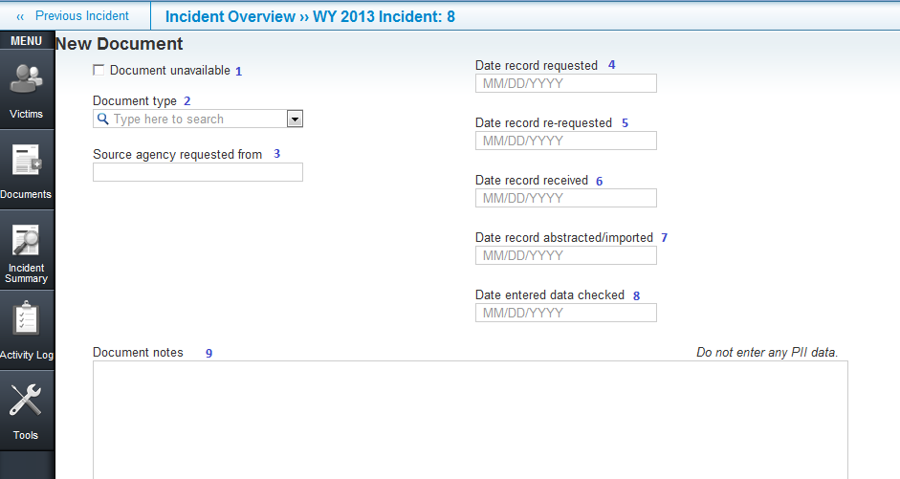
1 | DocumentUnavailable | 5 | Date record re-requested
2 | DocumentType | 6 | Date record received
3 | AgencySource | 7 | AbstractedDate
4 | Date record requested | 8 | Date entered data checked
 |  | 9 | DocumentNotes

8.0 Incident

8.1 Incident Overview
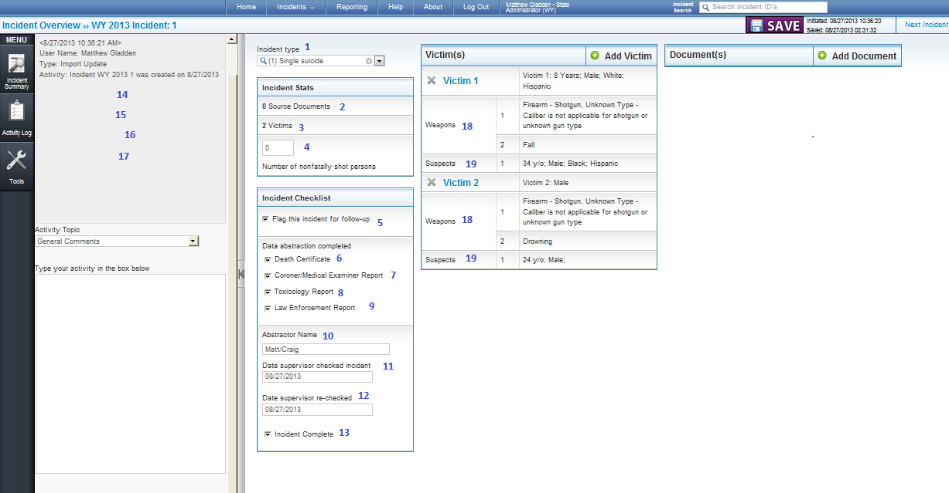
1 IncidentType | 8 | CompleteToxicology | 15 | LastUpdateDate
2 NumberOfDocuments | 9 | CompleteLE | 16 | DateDeleted
3 NumberofVictims | 10 | AbstractorName | 17 | DateMerged
4 NumberNonfatallyShot | 11 | SupervisorCheckedDate | 18 | NumberOfWeapons
5 FollowUp | 12 | SupervisorRecheckedDate | 19 | NumberOfSuspects
6 CompleteDC | 13 | CompleteIncident
7 CompleteCME | 14 | CreateDate

8.2 CME and LE Incident Narratives
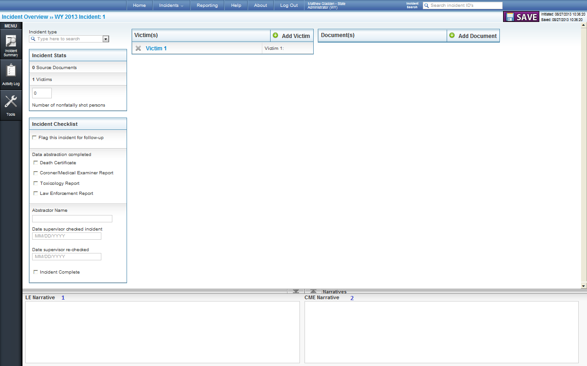

1 NarrativeLE | 2 | NarrativeCME

