**Attachment D-1**

**Advance Package**

**RCC ADVANCE LETTER**

Date

Director Name

Facility Name

Street Address

City, state, zip

Dear [Director Name]:

We greatly appreciate that your residential community participated in the National Study of Long-Term Care Providers (NSLTCP) survey in 2014. The enclosed Data Brief is an example of the information you helped make possible. We invite you to participate in an important project to assess how feasible it is to sample and collect resident-level data and how to improve the materials used to make it easier for providers like you to give this information in future NSLTCP surveys. There will be indirect benefits if you participate. By participating you will help to improve the value of long-term care data which will be used to inform providers like you, researchers, and policymakers. There are no anticipated risks other than your time. We ask for approximately one hour of your time to participate.

Participating in this study will involve completing a brief screening questionnaire, selecting three residents using random sampling procedures with the help of a telephone interviewer, and completing questionnaires for these three residents over the telephone. Your participation is voluntary and you do not have to answer any questions that you do not want to. Refusal to participate will involve no loss of benefits and participation can be discontinued at any time. We will not share your information or any information about the residents you report on with anyone outside the project, and your name will never be connected to your answers. Your answers will only be used to help us assess how easy or difficult it is to sample the residents, complete the resident questionnaires over the telephone, and how to improve the materials for national implementation. All information collected will be held in the strictest confidence according to section 308(d) of the Public Health Service Act (42, U.S. Code, 242m(d) and the Confidential Information Protection and Statistical Efficiency Act (Title 5 of PL 107-347). No resident names or social security numbers will be collected. This study also conforms to the Privacy Rule as mandated by HIPAA, where disclosure of resident data is permitted for public health purposes. If you have any questions about your rights as a participant in this research study, call the Research Ethics Review Board at the National Center for Health Statistics toll-free at 1-800-223-8118.

One of our interviewers will call you within the next few weeks with additional information about participating in this important feasibility project. If you have any questions about this study, please call (XXX) XXX-XXXX.

If you are eligible and choose to participate after you complete the interview, we will send you or your residential care community a $50 gift card as a token of appreciation.

We look forward to talking with you soon.

Sincerely,

Charles J. Rothwell, MS, MBA

Acting Director, National Center for Health Statistics

**ADSC ADVANCE LETTER**

Date

Director Name

Facility Name

Street Address

City, state, zip

Dear [Director Name]:

We greatly appreciate that your adult day services center participated in the National Study of Long-Term Care Providers (NSLTCP) survey in 2014. The enclosed Data Brief is an example of the information you helped make possible. We invite you to participate in an important project to assess how feasible it is to sample and collect participant-level data and how to improve the materials used to make it easier for providers like you to give this information in future NSLTCP surveys. There will be indirect benefits if you participate. By participating you will help to improve the value of long-term care data which will be used to inform providers like you, researchers, and policymakers. There are no anticipated risks other than your time. We ask for approximately one hour of your time to participate.

Participating in this study will involve completing a brief screening questionnaire, selecting three center participants using random sampling procedures, and completing questionnaires for these three participants over the telephone. Your participation is voluntary and you do not have to answer any questions that you do not want to. Refusal to participate will involve no loss of benefits and participation can be discontinued at any time. We will not share your information or any information about the participants you report on with anyone outside the project, and your name will never be connected to your answers. Your answers will only be used to help us assess how easy or difficult it is to sample the participants, complete the participant questionnaires over the telephone, and how to improve the materials for national implementation. All information collected will be held in the strictest confidence according to section 308(d) of the Public Health Service Act (42, U.S. Code, 242m(d) and the Confidential Information Protection and Statistical Efficiency Act (Title 5 of PL 107-347). No participant names or social security numbers will be collected. This study also conforms to the Privacy Rule as mandated by HIPAA, where disclosure of participant data is permitted for public health purposes. If you have any questions about your rights as a participant in this research study, call the Research Ethics Review Board at the National Center for Health Statistics toll-free at 1-800-223-8118.

One of our interviewers will call you within the next few weeks with additional information about participating in this important feasibility project. If you have any questions about this study, please call (XXX) XXX-XXXX.

If you are eligible and choose to participate, after you complete the interview we will send you or your adult day services center a $50 gift card as a token of appreciation.

We look forward to talking with you soon.

Sincerely,

Charles J. Rothwell, MS, MBA

Acting Director, National Center for Health Statistics

2014 RESIDENT DATA BRIEF (first page only)

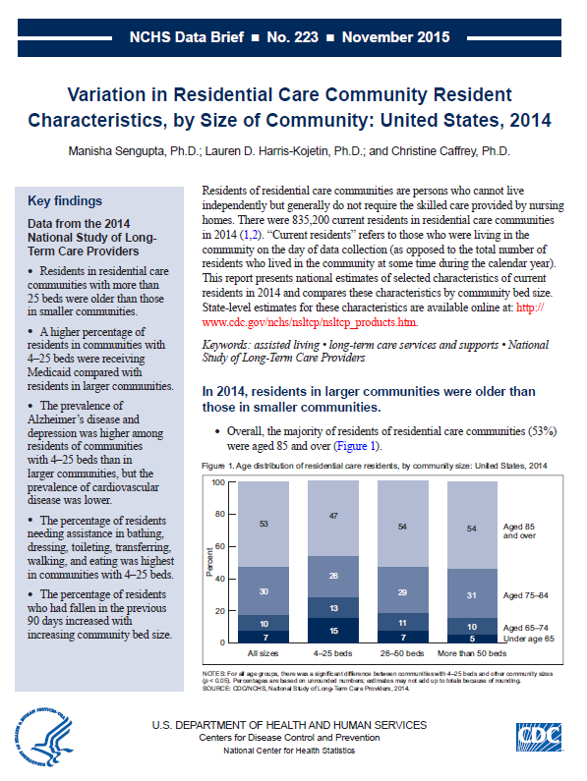

2014 PARTICIPANT DATA BRIEF (first page only)

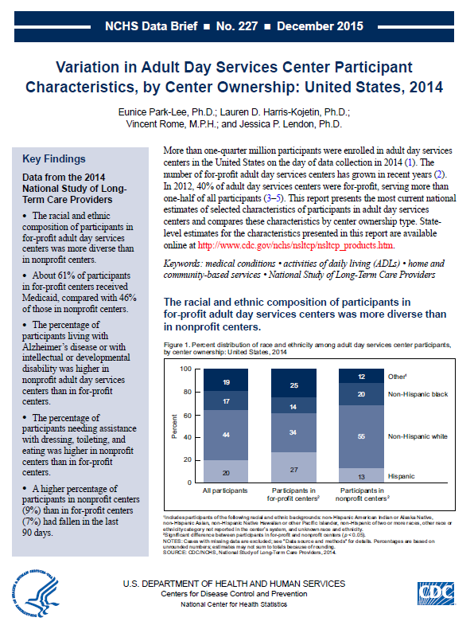

NCHS CONFIDENTIALITY BROCHURE

