Attachment F: Thank You Letter


DEPARTMENT OF HEALTH & HUMAN SERVICES
Centers for Disease Control and Prevention
National Center for Health Statistics
3311 Toledo Road
Hyattsville, Maryland 20782

Thank You

I want to personally thank you for helping us to learn about licensed residential care facilities in your state that serve adults with intellectual and developmental disabilities. It is only through the cooperation of state officials like you that we are able to make an informed decision as to whether to include these facilities in future surveys for the National Study of Long-Term Care Providers (NSLTCP). The NSLTCP’s findings are an invaluable source of information for health care professionals, long-term care providers, policymakers, researchers, and the general public.

Again, I appreciate the time and effort you have given in support of this study.

Sincerely,
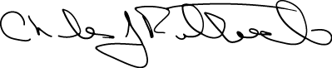
Charles J. Rothwell, MS, MBA
Director, National Center for Health Statistics

If you would like to learn more about this study, please visit http://www.cdc.gov/nchs/nsltcp.htm.

