**Attachment 6a.** Eligibility Screening survey cover letter and project fact sheet for licensed anglers

HeaderNoBG_WMF

[NAME AND ADDRESS]

Dear [NAME]:

The New York State Department of Health (NYSDOH) is looking at the amount of chemicals and metals in people who eat fish caught from one or more areas near the Great Lakes. The Great Lakes Biomonitoring Project is recruiting anglers who eat fish caught in Lake Ontario, Lake Erie and certain New York rivers and waterways.

We have contacted you because you bought a NYS fishing license and live near Lake Ontario or Lake Erie. Please see the enclosed fact sheet and screening survey to learn more about this project.

Please return your completed survey in the enclosed stamped envelope. If you are eligible to participate, a project staff member may contact you to schedule an appointment. This appointment will take place at a local health center in your area and should take about one hour. After the appointment you will be compensated for your time and effort with a $100 gift card.

If you need assistance completing the survey or have any questions or concerns, please call me at 518-XXX-XXXX.

Sincerely,

Julie Reuther, MPH

Project Coordinator

New York State Department of Health

Center for Environmental Health

547 River Street Room 200

Troy, NY 12180-2216

Great Lakes Biomonitoring Project

Insert logo here

[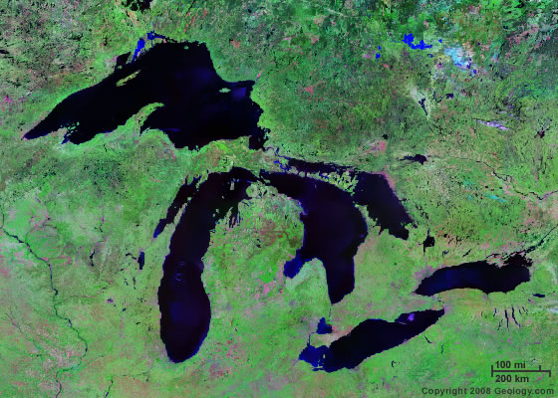](http://geology.com/satellite/tutorial-images/lakes-great-lakes.jpg)

This project aims to measure the amount of chemicals and metals in people who eat fish caught from the Great Lakes. We are recruiting anglers who fish and eat their catch from Lake Ontario, Lake Erie, and certain New York rivers and waterways. This brochure will help you determine if you might be interested in and are eligible to participate in this project.

**Why am I being asked to participate in this project?**

You are being asked to participate because you have a NYS fishing license and live near Lake Ontario or Lake Erie. People who eat fish caught from the Great Lakes are at risk for exposure to certain chemicals and metals.

**Who is conducting this project?**

This is a joint project between the federal Agency for Toxic Substances and Disease Registry (ATSDR) and New York State Department of Health (NYS DOH). There are also two other Great Lakes states conducting this project, Michigan and Minnesota.

**What is biomonitoring?**

Biomonitoring is the assessment of human exposure to contaminants by looking for them in human specimens, such as blood or urine. Blood, serum, and urine levels reflect the amount of a contaminant that actually gets into the body by all routes of exposure, including ingestion, inhalation, and dermal absorption. Once these contaminants enter the body, some are stored in body fat and it may take years for the body to get rid of them.

**What will be tested for in my blood and urine?**

NYS DOH labs will test your blood and urine for the following chemical mixtures: PCBs, PBDEs, PFOS and PFOA, and pesticides (mirex, toxaphene, chlordane, hexachlorobenzene, DDT, and DDE). Some of these chemical mixtures were banned many years ago but still exist in fish and other food sources because they do not break down in the environment and can build up in our bodies. The metals that will be tested for are mercury, lead, and cadmium. You will be sent the results from some of your blood and urine tests with information about what they mean.

**How will I be eligible to participate?**

You will be eligible if you are 18-69 years old, have purchased a NYS resident seasonal or lifetime fishing license with a residential address in the study areas, and ate fish caught in the Great Lakes and certain rivers and waterways. Based on previous studies, it is estimated that 15% of licensed anglers in the Great Lakes region eat their catch.

**If I give consent to participate, will my information remain confidential?**

Yes, all information about you (including your name and address, the screening survey, your interview answers, and your blood and urine test results) will be kept confidential. We keep track of your information using a code number rather than your name. All personal identifiers will be removed before specimens are sent to the laboratory.

**What kinds of questions will I be asked and how long is the procedure?**

If you are eligible and give consent to participate, you will be asked detailed fish consumption questions during the interview (where the fish was caught, what species, how often it was eaten, and how the fish was cooked/prepared). You will also be asked questions such as your occupation, reproductive history (if female), and tobacco use. You can refuse to answer any of the questions or withdraw from the project at any time for any reason. The interview and sample collection should take no longer than one hour. After the appointment you will be compensated for your time and effort with a gift card.

**Should I stop eating fish or worry about adverse health effects from these contaminants?**

No, fish are an excellent source of protein, omega-3 fatty acids, and other essential nutrients. There are many scientific studies that show there are various health benefits to eating fish such as heart, brain, immune, skin, and eye health. Even if you have measurable levels of these contaminants in your body, it does not mean you will develop disease. Your individual data (identified by code number) will be grouped with other participant’s data to help determine appropriate fish advisories in NYS and will be used to inform policy on reducing Great Lakes contaminants. To reduce your exposure to Great Lakes contaminants, you should continue to follow the NYS fish advisories posted at

<http://www.health.state.ny.us/environmental/outdoors/fish/fish.htm>

**If you have any further questions, please contact:**

Ms. Julie Reuther, MPH

Project Coordinator

New York State Department of Health

Center for Environmental Health

547 River Street Room 200

Troy, NY 12180-2216

518-402-7950