|  |
| --- |
| A: Looking For Health Information |

A1. Have you ever looked for information about health or medical topics from any source?

Yes

No   **GO TO A6 in the next column**

A2. The most recent time you looked for information about health or medical topics, where did you go first?

*X*

**Mark**  **only one.**

Books

Brochures, pamphlets, etc.

Cancer organization

Family

Friend/Co-worker

Doctor or health care provider

Internet

Library

Magazines

Newspapers

Telephone information number

Complementary, alternative, or unconventional practitioner

A3. [The most recent time you looked for information about health or medical topics, who was it for](http://staging.matthewsgroup.com/hints-gem/itemdetails.aspx?itemid=562)?

Myself

Someone else

Both myself and someone else

A4. Have you ever looked for information about cancer from any source?

Yes

No   **GO TO A6 in the next column**

A5. Based on the results of your most recent search for information about cancer, how much do you agree or disagree with each of the following statements?

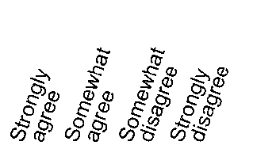

|  |  |  |  |  |
| --- | --- | --- | --- | --- |
|  |  |  |  |  |
| a. It took a lot of effort to get the information you needed |  |  |  |  |
| b. You felt frustrated during your search for the information |  |  |  |  |
| c. You were concerned about the quality of the information |  |  |  |  |
| d. The information you found was hard to understand |  |  |  |  |

A6. Overall, how confident are you that you could get advice or information about cancer if you needed it?

Completely confident

Very confident

Somewhat confident

A little confident

Not confident at all

A7. In general, how much would you trust information about cancer from each of the following?

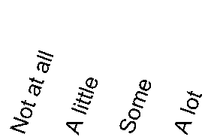

|  |  |  |  |  |
| --- | --- | --- | --- | --- |
|  |  |  |  |  |
| a. A doctor |  |  |  |  |
| b. Family or friends |  |  |  |  |
| c. Newspapers or magazines |  |  |  |  |
| d. Radio |  |  |  |  |
| e. Internet |  |  |  |  |
| f. Television |  |  |  |  |
| g. Government health agencies |  |  |  |  |
| h. Charitable organizations |  |  |  |  |
| i. Religious organizations and leaders |  |  |  |  |