As part of the National Children’s Study, we are asking you to collect a sample of your child’s stool. Please collect the stool sample from a bowel movement within 7 days of receiving the Child Stool Collection Kit. The stool sample should be mailed back within 24 hours after the sample is collected using the supplies provided. Mailed samples should be sent Monday through Thursday only.

The supplies included in the Child Stool Collection Kit are:
- 1 Collection container
- 3 Tongue depressors
- 1 Paper towel
- 1 Paper hat
- 7 Gel packs
- 1 Ziploc bag
- Packaging tape
- 1 Pre-paid, pre-labeled insulated shipper
- 1 Pre-paid, pre-labeled envelope
- Child Microbiome Stool Self-Administered Questionnaire (SAQ)

IMPORTANT NOTES

- Place gel packs in the freezer as soon as possible when you receive them.
- Collect the sample within 7 days of your home visit.
- Make sure before you collect the child’s stool sample that the gel packs have been in the freezer for at least 12 hours.
- If the sample collection was not completed, please explain why on the Child Microbiome Stool SAQ.

Instructions for collection with toilet-trained and diapered children:
Toilet-Trained Children: | Diapered Children:
- When the child indicates they feel they need to have a bowel movement, take the child to the bathroom. | - When the child has a bowel movement in their diaper, follow the steps below:
- Place the paper hat onto the toilet as shown in the diagram on the packaging. | - Remove the diaper from the child.
- Place child on the toilet and instruct them to have a bowel movement when ready. After they have finished, clean the child as you normally would. | - Clean and re-diaper the child as you normally would.
- Open the collection container provided and place the lid face down on the paper towel.
- Take the tongue depressor provided and scrape as much of the stool as possible from the hat into the collection container. Take care to avoid scraping any stool mixed with urine, if the child also urinated. | - Take the tongue depressor provided with the collection kit and scrape as much stool as possible from the diaper into the collection container. Take care to avoid scraping the diaper or any regions mixed with urine.
- Recap the collection container.

Stool Packaging and Shipping Instructions
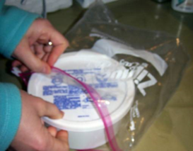
- As soon as possible following collection, place the stool sample in the provided Ziploc bag.
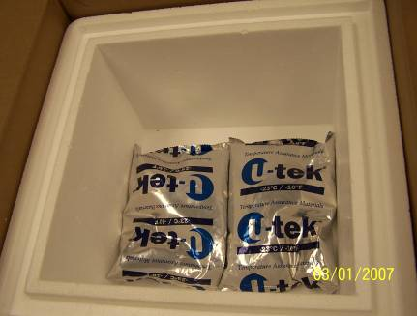
- Remove the gel packs from the freezer and place two gel packs in the bottom

of the Styrofoam container in the pre-paid, pre-labeled insulated shipper.
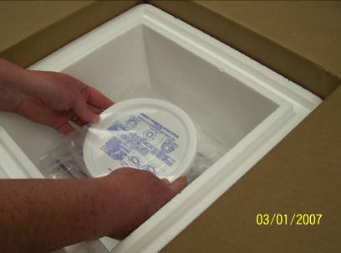
- Place the sealed bag containing the stool specimen on top of the two frozen gel packs in the Styrofoam container.
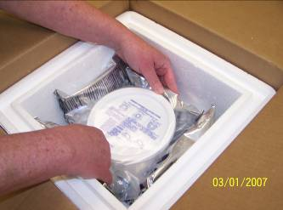
- Place four of the frozen gel packs around the sealed bag containing the stool specimen so that it is completely surrounded.
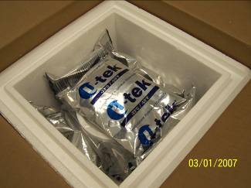
- Place one gel pack on top of the sealed bag.
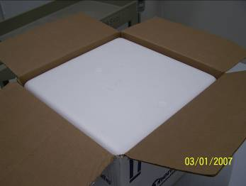
- Place the Styrofoam lid on the container and close the cardboard box.
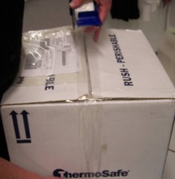
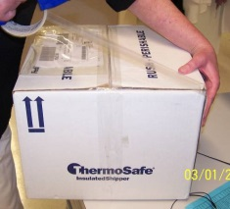
- Using the packaging tape provided, seal the middle of the box and both sides of the box.
- Complete the Child Microbiome Stool Collection SAQ and place it into the pre-paid, pre-labeled envelope.
- Ship the box as soon as you are able, on Monday through Thursday only. The envelope can be placed into the mail when the box is shipped.
Please call the Regional Operations Center number located on the last page, if you have any questions.

Thank you for providing this sample!

For Office Use Only:

Click here to insert Respondent ID.

Click here to insert Participant ID.

Click here to insert ROC contact information.

