Instructions for Placing Urine Bag on Your Child

Please review the following instructions before placing the child urine collection bag on your child. A Regional Operations Center (ROC) data collector will be present to assist you and can answer any questions you may have about these instructions.
The supplies required to collect the child urine sample include:
- 1 diaper
- 1 soap towelette
- 1 water wipe
- 1 urine sample collection bag
- Cleanse your hands and put on gloves if desired.
- Lay the child on his or her back and remove his or her diaper.
- Cleanse your child’s entire genital area.
  - If child powder/talc, diaper cream or ointment, Vaseline, child wipes, child shampoo/body wash, child lotion, or baby oil have been used on your child’s diaper area in the past 24 hours or if you do not know if these products were used, perform the following two steps to cleanse your child’s genital area:
    - First cleanse the area from front to back with a soap towelette to remove any product residue.
    - Follow by cleansing the area from front to back with the water wipe.
  - If none of the products listed above were used on your child’s diaper area in the past 24 hours, cleanse the area from front to back only with the water wipe. Do not use a soap towelette.
- Allow the newly cleansed area to air dry. Do not wipe the area to speed drying. Ensure that the skin is dry before applying the collection bag.

- Remove the paper backing from the bottom half of the adhesive patch. Note: It is easier to leave the top half of the adhesive covered until the bottom section has been applied to the skin.
- Open your child’s legs to expose the genital area. Begin application of the adhesive on the tiny area of skin between the anus and genitals, smoothing any folds of skin if necessary.
- For girls, it is best to place the adhesive so that the urethral opening is at the top of the bag opening (see the following figure).
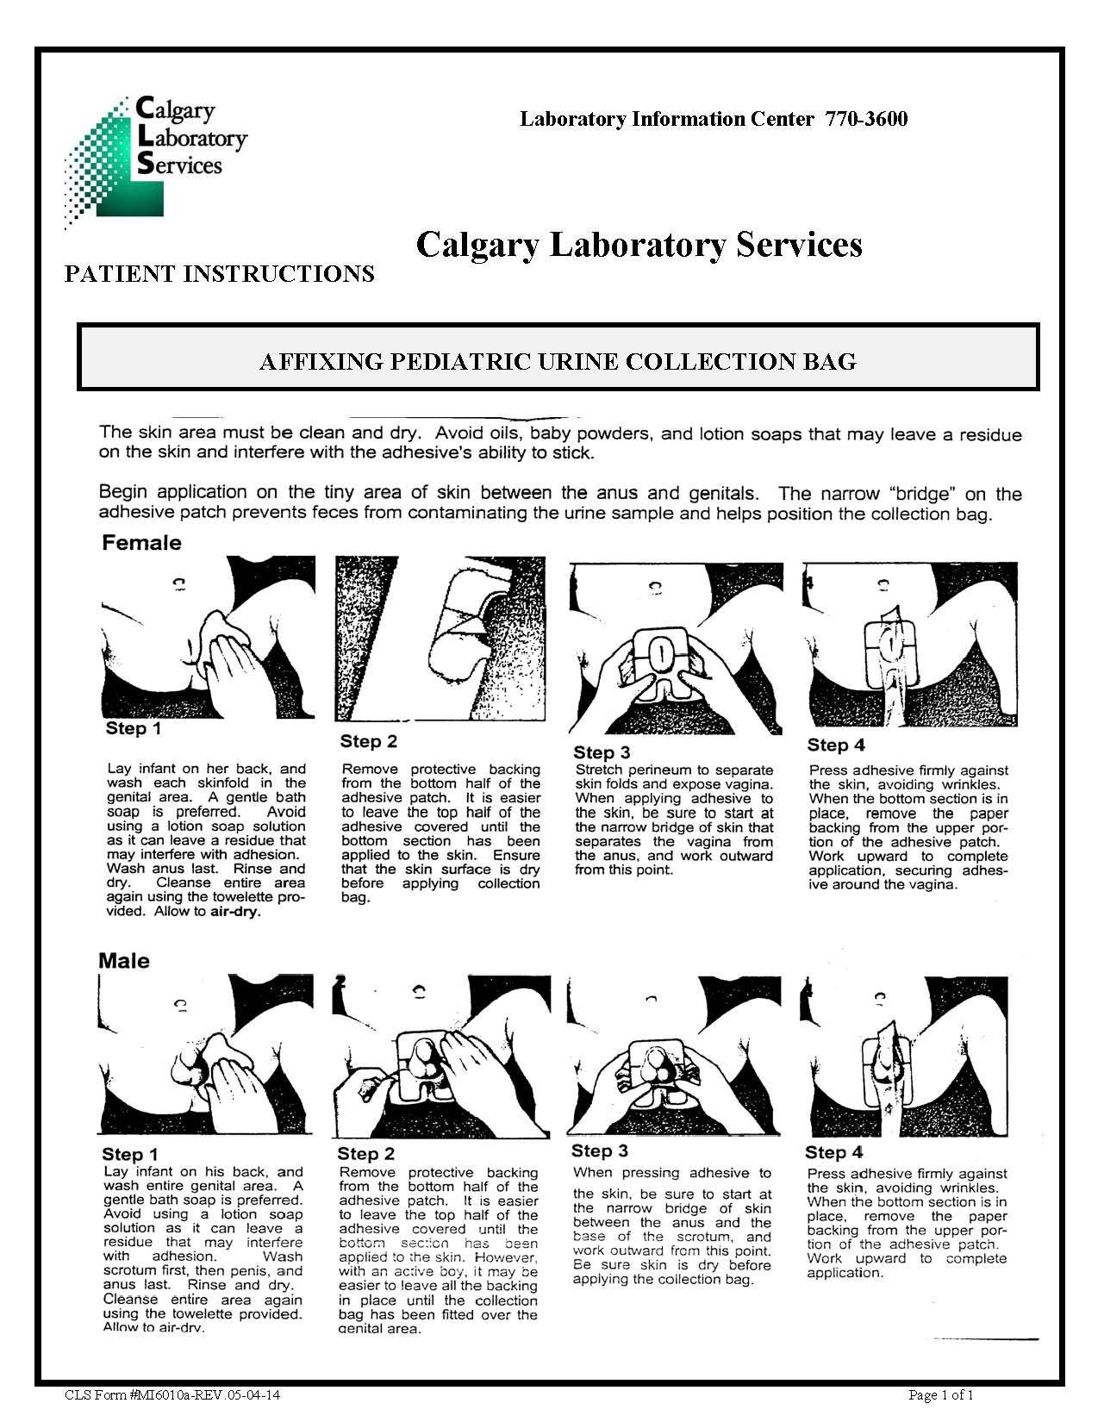

- For boys, the adhesive can be placed on or below the scrotum. Ensure that the penis is inside the bag opening (see the following figure).
- Press the adhesive firmly against the skin, avoiding wrinkles. When the bottom section is in place, remove the paper backing from the upper portion of the adhesive patch. Carefully smooth adhesive in an upward motion to complete application.
- Place a new diaper on your child over the collection bag.

Instructions for Removing the Urine Bag from Your Child
- Periodically check the collection bag for urine.
- If your child has a bowel movement while the bag is in place, if the bag leaks, or if the bag is pulled off by the child, promptly alert the data collector. The data collector will let you know if the bag needs to be removed and a second bag applied. If necessary, follow steps 1-10 above for placing a second collection bag on your child.
- Once your child has urinated, alert the data collector and remove the urine bag as soon as possible.
- To remove the bag, begin at the top and work downward. To minimize discomfort to the child, push the skin away from the adhesive rather than pulling the adhesive from the skin.
- Carefully give the child urine bag to the data collector taking care to avoid spilling any of the urine.

Click here to insert ROC contact information.

