Instructions for Returning Environmental Noise Monitor
- Call FedEx (1-800-463-3339 or 1-800-GO- FEDEX) to schedule a pickup.
- Have the following information ready when you call FedEx for FedEx Express (overnight delivery) shipment:

  - Your name
  - Address for pick-up
  - Approximate weight of the shipment
  - Date of pick-up
  - Time of pick-up
  - Exact location where the shipment will be picked-up
  - The FedEx account number to use for this prepaid shipment
Please refer to the pre-filled FedEx airbill for the approximate weight of the shipment and FedEx account number.

Photo x. Noise monitor stand with text indicating each part

- On the day the noise monitor is taken down, measure the distance of the microphone from the wall and height of the microphone from the floor (Questions 9 and 10, Photos x and x), if required. When taking the measurements, measure from the top of the microphone using the measuring tape. | Photo x. Measuring the distance of the microphone from the wall

- On the Noise Measurement Self-Administered Questionnaire (SAQ), write the date, mark the day of the week, and write the time when you took down the noise monitor (Questions 1, 2, and 3). Complete rest of the questions and make sure all the questions are answered. | Photo x: Measuring the height of the microphone from the floor

- Carefully unfasten the microphone from the stand (Photo x) and disconnect the cable from the case (Photo x). Do not use excessive force. Remove the stand from the case as shown in Photo x. | Photo x: Unfastening the microphone from the stand Photo x: Disconnecting the microphone cable from the case

- Wrap the microphone with bubble wrap. Place the stand, microphone, and electrical cord (if applicable) in the smaller shipping box (Photo x). | Photo x: Removing the stand from the case

- Place the completed questionnaire in the resealable plastic bag and place it in the box along with the stand, microphone and electrical cord (if applicable) as shown in Photo x. Close and seal the box. | Photo x: Smaller shipping box with microphone cable, stand, and electrical cord Photo x: Smaller shipping box with microphone cable, stand, electrical cord, and completed questionnaire

- Place the locked noise monitor case and the sealed box containing the stand, microphone, completed questionnaire, and electrical cord (if applicable) inside the shipper. Fill the extra space with the packing material provided. Close and seal the shipper (Photo x). | Photo x: Sealed smaller shipping box and locked noise case in the shipper

- Leave the sealed shipper for FedEx to pick up at a location you provided when you called the FedEx to schedule a pick-up.

- The shipment will be shipped to the address indicated on the prefilled FedEx label. | 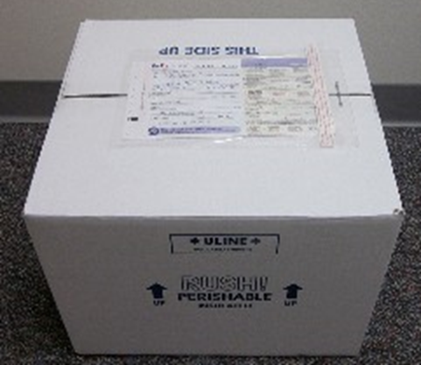  Photo x: The prefilled FedEx label

Thank you for completing the noise measurement questionnaire and for sending back the noise monitor.

Your continued participation in the National Children’s Study is greatly appreciated.
Please contact us if you have any questions about the noise measurement and/or shipping the noise monitor.
Include the contact information (phone number, e-mail address etc.) here.

Please ship the noise monitor to the following address:

Include the address here.

For Office Use Only:

Click here to insert Respondent ID.

Click here to insert Participant ID.

Click here to insert ROC contact information.

