As part of the National Children’s Study, we ask that you collect a rectal swab.

IMPORTANT NOTES
- DO NOT touch the tip of the swab or the inside of the container.

Instructions for collection of rectal swab:
- Wash your hands with soap and water. | 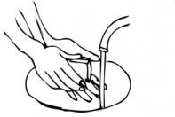
- Remove your pants and underwear and either squat down or lift one of your legs onto the toilet. | 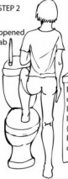
- Remove the swab from the packaging.
- Hold the swab in your dominant hand, about 1.5 inches from the tip of the swab. | 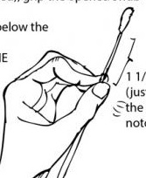
- With the other hand, hold one cheek of your buttock to the side to allow for access to your rectum. | 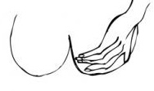
- Insert the swab 0.5 inches into your rectum just until the head of the swab is in the rectum. | 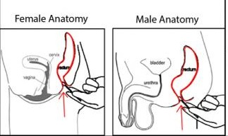
- With a twisting motion, gently swab the inside of the rectum going around the area two times.
- Slowly and gently remove the swab from your rectum.
- Place the swab, tip down, into the container provided.
- Wash hands and return the container to the data collector.

Thank you for providing this sample!

For Office Use Only:

Click here to insert Respondent ID.

Click here to insert Participant ID.

Click here to insert ROC contact information.

