OMB #: 0925-0593
OMB Expiration Date: 08/31/2014

Pregnancy Health Care Log

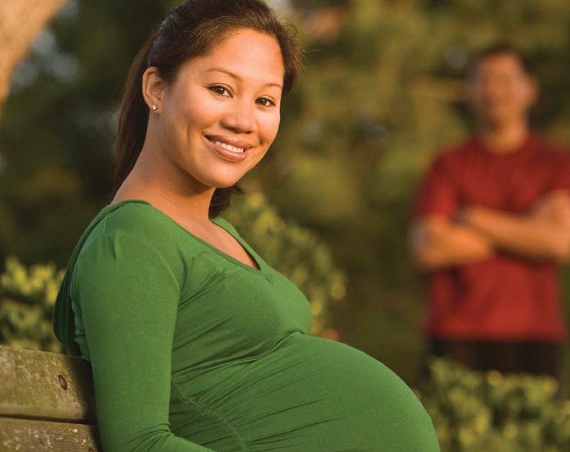BRING THIS LOG TO ALL HEALTH CARE VISITS. USE THIS LOG FOR ALL STUDY TELEPHONE CALLS AND VISITS.

Save all bottles and containers of medications. Bring to Study visits and have available for telephone calls:
- Medicines (those prescribed by a health care provider and those bought over-the-counter)
  - Vitamins, minerals, herbs, and any other supplements
Last Name: First Name:

Public reporting for this collection of information is estimated to average 5 minutes per response including the time for reviewing instructions, searching existing data sources, gathering and maintaining the data needed, and completing and reviewing the collection of information. An agency may not conduct or sponsor, and a person is not required to respond to, a collection of information unless it displays a currently valid OMB control number. Send comments regarding this burden estimate or any other aspect of this collection of information, including suggestions for reducing this burden, to: NIH, Project Clearance Branch, 6705 Rockledge Drive, MSC 7974, Bethesda, MD 20892-7974,ATTN: PRA (0925-0593). Do not return the completed form to this address.

Pregnancy Health Care Log

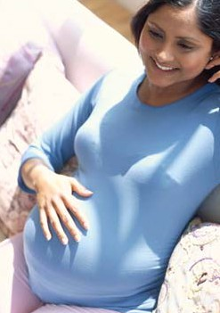This Pregnancy Health Care Log will help you keep track of all your visits to doctors or other health care providers (such as your obstetrician (OB-GYN), family doctor, nurse, midwife, or other type of provider) during your pregnancy. We will ask you about all of your visits whenever we interview you by telephone or in person.

The log has two parts:

- Health Care Provider Log is to record information about where you visit your doctor or other health care provider.

- Health Care Visits and Overnight Hospital Stays Log is to record information about all your visits to doctors, other health care providers, or an emergency room. This includes overnight hospital stays as well as outpatient visits. Use one page for each visit or hospital stay.

BRING this Pregnancy Health Care Log with you to all health care and National Children’s Study visits. Also, have it available for all National Children’s Study telephone interviews.

If you forget to bring it with you to a health care visit, please fill it in as soon as possible.

Health Care Provider Log Instructions

The health care provider is the person who cared for you at this visit (doctor, midwife, nurse, etc.)

Column 1 A number is listed for each health care provider (for example, 1,2,3,4, etc). This number will be referred to on the Health Care Visits and Overnight Hospital Stays log page.

Column 2 Attach the health care provider’s business card here.

Fill in columns 3–10 only if you have not attached the health care provider’s business card.

Column 3 Write in the name of the health care provider.

Column 4 Check (✓) the box for the type of provider. If it was “Another type of provider,” write in the type of health care provider.

Column 5 Check (✓) the box for the type of place where you saw the provider. If it was “Some other place,” write in the type of place where you visited the health care provider.

Columns 6–9 Write in the address of the place including city/town, state, and ZIP Code.

Column 10 Write in the telephone number of the health care provider including area code.

See sample log on next page.

After you fill out the Health Care Provider Log, please fill out the Health Care Visits and Overnight Hospital Stays Log.

 |  | Fill in ONLY if you HAVE NOT attached a business card
1 | 2 | 3 | 4 | 5 | 6 | 7 | 8 | 9 | 10
Health Care Provider Number | Attach Health Care Provider Business Card | Name of Health Care Provider | Type of Health Care Provider | Type of Place | Street Number and Name | City or Town | State | ZIP  Code | Telephone Number
0  (Sample) |  | Dr. Robert Jones | D Obstetrician/ Gynecologist (OB/GYN)  D Family physician  D Nurse  D Midwife  D Another type of provider (specify): | D Doctor’s office, clinic, or health center  D Emergency room  D Urgent care center  D Hospital for hospitalization  D Some other place (specify): | 400Main Street | Capitol City | MN | 56087 | 937-889-  9275
1 |  |  | D Obstetrician/ Gynecologist (OB/GYN)  D Family physician  D Nurse  D Midwife  D Another type of provider (specify): | D Doctor’s office, clinic, or health center  D Emergency room  D Urgent care center  D Hospital for hospitalization  D Some other place (specify):
2 |  |  | D Obstetrician/ Gynecologist (OB/GYN)  D Family physician  D Nurse  D Midwife  D Another type of provider (specify): | D Doctor’s office, clinic, or health center  D Emergency room  D Urgent care center  D Hospital for hospitalization  D Some other place (specify):
3 |  |  | D Obstetrician/ Gynecologist (OB/GYN)  D Family physician  D Nurse  D Midwife  D Another type of provider (specify): | D Doctor’s office, clinic, or health center  D Emergency room  D Urgent care center  D Hospital for hospitalization  D Some other place (specify):

Health Care Provider Log

 |  | Fill in ONLY if you HAVE NOT attached a business card
1 | 2 | 3 | 4 | 5 | 6 | 7 | 8 | 9 | 10
Health Care Provider Number | Attach Health Care Provider Business Card | Name of Health Care Provider | Type of Health Care Provider | Type of Place | Street Number and Name | City or Town | State | ZIP  Code | Telephone Number
4 |  |  | D Obstetrician/ Gynecologist (OB/GYN)  D Family physician  D Nurse  D Midwife  D Another type of provider (specify): | D Doctor’s office, clinic, or health center  D Emergency room  D Urgent care center  D Hospital for hospitalization  D Some other place (specify):
5 |  |  | D Obstetrician/ Gynecologist (OB/GYN)  D Family physician  D Nurse  D Midwife  D Another type of provider (specify): | D Doctor’s office, clinic, or health center  D Emergency room  D Urgent care center  D Hospital for hospitalization  D Some other place (specify):
6 |  |  | D Obstetrician/ Gynecologist (OB/GYN)  D Family physician  D Nurse  D Midwife  D Another type of provider (specify): | D Doctor’s office, clinic, or health center  D Emergency room  D Urgent care center  D Hospital for hospitalization  D Some other place (specify):
7 |  |  | D Obstetrician/ Gynecologist (OB/GYN)  D Family physician  D Nurse  D Midwife  D Another type of provider (specify): | D Doctor’s office, clinic, or health center  D Emergency room  D Urgent care center  D Hospital for hospitalization  D Some other place (specify):

Health Care Provider Log

 |  | Fill in ONLY if you HAVE NOT attached a business card
1 | 2 | 3 | 4 | 5 | 6 | 7 | 8 | 9 | 10
Health Care Provider Number | Attach Health Care Provider Business Card | Name of Health Care Provider | Type of Health Care Provider | Type of Place | Street Number and Name | City or Town | State | ZIP  Code | Telephone Number
8 |  |  | D Obstetrician/ Gynecologist (OB/GYN)  D Family physician  D Nurse  D Midwife  D Another type of provider (specify): | D Doctor’s office, clinic, or health center  D Emergency room  D Urgent care center  D Hospital for hospitalization  D Some other place (specify):
9 |  |  | D Obstetrician/ Gynecologist (OB/GYN)  D Family physician  D Nurse  D Midwife  D Another type of provider (specify): | D Doctor’s office, clinic, or health center  D Emergency room  D Urgent care center  D Hospital for hospitalization  D Some other place (specify):
10 |  |  | D Obstetrician/ Gynecologist (OB/GYN)  D Family physician  D Nurse  D Midwife  D Another type of provider (specify): | D Doctor’s office, clinic, or health center  D Emergency room  D Urgent care center  D Hospital for hospitalization  D Some other place (specify):
11 |  |  | D Obstetrician/ Gynecologist (OB/GYN)  D Family physician  D Nurse  D Midwife  D Another type of provider (specify): | D Doctor’s office, clinic, or health center  D Emergency room  D Urgent care center  D Hospital for hospitalization  D Some other place (specify):

Health Care Provider Log

Pregnancy Health Care Log

Health Care Visits and Overnight Hospital Stays Log Instructions:

Each time you go to the doctor or any other health care provider (for example, midwife or nurse practitioner) or are hospitalized overnight, write the information about the visit on a new page in the “Health Care Visits and Overnight Hospital Stays” log.

At the top of the page, write the visit date and also copy the provider number and provider name from the Health Care Provider Log.

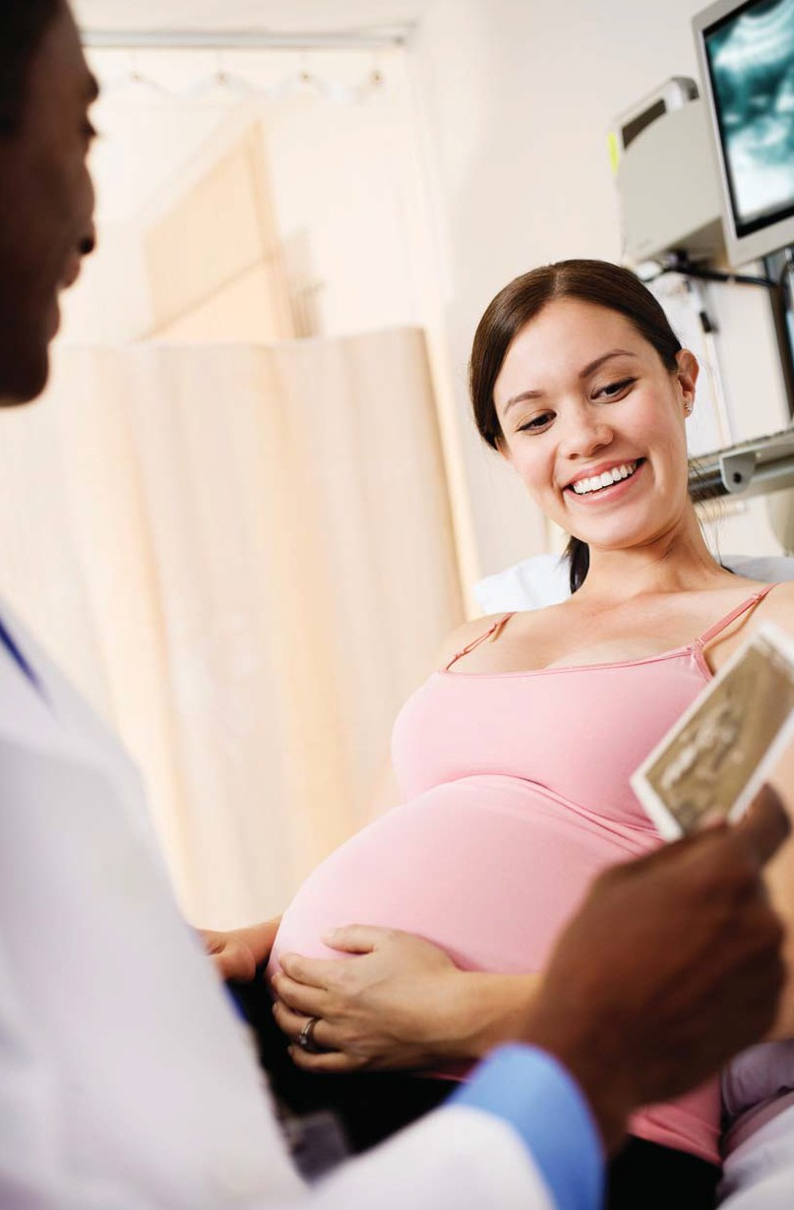Column 1

Column 2

Column 3

Column 4

Column 5

Column 6

Column 7

Column 8

Column 9
Check (✓) the box for the reason for the visit. If you were hospitalized, include the number of nights you stayed at the hospital. If the reason is not listed, check “Some other reason” and write in the reason for the visit.

Weight

Blood pressure

If you received any pregnancy care related procedures, check (✓) the box(es) for those procedures. If the procedure is not listed, check (✓) the box “Other tests to check on the health of your baby” and write in a description.
Enter information about any vaccinations (“shots”) you received. List any other tests or procedures (such as a glucose tolerance
test, etc.).

If you received any treatments or were told to take any medications (over-the-counter or prescription medications), write them here.

If you were told that you had a medical condition or diagnosis at this visit (for example, high blood pressure, diabetes, infection), write the diagnosis here.

Check (✓) the box showing whether you or the office staff completed the log. After you report the visit to the National Children’s Study staff, write in the date reported.

The National Children’s Study
h
Visit Date:

03 / 18 / 2010

Month Day Year
Provider Number from Health Care Provider Log: 0

Health Care Visits and Overnight Hospital Stays

Name of Provider Seen:
Dr. Robert Jones

Sample Log
Be sure to also write this provider’s contact information in the HEALTH CARE PROVIDER LOG.

1 | 2 | 3 | 4 | 5 | 6 | 7 | 8 | 9
Reason for Visit | Weight | Blood Pressure | Pregnancy Care Procedures  (tests to check on your baby’s health) | Vaccination/Shot/ Immunization | Other Tests and Procedures (tests to check on YOUR health) (For example, lab tests (blood, urine, etc.)) | Medications/ Other Treatments (For example,  over-the-counter or prescribed medications) | Diagnoses | Completed by Office or Self
 |  |  |  |  |  |  |  | Date Reported to National Children’s Study
D Routine pregnancy care  D Illness or injury  D Overnight hospital stay (hospitalized)  How many nights?  D Some other reason (explain): | 155  lb  D Not done/ don’t know | 120  / 80  D Not done/ don’t know | (Check all that apply)  D Ultrasound or Sonogram  D Chorionic Villus Sampling (CVS)  D Amniocentesis  D Other tests to check on the health of your baby (describe below):  Triple Screen Test | D No  D Yes (Specify type below. Check  all that apply).  D Influenza  D Hepatitis B D Hepatitis A D Tetanus /  Diphtheria (Td)  D Tetanus / Diphtheria Pertussis (Tdap)  D Meningococcal D Pneumococcal D Other: | Urine test Glucose tolerance  test  Blood test Ankle x-ray | Tylenol Amoxicillin Folic Acid  RhoGAM injection  Physical therapy | Protein in urine Urinary tract  infection  Sprained ankle | D Office  D Self
Date:
4/1/10

Health Care Visit/Hospital Stay 1

1 | 2 | 3 | 4 | 5 | 6 | 7 | 8 | 9
Reason for Visit | Weight | Blood Pressure | Pregnancy Care Procedures  (tests to check on your baby’s health) | Vaccination/Shot/ Immunization | Other Tests and Procedures (tests to check on YOUR health) (For example, lab tests (blood, urine, etc.)) | Medications/Other Treatments (For example,  over-the-counter or prescribed medications) | Diagnoses | Completed by Office or Self
 |  |  |  |  |  |  |  | Date Reported to National Children’s Study
D Routine pregnancy care  D Illness or injury  D Overnight hospital stay (hospitalized)  How many nights?  D Some other reason (explain): | lb  D Not done/ don’t know | /  D Not done/ don’t know | (Check all that apply)  D Ultrasound or Sonogram  D Chorionic Villus Sampling (CVS)  D Amniocentesis  D Other tests to check on the health of your baby (describe below): | D No  D Yes (Specify type below. Check  all that apply).  D Influenza  D Hepatitis B D Hepatitis A D Tetanus /  Diphtheria (Td)  D Tetanus / Diphtheria Pertussis (Tdap)  D Meningococcal D Pneumococcal D Other: |  |  |  | D Office  D Self
 |  |  |  |  |  |  |  | Date:

Health Care Visit/Hospital Stay 2

1 | 2 | 3 | 4 | 5 | 6 | 7 | 8 | 9
Reason for Visit | Weight | Blood Pressure | Pregnancy Care Procedures  (tests to check on your baby’s health) | Vaccination/Shot/ Immunization | Other Tests and Procedures (tests to check on YOUR health) (For example, lab tests (blood, urine, etc.)) | Medications/Other Treatments (For example,  over-the-counter or prescribed medications) | Diagnoses | Completed by Office or Self
 |  |  |  |  |  |  |  | Date Reported to National Children’s Study
D Routine pregnancy care  D Illness or injury  D Overnight hospital stay (hospitalized)  How many nights?  D Some other reason (explain): | lb  D Not done/ don’t know | /  D Not done/ don’t know | (Check all that apply)  D Ultrasound or Sonogram  D Chorionic Villus Sampling (CVS)  D Amniocentesis  D Other tests to check on the health of your baby (describe below): | D No  D Yes (Specify type below. Check  all that apply).  D Influenza  D Hepatitis B D Hepatitis A D Tetanus /  Diphtheria (Td)  D Tetanus / Diphtheria Pertussis (Tdap)  D Meningococcal D Pneumococcal D Other: |  |  |  | D Office  D Self
 |  |  |  |  |  |  |  | Date:

Health Care Visit/Hospital Stay 3

1 | 2 | 3 | 4 | 5 | 6 | 7 | 8 | 9
Reason for Visit | Weight | Blood Pressure | Pregnancy Care Procedures  (tests to check on your baby’s health) | Vaccination/Shot/ Immunization | Other Tests and Procedures (tests to check on YOUR health) (For example, lab tests (blood, urine, etc.)) | Medications/Other Treatments (For example,  over-the-counter or prescribed medications) | Diagnoses | Completed by Office or Self
 |  |  |  |  |  |  |  | Date Reported to National Children’s Study
D Routine pregnancy care  D Illness or injury  D Overnight hospital stay (hospitalized)  How many nights?  D Some other reason (explain): | lb  D Not done/ don’t know | /  D Not done/ don’t know | (Check all that apply)  D Ultrasound or Sonogram  D Chorionic Villus Sampling (CVS)  D Amniocentesis  D Other tests to check on the health of your baby (describe below): | D No  D Yes (Specify type below. Check  all that apply).  D Influenza  D Hepatitis B D Hepatitis A D Tetanus /  Diphtheria (Td)  D Tetanus / Diphtheria Pertussis (Tdap)  D Meningococcal D Pneumococcal D Other: |  |  |  | D Office  D Self
 |  |  |  |  |  |  |  | Date:

Health Care Visit/Hospital Stay 4

1 | 2 | 3 | 4 | 5 | 6 | 7 | 8 | 9
Reason for Visit | Weight | Blood Pressure | Pregnancy Care Procedures  (tests to check on your baby’s health) | Vaccination/Shot/ Immunization | Other Tests and Procedures (tests to check on YOUR health) (For example, lab tests (blood, urine, etc.)) | Medications/Other Treatments (For example,  over-the-counter or prescribed medications) | Diagnoses | Completed by Office or Self
 |  |  |  |  |  |  |  | Date Reported to National Children’s Study
D Routine pregnancy care  D Illness or injury  D Overnight hospital stay (hospitalized)  How many nights?  D Some other reason (explain): | lb  D Not done/ don’t know | /  D Not done/ don’t know | (Check all that apply)  D Ultrasound or Sonogram  D Chorionic Villus Sampling (CVS)  D Amniocentesis  D Other tests to check on the health of your baby (describe below): | D No  D Yes (Specify type below. Check  all that apply).  D Influenza  D Hepatitis B D Hepatitis A D Tetanus /  Diphtheria (Td)  D Tetanus / Diphtheria Pertussis (Tdap)  D Meningococcal D Pneumococcal D Other: |  |  |  | D Office  D Self
 |  |  |  |  |  |  |  | Date:

Health Care Visit/Hospital Stay 5

1 | 2 | 3 | 4 | 5 | 6 | 7 | 8 | 9
Reason for Visit | Weight | Blood Pressure | Pregnancy Care Procedures  (tests to check on your baby’s health) | Vaccination/Shot/ Immunization | Other Tests and Procedures (tests to check on YOUR health) (For example, lab tests (blood, urine, etc.)) | Medications/Other Treatments (For example,  over-the-counter or prescribed medications) | Diagnoses | Completed by Office or Self
 |  |  |  |  |  |  |  | Date Reported to National Children’s Study
D Routine pregnancy care  D Illness or injury  D Overnight hospital stay (hospitalized)  How many nights?  D Some other reason (explain): | lb  D Not done/ don’t know | /  D Not done/ don’t know | (Check all that apply)  D Ultrasound or Sonogram  D Chorionic Villus Sampling (CVS)  D Amniocentesis  D Other tests to check on the health of your baby (describe below): | D No  D Yes (Specify type below. Check  all that apply).  D Influenza  D Hepatitis B D Hepatitis A D Tetanus /  Diphtheria (Td)  D Tetanus / Diphtheria Pertussis (Tdap)  D Meningococcal D Pneumococcal D Other: |  |  |  | D Office  D Self
 |  |  |  |  |  |  |  | Date:

Health Care Visit/Hospital Stay 6

1 | 2 | 3 | 4 | 5 | 6 | 7 | 8 | 9
Reason for Visit | Weight | Blood Pressure | Pregnancy Care Procedures  (tests to check on your baby’s health) | Vaccination/Shot/ Immunization | Other Tests and Procedures (tests to check on YOUR health) (For example, lab tests (blood, urine, etc.)) | Medications/Other Treatments (For example,  over-the-counter or prescribed medications) | Diagnoses | Completed by Office or Self
 |  |  |  |  |  |  |  | Date Reported to National Children’s Study
D Routine pregnancy care  D Illness or injury  D Overnight hospital stay (hospitalized)  How many nights?  D Some other reason (explain): | lb  D Not done/ don’t know | /  D Not done/ don’t know | (Check all that apply)  D Ultrasound or Sonogram  D Chorionic Villus Sampling (CVS)  D Amniocentesis  D Other tests to check on the health of your baby (describe below): | D No  D Yes (Specify type below. Check  all that apply).  D Influenza  D Hepatitis B D Hepatitis A D Tetanus /  Diphtheria (Td)  D Tetanus / Diphtheria Pertussis (Tdap)  D Meningococcal D Pneumococcal D Other: |  |  |  | D Office  D Self
 |  |  |  |  |  |  |  | Date:

Health Care Visit/Hospital Stay 7

1 | 2 | 3 | 4 | 5 | 6 | 7 | 8 | 9
Reason for Visit | Weight | Blood Pressure | Pregnancy Care Procedures  (tests to check on your baby’s health) | Vaccination/Shot/ Immunization | Other Tests and Procedures (tests to check on YOUR health) (For example, lab tests (blood, urine, etc.)) | Medications/Other Treatments (For example,  over-the-counter or prescribed medications) | Diagnoses | Completed by Office or Self
 |  |  |  |  |  |  |  | Date Reported to National Children’s Study
D Routine pregnancy care  D Illness or injury  D Overnight hospital stay (hospitalized)  How many nights?  D Some other reason (explain): | lb  D Not done/ don’t know | /  D Not done/ don’t know | (Check all that apply)  D Ultrasound or Sonogram  D Chorionic Villus Sampling (CVS)  D Amniocentesis  D Other tests to check on the health of your baby (describe below): | D No  D Yes (Specify type below. Check  all that apply).  D Influenza  D Hepatitis B D Hepatitis A D Tetanus /  Diphtheria (Td)  D Tetanus / Diphtheria Pertussis (Tdap)  D Meningococcal D Pneumococcal D Other: |  |  |  | D Office  D Self
 |  |  |  |  |  |  |  | Date:

Health Care Visit/Hospital Stay 8

1 | 2 | 3 | 4 | 5 | 6 | 7 | 8 | 9
Reason for Visit | Weight | Blood Pressure | Pregnancy Care Procedures  (tests to check on your baby’s health) | Vaccination/Shot/ Immunization | Other Tests and Procedures (tests to check on YOUR health) (For example, lab tests (blood, urine, etc.)) | Medications/Other Treatments (For example,  over-the-counter or prescribed medications) | Diagnoses | Completed by Office or Self
 |  |  |  |  |  |  |  | Date Reported to National Children’s Study
D Routine pregnancy care  D Illness or injury  D Overnight hospital stay (hospitalized)  How many nights?  D Some other reason (explain): | lb  D Not done/ don’t know | /  D Not done/ don’t know | (Check all that apply)  D Ultrasound or Sonogram  D Chorionic Villus Sampling (CVS)  D Amniocentesis  D Other tests to check on the health of your baby (describe below): | D No  D Yes (Specify type below. Check  all that apply).  D Influenza  D Hepatitis B D Hepatitis A D Tetanus /  Diphtheria (Td)  D Tetanus / Diphtheria Pertussis (Tdap)  D Meningococcal D Pneumococcal D Other: |  |  |  | D Office  D Self
 |  |  |  |  |  |  |  | Date:

Health Care Visit/Hospital Stay 9

1 | 2 | 3 | 4 | 5 | 6 | 7 | 8 | 9
Reason for Visit | Weight | Blood Pressure | Pregnancy Care Procedures  (tests to check on your baby’s health) | Vaccination/Shot/ Immunization | Other Tests and Procedures (tests to check on YOUR health) (For example, lab tests (blood, urine, etc.)) | Medications/Other Treatments (For example,  over-the-counter or prescribed medications) | Diagnoses | Completed by Office or Self
 |  |  |  |  |  |  |  | Date Reported to National Children’s Study
D Routine pregnancy care  D Illness or injury  D Overnight hospital stay (hospitalized)  How many nights?  D Some other reason (explain): | lb  D Not done/ don’t know | /  D Not done/ don’t know | (Check all that apply)  D Ultrasound or Sonogram  D Chorionic Villus Sampling (CVS)  D Amniocentesis  D Other tests to check on the health of your baby (describe below): | D No  D Yes (Specify type below. Check  all that apply).  D Influenza  D Hepatitis B D Hepatitis A D Tetanus /  Diphtheria (Td)  D Tetanus / Diphtheria Pertussis (Tdap)  D Meningococcal D Pneumococcal D Other: |  |  |  | D Office  D Self
 |  |  |  |  |  |  |  | Date:

Health Care Visit/Hospital Stay 10

1 | 2 | 3 | 4 | 5 | 6 | 7 | 8 | 9
Reason for Visit | Weight | Blood Pressure | Pregnancy Care Procedures  (tests to check on your baby’s health) | Vaccination/Shot/ Immunization | Other Tests and Procedures (tests to check on YOUR health) (For example, lab tests (blood, urine, etc.)) | Medications/Other Treatments (For example,  over-the-counter or prescribed medications) | Diagnoses | Completed by Office or Self
 |  |  |  |  |  |  |  | Date Reported to National Children’s Study
D Routine pregnancy care  D Illness or injury  D Overnight hospital stay (hospitalized)  How many nights?  D Some other reason (explain): | lb  D Not done/ don’t know | /  D Not done/ don’t know | (Check all that apply)  D Ultrasound or Sonogram  D Chorionic Villus Sampling (CVS)  D Amniocentesis  D Other tests to check on the health of your baby (describe below): | D No  D Yes (Specify type below. Check  all that apply).  D Influenza  D Hepatitis B D Hepatitis A D Tetanus /  Diphtheria (Td)  D Tetanus / Diphtheria Pertussis (Tdap)  D Meningococcal D Pneumococcal D Other: |  |  |  | D Office  D Self
 |  |  |  |  |  |  |  | Date:

Health Care Visit/Hospital Stay 11

1 | 2 | 3 | 4 | 5 | 6 | 7 | 8 | 9
Reason for Visit | Weight | Blood Pressure | Pregnancy Care Procedures  (tests to check on your baby’s health) | Vaccination/Shot/ Immunization | Other Tests and Procedures (tests to check on YOUR health) (For example, lab tests (blood, urine, etc.)) | Medications/Other Treatments (For example,  over-the-counter or prescribed medications) | Diagnoses | Completed by Office or Self
 |  |  |  |  |  |  |  | Date Reported to National Children’s Study
D Routine pregnancy care  D Illness or injury  D Overnight hospital stay (hospitalized)  How many nights?  D Some other reason (explain): | lb  D Not done/ don’t know | /  D Not done/ don’t know | (Check all that apply)  D Ultrasound or Sonogram  D Chorionic Villus Sampling (CVS)  D Amniocentesis  D Other tests to check on the health of your baby (describe below): | D No  D Yes (Specify type below. Check  all that apply).  D Influenza  D Hepatitis B D Hepatitis A D Tetanus /  Diphtheria (Td)  D Tetanus / Diphtheria Pertussis (Tdap)  D Meningococcal D Pneumococcal D Other: |  |  |  | D Office  D Self
 |  |  |  |  |  |  |  | Date:

Health Care Visit/Hospital Stay 12

1 | 2 | 3 | 4 | 5 | 6 | 7 | 8 | 9
Reason for Visit | Weight | Blood Pressure | Pregnancy Care Procedures  (tests to check on your baby’s health) | Vaccination/Shot/ Immunization | Other Tests and Procedures (tests to check on YOUR health) (For example, lab tests (blood, urine, etc.)) | Medications/Other Treatments (For example,  over-the-counter or prescribed medications) | Diagnoses | Completed by Office or Self
 |  |  |  |  |  |  |  | Date Reported to National Children’s Study
D Routine pregnancy care  D Illness or injury  D Overnight hospital stay (hospitalized)  How many nights?  D Some other reason (explain): | lb  D Not done/ don’t know | /  D Not done/ don’t know | (Check all that apply)  D Ultrasound or Sonogram  D Chorionic Villus Sampling (CVS)  D Amniocentesis  D Other tests to check on the health of your baby (describe below): | D No  D Yes (Specify type below. Check  all that apply).  D Influenza  D Hepatitis B D Hepatitis A D Tetanus /  Diphtheria (Td)  D Tetanus / Diphtheria Pertussis (Tdap)  D Meningococcal D Pneumococcal D Other: |  |  |  | D Office  D Self
 |  |  |  |  |  |  |  | Date:

Health Care Visit/Hospital Stay 13

1 | 2 | 3 | 4 | 5 | 6 | 7 | 8 | 9
Reason for Visit | Weight | Blood Pressure | Pregnancy Care Procedures  (tests to check on your baby’s health) | Vaccination/Shot/ Immunization | Other Tests and Procedures (tests to check on YOUR health) (For example, lab tests (blood, urine, etc.)) | Medications/Other Treatments (For example,  over-the-counter or prescribed medications) | Diagnoses | Completed by Office or Self
 |  |  |  |  |  |  |  | Date Reported to National Children’s Study
D Routine pregnancy care  D Illness or injury  D Overnight hospital stay (hospitalized)  How many nights?  D Some other reason (explain): | lb  D Not done/ don’t know | /  D Not done/ don’t know | (Check all that apply)  D Ultrasound or Sonogram  D Chorionic Villus Sampling (CVS)  D Amniocentesis  D Other tests to check on the health of your baby (describe below): | D No  D Yes (Specify type below. Check  all that apply).  D Influenza  D Hepatitis B D Hepatitis A D Tetanus /  Diphtheria (Td)  D Tetanus / Diphtheria Pertussis (Tdap)  D Meningococcal D Pneumococcal D Other: |  |  |  | D Office  D Self
 |  |  |  |  |  |  |  | Date:

Health Care Visit/Hospital Stay 14

1 | 2 | 3 | 4 | 5 | 6 | 7 | 8 | 9
Reason for Visit | Weight | Blood Pressure | Pregnancy Care Procedures  (tests to check on your baby’s health) | Vaccination/Shot/ Immunization | Other Tests and Procedures (tests to check on YOUR health) (For example, lab tests (blood, urine, etc.)) | Medications/Other Treatments (For example,  over-the-counter or prescribed medications) | Diagnoses | Completed by Office or Self
 |  |  |  |  |  |  |  | Date Reported to National Children’s Study
D Routine pregnancy care  D Illness or injury  D Overnight hospital stay (hospitalized)  How many nights?  D Some other reason (explain): | lb  D Not done/ don’t know | /  D Not done/ don’t know | (Check all that apply)  D Ultrasound or Sonogram  D Chorionic Villus Sampling (CVS)  D Amniocentesis  D Other tests to check on the health of your baby (describe below): | D No  D Yes (Specify type below. Check  all that apply).  D Influenza  D Hepatitis B D Hepatitis A D Tetanus /  Diphtheria (Td)  D Tetanus / Diphtheria Pertussis (Tdap)  D Meningococcal D Pneumococcal D Other: |  |  |  | D Office  D Self
 |  |  |  |  |  |  |  | Date:

Health Care Visit/Hospital Stay 15

1 | 2 | 3 | 4 | 5 | 6 | 7 | 8 | 9
Reason for Visit | Weight | Blood Pressure | Pregnancy Care Procedures  (tests to check on your baby’s health) | Vaccination/Shot/ Immunization | Other Tests and Procedures (tests to check on YOUR health) (For example, lab tests (blood, urine, etc.)) | Medications/Other Treatments (For example,  over-the-counter or prescribed medications) | Diagnoses | Completed by Office or Self
 |  |  |  |  |  |  |  | Date Reported to National Children’s Study
D Routine pregnancy care  D Illness or injury  D Overnight hospital stay (hospitalized)  How many nights?  D Some other reason (explain): | lb  D Not done/ don’t know | /  D Not done/ don’t know | (Check all that apply)  D Ultrasound or Sonogram  D Chorionic Villus Sampling (CVS)  D Amniocentesis  D Other tests to check on the health of your baby (describe below): | D No  D Yes (Specify type below. Check  all that apply).  D Influenza  D Hepatitis B D Hepatitis A D Tetanus /  Diphtheria (Td)  D Tetanus / Diphtheria Pertussis (Tdap)  D Meningococcal D Pneumococcal D Other: |  |  |  | D Office  D Self
 |  |  |  |  |  |  |  | Date:

Health Care Visit/Hospital Stay 16

1 | 2 | 3 | 4 | 5 | 6 | 7 | 8 | 9
Reason for Visit | Weight | Blood Pressure | Pregnancy Care Procedures  (tests to check on your baby’s health) | Vaccination/Shot/ Immunization | Other Tests and Procedures (tests to check on YOUR health) (For example, lab tests (blood, urine, etc.)) | Medications/Other Treatments (For example,  over-the-counter or prescribed medications) | Diagnoses | Completed by Office or Self
 |  |  |  |  |  |  |  | Date Reported to National Children’s Study
D Routine pregnancy care  D Illness or injury  D Overnight hospital stay (hospitalized)  How many nights?  D Some other reason (explain): | lb  D Not done/ don’t know | /  D Not done/ don’t know | (Check all that apply)  D Ultrasound or Sonogram  D Chorionic Villus Sampling (CVS)  D Amniocentesis  D Other tests to check on the health of your baby (describe below): | D No  D Yes (Specify type below. Check  all that apply).  D Influenza  D Hepatitis B D Hepatitis A D Tetanus /  Diphtheria (Td)  D Tetanus / Diphtheria Pertussis (Tdap)  D Meningococcal D Pneumococcal D Other: |  |  |  | D Office  D Self
 |  |  |  |  |  |  |  | Date:

Health Care Visit/Hospital Stay 17

1 | 2 | 3 | 4 | 5 | 6 | 7 | 8 | 9
Reason for Visit | Weight | Blood Pressure | Pregnancy Care Procedures  (tests to check on your baby’s health) | Vaccination/Shot/ Immunization | Other Tests and Procedures (tests to check on YOUR health) (For example, lab tests (blood, urine, etc.)) | Medications/Other Treatments (For example,  over-the-counter or prescribed medications) | Diagnoses | Completed by Office or Self
 |  |  |  |  |  |  |  | Date Reported to National Children’s Study
D Routine pregnancy care  D Illness or injury  D Overnight hospital stay (hospitalized)  How many nights?  D Some other reason (explain): | lb  D Not done/ don’t know | /  D Not done/ don’t know | (Check all that apply)  D Ultrasound or Sonogram  D Chorionic Villus Sampling (CVS)  D Amniocentesis  D Other tests to check on the health of your baby (describe below): | D No  D Yes (Specify type below. Check  all that apply).  D Influenza  D Hepatitis B D Hepatitis A D Tetanus /  Diphtheria (Td)  D Tetanus / Diphtheria Pertussis (Tdap)  D Meningococcal D Pneumococcal D Other: |  |  |  | D Office  D Self
 |  |  |  |  |  |  |  | Date:

U.S. DEPARTMENT OF HEALTH AND HUMAN SERVICES
National Institutes of Health
Centers for Disease Control and Prevention
U.S. ENVIRONMENTAL PROTECTION AGENCY

