|  |
| --- |
|  |
| Open Payments: Review & Dispute |
| Wireframes and Email Correspondence To Be Updated |
|  |

To reflect removal of “dismiss dispute” language from Open Payments system

Draft June 20

Applicable Manufacturer or Applicable GPO Review and Disputes Page

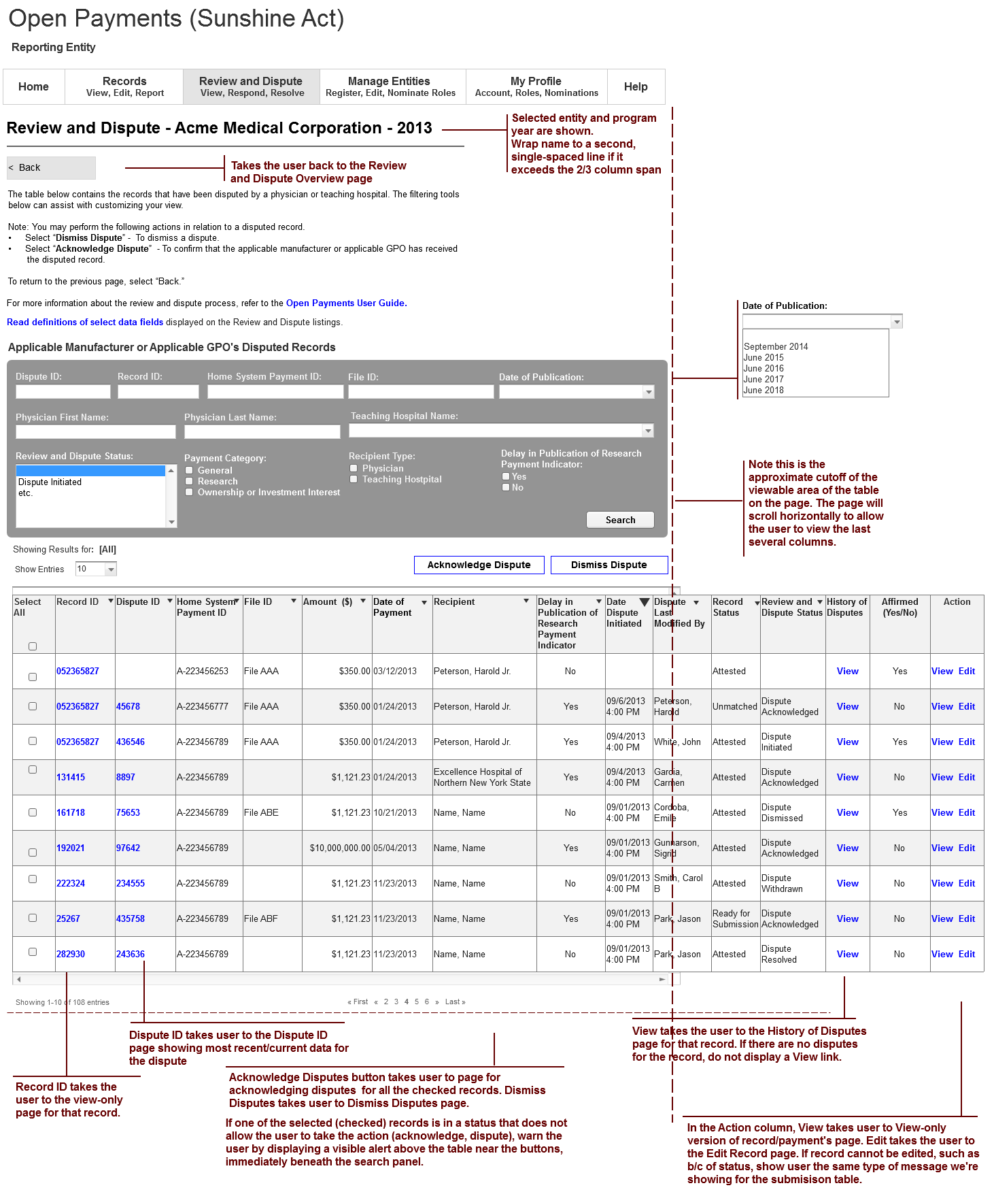

**Replace crossed out text with:**

* Select **“Resolved No Change”** to acknowledge that the applicable manufacturer or applicable GPO and the physician or teaching hospital have resolved the dispute in accordance with the guidance in the Final Rule. **This action should only be taken when dispute resolution does not require a change to the data by the reporting entity.**

**“Review and Dispute Status” to be modified to show table column value with “Resolved No Change” as status instead of “Dispute Dismissed”**

**“Review and Dispute Status” drop-down to be modified to show “Resolved No Change” as status instead of “Dispute Dismissed”**

**Title of button to be changed to “Resolved No Change”**

Dismiss Dispute Page - AM/GPO

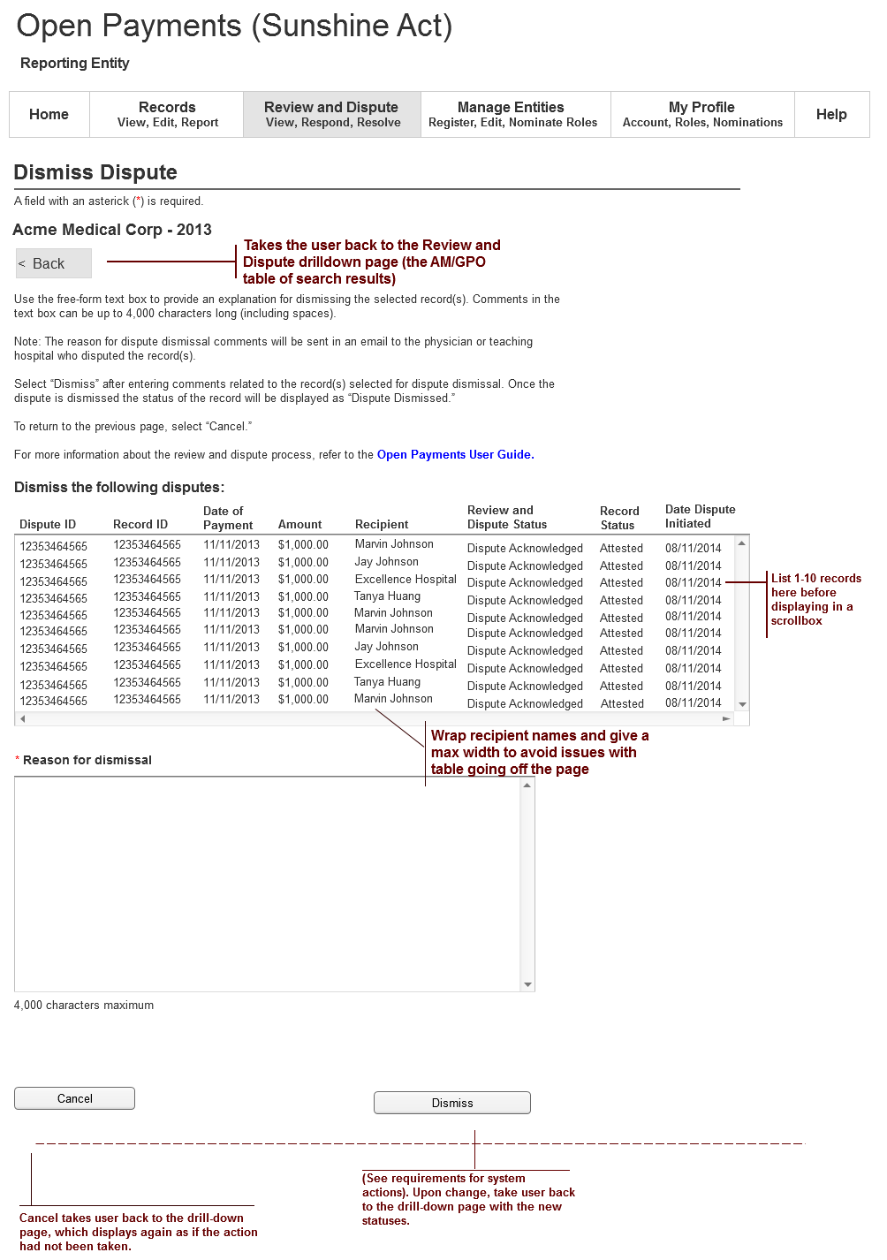

**Title of button to be changed to “Resolved No Change”**

**Title of box to be changed to “Reason for dispute resolution with no change to the data”**

**Sub-title to be changed to “Resolve the following disputes with no changes to the data”**

**Replace “Dispute Dismissed” with “Resolved No Change”**

**Replace “is dismissed” with “has been resolved with no change made to the data,”**

**Replace “Dismiss” with “Resolved No Change”**

**Replace “dismissal” with “resolution with no change”**

**Add as first paragraph:**

An applicable manufacturer or applicable GPO should select “**Resolved No Change”** to acknowledge that the applicable manufacturer or applicable GPO and the physician or teaching hospital have resolved the dispute in accordance with the guidance in the Final Rule. **This action should only be taken when dispute resolution does not require a change to the data by the reporting entity.**

**Keep text that starts (and start new paragraph)** “Use the free-form text box…” and ends with “…4,000 characters long (including spaces).”

**THEN ADD:**

For example, the explanation for the dispute that has been resolved with no change to the data could say: “This dispute is resolved with no changes made to the data because there is now agreement relating to the reported payment amount. The physician was able to verify that the payment amount of $6,500 is correct. Therefore, we are moving forward with resolving the dispute without changing the data.

**THEN PICK-UP AT TEXT:** Note: The reason for dispute…

**Title of page to be changed to “Resolved No Change”**

History of Disputes Page - AM/GPO

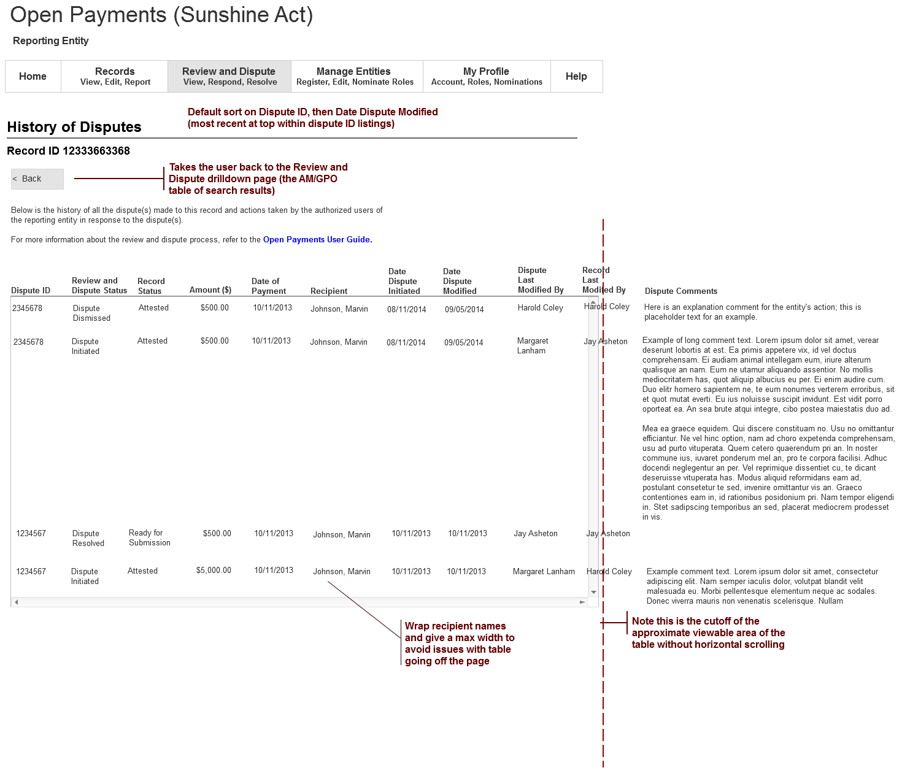

**“Review and Dispute Status” to be modified to show table column value with “Resolved No Change” as status instead of “Dispute Dismissed”**

Dispute ID Page - AM/GPO

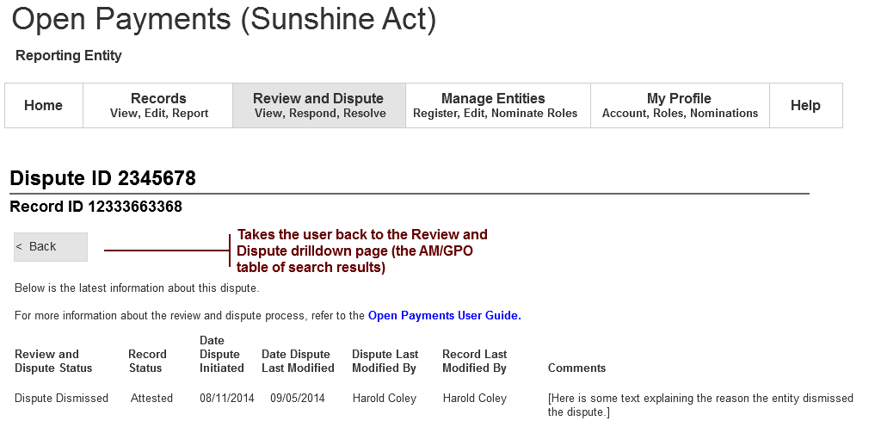

View Records for Entity - AM/GPO

**“Review and Dispute Status” to be modified to show table column value with “Resolved No Change” as status instead of “Dispute Dismissed”**

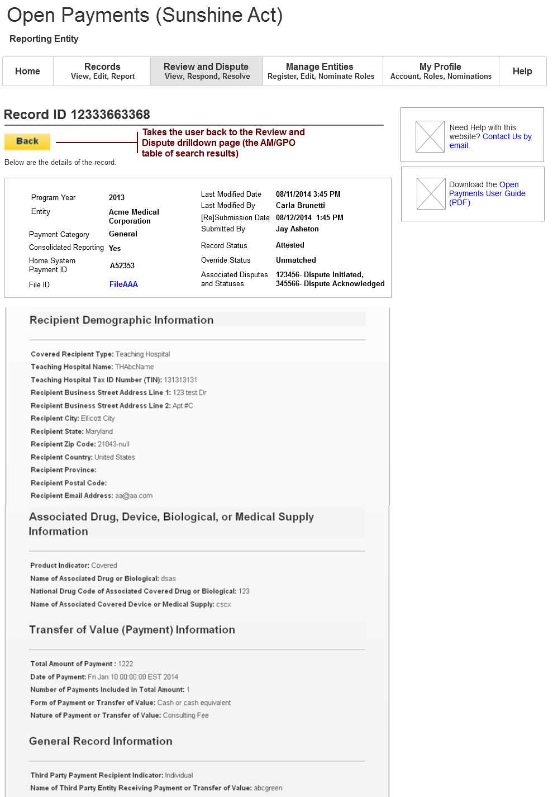

**“Associated Disputes and Statuses” field to be modified to show “Resolved No Change” as status instead of “Dispute Dismissed”**



Success Confirmation Alert msg after taking action - AM/GPO

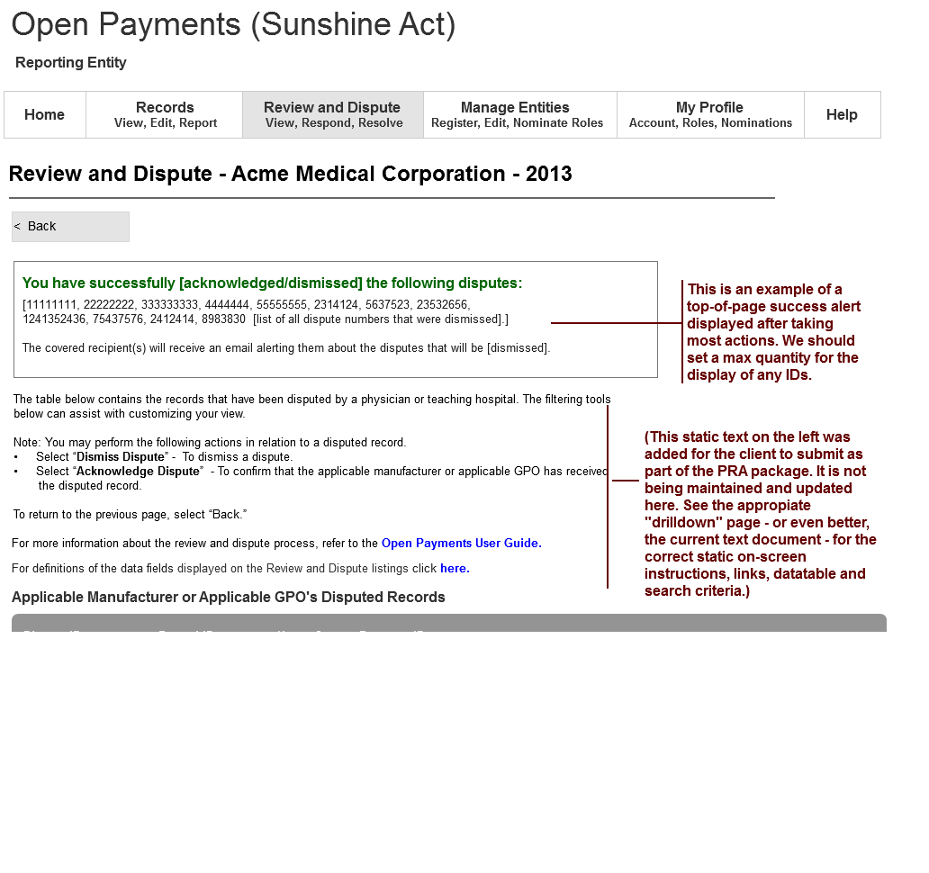

**Replace crossed out text with:**

* Select **“Resolved No Change”** to acknowledge that the applicable manufacturer or applicable GPO and the physician or teaching hospital have resolved the dispute in accordance with the giodance in the Final Rule. **This action should only be taken when dispute resolution does not require a change to the data by the reporting entity.**

**Replace “dismised” with “resolved with no change to the data”**

**Replace “dismised” with “resolved with no change to the data”**

**Replace “dismised” with “resolved with no change to the data”**

Physician Records Table Page

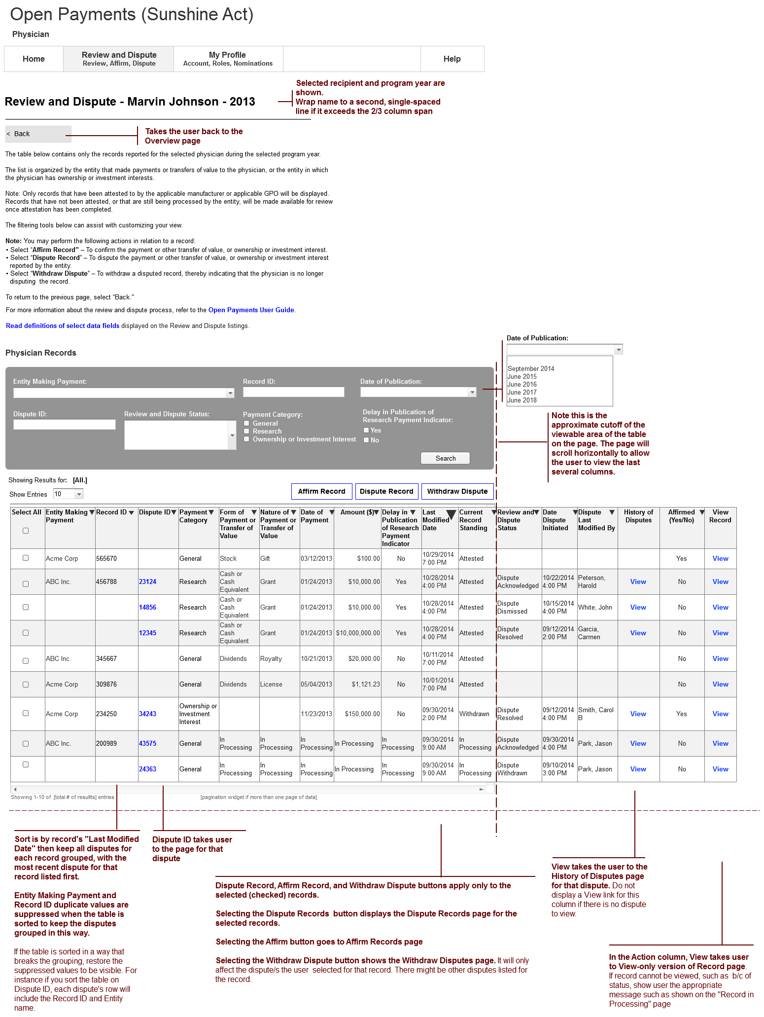

**“Review and Dispute Status” to be modified to show table column value with “Resolved No Change” as status instead of “Dispute Dismissed”**

**“Review and Dispute Status” drop-down to be modified to show “Resolved No Change” as status instead of “Dispute Dismissed”**

Dispute Records - Physician or Teaching Hospital

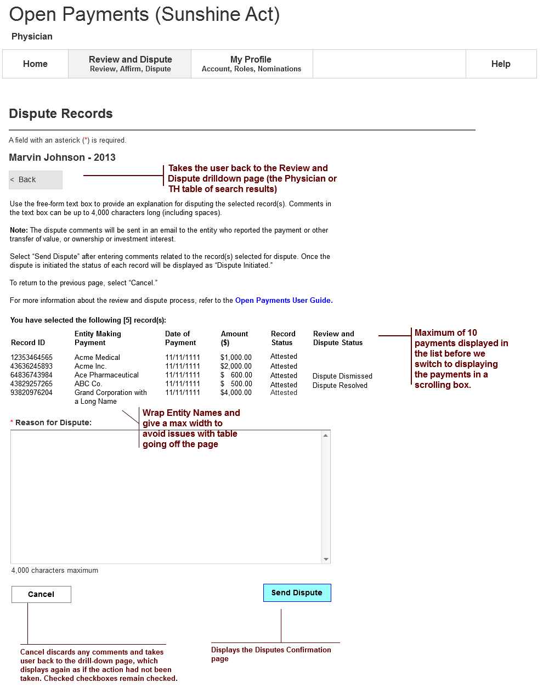

**“Review and Dispute Status” to be modified to show table column value with “Resolved No Change” as status instead of “Dispute Dismissed”**

Affirm Records - Physician or Teaching Hospital

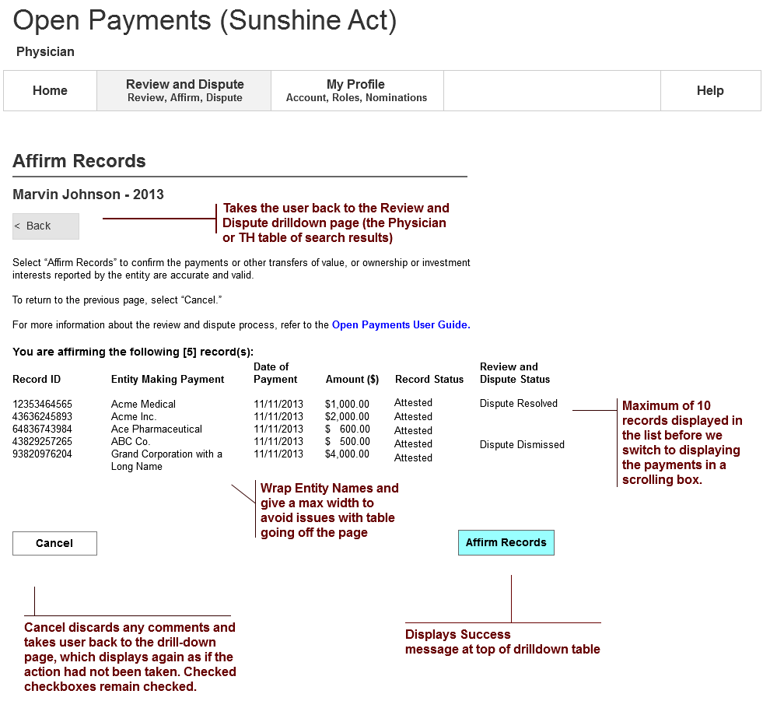

**“Review and Dispute Status” to be modified to show table column value with “Resolved No Change” as status instead of “Dispute Dismissed”**

Withdraw Dispute - Physician or Teaching Hospital

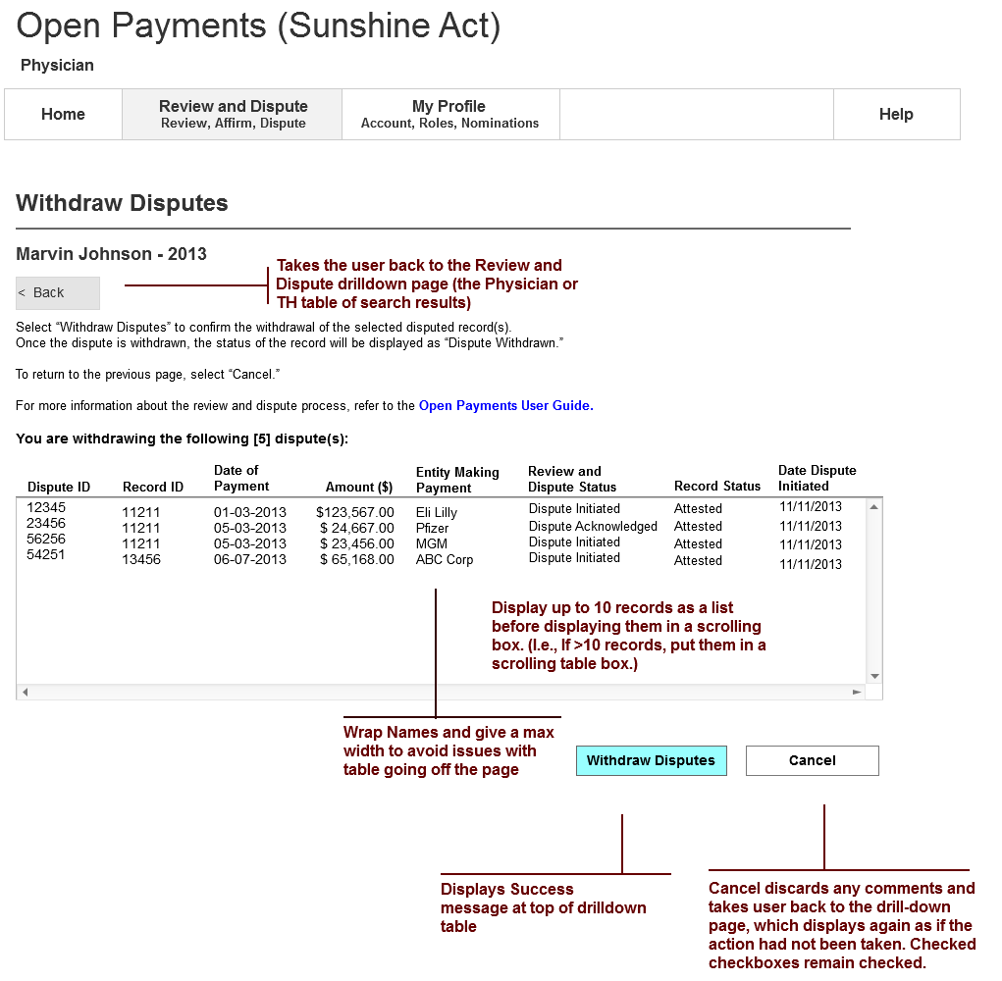

**“Review and Dispute Status” to be modified to show table column value with “Resolved No Change” as status instead of “Dispute Dismissed”**

View Record for Physician or Teaching Hospital User

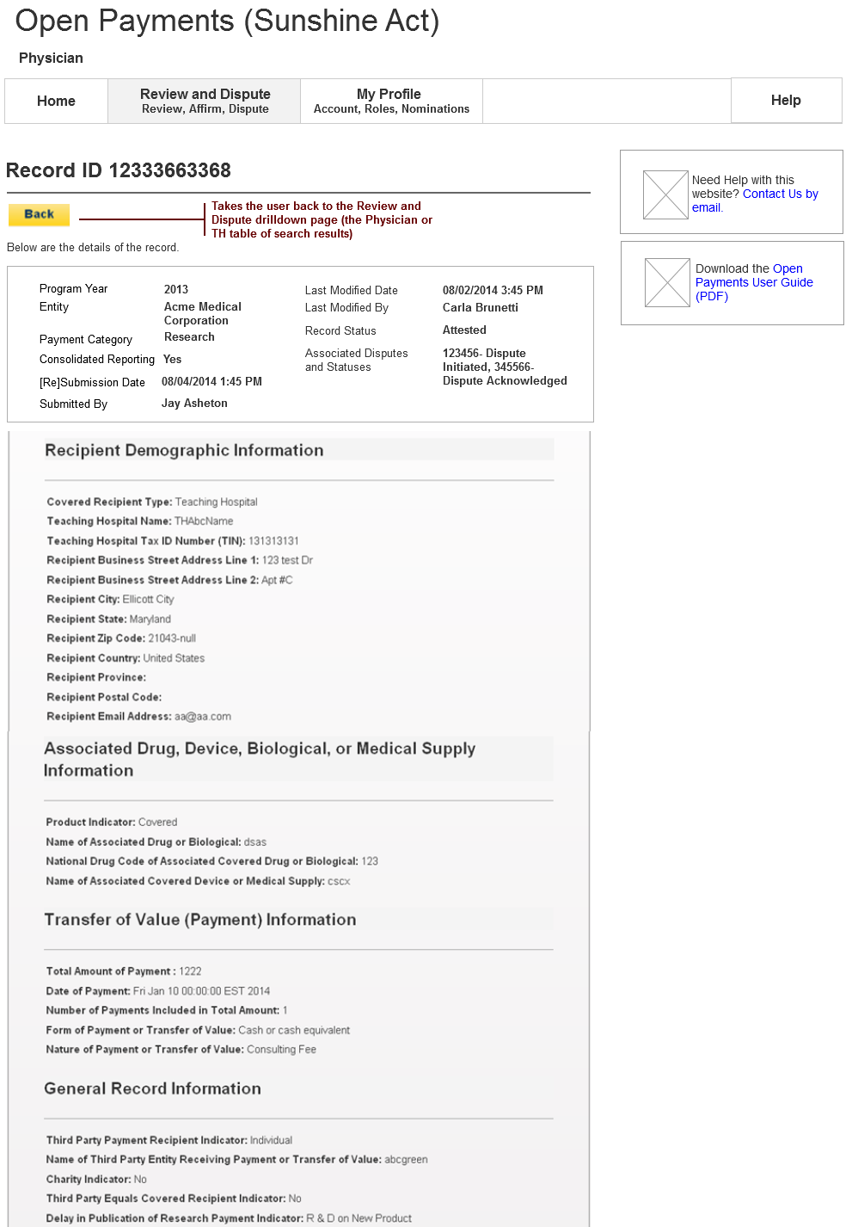

**“Associated Disputes and Statuses” field to be modified to show “Resolved No Change” as status instead of “Dispute Dismissed”**



Dispute ID Page - Physician or Teaching Hospital

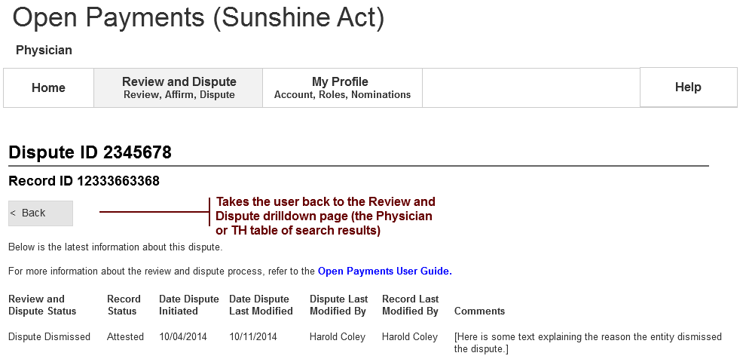

History of Disputes Page - Physician or Teaching Hospital

**“Review and Dispute Status” to be modified to show table column value with “Resolved No Change” as status instead of “Dispute Dismissed”**

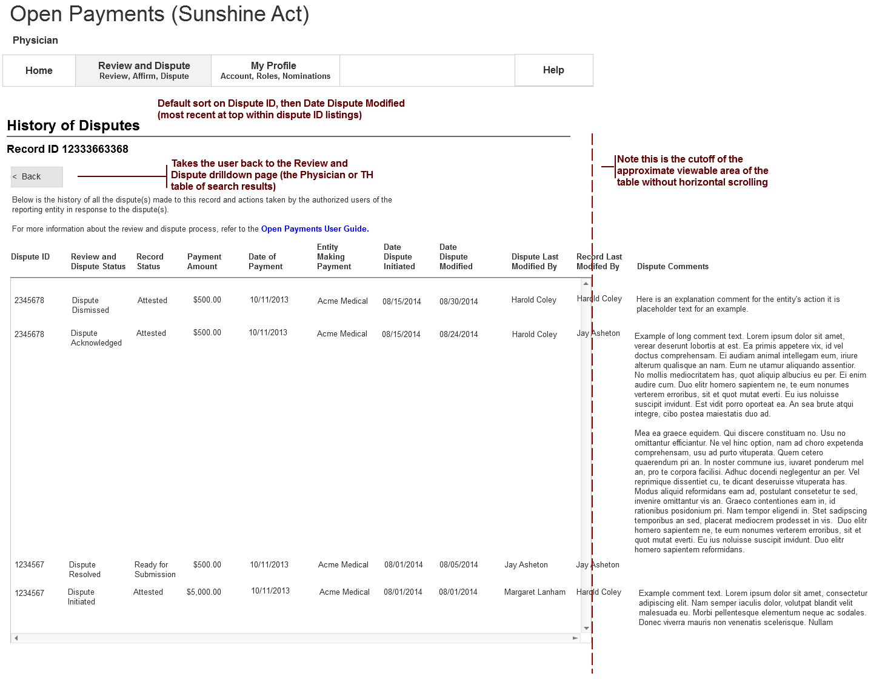

**“Review and Dispute Status” to be modified to show table column value with “Resolved No Change” as status instead of “Dispute Dismissed”**

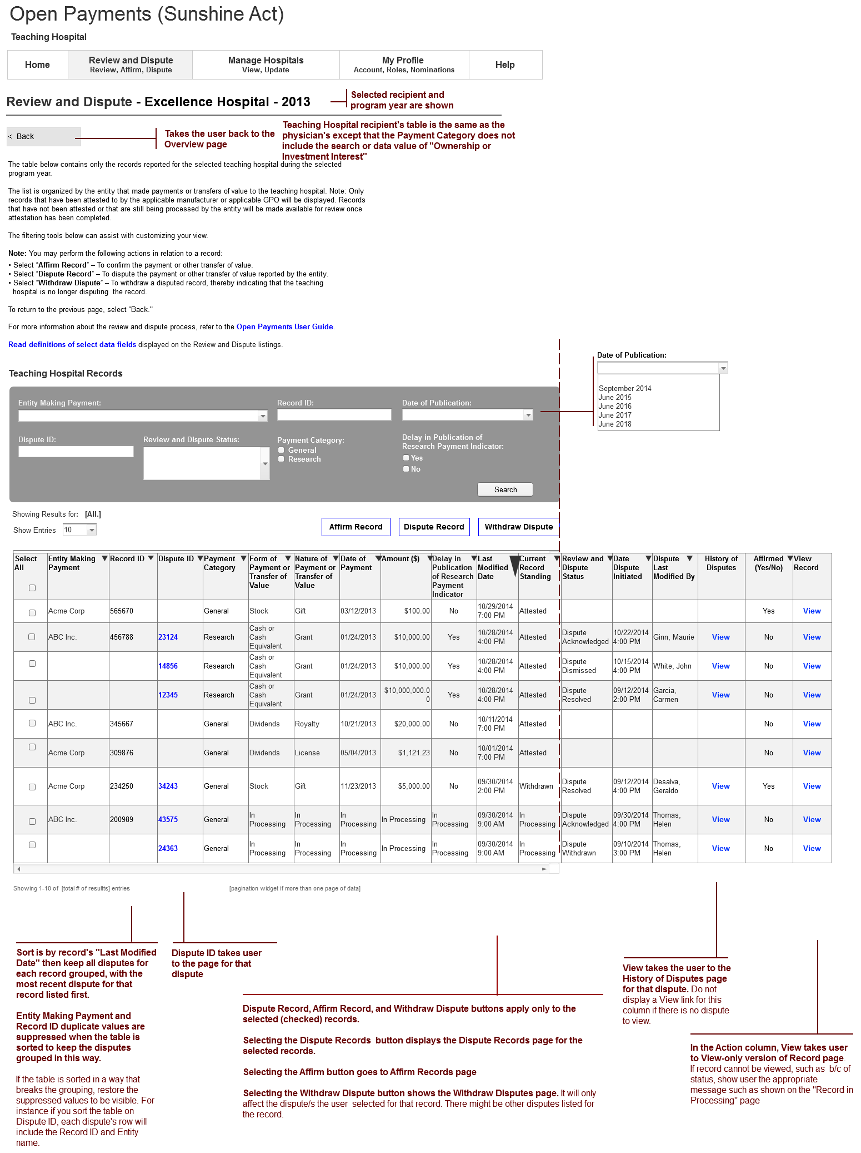

**“Review and Dispute Status” to be modified to show table column value with “Resolved No Change” as status instead of “Dispute Dismissed”**

**“Review and Dispute Status” drop-down to be modified to show “Resolved No Change” as status instead of “Dispute Dismissed”**

# Email Correspondence to be Updated

# Dispute Initiated By the Physician or Teaching Hospital - EML_RD_002

Email Conditions: The applicable manufacturer or applicable GPO (entity) shall receive an email when the physician or teaching hospital initiates a dispute of certain payments or transfers of value, or ownership or investment interests.

**Email Subject Line: Open Payments Dispute Initiated**

**Body:**

A dispute has been initiated in relation to a payment or other transfer of value, or ownership or investment interest reported by <INSERT ENTITY NAME> for the <INSERT PROGRAM YEAR> program year. The dispute was initiated regarding the following record:

* Record ID: XXXX [dynamic text]
* Payment or Other Transfer of Value Date: XXXX [dynamic text]
* Payment Amount or Dollar Amount Invested: XXXX [dynamic text]
* Payment Category: XXXX[dynamic text]
* Physician or Teaching Hospital Name: XXXX

Dispute ID: **XXXX**

Dispute Details

<Physician or Teaching Hospital Dispute Comments>

XXXXXXXXXXXXXXXXXXXXXXXXXXXXXXXXXXXXXXXXXXXXXXXXXXXXXXXXXXXXXXXXXXXXXXXXXXXXXXXXXXXX

You may acknowledge receipt of the dispute by logging into the Open Payments system, navigating to the “Review and Dispute” tab, and selecting “Acknowledge Dispute.” The physician or teaching hospital who initiated the dispute will receive an email acknowledging your receipt of the dispute.

You may review the details of the dispute by navigating to the “Review and Dispute” tab of the Open Payments system and searching for the disputed record using the Record ID or Dispute ID noted above. You may resolve the dispute by submitting and attesting to the corrected data. After reviewing the disputed information, if you determine that no change is required to the data, you may select “Resolved No Change” to acknowledge that your entity and the physician or teaching hospital have resolved the dispute in accordance with the guidance in the Final Review, or you may request the physician or teaching hospital who initiated the dispute to withdraw it. If you select “Resolved No Change,” this action should only be taken when dispute resolution does not require a change to the data by the reporting entity.

If you have questions or require any further information about this dispute, please contact <INSERT PHYSICIAN OR TEACHING HOSPITAL NAME> directly.

**Recipients:** submitter

# Dispute Resolved With No Changes By the Applicable Manufacturer or Applicable Group Purchasing Organization (GPO) - EML_RD_004

Email Conditions: The physician or teaching hospital shall receive an email when the applicable manufacturer or applicable GPO (entity) resolves the dispute of certain payments or transfers of value, or ownership or investment interests and makes no changes to the data.

**Email Subject Line: Open Payments Dispute Resolved with No Change to Data**

**Body:**

<INSERT ENTITY NAME> has resolved your dispute (Dispute ID <XXXX>) regarding the following record, and has not made any change to the data:

* Record ID: XXXX [dynamic text]
* Payment or Other Transfer of Value Date: XXXX [dynamic text]
* Payment Amount or Dollar Amount Invested: XXXX [dynamic text]
* Payment Category: XXXX [dynamic text]

<INSERT ENTITY NAME> specified the following reason(s) for resolving the dispute without changing the data:

<Reason for Dispute Resolution With No Change to the Data Comments>

XXXXXXXXXXXXXXXXXXXXXXXXXXXXXXXXXXXXXXXXXXXXXXXXXXXXXXXXXXXXXXXXXXXXXXXXXXXXXXXXXXXX

You may view the updated status of this record by logging into the Open Payments system and navigating to the “Review and Dispute” tab. Note that the applicable manufacturer or applicable GPO has selected “Resolved No Change” to acknowledge that they believe that they resolved the dispute with you in accordance with the guidance in the Final Rule. If you disagree with this dispute resolution that does not require a change to the data by the reporting entity, you may dispute this transaction again.

If you have questions pertaining to this dispute, please contact <INSERT ENTITY NAME> directly.

**Recipients:** physician, physician authorized representative, teaching hospital authorized official, teaching hospital authorized representative.