Supporting Statement for OMB Clearance Request

Appendix D: Modified Basic Information Form

Innovative Strategies for Increasing Self-Sufficiency (ISIS) – Follow-up Data Collection

OMB No. 0970-0397

March 2013

Submitted by:
Brendan Kelly
Office of Planning, Research
and Evaluation
Administration for Children
and Families
U.S. Department of Health and Human Services

Appendix D: Modified Basic Information Form

Note: The Basic Information Form (BIF) used during the baseline data collection was previously approved by OMB. The modified BIF, one of the instruments requesting clearance in this submission, includes some new questions about the participant’s children.
Proposed changes to the BIF are highlighted in yellow.

The time for completing the BIF without the child roster is estimated to be 15 minutes.

The time for completing the child roster is estimated to be 3 minutes, depending on the number of children.

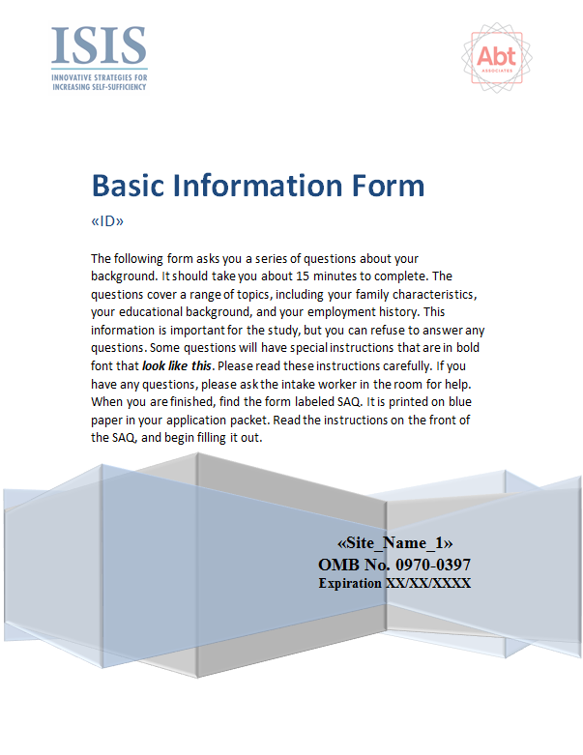
Paperwork Reduction Act (PRA) Statement: An agency may not conduct or sponsor, and a person is not required to respond to, a collection of information unless it displays a currently valid OMB control number. The OMB control number for this collection is 0970-0397 and it expires xx/xx/xxxx. If you have comments regarding this burden estimate or any other aspect of this collection of information, including suggestions for reducing this burden, please send them to [Contact Name]; [Contact Address]; Attn: OMB-PRA (0970-0397).
