Narrative of Changes
The purpose of the Narrative of Changes is to clearly indicate changes to a collection since the previous approval.

Collection Title:
OMB Control No.: 1660-0129
Current Expiration Date: 8/31/2014
Collection Instruments: FEMA Form 007-0-14 Survivor Centric Customer Satisfaction Survey (formerly Follow-Up Program Effectiveness & Recovery Survey)

The following are the changes to the collection:

FEMA Form name has been changed from Follow-Up Program Effectiveness and Recovery Survey to Survivor Centric Customer Satisfaction Survey to more accurately align with the Administrator’s strategic plan to improve the delivery of survivor services to ensure effective and efficient outcomes for survivors.

Supporting Statement:

Question 8a updated to reflect FRN publication information: A 60-day Federal Register Notice inviting public comments was published on February 28, 2014 [FR Doc. 2014-04413 Volume 79, No.40] under the old title. No comments were received. The 30-day Federal Register Notice will be published with the new title.

Question 10 – Updated to reflect current privacy information: A Privacy Threshold Analysis (PTA) was approved on 6/17/14.

Question 12 – Number of respondents increased: With this change, there will be an increase from 1600 to 2832 respondents, or 1232 additional respondents and additional burden from 400 hours to 1545, or an increase of 1145 burden hours. The added and/or modified questions increased the estimated burden time by 2 minutes from 12 minutes in the original submission posted after the 60-Day Federal Register Notice. This revised Supporting Statement reflects the increase to 14 minutes. Also, the number of times the questionnaire will be deployed increased from 4 times a year to an approximate 6 times a year. This increase will broaden the population sample either geographically or by disaster type and provide more timely results for Program Managers. In addition, focus group burden hours and participant/respondents were added to the information collection to obtain feedback from the customer for future collections. See Question 15 for explanation.

Question 14 costs to the Federal Government updated: An increase in annualized cost to the federal government is expected due to redirecting resources to this survey to achieve statistically valid responses to approximately 6 times per year.

Question 15 – Burden hour increase explained. Due to the scope of the survey expanding to include additional FEMA divisions and program offices that will benefit from the survey results, the length of the survey burden will increase from 12 minutes to 14 minutes. Adding focus groups will also increase the burden hours. An increase from 400 to 1545 burden hours is an 1145 increase.

Insert full explanation and chart from 15 as highlighted below.

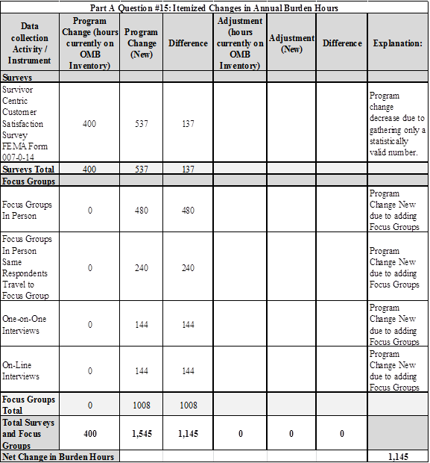

Explain:
For the Survivor Centric Customer Satisfaction Survey (formerly, Follow-Up Program Effectiveness & Recovery Survey), the previously approved burden hours were 400. The current estimated annual hour burden is 1,545 hours, resulting in an increase of 1,145. The increase in burden hours is due to increasing the number of times the survey will be utilized from quarterly to approximately 6 times per year, due to an increase of 2 minutes interview time per survey, plus the addition of focus groups to obtain feedback from the respondent for future collections. The total net burden of 1,145 hours is an increase for Survivor Centric Customer Satisfaction Survey (formerly, Follow-Up Program Effectiveness & Recovery Survey).

PLEASE NOTE ANY OTHER MAJOR CHANGES HERE IF APPLICABLE.
-
-
-

