United States Consumer Product Safety Commission

CHAIRMAN’S COMMENDATION
CIRCLE AWARD PROGRAM

Do you know a person, business, or organization that has made a significant contribution toward reducing deaths, preventing injuries, and improving consumer product safety?

If so, NOMINATE your potential award winner for a CPSC Chairman’s Commendation Circle
Award.
Send your nomination by July 11, 2014 to: Chairman’s Commendation Circle Award
U.S. Consumer Product Safety Commission
4330 East West Highway, Suite 724
Bethesda, MD 20814

E-mail: chairmansaward@cpsc.gov
Fax: (301) 504-0768

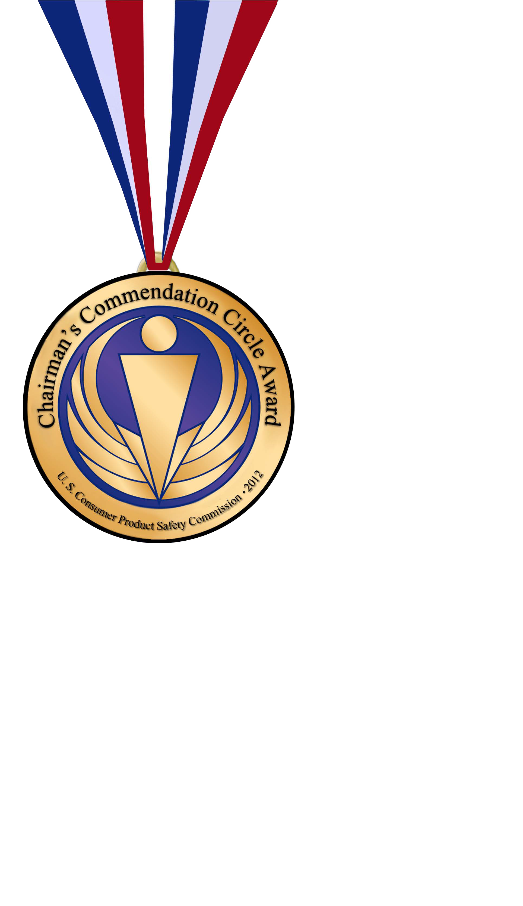U.S. CONSUMER PRODUCT SAFETY COMMISSION

4330 East West Highway
Bethesda, MD 20814

Submission requirements and nomination forms are available at www.cpsc.gov/award.

