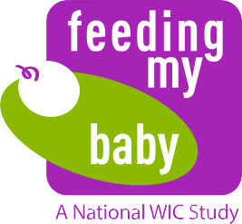

**Appendix B.1**

OMB Approval No. 0584-0580

Approval Expires: XX/XX/20 XX

**We have good news**

**to share!**



**Age 3 Extension Infant and Toddler Feeding Practices Study–II**

**Flyer–English**

The USDA Food & Nutrition Service is finding the *Feeding My Baby Study*

**so important** that they want to continue to collect information about your baby through his or her 3rd birthday, and possibly until age 4 or 5.

This unique national study is providing information on what children eat and how they

grow. 4,367 parents from 27 states enrolled in the study. YOU are one of them and a critical part of the study!

We want to interview you when your baby is 2½ and 3 years old. After you complete

the interview when your child is 2½ years old you will receive an incentive of **$30** as a token of appreciation(**$40** if you are using your own cell phone); and after you complete the interview when your child is 3 years old you will receive **$40** (or **$50** with your own cell phone). Each interview will take about 30 minutes.

We ask you to let us know you will continue in the study by signing one copy of the

consent form, and let us know how best to reach you by filling out the contact form. Please return the two forms in the self-addressed postage-paid envelope and we will add **$5** to your debit card. Your continued participation is key to the success of the study.

According to the Paperwork Reduction Act of 1995, no persons are required to respond to a collection of information unless it displays a valid OMB number. The valid OMB control number for this information collection is 0584-0580. The time required to complete this information collection is estimated to average 0.5 minutes per response, including the time for reviewing instructions, searching existing data sources, gathering and maintaining the data needed, and completing and reviewing the collection of information.

41904.0914.101000