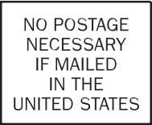
APPENDIX V.1
WIC INFANT AND TODDLER FEEDING PRACTICES STUDY – II
WEIGHT/HT MEASUREMENT CARD - ENGLISH

1600 Research Boulevard
Rockville, Maryland 20850-9973

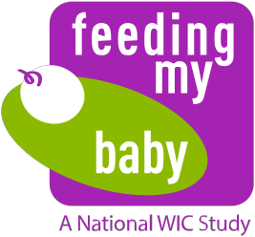
Measurement Card

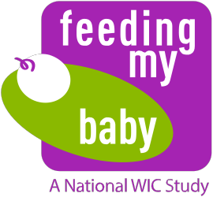
Measurement Card Instructions
OMB Approval No. 0584-0580
Approval Expires: XX/XX/20XX

This child is taking part in the WIC Feeding My Baby Study sponsored by the United States Department of Agriculture (USDA), Food and Nutrition Service. The purpose of this study is to understand health, growth, and feeding practices of children between birth and 36 months of age. To study growth, we are obtaining the height and weight measurements for these children during this critical development period. For any questions, please call [TOLL FREE NUMBER].

Please complete and return this postage-paid card to Westat by mail. The parent/ caregiver will receive an incentive for bringing the child in for measurements when the card is received by Westat.

Child’s First and Last Name | Child’s Birthdate
Parent/Caregiver’s First and Last Name
Provider Type (check box)

 WIC Program  Healthcare Provider/Clinic  Other
Provider Name, Address and Phone Number

Measurements
Height | in OR cm
Weight | lb oz OR kg
Date of Measurements

According to the Paperwork Reduction Act of 1995, no persons are required to respond to a collection of information unless it displays a valid OMB number. The valid OMB control number for this information collection is 0584-0580. The time required to complete this information collection is estimated to average 10 minutes, including the time for reviewing instructions, searching existing data sources, gathering and maintaining the data needed, and completing and reviewing the collection of information.

42320.1014.8967020301

