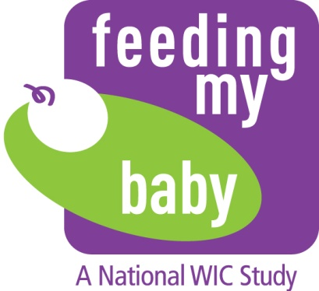
ID:
OMB Approval No. 0584-0580
Approval Expires: XX/XX/20XX
<TODAY’S DATE>

Dear Records Administrator,

The United States Department of Agriculture (USDA), Food and Nutrition Service (FNS) is conducting the national Women, Infants and Children (WIC) Feeding My Baby Study. The purpose of this study is to understand birth, health, growth, and feeding practices of children between birth and 36 months of age. To this end, FNS has contracted with Westat a contract research organization headquartered in Rockville, Maryland. On behalf of FNS, Westat will obtain health record information for these children during this critical development period.

Enclosed you will find the Medical Records Release Form for the following study participant who received care at your facility:

Child’s Name: <Child’s name> Date of Birth: <DOB>
Measurement date of interest: <MILESTONE DATE>

We are interested in collecting measurements that were taken as close to the child’s 3rd birthday (the measurement date of interest) as possible. Please indicate whether your office has measurements for the child around the child’s 3rd birthday. If you do have measurements, please fill in the table below for this study participant, making sure to include the unit of measurement.

- We have records for this child around that date:

 | Date of Measurement | Measurement
Height | _____/_____/20_____ | __________ cm OR _________ in.
Weight | _____/_____/20_____ | __________ kg OR ______ lb _______oz

- We do not have records for this child around that date.

Please contact Lauren Faulkner at 240-314-5860 or LaurenFaulkner@westat.com should you have any questions or require assistance. If at all possible we would like to receive the information within 4 weeks of receipt of this request. Please fill in the table with the relevant information and fax it to Lauren Faulkner at the following number.

Lauren Faulkner, Fax: 301-315-5910

Thank you very much for your assistance with this important research study.

Sincerely,

Gail Harrison, PhD | Suzanne McNutt | Allison Magness
Feeding My Baby Study Principal Investigator | Feeding My Baby Study  Project Director | USDA, Food and Nutrition Service

Permission to Get Height and Weight Information from Medical Records - English
WIC Feeding My Baby Study
Food and Nutrition Service, U.S. Department of Agriculture
(MEDICAL RELEASE FORM)

If you sign this document, you are giving permission to your child’s doctor to release health information that identifies you to Westat for the WIC Feeding My Baby Study. The health information that we will use for the Feeding My Baby Study includes your child’s weight and length from your child’s doctor up until your child is 3½ years old. Westat will use this health information, along with information you give during your interviews and information from your WIC records, to learn more about the health and feeding choices of WIC families.
Your child’s doctors are required by law to protect your health information. The Health Insurance Portability and Accountability Act of 1996 (HIPAA) prevents them from releasing your health information without your permission. Once your information is released to Westat it is no longer protected by HIPAA, but the same privacy protections Westat takes with your other information will also apply to your child’s medical records. Your name and your child’s name will not be used in any research reports, and Westat will not share personal information about you with WIC or with anyone else who is not on the study staff, except as otherwise required by law.
Your child’s doctor may not refuse to treat you because of your decision to sign or not sign this authorization. You can change your mind and take back this authorization at any time by contacting the Feeding My Baby study by phone at 1-888-452-2083 or in writing at Westat, 1600 Research Blvd., Rockville, MD 20850, Attn: Bryan Williams, RW2653. The Feeding My Baby study would not seek any more records about you or your child, but would still use any records that had already been released.
By signing this document, you are authorizing your child’s doctor to release information on your child’s height and weight to Westat for this research. The permission is only for the study period of May 15, 2013 to December 31, 2018.

I am voluntarily giving permission for my child’s height and weight medical records, as described above, to be released to Westat for the Feeding My Baby Study.

Patient’s Name (Child):
Please Print Your Child’s Full Name

Date of Birth: ____ / ____ / ____
Month Day Year

Parent or Guardian Signature for Child:

Signer’s Relationship to Child:

Date Signed:

