Agency Notice on ICE

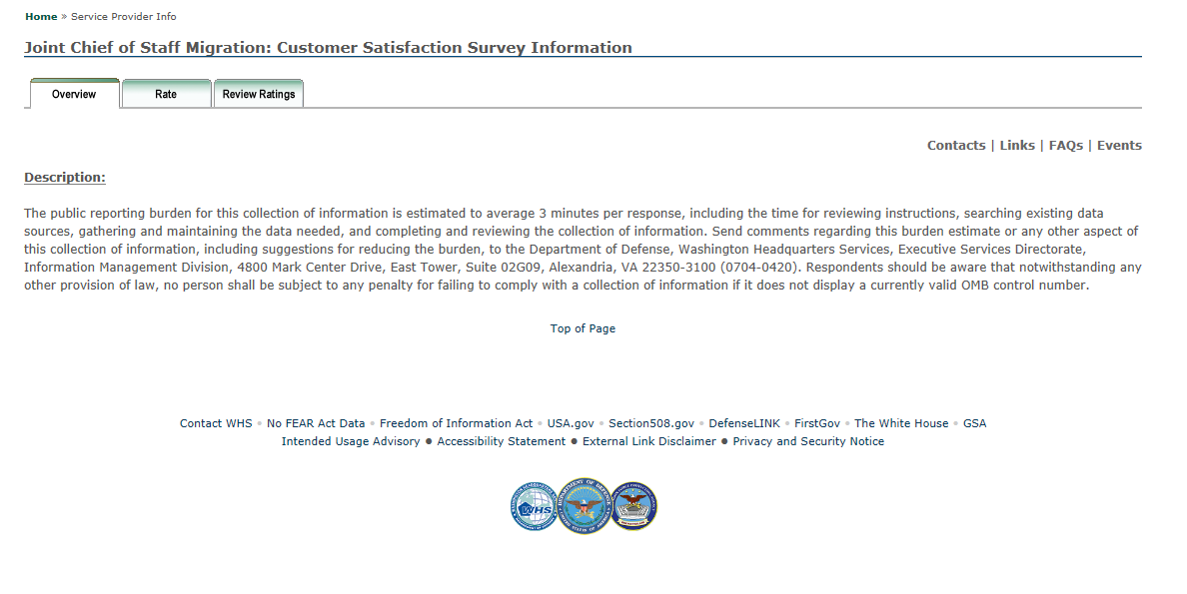

Comment Card Questionnaire in ICE

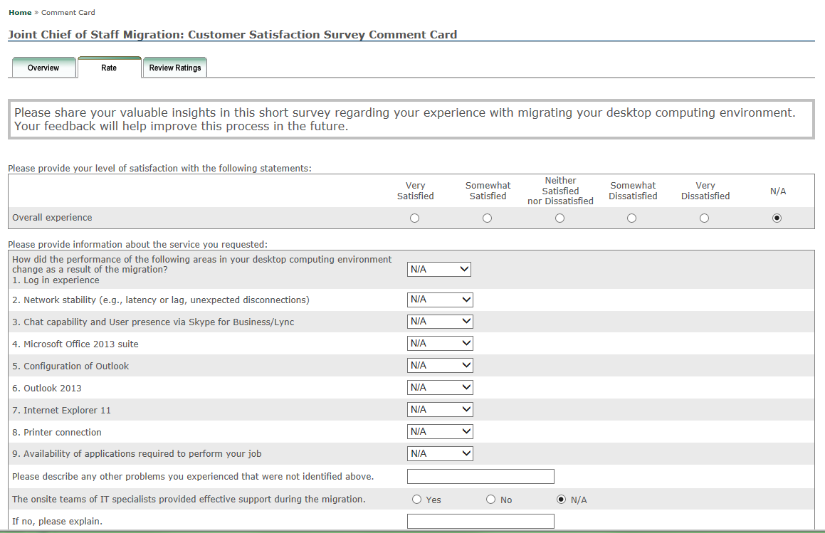
Answer Options:
Improved
No Change
Declined

