2014 AIDS Drug assistance program

data report INSTRUCTION MANUAL

Release Date: xx/xx/2014

*Public Burden Statement*: An agency may not conduct or sponsor, and a person is not required to respond to, a collection of information unless it displays a currently valid OMB control number. The OMB control number for this project is 0915-0345, with an expiration date of xx/xx/20xx. Public reporting burden for this collection of information is estimated to average 87 hours per response, including the time for reviewing instructions, searching existing data sources, and completing and reviewing the collection of information. Send comments regarding this burden estimate or any other aspect of this collection of information, including suggestions for reducing this burden, to: HRSA Reports Clearance Officer, 5600 Fishers Lane, Room 10C-031, Rockville, MD 20857.

HIV/AIDS Bureau

Division of Policy and Data

Health Resources and Services Administration

U.S. Department of Health and Human Services

5600 Fishers Lane, Room 7C-07

Rockville, MD 20857

Table of Contents

Introduction 1

What’s New: 1

About the ADAP Data Report 2

Who is an ADAP client? 2

What are ADAP services? 2

Medication Services 3

Insurance Assistance Services 3

Services Provided under the ADAP Flexibility Policy 3

How is the ADR submitted to HAB? 3

Who submits the ADR? 3

What are the reporting periods? 3

The Grantee Report 5

Grantee Contact Information 5

Programmatic Summary Submission 6

The Client Report 12

Reporting Client-Level Data 12

Submitting Client-Level Data to HAB 12

Client-Level Data Fields 12

System Variables 13

Client Demographics 13

Enrollment and Certification 19

ADAP Services 20

ADAP Insurance Services 21

Drugs and Drug Expenditures 22

Clinical Information 23

Importing the XML Client File 23

Report Validation 24

Submitting Your Report 24

Appendix A: Required Client-Level Data Elements 25

Appendix B: Frequently Asked Questions from the Field 26

Appendix C: Calculating Client Income as a Percent of the Federal Poverty Measure Using HHS Federal Poverty Guidelines 31

Appendix D: Glossary 32

ADAP Manual Index – Need to update 38

# Introduction

The Ryan White HIV/AIDS Treatment Extension Act of 2009 (Public Law 111-87, October 30, 2009) provides the Federal HIV/AIDS programs in the Public Health Service (PHS) Act under Title XXVI flexibility to respond effectively to the changing epidemic. Its emphasis is on providing life-saving and life-extending services for people living with HIV/AIDS across the country and on providing resources to targeted areas with the greatest need.

All Program Parts of the Ryan White HIV/AIDS Program (RWHAP) specify the Health Resources and Services Administration’s (HRSA’s) responsibilities in the allocation and administration of grant funds, as well as the evaluation of programs for the population served, and the improvement of the quality of care. Accurate records of the grantees receiving RWHAP funding, the services provided, and the clients served continue to be critical to the implementation of the legislation and thus are necessary for HRSA to fulfill its responsibilities.

The Ryan White HIV/AIDS Program legislation authorizes a portion of Part B funds to be designated for the AIDS Drug Assistance Program (ADAP), which primarily provides medications for the treatment of HIV disease. Program funds may also be used to purchase health insurance for eligible clients and for services that enhance access, adherence, and monitoring of drug treatments. All 50 States, the District of Columbia and several Territories receive ADAP grants.

The HIV/AIDS Bureau (HAB) currently requires that all ADAPs report client-level data using the ADAP Data Report (ADR). The ADR was developed and implemented in 2013. The ADR will enable HAB to evaluate the impact of the ADAP program on a national level and will allow HAB to characterize the individuals using the program, describe the ADAP-funded services being used, and delineate the costs associated with these services.

HAB’s goal is to have a client-level data reporting system that provides data on the characteristics of the ADAPs and the clients served with program funds. The ADAP client-level data submitted will be used to:

* monitor the clinical outcomes of clients receiving care and treatment through ADAP
* monitor the use of ADAP funds for appropriately addressing the HIV/AIDS epidemic in the United States
* monitor the support provided by ADAP to the most vulnerable communities, especially minorities
* address the needs of Congress and the Department of Health and Human Services (HHS) concerning the HIV/AIDS epidemic and the RWHAP
* monitor the outcomes achieved in response to the National HIV/AIDS Strategy

**NOTE:** HAB uses an encrypted Unique Client Identifier (UCI), to limit data collection to only that information reasonably necessary to accomplish the purpose of the ADAP Data Report.

## What’s New:

Revisions to the ADR were made to support the implementation of the HIV/AIDS core indicators as developed by the HIV/AIDS Indicators Implementation Group (HAIIG) and to streamline data collection and reduce reporting burden. Eleven items were deleted from the ADR and several response items were modified. In addition, new items were added:

* *Sex at Birth*, defined as the biological sex assigned to the client at birth, was added to align with data collected by other HHS Operating Divisions.
* *Type of ADAP-funded insurance assistance received* was also added to track ADAP’s payment of full or partial premiums and medication co-pays and deductibles.
* *Hispanic, Asian, and Native Hawaiian/Pacific Islander subgroup identification* was added to comply with the requirement under Section 4302 of the Affordable Care Act.

## About the ADAP Data Report

The ADR includes two components: (1) the Grantee Report, and (2) the Client Report. All ADAPs are required to submit both reports.

***The Grantee Report*** is a collection of basic information about grantee characteristics and policies.

***The Client Report (or client-level data***) is a collection of records (one record for each client enrolled in the ADAP) which includes the client’s encrypted unique identifier, basic demographic data, and enrollment and certification information. A client’s record may also include data about the ADAP-funded insurance and medication received, including the costs of these services, as well as HIV clinical information. The ADAP does not collect client-level data for any funds that were used under the Flexibility Policy. See the *ADAP Flexibility Policy* section on page 3 of this manual.

## Who is an ADAP client?

An ADAP client is any individual who is enrolled in the ADAP, (i.e., certified as eligible to receive ADAP services, regardless of whether the individual used ADAP services during the reporting period).

During the reporting period, an ADAP client may have:

* received medications and/or insurance assistance
* been placed on a waiting list
* been disenrolled
* been eligible, but did not receive services for clinical or other reasons

## What are ADAP services?

The ADAP is a state-administered program authorized under Part B of the Ryan White HIV/AIDS Program. Funds are designated to provide medications for the treatment of HIV disease and for the prevention and treatment of opportunistic infections. Program funds may also be used to purchase health insurance for eligible clients and for services that enhance access, adherence, and monitoring of drug treatments. All 50 States, the District of Columbia, and several U.S. Territories receive ADAP grants.

### Medication Services

Medication services are the purchase of U.S. Food and Drug Administration (FDA) approved medications for the treatment of HIV disease and the prevention and treatment of opportunistic infections. These medications are purchased with ADAP funds on behalf of a client.

### Insurance Assistance Services

Insurance assistance services are the provision of financial assistance for clients to maintain continuity of health insurance or to receive medical benefits under a health insurance program. This includes premium payments (partial or full), Medicare Part D co-insurance, deductibles, TrOOP, and co-insurance under catastrophic coverage. Co-pays and deductibles for medications are also considered insurance assistance services and should be reported in this section, not in the Drug and Drug Expenditures section.

### Services Provided under the ADAP Flexibility Policy

The HAB Policy Notice 07—03 allows grantees greater flexibility in the use of ADAP funds and permits expenditures of ADAP funds for services that improve access to medications, increase adherence to medication regimens, and help clients monitor their progress in taking HIV-related medications.To use ADAP dollars for services under the ADAP Flexibility Policy, grantees ***must*** request approval annually, in their grant application or through the prior approval process in the EHB.

## How is the ADR submitted to HAB?

The ADR is submitted online using HAB’s ADR Web Application. Grantees access the ADR Web Application via the HRSA Electronic Handbooks for Applicants/Grantees (EHBs), a Web-based grants administration system. The EHBs are located at <https://grants.hrsa.gov/webexternal/>.

The ADR Grantee Report is completed by filling out the online forms in the ADR Web Application. After completing the Grantee Report, grantees upload the Client Report as an XML (eXtensible Mark-up Language) file from within the Grantee Report. For additional information, see the *Submitting Client-Level Data to HAB* section on page 12 of this manual.

## Who submits the ADR?

The submission of the ADR is a condition of the Part B grant award. Each Part B grantee of record must complete both components of the ADR. The grantee of record (also referred to as the grantee) is the agency that receives ADAP funding directly from HRSA.

## What are the reporting periods?

ADAPs are required to submit the ADR annually. The 2014 ADR is due on June 8, 2015. Both the Grantee Report and the Client Report have different reporting periods.

For the Grantee Report, ADAPs report data based on the grant year reporting period, April 1, 2014 to March 31, 2015.

For the Client Report, ADAPs report client-level data for clients enrolled during the calendar year reporting period, January 1, 2014 to December 31, 2014.

**Important Dates to Note**

|  |  |  |
| --- | --- | --- |
| **Date** | **Client XML File**  **(January 1 – December 31, 2014)** | **Grantee Report**  **(April 1, 2014 – March 31, 2015)** |
| **Monday, March 2, 2015** | 2014 ADR Test Your XML and Data Quality Feature Opens |  |
| **Thursday, April 9, 2015** | 2014 ADR Web System opens for 2014 data collection | |
| **Monday, April 27, 2015** | Target upload date for all 2014 ADR Client-level data files |  |
| **Monday, June 8, 2015** | All ADRs (including the Grantee Report) must be in “Submitted” Status by 6:00 PM ET. | |

Please make sure to visit the HAB Web site: <http://hab.hrsa.gov/manageyourgrant/adr.html>

at the beginning of the report submission period to obtain up-to-date information regarding the reporting deadlines.

# The Grantee Report

For the Grantee Report, ADAPs will be reporting data based on the grant year reporting period, April 1, 2014 to March 31, 2015. Each ADAP completes the Grantee Report.

## Grantee Contact Information

1. Grantee name (display only): The grantee name must match the organization name on the Notice of Grant Award (NoA). There should be no abbreviations or acronyms unless they are also used in the NoA.
2. Grant number (display only): This is the grant number displayed on your NoA.
3. DUNS number (display only): This number, assigned by Dun & Bradstreet, indicates the grantee’s credit worthiness.
4. Grantee address (display only): This address should match the mailing address of the grantee of record. There should be no abbreviations or acronyms unless they are also used in the NoA.

**NOTE:** The Grantee Contact Information displayed reflects the information on the grantee of record that is stored in the EHBs. If this information is not correct, you must update your agency information in the EHB.

1. Contact information of person completing the Grantee Report: Enter name, title, email, telephone number, and FAX number.

See Figure 1 below for the Grantee Contact Information screenshot. Once you’ve updated, entered, and/or verified the data on the Grantee Contact Information page, click **Next** to save the data and advance to the next page, *Programmatic Summary Submission*.

**NOTE**: To enter data in the Grantee Report, use the menu on the left side of the ADR Web Application to navigate through Questions 1-7. **Click on the Save button** before navigating to a different page or your data will be lost.

Figure 1. ADR Grantee Report Online Form: Grantee Contact Information

Screenshot needs to be updated.

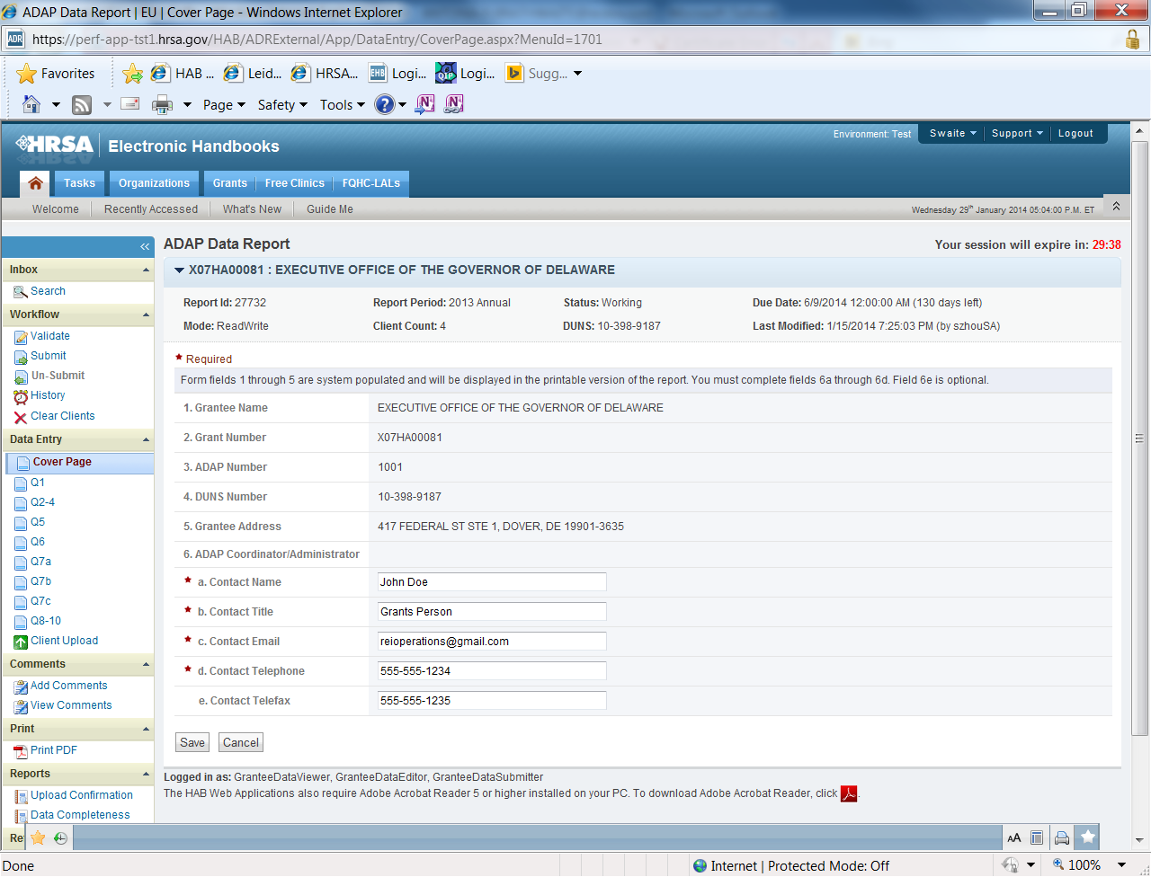

## Programmatic Summary Submission

The *Programmatic Summary Submission* consisting of sub sections A through E, numbers 1-7, should be completed for the grant year reporting period, April 1, 2014 to March 31, 2015. You must answer all questions.

***A. Program Administration***

1. **ADAP Limits:** Indicate whether your program has adopted any of the following limits in order to control costs. You may check more than one box if applicable (see Figure 2). If your ADAP did not apply any of these limits, only check **None of these limits were applied to the ADAP during the reporting period.**
   1. *Waiting list*—A list of clients who have been certified as eligible and have been enrolled to receive ADAP services, but are not receiving ADAP services due to caps on service enrollment or other cost-containment strategies.
   2. *Enrollment cap*—A limit on the maximum number of people who can be enrolled in your program and receive services at any given time.
   3. *Capped number of prescriptions per month­―*A limit on the number of prescriptions allowed per month.

If your ADAP has capped prescriptions per month, enter the number per month.

* 1. *Capped expenditure*—A limit on the maximum amount of dollars that can be spent per client.

If your ADAP has capped expenditures, enter the monetary cap per client and whether the cap applies monthly or annually.

* 1. *Drug-specific enrollment caps for ARVs or Hepatitis B & C medications*—A limit on the maximum number of clients who can receive a specific medication at any given time.

If your ADAP has adopted drug-specific enrollment caps, indicate the medications for which you have enrollment caps.

* 1. Formulary reduction―A change in your ADAP formulary that reduced the number of medications that are available to your clients.
  2. Decrease in financial eligibility criteria― A change in your income eligibility requirement that decreased the FPL criteria for participation in your ADAP.
  3. None of these limits were applied to the ADAP during the reporting period―If your ADAP did not apply any limits, check this box as your only response to this question.

**NOTE:** If you select **Capped prescriptions or Capped expenditure**, you must enter the maximum limit for that option. For the **Drug-specific enrollment caps,** indicate the specific medication.

**Figure 2. ADR Grantee Report Online Form:**

Screenshot of the Programmatic Summary Submission: 1-3 Screenshot needs to be updated.

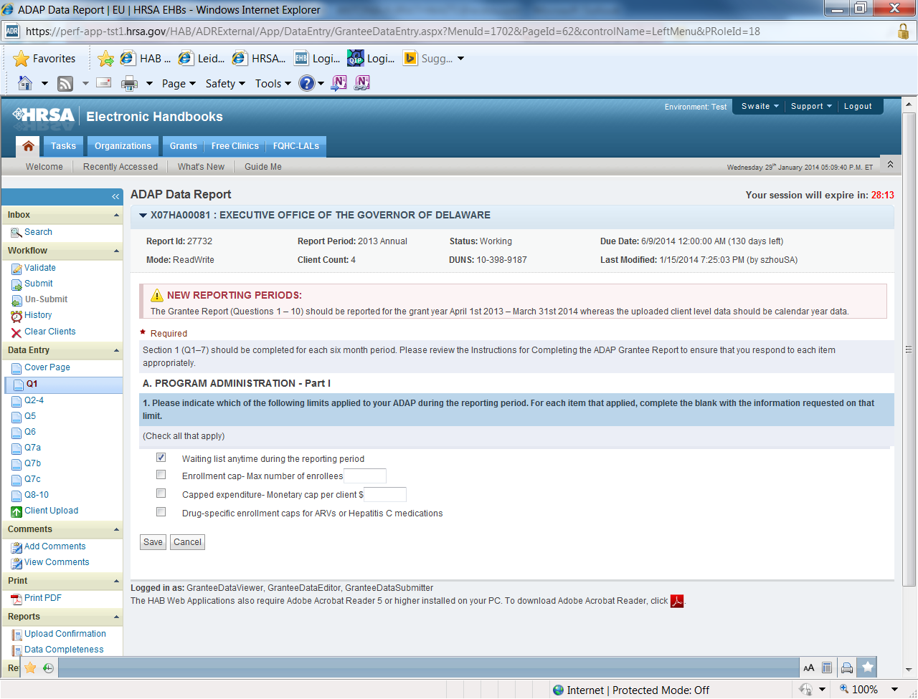

2. **ADAP income eligibility**: Enter the maximum income eligibility cap for participation in your State ADAP (see Figure 2). This should be expressed as a percentage of the Federal Poverty Level (FPL). For example, individuals living with HIV who have an income of 200 percent of the FPL or lower may be eligible to participate.

3. **Clinical criteria required to access ADAP:** Check all of the clinical eligibility criteria for enrolling in the ADAP in your state or territory (See Figure 2). For CD4 count or viral load (VL) medical criteria, indicate the threshold number in the space provided. For **Other** medical criteria, indicate each criterion used and any corresponding threshold number. If your ADAP does not require clinical eligibility criteria for clients, only check **No clinical eligibility criteria required to enroll in the ADAP**.

**Click on the Save button** before navigating to the next page or your data will be lost.

***B. Purchasing Mechanisms***

4. **Drug pricing cost-saving strategies:** Check all items that apply to your drug pricing program (see Figure 3). Definitions of cost-saving strategies can be found in the Glossary. If your ADAP did not apply any of these cost-saving strategies, only check **None of these apply to our Drug Pricing Program**.

**Click on the Save button** before navigating to the next page or your data will be lost.

**Figure 3. ADR Grantee Report Online Form:**

Screenshot of the Programmatic Summary Submission: 4 Screenshot needs to be updated.

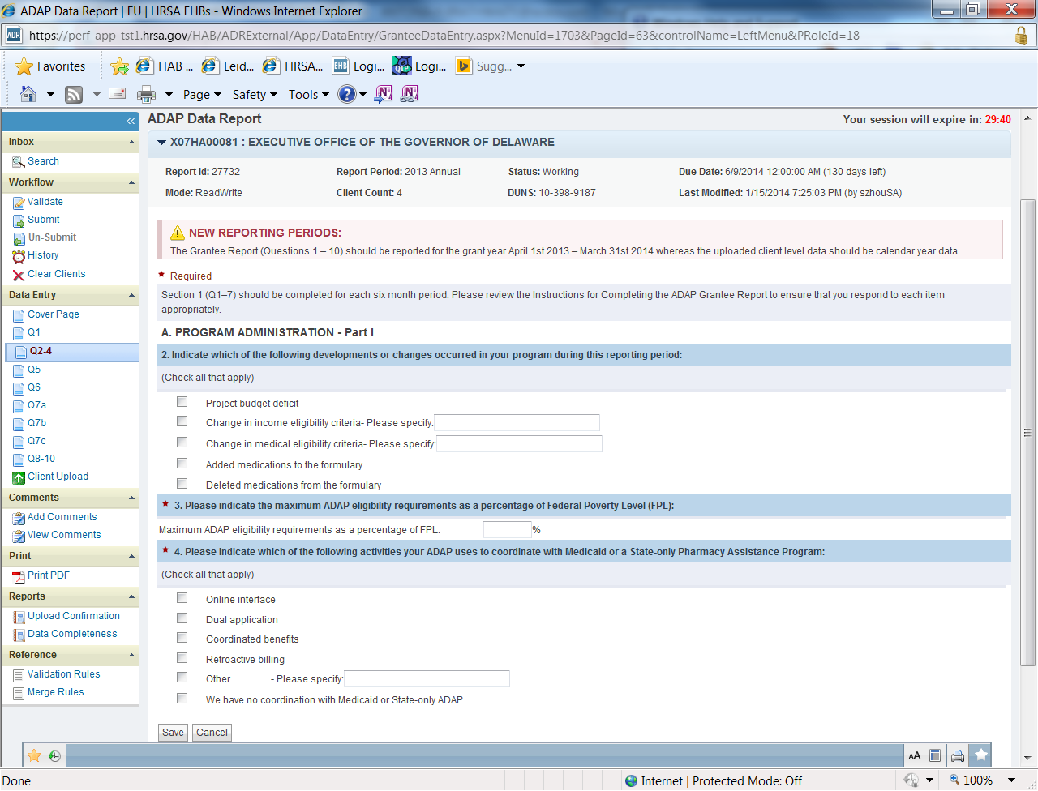

***C. Funding***

5. **ADAP funding received during the reporting period:** Enter the amount of funding your program received from the sources listed during the reporting period (See Figure 4). Report funding *received*, not awarded. Enter **0** if your ADAP did not receive funding from any given source during the period. Do not leave any boxes blank.

**Click on the Save button** before navigating to the next page or your data will be lost.

**Figure 4. ADR Grantee Report Online Form:**

Screenshot of the Programmatic Summary Submission: 5 Screenshot needs to be updated.

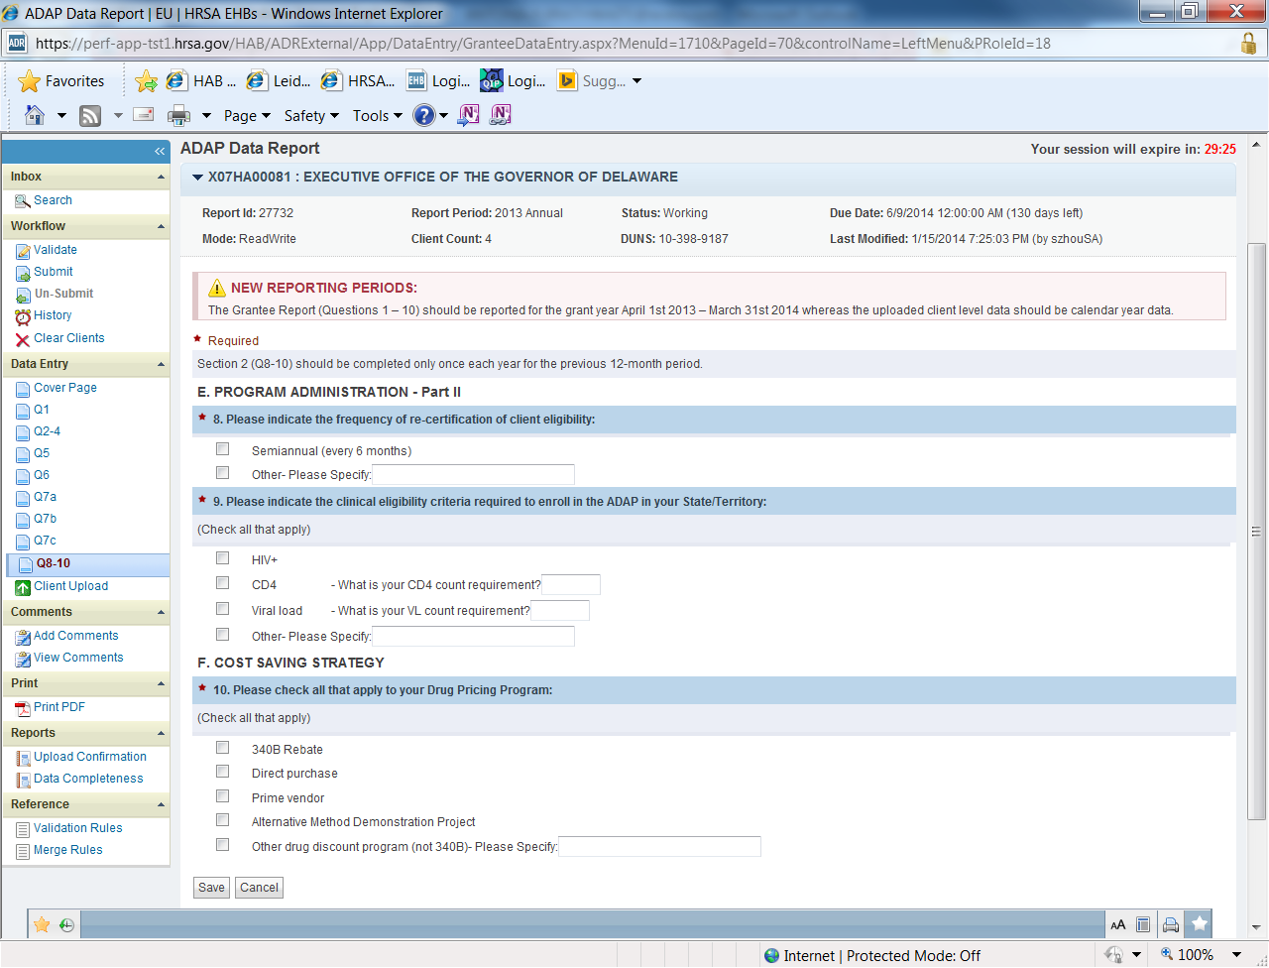

***D. Expenditures***

6. **Expenditures:** Enter the total expenditures for pharmaceuticals, dispensing and other administrative costs, and insurance coverage for the reporting period (See Figure 5). Administrative costs include items such as shipping and handling and other bulk order fees. The total expenditures for the reporting period will be calculated automatically. Total expenditures in item #6 cannot exceed total funding in item #5.

**Click on the Save button** before navigating to the next page or your data will be lost.

Add New Screenshot the **Programmatic Summary Submission: 6**

***E. ADAP Medication Formulary***

7. **ADAP Medication Formulary**: A list of (a) ARVs, (b) A1-OI’s, and (c) Hepatitis medications will be provided separately on one page (See Figures 6-8). The medication’s generic name appears first, followed by the brand name and its D-code number. For each list, check the box on the left if your ADAP currently includes the medication in the formulary. These columns can also be sorted to easily locate medications on your formulary.

**Click on the Save button** before navigating to the next list of medications or your data will be lost.

For ARVs, indicate whether the medication was added to the formulary during the reporting period. Check the box provided and enter the date that the ARV was added. This data is not required for A1-OI’s and Hepatitis medications.

Add New Screenshots of the **Programmatic Summary Submission: 7**

**Next Step: Upload Your Client-Level Data**

Once you are satisfied that your Grantee Reports is complete and correct, upload your client-level data. The Grantee Report cannot be submitted until the Client Report is uploaded into the ADR Web Application. The Client Report is a collection of ADAP client records that must be submitted in one or more properly formatted client-level data XML files. For more explanations on the client-level data elements, see the section, *The Client Report* on page 11. To learn how to upload the client-level data XML file, see the section *Importing the XML Client File* on page 23.

If you need help on completing the Grantee Report, contact Data Support at 1-888-640-9356.

# The Client Report

For the Client Report, ADAPs will be reporting client-level data for clients enrolled during the calendar year reporting period, January 1, 2014 to December 31, 2014.

## Reporting Client-Level Data

The Client Report should contain one record (“row” of data in a database) for each client enrolled in the ADAP during the reporting period. An enrolled client is an individual who is certified as eligible to receive services, whether or not the individual actually received ADAP services during the reporting period. For all enrolled clients, ADAPs must report client demographics and enrollment and certification data. For clients who received services, ADAPs must report whether they received insurance services and/or medications services and their related data. Note that clinical data is only required for clients who received medication services. See appendix A: *Required Client-Level Data Elements* to determine the client-level data elements required to be reported for an enrolled client.

## Submitting Client-Level Data to HAB

The Client Report (i.e., client-level data set) must be uploaded as an XML file. XML is a standard, simple, and widely adopted method of formatting text and data so that it can be exchanged across different computer platforms, languages, and applications. To learn how to upload the client-level data XML file, see the section *Importing the XML Client File* on page 21.

Grantees need to extract the client-level data elements from their systems into the proper XML format before they can be uploaded to the HAB server. If your ADAP uses an ADR Ready System such as CAREWare, eCOMPASS or Provide Enterprise, no special action will be required to generate the XML file. These ADR Ready Systems are able to export the data in the required XML format.

If you do not use an ADR Ready System, you will need to use a program that extracts the data from your system and inserts it into an XML file that conforms to the rules of the ADR XML schema. The schema is available at <https://careacttarget.org/library/adap-data-report-adr-download-package>

**NOTE:** Technical support is available to grantees through the HAB Web site at <http://hab.hrsa.gov/manageyourgrant/techdataassistance.html> or the Target Center Web site at https://careacttarget.org/category/topics/adap-data-report-adr.

## Client-Level Data Fields

The *Client-Level Data Fields* section outlines the data fields that will be submitted in the client-level data XML file. For common questions from grantees, see appendix B: *Frequently Asked Questions from the Field*.

**Encrypted Unique Client Identifier**

The XML file will contain one system field: encrypted Unique Client Identifier (eUCI). To protect client information, an eUCI is used for reporting Ryan White client data.

A Unique Client Identifier (UCI) is a unique 11-character alphanumeric code that is the same for the client across all provider settings. The UCI is derived from the first and third characters of a client’s first and last name, his or her date of birth (MM/DD/YY), and a code for gender (1=male, 2=female, 3=transgender, 9=unknown). The eUCI is a 40-character alphanumeric code created when SHA-1, a one-way hashing algorithm that meets the highest privacy and security standards, encrypts the client’s UCI.

It is possible that different clients have identical 40-digit eUCIs. Therefore, ADAPs must add a 41st character at the end of the eUCI to distinguish these clients. If only one client within the ADAP data system has a given UCI, the suffix should be **U** for unique. If more than one client has the same UCI, the final character of the first client’s eUCI needs to be **A**, the final character of the next client’s eUCI needs to be **B**, and so on. The suffix prevents multiple clients from having the same eUCI.

The UCI is encrypted with SHA-1 at the provider site BEFORE the data are submitted to HAB. SHA-1 is a trap door algorithm, meaning that the original UCI is unrecoverable from the eUCI. The resulting alphanumeric code, the eUCI, is used to distinguish one Ryan White client from all others in a region.

**NOTE**: To learn more about the eUCI, view the resources available on the TARGET Center Web site at <http://careacttarget.org/adr.asp>.

#### Guidelines for Collecting and Recording Client Names

Grantees should develop business rules/operating procedures outlining the method by which client names should be collected and recorded, for example:

* Enter the client’s entire name as it normally appears on documentation such as a driver’s license, birth certificate, passport, or social security card.
* Follow the naming patterns, practices, and customs of the local community or region (i.e., for Hispanic clients living in Puerto Rico, record both surnames in the appropriate order).
* Avoid the use of nicknames (i.e., do not use Becca if the client’s full name is Rebecca).
* Avoid using initials.

Grantees should instruct their staff on the correct entry of client names. Client names must be entered in the same way every time in order to avoid false duplicates.

### Client Demographics

The purpose of the Client Demographics section is to describe the socio-demographic characteristics of all clients **enrolled** in the ADAP, **regardless of whether they received services.**

#### Reporting Client Race and Ethnicity

The Office of Management and Budget (OMB) Revisions to the Standards for the Classification of Federal Data on Race and Ethnicity provides a minimum standard for maintaining, collecting, and presenting data on race and ethnicity for all federal reporting purposes. The standards were developed to provide a common language for uniformity and comparability in the collection and use of data on race and ethnicity by federal agencies.

The standards have five categories for data on race: American Indian or Alaska Native; Asian; Black or African American; Native Hawaiian or Other Pacific Islander; and White. There are two categories for data on ethnicity: Hispanic or Latino and Not Hispanic or Latino. Identification of ethnic and racial subgroups are required for the categories of Hispanic/Latino, Asian, and Native Hawaiian/Pacific Islander. The racial category descriptions, defined in October 1997, are required for all federal reporting, as mandated by the OMB. For more information, go to: <http://aspe.hhs.gov/datacncl/standards/aca/4302/index.pdf>

HAB is required to use the OMB reporting standard for race and ethnicity. However, ADAPs can choose to collect race and ethnicity data in greater detail. If the agency chooses to use a more detailed collection system, the data collected should be organized so that any new categories can be aggregated into the standard OMB breakdown.

**NOTE:** All Ryan White HIV/AIDS Program grantees are expected to make every effort to obtain and report race and ethnicity based on each client’s self-report. Self-identification is the preferred means of obtaining this information. Grantees should not establish criteria or qualifications to determine a particular individual's racial or ethnic classification, nor specify how someone should classify himself or herself.

4. Ethnicity

Indicate the client’s ethnicity based on his or her self-report.

* *Hispanic/Latino(a)*—A person of Cuban, Mexican, Puerto Rican, South or Central American, or other Spanish culture or origin, regardless of race. The term “Spanish origin” can be synonymous with “Hispanic or Latino.” If a client identifies as Hispanic/Latino, go to Item 68 below and choose all Hispanic subgroups that apply.
* *Non-Hispanic—*A person who does not identify his or her ethnicity as Hispanic or Latino.

68. Hispanic/Latino Subgroup

Indicate the client’s Hispanic/Latino subgroup based on his or her self-report.

* + Mexican, Mexican American, Chicano/a
  + Puerto Rican
  + Cuban
  + Another Hispanic, Latino/a or Spanish origin

5. Race (Select one or more)

Indicate the client’s race based on his or her self-report.

* *American Indian or Alaska Native*—A person having origins in any of the original peoples of North and South America (including Central America), and who maintains tribal affiliation or community attachment.
* *Asian*—A person having origins in any of the original peoples of the Far East, Southeast Asia, or the Indian subcontinent including, for example, Cambodia, China, India, Japan, Korea, Malaysia, Pakistan, the Philippine Islands, Thailand, and Vietnam. If a client identifies as Asian, go to Item 69 below and choose all Asian subgroups that apply.
* *Black or African American*—A person having origins in any of the black racial groups of Africa.
* *Native Hawaiian or Other Pacific Islander*—A person having origins in any of the original peoples of Hawaii, Guam, Samoa, or other Pacific Islands. If a client identifies as Native Hawaiian/Pacific Islander, go to Item 70 below and choose all Native Hawaiian/Pacific Islander subgroups that apply.
* *White*—A person having origins in any of the original peoples of Europe, the Middle East, or North Africa.
* *Unknown*—Indicates the client’s racial category is unknown or was not reported.

**NOTE:** Multiracial clients should select all categories that apply. Select *Unknown* only if no other options are selected.

69. Asian Subgroup (Select one or more)

Indicate the client’s Asian subgroup based on his or her self-report.

* + Asian Indian
  + Chinese
  + Filipino
  + Japanese
  + Korean
  + Vietnamese
  + Other Asian

70. Native Hawaiian/Pacific Islander Subgroup (Select one or more)

Indicate the client’s Native Hawaiian/Pacific Islander subgroup based on his or her self-report.

* + Native Hawaiian
  + Guamanian or Chamorro
  + Samoan
  + Other Pacific Islander

6. Current Gender

Indicate the client’s current gender (the socially and psychologically constructed, understood, and interpreted set of characteristics that describe the current sexual identity of an individual) based on his or her self-report. Gender cannot be missing; one of the options below must be reported for current gender.

* *Male*—An individual with strong and persistent identification with the male sex.
* *Female*—An individual with strong and persistent identification with the female sex.
* *Transgender*—An individual whose gender identity is not congruent with his or her biological gender, regardless of the status of surgical and hormonal gender reassignment processes. Sometimes the term is used as an umbrella term encompassing transsexuals, transvestites, cross-dressers, and others. The term transgender refers to a continuum of gender expressions, identities, and roles, which expand the current dominant cultural values of what it means to be male or female.
* *Unknown*—Indicates the client’s gender category is unknown or was not reported.

7. Transgender

If the client is reported as **Transgender** in Item 6, indicate the following:

* Male-to–Female
* Female-to–Male
* Unknown

71. Sex at Birth

Indicate the biological sex assigned to the client at birth.

* Male
* Female

9. Year of Birth

Indicate the client’s birth year in the form YYYY. This data element is required.

**NOTE:** Even though only the year of birth will be reported to HAB, ADAPs should collect the client’s full date of birth. The client’s birth month, day, and year are used to generate the UCI.

10. HIV/AIDS Status

Indicate the HIV/AIDS status of the client at the end of the reporting period.

* *HIV-positive, not AIDS*—Client has been diagnosed with HIV but has not been diagnosed with AIDS.
* *HIV-positive, AIDS status unknown*—Client has been diagnosed with HIV. It is not known whether the client has been diagnosed with AIDS.
* *CDC-defined AIDS*—Client is an HIV-infected individual who meets the CDC AIDS case definition for an adult or child. For additional information, see: <http://www.cdc.gov/mmwr/preview/mmwrhtml/00018871.htm>

**NOTE**: Once a client has been diagnosed with AIDS, he or she is always counted in the CDC-defined AIDS category regardless of changes in CD4 counts.

11. Poverty Level

Report the client’s annual household income as a percent of the Federal poverty measure at the end of the reporting period. See appendix D: *Calculating Client Income Percentage of the Federal Poverty Measure Using HHS Federal Poverty Guidelines*.

* Below 100% of the Federal poverty level
* 100 – 138% of the Federal poverty level
* 139 – 200% of the Federal poverty level
* 201– 250% of the Federal poverty level
* 251 -400% of the Federal poverty level
* 401-500% of the Federal poverty level
* More than 500% of the Federal poverty level

If your organization collects this information early in the reporting period, it is not necessary to collect it again at the end of the reporting period. Report the latest information on file for each client.

**NOTE:** There are two slightly different versions of the *Federal poverty measure*—the poverty thresholds (updated annually by the U.S. Bureau of the Census) and the poverty guidelines (updated annually by HHS.) If your agency already uses one of these measures, use that to report this data item. Otherwise, HAB recommends and prefers that your organization use the HHS poverty guidelines to collect and report it. For more information on poverty measures and to see the 2014 HHS Poverty Guidelines, go to <http://aspe.hhs.gov/poverty/14poverty.cfm>

12. High Risk Insurance

Indicate whether the client was in a High Risk Insurance Pool, including a [Pre-existing Condition Insurance Plan](http://search.yahoo.com/r/_ylt=A0oG7kB5KuJPLTEArfRXNyoA;_ylu=X3oDMTByMTNuNTZzBHNlYwNzcgRwb3MDMgRjb2xvA2FjMgR2dGlkAw--/SIG=11bo9uf1r/EXP=1340250873/**http%3a/www.pciplan.com/) **(**PCIP), at any time during the reporting period. A High Risk Insurance Pool is a state or federal health insurance program that provides coverage for individuals who are denied coverage due to a preexisting condition or who have health conditions that would normally prevent them from purchasing insurance coverage in the private market.

* No
* Yes
* Unknown

13. Health Insurance

Report all sources of health insurance the client had for any part of the reporting period, regardless of whether the ADAP paid for it. For individuals enrolled in a high-risk insurance pool or PCIP, health insurance should be reported based on who pays the premium for the insurance. For example, if the client pays the premiums for their insurance, select **private**. If the federal or state government pays, select Medicaid, Children’s Health Insurance Program (CHIP), or other public plan. If the client did not have health insurance at any time during the reporting period, report **No insurance.** (Select one or more).

* *Private – Employer is private health insurance such as BlueCross/BlueShield, Kaiser Permanente and Aetna and is paid by an employer.*
* *Private – Individual is private health insurance such as BlueCross/BlueShield, Kaiser Permanente and Aetna and is paid by the client.*
* *Medicare Part A/B* is a public health insurance program for people 65 years of age and older, some disabled people under 65 years of age, and people with End-Stage Renal Disease (permanent kidney failure treated with dialysis or a transplant). Part A (hospital insurance) covers inpatient care in hospitals and hospice and home health care. Part B (medical insurance) covers medically necessary services and supplies provided by Medicare such as outpatient care, doctor's services, physical or occupational therapists, and additional home health care.
* *Medicare Part D* is a stand-alone prescription drug coverage insurance.
* *Medicaid, Children’s Health Insurance Program (CHIP), or other public plan.* Medicaid is a jointly funded, federal-state health insurance program for people with limited income and resources. CHIP provides health coverage to children in families who do not qualify for Medicaid. Other public plan is any federal or state-funded health insurance plan.
* *VA, Tricare or other military health care.* VA is health coverage for eligible Veterans. Tricare and other military health care are health care programs for uniformed service members, retirees and their families.
* *Indian Health Services (IHS)* provides health services to American Indians and Alaska Natives.
* *Other plan* means the client has an insurance type other than those listed above.
* *No insurance/uninsured* means the client did not have insurance to cover the cost of services at any time during the reporting period, the client self-pays, or the client had no source to pay for services other than ADAP or other RWHAP funds.

### Enrollment and Certification

The purpose of the Enrollment and Certification section is to describe client enrollment patterns and certification processes. Report the applicable data elements in this section for all clients who were ***enrolled*** in the ADAP during the report period, whether or not they received services.

14. Was the client a new or existing client?

Report whether the client was new or existing as of the beginning of the reporting period, even if the client was disenrolled at the end of the period.

*Newly enrolled client* refers to individuals who meet all of the following criteria:

* applied to your state ADAP for the first time ever
* met the financial and medical eligibility criteria of the ADAP during the period for which you are reporting data

Examples of clients who should **NOT** be included as newly enrolled are the following:

* clients who have been recertified as eligible or clients who have been re-enrolled after a period of having been decertified/disenrolled
* clients who have moved out of the state and then returned
* clients who move on and off ADAP because of fluctuations in eligibility for a Medicaid/ Medically Needy program, based on whether they met spend-down requirements.

***Existing client***refers to individuals who meet the following criteria:

* enrolled in your ADAP in a previous reporting period
* continue to be enrolled in the current reporting period, regardless of whether they ever used ADAP services

**NOTE:** An individual enrolled in ADAP (new or existing client) may or may not use services. Use of services is not required to be an enrolled client.

15. Date Completed Application Received (If client is a new client.)

For all ***newly enrolled clients***, report the date that the completed application was received by the ADAP program. Each ADAP should have a policy of when an application is considered completed and approved and apply it consistently to all applicants. Indicate this date in the form MM/DD/YYYY. Dates should be within the reporting period.

16. Date Application Approved (If client is a new client.)

For all ***newly enrolled clients***, report the date that the client was first approved to begin receiving ADAP services. For those ADAPs who may have two different application processes for medication or insurance services or if a client applies to the program more than once within the reporting period, enter the first date a client is approved for any ADAP service. Indicate this date in the form MM/DD/YYYY. Dates should be within the reporting period.

17. Date of Recertification (If client has been enrolled for more than 6 months.)

Report the date the client was determined to be eligible to continue receiving ADAP services. All clients enrolled for more than 6 months or existing clients who were re-enrolled to receive services during the reporting period should have recertification dates. Indicate this date in the form MM/DD/YYYY. Dates should be within the reporting period.

**NOTE:** All individuals enrolled in ADAP, regardless of whether or not they receive services, must be recertified every 6 months. This includes clients on a waiting list. Information on client eligibility determinations and recertification requirements can be found at <http://hab.hrsa.gov/manageyourgrant/pinspals/pcn1302clienteligibility.pdf>

18. Enrollment Status

Indicate the enrollment status of the client at the end of the reporting period.

* The client is enrolled in ADAP but did not need/request any services
* The client is enrolled in ADAP but is on a waiting list
* The client is enrolled in ADAP and received ADAP-funded medications or insurance services during the reporting period
* The client was disenrolled from ADAP

If the client is currently enrolled, skip to Item 20.

19. Reason(s) for Disenrollment

Indicate ***all*** reasons for disenrollment/discharge. Choose the best reason(s) that apply to your ADAP’s disenrollment policies. If the reason is unknown, please report under **Other/unknown**.

* Ineligible due to change in ADAP eligibility criteria
* Ineligible for ADAP, no longer meets ADAP eligibility criteria
* Did not recertify
* Did not fill prescription, as required by program
* Deceased
* Dropped out, no reason given
* Other/unknown

### ADAP Services

ADAP services are insurance assistance and medication services provided to enrolled clients in the ADAP program. ADAP funds, regardless of its source (state funds, Ryan White Part B ADAP, Ryan White Part B formula, Part B Supplemental Funding, ADAP Emergency Relief Fund, Part A contributions, 340B rebates, AIDS Crisis Task Force Rebates, etc.) were used to provide these services. All ADAP services that a client received during the reporting period should be reported in these sections. Additional definitions for ADAP services can be found in the “What are the ADAP Services?” section on page 2 of this manual.

### ADAP Insurance Services

The purpose of the ADAP Insurance Services section is to describe ADAP-funded insurance assistance services and expenditures. ADAP-funded insurance assistance includes premiums (partial or full), Medicare Part D co-insurance, deductibles, TrOOP, and co-insurance under catastrophic coverage. Co-pays and deductibles for medications are also considered insurance assistance services and should be reported in this section, not in the *Drugs and Drug Expenditures* section. Lastly, report the ADAP-funded insurance services your clients received during the reporting period based on when the premiums, deductibles, co-pays, etc. were paid, **not according to the coverage period**.

20. Receipt of Insurance Services

Indicate whether the client received ADAP-funded insurance assistance during the reporting period including premiums (partial or full), Medicare Part D co-insurance, deductibles, TrOOP, and co-insurance under catastrophic coverage. Co-pays and deductibles for medications are also considered insurance assistance services and should be reported in this section, not in the Drugs and Drug Expenditures section.

If the response is No, skip to Item 25.

67. Type of Insurance Assistance Received

Indicate the types of insurance service(s) that the client received during the reporting period. Choose all that apply.

* Full premium payment
* Partial premium payment
* Copay/deductible including Medicare Part D Co-insurance, Co-payment or donut hole coverage

21. Amount Paid for Premiums

Indicate the total amount of insurance premiums, ***including premiums paid for Medicare Part D***, paid on behalf of the client during the reporting period. This includes any premium paid (partial or full) during the reporting period, regardless of the time frame that the premium covers (i.e., if the time frame covered extends outside the reporting period).

If an amount was entered, go to Item 22.

22. Months Coverage of Premiums Paid

Indicate the total number of months of coverage for which the insurance premium in Item 21 was paid. Include all months, even if they fall outside of the reporting period. If ADAP pays part of the premium, report the full coverage period of the policy. ADAPs do not need to prorate the months based on the portion of the premium paid.

23. Amount Paid for Co-pays and Deductibles

Indicate the total amount of insurance deductibles and co-pays paid on behalf of the client ***including Medicare Part D deductibles and co-pays or donut hole coverage*** during the reporting period. This includes any deductibles and co-pays paid during the reporting period, regardless of when the services were delivered.

### Drugs and Drug Expenditures

The purpose of the *Drugs and Drug Expenditures* section is to describe the ADAP-funded medications (ARVs, Hepatitis B, Hepatitis C and A1-OI medications **only**) dispensed to clients during the reporting period and the total expenditures for those services. This section is only for clients who were dispensed ADAP-funded medications that were **paid for in full by ADAP.**  (ADAP payments for medication co-pays or deductibles are considered insurance assistance services and should be reported in the *Insurance Services* section).

25. Receipt of Medication Services

Indicate whether ADAP-funded medications were dispensed to this client during this reporting period. Only report ARVs, Hepatitis B, Hepatitis C and A1-OI medications included in your ADAP formulary that were paid for in full with ADAP funds.

If the response is No, this is the end of this client’s record.

26. Medication(s) Dispensed

Report each ADAP-funded medication dispensed to the client during the reporting period, including A1-OI medications for CY14. Use the five-digit drug code (d-xxxxx) of the medication. Drug codes (d-codes) are unique 5-digit codes assigned by the MULTUM Lexicon drug database. You may be able to get d-codes from your pharmacy, PBM or other provider. If you use CAREWare, d-codes are already built into the system. You may also make a request to HAB to access the Multum Database via <https://careacttarget.org/library/hab-grantee-request-form-multum-medication-information>

For more information on how to report medications using d-codes, see the webinar, *Tools for Reporting Medications in the ADR* located at <https://careacttarget.org/library/tools-reporting-medication-adr>

27. Medication Dispensed Date

Report the date each ADAP-funded medication listed in Item 26 was dispensed. Indicate this date in the form MM/DD/YYYY.

28. Day(s) Supply of Medication

Indicate the number of days for which each medication listed in Item 26 was dispensed to the client during the reporting period. Report the number of days in 30-day increments (i.e. 30, 60, 90, etc.) Anything less than 30 days should be reported as the actual number of days supplied (e. g. 14 days).

29. Amount Paid for Medication

Indicate the total cost of each ADAP-funded medication listed in Item 26 that was dispensed to the client during the reporting period. Cost should be reported per medication dispensed. Include the total costs paid for each prescription that is dispensed, even if the medication prescription period extended beyond the reporting period. Do not report medication reversals.

### Clinical Information

The purpose of the *Clinical Information* section is to describe the clinical characteristics of ADAP clients who received medications paid in full by ADAP (ARVs, Hepatitis B, Hepatitis C and A1-OI medications **only**). Clinical information is required to be reported for each client who was dispensed ADAP-funded medications (as reported in Item 25) during the reporting period. Clinical information must come from labs, other clinical sources or from the State Surveillance Program, not from client self-report.

32. CD4 Count Date

Report the date of the most recent CD4 count test administered to the client during the data collection period. The date must be in the form MM/DD/YYYY. The CD4 cell count measures the number of T-helper lymphocytes per cubic millimeter of blood. It is a good predictor of immunity. As CD4 cell count declines, the risk of developing opportunistic infections increases. The test date is the date the client’s blood sample is taken.

33. CD4 Count Value

Indicate the value of the most recent CD4 count test for the client during this reporting period.

34. Viral Load Date

Report the date of the most recent viral load test administered to the client during the data collection period. The date must be in the form MM/DD/YYYY. Viral load is the quantity of HIV RNA in the blood and is a predictor of disease progression. Test results are expressed as the number of copies per milliliter of blood plasma. The test date is the date the client’s blood sample is taken.

35. Viral Load Value

Indicate the value of the most recent viral load test for the client during this reporting period. If a test result is undetectable, report the lower test limit for the viral load value which should be available from a clinical data source. If the test limit is not available, report zero (0).

## Importing the XML Client File

To upload a client-level data XML file, open your ADR Grantee Report. From within the ADR Grantee Report, click the **Import Clients** link in the ADR Administration menu (near the upper left-hand corner of the Grantee Report Web pages). This will open another window. Then, follow the on-screen instructions.

NOTE: Grantees may upload more than one client-level data file to “build” the Client Report. Before uploading multiple client-level data XML files, grantees should understand the ADR Web Application’s data merge rules. To learn more about the ADR Web Application merge rules, see the webinar, *Rules for Merging ADR Client-level Data Files* located at<https://careacttarget.org/library/rules-merging-adr-client%E2%80%90level-data-files>

Grantees should generate and review a Client-level Data Upload Confirmation Report before they submit their ADR, including their client-level data. The Upload Confirmation Report is an aggregate report that can be used to verify that the counts and totals reported in your Client Report match data stored in your source system(s) (i.e., the correct number of clients, services, medications, and expenditures are being reported). The Upload Confirmation Report is available for users only after they have uploaded their client-level data into the ADR Web application. To run this report, select the **Upload Confirmation Report** link in the ADR Administration menu on the left hand side of the Grantee Report Web page. The Upload Confirmation Report will open in a separate window.

## Report Validation

After completing the ADR Grantee Report and uploading the client-level data XML file, you must validate your report. To validate your report, click **Validate Report** in the ADR Administration menu. The validation process checks to make sure that your data are complete and correct. If your report has some potential data issues, you will receive **warnings or alerts.**  Review these issues, correct them, and re-upload your client XML file. To submit your report with warnings, you must write a comment for each warning by clicking the “Add Warning Comments” link at the top of the validation report window. You are not required to fix alerts to submit your report, however you should if they indicate an error in your data. HAB also suggests that you review these alerts as they may become warnings or errors in future reporting periods.

## Submitting Your Report

When your report is complete, submit the Grantee and Client Reports by clicking on **Submit Report** in the ADR Administration menu and following the instructions on your screen.

# Appendix A: Required Client-Level Data Elements

● Report this data element

|  |  |  |  |  |
| --- | --- | --- | --- | --- |
|  |  | **Type of Client, by Services Received** | | |
| **Field #** | **Client-Level Data Elements** | **All Enrolled Clients** | **Insurance Services** | **Medication Services** |
| **System Variables** | | | | |
| 2 | Encrypted UCI | ● |  |  |
| **Client Demographics** | | | | |
| 4 | Ethnicity | ● |  |  |
| 68 | Hispanic/Latino Subgroup | ● |  |  |
| 5 | Race | ● |  |  |
| 69 | Asian Subgroup | ● |  |  |
| 70 | Native American/Pacific Islander Subgroup | ● |  |  |
| 6 | Gender | ● |  |  |
| 7 | Transgender | ● |  |  |
| 71 | Sex at Birth | ● |  |  |
| 9 | Year of Birth | ● |  |  |
| 10 | HIV/AIDS Status | ● |  |  |
| 11 | Poverty Level | ● |  |  |
| 12 | High Risk Insurance | ● |  |  |
| 13 | Health Insurance | ● |  |  |
| **Enrollment and Certification** | | | | |
| 14 | New or Existing Client | ● |  |  |
| 15 | Date Completed Application Received (new client only) | ● |  |  |
| 16 | Date Application Approved (new client only) | ● |  |  |
| 17 | Date of Recertification | ● |  |  |
| 18 | Enrollment Status | ● |  |  |
| 19 | Reason(s) for Disenrollment | ● |  |  |
| **ADAP Insurance Services** | | | | |
| 20 | Receipt of Insurance Services | ● |  |  |
| 21 | Amount Paid for Premiums |  | ● |  |
| 67 | ADAP-funded insurance assistance service |  | ● |  |
| 22 | Months Coverage of Premiums Paid |  | ● |  |
| 23 | Amount Paid for Co-pays and Deductibles |  | ● |  |
|  |  |  |  |  |
| **Drugs and Drug Expenditures** | | | | |
| 25 | Receipt of Medication Services | ● |  |  |
| 26 | Medications Dispensed |  |  | ● |
| 27 | Start/Dispense Date for Medication |  |  | ● |
| 28 | Days Supply of Medication |  |  | ● |
| 29 | Amount Paid for Medication |  |  | ● |
| **Clinical Information** | | | | |
| 32 | CD4 Count Date |  |  | ● |
| 33 | CD4 Count Value |  |  | ● |
| 34 | Viral Load Date |  |  | ● |
| 35 | Viral Load Value |  |  | ● |
|  | |  |  |  |
|  | |  |  |  |
|  | |  |  |  |

# Appendix B: Frequently Asked Questions from the Field

1. **Does the certification and recertification process count as an ADAP service that should be reported?**

Certification and recertification is not an ADAP service, and therefore should not be reported in the ADR.

1. **If a client is initially ineligible for ADAP and is declined and then 2 months later reapplies and is eligible, which date should be used for the completed application?**

Grantees should use the application date under which the client was approved.

1. **How do I report Medicare Advantage as a type of insurance?**

Medicare Advantage is an alternative to private health insurance for Medicare beneficiaries. You can report Medicare Advantage under **Other public**.

1. **Should ADAPs stop reporting after the donut hole (Medicare)?**

After leaving the Donut Hole, a Medicare Part D beneficiary enters the Catastrophic Coverage. From this point on, the Medicare Part D beneficiary pays $2.60 per month for generics / $6.50 per month for name brand medications or 5 percent of the medication's retail cost, whichever cost is higher. If ADAP continues to pay these amounts for the client, please continue to report amounts under Amount Paid for Co-pays and Deductibles.

1. **Can ADAP medications be dispensed for less than 30 days?**

Yes, medications may be dispensed for less than 30 days. Grantees can enter the actual number of days for any period less than 30 days; however, for all other time periods, 30-day increments are used (i.e., 30, 60, 90, etc).

1. **For states that run state high risk insurance pool and a PCIP, how should they report? Should the PCIP be entered as a high risk insurance pool?**

Yes. Both PCIPs and high risk insurance pools will be coded under the high risk insurance pool question in the ADR (Item #12).

1. **Where are copays for medical visits reported?**

Grantees should report copays for medical visits under **Receipt of Insurance Services** and **Amount Paid for Co-Pays and Deductibles** (i.e., Items #20 and #23).

1. **I'm new to the ADAP/ADR process, but have been doing RSR reporting. Am I correct in my interpretation of the materials that there is no provider report due, just Grantee and client-level data?**

It is correct that there is no provider report in the ADAP Data Report. It consists of the Grantee Report and the Client Level Data Report. However, you may need your PBM or contractor(s) to supply you with your client level data.

1. **Why is HAB using the UCI when the URN is already in CAREWare? Will the URN be used interchangeably with the UCI in CAREWare? URN has a U in string. The UCI doesn't so they aren't identical.**

The URN is used as the UCI in RSR. Both the URN and UCI contain the same unique 12-character alphanumeric code that distinguishes one Ryan White client from all others (including the "U"). For the ADR, HAB simply uses the term UCI as all grantees do not necessarily use CAREWare. The UCI is used to generate the eUCI, a 41 string character to de-identify the client data. To learn more about how the UCI is generated, see “the Encrypted Unique Client Identifier (eUCI): Application and User Guide” at <https://careacttarget.org/library/encrypted-unique-client-identifier-euci-application-and-user-guide>

1. **In the ADR Grantee Report, if we did not receive any new funding during the report period, am I permitted to enter zero in Item #5?**

Report all funding received during the reporting period in Item #5, not just **new** funding.

1. **What does the eUCI generator do? Does it create the UCI and then encrypt it?**

The eUCI generator can both create the UCI and then convert the 12 character UCI into a 40 character string using the SHA-1 hashing algorithm. The SHA-1 is a trap door algorithm, meaning that the original UCI is unrecoverable from the eUCI and therefore meets the highest privacy and security standards. When using an ADR-Ready System such as CAREWare and Rx-Rex, the eUCI is generated directly from the raw data elements when the XML file is created. For more information, see “the Encrypted Unique Client Identifier (eUCI): Application and User Guide” at <https://careacttarget.org/library/encrypted-unique-client-identifier-euci-application-and-user-guide>

1. **If the client has high risk insurance, what insurance option should be chosen?**

For individuals enrolled in a high risk insurance pool or PCIP, insurance should be reported based on who pays the premium for the insurance. If an individual pays the premium, select **private**. If the federal or state government pays the premium, select **other public.**

1. **How should I round the cost data?**

Grantees should round all amounts to the nearest whole number.

1. **Do grantees have to report historical start dates in formulary?**

No. Grantees only need to include the date that an ARV was added to the formulary if the date was within the reporting period. If the medication was added prior to the reporting period, grantees do not need to enter this date.

1. **Can HAB develop a matrix of which data elements are needed for each type of client?**

For a matrix of data elements required for each type of client, see appendix A in this instruction manual.

1. **May grantees report medications for insurance clients?**

Medications not paid in full under ADAP should not be reported in the Drugs and Drug Expenditures section of the Client-level Report. Amounts paid for co-pays and deductibles for medications should be reported in the Insurance Service section under **Amount Paid for Co-pays and Deductibles**. In addition, if ADAP purchases the medications and then bills insurance, these medications should also not be reported in client-level data.

1. **May grantees submit CD4 and VL data for insurance clients?**

CD4 and VL data are only required for ADAP clients who are receiving medications paid in-full by ADAP. CD4 and VL data for all other clients should not be reported in the ADR.

1. **Is it feasible for HRSA to develop a tool to automatically pull ADR and RSR CLD from HRSA-approved systems especially if a state has this data residing on one server and they pre-approve HRSA's ability to do it?**

HAB has no plans to automatically pull ADR or RSR CLD from HRSA approved systems.

1. **May ADAPs provide services to a client before eligibility has been determined? What if it is an emergency?**

It is not allowable for an ADAP to provide services before a client has been determined to meet that ADAP’s eligibility criteria (i.e., presumptive eligibility). Expedited enrollment (i.e., emergency enrollment) is allowed if the process ensures that clients have been determined eligible prior to services being provided. Providing temporary assistance to ADAP-eligible clients while eligibility is determined for Medicaid or other insurance (i.e., provisional status) is allowed, with the clear understanding that Medicaid is back-billed if Medicaid is awarded retroactively. Data for these clients should be reported in the ADR Client report. ADAP services that are retroactively paid for by Medicaid (i.e. backbilling) should be reported. ADAPs are not required to go back into their data system and delete services for which they backbilled Medicaid and received reimbursement.

1. **Is it permissible for ADAPs to purchase medications through their 340B program and bill insurance for their insurance clients?**

It is allowable for a grantee to use ADAP funds to purchase medications at 340B pricing and to then bill the medication to insurance for ADAP-eligible clients with insurance, so long as they: (1) do not pass on the 340B pricing to the insurance company, and (2) treat the difference between the 340B price and the insurance payment as program income. ADAPs that purchase medications through 340B and then bill insurance are considered to be providing an insurance service to the client, not a medication service. An insurance service is paying for a co-pay, deductible, insurance premium or Medicare Part D service. If an ADAP is not paying for any of these insurance services, the client is not considered an ADAP client.

1. **All ADAP clients must be recertified every 6 months from the date of their initial certification or subsequent recertification. Is there a cushion period for client recertification? For example, if a client fails to recertify, say one week after the 6-month anniversary of her certification, is the client automatically disenrolled? Does the 6-month recertification requirement mean that ADAPs must certify their clients on a daily basis? Will the ADR be capable of capturing individual recertifications?**

The grantee must ensure that eligibility happens every 6 months, but are given flexibility as to whether they recertify all clients at the same time or have a rolling recertification based on some other factor (e.g. original enrollment date, birthdate, etc.). If a client does not recertify by the date specified by the grantee, the client is ineligible for the program as of that date; there is no grace period or cushion. ADAPs are required to report the recertification date for every existing client. The ADR is able to capture individual dates of recertification.

1. **Our program uses federal as well as non-federal funding for our ADAP clients. For the clients served with non-federal funds (such as state), can we use a different set of certification or reporting rules?**

All funds that go into the ADAP program are considered ADAP funds and therefore must align with the ADAP guidelines (i.e., same program/same rules); and all data should therefore be reported in the ADR. If, however, a state chooses to establish a separate program funded by non-ADAP funds, the state could choose to have different rules for that program and data for that program would not be reported on the ADR. The state needs to be cognizant of the fact that 340B pricing would not be available to the separate, non-ADAP-funded program.

1. **If a client is enrolled in ADAP but then Medicaid challenged, should they be reported?**

By the term, “Medicaid challenged” HAB assumes you mean the following scenario: a situation in which a client was deemed eligible for ADAP and provided an ADAP service, but later was deemed eligible for Medicaid. The client was granted retroactive eligibility for the same period and Medicaid was backbilled for the services provided by ADAP. Data for these clients should be reported in the ADR client report. ADAP services that are retroactively paid for by Medicaid (i.e., backbilling) should be reported. ADAPs are not required to go back into their data system and delete services for which they backbilled Medicaid and received reimbursement.

1. **Are ADAPs allowed to dispense more than a 30 day supply of medication?**

Each state has the authority to determine its own policy on the maximum day supply of medication for its ADAP clients.

1. **Is an ADAP permitted to pay insurance premiums for in-patient care?**

ADAPs are allowed to pay insurance premiums for plans that cover inpatient care. However, Ryan White funds may not be used to pay copays or deductibles for inpatient care.

1. **For reporting the medication cost, are we permitted to approximate the cost of ADAP medications purchased in bulk? Are there other ways to calculate the cost purchased in bulk?**

ADAPs should not approximate cost for the purchase of medications. Each purchase includes quantity and price that would allow the ADAP to provide a specific cost for the medication. If the ADAP carries stock from one reporting period to the next, the ADAP should prorate the cost for the period for which they are reporting. The amount of medication cost reported in Item #29 must be the actual price calculated from the quantity purchased and the total price.

1. **Can CAREWare be used solely to create the XML? Do grantees have to use CAREWare to create the XML?**

There are several options to create the ADR client-level XML file:

* Rx Rex- helps you move your data from an Excel spreadsheet into an Access database, and then into the proper XML format
* CAREWare ADAP module-requires grantees to set up the module first and then import or enter the data into CAREWare.
* You may also generate the XML yourself. Programmers will be able to generate the XML file by following the specifications in the Data Schema and Data Dictionary located at <https://careacttarget.org/library/adap-data-report-client-data-dictionary>

1. **I understand that I must report clinical data for clients receiving ADAP-funded medications. However, some clients may switch from receiving ADAP-funded medications to receiving insurance services within the same reporting period. Is there a minimum amount of time during which a client must receive ADAP-funded medications for the clinical data to be required?**

Clinical data must be reported on all clients who received ADAP funded-medications at any time during the reporting period.

1. **If a new client application is completed near the end of the year but the first service is not received during the reporting year, how should grantees report this?**

Grantees would report Items #15 and #16 for this client and for Item #18, report the option of **enrolled, services not requested**.

1. **Is unknown/blank acceptable for CD4 and/or viral load?**

For clients receiving ADAP-funded medication, CD4 and viral load data are required to be reported. This data should come from clinical sources such as a lab, physician’s report or from your surveillance program, not from client self-report. HAB’s TA providers can work with grantees who are having difficulty gathering these data for the ADR.

1. **Is HAB considering an alternative method of completing the ADR Grantee Report other than filling in the online forms (i.e., an ADR Grantee Report XML upload)?**

HAB is exploring this possibility.

1. **Is it possible for HAB to prepopulate the formulary list after the first submission?**

HAB has pre-populated the formulary list after the first submission. ADAPs must remember to add any new medications as well as uncheck the medications that are no longer available in this and subsequent reporting periods.

# Appendix C: Calculating Client Income as a Percent of the Federal Poverty Measure Using HHS Federal Poverty Guidelines

***Calculation Steps***

Here are five easy steps you can use to determine a client’s income as a percent of the Federal poverty measure using the U.S. Department of Health and Human Services Federal poverty guidelines (FPG):

1. Count the client’s family size.
2. Add up the family income.
3. Look up the FPG for the family size, year, and geographic location.
4. Calculate the family income as a percent of the family FPG:

family income / guideline * 100 = % family FPG

1. Use the percent of the family FPG to report the client percent of the Federal poverty measure for Item 12 of your ADR Client Report.

Background, Definitions, and Notes

To find the **Poverty Guidelines** and more information on poverty measurement, go to the HHS Poverty Guidelines, Research, and Measurement Web page at <http://aspe.hhs.gov/POVERTY/index.cfm>

The Federal poverty guidelines are dollar amounts that vary according to family size and are used to determine poverty status. HHS issues them each year in the *Federal Register.*

There are separate guidelines for the contiguous 48 States, Alaska, and Hawaii.

Family size is the number of family members who live together. An individual living alone (or with only non-relatives) counts as a family of one.

Family income is the sum of income of all family members who live together.

* It includes pre-tax money (or “cash”) income (earnings; unemployment compensation; Social Security; public assistance; veterans’ payments; survivor benefits; pension or retirement income; interest; dividends; rents; royalties; income from estates, trusts, educational assistance, alimony, child support, assistance from outside the household, and other miscellaneous sources)
* It excludes non-cash benefits (e.g., food stamps, housing subsidies) and capital gains (or losses)

All family members have the same poverty status; thus all family members have the same income as a percent of the Federal poverty measure.

# Appendix D: Glossary

|  |  |
| --- | --- |
| **ADAP** | *AIDS Drug Assistance Program—*A State-administered program authorized under Part B of the Ryan White HIV/AIDS Treatment Extension Act of 2009 that provides FDA-approved medications to low-income individuals with HIV disease who have limited or no coverage from private insurance or Medicaid. |
| **ADAP client** | An ADAP client is any individual who is enrolled in the ADAP, (i.e., certified as eligible to receive ADAP services, regardless of whether the individual used ADAP services during the reporting period). |
| **ADAP Base Funds** | Federal funds specifically designated to be used for the State/Territory ADAP. |
| **ADAP Flexibility Policy** | HIV/AIDS Bureau’s (HAB) Policy Notice 07—03 provides grantees greater flexibility in the use of ADAP funds and permits expenditures of ADAP funds for services that improve access to medications, increase adherence to medication regimens, and help clients monitor their progress in taking HIV-related medications. Please note that to use ADAP dollars for services under the ADAP flexibility policy, grantees **must** request approval annually, in their grant application or through the prior approvals process in EHB. |
| **ADAP Supplemental Drug Treatment Grant Award** | Federal funds awarded to an ADAP with demonstrated severe need based on established criteria, in addition to the ADAP Base funds. |
| **ADR Web application** | HAB’s online ADR Web Application is where grantees submit their ADR. Grantees access the ADR Web Application via the HRSA Electronic Handbooks for Applicants/Grantees (EHBs), a Web-based grants administration system. |
| **Administrative costs** | Administrative costs for medication purchases include items such as shipping and handling, and other bulk order fees. |
| **AIDS** | *Acquired immune deficiency syndrome—*A disease caused by the human immunodeficiency virus. |
| **Alternative Method Demonstration Project** | A program of the Office of Pharmacy Affairs that allows for a formal process of testing alternative methods of participating in the 340B drug discount program. New methods of accessing discounted drugs in successful time-limited demonstrations are incorporated into the 340B program’s published guidelines*.* |
| **ARV** | Antiretroviral. A drug that interferes with the ability of a retrovirus, such as HIV, to make more copies of itself. |
| **Capped expenditure** | A limit on the amount of money to be spent on one service or client per month or per year. |
| **CAREWare** | CAREWare is a free, scalable software used for managing and monitoring HIV clinical and supportive care and producing reports. |
| **CDC** | Centers for Disease Control and Prevention. The U.S. Department of Health and Human Services agency that administers HIV/AIDS prevention programs, including the HIV Prevention Community Planning process, among others. The CDC is responsible for monitoring and reporting infectious diseases, administers HIV surveillance grants, and publishes epidemiologic reports such as the HIV/AIDS Surveillance Report. |
| **CD4 or CD4+ cells** | Also known as helper T-cells, these cells are responsible for coordinating much of the immune response. HIV’s preferred targets are cells that have a docking molecule called “cluster designation 4” (CD4) on their surfaces. Cells with this molecule are known as CD4-positive (CD4+) cells. Destruction of CD4+ lymphocytes is the major cause of the immunodeficiency observed in AIDS, and decreasing CD4 levels appear to be the best indicator for developing opportunistic infections. |
| **CD4 cell count** | The number of T-helper lymphocytes per cubic millimeter of blood. The CD4 count is a good predictor of immunity. As the CD4 cell count decreases, the risk of developing opportunistic infections increases. The normal range for CD4 cell counts is 500 to 1,500 per cubic millimeter of blood. CD4 counts should be rechecked at least every 6 to 12 months if CD4 counts are greater than 500/mm3. If the count is lower, testing every 3 months is advised. A CD4 count of 200 or less indicates AIDS. |
| **Combination therapy** | Two or more drugs or treatments used together to achieve optimum results against HIV infection and/or AIDS. For more information on treatment guidelines, visit <http://www.aidsinfo.nih.gov/> |
| **Confidential information** | Information that is collected on the client and whose unauthorized disclosure could cause the client unwelcome exposure, discrimination, and /or abuse. |
| **Coordinated benefits** | The provision of services by either ADAP or Medicaid, but not both, so that clients do not receive duplicated services. |
| **Co-insurance** | A form of medical cost sharing in a health insurance plan that requires an insured person to pay a percentage of medical expenses received. |
| **Co-payment** | A fee charged to an individual per visit or per prescription. |
| **Deductible** | An annual fixed dollar amount that an insured person pays before the health insurance starts to reimburse or make payments for covered medical services. |
| **Dispensing fees** | The cost to pharmacies to dispense drugs which is then transferred as a fee to the buyer. |
| **Dispensing of pharmaceuticals** | The provision of prescription drugs to prolong life or prevent the deterioration of health. |
| **Direct Purchase** | A prescription drug purchasing model in which State ADAPs purchase drugs directly from a manufacturer or wholesaler at the 340B pricing schedule. ADAPs then distribute the drugs using a centralized State system or through their own pharmacies. |
| **Donut hole coverage** | The coverage gap of the Medicare Part D plan where, after a certain point, the beneficiary is 100% responsible for the costs of the medication. |
| **Drug formulary** | A list of pharmaceuticals that can be or should be preferentially prescribed within a reimbursement (insurance) program. |
| **Drug pricing cost strategies** | See 340B, direct purchase, prime vendor and Alternative Method Demonstration Project |
| **Dual Application** | One application form for assistance that is used by both the ADAP and Medicaid, such that clients only need apply once and may receive services from both ADAP and Medicaid. |
| **D-Codes** | A five-digit drug identification number developed by Multum Cerner® to identify groups of medications. D-codes have the format d#####, and may also be referred to as ‘d-codes’ or ‘HRSA codes.’ |
| **Electronic Handbook (EHB)** | The HRSA Electronic Handbooks for Applicants/Grantees (EHBs) is a Web-based grants administration system. The EHBs are located at <https://grants.hrsa.gov/webexternal> |
| **Eligibility criteria** | The standards set by a State ADAP, usually through an advisory committee, to determine who receives access to ADAP services. Financial eligibility is usually determined as a percentage of the Federal Poverty Level (FPL), such as 200 percent FPL. Medical eligibility is most often a positive HIV diagnosis. Eligibility criteria vary among ADAPs. |
| **Epidemic** | A disease that occurs clearly in excess of normal expectation and spreads rapidly through a demographic segment of the human population. Epidemic diseases can be spread from person to person or from a contaminated source such as food or water. |
| **Fee-for-service** | The method of billing for health services whereby a physician or other health service provider charges the payer (whether it be the patient or his or her health insurance plan) separately for each patient encounter or service rendered. |
| **Fiscal Year** | The Part B Ryan White Program grant year of April 1 – March 31 |
| **Fixed co-payment** | A set fee charged to all clients per prescription filled. |
| **Grantee of record** | The official Ryan White HIV/AIDS Program grantee that receives funding directly from the Federal government (HRSA). |
| **HAART** | *Highly active antiretroviral therapy—*An aggressive anti-HIV treatment including a combination of three or more drugs with activity against HIV whose purpose is to reduce viral load to undetectable levels. Currently, antiretroviral therapies include several classes of drugs. |
| **HAB** | *HIV/AIDS Bureau—*The Bureau within the Health Resources and Services Administration (HRSA) of HHS that is responsible for administering the Ryan White HIV/AIDS Program. |
| **HIP** | Health Insurance Program. A program of financial assistance for eligible individuals living with HIV to enable them to maintain continuity of health insurance or to receive medical benefits under a health insurance program. This includes premium payments, risk pools, co-payments, and deductibles. |
| **HIV disease** | Any signs, symptoms, or other adverse health effects due to the human immunodeficiency virus. |
| **HRSA** | *Health Resources and Services Administration*—The HHS agency that is responsible for directing national health programs that improve the Nation’s health by ensuring equitable access to comprehensive, quality health care for all. HRSA works to improve and extend life for people living with HIV/AIDS, provide primary health care to medically underserved people, serve women and children through State programs, and train a health workforce that is both diverse and motivated to work in underserved communities. HRSA is also responsible for administering the Ryan White HIV/AIDS Program. |
| **Hybrid/Dual** | A prescription drug purchasing model in which State ADAPs utilize both Direct Purchase and Rebate Models in purchasing and distributing medications under the 340 pricing schedule. |
| **Manufacturers’ rebates** | Dollars received from drug manufacturers, which represent a percentage of the cost of the drug. |
| **Medicaid** | A jointly funded, federal-state health insurance program for certain low-income and needy people. |
| **Medicaid/Medically Needy Program** | The option to have a medically needy program allows States to extend Medicaid eligibility to additional qualified persons who may have too much income to qualify under the mandatory or optional categorically needy groups. This option allows them to spend down to Medicaid eligibility by incurring medical and/or remedial care expenses to offset their excess income, thereby reducing it to a level below the maximum allowed by that State's Medicaid plan. |
| **Medication Protocol** | A document developed to ensure that medications are prescribed appropriately. This document describes specific medical criteria that must be met before clients can be prescribed a specific medication(s). |
| **Monetary cap** | A limit on the amount of money to be spent on one service or client per month or per year. |
| **NDC** | *National Drug Code*—The identifying drug number maintained by the FDA. For purposes of the Section 340B Drug Discount Program, the NDC number is used, including labeler code (assigned by the FDA and identifies the establishment), product code (identifies the specified product or formulation), and package size code when reporting requested information. |
| **OMB** | *Office of Management and Budget—*The office within the executive branch of the Federal Government that prepares the President’s annual budget, develops the Federal Government’s fiscal program, oversees administration of the budget, and reviews Government regulations. |
| **Online interface** | A shared intranet or Web site between the State’s ADAP and Medicaid program. |
| **Other negotiated rebates** | Discounts negotiated between ADAP officials and drug companies on the price of medications. |
| **Part B** | The part of the Ryan White HIV/AIDS Program that authorizes the distribution of Federal funds to States and Territories to improve the quality, availability, and organization of health care and support services for individuals with HIV disease and their families. The Ryan White HIV/AIDS Program emphasizes that such care and support is part of a continuum of care in which all the needs of individuals with HIV disease and their families are coordinated. The funds are distributed among States and Territories based, in part, on the number of AIDS cases in each State or Territory as a proportion of the number of AIDS cases reported in the entire United States. |
| **Premium** | The amount paid for health insurance by an individual and/or plan sponsor such as an employer. |
| **PHSA** | *Public Health Service Act* |
| **PLWH** | *People living with HIV* |
| **Prime Vendor** | A voluntary program of 340B-covered entities in which the prime vendor handles price negotiation and drug distribution responsibilities for members. Since the prime vendor has the potential to control a large volume of pharmaceuticals, it can negotiate favorable prices and develop a national distribution system that would not be possible for covered entities to obtain individually. |
| **Prophylaxis** | Treatment to prevent the onset of a particular disease (primary prophylaxis) or recurrence of symptoms in an existing infection that has been brought under control (secondary prophylaxis). |
| **Rebate** | A prescription drug purchasing model in which State ADAPs reimburse a broad network of retail pharmacies for costs associated with filling prescriptions for eligible clients. ADAPs then submit rebate claims to the manufacturer at the 340B pricing schedule. |
| **Retroactive billing** | Billing for services previously rendered rather than at the time of delivery. |
| **Retrovirus** | A type of virus that, when not infecting a cell, stores its genetic information on a single-stranded RNA molecule instead of the more usual double-stranded DNA. HIV is an example of a retrovirus. After a retrovirus penetrates a cell, it constructs a DNA version of its genes using a special enzyme, reverse transcriptase. This DNA then becomes part of the cell’s genetic material. |
| **RWHAP-funded service** | A service paid for with Ryan White HIV/AIDS Program funds. |
| **Ryan White HIV/AIDS Program (RWHAP)** | Ryan White HIV/AIDS Treatment Extension Act of 2009*—*The federal legislation created to address the health care and service needs of people living with HIV/AIDS (PLWHA) disease and their families in the United States and its Territories. The Ryan White HIV/AIDS Program was enacted in 1990 (Pub. L. 101—381), reauthorized in 1996 as the Ryan White CARE Act Amendments of 1996, in 2000 as the Ryan White CARE Act Amendments of 2000, and in 2006 as the Ryan White HIV/AIDS Treatment Modernization Act of 2006. The most recent reauthorization was in 2009 as the Ryan White HIV/AIDS Treatment Extension Act of 2009. |
| **Section 340B Drug Discount Program** | Administered by the Office of Pharmacy Affairs, this provision indicates that as a condition for participation in Medicaid, drug manufacturers must sign a pharmaceutical pricing agreement with the Secretary of the Department of Health and Human Services. This agreement States that the price charged for covered outpatient drugs will not exceed the statutory ceiling price (the average manufacturers’ price reduced by the Medicaid rebate percentage). |
| **Sliding scale co-payment** | A fee charged to clients for filled prescriptions that varies based on the income of the client. |
| **State Match for Supplemental Drug Treatment Award** | Funding and/or resources from the State budget that matches, in part or in whole, the ADAP Supplemental Drug Treatment Grant Award. |
| **XML** | eXtensible Markup Language . A standard, simple, and widely adopted method of formatting text and data so that it can be exchanged across all of the different computer platforms, languages, and applications |

# ADAP Manual Index

ADAP Client, 2, 17, 30

Existing, 17

Newly enrolled, 17

ADAP Data Report Goals, 1

ADAP Medication, 10

ADAP Quarterly Report (AQR), 1

ADAP Services, 2

Health Insurance, 3

Insurance, 19

Medication, 3, 20

ADAP-funded medications, 20, 21

ADR Due Dates, 4

ADR Submission, 3, 11

Capped Expenditure, 7, 30

CD4, 8, 15, 21, 31

Client Report, 2, 11–21, 11

ADAP Insurance Services, 19–20

Client Demographics, 12–18

Clinical Information, 21

Enrollment and Certification, 17–18

System Variables, 11–12

ClientReport

Drugs and Drug Expenditures, 20–21

Co-pays, 19, 20, 24, 31

Deductibles, 20, 24, 31

Disenrollment, 18

Dispensing Fees, 31

Donut hole coverage, 31

drug code, 20

Drug code, 32, 33

encrypted Unique Client Identifier, 1

Enrollment cap, 6

Drug-specific, 7

eUCI, 11

Flexibility Policy, 3, 30

Gender, 14

Grantee Report, 2, 3, 5–10, 30

Annual Submission, 10

Grantee Contact Information, 5

Programmatic Summary Submission, 6–10

health insurance, 16

High Risk Insurance, 16

HIV Status, 15

Medicaid, 16, 33, 34

Medicare Part A/B, 16

Medicare Part D, 16, 19, 20, 31

MULTUM Lexicon drug database, 20

Poverty Level

ADAP income eligibility, 8

Calculation of, 29

Client’s Annual Household, 15

Premiums, 19, 33

Race and Ethnicity, 12–14

Recertification, 18

Transgender, 14

Validation, 22

Viral Load, 21

Waiting List, 6

XML, 11, 21, 22, 34