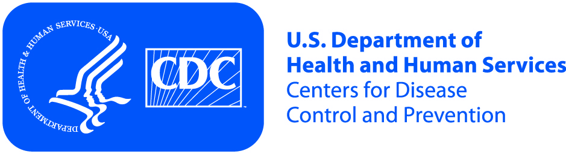
United States Department of Health and Human Services (HHS)
Centers for Disease Control and Prevention, Division of Cancer Prevention and Control (DCPC)

Purpose of the Project | You are invited to voluntarily participate in a focus group conducted by Oak Ridge Associated Universities (ORAU) for the U.S. Government Department of Health and Human Services (HHS) Centers for Disease Control and Prevention (CDC).  During the focus group, you will be asked questions about your awareness of a health issue that affects young women. You will be shown a series of educational materials about this issue and asked to share your opinions.

If you Agree to Participate Remember | - You choose to participate.  - Your focus group will be audio recorded.  - Members of the research team may be observing the group.  - You are not required to answer the questions.  - This session should last about 2 hours.  - You will receive an incentive for participating in the discussion.  - You are free to leave at any time without losing the incentive or other penalty.

Risks | The risks of taking part in the focus group are the same as you would face in daily life activities at home or work.

Benefits | - You may become better informed about a health issue.  - You may have a sense of satisfaction from contributing.  - Your comments may help improve the information given to young women and medical providers.

Confidentiality | We will keep the information you give us private to the extent allowed by law. Your name or image will not be used in the final report. No statement you make will be linked to you by name. Only members of the project staff will be allowed to look at the records. When we present this study, your name, image, or other facts that point to you will not show or be used.

Persons to Contact | If you have any questions about the project, you may call: Jennifer Reynolds, Oak Ridge Associated Universities (ORAU), 919-619-0403. If you have questions about your rights as a participant, you can contact: Oak Ridge Site-Wide Institutional Review Board, Oak Ridge Associated Universities, Oak Ridge, TN 37831-0117, 865-576-1725 or ORSIRB@orau.org.

