Attachment 6: Chimpanzee Research Use Form

This document presents the Chimpanzee Research Use Form in two ways.
Part 1 shows the screen shots from the CRU Reporting System
Part 2 provides the form in text only (for greater readability)

Part 1: Screen Shots from CRU Reporting System

First Screen After Login—Assignments
User sees assignments and clicks on CRU Report # (hotlink) to access the form. User submits one form per research application or proposal that involves use of chimpanzees or chimpanzee biomaterials.

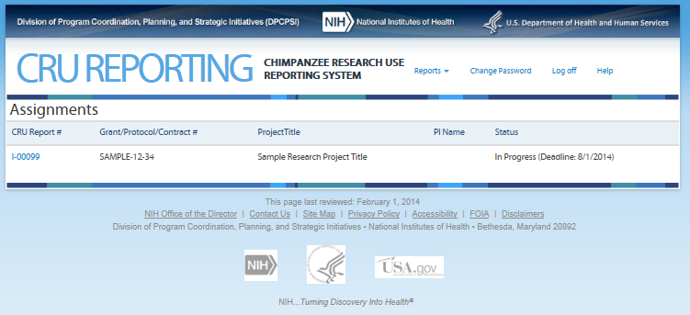

Second Screen—Initiate CRU Report
Information screen including Privacy Notice and Burden Disclosure Statement.
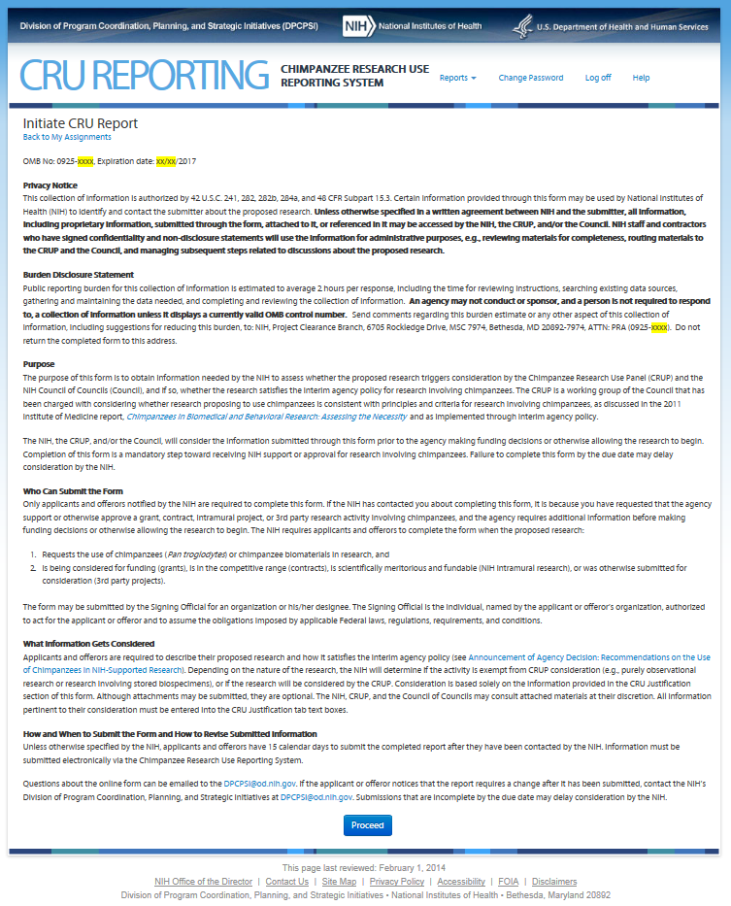
Third Screen—Project Information
For grant applicants (external to NIH), the information on this screen is pre-populated with information they submitted in the applicant’s grant application.
Note: On this screen the users see the icon that allows them to access additional information about the item. The text can be found in Attachment 8 CRU Report Guidance.
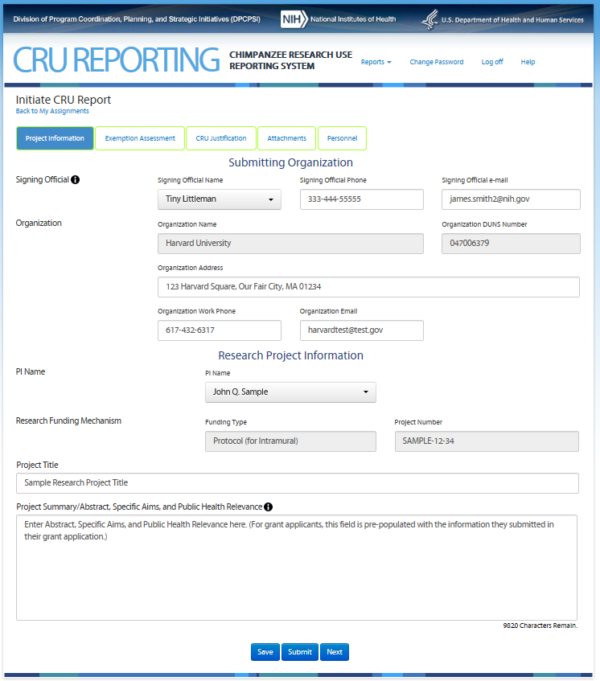
Fourth Screen—Exemption Assessment
This screen allows the user to assess whether his/her proposed research is exempt from consideration by the Chimpanzee Research Use Panel.
Note: On this screen the users see the icon that allows them to access additional information about the item. The text can be found in Attachment 8 CRU Report Guidance.
Option A Screen:
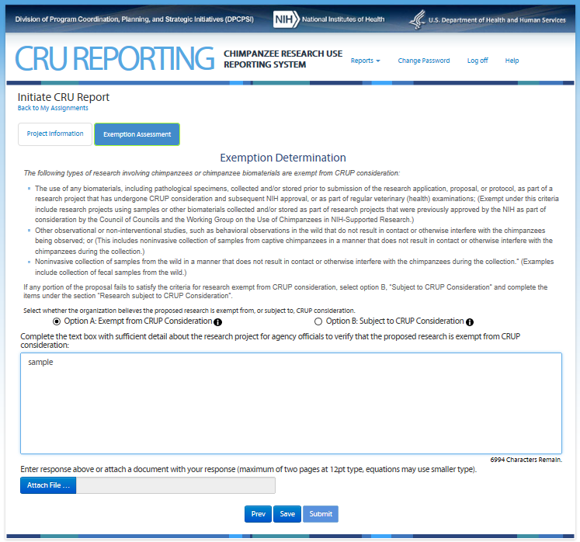

If Option A (above) is selected, user enters information in a text box and/or attaches file and may submit the materials. User is then brought to Screen Eight—Certifications and then the report is complete. If Option B (below) is selected, the user proceeds to screens Five through Eight to complete the form.

Option B Screen:
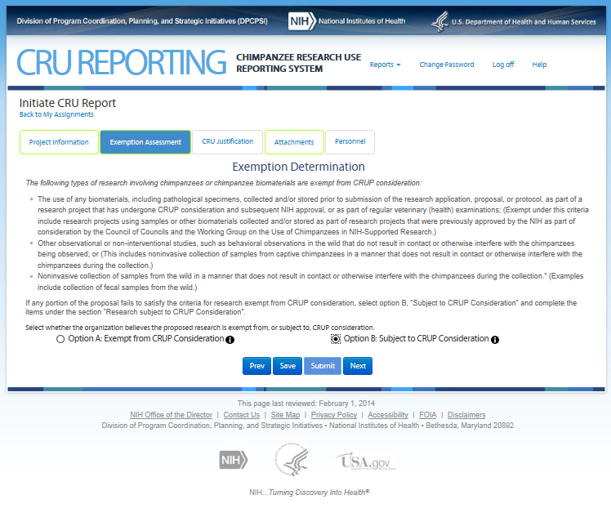

Fifth Screen—CRU Justification (top portion)
The Fifth Screen captures information to allow the Chimpanzee Research Use Panel to assess whether the proposed research is consistent with NIH interim policy on the use of chimpanzees.
Note: On this screen the users see the icon that allows them to access additional information about the item. The text can be found in Attachment 8 CRU Report Guidance.
Enumerated items 1 and 3 are available for entry only if “Humans” is selected. If “Chimpanzees” is selected an additional text box appears asking user to “Explain how the research is in the best interest of the chimpanzee and how it addresses the mission of the NIH.”
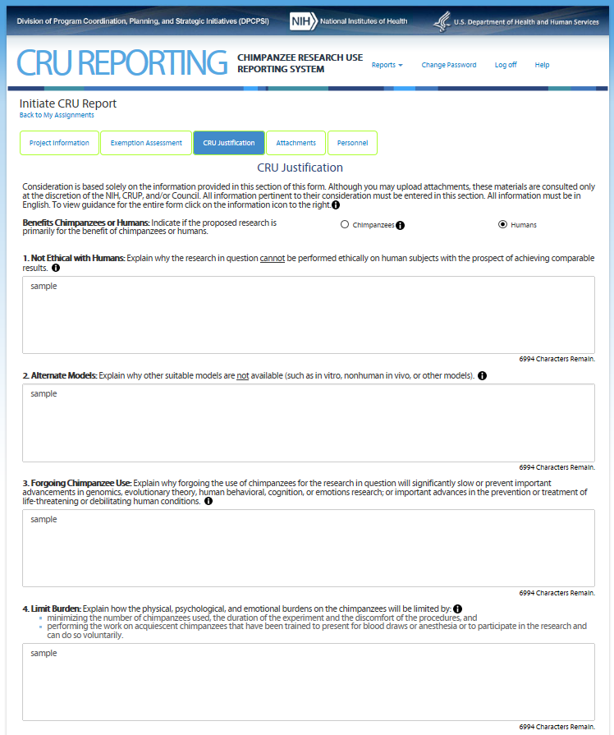
Fifth Screen—CRU Justification (continued)
Note: On this screen the users see the icon that allows them to access additional information about the item. The text can be found in Attachment 8 CRU Report Guidance.

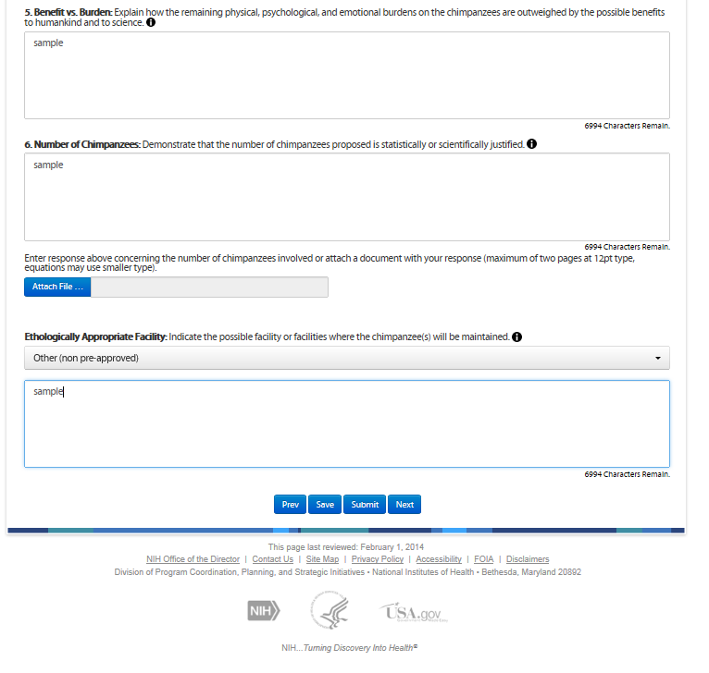

Sixth Screen—Attachments
The screen allows the user to attach supplemental information, e.g., images. Attachments are optional.
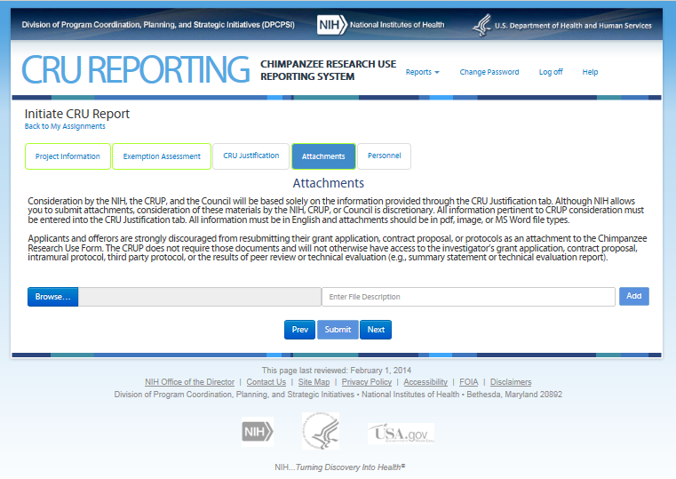

Seventh Screen—Personnel
This screen requires the user to provide information to NIH that will allow staff to avoid conflicts of interest when selecting members for the Chimpanzee Research Use Panel. Users may also upload a file (e.g., publications list) if preferred.
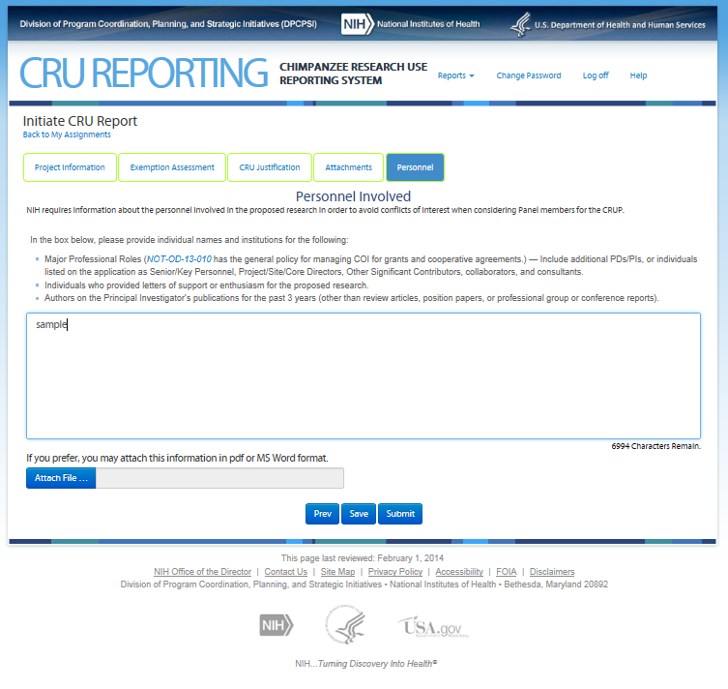

Eighth Screen—Certifications
Upon hitting “Submit” the Signing Official is presented with the following certifications.
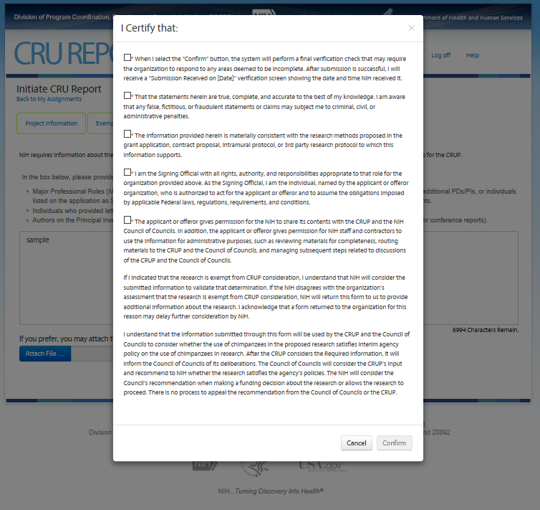

If a user other than the Signing Official submits the form, he/she is presented with only the first certification check box plus the last two paragraphs, and must attach the full certification text on agency letterhead signed by the Signing Official.
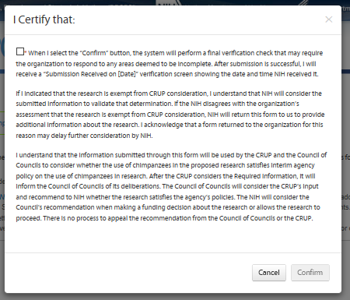
In this case, the “Sample SO Certification Letter” link and a required attach file tool labeled “Add Certification Letter…” will appear on the Project Information screen to allow the user to attach the signed certification letter.
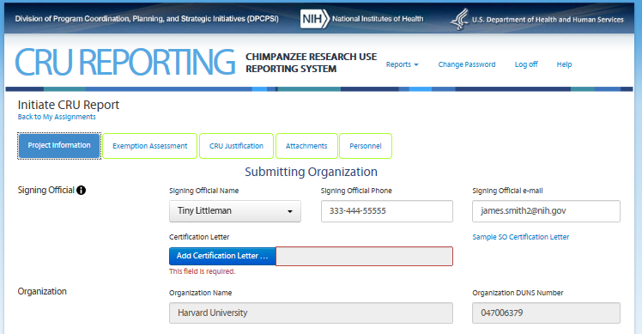
Part 2: Text from Screens
(provided for readability)

Black text contains notes for the reader of this document. Blue text is what is onscreen.

First Screen After Login—Assignments
User sees assignments and clicks on CRU Report # (hotlink) to access the form. Users see the following information for the research project(s) they have in the system.
CRU Report #, Grant/Protocol/Contract #, Project title, PI Name, Status (Deadline)

Second Screen—Initiate CRU Report
OMB No: 0925-xxxx, Expiration date: xx/xx/2017
Privacy Notice
This collection of information is authorized by 42 U.S.C. 241, 282, 282b, 284a, and 48 CFR Subpart 15.3. Certain information provided through this form may be used by the National Institutes of Health (NIH) to identify and contact the submitter about the proposed research. Unless otherwise specified in a written agreement between NIH and the submitter, all information, including proprietary information, submitted through the form, attached to it, or referenced in it may be accessed by the NIH, the CRUP, and/or the Council. NIH staff and contractors who have signed confidentiality and non-disclosure statements will use the information for administrative purposes, e.g., reviewing materials for completeness, routing materials to the CRUP and the Council, and managing subsequent steps related to discussions about the proposed research.
Burden Disclosure Statement
Public reporting burden for this collection of information is estimated to average 2 hours per response, including the time for reviewing instructions, searching existing data sources, gathering and maintaining the data needed, and completing and reviewing the collection of information. An agency may not conduct or sponsor, and a person is not required to respond to, a collection of information unless it displays a currently valid OMB control number. Send comments regarding this burden estimate or any other aspect of this collection of information, including suggestions for reducing this burden, to: NIH, Project Clearance Branch, 6705 Rockledge Drive, MSC 7974, Bethesda, MD 20892-7974, ATTN: PRA (0925-xxxx). Do not return the completed form to this address.

Purpose
The purpose of this form is to obtain information needed by the NIH to assess whether the proposed research triggers consideration by the Chimpanzee Research Use Panel (CRUP) and the NIH Council of Councils (Council), and if so, whether the research satisfies the interim agency policy for research involving chimpanzees. The CRUP is a working group of the Council that has been charged with considering whether research proposing to use chimpanzees is consistent with principles and criteria for research involving chimpanzees, as discussed in the 2011 Institute of Medicine report, Chimpanzees in Biomedical and Behavioral Research: Assessing the Necessity as implemented through interim agency policy.
The NIH, the CRUP, and/or the Council, will consider the information submitted through this form prior to the agency making funding decisions or otherwise allowing the research to begin. Completion of this form is a mandatory step toward receiving NIH support or approval for research involving chimpanzees. Failure to complete this form by the due date may delay consideration by the NIH.
Who Can Submit the Form
Only applicants and offerors notified by the NIH are required to complete this form. If the NIH has contacted you about completing this form, it is because you have requested that the agency support or otherwise approve a grant, contract, intramural project, or 3rd party research activity involving chimpanzees, and the agency requires additional information before making funding decisions or otherwise allowing the research to begin. The NIH requires applicants and offerors to complete the form when the proposed research:
- Requests the use of chimpanzees (Pan troglodytes) or chimpanzee biomaterials in research, and
- Is being considered for funding (grants), is in the competitive range (contracts), is scientifically meritorious and fundable (NIH intramural research), or was otherwise submitted for consideration (3rd party projects).
The form may be submitted by the Signing Official for an organization or his/her designee. The Signing Official is the individual, named by the applicant or offeror’s organization, authorized to act for the applicant or offeror and to assume the obligations imposed by applicable Federal laws, regulations, requirements, and conditions.
What Information Gets Considered
Applicants and offerors are required to describe their proposed research and how it satisfies the interim agency policy (see Announcement of Agency Decision: Recommendations on the Use of Chimpanzees in NIH-Supported Research). Depending on the nature of the research, the NIH will determine if the activity is exempt from CRUP consideration (e.g., purely observational research or research involving stored biospecimens), or if the research will be considered by the CRUP. Consideration is based solely on the information provided in the Required Information section of this form. Although attachments may be submitted, they are optional. The NIH, CRUP, and the Council of Councils may consult attached materials at their discretion. All information pertinent to their consideration must be entered into the CRU Justification tab text boxes.
How and When to Submit the Form and How to Revise Submitted Information
Unless otherwise specified by the NIH, applicants and offerors have 15 calendar days to submit the completed form after they have been contacted by the NIH. Information must be submitted electronically via the Chimpanzee Research Use Form.
Questions about the online form can be emailed to the DPCPSI@od.nih.gov. If the applicant or offeror notices that the completed form requires a change after it has been submitted, contact the NIH’s Division of Program Coordination, Planning, and Strategic Initiatives at DPCPSI@od.nih.gov. Submissions that are incomplete by the due date may delay consideration by the NIH.

Third Screen—Project Information
For grant applicants (external to NIH), the information on this screen is pre-populated with information they submitted in their grant application. Prepopulate fields are designated with underline.
Note: On this screen the users see the icon that allows them to access additional information about the item. The text can be found in Attachment 8 CRU Report Guidance.

Signing Official
Signing Official Name (dropdown) Signing Official Phone Signing Official e-mail
Organization
Organization Name Organization DUNS Number
Organization Address
Organization Work Phone Organization Email
PI Name
PI Name (dropdown)
Research Funding mechanism
Funding Type Project Number
Project Title

Project Summary/Abstract, Specific Aims, and Public Health Relevance (Limit 10,000 characters)

Fourth Screen—Exemption Determination
Note: On this screen the users see the icon that allows them to access additional information about the item. The text can be found in Attachment 8 CRU Report Guidance.
Exemption Determination
The following types of research involving chimpanzees or chimpanzee biomaterials are exempt from CRUP consideration:
- The use of any biomaterials, including pathological specimens, collected and/or stored prior to submission of the research application, proposal, or protocol, as part of a research project that has undergone CRUP consideration and subsequent NIH approval, or as part of regular veterinary (health) examinations; (Exempt under this criteria include research projects using samples or other biomaterials collected and/or stored as part of research projects that were previously approved by the NIH as part of consideration by the Council of Councils and the Working Group on the Use of Chimpanzees in NIH-Supported Research.)
- Other observational or non-interventional studies, such as behavioral observations in the wild that do not result in contact or otherwise interfere with the chimpanzees being observed; or (This includes noninvasive collection of samples from captive chimpanzees in a manner that does not result in contact or otherwise interfere with the chimpanzees during the collection.)
- Noninvasive collection of samples from the wild in a manner that does not result in contact or otherwise interfere with the chimpanzees during the collection.” (Examples include collection of fecal samples from the wild.)
If any portion of the proposal fails to satisfy the criteria for research exempt from CRUP consideration, select option B, “Subject to CRUP Consideration” and complete the items under the section “Research subject to CRUP Consideration”.
Select whether the organization believes the proposed research is exempt from, or subject to, CRUP consideration.
Option A: Exempt from CRUP Consideration Option B: Subject to CRUP Consideration

If Option A is selected, the following appears.
Complete the text box with sufficient detail about the research project to agency officials to verity that the proposed research is exempt from CRUP consideration.
[text box] (Limit 7,000 characters)
Enter response above or attach a document with your response (maximum of two pages at 12pt type, equations may use smaller type).
[attach file option]
User can then Submit and is then brought to Screen Eight—Certifications and then the report is complete. If Option B is selected, the user proceeds to Screen Five through Screen Eight to complete the form.
Fifth Screen—CRU Justification
Note: On this screen the users see the icon that allows them to access additional information about the item. The text can be found in Attachment 8 CRU Report Guidance.

Consideration is based solely on the information provided in this section of this form. Although you may upload attachments, these materials are consulted only at the discretion of the NIH, CRUP, and/or Council. All information pertinent to their consideration must be entered in this section. All information must be in English. To view guidance for the entire form click on the information icon to the right.
Benefits Chimpanzees or Humans: Indicate if the proposed research is primarily for the benefit of chimpanzees or humans.
Chimpanzees Humans

[Appears only if “Chimpanzees” selected above.]

Explain how the research is in the best interest of the chimpanzee and how it addresses the mission of the NIH.
[text box] (Limit 7,000 characters)

1. Not Ethical with Humans: Explain why the research in question cannot be performed ethically on human subjects with the prospect of achieving comparable results. (Available for entry if “Humans” selected above.)
[text box] (Limit 7,000 characters)

2. Alternate Models: Explain why other suitable models are not available (such as in vitro, nonhuman in vivo, or other models).
[text box] (Limit 7,000 characters)

3. Forgoing Chimpanzee Use: Explain why forgoing the use of chimpanzees for the research in question will significantly slow or prevent important advancements in genomics; evolutionary theory; human behavioral, cognition, or emotions research; or important advances in the prevention or treatment of life-threatening or debilitating human conditions. (Available for entry if “Humans” selected above.)
[text box] (Limit 7,000 characters)

4. Limit Burden: Explain how the physical, psychological, and emotional burdens on the chimpanzees will be limited by:
- minimizing the number of chimpanzees used, the duration of the experiment and the discomfort of the procedures, and
- performing the work on acquiescent chimpanzees that have been trained to present for blood draws or anesthesia or to participate in the research and can do so voluntarily.
[text box] (Limit 7,000 characters)

5. Benefit vs. Burden: Explain how the remaining physical, psychological, and emotional burdens on the chimpanzees are outweighed by the possible benefits to humankind and to science.
[text box] (Limit 7,000 characters)

6. Number of Chimpanzees: Demonstrate that the number of chimpanzees proposed is statistically or scientifically justified.
[text box] (Limit 7,000 characters)
Enter response above concerning the number of chimpanzees involved or attach a document with your response (maximum of two pages at 12pt type, equations may use smaller type.)
[attach file option]

Ethologically Appropriate Facility: Indicate the possible facility or facilities where the chimpanzee(s) will be maintained.
[Dropdown of pre-approved facilities. If “Other” is selected, user enters facility name, address, and contact information.]
[text box] (Limit 7,000 characters)

Sixth Screen—Attachments
Consideration by the NIH, the CRUP, and the Council will be based solely on the information provided through the CRU Justification tab. Although NIH allows you to submit attachments, consideration of these materials by the NIH, CRUP, or Council is discretionary. All information pertinent to CRUP consideration must be entered into the CRU Justification tab. All information must be in English and attachments should be in pdf, image, or MS Word file types.
Applicants and offerors are strongly discouraged from resubmitting their grant application, contract proposal, or protocols as an attachment to the Chimpanzee Research Use Form. The CRUP does not require those documents and will not otherwise have access to the investigator’s grant application, contract proposal, intramural protocol, third party protocol, or the results of peer review or technical evaluation (e.g., summary statement or technical evaluation report).
[attach file option]

Seventh Screen—Personnel
NIH requires information about the personnel involved in the proposed research in order to avoid conflicts of interest when considering Panel members for the CRUP.
In the box below, please provide individual names and institutions for the following:
- Major Professional Roles (NOT-OD-13-010 has the general policy for managing COI for grants and cooperative agreements.)—Include additional PDs/PIs, or individuals listed on the application as Senior/Key Personnel, Project/Site/Core Directors, Other Significant Contributors, collaborators, and consultants.
- Individuals who provided letters of support or enthusiasm for the proposed research.
- Authors on the Principal Investigator’s publications for the past 3 years (other than review articles, position papers, or professional group or conference reports).

[text box] (Limit 7,000 characters)

If you prefer, you may attach this information in pdf or MS Word format.
[attach file option]

Eighth Screen—Certifications
Upon hitting “Submit” the Signing Official (SO) is presented with the following certifications. User must check each box to confirm.
I certify that:
When I select the “Submit” button, the system will perform a final verification check that may require the organization to respond to any areas deemed to be incomplete. After submission is successful, I will receive a “Submission Received on [Date]” verification screen showing the date and time NIH received it.
That the statements herein are true, complete, and accurate to the best of my knowledge. I am aware that any false, fictitious, or fraudulent statements or claims may subject me to criminal, civil, or administrative penalties.
The information provided herein is materially consistent with the research methods proposed in the grant application, contract proposal, intramural protocol, or 3rd party research protocol to which this information supports.
I am the Signing Official with all rights, authority, and responsibilities appropriate to that role for the organization provided above. As the Signing Official, I am the individual, named by the applicant or offeror organization, who is authorized to act for the applicant or offeror and to assume the obligations imposed by applicable Federal laws, regulations, requirements, and conditions.
The applicant or offeror gives permission for the NIH to share its contents with the CRUP and the NIH Council of Councils. In addition, the applicant or offeror gives permission for NIH staff and contractors to use the information for administrative purposes, such as reviewing materials for completeness, routing materials to the CRUP and the Council of Councils, and managing subsequent steps related to discussions of the CRUP and the Council of Councils.
If I indicated that the research is exempt from CRUP consideration, I understand that NIH will consider the submitted information to validate that determination. If the NIH disagrees with the organization’s assessment that the research is exempt from CRUP consideration, NIH will return this form to us to provide additional information about the research. I acknowledge that a form returned to the organization for this reason may delay further consideration by NIH.
I understand that the information submitted through this form will be used by the CRUP and the Council of Councils to consider whether the use of chimpanzees in the proposed research satisfies interim agency policy on the use of chimpanzees in research. After the CRUP considers the Required Information, it will inform the Council of Councils of its deliberations. The Council of Councils will consider the CRUP’s input and recommend to NIH whether the research satisfies the agency’s policies. The NIH will consider the Council’s recommendation when making a funding decision about the research or allows the research to proceed. There is no process to appeal the recommendation from the Council of Councils or the CRUP.
If a user other than the Signing Official submits the form, he/she is presented with only the first certification check box plus the last two paragraphs and must attach the full certification text on agency letterhead signed by the Signing Official. In this case, the “Sample SO Certification Letter” link and a required attach file tool labeled “Add Certification Letter…” will appear on the Project Information screen to allow the user to attach the signed certification letter.

