

Development Services Group, Inc.

Institutional Review Board

TO: Marcia Cohen
Principal Investigator

FROM: Judith L. Pokorni, Ph.D.
Institutional Research Board Chair

TITLE: Exemption of the Survey of Current and Former Fellows of the SAMHSA Minority Fellowship Program (MFP)

DATE: April 6, 2014

I have reviewed the survey of current and former fellows of the SAMHSA MFP and, on behalf of the Development Services Group, Inc. Institutional Review Board (DSG IRB #IORG0002047, IRB00002564), deem this project exempt.

No further review of this project by the IRB is necessary unless changes are made to the survey protocol that may increase risk to human subjects.

If you have any questions, please do not hesitate to contact me.

Regards,

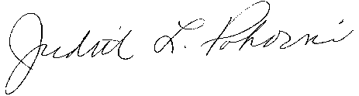

Judith L. Pokorni, Ph.D.
Chair

