OMB Control Number: 1024-0224
Expiration Date: 8/31/2014
One Health Messaging Survey about Bats and Rabies

Interviewer Script
“Hello, I am _________________ and I am conducting a survey for the National Parks Service. This survey will help us to better understand how to communicate with visitors about bats. Your participation in the study is voluntary, and all your responses will be kept anonymous. This study has been approved by the Office of Management and Budget as well as our University’s Institutional Review Board. It will take about 15 minutes to complete. You will not be asked to provide your name or address. Your responses are voluntary will remain anonymous. Would you be willing to complete the questionnaire using this iPad? If not, we have a paper version with the same question for your convenience.

Before we start, are you at least 18 years old?

The interviewer will check the boxes below to indicate that the respondent is at least 18 years old or older and understands the Paperwork Reduction Act Statement below.

The respondent is at least 18 years old or older
The respondent understands the Paperwork Reduction Act Statement

The interviewer will ask: “Has any member of your group been asked to participate in this survey before today?”

If “YES” (already asked to participate) then, “Thank you for agreeing to participate in this study. Have a great day.”
If “NO” (have not been previously asked to participate but agreed to take the survey) the interviewer will say “Please feel free to ask me any questions you may have, once you are done you can return the complete survey instrument to me. Thanks”.

If the visitor refuses to complete the survey– (soft refusal) – The surveyor will ask if they would be willing to answer the two non-response bias questions (listed below) and then thank them for their time. [The surveyor will record responses on a tracking sheet].

If NO– (hard refusal) - end the contact and thank them for their time
.
Paperwork Reduction and Privacy Act Statements: The National Park Service is authorized by 16 U.S.C. 1a-7 to collect this information. We will use this information to learn more about how people think about messages regarding the management of bats. Your response is voluntary and anonymous. Your name will never be associated with your responses. You may quit at any time by simply closing the web browser A Federal agency may not conduct or sponsor, and you are not required to respond to, a collection of information unless it displays a currently valid OMB Control Number.
BURDEN ESTIMATE Statement: Public reporting burden for this collection is estimated to be 15 minutes per respondent to complete this process. Please direct comments regarding any other aspect of this collection to Professor Katherine McComas at (kam19@cornell.edu) email; or Phadrea Ponds, NPS Information Collections Coordinator, at pponds@nps.gov (email).
IRB and Human Right Statement: Cornell University requires that we obtain your consent to complete this survey. If you have any questions or concerns regarding your rights as a subject in this study, you may contact the Cornell Institutional Review Board (IRB) at 607-255-5138 (phone) or http://www.irb.cornell.edu (website). You may also report your concerns or complaints anonymously through Ethicspoint’s website (www.ethicspoint.com) or by calling toll free at 1-866-293-3077. Ethicspoint is an independent organization that serves as a liaison between the University and the person bringing the complaint so that anonymity can be ensured.

NOTE TO OMB REVIEWER:
For the purposes of this review and submission the questions in this survey are all included and are consistent with the currently approved pool questions for the NPS Programmatic Review Process (1024-0224 – Current Expiration Date: 8-31-2014).

This questionnaire will be administered on-site by interviewers using computer tablet to administer the questionnaires. Only one questionnaire per group will be collected. This is an effort to limit the individual respondent burden

Once the respondent consents to participate in the survey, one of eight prepared messages (see appendix for Messages 2-8) will be randomly selected and presented by the survey software. The respondent will read the message and then answer the questions that follow. If the respondent receives the “no message” treatment (or Message #9), that respondent will start the survey without reading a message.

Thank you for helping us with this study. The National Park Service is interested in understanding how people respond to publications that are used to communicate information about bats. Your responses will help us to design better publications. Below is a short message about bats. We would like for you to read the message before answering the questions that follow.

Message #1

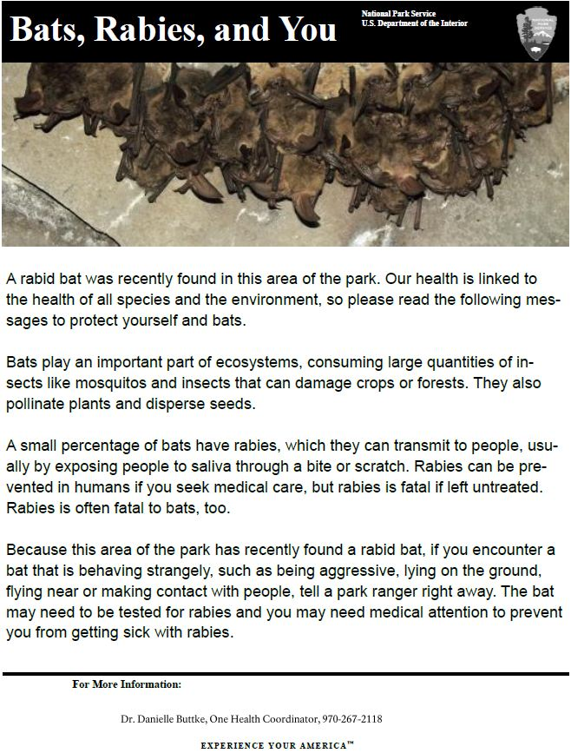

TOPIC AREA 4: TpB1

1. How likely are you to engage in the following actions related to bats in the next year?

 | Very Unlikely | Unlikely | Neutral | Likely | Very Likely
Construct homes for bats at my residence.
Allow bats to use the outside of my residence.
Seek out more information about bats.
Talk to others about bats.
Join or support a bat conservation group.
Avoid going places where I might see bats.

2. How likely are you to engage in the following behaviors in the next year?

 | Very Unlikely | Unlikely | Neutral | Likely | Very Likely
Volunteer to reduce my use of a favorite spot in a park or natural area if it needs to recover from environmental damage
Participate in a public meeting about managing a park or natural area
Write letters in support of a park or natural area
Volunteer my time to projects that help a park or natural area

3: How likely are you to engage in the following behaviors if you encountered a bat behaving strangely in the park, such as lying on the ground or flying in the middle of the day?

 | Very Unlikely | Unlikely | Neutral | Likely | Very Likely
Approach the bat
Tell a park ranger
Try to catch the bat
Leave the area
Move the bat

4. Please tell us how you feel about wildlife, in general?

 | Strongly Agree | Agree | Neutral | Disagree | Strongly Disagree
All animals have a right to live.
As humans, we have a moral obligation to ensure that we do not cause the extinction of other species.
The Earth's fragile ecosystems can be disrupted by very small changes in the balance of species.
Losing one species will have far-reaching effects on the ecosystem as a whole.
The Earth's remaining ecosystems should be conserved at all costs.
Plants and animals exist primarily to be used by humans.
Every species has equal value and an equal right to exist.

NEW QUESTION: This question will be used to measure risk perceptions.

5 Would you agree or disagree that the risks that bats pose to humans are:

 | Strongly Agree | Agree | Neutral | Disagree | Strongly Disagree
Controllable
Immediate
Known to science
Increasing
Avoidable
Visible
Dreadful

6. Do you agree or disagree that bats are:

 | Strongly Agree | Agree | Neutral | Disagree | Strongly Disagree
Attractive
Vulnerable
Worthless
Common
Harmless
Native
Frightening

TOPIC AREA 1: KNOW 9

7. Prior to this visit, were you aware that some bats carry rabies?
Not aware
Somewhat aware
Very aware

8. Have you ever seen a rabid bat?
Yes
No
I'm not sure

TOPIC AREA 3: LEARN9
Questions 9-12 will not be included in the control “no message” condition.

9. Recalling the message you read, was a rabid bat recently found in this area of the park?
Yes
No

10: Recalling the message you read, do bats consume large quantities of insects?
Yes
No

11. Recalling the message you read, does bat behavior contribute to the spread of rabies?
Yes
No

TOPIC AREA 6: EVALSERV21

12: What did you think about the message you read at the beginning of the survey?

 | Strongly Agree | Agree | Neutral | Disagree | Strongly Disagree
The message I read was clear.
The message I read was informative.
This message I read was persuasive.

TOPIC AREA 1: GEND1

13: Are you male or female?
Male
Female

TOPIC AREA 1: AGE3

14: What is your age (in years)?

TOPIC AREA 1: ED2

15: What is the highest level of school you have completed?
Grade 8 or lower
Some high school, no diploma
High school diploma or equivalent
Some college, no degree
Associate degree
Bachelor's degree
Master's degree
Professional degree
Doctorate degree

TOPIC AREA 1: ECON1

16. Which category best represents your annual household income? Please mark only one.
Less than $24,999
$25,000 to $34,999
$35,000 to $49,999
$50,000 to $74,999
$75,000 to $99,999
$100,000 to $149,999
$150,000 to $199,999
$200,000 or more

TOPIC AREA 1: RACE/ETH2

17. Are you Hispanic or Latino?
No
Yes

TOPIC AREA 1: RACE/ETH4

18. What race do you consider yourself?
American Indian or Alaska Native
Asian
Black or African-American
Native Hawaiian or other Pacific Islander
White

TOPIC AREA 1: LANG2

19. What language is most frequently spoken in your home?
English
Other

TOPIC AREA 1: VISITHIS1

20: Have you visited an NPS site before today?
Yes
No

TOPIC AREA 1: VISITHIS1

21. If yes, how many times have you visited an NPS site in the past year?
0nce
2-5 times
6-10 times
More than 10 times

TOPIC AREA 1: PKQ FVIS1

22. How likely are you to visit an NPS site in the future?
Very unlikely
Unlikely
Neutral
Likely
Very likely

TOPIC AREA 1: GR1

23. On this visit, what kind of personal group (not guided tour/school group) are you with?
Alone
Family
Friends
Family and friends
Others (please specify) ______________________________________________

Thank you for participation in this study.

Message #2
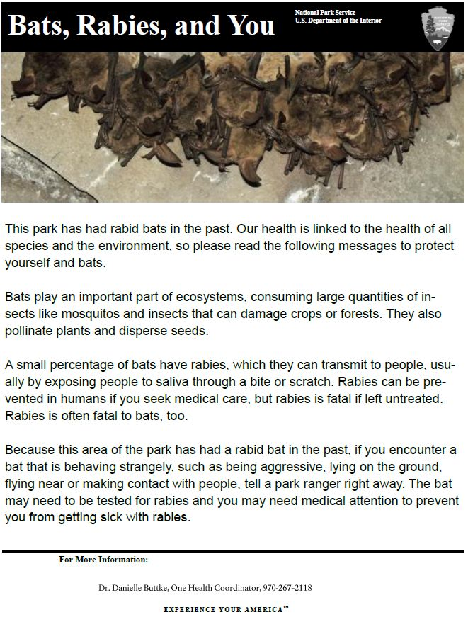

Message 3

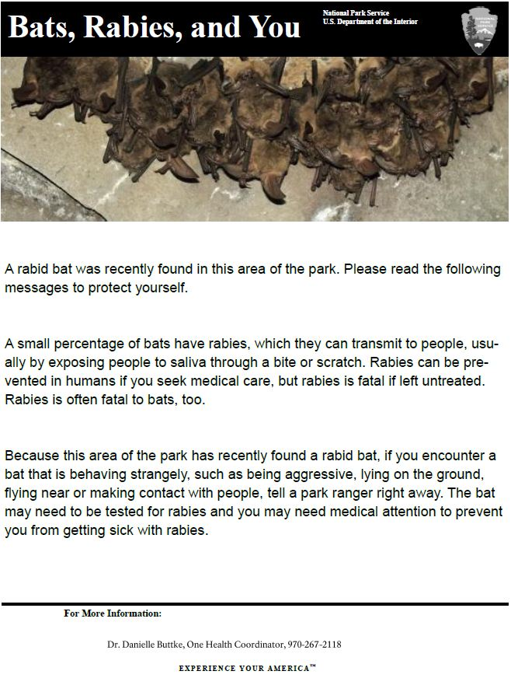

Message 4
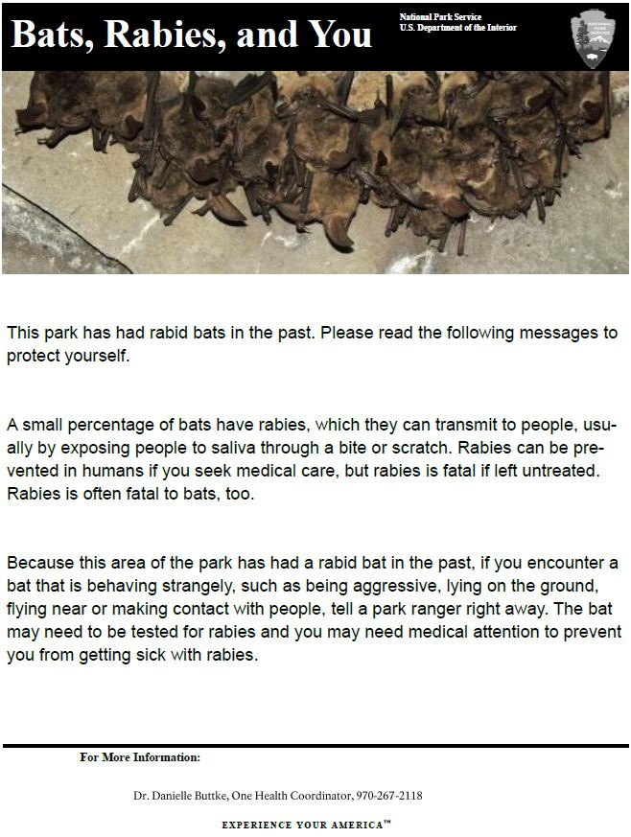

Message 5
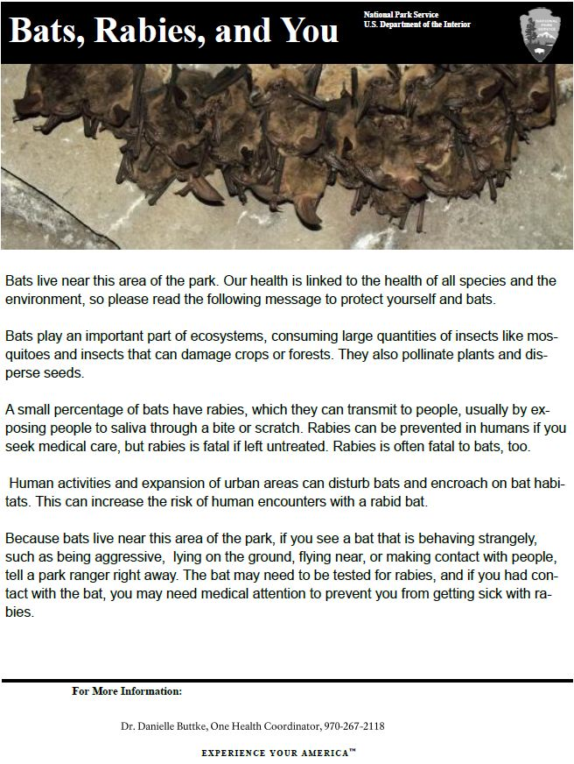

Message 6
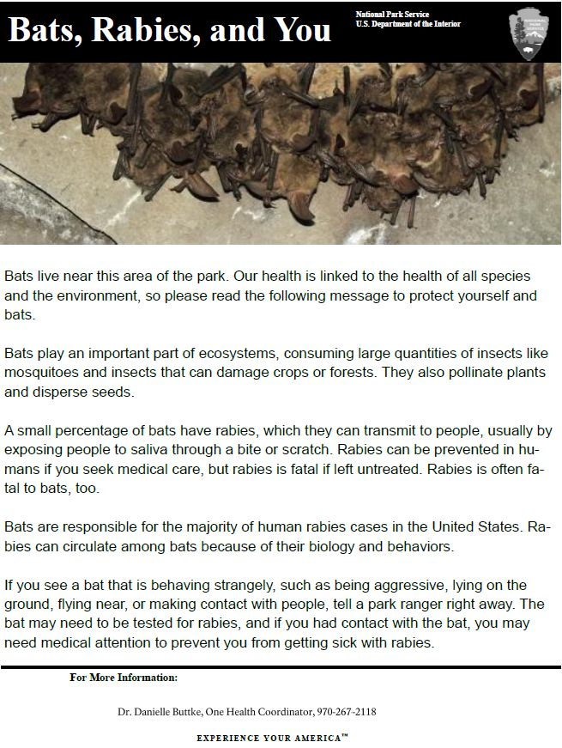

Message 7
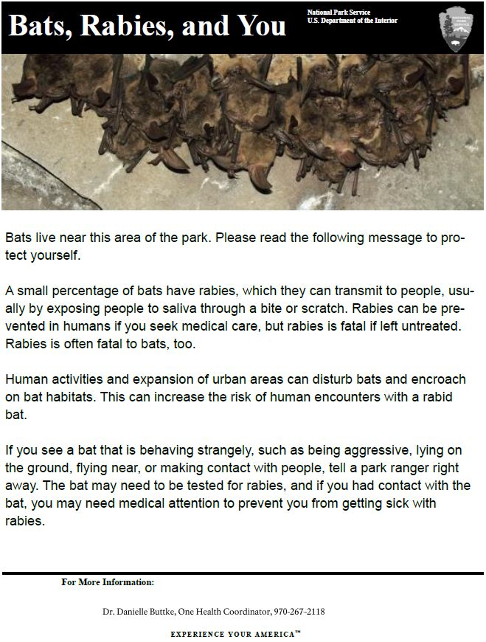

Message 8

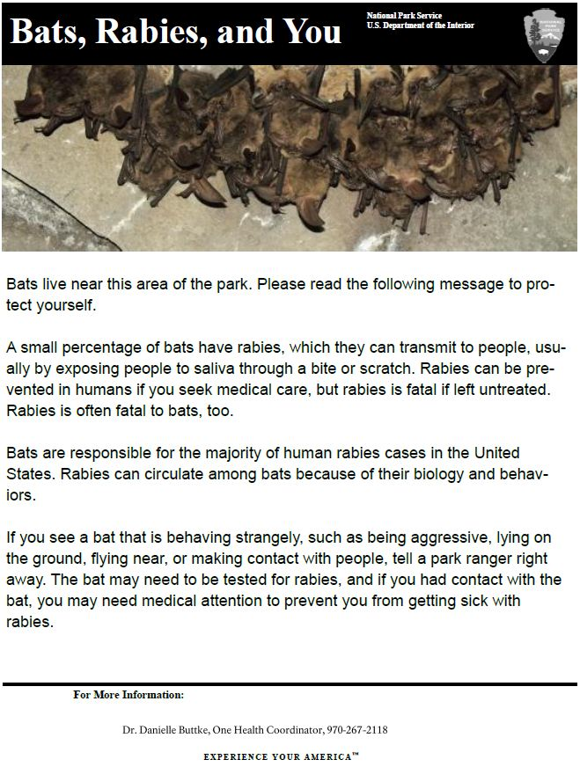

Message 9

No message – control group: Respondents will advance straight to instructions.

