**OMB Control Number 1024-0224**

**Current Expiration Date: 8-31-2014**

**An Assessment of Public Engagement at Fort McHenry, Boston, and**

**Boston Harbor Islands National Park Sites**

Interview Protocol and Script

**INTRODUCTION**

*Hi, I am from _______________________ (University) and we are conducting this study for the National Park Service. This study has been approved by the Office of Management and Budget as well as our University’s Institutional Review Board. It will take about 30 minutes to complete the full interview. You will not be asked to provide your name or address. Your responses are voluntary will remain anonymous*.

If the visitor says **YES** – the interviewer will continue by asking the visitor to read the Paper work Reduction and Privacy Act Statement (below) and sign the informed consent form (required by the University).

*Thank you for agreeing to participate in this study. Our purpose today is to understand visitor’s onsite experiences, and how they use some of features and services offered here at the park. Can we get started?*

🡺If the visitor says **NO -** the interviewer will continue by asking the visitor if they would be willing to answer the non-response bias survey. *Okay. Then would you be willing to answer two questions that will help us to understand the visitors who spent time at the park today?*

🡺If the visitor says **YES** (to answering the nonresponse survey questions)the interviewer will continue by recording gender, group composition and reason for refusal and end asking the following questions:

1. Is this your first time visiting this site?
2. Where are you from (state)

*“Thank you for your time today*.”

🡺If the visitor says **NO** (to answer the nonresponse survey questions)the interviewer will thank them for their consideration.

**PAPERWORK REDUCTION and PRIVACY ACT STATEMENTS:** The National Park Service is authorized by 16 U.S.C. 1a-7 to collect this information. This information will be used by park managers to better understand visitor engagement at Fort McHenry, Boston, and Boston Harbor Islands National Park Sites. Your response to this request is voluntary. The data collected will remain anonymous and there will be no way to connect you to the responses you provide. No action may be taken against you for refusing to supply the information requested. According to the Paperwork Reduction Act a federal agency may not conduct or sponsor, and a person is not required to respond to, a collection of information unless it displays a currently valid OMB number.

**BURDEN ESTIMATE STATEMENT:** The public reporting time for this collection averages 30 minutes per response. Please direct comments regarding the burden estimate or any other aspect for this collection to Theresa Coble, Associate Professor, at [tcoble@sfasu.edu](mailto:tcoble@sfasu.edu) (email), or Phadrea Ponds, NPS Information Collections Coordinator, at [pponds@nps.gov](mailto:pponds@nps.gov) (email).

**Interview Questions**

**Section 1 –** In this section we will ask the visitor about the characteristics of their visit (e.g., planning visitation history, importance of the site, etc.)

*I would like to start by asking why you visited this site today?*

**Probe 1**: *Have you visited this site before?*

*If yes, how many times have you visited this site before today?*

**Probe 2:** *How important is this site to you? Why?*

**Probe 3:**  *Looking at this diagram, which one these categories best represents you as a visitor here today. What is your connection to this site?*

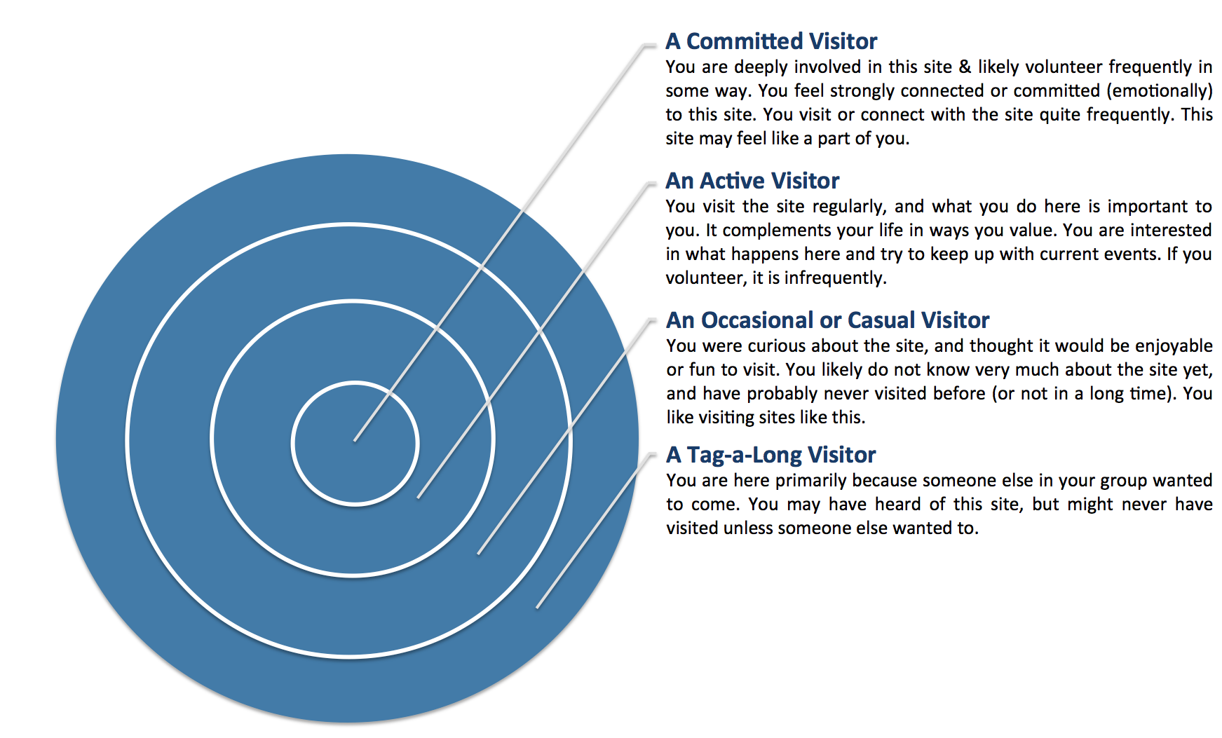

**Probe 4:** *Did you do any pre-visit planning for this trip?*

**Probe 5:** *How did you figure out where to go and what to do once you arrived at the park today?*

**Probe 6:** *Did you find anything onsite to be personally relevant to you? Which things were most relevant? Why****?***

**Section 2** - In this section we will be asking the respondent to tell us about their preferences using a 4-square learning grid that we developed to assist respondents in identifying their preferences.

*Please take a moment to reflect on how you like to learn. We are interested in knowing how to create the best situations where people can have an enjoyable learning experience. Looking at these categories can you tell me which two best describes your learning style?* [The interviewer will show respondent the 4-quadrant learning preferences grid below. The statements can be used to help explain each quadrant if necessary.]

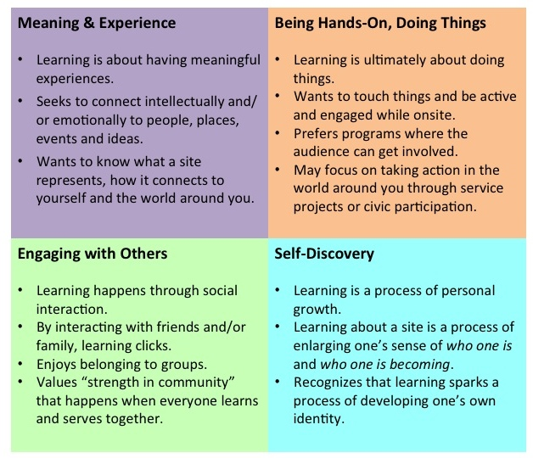

**Section 3** - The responses in this section will help managers understand how respondents engage in the meaning making process and the range of beneficial onsite experiences respondents attain.

*Now I am going to ask you about some of your experiences while visiting [this site].*

***Probe 1:*** *Can you tell me about some of the meaningful experiences you’ve had today?*

***Probe 2:*** *Was there any point where you understood something better or thought about something differently about what you saw or learned today?*

***Probe 3:*** *Did you experience any moments filled with awe, gratitude, sadness, regret or any other emotion?*

***Probe 4:*** *How important was it for you to be able to engage intellectually and/or emotionally with the meanings of this site?*

*Next I am going to show you a set of photographs and I am going to ask you to select three pictures that have the most significant meaning to you or that significantly influenced you during your visit. (The interviewer will pick one of the three photos selected and continue the questioning. [The interviewer will repeat the questions below for Photos 2 and 3]*

Below are examples of the types of pictures that may be uses during interviews:

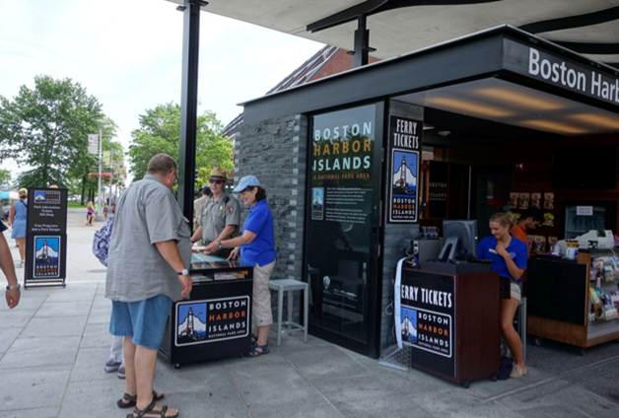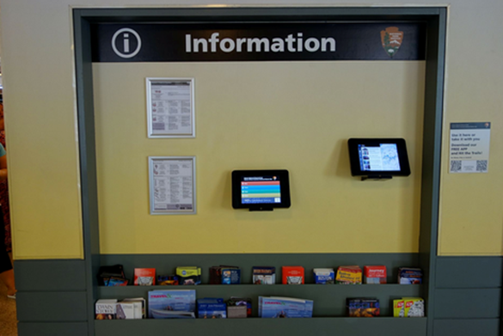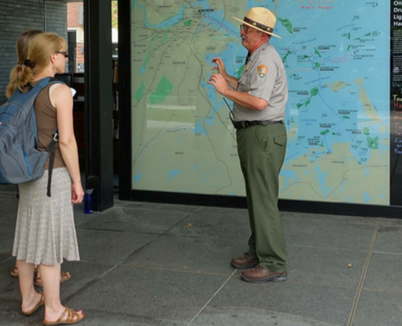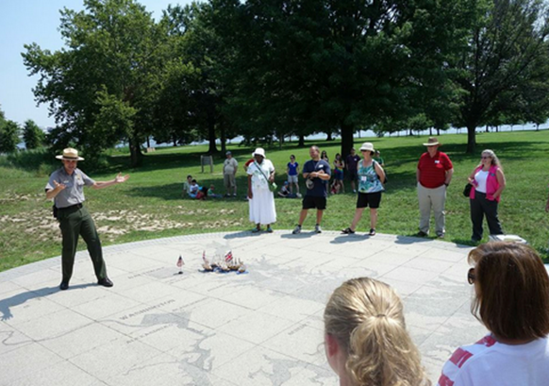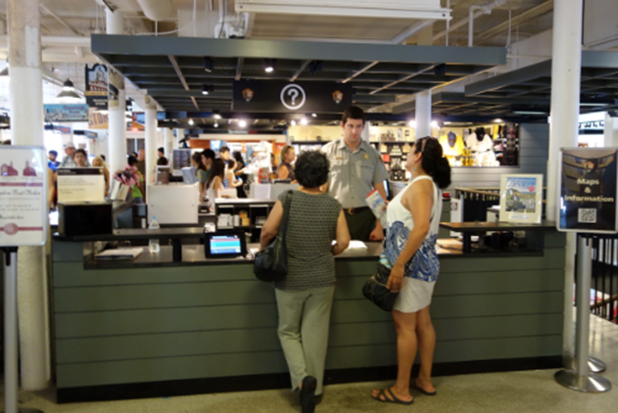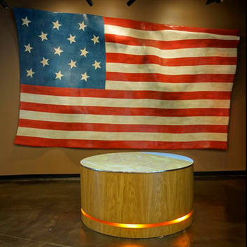

|  |
| --- |
| * Please tell me how this feature [or service] influenced your experience by making it more or less meaningful? * Why was [that meaningful experience] important to you?   ***Probe 1:*** *Please tell me what significant meaning does this picture hold for you – either positively or negatively.*  ***Probe 2****: Why do you value [that meaningful experience]?*  ***Probe 3:*** *What would your experience have been like if [that meaningful experience] was absent?*  ***Probe 4****: Why do you think other people might value [that meaningful experience]?*  ***Probe 5****: Why is [that meaningful experience] special or significant?*  ***Probe 6:*** *What draws you to [that kind of meaningful experience]?*  **Section 4-** The responses in this section will help managers understand how respondents engage in hands-on learning, resource immersion, citizen engagement, and other onsite activities, while also documenting the range of respondents’ activity involvement.  *Now I am going to ask you about some of the activities you engaged in while visiting [this site].*  **Probe 1:** Please tell me about some of the hands-on or active experiences you had onsite.  **Probe 2:** Are there activities that you would have liked to do‒*or do more of*‒at this park? Why?  **Probe 3:** Did the site help you learn skills or prepare you to be more involved in the world around you?  **Probe 4**: How important is it to you to be “hands on” and to engage actively while onsite? Why is this important to you?  *Next I am going to show you a set of photographs and I am going to ask you to select three pictures that influenced how much active engagement you were able to have at this site.* (Using the same set of pictures used in section 3 above, *the interviewer will pick one of the three photos selected and continue the questioning.*)  • How did [this feature or service] influence your experience by making it more or less hands-on and active?  • Why was [that hands-on/active experience] important to you?  **Probe 1**: Why do you value [that hands-on/active experience]?  **Probe 2**: What would your experience have been like if [that hands-on/active experience] was absent?  **Probe 3:** Why do you think other people might value [that hands-on/active experience]?  **Probe 4:** Why is [that hands-on/active experience] special or significant?  **Probe 5**: What draws you to [that kind of hands-on/active experience]? |
| **Section 5 -**The responses in this section will help managers understand how onsite features and services facilitated the respondent’s sense of belonging and/or how connecting with others onsite fostered a deeper sense of community.  *Now I am going to ask you about some of the activities you engaged in while visiting [this site].*  **Probe 1:** Please tell me about some of the ways you experienced self-discovery while onsite.  **Probe 2:** Was there anything at this site that resonated with who you are? Was there anything that reinforced your self-image? Was there anything that caused you to challenge or re-think your self-image?  **Probe 3:** Did this site line up with your view of the world? How so?  **Probe 4:** How important is it to you to affirm your identity or engage in self-discovery while onsite? Why is this important to you?  Next I am going to show you a set of photographs and I am going to ask you to select three pictures that influenced your ability to experience self-discovery at this site. ((Using the same set of pictures used in section 3 above, *the interviewer will pick one of the three photos selected and continue the questioning.*)  • How did [this feature or service] influence your experience by promoting or hindering self-discovery  • Why was [that self-discovery experience] important to you?  **Probe 1:** Why do you value [self-discovery experiences]?  **Probe 2:** What would your experience have been like if [that self-discovery experience] was absent?  **Probe 3:** Why do you think other people might value [that self-discovery experience]?  **Probe 4:** Why is [that self-discovery experience] special or significant?  **Probe 5:** What draws you to [that kind of self-discovery experience]?  **Section 6 -**The responses in this section will help managers understand how onsite features and services facilitated the respondent’s sense of belonging and/or how connecting with others onsite fostered a deeper sense of community.  *Now I am going to ask you about some of the activities you engaged in while visiting [this site].*  **Probe 1:** Did the site help you feel a sense of belonging? If so, what did you feel a part of?  **Probe 2:** Please tell me about some of the ways you connected with others while onsite.  **Probe 3:** Who did you visit with today?  **Probe 4:** Did you get into any discussions about this site with members of your group? What did you talk about? How did those interactions influence your experience onsite?  **Probe 5:** Did the space encourage you to interact with other people? How so?  **Probe 6:** When you think about community, how do you define it?  **Probe 7:** In what ways, and to what extent, did the site help you connect with community? Or hinder you?  **Probe 8:**  How important is it to you that parks foster a sense of community? Why?  **Probe 9:** How important is connecting with others while onsite? Why is this important to you?  *Next I am going to show you a set of photographs and I am going to ask you to select three pictures that influenced how much you were able to connect with others at this site. (Using the same set of pictures used in section 3 above, the interviewer will pick one of the three photos selected and continue the questioning.)*   * How did [this feature or service] influence your experience by making it easier or harder to connect with others? * Why was [that experience of connecting with others] important to you?   **Probe 1**: Why do you value [connecting with others]?  **Probe 2**: What would your experience have been like if [connecting with others] was absent?  **Probe 3:** Why do you think other people might value [connecting with others]?  **Probe 4**: Why is [connecting with others] special or significant?  **Probe 5:** What draws you to [places where you can connect with others.  **Section 6**  *I would like to conclude by asking you a few additional questions about how you prefer to receive information while vising the park.*  **Probe 1:** You selected the following learning preferences (provide listing). Of the two, which one is most important to you? Are any of the ones you didn’t select also important to you? Why?  **Probe 2:** Did you use any hand-held devices like smartphones or tablets while onsite? Which ones?  **Probe 3**: What did you use them for?  **Probe 4:** How important is it to you to use them while onsite? Why?  **Probe 5:** Was there anything about the site that made you feel uncomfortable or unwelcome?  **Probe 6:** On a scale of 1 to 5, with 1 being “did not match at all” and 5 being “matched completely,” how well did your onsite experiences match how you prefer to experience a site? |

*Thanks for your participation in the interview. Now I would like to ask you to take less than one minute to tell us a little about yourself. This will help the park understand more about the types of visitors we interviewed for this study. Thank you.*

**Section 7** – Demographic Questions

Topic Area 1 – GEND

1. What is your gender?  (Please check one.)

* Male
* Female

Topic Area 1 – AGE

1. What is your age? (Check one.)

□ Under 18 □ 45-54

□ 18-24 □ 55-64

□ 25-34 □ 65-74

□ 35-44 □ 75- and over

Topic Area 1 – ED

1. What is the highest grade of school or year of college that you completed?  (Please check one.)

* Less than high school
* High school graduate or GED
* Some college or associate degree
* Four year college degree
* Masters, doctoral, or professional degree

Topic Area 1 – RES

1. Are you a permanent resident or citizen of the U.S.?

* No ―  What is your country of origin? ________________________
* Yes ― What is your zip code and state of residence?

Zip Code _____________________________

State     _____________________________

Topic Area 1 – GR1

5. a. Which of the following best describes your personal group you are traveling with?  (Please check one.)

* + Alone
  + Family
  + Friends
  + Family and Friends
  + Other (Please specify) ____________________________________

[Topic Area 1 – GR (variation)

b. Are there any children under age 18 in your group?

* + No
  + Yes ― How many children are in each of these age categories?

______ Number of children under 5 years old.

______ Number of children age 5-12

______ Number of children age 13-17