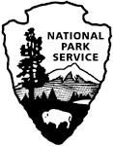**Social Science Program National Park Service**

**U.S. Department of the Interior Visitor Services Project**

**Yosemite National Park**

**Visitor Study**

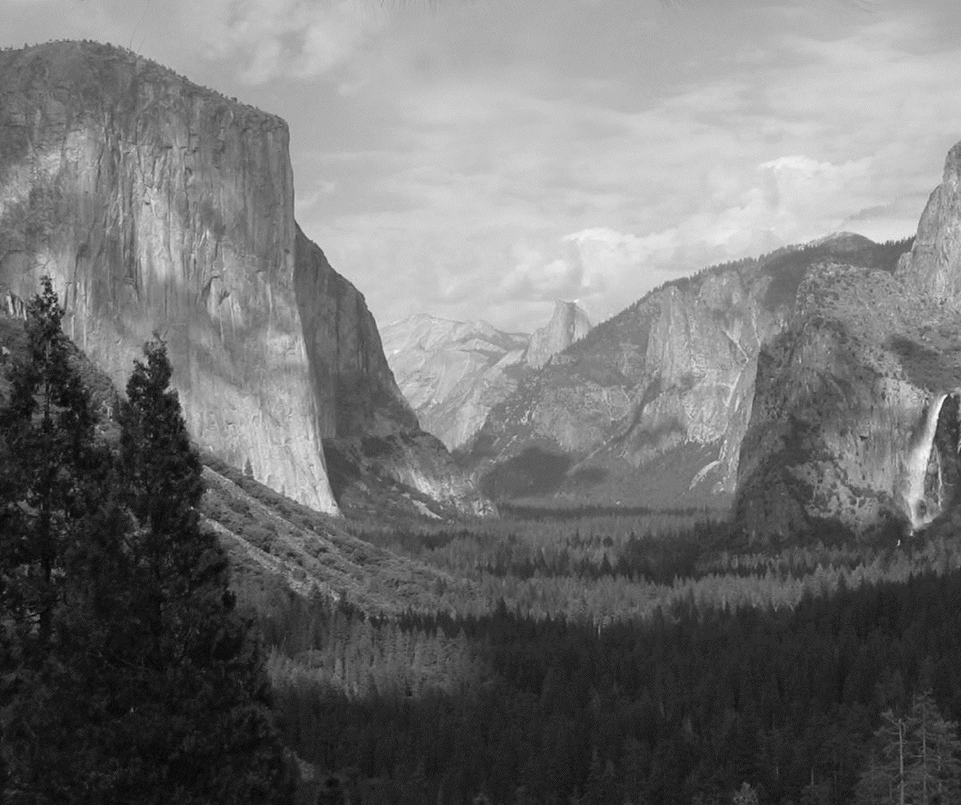

**2015**

Yosemite National Park Visitor Study 2

OMB Approval 1024-0224 (NPS# )

Expiration date:

# United States Department of the Interior

**NATIONAL PARK SERVICE**

Yosemite National Park

P.O. Box 700

El Portal, CA 95318

June 2015

Dear Visitor:

Thank you for participating in this important study. We want to learn about the expectations, opinions, and interests of visitors to Yosemite National Park. This information will help us improve our management of this park and better serve you, our visitor.

This questionnaire will be given to only a select number of visitors, so your participation is very important! It should only take about 20 minutes to complete after your visit.

When your visit is over, please complete the questionnaire. Seal it with the stickers provided on the last page and drop it in any U.S. mailbox.

If you have any questions, please contact Social Science Program Chief, National Park Service, 1201 Oakridge Drive, Fort Collins, CO, 80525-5596; nps_nrss_social_science@nps.gov (email).

We appreciate your help. Sincerely,

Don Neubacher Superintendent

|  |
| --- |
| **DIRECTIONS**  At the end of your visit:  1. Please have the adult in your group (at least 18 years old) who has the next birthday complete this questionnaire. That will help give us a statistically reliable sample.  2. For questions that use circles (O), please mark your answer by filling in the circle with ***black or blue ink***. Please do not use pencil.  Description: bubble-fill-example  4. Seal it in the postage-paid envelope provided.  5. Drop it in a U.S. Postal mailbox. |

|  |
| --- |
| **Paperwork Reduction and Privacy Act Statements:** The Paperwork Reduction Act requires us to tell you why we are collecting this information, how we will use it, and whether or not you have to respond. This information will be used by the National Park Service as authorized by *16 USC 5931 §201*. We will use this information to evaluate visitor services and facilities managed by Yosemite National Park. Your responses are voluntary and anonymous. Your name and address have been requested for follow-up purposes only. At the completion of this collection all names and personal information will be destroyed and in no way be connected with the results of this survey. A Federal agency may not conduct or sponsor and you are not required to respond to, a collection of information unless it displays a currently valid OMB Control Number.  **Burden Estimate:** We estimate that it will take an average of 20 minutes to complete the survey associated with this collection of information. You may send comments concerning the burden estimates or any aspect of this information collection to the Social Science Program Chief, National Park Service, 1201 Oakridge Drive, Fort Collins, CO, 80525-5596; nps_nrss_social_science@nps.gov (email). |

**SPECIAL INSTRUCTIONS**

**Personal group -** anyone that you are visiting the park with, such as spouse, family, friends, etc. This does not include a larger group that you might be traveling with, such as school, church, scouts, or tour group

**You** - your personal or individual experience while visiting the park

**A. Trip Description**

Please have the adult in your group (at least 18 years old) who has the next birthday complete this questionnaire.

**TOPIC AREA 1** – GR3

1. Including yourself, how many people were in your **personal group** on this trip to Yosemite National Park?

Number of adults (18 years or over)

Number of children (under 18 years)

**TOPIC AREA 1** – GR1

2. On this trip to Yosemite National Park, what type of group were **you** with? Please mark (●) **one**.

O Alone

O Friends

O Family

O Family and friends

O Other (Please specify): __________________________________________

**TOPIC AREA 3** – TRANS1

3. Please indicate all of the forms of transportation **you** used to travel from your home to Yosemite National Park, on this trip. Please mark (●) **all** **that apply**.

|  |  |
| --- | --- |
| O Car, truck, or SUV (Number of people in vehicle, including you) ______ | O Train or long-distance passenger bus |
| O Recreational Vehicle or motorhome | O Cruise ship or other water transportation |
| O Airplane | O Bicycle |
| O Tour bus or tour van | O Walk/hike |
| O City bus or subway | O Other (Please specify) |

**TOPIC AREA 7** – ECON7

4. a) On this visit, which one of the following entrance fees/passes applied to **you**? Please mark (●) **one**.

O $30 per car (valid for 7 days)

O $15 per motorcycle (valid for 7 days)

O $15 per person arriving on foot or bicycle or a bus in a non-commercial group (free for those who are 15 years old and younger)

O As part of a commercial tour package or school/educational permit

O Annual passes (Yosemite Annual Pass, Interagency Pass)

O Other passes (e.g. Interagency Access Pass, Interagency Senior Pass)

**TOPIC AREA 6** – EVALFEE4

b) On this visit, how would you rate the value **you** received for the entrance fee **you** paid or the pass **you** used to enter Yosemite National Park? Please mark (●) **one**.

O Very good

O Good

O Average

O Poor

O Very poor

**TOPIC AREA 2** – TPLAN12

5. When did **you** make the decision to visit Yosemite National Park? Please mark (●) **one.**

O On the day of the visit

O 2-7 days before the visit

O 8-30 days before the visit

O 1-6 months before the visit

O More than 6 months but less than a year before the visit

O A year or more before the visit

**TOPIC AREA 2** – TRIPC17

6. On this visit, at what time did **you** first enter Yosemite National Park? Please mark (●) **one.**

O 2 am to 6 am

O 6 am to 10 am

O 10 am to 2 pm

O 2 pm to 6 pm

O 6 pm to 10 pm

O 10 pm to 2 am

**TOPIC AREA 3** – TRIPC7

7. On how many days during this trip did **you** enter or re-enter Yosemite National Park? If you were on a day trip or if you camped or lodged inside the park and did not leave the park boundaries for the entire length of your stay, then answer 1 day.

________ Number of days entering or re-entering Yosemite National Park

**OR**

O Don’t Know/Not sure

**TOPIC AREA 3** – TRIPC8

8. On this trip, how much total time did **you** spend within Yosemite National Park?

Number of hours, if a day trip

Number of days, if greater than 1 day

**B. Trip Planning**

**TOPIC AREA 2** - TPLAN1

9. Prior to this trip, how did **you** obtain information about Yosemite National Park? Please mark (●) **all** **that apply**.

|  |  |
| --- | --- |
| O | Did not obtain information prior to this visit |
| O | Previous visits |
| O | Friends/relatives/word of mouth |
| O | Travel guides/tour books (such as AAA, etc.) |
| O | Maps/brochures |
| O | Newspaper/magazine articles |
| O | Inquiry to park via phone, mail, or email |
| O | Television/radio programs/videos |
| O | Social media (such as Facebook, Twitter, etc.) |
| O | Yosemite National Park website (www.nps.gov/yose) |
| O | DNC Parks and Resorts website (www.yosemitepark.com) |
| O | Yosemite Association website (www.yosemite.org) |
| O | Yosemite Conservancy website (www.yosemiteconservancy.org) |
| O | Other websites (Please specify) ____________________________________________ |
| O | Other National Park Service areas (Please specify) _____________________________ |
| O | Other (Please specify) ____________________________________________________ |

**TOPIC AREA 2** – TPLAN2 & TPLAN3

10. Did you have the type of information about Yosemite National Park **you** needed on this trip? Please mark (●) **one.**

O Yes

O No (Specify information you needed but didn’t have on this trip) ___________________

____________________________________________________________________________

____________________________________________________________________________

**TOPIC AREA 1** – KNOW9

11. a) Prior to your visit, were **you** aware of food storage regulations to protect wildlife at Yosemite National Park? Please mark (●) **one.**

O Yes

O No ➔ **Go to part d) of this question**

b) Prior to your visit, were you aware that food storage regulations apply to all forms of wildlife (not just bears) at Yosemite National Park? Please mark (●) **one.**

O Yes

O No

c) Prior to your visit, were you aware that food storage regulations apply to any item with a scent, regardless of packaging (including toiletries, canned goods, trash)? Please mark (●) **one.**

O Yes

O No

d) During your visit, where did you learn about food storage regulations? Please mark (●) **all that apply.**

O Personal contact with a ranger

O Brochures, exhibits, or other means

**OR**

* I didn’t receive any information about food storage during my visit

**C. Park Activities, Programs, and Services**

**TOPIC AREA 3** – ACT1

12. In which of the following activities did **you** participate, on this trip to Yosemite National Park? Please mark (●) **all that apply**.

O Viewing scenery (from outside the vehicle)

O Bicycling

O Wildlife viewing/birdwatching

O Day hiking

O Eating in park restaurant

O Nature study

O Staying in park lodging

O Picnicking

O Attending ranger-led programs

O Rock climbing

O Overnight backpacking

O Taking scenic drive

O Camping in developed campground

O Visiting visitor center

O Shopping in visitor center bookstore

O Visiting museum

O Shopping inside park (other than at visitor center bookstore)

O Creative arts (photography, painting, drawing, writing, etc.)

O Other (Please specify):

**TOPIC AREA 3** – ACT2

13. Of the activities listed in Question 12, which was **your** primary activity on this trip to Yosemite National Park?

_________________________________________________________________________

**OR**

* I did not have a primary activity on this trip to Yosemite National Park

**TOPIC AREA 3** – ITIN1

14. On this visit, which of the following sites in Yosemite National Park did **you** visit? Please mark (●) **all** that apply on the map below.

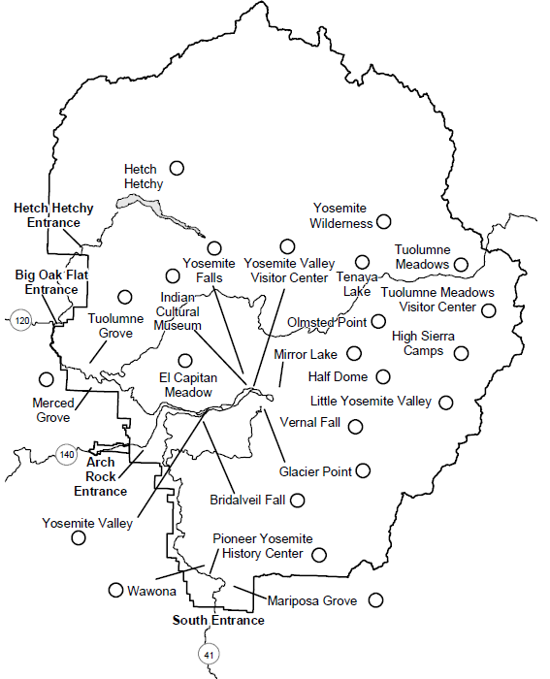

O Other (Please specify):

**TOPIC AREA 6** – EVALSERV13

15. This question requires two responses per item listed. Please rate the **IMPORTANCE and QUALITY** ofthe services or facilities for **you** in Yosemite National Park. For each item, please mark (●) **one for importance and one for quality of service**.

|  |  |  |  |  |  |  |  |  |  |  |  |
| --- | --- | --- | --- | --- | --- | --- | --- | --- | --- | --- | --- |
|  | **IMPORTANCE** | | | | | **QUALITY** | | | | | |
| **Extremely Important** | **Somewhat Important** | **Moderately Important** | **Somewhat Important** | **Not Important** | **Very Good** | **Good** | **Average** | **Poor** | **Very Poor** | **Not Applicable** |
| Directional signs in park | O | O | O | O | O | O | O | O | O | O | O |
| Directional signs outside park | O | O | O | O | O | O | O | O | O | O | O |
| Roads | O | O | O | O | O | O | O | O | O | O | O |
| Trails | O | O | O | O | O | O | O | O | O | O | O |
| Restrooms | O | O | O | O | O | O | O | O | O | O | O |
| Campgrounds | O | O | O | O | O | O | O | O | O | O | O |
| Picnic areas | O | O | O | O | O | O | O | O | O | O | O |
| Trash collection | O | O | O | O | O | O | O | O | O | O | O |
| Recycling | O | O | O | O | O | O | O | O | O | O | O |
| Parking | O | O | O | O | O | O | O | O | O | O | O |
| In park lodging | O | O | O | O | O | O | O | O | O | O | O |
| In park restaurants | O | O | O | O | O | O | O | O | O | O | O |
| Items purchased in gift shops (other than visitor center bookstore) | O | O | O | O | O | O | O | O | O | O | O |
| Access for disabled persons | O | O | O | O | O | O | O | O | O | O | O |

**TOPIC AREA 1** – GR4

16. a) Does anyone in your **personal group** have a physical condition that made it difficult to access or participate in park activities or services, on this trip to Yosemite National Park? Please mark (●) **one**.

O Yes

O No ➔ **Go to Question 17**

b) If YES, what activities, services, or facilities did the person(s) have difficulty participating in or accessing?

_______________________________________________________________________

_______________________________________________________________________

_______________________________________________________________________

**TOPIC AREA 6** – EVALSERV13

17. Please rate the **IMPORTANCE** and **QUALITY** of the information services and facilities for **you** in Yosemite National Park. For each item, please mark (●) **one for Importance and one for quality of service**.

|  |  |  |  |  |  |  |  |  |  |  |  |
| --- | --- | --- | --- | --- | --- | --- | --- | --- | --- | --- | --- |
|  | **IMPORTANCE** | | | | | **QUALITY** | | | | | |
| **Extremely Important** | **Somewhat Important** | **Moderately Important** | **Somewhat Important** | **Not Important** | **Very Good** | **Good** | **Average** | **Poor** | **Very Poor** | **Not Applicable** |
| Park brochure/map | O | O | O | O | O | O | O | O | O | O | O |
| Yosemite Guide (booklet distributed at park entrances) | O | O | O | O | O | O | O | O | O | O | O |
| Trail guides | O | O | O | O | O | O | O | O | O | O | O |
| Items purchased in visitor center bookstore (selection, price, etc.) | O | O | O | O | O | O | O | O | O | O | O |
| Assistance from park staff | O | O | O | O | O | O | O | O | O | O | O |
| Ranger led walks/talks | O | O | O | O | O | O | O | O | O | O | O |
| Ranger led campground programs | O | O | O | O | O | O | O | O | O | O | O |
| Junior Ranger program | O | O | O | O | O | O | O | O | O | O | O |
| Indoor exhibits | O | O | O | O | O | O | O | O | O | O | O |
| Outdoor exhibits (outside visitor centers, museums or in campgrounds, parking lots, etc.) | O | O | O | O | O | O | O | O | O | O | O |
| Trailside exhibits (along walking/hiking trails) | O | O | O | O | O | O | O | O | O | O | O |
| Yosemite Valley loop shuttle bus service | O | O | O | O | O | O | O | O | O | O | O |
| Yosemite National Park website: [www.nps.gov/yose](http://www.nps.gov/yose) (used before or during visit) | O | O | O | O | O | O | O | O | O | O | O |
| Yosemite National Park social media (Facebook Twitter, Instagram) | O | O | O | O | O | O | O | O | O | O | O |
| Yosemite National Park Blogs | O | O | O | O | O | O | O | O | O | O | O |

**TOPIC AREA 6** – EVALSERV1

18. Overall, how would **you** rate the quality of the facilities, services, and recreational opportunities in Yosemite National Park? Please mark (●) **one**.

O Very good

O Good

O Average

O Poor

O Very poor

**TOPIC AREA 3 – TRIPC21 Variation**

19. Is there any service/facility that **you** or anyone in your **personal group** needed inside Yosemite National Park that was not available?

O Yes (Specify service/facility you needed but didn’t have on this trip) ___________________

_____________________________________________________________________________

_____________________________________________________________________________

O No

**D. Park Management**

**TOPIC AREA 6** – OPMGMT7 Variation

20. To what extent do **you** agree or disagree with each of the following statements? Please mark (●) **one** **for each row**.

|  |  |  |  |  |  |  |
| --- | --- | --- | --- | --- | --- | --- |
|  | **Strongly Agree** | **Agree** | **Neither Agree nor Disagree** | **Disagree** | **Strongly Disagree** | **Don’t Know/Not Sure** |
| I felt unsafe near rivers or waterfalls in the park. | O | O | O | O | O | O |
| I assume park rangers are nearby to help, if there is an accident in a river or at a waterfall in the park. | O | O | O | O | O | O |
| Railings and signage in the park are not adequate to protect visitors from being swept over waterfalls | O | O | O | O | O | O |
| If there was a high risk of an accident in an area of the park, I assume visitors wouldn’t be allowed to enter the area. | O | O | O | O | O | O |
| There are adequate safety measures in place at cliff edges to prevent visitors from falling accidents. | O | O | O | O | O | O |

**TOPIC AREA 3** – FVIS5

21. If you were to visit Yosemite National Park in the future, how would **you** prefer to learn about the park? Please mark (●) **all** that apply.

O Not interested in learning about the park ➔ **Go to Question 22**

O Indoor exhibits

O Self-guided tours

O Outdoor exhibits

O Special events

O Trailside exhibits

O Volunteer opportunities

O Park website: [www.nps.gov/yose](http://www.nps.gov/yose)

O Living history/costumed interpretive programs

O Electronic media/devices available to visitors (downloadable digital files, podcasts, cell phone tours, interactive computer tours, audio, etc.)

O Films, movies, slideshows

O Printed materials (brochures, books, maps, etc.)

O Other (Please specify):

**TOPIC AREA 7** – OPMGMT1

22. If **you** were a manager planning for the future of Yosemite National Park, what would **you** propose? Please be specific.

_______________________________________________________________________

_______________________________________________________________________

_______________________________________________________________________

**E. Expenditures on This Trip**

Please refer to the map when answering the questions in this section.

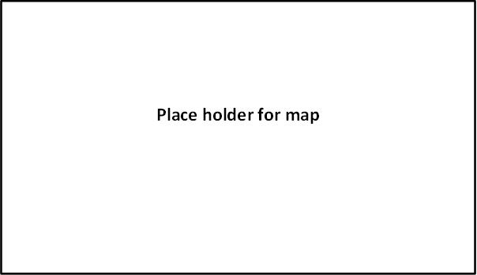

**TOPIC AREA 1** – RES1 Variation

23. Do **you** live within the highlighted area shown on the enclosed map? Please mark (●) **one**.

O Yes

O No

**TOPIC AREA 3** – TRIPC3

24. a) On this trip to Yosemite National Park and the nearby area, did **you** stay overnight away from your permanent residence either inside Yosemite National Park or within the highlighted area of the map? Please mark (●) **one.**

O Yes

O No 🡺 **Go to Question 25**

b) If **YES**, please list the number of nights **you** stayed in Yosemite National Park (NP) and/or anywhere within the highlighted area of the map on this trip.

|  |  |
| --- | --- |
| **Accommodation** | **Number of Nights** |
| Backcountry camping in Yosemite NP | ________ |
| Camping in Yosemite NP | ________ |
| Camping outside Yosemite NP | ________ |
| Lodging in Yosemite NP | ________ |
| Lodging outside Yosemite NP | ________ |
| Other accommodations (e.g. friends/relatives) | ________ |

**TOPIC AREA 3** – TRIPC4

25. a) On this trip, where did **you** stay on the night prior to visiting Yosemite National Park? If **you** stayed at home, please write the name of your hometown and state.

Town/city: State:

**TOPIC AREA 3** – TRIPC5

b) On this trip, where did **you** stay on the night after leaving Yosemite National Park? If **you** stayed at home, please write the name of your hometown and state.

Town/city: State:

**TOPIC AREA 2** – TPLAN5

26. Was this trip to Yosemite National Park? Please mark (●) **one**.

O **Your** primary or sole purpose of **your** trip away from home?

O One of several equally important destinations on **your** trip away from home?

* Was one or more of the other equally important destinations located within the highlighted area of the map? Please mark (●) **one**.

O Yes

O No

O Just an incidental or spur of the moment stop on **your** trip away from home?

* Was **your** primary destination located within the highlighted area of the map? Please mark (●) **one**.

O Yes

O No

**TOPIC AREA 3** – TRIPC8

27. On this trip, how long did **you** stay within the highlighted area of the map?

Number of hours, if a day trip

Number of days, if greater than 1 day

**TOPIC AREA 3** – TRIPC19 Variation

28. Did **you** visit any other National Park Service sites on **your** trip away from home? Please mark (●) **one**.

O Yes (Please specify)______________________________________________________

O No

**TOPIC AREA 7** – ECON4

29. Please estimate how much **you** and your **personal group** with whom you shared expenses (e.g., other family members, traveling companions) spent both inside Yosemite National Park and within the highlighted area of the map during this trip to Yosemite National Park and the nearby area?

If you no longer have your receipts, estimate as closely as you can how much you and your personal group spent. Please enter 0 (zero) if you and your personal group did not spend any money in a particular category.

Note: Residents living within the highlighted area of the map should only include expenditures that were directly related to this trip to Yosemite National Park (NP).

|  |  |
| --- | --- |
| **Expenses** | **Amount spent in Yosemite NP and nearby area** |
| Park entrance fee | $________ |
| Gas and oil (auto, RV, etc.) | $________ |
| Rental cars | $________ |
| Taxis, shuttles, and public transportation | $________ |
| Restaurants and bars | $________ |
| Groceries and convenience foods | $________ |
| Hotels, motels, resorts | $________ |
|  |  |
| Specialty lodging (B&Bs, hostels, cabins, vacation rentals) | $________ |
| Camping fees (tent, RV) | $________ |
| Recreation and entertainment expenses (e.g., movies, bowling, miniature golf, etc.) | $________ |
| Souvenirs, clothing, supplies, other retail | $________ |
| Equipment rental | $________ |
| Guides and tour fees | $________ |
| Other (please list)____________________ | $________ |

**OR**

O Don’t know/Not sure

**TOPIC AREA 7** – ECON6 Variation

30. For **you** and any members of your **personal group** with whom you shared expenses, please estimate any additional money spent outside of the map area during your trip away from home (for example, travel or food expenditures)?

$ _________

**OR**

O Don’t know/Not sure

**TOPIC AREA 7** – ECON5

31. a) Including yourself, how many people in your **personal group** were covered by the expenses for this trip away from home?

Number of adults (18 years or over)

Number of children (under 18 years)

b) Including yourself, how many people in your **personal group** split these trip expenses?

Number of people

**F. Background**

**TOPIC AREA 1** – AGE1

32. For your **personal group** on this trip to Yosemite National Park, please provide the following. (If you do not know the answer, enter “DK.” in the space provided)

|  |  |  |  |  |
| --- | --- | --- | --- | --- |
|  | **a) Current age** | **b) U.S. ZIP code or name of country other** | **c) Number of visits to Yosemite NP past 12 months** | **d) Number of visits to Yosemite NP in lifetime** |
| Yourself |  |  |  |  |
| Member #2 |  |  |  |  |
| Member #3 |  |  |  |  |
| Member #4 |  |  |  |  |
| Member #5 |  |  |  |  |
| Member #6 |  |  |  |  |
| Member #7 |  |  |  |  |

**TOPIC AREA 1** – RACE/ETH1

33. a) Are **you** or members of your **personal group** Hispanic or Latino? Please mark (●) **one for each group member, including yourself**.

|  |  |  |  |  |  |  |  |
| --- | --- | --- | --- | --- | --- | --- | --- |
|  | **Yourself** | **Member**  **#2** | **Member**  **#3** | **Member**  **#4** | **Member**  **#5** | **Member**  **#6** | **Member**  **#7** |
| Hispanic or Latino | O | O | O | O | O | O | O |
| Not Hispanic or Latino | O | O | O | O | O | O | O |
| Don’t know | - | O DK | O DK | O DK | O DK | O DK | O DK |

**TOPIC AREA 1** – RACE/ETH3

b) What is the race of each member of your **personal group** on this trip to Yosemite National Park? Please mark (●) **one or more for each group member, including yourself**. If you are unsure or don’t know please mark (●) DK.

|  |  |  |  |  |  |  |  |
| --- | --- | --- | --- | --- | --- | --- | --- |
|  | **Yourself** | **Member #2** | **Member #3** | **Member #4** | **Member #5** | **Member #6** | **Member #7** |
| American Indian or Alaska Native | O | O | O | O | O | O | O |
| Asian | O | O | O | O | O | O | O |
| Black or African American | O | O | O | O | O | O | O |
| Native Hawaiian or other Pacific Islander | O | O | O | O | O | O | O |
| White | O | O | O | O | O | O | O |
| Don’t know | - | O DK | O DK | O DK | O DK | O DK | O DK |

NOTE: Questions 33c and 34 concern Middle Eastern and Asian visitors. These groups represent a significantly growing of visitors to Yosemite National Park. These questions were included in the 2009 VSP study in Yosemite National Park and results at the time, suggested that 1% of park visitors were of Middle Eastern and 11% were Asian. Of the Asian visitors, 24% were Chinese and 22% were Japanese. Managers and planners wou

c) Are **you** or members of your **personal group** of Middle Eastern/Arab ancestry/ descent? Please mark (●) **one for each group member, including yourself**. If you are unsure or don’t know please mark (●) DK.

|  |  |  |  |  |  |  |  |
| --- | --- | --- | --- | --- | --- | --- | --- |
|  | **Yourself** | **Member #2** | **Member #3** | **Member #4** | **Member #5** | **Member #6** | **Member #7** |
| Middle Eastern/Arab | O | O | O | O | O | O | O |
| Not Middle  Eastern/Arab | O | O | O | O | O | O | O |
| Don’t know | - | O DK | O DK | O DK | O DK | O DK | O DK |

**TOPIC AREA 1** – RACE/ETH

34. If you selected Asian as a response to Question 34b for **you** or anyone in your **personal group**, please select from the following list the response to better identify the race. Please mark (●) **one or more** for your group.

O No group members of Asian race ➔ **Go to Question 36**

|  |  |
| --- | --- |
| O Asian Indian | O Pakistani |
| O Cambodian | O Thai |
| O Chinese | O Vietnamese |
| O Filipino | O Japanese |
| O Korean | O Other Asian (Please specify) |
| O Laotian | ________________________________________________ |

**TOPIC AREA 1** – LANG1

35. a) When visiting an area such as Yosemite National Park, what **one** language do **you** prefer to use for the following?

|  |  |  |
| --- | --- | --- |
|  | **Speaking** | **Reading** |
| English | O | O |
| Spanish | O | O |
| Other (Specify) ________________________ | O | O |

b) What **services** in the park need to be provided in languages other than English? Please specify a **service(s)** or mark (●) “None.”

Service(s):

O None

**TOPIC AREA 6** – OPMGMT3

36. Is there anything else **you** would like to tell us about your visit to Yosemite National Park?

_______________________________________________________________________

_______________________________________________________________________

_______________________________________________________________________

Thank you for your help! Please seal the questionnaire with the stickers provided and drop it in any U.S. mailbox.

|  |  |
| --- | --- |
|  | Printed on recycled paper |