OMB #: 1024-0224

Expiration Date: 10-31-2015

**Great Sand Dunes National Park and Preserve**

**Backcountry [Overnight Hunter*[1]] Survey**

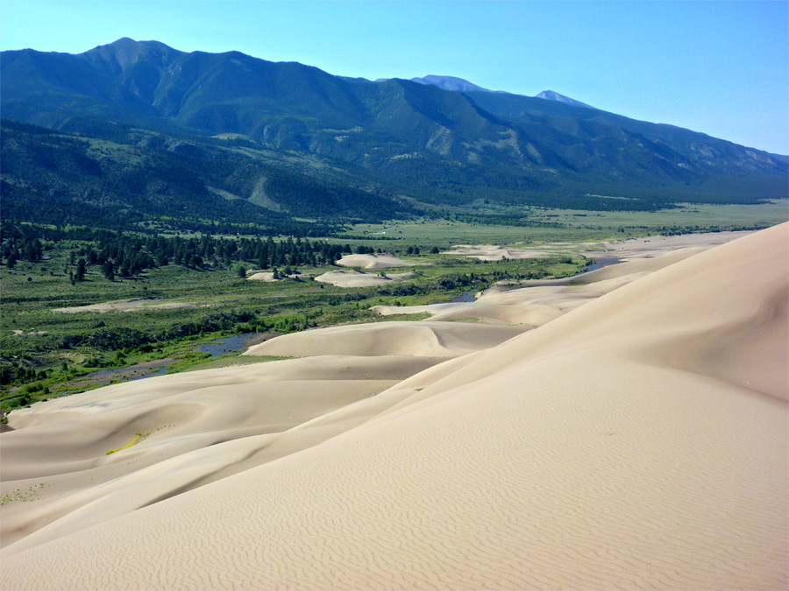**2015**

## ID: ________ Date: ______________ Time: ___________AM/PM

## Location: ___________ Weather: Sunny / Partly / Overcast / Raining Special Event: No / Yes ________________

**Paperwork Reduction Act Statement:** The Paperwork Reduction Act requires us to tell you why we are collecting this information, how we will use it, and whether or not you have to respond. This information will be used by the National Park Service as authorized by *16 USC 5931 §201*. We will use this information to backcountry use by both hunters and non-hunters in areas managed by Great Sand Dunes National Park. Your response is voluntary. Your name and contact information have been requested for follow-up mailing purposes only. When analysis of the questionnaire is completed, all name and address files will be destroyed and will in no way be connected with the results of this survey. A Federal agency may not conduct or sponsor, and you are not required to respond to, a collection of information unless it displays a currently valid OMB Control Number.

We estimate that it will take about 13 minutes to complete this questionnaire. You may send comments concerning the burden estimates or any aspect of this information collection to: Steve Lawson, Director, Public Lands Planning and Management, Resource Systems Group, Inc., 55 Railroad Row White River Junction, VT 05001 or [steve.lawson@rsginc.com](mailto:steve.lawson@rsginc.com) (email).

|  |
| --- |
| **REVIEWER NOTES:**  **Survey Organization: There will be four separate surveys associated with this collection. For the purposes of this review, however, we are submitting one instrument and highlighting the questions that are exclusive to a particular survey. All user groups will answer the majority of the questions in the survey. The additional questions are denoted in the gray box above the question. The labels below are for the four surveys in this submission:**   1. **OVERNIGHT NON-HUNTING SURVEY** 2. **DAY TIME NON-HUNTING SURVEY** 3. **HUNTING SURVEY (day and overnight)** 4. **OVERNIGHT HUNTING SURVEY** – |

This questionnaire asks about your trip in the backcountry of Great Sand Dunes National Park and Preserve that ends on the day you were contacted to participate in this survey. Your participation in the survey will help the National Park Service meet the needs of visitors like you. Thank you for your help.

**A. Trip Description**

**TOPIC AREA 3: ITIN7 and TBACK3 (*Variation: Respondent indicates time, date, and locations on map*)**

**OVERNIGHT NON HUNTING and OVERNIGHT HUNTING SURVEYS ONLY**

1. Using the map provided on the next page and the symbols described below, please record the following information about this overnight trip in the backcountry of Great Sand Dunes National Park and Preserve (GRSA).

***Trip Duration***

* 1. Record the date, time, and location of the start of your trip.
  2. Record the date, time, and location of the end of your trip.

***Overnight Camping***

* 1. Mark with an “**X**” each location on the map where you camped.
  2. Write the date you stopped and number of nights you camped at each location.

***Wilderness Experience***

* 1. Mark with a “**C**” each location on the map where you felt crowded (i.e. sections of trail, lakes, campsites).

**OR** fill in the circle below if you did not feel crowded

⭘ I did not feel crowded at any point during my overnight trip.

* 1. Mark with an “**S**” each location on the map where you experienced a sense of solitude (i.e. sections of the trail, lakes, campsites).

**OR** fill in the circle below if you did not experience a sense of solitude

⭘ I did not experience a sense of solitude at any point during my overnight trip.

**SEE NEXT PAGE FOR AN EXAMPLE OF A COMPLETED MAP.**

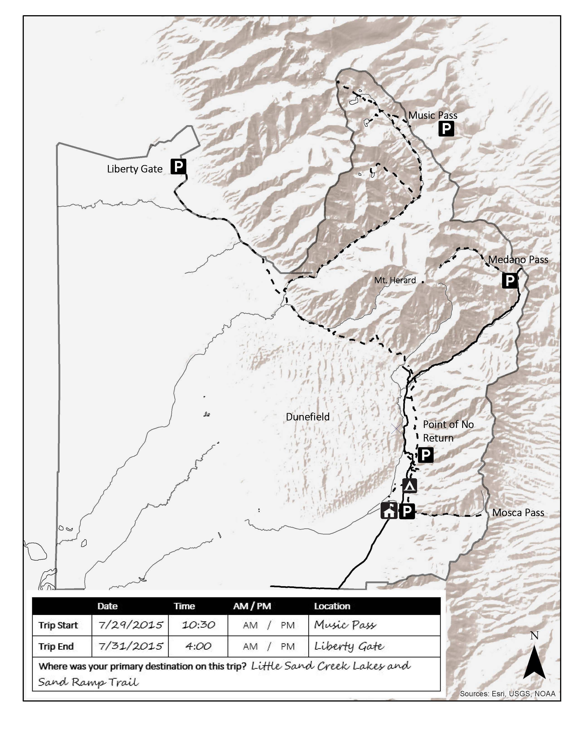

**EXAMPLE**

7/29/15 1 night

X

7/30/2015 1 night

S

C

S

C

X

**Hiking Route Map**

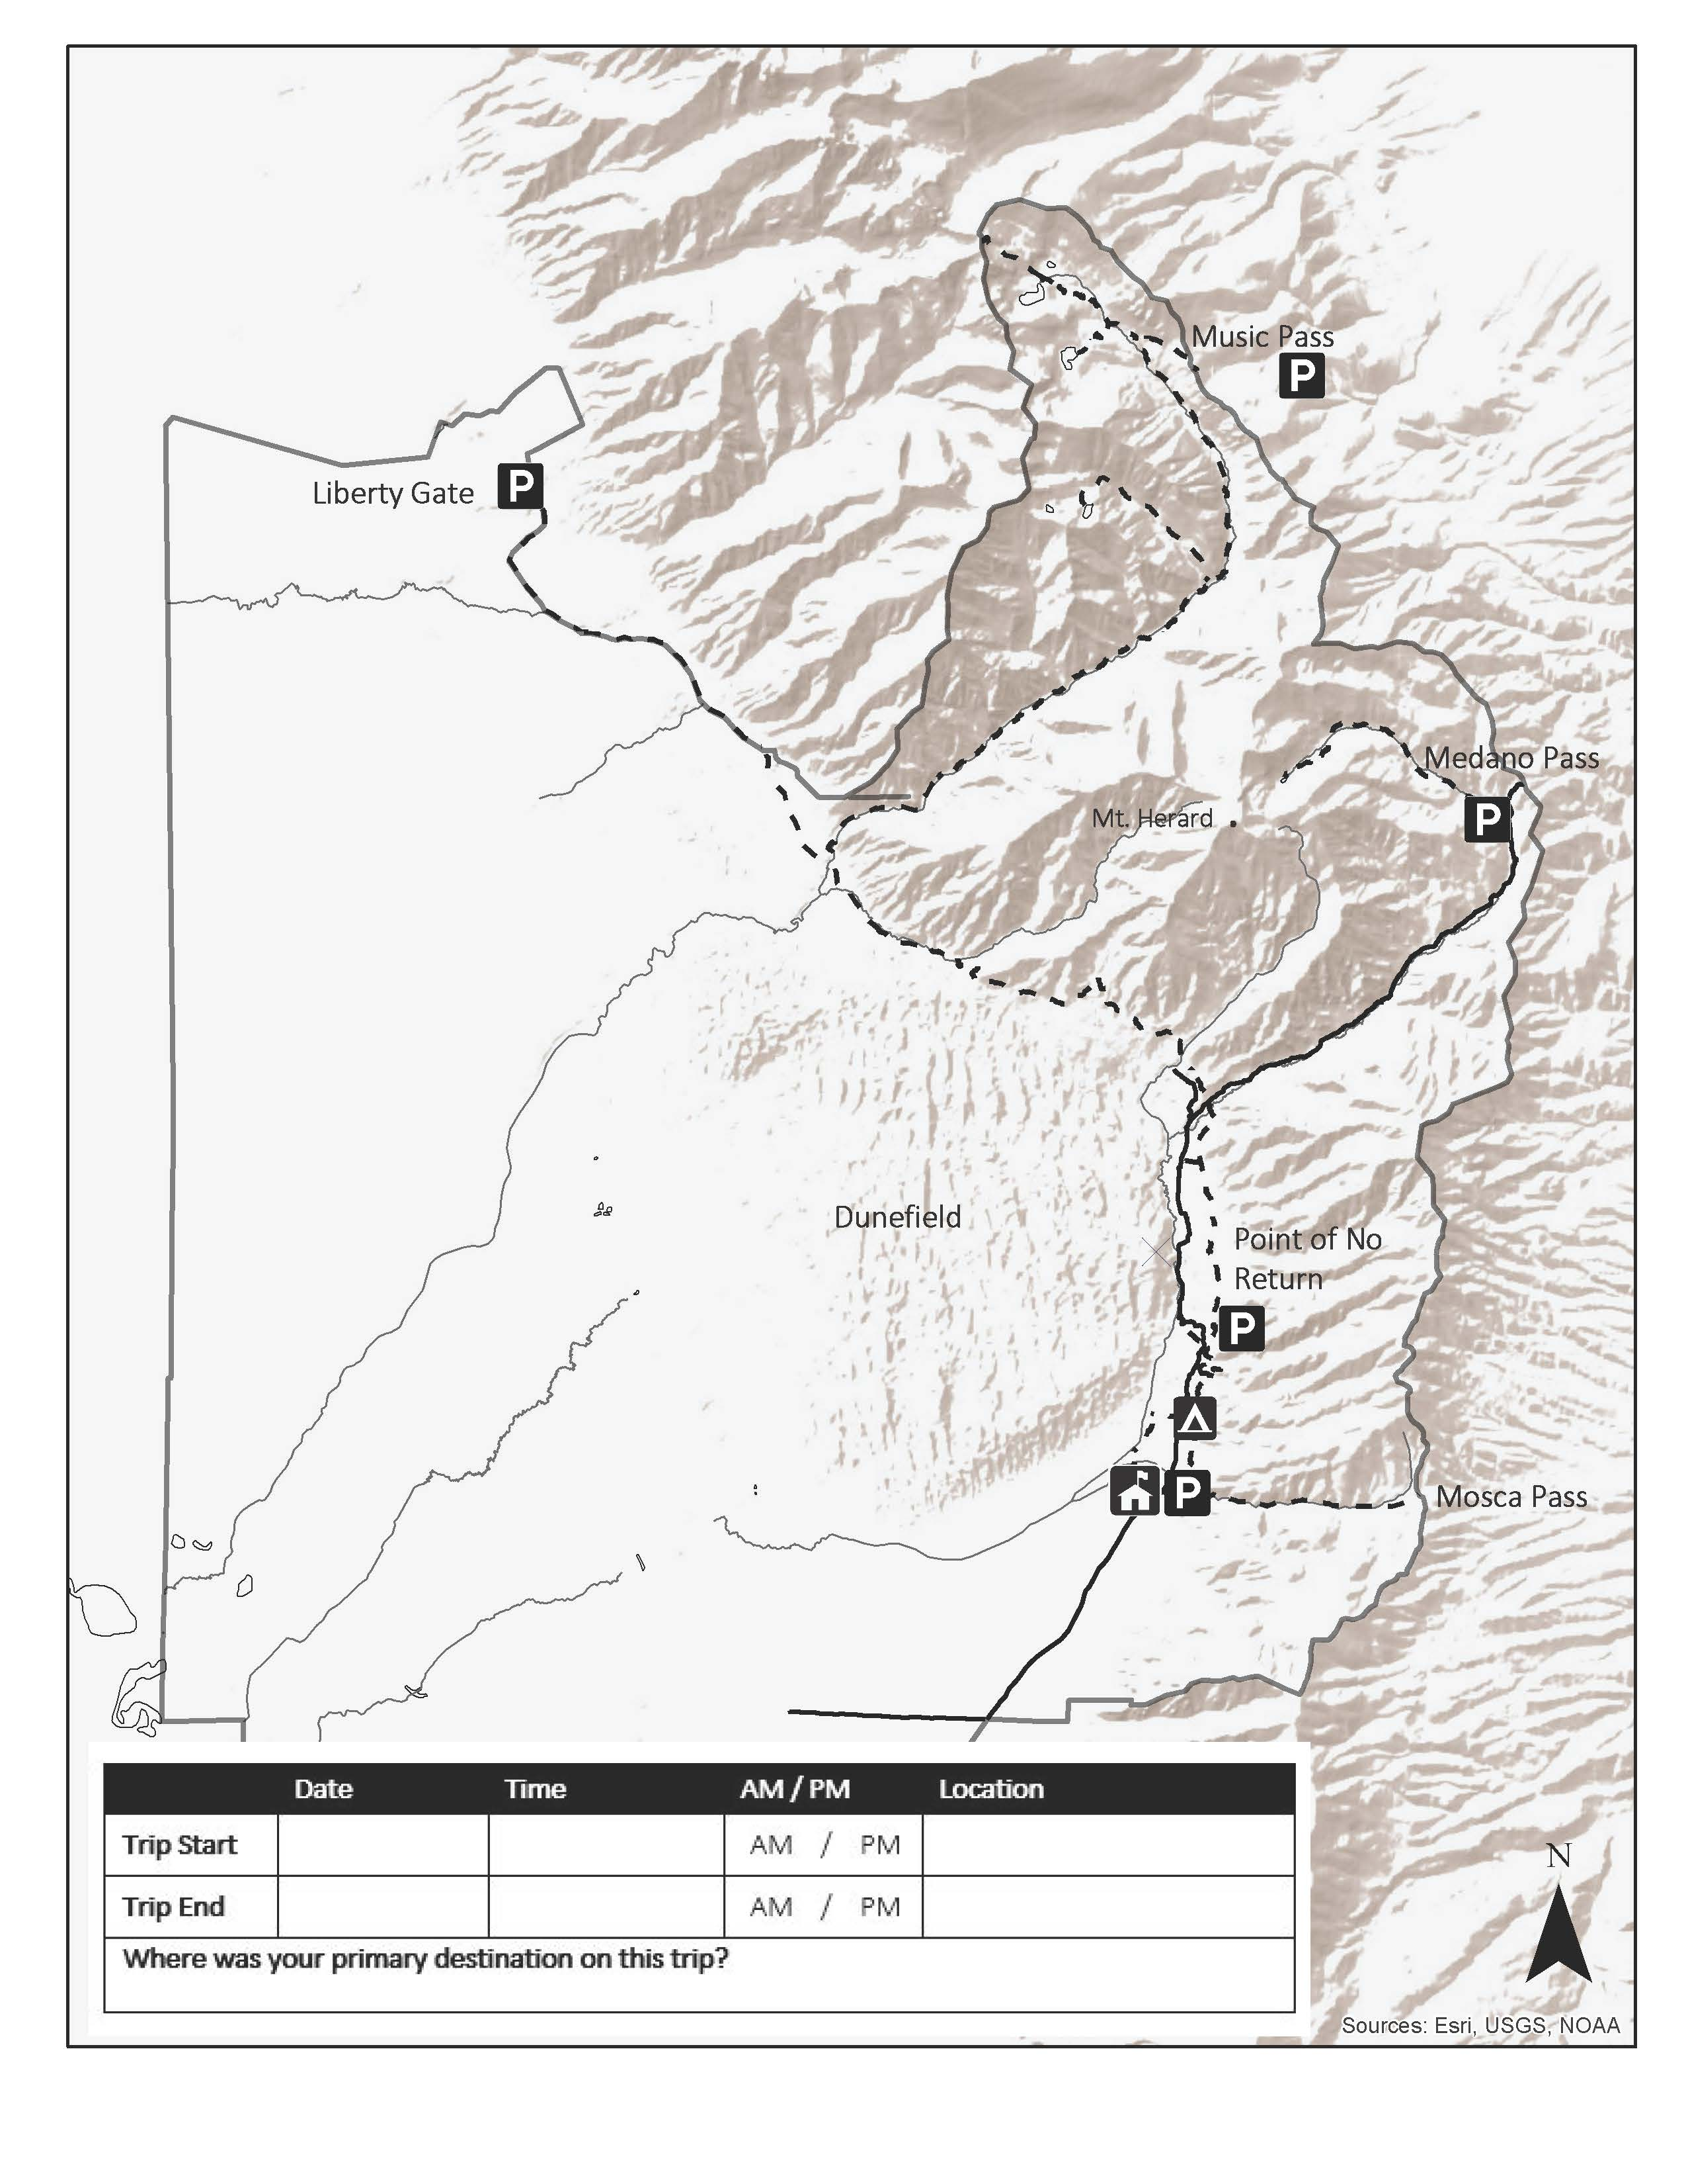

Please use this map to complete your responses for Question 1 above.

**Hiking Route Map**

**TOPIC AREA 1: GR3**

2. Including yourself, how many people were in your personal group on this trip in the backcountry of GRSA?

_______ Number of adults (18 years or over)

_______ Number of children (under 18 years)

**TOPIC AREA 1: GR5**

3. Did you travel with a dog(s) on this trip in the backcountry of GRSA? Please mark (•) **one**.

⭘ Yes (*Specify number*) _____________

⭘ No (SKIP TO QUESTION 5)

**TOPIC AREA 1: GR5**

**OVERNIGHT HUNTING SURVEY ONLY**

4. Did you hunt with a dog(s) off-leash on this overnight trip in the backcountry of GRSA? Please mark (•) **one**.

⭘ Yes

⭘ No

**TOPIC AREA 1: GR1**

5. Which of the following best describes your personal group on this trip in the backcountry of GRSA? Please mark (•) **one**.

⭘ Alone

⭘ Family

⭘ Friends

⭘ Family and Friends

⭘ Other (*Specify*) ________________________________________________________

**TOPIC AREA 3: TRANS4**

6. How did you travel in the backcountry on this trip in the backcountry of GRSA? Please mark (•) **all that apply**.

⭘ Motorized vehicles (*Specify number*) _____________

⭘ Pack stock animals – horses (*Specify number*) _____________

⭘ Pack stock animals – mules (*Specify number*) _____________

⭘ Pack stock animals – llamas (*Specify number*) _____________

⭘ Pack stock animals – other (*Specify number*) _____________

**OR** mark (•) the following response

⭘ Did not travel in the backcountry with pack stock or motorized vehicles

**TOPIC AREA 2: TPLAN1**

7. Which of the following sources of information did you use to plan this trip in the backcountry of GRSA?

⭘ Did not obtain information prior to this visit

**OR** mark (•) **all that apply**

⭘ Previous visit

⭘ Great Sand Dunes National Park and Preserve Visitor Center

⭘ Trailhead kiosk/bulletin board

⭘ Family/friends/word of mouth

⭘ Inquiry to park via phone, mail, or email

⭘ Maps/brochures

⭘ Newspaper/magazine articles

⭘ Social media (such as Facebook, Twitter, etc.)

⭘ State welcome center/visitors bureau/chamber of commerce

⭘ NPS roadway signage at Great Sand Dunes National Park and Preserve

⭘ Television/radio program/DVDs

⭘ Local business (hotels, restaurants, bookstores, etc.)

⭘ Great Sand Dunes National Park and Preserve website (www.nps.gov/grsa)

⭘ Other website (*Specify*) ___________________________________________________

⭘ Guidebook (*Specify*) ______________________________________________________

⭘ Other (*Specify*) __________________________________________________________

**TOPIC AREA 1: GR2**

8. Did you and your personal group use either of the following commercial services on this trip in the backcountry of GRSA? Please mark (•) **all that apply**.

⭘ Guide (*Specify name*) _____________________________________

⭘ Outfitter (*Specify name*) ___________________________________

**OR** mark (•) the following response

⭘ I did not use either of the commercial services listed above. (SKIP TO QUESTION 12)

**TOPIC AREA 2: TPLAN1**

9. Which of the following sources of information did you use to select a commercial guide and/or outfitter for this backcountry trip? Please mark (•) **all that apply**.

⭘ Previous experience with the guide/outfitter

⭘ Family/friends/word of mouth

⭘ Travel agent

⭘ Guidebook (*Specify*) ______________________________________________________

⭘ Other website (*Specify*) ___________________________________________________

⭘ Local business (*Specify*) ___________________________________________________

⭘ Other (*Specify*) __________________________________________________________

**TOPIC AREA 6: EVALSERV18 & 19**

10. Did the commercial guiding/outfitting services that you and your personal group used meet your expectations?

⭘ Yes

⭘ No (*Please explain*) ______________________________________________________________

____________________________________________________________________________________________________________________________________________________________

**TOPIC AREA 5: CRWDATT10 (*Variation: statements about commercial guide and/or outfitter***

11. Please indicate the extent to which you agree or disagree with each of the following statements concerning commercial guides/outfitters in the backcountry in GRSA. Please mark (•) **only one** for each item**.**

|  |  |  |  |  |  |  |
| --- | --- | --- | --- | --- | --- | --- |
|  | Strongly Agree | Agree | Neutral | Disagree | Strongly Disagree | Don’t Know |
| I could not have done this trip without the equipment provided by my commercial guide and/or outfitter. | O | O | O | O | O | O |
| I used a commercial guide and/or outfitter on this trip as a convenience, not a necessity. | O | O | O | O | O | O |
| I learned more about GRSA from my guide and/or outfitter than I would have learned if I did this trip on my own. | O | O | O | O | O | O |
| I did not possess the knowledge I needed to do this trip on my own. | O | O | O | O | O | O |

**TOPIC AREA 3: TBACK1 (*Variation: Modified to ask about specific backcountry areas within GRSA)***

12. In which of the following areas did you travel on this trip in the backcountry of GRSA? Please mark (•) **one for each row.**

|  |  |  |  |
| --- | --- | --- | --- |
|  | Traveled in  this Area | Did Not Travel  in this Area | Don’t Know/  Not Sure |
| Great Sand Dunes National Park | O | O | O |
| Great Sand Dunes National Preserve | O | O | O |
| Sangre de Cristo Wilderness | O | O | O |
| San Isabel National Forest | O | O | O |
| Great Sand Dunes Wilderness | O | O | O |
| Rio Grande National Forest | O | O | O |

**B. The Visitor Experience**

**TOPIC AREA 3: ACT1**

13. In which of the following activities did you personally participate on this trip in the backcountry of GRSA? Please mark (•) **all that apply**.

⭘ Scouting for future hunting trips

⭘ Hiking on trails

⭘ Horseback riding

⭘ Hiking in a trail-less area (i.e. cross-country travel)

⭘ Technical mountain climbing (i.e. using ropes and special gear)

⭘ Non-technical mountain climbing (i.e. without ropes and special gear)

⭘ Photography

⭘ Wildlife viewing / bird watching

⭘ Identifying flora and fauna

⭘ Star gazing

⭘ Listening to natural sounds

⭘ Swimming

⭘ Packing stock

⭘ Overnight backpacking (OVERNIGHT VISITORS ONLY)

⭘ Motorized recreation (e.g., OHV use, four-wheeling)

⭘ Family gathering / reunion

⭘ Camping in developed, roadside camping areas (OVERNIGHT VISITORS ONLY)

⭘ Hunting 🡪 Did you harvest an animal? ⭘ No ⭘ Yes (*Specify game*) ______________________ (HUNTING VISITORS ONLY)

⭘ Fishing / Fly-fishing 🡪 Did you consume any fish? ⭘ No ⭘ Yes

⭘ Other (*Specify*) __________________________________________________________

**TOPIC AREA 3: ACT2**

14. Of the activities listed in Question 13, which was your primary activity on this trip?

________________________________________________________________________

**OR** mark (•) the following response

⭘ I did not have a primary activity on this trip.

**TOPIC AREA 4: PREF1 and SOUND2**

15. People take trips in backcountry areas for a number of different reasons. How important to you was each of the following reasons for taking this trip in the backcountry of GRSA. Please mark (•) **one for each row**.

|  |  |  |  |  |  |
| --- | --- | --- | --- | --- | --- |
| **Importance** | Not at all | Slightly | Somewhat | Moderately | Very much |
| To experience a sense of freedom | O | O | O | O | O |
| To experience solitude | O | O | O | O | O |
| To be close to nature | |  |  |  |  |  | | --- | --- | --- | --- | --- | | O | O | O | O | O | | |  |  |  |  |  | | --- | --- | --- | --- | --- | | O | O | O | O | O | | |  |  |  |  |  | | --- | --- | --- | --- | --- | | O | O | O | O | O | | |  |  |  |  |  | | --- | --- | --- | --- | --- | | O | O | O | O | O | | |  |  |  |  |  | | --- | --- | --- | --- | --- | | O | O | O | O | O | |
| To experience mental relaxation | |  |  |  |  |  | | --- | --- | --- | --- | --- | | O | O | O | O | O | | |  |  |  |  |  | | --- | --- | --- | --- | --- | | O | O | O | O | O | | |  |  |  |  |  | | --- | --- | --- | --- | --- | | O | O | O | O | O | | |  |  |  |  |  | | --- | --- | --- | --- | --- | | O | O | O | O | O | | |  |  |  |  |  | | --- | --- | --- | --- | --- | | O | O | O | O | O | |
| To have a feeling of remoteness | |  |  |  |  |  | | --- | --- | --- | --- | --- | | O | O | O | O | O | | |  |  |  |  |  | | --- | --- | --- | --- | --- | | O | O | O | O | O | | |  |  |  |  |  | | --- | --- | --- | --- | --- | | O | O | O | O | O | | |  |  |  |  |  | | --- | --- | --- | --- | --- | | O | O | O | O | O | | |  |  |  |  |  | | --- | --- | --- | --- | --- | | O | O | O | O | O | |
| To experience wilderness opportunities | |  |  |  |  |  | | --- | --- | --- | --- | --- | | O | O | O | O | O | | |  |  |  |  |  | | --- | --- | --- | --- | --- | | O | O | O | O | O | | |  |  |  |  |  | | --- | --- | --- | --- | --- | | O | O | O | O | O | | |  |  |  |  |  | | --- | --- | --- | --- | --- | | O | O | O | O | O | | |  |  |  |  |  | | --- | --- | --- | --- | --- | | O | O | O | O | O | |
| To be challenged physically | |  |  |  |  |  | | --- | --- | --- | --- | --- | | O | O | O | O | O | | |  |  |  |  |  | | --- | --- | --- | --- | --- | | O | O | O | O | O | | |  |  |  |  |  | | --- | --- | --- | --- | --- | | O | O | O | O | O | | |  |  |  |  |  | | --- | --- | --- | --- | --- | | O | O | O | O | O | | |  |  |  |  |  | | --- | --- | --- | --- | --- | | O | O | O | O | O | |
| To have a sense that the surroundings haven’t  been impacted by people | |  |  |  |  |  | | --- | --- | --- | --- | --- | | O | O | O | O | O | | |  |  |  |  |  | | --- | --- | --- | --- | --- | | O | O | O | O | O | | |  |  |  |  |  | | --- | --- | --- | --- | --- | | O | O | O | O | O | | |  |  |  |  |  | | --- | --- | --- | --- | --- | | O | O | O | O | O | | |  |  |  |  |  | | --- | --- | --- | --- | --- | | O | O | O | O | O | |
| To be away from modern technology | |  |  |  |  |  | | --- | --- | --- | --- | --- | | O | O | O | O | O | | |  |  |  |  |  | | --- | --- | --- | --- | --- | | O | O | O | O | O | | |  |  |  |  |  | | --- | --- | --- | --- | --- | | O | O | O | O | O | | |  |  |  |  |  | | --- | --- | --- | --- | --- | | O | O | O | O | O | | |  |  |  |  |  | | --- | --- | --- | --- | --- | | O | O | O | O | O | |
| To be self-reliant | |  |  |  |  |  | | --- | --- | --- | --- | --- | | O | O | O | O | O | | |  |  |  |  |  | | --- | --- | --- | --- | --- | | O | O | O | O | O | | |  |  |  |  |  | | --- | --- | --- | --- | --- | | O | O | O | O | O | | |  |  |  |  |  | | --- | --- | --- | --- | --- | | O | O | O | O | O | | |  |  |  |  |  | | --- | --- | --- | --- | --- | | O | O | O | O | O | |
| To feel independence | |  |  |  |  |  | | --- | --- | --- | --- | --- | | O | O | O | O | O | | |  |  |  |  |  | | --- | --- | --- | --- | --- | | O | O | O | O | O | | |  |  |  |  |  | | --- | --- | --- | --- | --- | | O | O | O | O | O | | |  |  |  |  |  | | --- | --- | --- | --- | --- | | O | O | O | O | O | | |  |  |  |  |  | | --- | --- | --- | --- | --- | | O | O | O | O | O | |
| To hear natural sounds (e.g., birds, wildlife, water) | |  |  |  |  |  | | --- | --- | --- | --- | --- | | O | O | O | O | O | | |  |  |  |  |  | | --- | --- | --- | --- | --- | | O | O | O | O | O | | |  |  |  |  |  | | --- | --- | --- | --- | --- | | O | O | O | O | O | | |  |  |  |  |  | | --- | --- | --- | --- | --- | | O | O | O | O | O | | |  |  |  |  |  | | --- | --- | --- | --- | --- | | O | O | O | O | O | |
| To recreate free from rules and regulations | |  |  |  |  |  | | --- | --- | --- | --- | --- | | O | O | O | O | O | | |  |  |  |  |  | | --- | --- | --- | --- | --- | | O | O | O | O | O | | |  |  |  |  |  | | --- | --- | --- | --- | --- | | O | O | O | O | O | | |  |  |  |  |  | | --- | --- | --- | --- | --- | | O | O | O | O | O | | |  |  |  |  |  | | --- | --- | --- | --- | --- | | O | O | O | O | O | |
| To view wildlife or natural scenery | |  |  |  |  |  | | --- | --- | --- | --- | --- | | O | O | O | O | O | | |  |  |  |  |  | | --- | --- | --- | --- | --- | | O | O | O | O | O | | |  |  |  |  |  | | --- | --- | --- | --- | --- | | O | O | O | O | O | | |  |  |  |  |  | | --- | --- | --- | --- | --- | | O | O | O | O | O | | |  |  |  |  |  | | --- | --- | --- | --- | --- | | O | O | O | O | O | |
| To spend time with family/friends | |  |  |  |  |  | | --- | --- | --- | --- | --- | | O | O | O | O | O | | |  |  |  |  |  | | --- | --- | --- | --- | --- | | O | O | O | O | O | | |  |  |  |  |  | | --- | --- | --- | --- | --- | | O | O | O | O | O | | |  |  |  |  |  | | --- | --- | --- | --- | --- | | O | O | O | O | O | | |  |  |  |  |  | | --- | --- | --- | --- | --- | | O | O | O | O | O | |

**TOPIC AREA 4: PA1**

**HUNTING (Day and Overnight) SURVEYS ONLY**

16. Please indicate your level of agreement with each of the following statements. Please mark (•) **only one** for each item**.**

|  | Strongly Agree | Agree | Neutral | Disagree | Strongly Disagree | Don’t Know |
| --- | --- | --- | --- | --- | --- | --- |
| I prefer hunting in GRSA more than in any other place. | O | O | O | O | O | O |
| In the future, I’d prefer to hunt somewhere other than GRSA. | O | O | O | O | O | O |
| I have been hunting in this same area for many years. | O | O | O | O | O | O |
| I wouldn’t substitute any other place for the hunting I do in GRSA. | O | O | O | O | O | O |
| I enjoy hunting even if I do not see any game. | O | O | O | O | O | O |
| If I do not have a successful harvest, I will not return to GRSA to hunt. | O | O | O | O | O | O |
| I enjoy hunting only when I have a successful harvest. | O | O | O | O | O | O |

**TOPIC AREA 5: CROWD15, CRWDATT7, CRWDATT8, and CRWDATT12**

17. For each of the following visitor group types, please:

a) Indicate about how many groups you saw during this trip in the backcountry of GRSA. Enter a “?” if you don’t remember, and enter “0” if you saw none.

b) Indicate whether you saw more or less groups than expected.

c) Indicate whether the number of groups you saw added to or detracted from your experience.

Impact of number of groups on experience

Number of groups compared to expectations

|  |  |  |  |  |  |  |  |  |
| --- | --- | --- | --- | --- | --- | --- | --- | --- |
|  | Total Number of Groups | Less than Expected | About as Expected | More than Expected | Added to Experience | No Effect on Experience | Detracted from Experience | Not Applicable |
| Hiking Groups | _____ | O | O | O | O | O | O | O |
| Pack Stock Groups | _____ | O | O | O | O | O | O | O |
| Hunting Groups | _____ | O | O | O | O | O | O | O |
| Motorized Groups | _____ | O | O | O | O | O | O | O |

**TOPIC AREA 5: CROWD16**

**OVERNIGHT NON-HUNTERS and OVER NIGHT HUNTERS SURVEYS**

18. How many nights were you able to see or hear other visitor groups camping overnight near your campsite during this overnight trip in the backcountry of GRSA? Enter a question mark “?” if you don’t remember. Enter a “0” if you did not see or hear any groups on any night.

________ Total number of nights

**TOPIC AREA 3: TRIPC31 *(Variation: Asking about hunting camp components instead of technology)***

**OVERNIGHT HUNTING SURVEY ONLY**

19. Did you and your personal group use any of the following items as part of your backcountry camp setup during this overnight trip in the backcountry of GRSA?

|  |  |  |  |
| --- | --- | --- | --- |
|  | Yes | No | Don’t Know/  Not Sure |
| Meat rack / pole | O | O | O |
| Smoke pit | O | O | O |
| Constructed latrine | O | O | O |
| Canvas-walled tent cabin | O | O | O |
| Ditched tent pads | O | O | O |
| Portable corral, high line, or pickets | O | O | O |
| Other (*Specify*) _____________________________________________________________ | | | |

**TOPIC AREA 5: CROWD1**

20. Please indicate how crowded you felt in the following locations during this trip in the backcountry of GRSA.

|  |  |  |  |  |  |
| --- | --- | --- | --- | --- | --- |
|  | Not at all  Crowded | Slightly  Crowded | Moderately  Crowded | Very  Crowded | Extremely  Crowded |
| At the trailhead / trail parking area | O | O | O | O | O |
| While traveling on trails | O | O | O | O | O |
| At destinations (such as lakes or viewpoints) | O | O | O | O | O |
| While hunting (HUNTING VISITORS ONLY) | O | O | O | O | O |
| At campsites (OVERNIGHT VISITORS ONLY) | O | O | O | O | O |

**TOPIC AREA 5: CROWDATT5**

**DAY TIME NON-HUNTERS ONLY**

21. Please indicate for each of the following lengths of time without seeing other people while traveling in the backcountry of GRSA, how likely you would be to experience solitude during that amount of time. Please mark (•) **only one** for each item**.**

|  |  |  |  |  |  |  |
| --- | --- | --- | --- | --- | --- | --- |
|  | Completely Likely | Very Likely | Moderately Likely | Slightly Likely | Not at all Likely | Do Not Know |
| 15 minutes without seeing other people | O | O | O | O | O | O |
| 30 minutes without seeing other people | O | O | O | O | O | O |
| 1 hour without seeing other people | O | O | O | O | O | O |
| 2 hours without seeing other people | O | O | O | O | O | O |
| 3 hours without seeing other people | O | O | O | O | O | O |

**TOPIC AREA 5: CRWDATT10/EVALSERV35/SOUND3/OMPGMT7 (*Combination of 4 Questions*)**

22. To what extent was each of the following potential issues a problem for you during this trip in the backcountry of GRSA? If you did not notice an item, mark the answer choice “Did not notice”.

|  | How much did it detract from your experience? | How much was it a problem during your trip? | | | |
| --- | --- | --- | --- | --- | --- |
| Did Not  Notice | Not at All | A Small Problem | A Moderate Problem | A Big Problem |
| **Visitor Experience** |  |  |  |  |  |
| Noise from motorized vehicles | O | O | O | O | O |
| Noise from aircraft | O | O | O | O | O |
| Noise from other visitors | O | O | O | O | O |
| Encounters with dogs | O | O | O | O | O |
| Presence of rock cairns to designate trail direction | O | O | O | O | O |
| Stock manure on trails | O | O | O | O | O |
|  |  |  |  |  |  |
| **Facilities and Administrative Services** |  |  |  |  |  |
| Area rules/regulations not adequately enforced | O | O | O | O | O |
| Trail wear and tear | O | O | O | O | O |
| Too frequent contact with NPS backcountry rangers | O | O | O | O | O |
| Too many rules/regulations | O | O | O | O | O |
| Poorly marked trails | O | O | O | O | O |
| Seeing NPS vehicles or equipment in the backcountry | O | O | O | O | O |
|  |  |  |  |  |  |
| **Resource Conditions** |  |  |  |  |  |
| Presence of trash/human waste at campsites | O | O | O | O | O |
| Presence of campfire pits | O | O | O | O | O |
| Artificial light glow (“light pollution”) in night sky | O | O | O | O | O |
| Presence of human-caused damage to trees | O | O | O | O | O |
| Presence of stream bank erosion at creek crossings | O | O | O | O | O |
| Degraded lake shore views due to presence of campsites | O | O | O | O | O |
| Encounters with habituated wildlife | O | O | O | O | O |
| Presence of haze/reduced visibility | O | O | O | O | O |

**C. Attitudes toward Management**

**TOPIC AREA 6: OPMGMT6**

23. Please indicate the extent to which you would support or oppose each of the following management actions in the backcountry of GRSA? Please mark (•) **only one** for each item**.**

|  | Strongly  Support | Support | Neutral | Oppose | Strongly  Oppose | Do not Know |
| --- | --- | --- | --- | --- | --- | --- |
| Tagging animals for research purposes | O | O | O | O | O | O |
| Implementing catch-and-release only fishing throughout GRSA backcountry | O | O | O | O | O | O |
| Using poison to remove non-native fish from lakes and streams to increase the number of native fishnative fish | O | O | O | O | O | O |
| Using electrofishing to remove non-native fish from lakes and streams to increase the number of native fish. | O | O | O | O | O | O |
| Using gill nets to remove non-native fish from lakes and streams to increase the number of native fish. | O | O | O | O | O | O |
| Requiring users to obtain a free, backcountry overnight use permit for information collection purposes only | O | O | O | O | O | O |
| Requiring backcountry users to camp in designated sites to minimize resource impacts | O | O | O | O | O | O |
| Increasing backcountry access by adding new trails | O | O | O | O | O | O |
|  |  |  |  |  |  |  |

**TOPIC AREA 5: CROWDING21**

24. Several ways to reduce camping congestion and improve the views at backcountry lakes are being considered. Which option do you prefer? Please mark (•) **only one.**

⭘ Allow unrestricted lakeshore camping and campfire use, even if lakeshores are degraded

⭘ Allow unrestricted lakeshore camping, but prohibit all campfire use

⭘ Limit lakeshore camping and campfire use to designated sites/fire rings available on a first-come, first-served basis

⭘ Limit lakeshore camping and campfire use to designated sites/fire rings available through a limited-use backcountry camping permit system administered by GRSA

⭘ Close lake shores to all backcountry camping and campfire use to restore natural lakeshore qualities and views

**TOPIC AREA 6: OPMGMT6**

25. Please indicate the extent to which you agree or disagree with each of the following statements concerning management of the backcountry in GRSA. Please mark (•) **only one** for each item**.**

|  |  |  |  |  |  |  |
| --- | --- | --- | --- | --- | --- | --- |
|  | Strongly Agree | Agree | Neutral | Disagree | Strongly Disagree | Don’t Know |
| If people feel crowded, limits should be imposed on backcountry **day use** | O | O | O | O | O | O |
| If people feel crowded, limits should be imposed on backcountry **overnight use** | O | O | O | O | O | O |
| If visitor-caused resource impacts are high, use limits should be imposed | O | O | O | O | O | O |
| Allow use to continue to increase without controls, even if there is frequent crowding | O | O | O | O | O | O |
| Allow use to continue to increase without controls, even if resource impacts are high | O | O | O | O | O | O |

**TOPIC AREA 6: EVALSERV17**

26. On this visit, how satisfied or dissatisfied were you with the following types of information about backcountry conditions and regulations available from GRSA?

|  |  |  |  |  |  |  |  |
| --- | --- | --- | --- | --- | --- | --- | --- |
|  | Very Satisfied | Somewhat Satisfied | Neutral | Somewhat Dissatisfied | Very Dissatisfied | Don’t Know | Not Applicable |
| Backcountry rules and regulations | O | O | O | O | O | O | O |
| River crossing hazards | O | O | O | O | O | O | O |
| Wildlife hazards | O | O | O | O | O | O | O |
| Weather hazards | O | O | O | O | O | O | O |
| Leave-No-Trace practices | O | O | O | O | O | O | O |
| Descriptions of trails | O | O | O | O | O | O | O |
| Park maps | O | O | O | O | O | O | O |
| Hunting rules and regulations (HUNTING VISITORS ONLY) | O | O | O | O | O | O | O |

**D. Background Information**

**TOPIC AREA 3: LEARN9 (*Variation: asking about Wilderness designation*)**

27. Parts of GRSA are federally designated as Wilderness areas to protect special qualities of the area. To your knowledge, what special qualities does the Wilderness designation in GRSA protect?

_____________________________________________________________________________

**TOPIC AREA 3: ACT32**

28. Including this trip, how many trips (day and overnight) have you taken in the backcountry of GRSA during your lifetime? Please mark (•) **only one**.

⭘ 1 (SKIP TO QUESTION30)

⭘ 2-3

⭘ 4-5

⭘ 6-8

⭘ 9+

**TOPIC AREA 3: ACT33**

29.To the best of your recollection, in what year was your first trip (day or overnight) in the backcountry of GRSA?

___________ Year

**TOPIC AREA 3: ACT34 *(Variation)***

30. Since the first time you went on a backcountry trip (day or overnight) anywhere, about how often have you gone on backcountry trips (day and overnight) **each year**? Please mark (•) **only one**.

⭘ This was my first trip in a backcountry area

⭘ Less than once every 2 years

⭘ Less than once a year

⭘ Once a year

⭘ 2-5 times a year

⭘ 6-10 times a year

⭘ More than 10 times a year

**TOPIC AREA 1: AGE2**

31. In what year were you born? _____________

⭘ I prefer not to answer.

**TOPIC AREA 1: GEND1**

32.What is your gender?

⭘ Male

⭘ Female

⭘ I prefer not to answer.

**TOPIC AREA 1: ED2**

33.What is the highest level of formal education you have completed? Please mark (•) **only one.**

⭘ Less than high school

⭘ Some high school

⭘ High school graduate or GED

⭘ Some college, business, or trade school

⭘ College, business, or trade school graduate

⭘ Some graduate school

⭘ Master’s, doctoral, or professional degree

⭘ I prefer not to answer.

**TOPIC AREA 1: RACE/ETH2**

34. Are you Hispanic or Latino?

⭘ Yes

⭘ No

⭘ I prefer not to answer.

**TOPIC AREA 1: RACE/ETH4**

35. What is your race? Please mark (•) **one or more.**

⭘ American Indian or Alaska Native

⭘ Black or African American

⭘ White

⭘ Asian

⭘ Native Hawaiian or other Pacific Islander

⭘ I prefer not to answer.

**TOPIC AREA 1: RES1**

36. Where do you live?

US ZIP _______________

Country (if not US) ______________________________

Do you have any other comments you would like to make?

1. This title will change to reflect one of four versions of this survey: OVERNIGHT NON-HUNTING SURVEY, DAY TIME NON-HUNTING SURVEY, HUNTING SURVEY or OVERNIGHT HUNTING SURVEY