

**Social Science Program**

**National Park Service**

**U.S. Department of the Interior**

OMB Control Number 1024-0224

Expiration Date 10-31-2015

**Gateway National Recreation Area**

**Visitor Study**

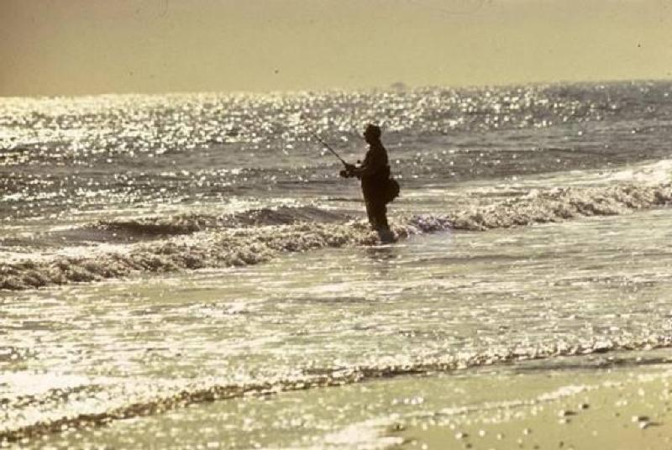

**2015**

**United States Department of the Interior**

**NATIONAL PARK SERVICE**

Gateway National Recreation Area

August, 2015

Dear Visitor:

Thank you for participating in this important study. We want to learn about the expectations, opinions, and interests of visitors to Gateway National Recreation Area. This information will help us improve our management of this park and better serve you, our visitor.

This questionnaire will be given to only a select number of visitors, so your participation is very important! It should only take about 20 minutes to complete after your visit.

When your visit is over, the adult in your group who will have the next birthday should complete this questionnaire. Seal it in the postage-paid envelope provided and drop it in any U.S. Postal mailbox.

If you have any questions, please contact Social Science Program Chief, National Park Service, 1201 Oakridge Drive, Fort Collins, CO, 80525-5596; nps_nrss_social_science@nps.gov (email).

We appreciate your help. Sincerely,

Jennifer Nersesian

Superintendent



|  |
| --- |
| **DIRECTIONS**  At the end of your visit:  1. Please have the adult in your group (at least 18 years old) who has the next birthday complete this questionnaire. That will help give us a statistically reliable sample.  2. For questions that use circles (O), please mark your answer by filling in the circle with ***black or blue ink***. Please do not use pencil.  Description: bubble-fill-example  3. Seal it in the postage-paid envelope provided.  4. Drop it in a U.S. Postal mailbox. |

|  |
| --- |
| **Paperwork Reduction Act Statement:** The Paperwork Reduction Act requires us to tell you why we are collecting this information, how we will use it, and whether or not you have to respond. This information will be used by the National Park Service as authorized by 16 U.S.C. 1a-7. We will use this information to evaluate visitor services and facilities managed by Yosemite National Park. Your responses are voluntary and anonymous. Your name and address have been requested for follow-up purposes only. At the completion of this collection all names and personal information will be destroyed and in no way be connected with the results of this survey. A Federal agency may not conduct or sponsor and you are not required to respond to, a collection of information unless it displays a currently valid OMB Control Number.  **Burden Estimate:** We estimate that it will take an average of 20 minutes to complete the survey associated with this collection of information. You may send comments concerning the burden estimates or any aspect of this information collection to the Social Science Program Chief, National Park Service, 1201 Oakridge Drive, Fort Collins, CO, 80525-5596; nps_nrss_social_science@nps.gov (email). |

**A. Trip Description**

Please have the adult in your group (at least 18 years old) who has the next birthday complete this questionnaire.

**NOTE**: In this questionnaire, **personal group** is defined as you and anyone with whom you visited Gateway National Recreation Area on this trip, such as spouse, family, friends, etc. This does not include the larger group that you might have traveled with, such as school, church, scouts, or tour group.

**TOPIC AREA 1** – GR3

1. Including yourself, how many people were in your personal group on this trip to Gateway National Recreation Area (Gateway)?

________ Number of adults (18 years or over)

________ Number of children (under 18 years)

**TOPIC AREA 1** – GR1

2. On this trip to Gateway, what type of group were you with? Please mark (●) **one**.

O Alone

O Friends

O Family

O Family and friends

O Other (Please specify):

**TOPIC AREA 3** – TRANS1

3. Please indicate all of the forms of transportation you personally used to travel from your home to Gateway, on this trip. Please mark (●) **all** **that apply**.

O Car, truck, or SUV (Number of people in vehicle, including you) ________

O City bus

O Subway or train

O Long-distance passenger bus

O Recreational vehicle or motorhome

O Airplane

O Tour bus or tour van

O Public ferry or other water transportation

O Bicycle

O Walk/hike

O Other (Please specify) ___________________________________________

**TOPIC AREA 1** – VISITHIST3

4. Including today, how many times have you visited the following places in Gateway within the past 12 months? Please enter a number **for each row**.

|  |  |  |  |  |  |
| --- | --- | --- | --- | --- | --- |
| **Place** | | **Number of visits in the past 12 months (including today)** | | | |
| Fort Wadsworth on Staten Island | |  | |  |  |
| Miller Field on Staten Island | |  | |  |  |
| Great Kills Park on Staten Island | |  | |  |  |
| Jamaica Bay Wildlife Refuge in Jamaica Bay | |  | |  |  |
| Floyd Bennett Field in Jamaica Bay | |  | |  |  |
| Jacob Riis Park in Jamaica Bay | |  | |  |  |
| Fort Tilden in Jamaica Bay | |  | |  |  |
| Breezy Point in Jamaica Bay | |  | |  |  |
| Beaches at Sandy Hook | |  | |  |  |
| Fort Hancock at Sandy Hook | |  | |  |  |
| Other (Please specify) |  | |  |  |  | |

**B. Trip Planning**

**TOPIC AREA 1** – KNOW2

5. Prior to this trip, were you and your personal group aware that Gateway is managed by the National Park Service (NPS)?

O Yes

O No

O Not sure

**TOPIC AREA 2** – TPLAN1

6. Prior to this trip, how did you and your personal group obtain information about Gateway? Please mark (●) **all that apply**.

O Did not obtain information prior to this visit

O Friends/relatives/word of mouth

O Inquiry to park via phone, mail, or email

O Gateway website (nps.gov/gate)

O Other website (Please specify) __________________________________________

O App for smartphone/tablet (Please specify) ________________________________

O Local businesses (hotels, motels, restaurants, etc.)

O Maps/brochures

O Newspaper/magazine articles

O Other units of the National Park System

O Previous visits

O School class/program

O Social media (such as Facebook, Twitter, etc.)

O State welcome center/visitors bureau/chamber of commerce

O Television/radio programs/DVDs

O Travel guides/tour books (such as AAA, etc.)

O Other (Please specify) ________________________________________________

**TOPIC AREA 2** – TPLAN2 Variation

7. Did you have the information about Gateway you needed on this trip? Please mark (●) **one**.

O Yes

O No (Please specify information you needed but didn’t have on this trip)

__________________________________________________________________________

____________________________________________________________________

__________________________________________________________________________

**C. Park Activities, Programs, and Services**

**TOPIC AREA 3** – ACT1 & ACT7 VARIATION

8. a) On this trip, which of the following activities, services, and facilities did you personally participate in or use within Gateway? Please mark (●) **all** **that apply**.

b) If you were to visit the park in the future, which of the following activities, services, and facilities would you personally participate in or use within Gateway? Please mark (●) **all** **that apply**.

|  |  |  |
| --- | --- | --- |
| **a)**  **This visit** | **b)**  **Future visit** | **Activity/Service/Facility** |
| O | O | Viewing wildlife, natural features, scenery, wildflowers, etc. |
| O | O | Creative arts (photography, drawing, painting, writing, etc.) |
| O | O | Visiting a cultural or historic site (missile site, lighthouse, fort, etc.) |
| O | O | Visiting a park visitor center or museum |
| O | O | Viewing indoor or outdoor exhibits |
| O | O | Attending a ranger- or volunteer-led activity such as a tour or talk |
| O | O | Walking/hiking |
| O | O | Running/jogging |
| O | O | Sports (baseball, soccer, golf, etc.) |
| O | O | Bicycling |
| O | O | Fishing |
| O | O | Swimming/surfing/windsurfing |
| O | O | Water travel (boating, kayaking, canoeing, sailing, jet skiing, etc.) |
| O | O | Family recreation (family gathering/reunion, visiting playground, etc.) |
| O | O | Participating with a child in your group in the Junior Ranger Program |
| O | O | Picnicking |
| O | O | Camping in developed sites |
| O | O | Attending a special event (concert, festival, etc.) |
| O | O | Other (Please specify) ________________________________________________ |
| O | O | Other (Please specify) ________________________________________________ |
| O | O | Other (Please specify) ________________________________________________ |

**Topic Area 3** – LEARN11 Variation

9. On this visit to Gateway, did you learn anything from park staff, programs, and/or exhibits about American history, nature, and/or culture? Please mark (●) **one**.

O Yes (Please specify subjects you learned about)

O No

**TOPIC AREA** 3– FVIS4

10. If you were to visit Gateway in the future, are there specific subjects you would like to learn about? Please mark (●) **one**.

O Yes (Please specify subjects you would like to learn about)

O No

**Topic Area 1** – GR4

11. a) Did anyone in your personal group have a physical condition that made it difficult to access or participate in park activities or services during your visit to Gateway? Please mark (●) **one**.

O Yes

O No 🡺 **Go to Question 12**

b) If YES, what activities, services, or facilities did the person(s) have difficulty participating in or accessing? Please be specific.

c) Because of the physical condition, which specific difficulties did the person(s) have? Please mark (●) **all** **that apply**.

O Hearing (difficulty hearing ranger programs, bus drivers, audio-visual exhibits or programs, or information desk staff even with hearing aid)

O Visual (difficulty in seeing exhibits, directional signs, visual aids that are part of programs even with prescribed glasses or due to blindness)

O Mobility (difficulty in accessing facilities, services, or programs even with walking aid and/or wheelchairs)

O Other (Please specify) _______________________________________________________

**D. Park Management**

**TOPIC AREA 6** – EVALSERV13 Variation

12. This question requires two responses per listed item.

Please mark (●) **one for the IMPORTANCE** of each of the services or facilities listed below.

Please mark (●) **one for the QUALITY** of the services or facilities that you participated in or used on this trip to Gateway. If you did not participate in or use a service or facility on this trip, please mark (●) **did not participate/use.**

|  |  |  |  |  |  |  |  |  |  |  |  |
| --- | --- | --- | --- | --- | --- | --- | --- | --- | --- | --- | --- |
|  | **IMPORTANCE** | | | | | **QUALITY** | | | | | |
| **Extremely Important** | **Very Important** | **Moderately Important** | **Slightly Important** | **Not Important** | **Very Good** | **Good** | **Average** | **Poor** | **Very Poor** | **Did not participate in/use on this trip** |
| Directional signs in park | O | O | O | O | O | O | O | O | O | O | O |
| Paved or boardwalk bicycle and walking paths | O | O | O | O | O | O | O | O | O | O | O |
| Natural surface walking trails | O | O | O | O | O | O | O | O | O | O | O |
| Campgrounds | O | O | O | O | O | O | O | O | O | O | O |
| Picnic areas | O | O | O | O | O | O | O | O | O | O | O |
| Trash collection | O | O | O | O | O | O | O | O | O | O | O |
| Recycling | O | O | O | O | O | O | O | O | O | O | O |
| Public transportation to the park | O | O | O | O | O | O | O | O | O | O | O |
| Public transportation within the park | O | O | O | O | O | O | O | O | O | O | O |
| Swimming beaches | O | O | O | O | O | O | O | O | O | O | O |
| Fishing | O | O | O | O | O | O | O | O | O | O | O |
| Sports and exercise facilities | O | O | O | O | O | O | O | O | O | O | O |
| In park restaurants/food trucks/bars | O | O | O | O | O | O | O | O | O | O | O |

**TOPIC AREA 6** – EVALSERV6 VARIATION

13. a) Inside Gateway, were the following types of signs adequate? Please mark (●) **one** **for each row**.

|  |  |  |
| --- | --- | --- |
| Directional signs for park facilities (e.g. visitors center, restroom) | O Yes | O No |
| Directional signs for park sites (e.g. beaches, historic sites) | O Yes | O No |
| Interpretive and educational signs | O Yes | O No |
| Signs with park rules and policies | O Yes | O No |

**TOPIC AREA 6** – EVALSERV5

b) If you answered NO to any of the above, please explain the problem.

______________________________________________________________________________

______________________________________________________________________________

______________________________________________________________________________

**TOPIC AREA 6** – OPMGMT7 Variation

14. To what extent do you agree or disagree with each of the following statements? Please mark (●) **one** **for each row**.

|  |  |  |  |  |  |  |
| --- | --- | --- | --- | --- | --- | --- |
|  | **Strongly Agree** | **Agree** | **Neither Agree  nor Disagree** | **Disagree** | **Strongly Disagree** | **Don't Know /  Not Sure** |
| Gateway is a safe place to visit | O | O | O | O | O | O |
| Gateway is too crowded | O | O | O | O | O | O |
| Natural resources in Gateway are in pristine condition | O | O | O | O | O | O |
| Graffiti, vandalism, and crime are a problem in Gateway | O | O | O | O | O | O |
| Historical and cultural features in Gateway are well maintained/ preserved | O | O | O | O | O | O |
| Litter is a problem at Gateway | O | O | O | O | O | O |
| It is easy to find parking at Gateway | O | O | O | O | O | O |

**TOPIC AREA 6** – OPMGMT4 VARIATION

15. It is the National Park Service’s responsibility to protect Gateway’s natural and cultural resources and the visitor experiences that depend on these and to provide recreational opportunities. How important are each of the following resources, experiences, and recreational opportunities for you at Gateway? Please mark (•) only one answer for each resource/experience/recreation opportunity.

|  |  |  |  |  |  |
| --- | --- | --- | --- | --- | --- |
| **Resource/Experience/ Recreation Opportunity** | **Extremely**  **Important** | **Very Important** | **Moderately Important** | **Somewhat Important** | **Not at All Important** |
| Outdoor recreation facilities (trails, boat ramps, fishing areas, etc.) | O | O | O | O | O |
| Family and group recreation facilities (picnic areas, playgrounds, etc.) | O | O | O | O | O |
| Group or team sports and exercise | O | O | O | O | O |
| Individual sports and exercise | O | O | O | O | O |
| Fishing areas | O | O | O | O | O |
| Beaches | O | O | O | O | O |
| Dark night skies/stars | O | O | O | O | O |
| Historic features/buildings | O | O | O | O | O |
| Interpretive/educational programs | O | O | O | O | O |
| Native wildlife and plants | O | O | O | O | O |
| To escape urban settings | O | O | O | O | O |
| Reflection or contemplation | O | O | O | O | O |

**TOPIC AREA 6** – EVALSERV1

16. Overall, how would you rate the quality of the facilities, services, and recreational opportunities in Gateway? Please mark (●) **one**.

O Very good

O Good

O Average

O Poor

O Very poor

**E. Expenditures on This Trip**

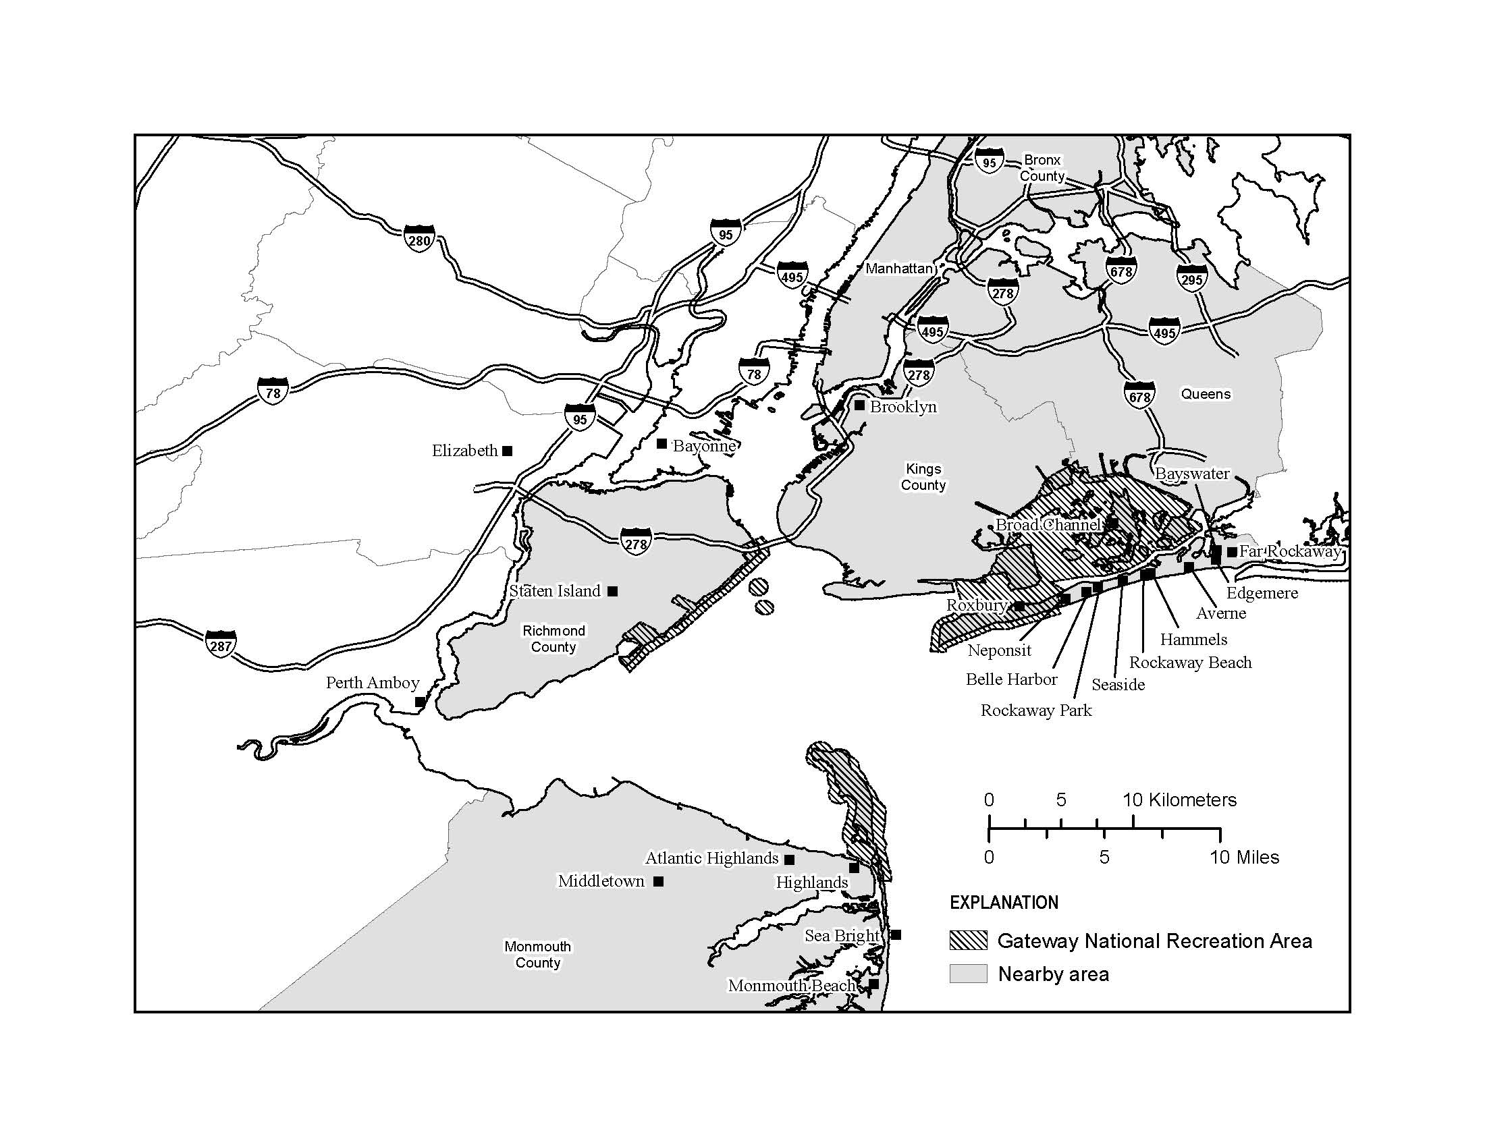Please refer to the enclosed map when answering the questions in this section.

**TOPIC AREA 1** – RES1 Variation

17. Do you live within the highlighted area shown on the enclosed map? Please mark (●) **one**.

O Yes

O No

**TOPIC AREA 3** – TRIPC3

18. a) On this trip to Gateway and the nearby area, did you stay overnight away from your permanent residence either inside Gateway or within the nearby area (within the highlighted area of the enclosed map)? Please mark (●) **one.**

O Yes

O No 🡺 **Go to Question 19**

b) If **YES**, please list the number of nights you stayed in Gateway and/or in the nearby area (within the highlighted area of the enclosed map) on this trip.

|  |  |
| --- | --- |
| **Accommodation** | **Number of Nights** |
| Camping in Gateway | ________ |
| Camping outside Gateway | ________ |
| Lodging outside Gateway | ________ |
| Cruise ship | ________ |
| Other accommodations (e.g., friends/relatives) | ________ |

**TOPIC AREA 3** – TRIPC1 Variation

19. Was this trip to Gateway? Please mark (●) **one**.

O Your primary or sole purpose of your trip away from home?

O One of several equally important destinations on your trip away from home?

* Was one or more of the other equally important destinations located within the nearby area (within the highlighted area of the enclosed map)? Please mark (●) **one**.

O Yes

O No

O Just an incidental or spur of the moment stop on your trip away from home?

* Was your primary destination located within the nearby area (within the highlighted area of the enclosed map)? Please mark (●) **one**.

O Yes

O No

**Topic Area 3** – TRIPC19 Variation

20. Did you visit any other National Park Service sites on your trip away from home? Please mark (●) **one**.

O Yes (Please specify) ________________________________________________________

O No

**TOPIC AREA 7** – ECON

21. a) Did you or anyone in your personal group purchase any package tours that included at least some meals, some lodging, and/or some transportation while on this trip?

O Yes

O No 🡺 **Go to Question 22**

b) What was the total length of your package tour(s)? #____________days

c) What was the total cost per person for the package tour(s)? $___________per person

d) How many people in your personal group were on the package tour(s)? #____________people

e) Which of the following were included in the package tour(s) as part of your visit to Gateway and the nearby area (within the highlighted area of the enclosed map)? Please mark (●) **all** that apply.

|  |  |
| --- | --- |
|  | Items included in your package tour(s) as part of your visit to Gateway and nearby area |
| Local Air transportation | O |
| Local Ground transportation | O |
| Local Water transportation | O |
| Local Lodging | O |
| Meals | O |
| Guide services | O |
| Fees (e.g., fishing licenses) | O |
| Gear (e.g., camping equipment, bikes, kayaks) | O |
| Admission to events or attractions | O |
| Other (please specify):___________________ | O |

**TOPIC AREA 7** – ECON4

22. Please estimate how much you and your personal group with whom you shared expenses (e.g., other family members, traveling companions) spent both inside Gateway and within the nearby area (within the highlighted area of the enclosed map) during your time in Gateway and the nearby area. If you reported expenditures for package tours, please only include individual expenses that were NOT part of your package tour(s).

If you no longer have your receipts, estimate as closely as you can how much you and your group spent. Please enter 0 (zero) if you did not spend any money in a particular category.

**Note**: Residents living within the highlighted area of the map should only include expenditures that were directly related to this trip to Gateway.

|  |  |
| --- | --- |
| **Expenses** | **Amount spent in Gateway and nearby area** |
| Park entrance fee/parking pass | $________ |
| Gas and oil (e.g., auto, RV, boat, etc.) | $________ |
| Rental cars | $________ |
| Taxis, Uber, shuttles, and public transportation | $________ |
| Restaurants, food trucks, and bars | $________ |
| Groceries and convenience foods | $________ |
| Hotels, motels, resorts | $________ |
| Specialty lodging (e.g., B&Bs, hostels, cabins, vacation rentals) | $________ |
| Camping fees (tent, RV) | $________ |
| Recreation and entertainment expenses (e.g., beach clubs, Aviator event center, miniature golf, etc.) | $________ |
| Souvenirs, clothing, supplies, other retail | $________ |
| Equipment rental | $________ |
| Guides and tour fees | $________ |
| Other (please list)____________________ | $________ |

**OR**

O Don’t know/Not sure

**TOPIC AREA 7** – ECON6 Variation

23. For you and any members of your personal group with whom you shared expenses, please record any additional money spent outside of the map area during your trip away from home (for example, travel or food expenditures).

$ ________

**OR**

O Don’t know/Not sure

**TOPIC AREA 7** – ECON5

24. a) Including yourself, how many people in your personal group were covered by the expenses for this trip away from home?

________ Number of adults (18 years or over)

________ Number of children (under 18 years)

b) Including yourself, how many people in your group split these trip expenses?

­­­­________ Number of people

**F. Background**

**TOPIC AREA 1** – AGE1

25. For your personal group during your visit to Gateway on the day you were contacted for this survey, please provide the following. (If you do not know the answer, enter “DK.”)

|  |  |  |  |  |
| --- | --- | --- | --- | --- |
|  | Current  age | U.S. ZIP code or name of country other | Number of visits to Gateway past 12 months, including this trip | Number of visits to other NPS sites in the last 12 months |
| Yourself | ________ | ________ | ________ | ________ |
| Member #2 | ________ | ________ | ________ | ________ |
| Member #3 | ________ | ________ | ________ | ________ |
| Member #4 | ________ | ________ | ________ | ________ |
| Member #5 | ________ | ________ | ________ | ________ |
| Member #6 | ________ | ________ | ________ | ________ |
| Member #7 | ________ | ________ | ________ | ________ |

**TOPIC AREA 1** – GEND1, RACE/ETH1

26. For your personal group during your visit to Gateway on the day you were contacted for this survey, please provide the following information. Please mark (●) **one for each group member, including yourself, for gender and Hispanic or Latino. (If you don’t know the answer, mark** (●) **“Don’t know.”)**

|  |  |  |  |  |  |  |  |  |
| --- | --- | --- | --- | --- | --- | --- | --- | --- |
|  |  | | Additional members of your personal group | | | | | |
|  | **Yourself** | **#2** | | **#3** | **#4** | **#5** | **#6** | **#7** |
| Male | O | O | | O | O | O | O | O |
| Female | O | O | | O | O | O | O | O |
| Hispanic or Latino | O | O | | O | O | O | O | O |
| Not Hispanic or Latino | O | O | | O | O | O | O | O |
| Don’t know | --- | O | | O | O | O | O | O |

**TOPIC AREA 1** – RACE/ETH3

27. For your personal group during your visit to Gateway on the day you were contacted for this survey, please provide the following information. Please mark (●) **one or more for each group member, including yourself**. **(If you don’t know the answer, mark** (●) **“Don’t know.”)**

|  |  |  |  |  |  |  |  |
| --- | --- | --- | --- | --- | --- | --- | --- |
|  | **Yourself** | **#2** | **#3** | **#4** | **#5** | **#6** | **#7** |
| American Indian or Alaska Native | O | O | O | O | O | O | O |
| Asian | O | O | O | O | O | O | O |
| Black or African American | O | O | O | O | O | O | O |
| Native Hawaiian or other Pacific Islander | O | O | O | O | O | O | O |
| White | O | O | O | O | O | O | O |
| Don’t know | - | O DK | O DK | O DK | O DK | O DK | O DK |

**Topic Area 1** – ED2 Variation

28. For your personal group during your visit to Gateway on the day you were contacted for this survey, what is the highest level of formal education completed by each member of your group? Please mark (●) **one or more for each group member, including yourself**. **(If you don’t know the answer, mark** (●) **“Don’t know.”)**

|  |  |  |  |  |  |  |  |
| --- | --- | --- | --- | --- | --- | --- | --- |
|  | **Yourself** | **#2** | **#3** | **#4** | **#5** | **#6** | **#7** |
| Less than high school | O | O | O | O | O | O | O |
| Some high school | O | O | O | O | O | O | O |
| High school graduate or GED | O | O | O | O | O | O | O |
| Some college, business, or trade school | O | O | O | O | O | O | O |
| College, business, or trade school graduate | O | O | O | O | O | O | O |
| Some graduate school | O | O | O | O | O | O | O |
| Master’s, doctoral, or professional degree | O | O | O | O | O | O | O |
| Don’t’ know | **-** | O DK | O DK | O DK | O DK | O DK | O DK |

**Topic Area 7** – ECON1

29. Which category best represents your annual household income? Please mark(●) **one**.

O Less than $24,999

O $25,000-$34,999

O $35,000-$49,999

O $50,000-$74,999

O $75,000-$99,999

O $100,000-$149,999

O $150,000-$199,999

O $200,000 or more

O Do not wish to answer

**Topic Area 7** – ECON1

30. Including yourself,how many people are in your household?

________ Number of people

**Topic Area 1** – LANG1

31. When visiting an area such as Gateway, what language do you personally prefer to use? Please mark(●) **one for speaking and one for reading**.

|  |  |  |
| --- | --- | --- |
|  | **Speaking** | **Reading** |
| English | O | O |
| Spanish | O | O |
| Other (Specify) _________________________ | O | O |

**TOPIC AREA 6** – OPMGMT3

32. Is there anything else you would like to tell us about Gateway facilities, services, or recreational opportunities?

_______________________________________________________________________

_______________________________________________________________________

_______________________________________________________________________

**Thank you for your help! Please seal the questionnaire in the postage-paid envelope and drop it in any U.S. Postal mailbox.**