OMB Control Number 1024-0224
Expiration Date: 10-31-2015



Great Smoky Mountains National Park
Creel Survey

http://www.nps.gov/grsm/naturescience/creelsurvey.htm

Paperwork Reduction and Privacy Act Statements: The National Park Service is authorized by 16 U.S.C. 1a-7 to collect this information. We will use this information to learn more about angler fishing experiences at Great Smokey Mountain National Park. Your response is voluntary and anonymous. Your name will never be associated with your responses. You may quit at any time by simply closing the web browser A Federal agency may not conduct or sponsor, and you are not required to respond to, a collection of information unless it displays a currently valid OMB Control Number.

BURDEN ESTIMATE Statement: Public reporting burden for this collection is estimated to be 3 minutes per response. This includes the time that it takes for you to navigate to the survey and the time to complete the entire questionnaire. Please direct your comments regarding any other aspect of this collection to Matt Kulp at matt_kulp@nps.gov (email).

Anger Creel Survey Overview:
An angler creel survey is a record of a single days fishing effort, providing details on what an angler caught, released and how much time was spent fishing. The purpose of this survey is to provide information on the numbers and sizes of fish caught and harvested in Great Smoky Mountain National Park (GRSM) streams.

Instructions on How to Fill Out an Angler Creel Survey:
- Anglers should fill out a survey once they return from their trip.

- One survey should be completed per person for each day fished. For example, if you fished for three hours after work, you would fill out one survey for that day. If you fished in the morning and then again in the evening of the same day, you would fill out one survey totaling the hours you fished that day. If you go on a backcountry trip and fish for 4 days, then you would fill out four separate surveys for each day you fished.

Note to reviewer: For each question, there would be a holdover box with the extra information (printed in italics) that will be used to provide additional information to help the respondent understand the question.

To complete the survey, please answer the following questions:

- Date: When did you fish at GRSM? Fill in the date you fished (please complete one survey for each day you fished at GRSM).

- Location fished: Where did you fish? Please list the name of stream you fished that day. If multiple streams were fished on the same day, please fill out one survey for each stream fished. If you do not know the name of the stream, name the watershed or closest landmark you are aware of.)

- What state are you from: What is your current state of residence.

- Do you live within 50 miles of the GRSM Park: Check ‘Yes’ or ‘No’ if you live within 50 miles of the park?

- Time started fishing: What time did you start fishing (ex. 9:00am)?

- Time ended fishing: What time did you finish fishing (ex. 3:00pm)?

- Hours fished: How many hours did you actually fish that stream that day? (Do not include hours hiking or driving to the stream, eating lunch, etc.)

- Did you fish catch and release? Did you practice ‘catch and release’ when fishing or did you harvest fish? (Note: GRSM does not encourage or discourage ‘catch and release’, but would like to track this angling trend over time.

- Number of fish released: How many fish did you catch, unhook and throw back while fishing?

- Number of fish kept: How many fish did you keep to take home?

- What was the Species of fish kept? What was the species (ex. brook, brown or rainbow trout and/or rock or smallmouth bass (If unsure, please see pictures below for species identification)? What was the total length of each fish kept

- What was length of fish kept? [Total length is measured from the tip of the nose to the longest length on the tip of tail when pinched together. Total length can be in inches (to ¼ of inch) or centimeters (to 1/10 of cm).]

- Were you interviewed in the field today? : Did an NPS ranger or NPS volunteer interview you in the field and tell you about the online creel survey form? Check box for ‘Yes’.

SUBMIT: Once all data is correctly entered, click on the ‘Submit’ button to send in your creel survey.

Thank you for taking time to fill in the survey!

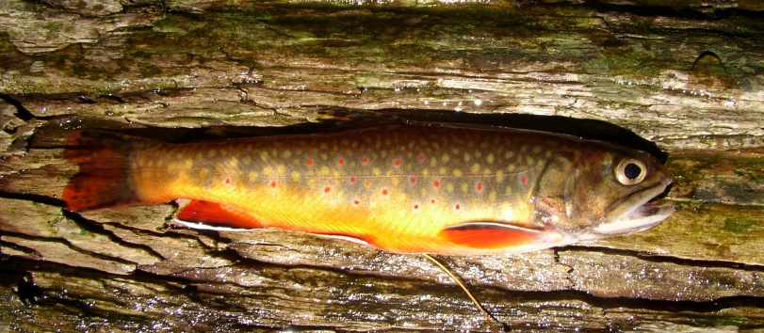
Brook Trout: Light spots on a dark body with worm-like vermiculation’s across its back. Will have tri-colored fins colored in orange, black and white edges, and may also have red coloring in its dorsal fin.

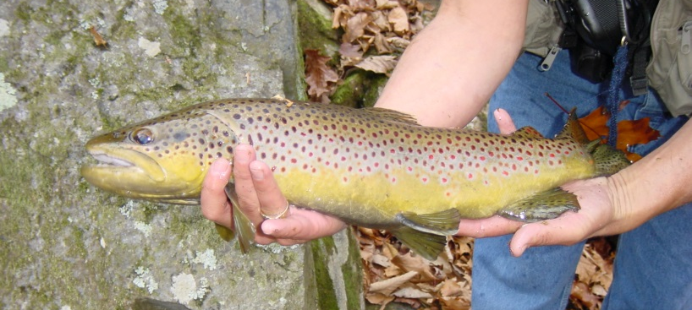
Brown Trout: Dark or red spots on a light body surrounded by white halos and may have white edged fins.

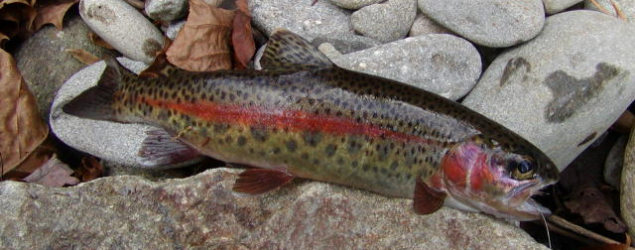
Rainbow Trout: Dark spots on a light body with a large pink stripe down the side. Some fish may also have a pink or red cheek patch and may also have white tips to some fins.

