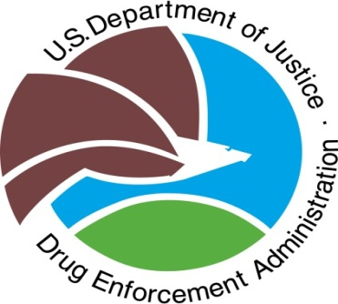
US DepartmentJustice
Drug EnforcementAdministion
Red Ribbon Week Patch
Activity Report

This form certifies your completion of all program requirements.
Complete this online form by Friday October 31, 2014 to receive your DEA Red Ribbon Week Patches.

Scout unit or troop number Council Name ____

Troop’s mailing address (print) ____

City State Zip Code ____
To ensure that you receive the patches, please enter the address where you would like to receive the patches. Make certain that the address has a valid street number, city, state and zip code or APO address.
Troop’s e-mail address (Print): ________________________________________________________

Number of Boy Scouts or Girl Scouts that attended the anti-drug prevention session: ______________
Number of Boy Scouts or Girl Scouts that took the drug free pledge: ___________________________
Number of patches requested for your troop or unit: ____

Please describe the Red Ribbon Week activity/event your troop or unit sponsored:

Approximately how many participants attended your Red Ribbon Week activity? _____

Did you partner with anyone? Yes No _

If so, please mark all that apply:

Business/Corporation
School
Government Agency (city, county, state, or federal)
Civic organization/non-profit
Faith-based organization
Coalition
Other

Please describe the anti-drug prevention education session attended by the scouts (i.e. discussion, lecture, etc.):

Are you planning to participate in next year’s Red Ribbon Week? Yes No

Is there anything that you recommend to improve DEA’s Red Ribbon Week Patch program for next year?

SUBMIT

