OMB No. 1117- EXP DATE:
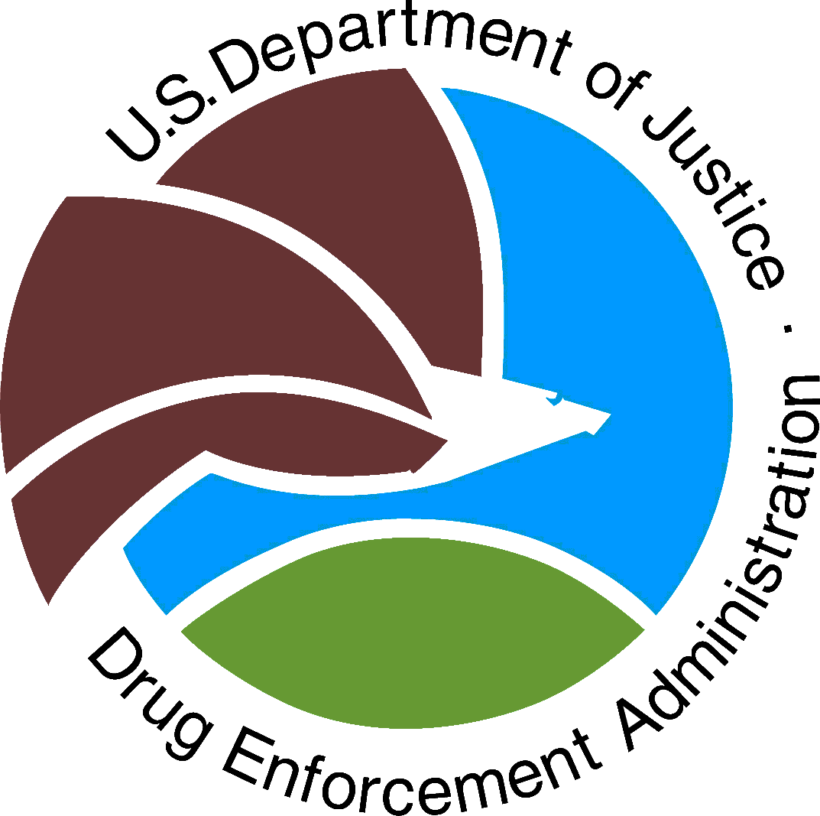 | US Department of Justice  Drug Enforcement Administration  Red Ribbon Week Patch  Intent to Participate | 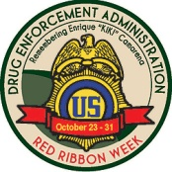
Scouting troops or units MUST submit this form to ensure patches are available.
Scout unit or troop number: _________ Council Name: _______________________________
City: ___________________________ State: _______________________________________
Troop’s e-mail address (print): ___________________________________________________
Number of Scouts in troop or unit intending to participate: _____________________________

Please mark as appropriate:
________Boy Scout unit
________Girl Scout unit

**Please note, in order to receive your DEA Red Ribbon Week Patches, the leader or contact
person MUST complete the Activity Report upon completion of all program requirements.

DEA-316

