The following non-substantive changes were made to the sister forms EOIR-31 (OMB# 1125-0012) and EOIR-31A (OMB# 1125-13) to provide clarity to the user, update addresses, and correct errors in the text:
Form EOIR-31 (OMB# 1125-0012):
- The “0001” was removed from the zip code of the mailing address to conform to the address on the EOIR-31A;
- The word “local” was removed from the USCIS and ICE proof of service boxes to conform to the information on the EOIR-31A;
- The Proof of Service instructions at the bottom of the first page were changed to read:
A complete copy of this application and any request for accreditation as well as all supporting documents must be served on the local District Director for U.S. Citizenship and Immigration Services (USCIS) of DHS and the local Chief Counsel for Immigration and Customs Enforcement (ICE) of DHS in the who have jurisdiction where the over the area in which the organization is located. To identify the appropriate DHS offices, consult the USCIS and ICE websites or a DHS office.
((These changes were made to conform to the instructions on the EOIR-31A, in response to a public comment received that was related to the same language on the EOIR-31A))

Form EOIR-31A (OMB# 1125-0013):
- The mailing address on the first page was changed as follows, as the PO box is no longer valid:
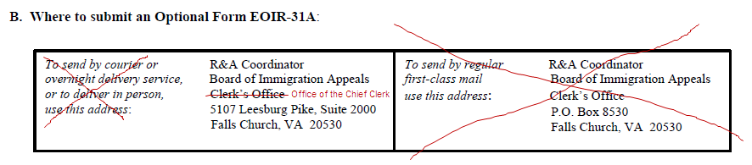

- Part 6. Attestations: The individual for the Officer of Organization was changed from “proposed representative” to “officer of organization”. This was our original intent, but due to an oversight, a typographical error in the language resulted in “proposed representative” being duplicated in both the Officer of Organization attestation and Proposed Representative attestation.

- Part 5. Item 3. The word “or” was changed to “and” in the following sentence to more accurately reflect the requirements (see EOIR-31, pg. 1, instructions for accreditation):
Full accreditation also requires documentation demonstrating the applicant possesses the essential skills for effective litigation. Attach documents showing relevant education, training, or and experience.

