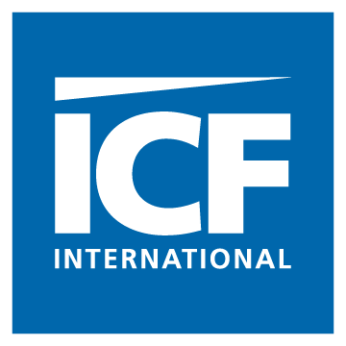

Date

<Recipient Name>
<Recipient Title>
<Organization Name>
<Organization Street Address>
<City, State Zip>

Greetings <Recipient>,

The U.S. Department of Labor’s (DOL) Employee Benefits Security Administration (EBSA) is seeking to explore current practices and the effects of a recent regulation by conducting focus groups related to the regulation. ICF International is helping with this focus group project, which is funded by the DOL. I am contacting you because your organization is impacted by these regulations, therefore your input will be valuable. Specifically, organizations that provide retirement plans as an employee benefit are most impacted by the regulation; accordingly, we are interested in gathering input from the individual who is primarily responsible for making decisions for your organization’s retirement plan.

The project is titled, “Evaluating the Effectiveness of the 408(b)(2) Disclosure Requirements” and is designed to understand the effects of EBSA’s recently implemented regulation known as Section 408(b)(2), which requires service providers to disclose specified information to retirement plan sponsors or other fiduciaries. In addition, EBSA intends to gather information about the need for a summary or guide to help plan sponsors or other fiduciaries with the disclosures. Accordingly, we will hold focus groups with retirement plan sponsors or fiduciaries in order to gather feedback about their experience with the regulation.

The focus group does not require any preparation on your part, but reviewing or bringing the disclosures you have received from your plan’s service providers would be helpful to you. We simply ask that you join approximately eight other focus group participants at <location> to respond to questions and discuss your reactions. That’s it!

Please email agyabaah@icfi.com or call 703.225.2201 to confirm your participation in this event. Once again, your input is very important; thank you in advance for your participation.

If you have questions, please contact Dr. Jon Hecht at 703.934.3411

Sincerely,
Akua Gyabaah
Technical Specialist

