Appendix A – ATUS Sleep Measures Online Study Protocol
Welcome!
Thanks for your interest in our research. We’re conducting this study to better understand how people spend their time as it relates to <JOBS AND EMPLOYMENT / HEALTH AND WELLNESS / CONTROL FRAMING>.

…Work and work-related activities. We will use this information to estimate the amount of time people spend working and doing other related activities. [JOB FRAMING]

…Health and wellness-related activities, such as exercise, sleep, and leisure activities. We will use this information to estimate the amount of time people spend doing healthy activities. [HEALTH FRAMING]

…How people spend their time. [CONTROL]

Unlike some surveys or online tasks, we ask that you complete this task all at one time. Please begin only when you are in a quiet place where you won't be disturbed for about 20 minutes.
Please do not use your browser's back button.

This voluntary study is being collected by the Bureau of Labor Statistics under OMB No. 1220-0141. We will use the information you provide for statistical purposes only. Your participation is voluntary, and you have the right to stop at any time. This survey is being administered by Qualtrics and resides on a server outside of the BLS Domain. The BLS cannot guarantee the protection of survey responses and advises against the inclusion of sensitive personal information in any response. By proceeding with this study, you give your consent to participate in this study.

Select ‘Next’ to continue
---page break---
Diary Introduction
On the next few pages, you will be prompted to think back to the last 24 hours, starting at 4 am yesterday morning and continuing through 4 am TODAY <INSERT DATE>. Please think back to each activity you did in as much detail as possible and what time you started and ended each activity. By activity, we mean anything you did during that time frame.
[Definition condition only]: Here are some examples of what we mean by activities:
- Work and work-related activities: By work and work-related activities, we mean time spent working, doing activities as part of one’s job, engaging in income-generating activities, and looking for jobs and interviewing. It does not include regular breaks, lunch breaks, or commuting to and from work.
- Sleeping: By sleep, we mean the number of hours you actually spend sleeping. This may be different from the number of hours you spend in your bed, time you spend preparing to go to sleep, resting with your eyes closed but not actually asleep. Please include any times you were sleeping during the day (or napping).
- Sports, exercise, and recreation: By sports and recreation, we mean organized physical activities that may be competitive in nature. By exercise, we mean activities that require physical exertion for fitness purposes.
On the next screen, you will be asked to select the type of activity you did from a drop-down list and what time you started and stopped that activity. If you don’t see the activity you were doing, please select ‘Other Activity’.
Please be sure to account for your whole day, so the end time of one activity should be the start time of the next activity. There should not be any gaps.
Below is an example of a completed version of how the activity log should appear:

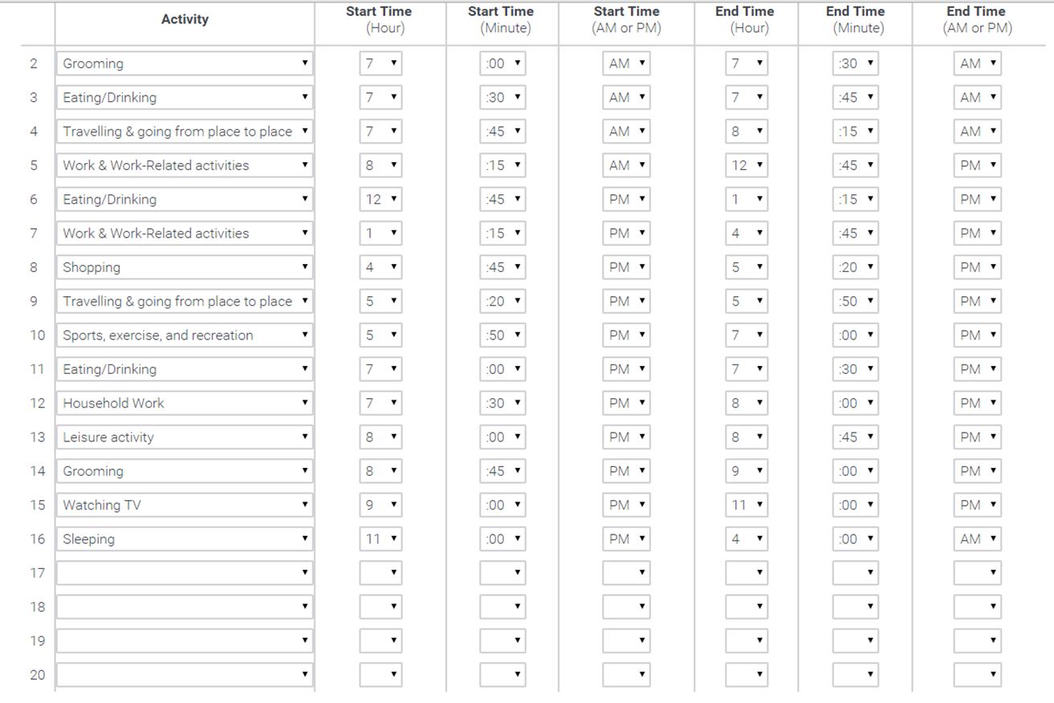
*Note that the drop-down menus for this study includes the digits 0-12 for hour, and the digits 0-60, in intervals of 5, for minutes. When we ask for clock time, we will use the singular (i.e., hour, minute) to signify a precise start and stop time. When we ask for duration, we will use the plural (i.e., hours, minutes) to signify to participants that they should indicate the number of hours and minutes they spent on an activity.

Select ‘Next’ to continue
---page break---

Think back to 4:00 am YESTERDAY morning.
Please select the activity that you were doing.
[Drop-down menu]:
- Sleeping
- Grooming
- Watching TV
- Work and Work-Related Activities
- Eating and Drinking
- Household work
- Shopping
- Traveling and going from place to place
- Leisure activity
- Sports, exercise, and recreation
- Studying or learning
- Other activity, specify: ___________
Think back to what time you stopped doing that activity.
Enter what time this activity ENDED:
hour: ___; minute ___ ; _____ AM/PM

---page break---
Thank you. Please fill out what you did next until 4 am this morning <INSERT DATE>. Please remember to account for your whole day, so the end time of one activity should be the start time of the next activity. There should not be any gaps.

<Participants will be presented with a 20-row matrix of drop-down menus (as seen above in the image of the Time Diary) where they can enter each activity they did, including start and stop times, for the remainder of the 24-hour period>

---page break---
Last Week Stylized Questions Instructions
Thank you for completing the activity log. Next, we’d like to know more about your activities during the previous week, that is, during the past 7 days from <DATE> to <DATE>.
Please think carefully before giving your answers and be as accurate and as specific as possible.

Select ‘Next’ to continue
---page break---

1.) [INSERT DEFINITION IF IN DEFINITION CONDITION]___Thinking back to the past week (that is, during the previous <DATE> to <DATE>), how many hours did you work, or engage in work-related activities? _____hours; _____ minutes
2.) How many hours per week do you usually work at your main job (or engage in work-related activities)? ____ hours; ____ minutes

3.) During the past week, on average, at what time did you start working each day?
____ hour; ____ minute; _____ AM/PM
4.) During the past week, on average, at what time did you stop working each day?
____ hour; ____ minute; _____ AM/PM

---page break---

1.) [INSERT DEFINITION IF IN DEFINITION CONDITION] Thinking back to the past week (that is, during the previous 7 days), how many hours did you engage in sports, exercise, or other recreational activities? ___ hours; ____ minutes

2.) How many hours per week do you usually engage in sports, exercise, or other recreational activities? ___ hours; ____ minutes
---page break---

1.) Thinking back to the past week (that is, during the previous 7 days), how many hours did you engage in household chores and other cleaning activities? ___ hours; ____ minutes

2.) Thinking back to the past week (that is, during the previous 7 days), how many hours did you use technological devices connected to the Internet, such as your personal computer, cellular phone, tablet, or e-Reader, for leisure (non-work related) purposes? ___ hours; ____ minutes

3.) Thinking back to the past week (that is, during the previous 7 days), how many hours did you spend traveling and going from place to place, such as commuting to and from work and other places? ____ hours; ____ minutes
---page break---

1.) [INSERT DEFINITION IF IN DEFINITION CONDITION]Thinking back to the past week (that is, during the previous 7 days), how many hours of sleep did you get on average each weeknight (excluding weekends)?
____ hours; ____ minutes
2.) During the past week, on average, at what time did you fall asleep each weeknight (excluding weekends)?
____ hour; ____ minute; ____AM/PM
3.) During the past week, on average, at what time did you wake up each weeknight (excluding weekends)?
____ hour; ____ minute; ; _____ AM/PM

4.) During the past week, did you take any naps during the weekdays? By naps, we periods of short sleep episodes during the day.
- Yes
- No
5.) (If yes), During the past week, how many naps did you take during the weekdays? ____
6.) During the past week, on average, how long did your nap(s) last?
____ hours; ____ minutes
---page break---

1.) The previous questions asked about your sleep over the past week. Now we’d like to know about your sleep in general. How many hours do you sleep on a typical weeknight?
___ hours; ___ minutes

Follow-up Questions
1.) How confident are you in the estimate you gave of the number of hours you slept on average each weeknight during the past week, from <DATE> to <DATE>?
- Extremely confident
- Very confident
- Moderately confident
- Slightly confident
- Not at all confident
2.) Do you usually wake up at the same time every weekday morning?
- Yes
- No
3.) Do you usually go to sleep at the same time every weeknight?
- Yes
- No
4.) How many hours do you think is appropriate for an average person, with a similar schedule to yours, to sleep in one night?
_____ hours; ____ minutes
5.) How many hours do you think most people would have to sleep before feeling embarrassed for sleeping too MUCH in one night? ____ hours; ____ minutes
6.) How embarrassing do you think it would be for most people to admit they slept more than <Insert Answer from #5> hours in one night?
- Extremely embarrassing
- Very embarrassing
- Moderately embarrassing
- Slightly embarrassing
- Not at all embarrassing
7.) How few hours do you think most people would have to sleep before feeling embarrassed for sleeping too LITTLE in one night? ____ hours; ____ minutes
8.) How embarrassing do you think it would be for most people to admit they slept fewer than <insert answer from #6> hours in one night?
- Extremely embarrassing
- Very embarrassing
- Moderately embarrassing
- Slightly embarrassing
- Not at all embarrassing
---page break---

Thank you for completing the previous section. We’re almost done – please answer the following questions about yourself.
Balanced Inventory of Socially Desirable Responding

1 2 3 4 5
(strongly disagree) (strongly agree)

- I sometimes tell lies if I have to.
- I never cover up my mistakes.
- I always obey laws, even if I am unlikely to get caught.
- I have said something bad about a friend behind his or her back.
- When I hear people talking privately, I avoid listening.
- I have received too much change from a salesperson without telling him or her.
- When I was young I sometimes stole things.
- I have done things that I don’t tell other people about.
- I never take things that don’t belong to me.
- I don’t gossip about other people’s business.

---page break---
Time Crunch Scale
Please answer the following questions about yourself.
How frequently do you feel rushed?
- Always
- Often
- Sometimes
- Rarely
- Never
How frequently do you have time on your hands that you didn’t know what to do with?
- Always
- Often
- Sometimes
- Rarely
- Never
(All questions below will appear on a ‘Yes’ or ‘No’ scale)
1.) Do you plan to slow down in the coming year?
2.) Do you consider yourself a workaholic?
3.) When you need more time, do you tend to cut back on your sleep?
4.) At the end of the day, do you often feel that you have not accomplished what you had set out to do?
5.) Do you worry that you don’t spend enough time with your family or friends?
6.) Do you feel that you’re constantly under stress trying to accomplish more than you can handle?
7.) Do you feel trapped in a daily routine?
8.) Do you feel that you just don’t have time for fun anymore?
9.) Do you often feel under stress when you don’t have enough time?
10.) Would you like to spend more time alone?

---page break---

Demographic information
1.) Which of the following best describes you?
  - Employed full time
  - Employed part time
  - Unemployed
  - Student
  - Retired

2.) What is your gender?
- Male
- Female
- Other

3.) What is your age as of today?
____ years

4.) What is your household size? By household, we mean the number of people currently living in your residence, including yourself.
- 1 person (including yourself)
- 2 people
- 3 people
- 4 people
- 5 or more people

5.) How many of the <insert answer from #4> people in your household are under the age of 16?
6.) How many of the <insert answer from #4> people in your household are under the age of 5?
7.) How personal a topic do you think it is for most people to talk about how much they sleep?
- Not at all personal
- A little personal
- Moderately personal
- Very personal
- Extremely personal
8.) Is talking about how much you sleep a sensitive topic for you?
- No
- Somewhat
- Yes

9.) (If Yes or Somewhat), How sensitive a topic is it for you to talk about how much you sleep?
- A little sensitive
- Moderately sensitive
- Very sensitive
- Extremely sensitive
Please explain (optional): ________________________
10.) How well-rested do you feel right now?
- Very rested
- Somewhat rested
- A little rested
- Not at all rested

---page break---
Thank you for your participation! If you have any additional thoughts on this survey, please provide them in the space below. ______________

