Appendix C: Screenshots of Electronic Diaries

VERSION 1
Sign-in screen.
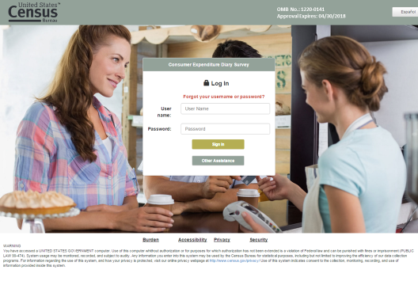

Main data collection screen
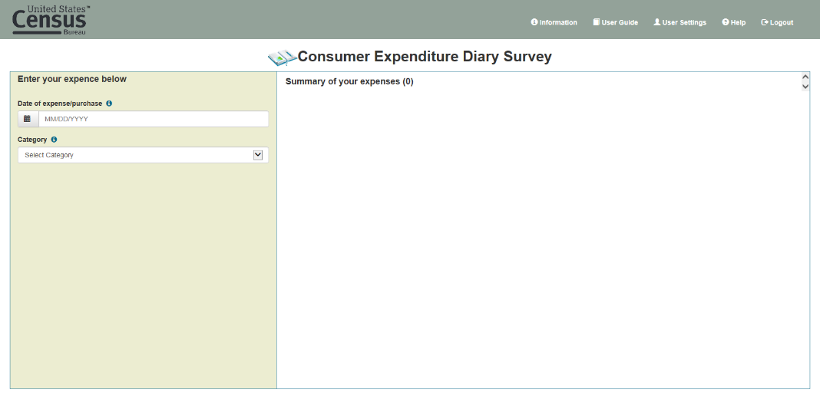

Example expense data collection fields (Food & Drinks Away From Home)
Example expense data collection fields (Food & Drinks Away From Home)
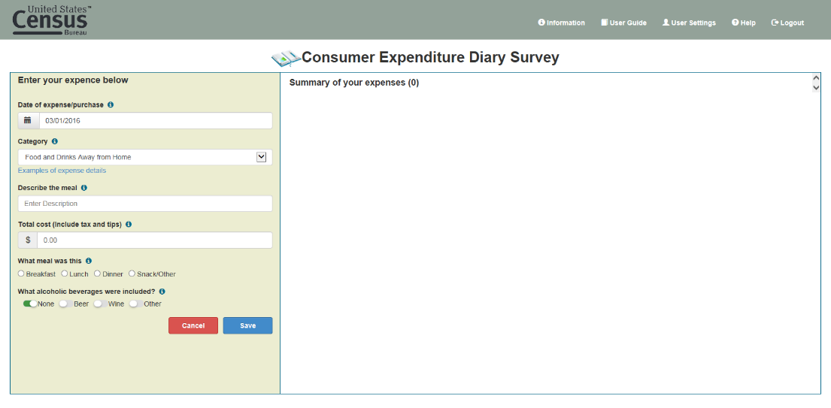

Example expense data collection fields (Food & Drinks For Home Consumption)
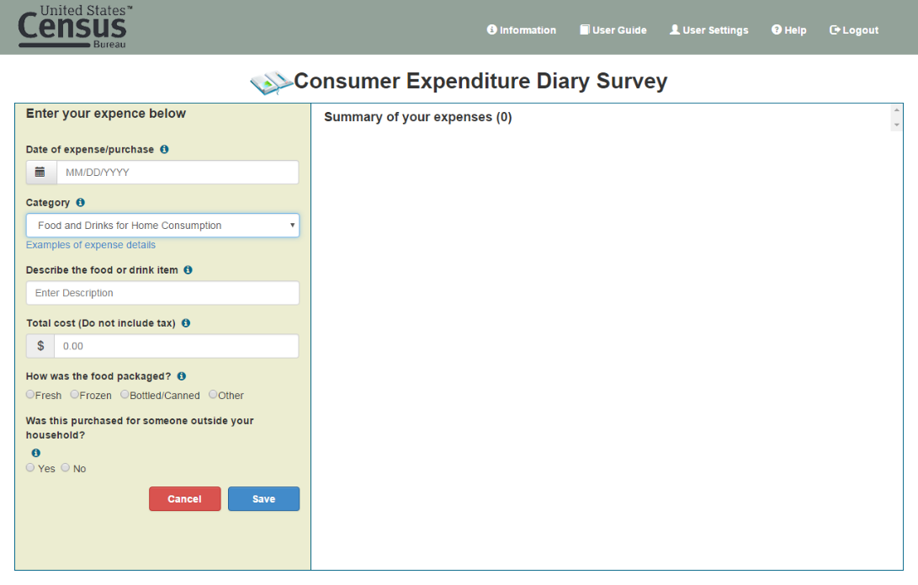

Example expense data collection fields (Clothing, Shoes, Jewelry, & Accessories)
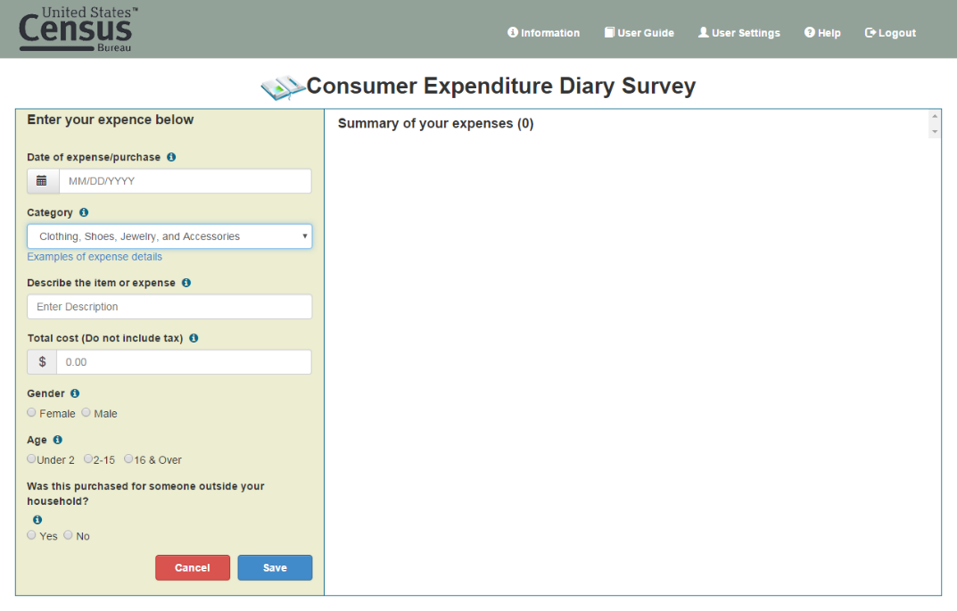

Example expense data collection fields (All Other Categories)
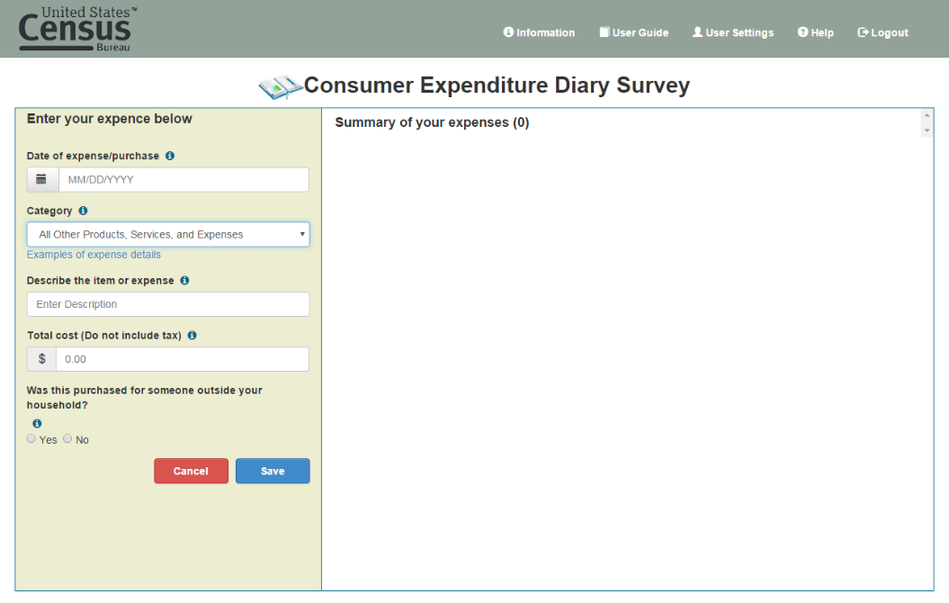

Example expense enter and new expense data collection fields
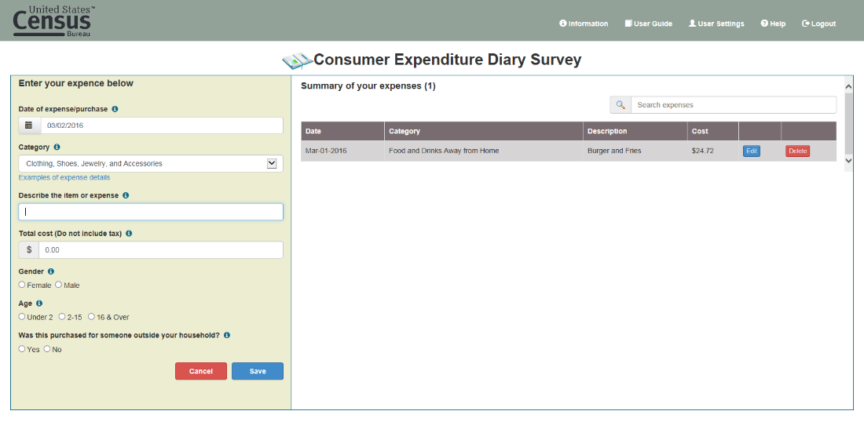

Example edit of entered expense
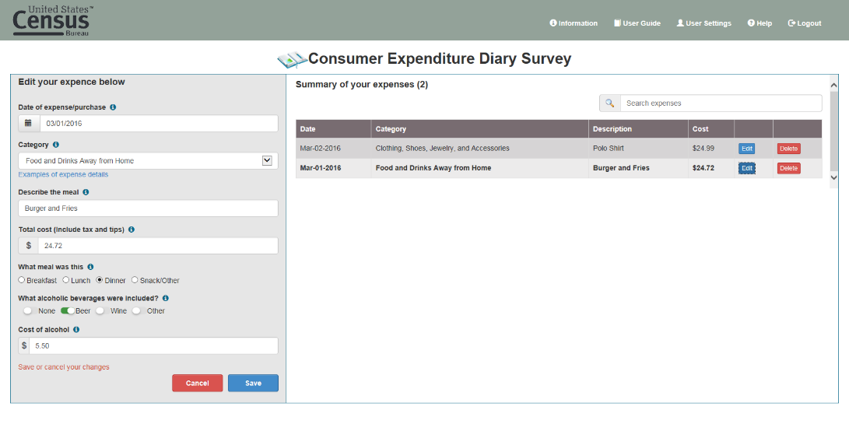

VERSION2
Sign in screen
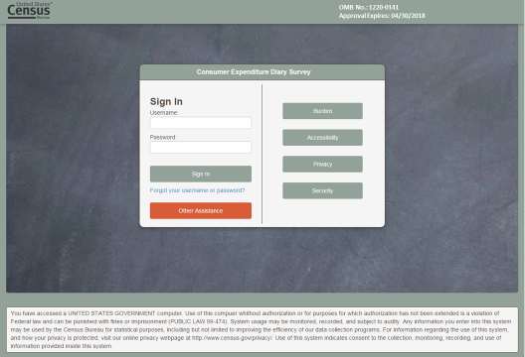

Expense day selection and summary expense screen
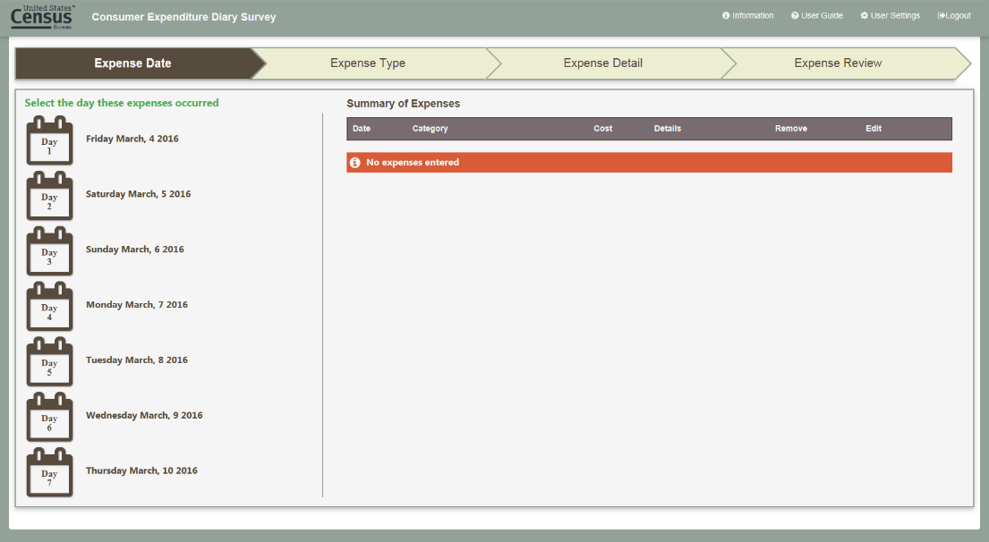
Expense type selection
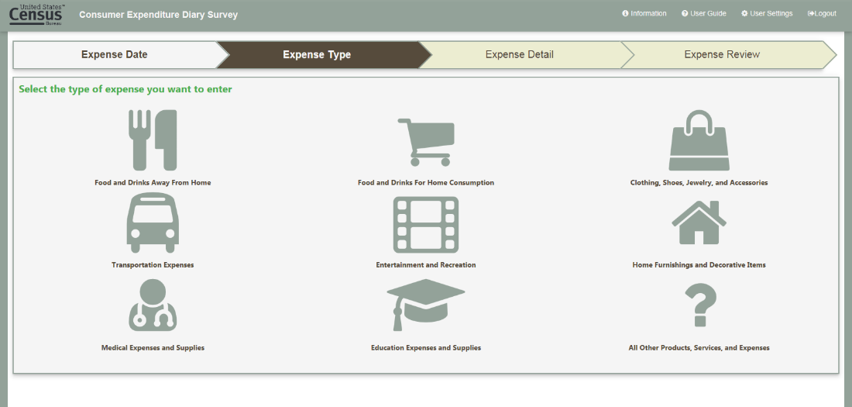

Example expense entry (Food and Drinks Away From Home)
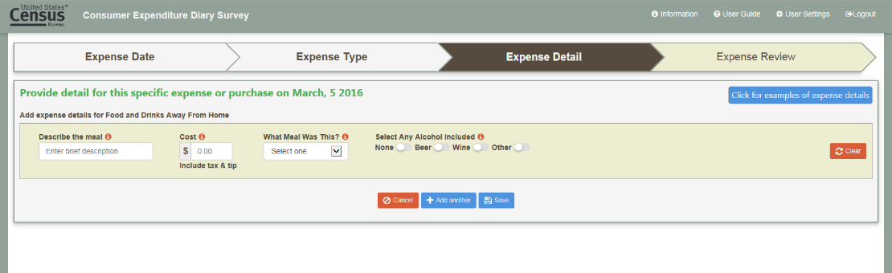

Example expense entry (Food and Drinks for Home Consumption)
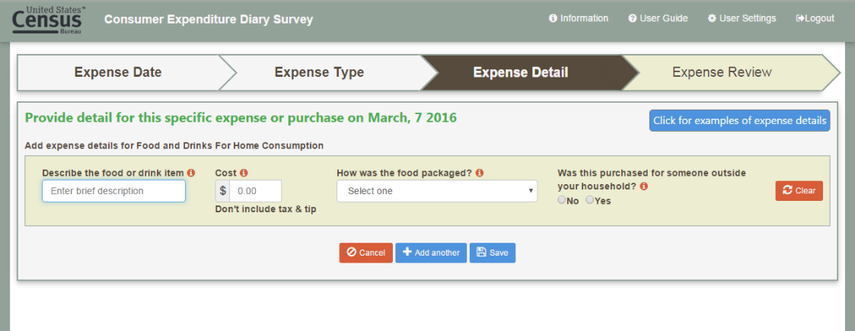

Example expense entry (Clothing, Shoes, Jewelry, & Accessories)
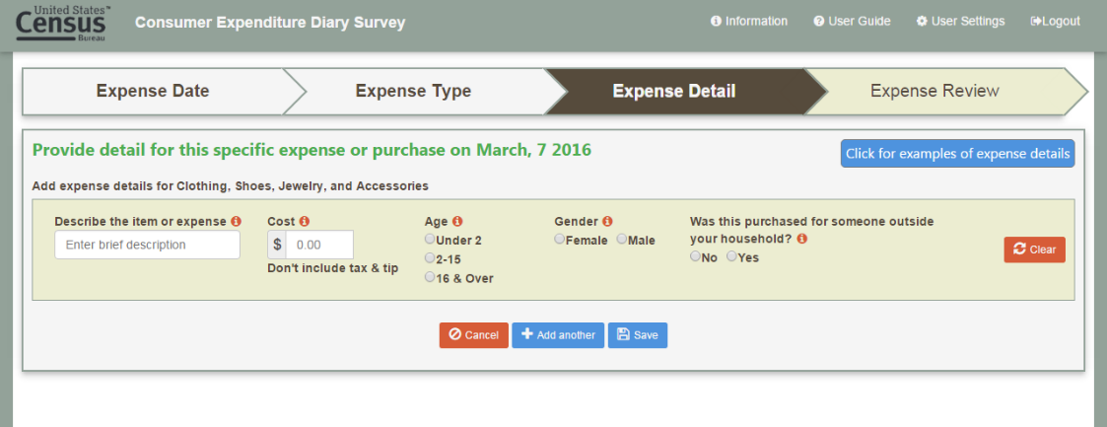

Example expense entry (All Other Categories)
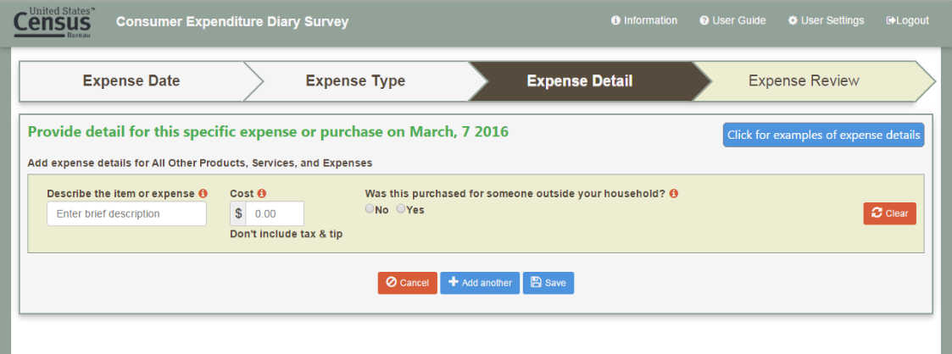

Example additional expense entry
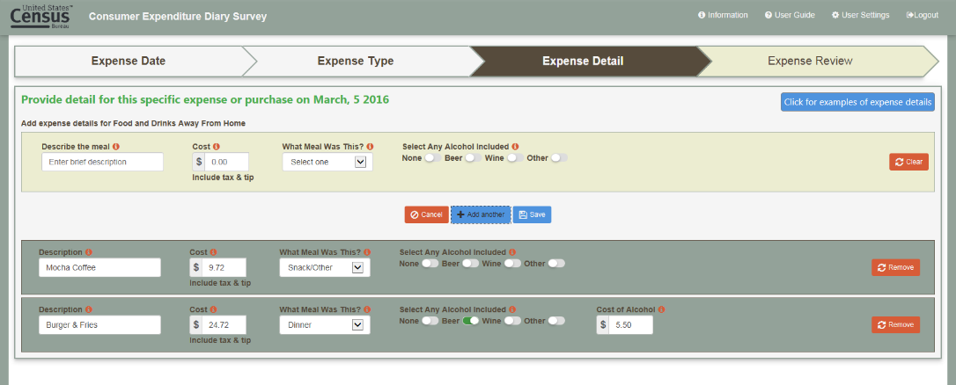

Review of entered expenses
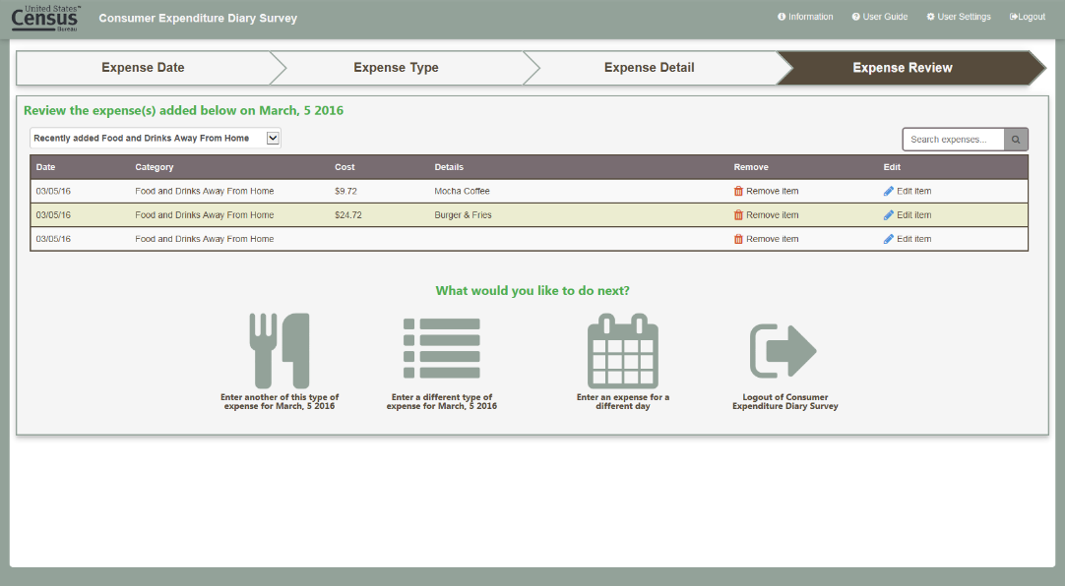

Expense date entry with summary of entered expenses shown
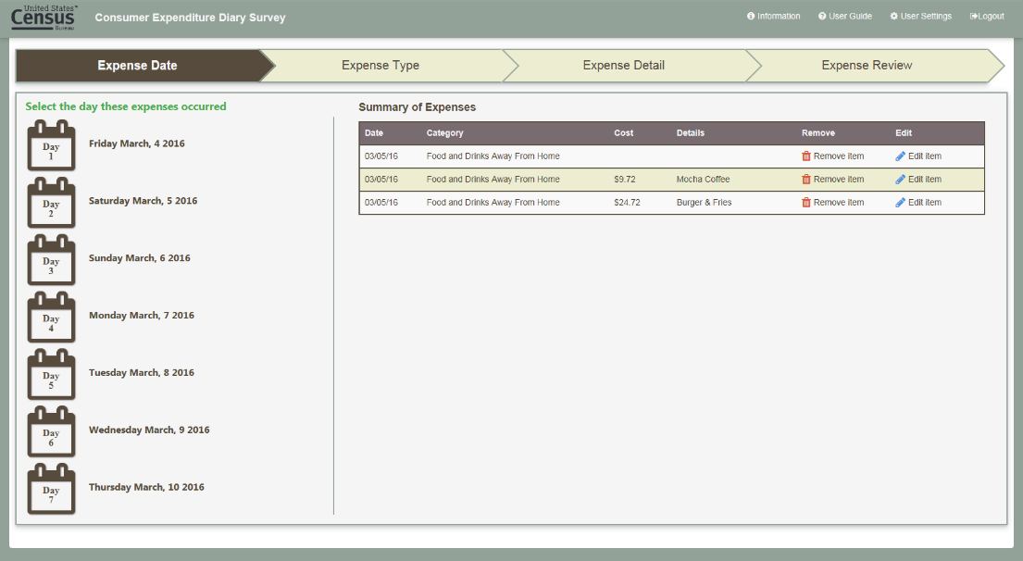

Example of other expense type question items
