APPENDIX G

RESPONDENT MATERIALS

Early Childhood Longitudinal Study, Kindergarten Class of 2010-11
(ECLS-K:2011)

Spring Fourth-Grade National Data Collection and Fifth-Grade Recruitment

OMB Clearance Package
#1850-0750 v.16
NOTE: The letters for respondents that are included in this appendix have headers indicating to whom the letter will be sent. These headers will be removed before the letters are printed and sent to respondents. Additionally, the OMB expiration date that currently appears as XX/XX/201X will be replaced once a new expiration date is received.

Description of the Materials Included in this Package

This package includes the letters to be sent to different school personnel in the spring of fourth grade and the fall of fifth grade. Below is a list of all the letters included in this package, along with an indication of the recipient and the time at which the letters are mailed. There are some formatting issues in the letters (e.g., signature size, pagination) that result from multiple letters being included in one document. These issues will be corrected in the final letters distributed to the respondents.

Spring Fourth-Grade Data Collection Round
- ECLS-K:2011 Parent Consent Form for Child Assessment- Revised to cite the most current confidentiality and consent language
- Materials mailed at the start of the round, before data collection begins:
  - SPRING 4TH GRADE PARENT LETTER- Mailed to parents/guardians of study children.
  - SPRING 4TH GRADE TEACHER LETTER- Teachers will be identified during advance school contacts in the fall of 2014. This letter will be mailed to them in spring 2015. If, during data collection in the spring of 2015, children are identified as having switched teachers (for example, because the child changed schools), the new teacher will be given this letter during spring 2015 data collection.
  - SPRING 4TH GRADE LETTER FOR SCHOOL COORDINATORS AT A CONTINUING (ORIGINAL OR DESTINATION) SCHOOL- Mailed to school coordinators in schools that have participated in the study since the base year or in schools that are identified as “destination schools,” that is, schools into which four or more study children from the same original school have transferred.
  - SPRING 4TH GRADE LETTER FOR SCHOOL COORDINATORS AT A TRANSFER SCHOOL THAT HAS PARTICIPATED IN A PREVIOUS DATA COLLECTION ROUND- Mailed to school coordinators in schools that were added after the base year because a child transferred into the school and that have participated in at least one prior round of data collection but are not destination schools. A separate letter is needed for these school coordinators because coordinators and schools do not receive an incentive.
  - SPRING 4TH GRADE LETTER FOR SCHOOL COORDINATORS AT A TRANSFER SCHOOL IDENTIFIED DURING RECRUITMENT- Mailed to school coordinators in schools that were added during the fall 4th grade recruitment and tracking because a child transferred into the school. These schools have not participated in at least one prior round of data collection and are not destination schools. A separate letter is needed for these school coordinators because they have not participated before and coordinators and schools do not receive an incentive.
- Letters mailed during data collection to districts, school administrators, and school coordinators in schools that are identified as having study children who transfer into them during the spring fourth-grade data collection:
  - SPRING 4TH GRADE LETTER FOR NEW TRANSFER DISTRICTS WITH PREVIOUSLY NON-PARTICIPATING SCHOOLS INTO WHICH STUDY CHILDREN HAVE TRANSFERRED - Mailed to school districts that did not have schools participating in the study in a prior round that are now being recruited into the study because a participating study child transferred into one of the district’s schools.
  - SPRING 4TH GRADE LETTER FOR CONTINUING DISTRICTS WITH PREVIOUSLY NON-PARTICIPATING SCHOOLS INTO WHICH STUDY CHILDREN HAVE TRANSFERRED- Mailed to school districts that have schools that participated in the study in a prior round but in which at least one new school (i.e., one that has not participated in a prior round) is being recruited because a study child transferred into the new school.
  - SPRING 4TH GRADE SCHOOL ADMINISTRATOR LETTER FOR TRANSFER SCHOOLS IDENTIFIED IN SPRING 2015- Mailed to administrators in schools that did not participate in a prior round of the study but are now being recruited into the study because a participating study child transferred into the administrator’s school.
  - SPRING 4TH GRADE LETTER FOR SCHOOL COORDINATORS AT A CONTINUING SCHOOL WITH NEW TRANSFER STUDENTS IDENTIFIED IN SPRING 2015- Mailed to school coordinators in schools that have participated in prior rounds of the study but that have new study children who have transferred into them. The school coordinator is mailed this new letter to make it clear that there are additional children who will be assessed during the school visit.
- Letters mailed at the end of the data collection round:
  - SCHOOL ADMINISTRATOR THANK YOU LETTER (HONORARIA)- Mailed to administrators of participating original and destination schools at the end of the fourth-grade school year along with the $200 school honorarium.
  - SCHOOL ADMINISTRATOR THANK YOU LETTER (NO HONORARIA)- Mailed to administrators of participating transfer schools at the end of the fourth-grade school year.

Spring Fifth-Grade Recruitment Letters
NOTE: A contract for the fifth-grade round of data collection has not been awarded as of the date of submission of this clearance request. For this reason, the letters currently include [TBD] where the name and contact information for the data collection contractor will be included. [TBD] will be replaced with the appropriate information before the letters are mailed.
- Advance recruitment letter mailed in August 2015:
  - SPRING 5TH GRADE SCHOOL COORDINATOR LETTER FOR CONTINUING SCHOOLS, SENT IN ADVANCE OF FALL RECRUITMENT - Mailed in advance of fall recruitment to school coordinators in schools that have participated in prior rounds of the study.
- Advance letters mailed in fall 2015 to districts, school administrators, and school coordinators in schools that are identified during recruitment as having study children who transfer into them after the spring fourth-grade round of data collection:
  - SPRING 5TH GRADE LETTER FOR NEW DISTRICTS WITH PREVIOUSLY NON-PARTICIPATING SCHOOLS INTO WHICH STUDY CHILDREN HAVE TRANSFERRED DURING RECRUITMENT - Mailed to school districts that did not have schools participating in the study in a prior round that are now being recruited into the study because a participating study child transferred into one of the district’s schools.
  - SPRING 5TH GRADE LETTER FOR CONTINUING DISTRICTS WITH PREVIOUSLY NON-PARTICIPATING SCHOOLS INTO WHICH STUDY CHILDREN HAVE TRANSFERRED DURING RECRUITMENT- Mailed to school districts that have schools that participated in the study in a prior round but in which at least one new school (i.e., one that has not participated in a prior round) is being recruited because a study child transferred into the new school.
  - SPRING 5TH GRADE SCHOOL ADMINISTRATOR LETTER FOR TRANSFER SCHOOLS IDENTIFIED DURING RECRUITMENT- Mailed to administrators in schools that did not participate in a prior round of the study but are now being recruited into the study because a participating study child transferred into the administrator’s school.
  - SPRING 5TH GRADE LETTER FOR SCHOOL COORDINATORS AT A CONTINUING SCHOOL WITH NEW TRANSFER STUDENTS IDENTIFIED DURING RECRUITMENT- Mailed to school coordinators in schools that have participated in prior rounds of the study but that have new study children who have transferred into them. The school coordinator is mailed this new letter to make it clear that there are additional children who will be assessed during the school visit.

Tracking Materials
- BIRTHDAY CARD – Mailed each month to children who have a birthday that month.
- POST-IT NOTES FOR PARENTS – Included with spring 2015 parent letter.
- HOLIDAY CARD – Mailed to school administrators in December 2015.

Spring Fourth-Grade Materials

Early Childhood Longitudinal Study, Kindergarten Class 2010-11 (ECLS-K:2011)

Parent Permission for Child to Participate

Your child is being asked to take part in the Early Childhood Longitudinal Study, Kindergarten Class of 2010-11 (ECLS-K:2011), which follows a sample of children from kindergarten through fifth grade. The ECLS-K:2011 is sponsored by the National Center for Education Statistics (NCES) of the U.S. Department of Education’s Institute of Education Sciences and is being conducted on behalf of NCES by Westat. In the 2010-11 school year, children in kindergarten in your child's school and other schools across the nation will be selected to participate in ECLS-K:2011. Your child will be asked to take individually administered assessments designed to measure skills in reading, mathematics, and science. Also as part of the assessment, through a brief number game and a picture game, we will be assessing your child's working memory and regulation of attention. Your child’s teacher and child care provider will complete questionnaires about themselves and your child.

The collection of information in this survey is authorized by 20 U.S. Code, Section 9543. Participation is voluntary. Your responses are protected from disclosure by federal statute (20 U.S. Code, Section 9573). All responses that relate to or describe identifiable characteristics of individuals may be used only for statistical purposes and may not be disclosed, or used, in identifiable form for any other purpose except as required by law. Information from multiple individuals will be combined to produce statistical reports; no information that identifies you or your child (e.g., name or address) will be included in any reports. Your child’s school will not receive any information about you or your child as a part of this study. The valid OMB control number for this information collection is 1850-0750. Approval expires 10/31/2016.

If you have any questions or concerns about the protection of the information you provide or your rights in this research study, contact Gail Mulligan at the National Center for Education Statistics at 1-202-502-7491 or Gail.Mulligan@ed.gov.

PARTICIPATION AGREEMENT

I have read the letter and the information above.

I consent to my child’s participation in the ECLS-K:2011.

I DO NOT consent to my child’s participation in the ECLS-K:2011.

Please complete, sign, and return this form in the enclosed envelope to your child’s school.

CHILD’S NAME:
First and last name

Sign your name:
Signature of parent/guardian Date

Print your name:
First Middle Last

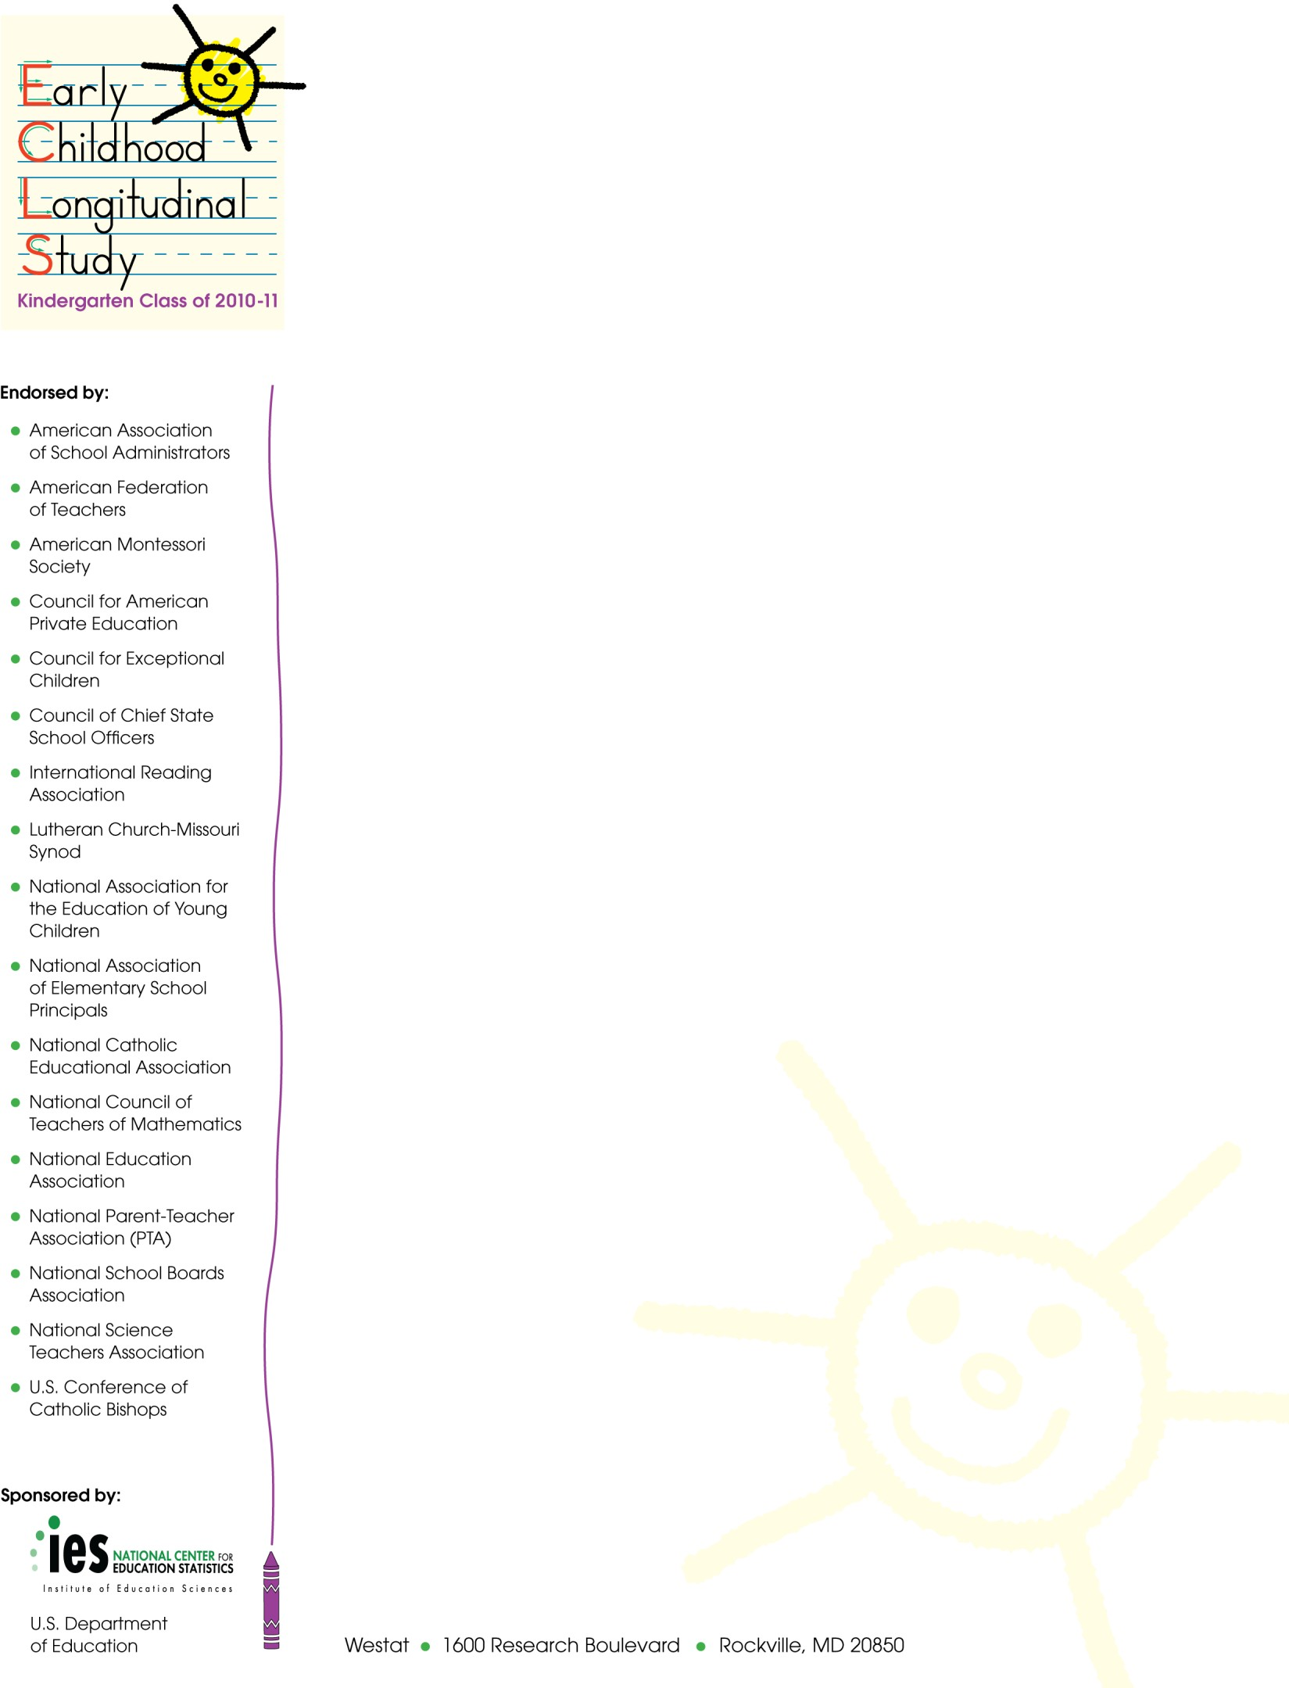
Spring 2015
SPRING 4TH GRADE PARENT LETTER

Dear Parent,

The Early Childhood Longitudinal Study, Kindergarten Class of 2010-11 (ECLS-K:2011) has completed four years of data collection! Thanks to the continued participation of families and schools across the country, we have collected a wealth of information that is already being used to gain a better understanding of today’s students and their experiences. Collecting information as your child moves into the upper elementary grades is very important for understanding how his or her experiences in the early years of elementary school have prepared him or her for the later grades. We are excited to talk with you and your child again this spring, to learn about your experiences during the 2014-15 school year.

As in the past, our field staff will be visiting your child’s school in the upcoming months to assess his or her knowledge and skills in reading, mathematics, and science. They also will be assessing your child’s memory and ability to follow directions, as well as measuring his/her height and weight. Once again, we are asking children to complete a questionnaire about themselves and their experiences in school. The assessment and the kinds of questions that will be asked are similar to those used in previous years, so the process should feel familiar to your child. As always, children may decline to answer any of the questions asked in the study. Also, participants’ responses will not be associated with their names or provided to school staff. In total, the assessment activities will take approximately 80 minutes to complete.

We are also asking parents to complete a telephone interview with a member of our data collection staff who will be calling your home to conduct the interview. The interview this round should take only about 35 minutes to complete. It includes questions about your child's school, your household, activities you do with your child at home, your child’s behavior and health, and contact with any parents who may not live with your child. As always, our field staff will be happy to conduct the interview at a time that is most convenient for you.

If you have questions about the study, please feel free to call Westat toll free at
1- 888-204-4864 or send an email to ECLSKHELP@westat.com. Also, more information about the ECLS-K:2011, including samples of the questions to be asked of children, is available at the NCES website at http://nces.ed.gov/ecls/myECLSK2011.

Thank you again for your participation!

Sincerely,
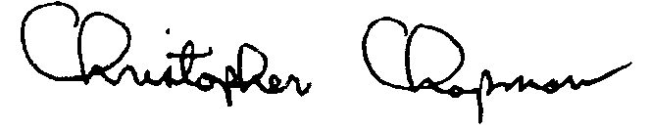
Christopher Chapman
Associate Commissioner, Sample Surveys Division
National Center for Education Statistics, Institute of Education Sciences

The collection of information in this survey is authorized by 20 U.S. Code, Section 9543. Participation is voluntary. Your responses are protected from disclosure by federal statute (20 U.S. Code, Section 9573). All responses that relate to or describe identifiable characteristics of individuals may be used only for statistical purposes and may not be disclosed, or used, in identifiable form for any other purpose except as required by law. Information from multiple individuals will be combined to produce statistical reports; no information that identifies you or your child (e.g., name or address) will be included in any reports. Your child’s school will not receive any information about you or your child as a part of this study. The valid OMB control number for this information collection is 1850-0750. Approval expires XX/XX/201X.

Spring 2015
SPRING 4TH GRADE TEACHER LETTER

Dear Teacher,

We are very happy that your school is participating in the Early Childhood Longitudinal Study, Kindergarten Class of 2010-11 (ECLS-K:2011), the third in a series of longitudinal studies of young children conducted by the National Center for Education Statistics (NCES). Like the earlier studies, the ECLS-K:2011 will be an important source of data for researchers and policy makers to address key issues related to children’s development and learning. The ECLS-K:2011 is described in more detail in the brochure included in your study package. For more information on this and the prior longitudinal studies, you can also visit the NCES website at http://nces.ed.gov/ecls/myECLSK2011.

The study began in the 2010-11 school year with students who were in kindergarten. Now that the ECLS-K:2011 is well underway, we have identified one or more students in the study who are in your classroom. For the study data to accurately represent the early schooling experiences of all children in America, it is vital that the sampled students take part in each phase of the study. Therefore, this spring we would like to conduct a child assessment with the sampled children who are attending your school. A component of the data collection involves collecting data about the sampled students from their teachers using self-administered questionnaires. We also will collect information from the school administrator, as well as the students’ parents.

Teachers are essential contributors to the ECLS-K:2011. You provide valuable insights into the classroom experiences of the children participating in the study. We will ask you to help us in several ways. As the teacher of at least one of our sampled children, we will ask you to answer some questions about your classroom and background, and we will ask you to complete a subject-specific questionnaire for each child participating in the study who is a student of yours. You will receive an honorarium of $20 for participating plus $7 for each of the child-level questionnaires you are asked to complete. We also will need your cooperation as we complete one-on-one child assessments in your school. We will make arrangements with your school’s ECLS-K:2011 school coordinator regarding the times that we can have access to the children and where the assessments will take place. It is possible that we will be taking children out of your classroom so that they can participate in the assessment. The assessments are designed to measure children’s reading, mathematics, and science skills and knowledge, as well as obtain indicators of children’s memory and ability to follow rules in a structured task. Children also will have their height and weight measured and will complete a questionnaire about themselves and their experiences in school. These assessment activities will take approximately 80 minutes per child to complete.

Your participation in this study is voluntary; however, I encourage you to participate in the ECLS-K:2011. Please read the enclosed materials for more information about the study and your important role in it. These materials provide instructions for you on how to complete the questionnaires and return them to your school’s ECLS-K:2011 school coordinator. They also provide information about the one-on-one child assessments.

The National Center for Education Statistics of the U.S. Department of Education’s Institute of Education Sciences is the primary sponsor of the ECLS-K:2011, which is being conducted on behalf of NCES by Westat. The ECLS-K:2011 has been endorsed by the national education organizations listed on this letter. NCES is authorized to conduct this study under 20 U.S. Code, Section 9543. Under that law, the data you provide may be used only for statistical purposes and may not be disclosed, or used, in identifiable form for any other purpose except as required by law (20 U.S. Code, Section 9573). The U.S. Office of Management and Budget has approved the data collection under OMB # 1850-0750 (expires XX/XX/201X). Information collected from multiple individuals will be combined to produce reports of findings from the ECLS-K:2011. The reports will not identify participating districts, schools, children and their parents, or individual staff.

Thank you for your support of the ECLS-K:2011. If you have questions about the study, please feel free to call Westat toll free at 1-888-204-4864 or send an email to ECLSKHELP@westat.com. Also, more information about the ECLS-K:2011 is available at http://nces.ed.gov/ecls/myECLSK2011.

Thank you for your time and consideration of the study.
Christopher Chapman
Associate Commissioner, Sample Surveys Division
National Center for Education Statistics, Institute of Education Sciences

Spring 2015
SPRING 4TH GRADE LETTER FOR SCHOOL COORDINATORS AT A CONTINUING (ORIGINAL OR DESTINATION) SCHOOL

[NAME]
[SCHOOL NAME]
[ADDRESS 1]
[ADDRESS 2]
[CITY, STATE ZIP]

Dear School Coordinator:

We are very happy that your school is participating in the Early Childhood Longitudinal Study, Kindergarten Class of 2010-11 (ECLS-K:2011). As you know, this spring we are planning to collect information from the study children at your school, their parents, their teachers, and their school’s administrator. Enclosed is a check for $25 in appreciation for your helping us with this important study.

As in our previous visits to your school, the participating children will complete one-on-one assessments with trained ECLS-K:2011 assessors. These assessments are designed to measure children’s reading, mathematics, and science skills and knowledge, as well as obtain indicators of children’s memory and ability to follow rules in a structured task. Children also will have their height and weight measured and will complete a questionnaire about themselves and their experiences in school. These assessment activities will take approximately 80 minutes for each child to complete.

A component of the data collection involves collecting information about the sampled students from their teachers using self-administered questionnaires. We also will collect information from the school administrator. As a token of our appreciation for its participation, your school will receive a check for $200.

We appreciate your help with four tasks, which are detailed in the enclosed materials. These are: (1) confirm that the children participating in the ECLS-K:2011 are attending your school (the list of participating children will be sent separately); (2) confirm the date and time for the spring activities; (3) identify an appropriate space for the assessments; and (4) identify the primary teachers of the participating children. Please read the enclosed materials for more information about the study and your important role in it.

The National Center for Education Statistics (NCES) of the U.S. Department of Education’s Institute of Education Sciences is the primary sponsor of the ECLS-K:2011, which is being conducted on behalf of NCES by Westat. The ECLS-K:2011 has been endorsed by the national education organizations listed on this letter. NCES is authorized to conduct this study under 20 U.S. Code, Section 9543. Under that law, the data you provide may be used only for statistical purposes and may not be disclosed, or used, in identifiable form for any other purpose except as required by law (20 U.S. Code, Section 9573). The U.S. Office of Management and Budget has approved the data collection under OMB # 1850-0750 (expires XX/XX/201X).

Thank you for your support of the ECLS-K:2011. We look forward to working with you and your school again. An ECLS-K:2011 representative will call you in the coming weeks to further explain the study and your responsibilities. If you have any questions or concerns in advance of the phone call, please call Westat toll free at 1-888-204-4864 or send an email to ECLSKHELP@westat.com.

Sincerely,
Christopher Chapman
Associate Commissioner, Sample Surveys Division
National Center for Education Statistics, Institute of Education Sciences

Spring 2015
SPRING 4TH GRADE LETTER FOR SCHOOL COORDINATORS AT A TRANSFER SCHOOL THAT HAS PARTICIPATED IN A PREVIOUS DATA COLLECTION ROUND

[NAME]
[SCHOOL NAME]
[ADDRESS 1]
[ADDRESS 2]
[CITY, STATE ZIP]

Dear School Coordinator:

We are very happy that your school is participating in the Early Childhood Longitudinal Study, Kindergarten Class of 2010-11 (ECLS-K:2011). As you know, this spring we are planning to collect information from the study children at your school, their parents, their teachers, and their school’s administrator.

As in our previous visits to your school, the participating children will complete one-on-one assessments with trained ECLS-K:2011 assessors. These assessments are designed to measure children’s reading, mathematics, and science skills and knowledge, as well as obtain indicators of children’s memory and ability to follow rules in a structured task. Children also will have their height and weight measured and will complete a questionnaire about themselves and their experiences in school. These assessment activities will take approximately 80 minutes for each child to complete.

A component of the data collection involves collecting information about the sampled students from their teachers using self-administered questionnaires. We also will collect information from the school administrator.

We appreciate your help with four tasks, which are detailed in the enclosed materials. These are (1) confirm that the children participating in the ECLS-K:2011 are attending your school (the list of participating children will be sent separately); (2) confirm the date and time for the spring activities; (3) identify an appropriate space for the assessments; and (4) identify the primary teachers of the participating children. Please read the enclosed materials for more information about the study and your important role in it.

The National Center for Education Statistics (NCES) of the U.S. Department of Education’s Institute of Education Sciences is the primary sponsor of the ECLS-K:2011, which is being conducted on behalf of NCES by Westat. The ECLS-K:2011 has been endorsed by the national education organizations listed on this letter. NCES is authorized to conduct this study under 20 U.S. Code, Section 9543. Under that law, the data you provide may be used only for statistical purposes and may not be disclosed, or used, in identifiable form for any other purpose except as required by law (20 U.S. Code, Section 9573). The U.S. Office of Management and Budget has approved the data collection under OMB # 1850-0750 (expires XX/XX/201X).

Thank you for your support of the ECLS-K:2011. We look forward to working with you and your school again. An ECLS-K:2011 representative will call you in the coming weeks to further explain the study and your responsibilities. If you have any questions or concerns in advance of the phone call, please call Westat toll free at 1-888-204-4864 or send an email to ECLSKHELP@westat.com.

Sincerely,
Christopher Chapman
Associate Commissioner, Sample Surveys Division
National Center for Education Statistics, Institute of Education Sciences

Spring 2015
SPRING 4TH GRADE LETTER FOR SCHOOL COORDINATORS AT A TRANSFER SCHOOL IDENTIFIED DURING RECRUITMENT

[NAME]
[SCHOOL NAME]
[ADDRESS 1]
[ADDRESS 2]
[CITY, STATE ZIP]

Dear School Coordinator:

We are very happy that your school is participating in the Early Childhood Longitudinal Study, Kindergarten Class of 2010-11 (ECLS-K:2011). One or more students who have participated in the study at a different school have transferred to your school. This spring we are planning to collect information from these students, their parents, their teachers, and their school’s administrator.

Participating children will complete one-on-one assessments with trained ECLS-K:2011 assessors. These assessments are designed to measure children’s reading, mathematics, and science skills and knowledge, as well as obtain indicators of children’s memory and ability to follow rules in a structured task. Children also will have their height and weight measured and will complete a questionnaire about themselves and their experiences in school. These assessment activities will take approximately 80 minutes for each child to complete.

A component of the data collection involves collecting information about the sampled students from their teachers using self-administered questionnaires. We also will collect information from the school administrator.

We appreciate your help with four tasks, which are detailed in the enclosed materials. These are (1) confirm that the children participating in the ECLS-K:2011 are attending your school (the list of participating children will be sent separately); (2) confirm the date and time for the spring activities; (3) identify an appropriate space for the assessments; and (4) identify the primary teachers of the participating children. Please read the enclosed materials for more information about the study and your important role in it.

The National Center for Education Statistics (NCES) of the U.S. Department of Education’s Institute of Education Sciences is the primary sponsor of the ECLS-K:2011, which is being conducted on behalf of NCES by Westat. The ECLS-K:2011 has been endorsed by the national education organizations listed on this letter. NCES is authorized to conduct this study under 20 U.S. Code, Section 9543. Under that law, the data you provide may be used only for statistical purposes and may not be disclosed, or used, in identifiable form for any other purpose except as required by law (20 U.S. Code, Section 9573). The U.S. Office of Management and Budget has approved the data collection under OMB # 1850-0750 (expires XX/XX/201X).

Thank you for your support of the ECLS-K:2011. We look forward to working with you and your school. An ECLS-K:2011 representative will call you in the coming weeks to further explain the study and your responsibilities. If you have any questions or concerns in advance of the phone call, please call Westat toll free at 1-888-204-4864 or send an email to ECLSKHELP@westat.com.

Sincerely,
Christopher Chapman
Associate Commissioner, Sample Surveys Division
National Center for Education Statistics, Institute of Education Sciences

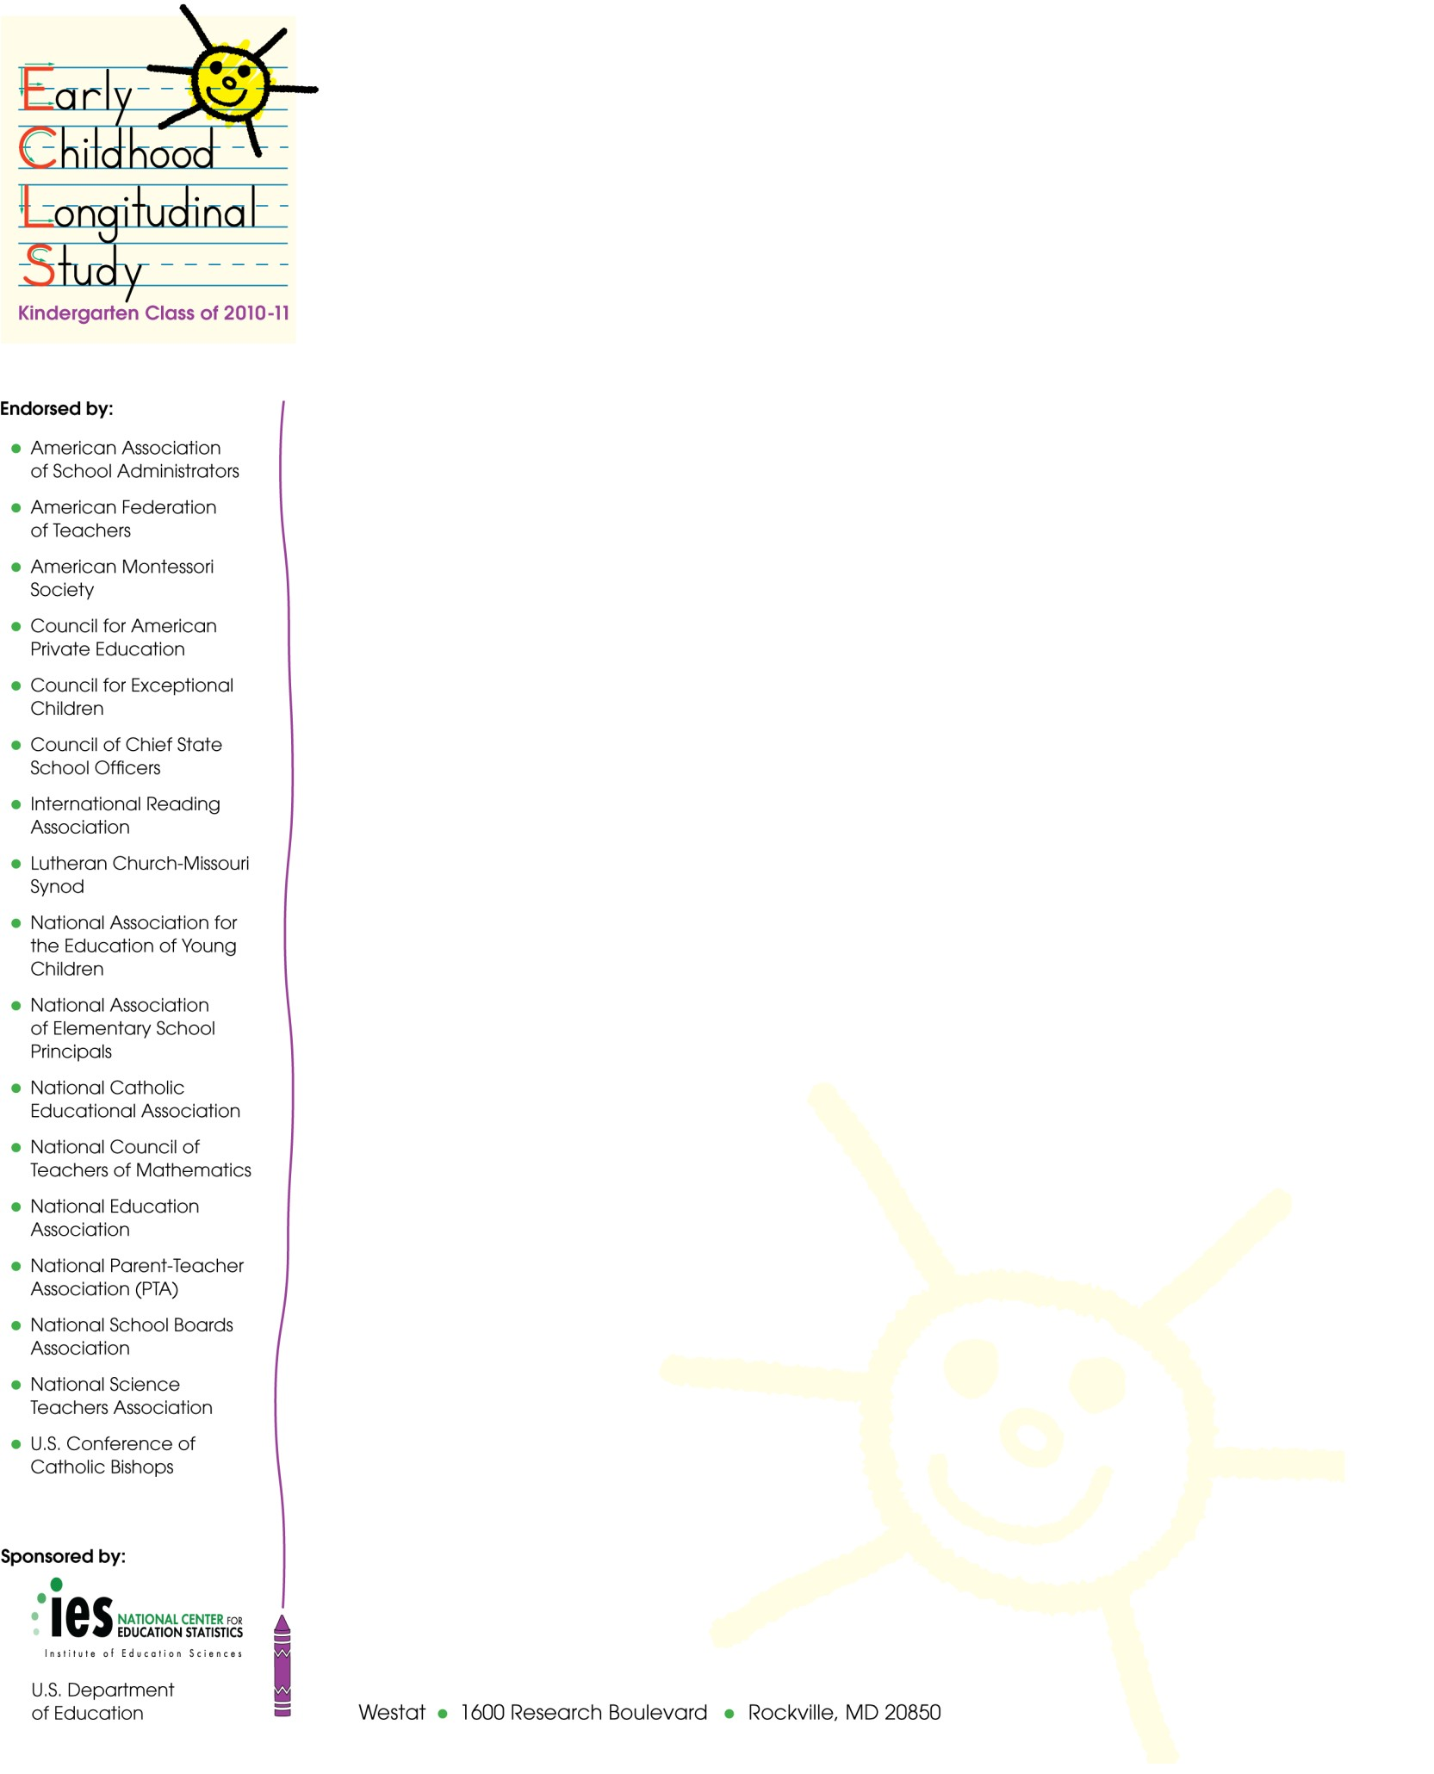
Spring 2015
SPRING 4TH GRADE LETTER FOR NEW TRANSFER DISTRICTS WITH PREVIOUSLY NON-PARTICIPATING SCHOOLS INTO WHICH STUDY CHILDREN HAVE TRANSFERRED

[SUPERINTENDENT NAME]
[DISTRICT NAME/DIOCESE]
[ADDRESS]
[ADDRESS2]
[CITY, STATE ZIP]

Dear Superintendent:

I am writing to inform you that one or more students who are participating in the Early Childhood Longitudinal Study, Kindergarten Class of 2010-11 (ECLS-K:2011) have transferred to a school in your district.

The ECLS-K:2011 is the third in a series of longitudinal studies of young children conducted by the National Center for Education Statistics (NCES). The earlier studies have been important sources of data for researchers and policy makers to address key issues related to children’s development and learning, including literacy in the home, the teaching of reading and mathematics, and the associations between physical exercise, childhood obesity, and well-being. Researchers using the data have published their findings widely in scientific journals and the popular press. NCES also presents results from these studies for practitioners and the general public on our website, http://nces.ed.gov/ecls.

Like its predecessor studies, the ECLS-K:2011 will provide important information on children’s early learning and development, transition into kindergarten, and progress through elementary school. The new cohort of students’ school experiences will be compared to those of over a decade earlier to study the extent to which the demographic profile of children and their environment for learning have changed, and how these changes relate to developmental and academic differences across the cohorts.

The participating children will complete individual assessments with trained ECLS-K:2011 assessors. These assessments are designed to measure children’s reading, mathematics, and science skills and knowledge, as well as obtain indicators of children’s memory and ability to follow rules in a structured task, both of which are associated with learning. Children also will have their height and weight measured and will complete a questionnaire about themselves and their experiences in school. These assessment activities will take approximately 80 minutes per child to complete. Parents of the study children will be asked to participate by providing background information about their children and their families during a telephone interview. The children’s teachers will be asked to provide information about themselves and the sampled children. We also will ask the school’s administrator to complete a self-administered questionnaire about the school and his or her background.

Participation in this study is voluntary; however, we ask your agency to support the participation of schools in your district in the ECLS-K:2011. Because the ECLS-K:2011 is designed to be a representative sample of U.S. students, its accuracy depends on the full participation of the sampled schools and students.

The National Center for Education Statistics of the U.S. Department of Education’s Institute of Education Sciences is the primary sponsor of the ECLS-K:2011, which is being conducted on behalf of NCES by Westat. The ECLS-K:2011 has been endorsed by the national education organizations listed on this letter. NCES is authorized to conduct this study under 20 U.S. Code, Section 9543. Under that law, the data provided by your schools, staff, students, and their parents may be used only for statistical purposes and may not be disclosed, or used, in identifiable form for any other purpose except as required by law (20 U.S. Code, Section 9573). The U.S. Office of Management and Budget has approved the data collection under OMB # 1850-0750 (expires XX/XX/201X).

In preparation for spring activities in the schools, in the next few days an ECLS-K:2011 representative will contact the schools in your district that the study’s students attend. We are required by law to protect the names of schools in the study from disclosure; we ask that each district respect this requirement and protect the identity of participating schools as well. Information collected from multiple individuals will be combined to produce reports of findings from the ECLS-K:2011. The reports will not identify participating districts, schools, children and their parents, or individual staff.

Detailed information about the ECLS-K:2011 can be found in the brochure enclosed with this letter. If you have questions about the study, please feel free to call Westat toll-free at 1-888-204-4864 or send an email to ECLSKHELP@westat.com. Also, more information about the ECLS-K:2011 is available at: http://nces.ed.gov/ecls/MyECLSK2011.

Thank you for your support of the ECLS-K:2011.

Sincerely,
Christopher Chapman
Associate Commissioner, Sample Surveys Division
National Center for Education Statistics, Institute of Education Sciences

Enclosures: ECLS-K:2011 Brochure
ECLS-K:2011 Schools in this District

Spring 2015
SPRING 4TH GRADE LETTER FOR CONTINUING DISTRICTS WITH PREVIOUSLY NON-PARTICIPATING SCHOOLS INTO WHICH STUDY CHILDREN HAVE TRANSFERRED

[SUPERINTENDENT NAME]
[DISTRICT NAME/DIOCESE]
[ADDRESS]
[CITY, STATE ZIP]

Dear Superintendent:

We are very happy that schools in your district are participating in the Early Childhood Longitudinal Study, Kindergarten Class of 2010-11 (ECLS-K:2011). Thank you for helping make their participation possible. I am writing to inform you that one or more students who are participating in the ECLS-K:2011 have transferred to a school in your district that was not previously part of the study.

The participating children will complete individual assessments with trained ECLS-K:2011 assessors. These assessments are designed to measure children’s reading, mathematics, and science skills and knowledge, as well as obtain indicators of children’s memory and ability to follow rules in a structured task, both of which are associated with learning. Children also will have their height and weight measured and will complete a questionnaire about themselves and their experiences in school. These assessment activities will take approximately 80 minutes per child to complete. Parents of the study children will be asked to participate by providing background information about their children and their families during a telephone interview. The children’s teachers will be asked to provide information about themselves and the sampled children. We also will ask the school’s administrator to complete a self-administered questionnaire about the school and his or her background.

Participation in this study is voluntary; however, we ask your agency to support the participation of schools in your district in the ECLS-K:2011. Because the ECLS-K:2011 is designed to be a representative sample of U.S. students, its accuracy depends on the full participation of the sampled schools and students.

The National Center for Education Statistics (NCES) of the U.S. Department of Education’s Institute of Education Sciences is the primary sponsor of the ECLS-K:2011, which is being conducted on behalf of NCES by Westat. The ECLS-K:2011 has been endorsed by the national education organizations listed on this letter. NCES is authorized to conduct this study under 20 U.S. Code, Section 9543. Under that law, the data provided by your schools, staff, students, and their parents may be used only for statistical purposes and may not be disclosed, or used, in identifiable form for any other purpose except as required by law (20 U.S. Code, Section 9573). The U.S. Office of Management and Budget has approved the data collection under OMB # 1850-0750 (expires XX/XX/201X).

In preparation for spring activities in the schools, in the next few days an ECLS-K:2011 representative will contact the schools in your district that the study’s students attend. We are required by law to protect the names of schools in the study from disclosure; we ask that each district respect this requirement and protect the identity of participating schools as well. Information collected from multiple individuals will be combined to produce reports of findings from the ECLS-K:2011. The reports will not identify participating districts, schools, children and their parents, or individual staff.

If you have questions about the study, please feel free to call Westat toll-free at 1-888-204-4864
or send an email to ECLSKHELP@westat.com. Also, more information about the ECLS-K:2011 is available at: http://nces.ed.gov/ecls/MyECLSK2011.

Thank you for your support of the ECLS-K:2011.

Sincerely,
Christopher Chapman
Associate Commissioner, Sample Surveys Division
National Center for Education Statistics, Institute of Education Sciences

Enclosure: List of ECLS-K:2011 Schools Added from your District

Spring 2015
SPRING 4TH GRADE SCHOOL ADMINISTRATOR LETTER FOR TRANSFER SCHOOLS IDENTIFIED IN SPRING 2015

[PRINCIPAL NAME]
[SCHOOL NAME]
[ADDRESS 1]
[ADDRESS 2]
[CITY, STATE ZIP]

Dear School Administrator:

I am writing to invite you to participate in an insightful study, the Early Childhood Longitudinal Study, Kindergarten Class of 2010-11 (ECLS-K:2011). The ECLS-K:2011 began in the 2010-11 school year with approximately 18,200 children in about 950 schools across the country. We are inviting you to participate because one or more students who are participating in the study have transferred to your school.

The ECLS-K:2011 is the third in a series of longitudinal studies of young children conducted by the National Center for Education Statistics (NCES). The earlier studies have been important sources of data for researchers and policy makers to address key issues related to children’s development and learning including literacy in the home, the teaching of reading and mathematics, and the associations between physical exercise, childhood obesity, and well-being. Researchers using the data have published their findings widely in scientific journals and the popular press. NCES also presents results from these studies for practitioners and the general public on our website, http://nces.ed.gov/ecls.

Like its predecessor studies, the ECLS-K:2011 will provide important information on children’s early learning and development, transition into kindergarten, and progress through elementary school. The new cohort of students’ school experiences will be compared to those of over a decade earlier to study the extent to which the demographic profile of children and their environments for learning have changed, and how these changes relate to developmental and academic differences across the cohorts. The study is described in more detail in the enclosed brochure.

The participation of each of the selected schools is crucial to the success of this important study. For the study data to accurately represent the early schooling experiences of all children in America, it is vital that the sampled students take part in each phase of the study. Therefore, this spring we would like to conduct a child assessment with the study children who are now attending your school.

The participating children will complete individual assessments with trained ECLS-K:2011 assessors. These assessments are designed to measure children’s reading, mathematics, and science skills and knowledge, as well as obtain indicators of children’s memory and ability to follow rules in a structured task, both of which are associated with learning. Children also will have their height and weight measured and will complete a questionnaire about themselves and their experiences in school. These assessment activities will take approximately 80 minutes per child to complete. Parents of the study children will be asked to participate by providing background information about their children and their families during a telephone interview. The children’s teachers will be asked to provide information about themselves and the sampled children. We also will ask you to complete a self-administered questionnaire about your school and background.

Participation in this study is voluntary; however, I encourage your school’s participation in the ECLS-K:2011. Because the ECLS-K:2011 is designed to be a representative sample of U.S. students, its accuracy depends on the full participation of your school, teachers, and students. We are asking you to identify a staff member at your school to act as a liaison with the ECLS-K:2011 and facilitate the activities in the school that are part of the study. In appreciation for their time and efforts, participating teachers will receive an honorarium.

The National Center for Education Statistics of the U.S. Department of Education’s Institute of Education Sciences is the primary sponsor of the ECLS-K:2011, which is being conducted on behalf of NCES by Westat. The ECLS-K:2011 has been endorsed by the national education organizations listed on this letter. NCES is authorized to conduct this study under 20 U.S. Code, Section 9543. Under that law, the data provided by your school, staff, students, and their parents may be used only for statistical purposes and may not be disclosed, or used, in identifiable form for any other purpose except as required by law (20 U.S. Code, Section 9573). The U.S. Office of Management and Budget has approved the data collection under OMB # 1850-0750 (expires XX/XX/201X). Information collected from multiple individuals will be combined to produce reports of findings from the ECLS-K:2011. The reports will not identify participating districts, schools, children and their parents, or individual staff.

Within the next few days, an ECLS-K:2011 representative will contact you about participating in this important study. If you have questions about the study, please feel free to call Westat toll-free at 1-888-204-4864 or send an email to ECLSKHELP@westat.com. Also, more information about the ECLS-K:2011 is available at http://nces.ed.gov/ecls/MyECLSK2011.

Thank you for your support of the ECLS-K:2011.

Christopher Chapman
Associate Commissioner, Sample Surveys Division
National Center for Education Statistics, Institute of Education Sciences

Enclosure: ECLS-K:2011 Brochure

Spring 2015
SPRING 4TH GRADE LETTER FOR SCHOOL COORDINATORS AT A CONTINUING SCHOOL WITH NEW TRANSFER STUDENTS IDENTIFIED IN SPRING 2015

[NAME]
[SCHOOL NAME]
[ADDRESS 1]
[ADDRESS 2]
[CITY, STATE ZIP]

Dear School Coordinator:

We are very happy that your school is participating in the Early Childhood Longitudinal Study, Kindergarten Class of 2010-11 (ECLS-K:2011). As you know, this spring we are planning to collect information from the study children at your school, their parents, their teachers, and their school’s administrator. One or more students who have participated in the study at a different school have transferred to your school, and we would like to complete assessments with them, along with the children who have participated in your school in the past.

As with the other participating children at your school, these additional children will complete one-on-one assessments with trained ECLS-K:2011 assessors. These assessments are designed to measure children’s reading, mathematics, and science skills and knowledge, as well as obtain indicators of children’s memory and ability to follow rules in a structured task. Children also will have their height and weight measured and will complete a questionnaire about themselves and their experiences in school. These assessment activities will take approximately 80 minutes for each child to complete.

A component of the data collection involves collecting information about the sampled students from their teachers using self-administered questionnaires. We also will collect information from the school administrator.

We appreciate your help with four tasks, which are detailed in the enclosed materials. These are (1) confirm that the children participating in the ECLS-K:2011 are attending your school (the list of participating children will be sent separately); (2) confirm the date and time for the spring activities; (3) identify an appropriate space for the assessments; and (4) identify the primary teachers of the participating children. Please read the enclosed materials for more information about the study and your important role in it.

The National Center for Education Statistics (NCES) of the U.S. Department of Education’s Institute of Education Sciences is the primary sponsor of the ECLS-K:2011, which is being conducted on behalf of NCES by Westat. The ECLS-K:2011 has been endorsed by the national education organizations listed on this letter. NCES is authorized to conduct this study under 20 U.S. Code, Section 9543. Under that law, the data you provide may be used only for statistical purposes and may not be disclosed, or used, in identifiable form for any other purpose except as required by law (20 U.S. Code, Section 9573). The U.S. Office of Management and Budget has approved the data collection under OMB # 1850-0750 (expires XX/XX/201X).

Thank you for your support of the ECLS-K:2011. We look forward to working with you and your school again. An ECLS-K:2011 representative will call you in the coming weeks to further explain the study and your responsibilities. If you have any questions or concerns in advance of the phone call, please call Westat toll free at 1-888-204-4864 or send an email to ECLSKHELP@westat.com.

Sincerely,
Christopher Chapman
Associate Commissioner, Sample Surveys Division
National Center for Education Statistics, Institute of Education Sciences

SCHOOL ADMINISTRATOR THANK YOU LETTER - HONORARIA

Spring 2015

[PRINCIPAL NAME]
[SCHOOL NAME]
[ADDRESS]
[CITY, ST ZIP]

Dear School Administrator,

Thank you for participating in the Early Childhood Longitudinal Study, Kindergarten Class of 2010-11 (ECLS-K:2011). Enclosed is an honorarium for your school as a token of our appreciation for your school’s participation in this important study of American education.

The study has been very successful to date because of the cooperation and participation of the children, parents, schools, school administrators, and teachers. You can find further information and results from the study at our website at http://www.myeclsk2011.com/default.html.

Thank you for your support of the ECLS-K:2011. We look forward to working with you in future rounds of the study. If you have any questions or concerns please call our toll-free number 1-888-204-4864 or email us at ECLSKHELP@westat.com.

Sincerely,
Christopher Chapman
Associate Commissioner, Sample Surveys Division
National Center for Education Statistics, Institute of Education Sciences

SCHOOL ADMINISTRATOR THANK YOU LETTER - NO HONORARIA

Spring 2015

[PRINCIPAL NAME]
[SCHOOL NAME]
[ADDRESS]
[CITY, ST ZIP]

Dear School Administrator,

Thank you for participating in the Early Childhood Longitudinal Study, Kindergarten Class of 2010-11 (ECLS-K:2011).

The study has been very successful to date because of the cooperation and participation of the children, parents, schools, school administrators, and teachers. You can find further information and results from the study at our website at http://www.myeclsk2011.com/default.html.

Thank you for your support of the ECLS-K:2011. We look forward to working with you in future rounds of the study. If you have any questions or concerns please call our toll-free number 1-888-204-4864 or email us at ECLSKHELP@westat.com.

Sincerely,
Christopher Chapman
Associate Commissioner, Sample Surveys Division
National Center for Education Statistics, Institute of Education Sciences
Spring Fifth-Grade Letters
Distributed During Fall 2015 Advance School Contact

Fall 2015
SPRING 5TH GRADE SCHOOL COORDINATOR LETTER FOR CONTINUING SCHOOLS, SENT IN ADVANCE OF FALL RECRUITMENT.

[NAME]
[SCHOOL NAME]
[ADDRESS 1]
[ADDRESS 2]
[CITY, STATE ZIP]

Dear School Coordinator:

We are very happy that your school is participating in the Early Childhood Longitudinal Study, Kindergarten Class of 2010-11 (ECLS-K:2011). As you may know, we collected information last year from the children participating in the study, their parents, their teachers, and their school’s administrator. We are looking forward to following these children this school year.

This spring, children will complete one-on-one assessments with trained ECLS-K:2011 assessors. These assessments are designed to measure children’s reading, mathematics, and science skills and knowledge, as well as obtain indicators of children’s memory and ability to follow rules in a structured task. Children also will have their height and weight measured and will complete a questionnaire about themselves and their experiences in school. These assessment activities will take approximately 80 minutes for each child to complete.

A component of the data collection involves collecting information about the sampled students from their teachers using self-administered questionnaires. We also will collect information from the school administrator.

We appreciate your help with four tasks, which are detailed in the enclosed materials. These are (1) confirm that the children participating in the ECLS-K:2011 are attending your school (the list of participating children will be sent separately); (2) determine the date and time for the spring activities; (3) identify an appropriate space for the assessments; and (4) identify the primary teachers of the participating children. Please read the enclosed materials for more information about the study and your important role in it.

The National Center for Education Statistics (NCES) of the U.S. Department of Education’s Institute of Education Sciences is the primary sponsor of the ECLS-K:2011, which is being conducted on behalf of NCES by [TBD]. The ECLS-K:2011 has been endorsed by the national education organizations listed on this letter. NCES is authorized to conduct this study under 20 U.S. Code, Section 9543. Under that law, the data you provide may be used only for statistical purposes and may not be disclosed, or used, in identifiable form for any other purpose except as required by law (20 U.S. Code, Section 9573). The U.S. Office of Management and Budget has approved the data collection under OMB # 1850-0750 (expires XX/XX/201X).

Thank you for your support of the ECLS-K:2011. We look forward to working with you and your school again. An ECLS-K:2011 representative will call you in the coming weeks to further explain the study and your responsibilities. If you have any questions or concerns in advance of the phone call, please call [TBD] toll free at [TBD] or send an email to [TBD].

Sincerely,
Christopher Chapman
Associate Commissioner, Sample Surveys Division
National Center for Education Statistics, Institute of Education Sciences

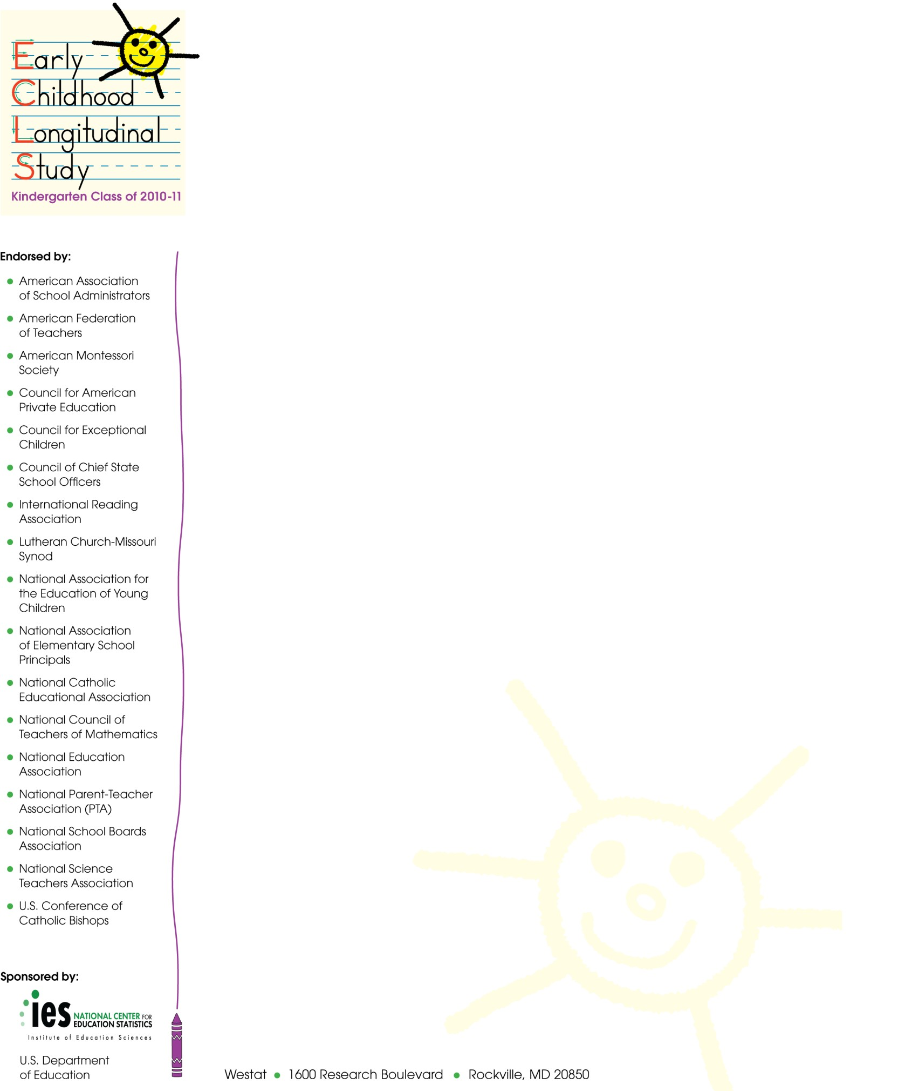
Fall 2015
SPRING 5TH GRADE LETTER FOR NEW DISTRICTS WITH PREVIOUSLY NON-PARTICIPATING SCHOOLS INTO WHICH STUDY CHILDREN HAVE TRANSFERRED DURING RECRUITMENT

[SUPERINTENDENT NAME]
[DISTRICT NAME/DIOCESE]
[ADDRESS]
[CITY, STATE ZIP]

Dear Superintendent:

I am writing to inform you that one or more students who are participating in the Early Childhood Longitudinal Study, Kindergarten Class of 2010-11 (ECLS-K:2011) have transferred to a school in your district.

The ECLS-K:2011 is the third in a series of longitudinal studies of young children conducted by the National Center for Education Statistics (NCES). The earlier studies have been important sources of data for researchers and policy makers to address key issues related to children’s development and learning, including literacy in the home, the teaching of reading and mathematics, and the associations between physical exercise, childhood obesity, and well-being. Researchers using the data have published their findings widely in scientific journals and the popular press. NCES also presents results from these studies for practitioners and the general public on our website, http://nces.ed.gov/ecls.

Like its predecessor studies, the ECLS-K:2011 will provide important information on children’s early learning and development, transition into kindergarten, and progress through elementary school. The new cohort of students’ school experiences will be compared to those of over a decade earlier to study the extent to which the demographic profile of children and their environment for learning have changed, and how these changes relate to developmental and academic differences across the cohorts.

This spring, the participating children will complete individual assessments with trained ECLS- K:2011 assessors. These assessments are designed to measure children’s reading, mathematics, and science skills and knowledge, as well as obtain indicators of children’s memory and ability to follow rules in a structured task, both of which are associated with learning. Children also will have their height and weight measured and will complete a questionnaire about themselves and their experiences in school. The assessment activities will take approximately 80 minutes per child to complete. Parents of the study children will be asked to participate by providing background information about their children and their families during a telephone interview. The children’s teachers will be asked to provide information about themselves and the sampled children. We also will ask the school’s administrator to complete a self-administered questionnaire about the school and his or her background.

Participation in this study is voluntary; however, we ask your agency to support the participation of schools in your district in the ECLS-K:2011. Because the ECLS-K:2011 is designed to be a representative sample of U.S. students, its accuracy depends on the full participation of the sampled schools and students.

The National Center for Education Statistics of the U.S. Department of Education’s Institute of Education Sciences is the primary sponsor of the ECLS-K:2011, which is being conducted on behalf of NCES by [TBD]. The ECLS-K:2011 has been endorsed by the national education organizations listed on this letter. NCES is authorized to conduct this study under 20 U.S. Code, Section 9543. Under that law, the data provided by your schools, staff, students, and their parents may be used only for statistical purposes and may not be disclosed, or used, in identifiable form for any other purpose except as required by law (20 U.S. Code, Section 9573). The U.S. Office of Management and Budget has approved the data collection under OMB # 1850-0750
(expires XX/XX/201X).

In preparation for our spring activities in the schools, in the next few days an ECLS-K:2011 representative will contact the schools in your district that the study’s students attend. We are required by law to protect the names of schools in the study from disclosure; we ask that each district respect this requirement and protect the identity of participating schools as well. Information collected from multiple individuals will be combined to produce reports of findings from the ECLS-K:2011. The reports will not identify participating districts, schools, children and their parents, or individual staff.

Detailed information about the ECLS-K:2011 can be found in the brochure enclosed with this letter. If you have questions about the study, please feel free to call [TBD] toll-free at
[TBD] or send an email to [TBD]. Also, more information about the ECLS-K:2011 is available at: http://nces.ed.gov/ecls/MyECLSK2011.

Thank you for your support of the ECLS-K:2011.

Sincerely,
Christopher Chapman
Associate Commissioner, Sample Surveys Division
National Center for Education Statistics, Institute of Education Sciences

Enclosures: ECLS-K:2011 Brochure
ECLS-K:2011 Schools in this District

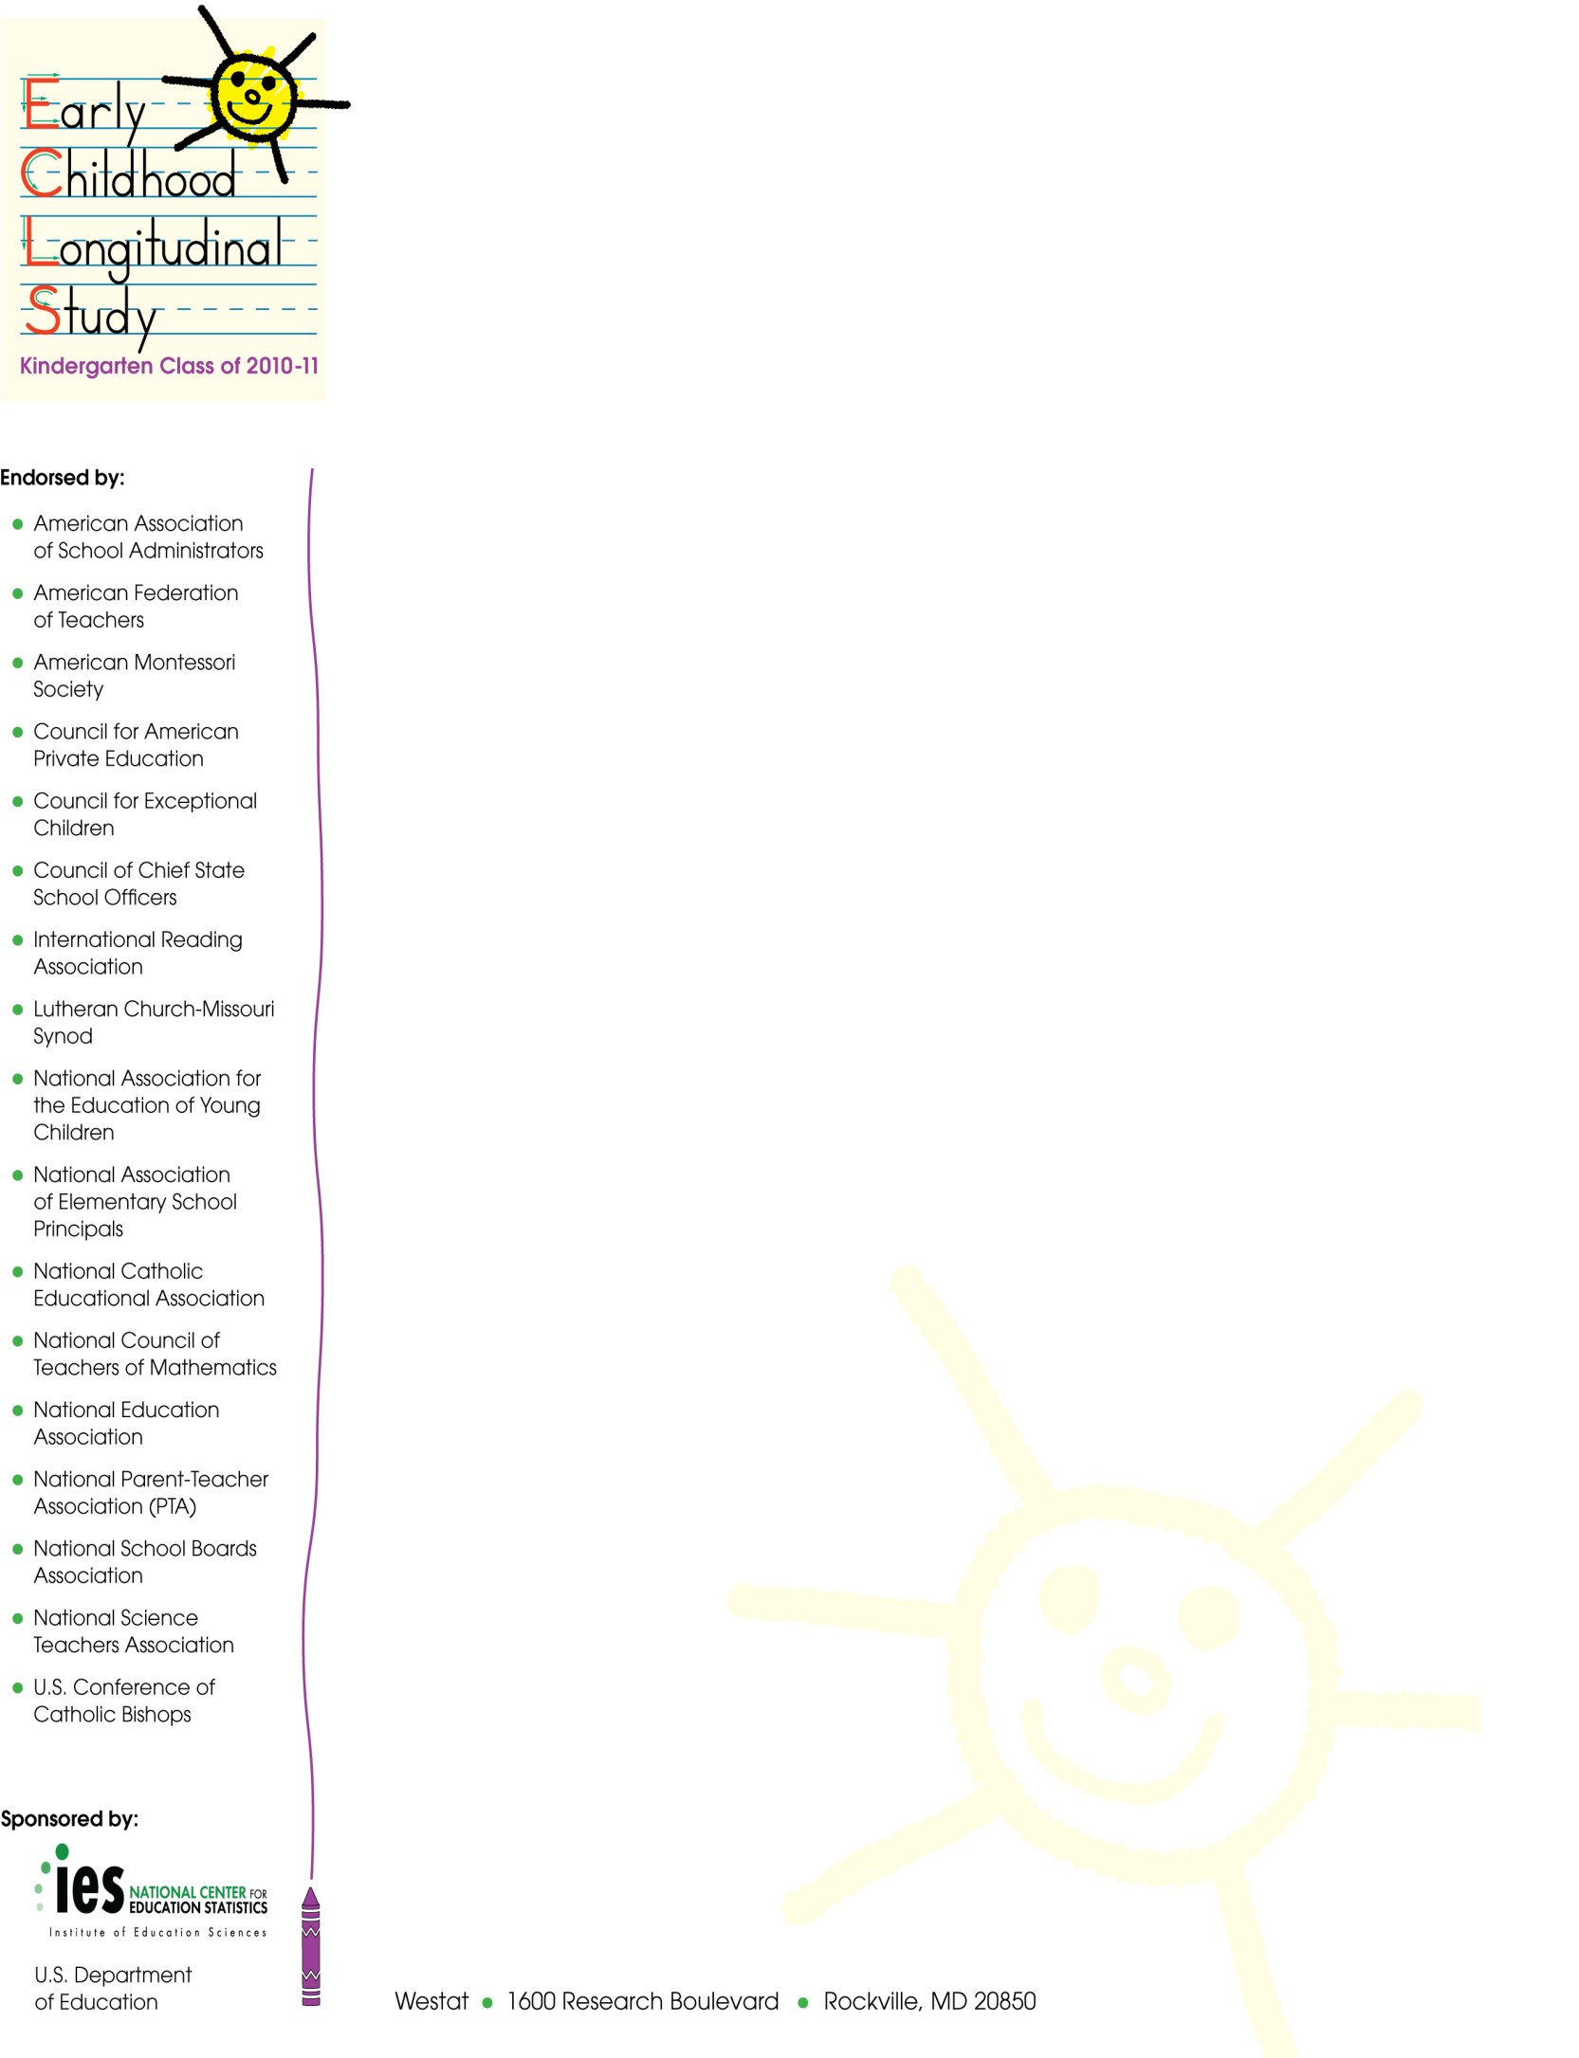
Fall 2015
SPRING 5TH GRADE LETTER FOR CONTINUING DISTRICTS WITH PREVIOUSLY NON-PARTICIPATING SCHOOLS INTO WHICH STUDY CHILDREN HAVE TRANSFERRED DURING RECRUITMENT

[SUPERINTENDENT NAME]
[DISTRICT NAME/DIOCESE]
[ADDRESS]
[CITY, STATE ZIP]

Dear Superintendent:

We are very happy that schools in your district are participating in the Early Childhood Longitudinal Study, Kindergarten Class of 2010-11 (ECLS-K:2011). Thank you for helping make their participation possible. I am writing to inform you that one or more students who are participating in the ECLS-K:2011 have transferred to a school in your district that was not previously part of the study.

This spring, the participating children will complete individual assessments with trained ECLS- K:2011 assessors. These assessments are designed to measure children’s reading, mathematics, and science skills and knowledge, as well as obtain indicators of children’s memory and ability to follow rules in a structured task, both of which are associated with learning. Children also will have their height and weight measured and will complete a questionnaire about themselves and their experiences in school. The assessment activities will take approximately 80 minutes per child to complete. Parents of the study children will be asked to participate by providing background information about their children and their families during a telephone interview. The children’s teachers will be asked to provide information about themselves and the sampled children. We also will ask the school’s administrator to complete a self-administered questionnaire about the school and his or her background.

Participation in this study is voluntary; however, we ask your agency to support the participation of schools in your district in the ECLS-K:2011. Because the ECLS-K:2011 is designed to be a representative sample of U.S. students, its accuracy depends on the full participation of the sampled schools and students.

The National Center for Education Statistics (NCES) of the U.S. Department of Education’s Institute of Education Sciences is the primary sponsor of the ECLS-K:2011, which is being conducted on behalf of NCES by [TBD]. The ECLS-K:2011 has been endorsed by the national education organizations listed on this letter. NCES is authorized to conduct this study under 20 U.S. Code, Section 9543. Under that law, the data provided by your schools, staff, students, and their parents may be used only for statistical purposes and may not be disclosed, or used, in identifiable form for any other purpose except as required by law (20 U.S. Code, Section 9573). The U.S. Office of Management and Budget has approved the data collection under
OMB # 1850-0750 (expires XX/XX/201X).

In preparation for our spring activities in the schools, in the next few days an ECLS-K:2011 representative will contact the schools in your district that the study’s students attend. We are required by law to protect the names of schools in the study from disclosure; we ask that each district respect this requirement and protect the identity of participating schools as well. Information collected from multiple individuals will be combined to produce reports of findings from the ECLS-K:2011. The reports will not identify participating districts, schools, children and their parents, or individual staff.

If you have questions about the study, please feel free to call [TBD] toll-free at
[TBD] or send an email to [TBD]. Also, more information about the ECLS-K:2011 is available at: http://nces.ed.gov/ecls/MyECLSK2011.

Thank you for your support of the ECLS-K:2011.

Sincerely,
Christopher Chapman
Associate Commissioner, Sample Surveys Division
National Center for Education Statistics, Institute of Education Sciences

Enclosure: List of ECLS-K:2011 Schools Added from your District

Fall 2015
SPRING 5TH GRADE SCHOOL ADMINISTRATOR LETTER FOR TRANSFER SCHOOLS IDENTIFIED DURING RECRUITMENT

[PRINCIPAL NAME]
[SCHOOL NAME]
[ADDRESS 1]
[CITY, STATE ZIP]

Dear School Administrator:

I am writing to invite you to participate in an insightful study, the Early Childhood Longitudinal Study, Kindergarten Class of 2010-11 (ECLS-K:2011). The ECLS-K:2011 began in the 2010-11 school year with approximately 18,200 children in about 950 schools across the country. We are inviting you to participate because one or more students who are participating in the study have transferred to your school.

The ECLS-K:2011 is the third in a series of longitudinal studies of young children conducted by the National Center for Education Statistics (NCES). The earlier studies have been important sources of data for researchers and policy makers to address key issues related to children’s development and learning including literacy in the home, the teaching of reading and mathematics, and the associations between physical exercise, childhood obesity, and well-being. Researchers using the data have published their findings widely in scientific journals and the popular press. NCES also presents results from these studies for practitioners and the general public on our website, http://nces.ed.gov/ecls.

Like its predecessor studies, the ECLS-K:2011 will provide important information on children’s early learning and development, transition into kindergarten, and progress through elementary school. The new cohort of students’ school experiences will be compared to those of over a decade earlier to study the extent to which the demographic profile of children and their environments for learning have changed, and how these changes relate to developmental and academic differences across the cohorts. The study is described in more detail in the enclosed brochure.

The participation of each of the selected schools is crucial for the success of this important study. For the study data to accurately represent the early schooling experiences of all children in America, it is vital that the sampled students take part in each phase of the study. Therefore, this spring we would like to conduct a child assessment with the sampled children who are now attending your school.

The participating children will complete individual assessments with trained ECLS-K:2011 assessors. These assessments are designed to measure children’s reading, mathematics, and science skills and knowledge, as well as obtain indicators of children’s memory and ability to follow rules in a structured task, both of which are associated with learning. Children also will have their height and weight measured and will complete a questionnaire about themselves and their experiences in school. These assessment activities will take approximately 80 minutes per child to complete. Parents of the study children will be asked to participate by providing background information about their children and their families during a telephone interview. The children’s teachers will be asked to provide information about themselves and the sampled children. We also will ask you to complete a self-administered questionnaire about your school and background.

Participation in this study is voluntary; however, I encourage your school’s participation in the ECLS-K:2011. Because the ECLS-K:2011 is designed to be a representative sample of U.S. students, its accuracy depends on the full participation of your school, teachers, and students. We are asking you to identify a staff member at your school to act as a liaison with the
ECLS-K:2011 and facilitate the activities in the school that are part of the study. In appreciation for their time and efforts, participating teachers will receive an honorarium.

The National Center for Education Statistics of the U.S. Department of Education’s Institute of Education Sciences is the primary sponsor of the ECLS-K:2011, which is being conducted on behalf of NCES by [TBD]. The ECLS-K:2011 has been endorsed by the national education organizations listed on this letter. NCES is authorized to conduct this study under 20 U.S. Code, Section 9543. Under that law, the data provided by your school, staff, students, and their parents may be used only for statistical purposes and may not be disclosed, or used, in identifiable form for any other purpose except as required by law (20 U.S. Code, Section 9573). The U.S. Office of Management and Budget has approved the data collection under OMB # 1850-0750 (expires XX/XX/201X). Information collected from multiple individuals will be combined to produce reports of findings from the ECLS-K:2011. The reports will not identify participating districts, schools, children and their parents, or individual staff.

Within the next few days, an ECLS-K:2011 representative will contact you about participating in this important study. If you have questions about the study, please feel free to call [TBD] toll-free at [TBD] or send an email to [TBD]. Also, more information about the ECLS-K:2011 is available at http://nces.ed.gov/ecls/MyECLSK2011.

Thank you for your support of the ECLS-K:2011.

Christopher Chapman
Associate Commissioner, Sample Surveys Division
National Center for Education Statistics, Institute of Education Sciences

Enclosure: ECLS-K:2011 Brochure

Fall 2015
SPRING 5TH GRADE LETTER FOR SCHOOL COORDINATORS AT A CONTINUING SCHOOL WITH NEW TRANSFER STUDENTS IDENTIFIED DURING RECRUITMENT

[SCHOOL COORDINATOR NAME]
[SCHOOL NAME]
[ADDRESS 1]
[CITY, STATE ZIP]

Dear School Coordinator:

We are very happy that your school is participating in the Early Childhood Longitudinal Study, Kindergarten Class of 2010-11 (ECLS-K:2011). As you know, this spring we are planning to collect information from the study children at your school, their parents, their teachers, and their school’s administrator. One or more students who have participated in the study at a different school have transferred to your school, and we would like to complete assessments with them along with the children who have participated in your school in the past.

As with the other participating children at your school, these additional children will complete one-on-one assessments with trained ECLS-K:2011 assessors. These assessments are designed to measure children’s reading, mathematics, and science skills and knowledge, as well as obtain indicators of children’s memory and ability to follow rules in a structured task. Children also will have their height and weight measured and will complete a questionnaire about themselves and their experiences in school. These assessment activities will take approximately 80 minutes for each child to complete.

A component of the data collection involves collecting information about the sampled students from their teachers using self-administered questionnaires. We also will collect information from the school administrator.

We appreciate your help with four tasks, which are detailed in the enclosed materials. These are (1) confirm that the children participating in the ECLS-K:2011 are attending your school (the list of participating children will be sent separately); (2) determine the date and time for the assessment activities next spring; (3) identify an appropriate space for the assessments; and (4) identify the primary teachers of the participating children. Please read the enclosed materials for more information about the study and your important role in it.

The National Center for Education Statistics (NCES) of the U.S. Department of Education’s Institute of Education Sciences is the primary sponsor of the ECLS-K:2011, which is being conducted on behalf of NCES by [TBD]. The ECLS-K:2011 has been endorsed by the national education organizations listed on this letter. NCES is authorized to conduct this study under 20 U.S. Code, Section 9543. Under that law, the data you provide may be used only for statistical purposes and may not be disclosed, or used, in identifiable form for any other purpose except as required by law (20 U.S. Code, Section 9573). The U.S. Office of Management and Budget has approved the data collection under OMB # 1850-0750 (expires XX/XX/201X).

Thank you for your support of the ECLS-K:2011. We look forward to working with you and your school again. An ECLS-K:2011 representative will call you in the coming weeks to further explain the study and your responsibilities. If you have any questions or concerns in advance of the phone call, please call [TBD] toll free at [TBD] or send an email to [TBD].

Sincerely,
Christopher Chapman
Associate Commissioner, Sample Surveys Division
National Center for Education Statistics, Institute of Education Sciences

Tracking Materials

BIRTHDAY CARD
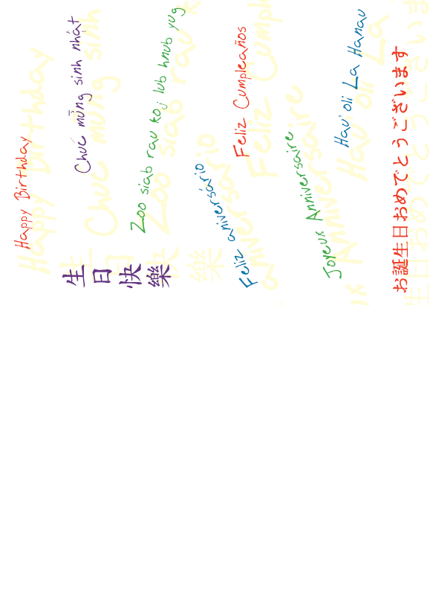
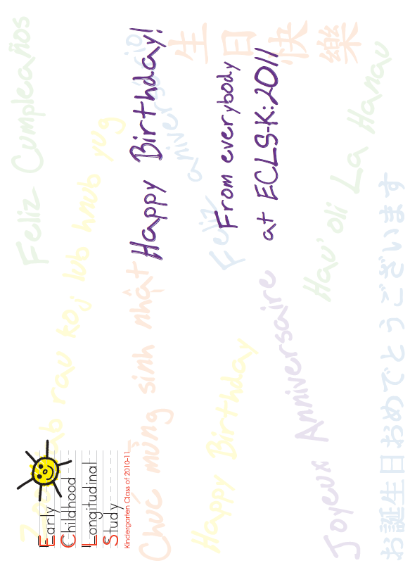

Post-it notes for parents

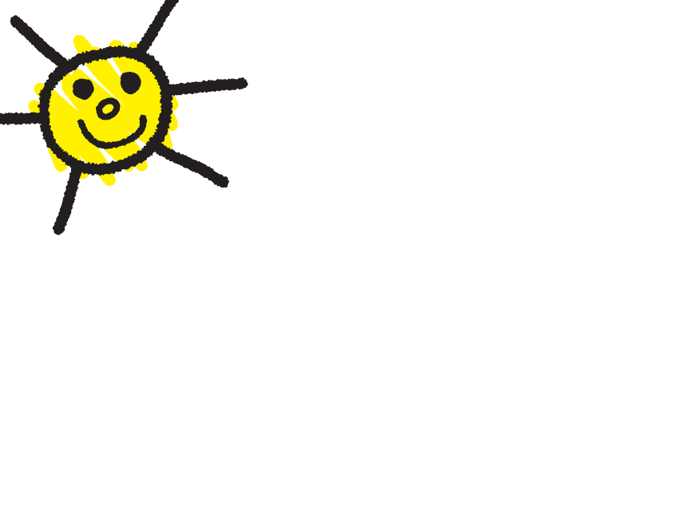
HOLIDAY CARD

