APPENDIX A: DRAFT RECRUITMENT MATERIALS

Draft State PISA Field Test Letter 2
Draft School District PISA Field Test Letter 3
Draft School PISA Field Test Letter 4
Draft PISA 2015 Field Test Study Brochure 5
Draft PISA 2015 Field Test FAQ 7
Draft PISA 2015 Field Test Student FAQ 9
Draft PISA 2015 Timeline of Activities 10
Draft Teacher Invite Email 12

[Date]
[Title] [Name First] [Name Last]

Draft State PISA Field Test Letter
[Title/Department]
[State]
[Address 1]
[Address 2]
[City], [State] [Zip code]

Dear [Title] [Name Last]:

The United States is participating in an important international study in 2015: the Program for International Student Assessment (PISA). PISA is the largest international education study in the world. Administered every 3 years since 2000, the U.S. has participated in each cycle of PISA. More than 60 countries representing approximately 90 percent of the world economy participate in PISA. Results are used by researchers and policymakers to chart national progress against international standards and the educational progress of our economic peers and competitors. Some schools in your state have been randomly selected to participate in the international field test for PISA this coming spring, and I am writing to ask your agency to support the participation of those schools in the field test.

PISA provides comparative information on the performance of U.S. 15-year-old students in science, reading, and mathematics with 15-year-old students in other countries. PISA 2015 will also include assessments of students’ collaborative problem-solving and financial literacy. The purpose of the field test is both to try out new questions and to help PISA transition from being a primarily paper-based to an entirely computer-based assessment in 2015.

PISA is described in more detail in the enclosed materials. PISA is sponsored in the United States by the National Center for Education Statistics (NCES) in the U.S. Department of Education and is conducted by Westat in Rockville, Maryland. The U.S. Office of Management and Budget has approved the data collection under OMB #1850-0755. For information on the confidentiality of the data collected, please see the enclosed FAQ. While participation in this study is voluntary, we ask your agency to support participation by schools in your state so that the United States has a representative sample of schools across the country.

Within the next few weeks, a representative of Westat will contact sampled school districts and schools to discuss participating in the field test. In the meantime, if you have questions about the study, please do not hesitate to call David Kastberg at 1-888-638-2597 or send an email to PISAHELP@westat.com. You may also get more information about these studies by contacting Dana Kelly at NCES at 202-219-7101 or dana.kelly@ed.gov or by visiting the PISA website at http://nces.ed.gov/surveys/pisa.

Thank you for your time and support.

Sincerely,

Jack Buckley
Commissioner
cc: [State assessment coordinator name]
Enclosures

NCES is authorized to conduct this study under the Education Sciences Reform Act of 2002 (ESRA 2002), 20 U.S. Code, § 9543. By law, the data provided by your schools, staff, and students may only be used for statistical purposes and may not be disclosed, or used, in identifiable form for any other purpose except as required by law (20 U.S. Code, § 9573).

Draft School District PISA Field Test Letter

[Date]
[Title] [Name First] [Name Last], [Title/Department]
[School District]
[Address 1]
[City], [State] [Zip code]

Dear [Title] [Name Last]:

The United States is participating in an important international study in 2015: the Program for International Student Assessment (PISA). PISA is the largest international education study in the world. Administered every 3 years since 2000, the U.S. has participated in each cycle of PISA. More than 60 countries representing approximately 90 percent of the world economy participate in PISA. Results are used by researchers and policymakers to chart national progress against international standards and the educational progress of our economic peers and competitors. Some schools in your district have been randomly selected to participate in the international field test for PISA this coming spring, and I am writing to ask your agency to support the participation of those schools in the field test.

PISA provides comparative information on the performance of U.S. 15-year-old students in science, reading, and mathematics with 15-year-old students in other countries. PISA 2015 will also include assessments of students’ collaborative problem-solving and financial literacy. The purpose of the field test is both to try out new questions and to help PISA transition from being a primarily paper-based to an entirely computer-based assessment in 2015. Participating schools will receive $200, and each school’s PISA school coordinator (school staff person designated to liaise with PISA staff) will receive $200 as compensation for the coordinator’s time and effort. Selected teachers will receive $20 for completing a brief questionnaire about themselves. Each student who participates will receive $25 and a volunteer service certificate of 4 hours from the U.S. Department of Education. Schools that participate in the 2014 field test are extremely unlikely to be sampled again for the 2015 main assessment.

PISA is described in more detail in the enclosed materials. PISA is sponsored in the United States by the National Center for Education Statistics (NCES) in the U.S. Department of Education and is conducted by Westat in Rockville, Maryland. The U.S. Office of Management and Budget has approved the data collection under OMB #1850-0755. For information on the confidentiality of the data collected, please see the enclosed FAQ. While participation in this study is voluntary, we ask your agency to support participation by schools in your district so that the United States has a representative sample of schools across the country.

Within the next few days, a representative of Westat will contact the following school or schools in your district that have been selected for the field test: [LIST SAMPLED SCHOOLS HERE…].

If you have any questions, please do not hesitate to call 1-888-638-2597 or send an email to PISAHELP@westat.com. You may also get more information about this study by contacting Dana Kelly at NCES at 202-219-7101 or dana.kelly@ed.gov or by visiting the PISA website at http://nces.ed.gov/surveys/pisa.

Thank you for your time and support.

Jack Buckley
Commissioner
Enclosures

NCES is authorized to conduct this study under the Education Sciences Reform Act of 2002 (ESRA 2002), 20 U.S. Code, § 9543. By law, the data provided by your schools, staff, and students may only be used for statistical purposes and may not be disclosed, or used, in identifiable form for any other purpose except as required by law (20 U.S. Code, § 9573).

Draft School PISA Field Test Letter

[Date]
[Title] [Name First] [Name Last], [Title/Department]
[School District]
[Address 1]
[City], [State] [Zip code]

Dear [Title] [Name Last]:

The United States is participating in an important international study in 2015: the Program for International Student Assessment (PISA). PISA is the largest international education study in the world. Administered every 3 years since 2000, the U.S. has participated in each cycle of PISA. More than 60 countries representing approximately 90 percent of the world economy participate in PISA. Results are used by researchers and policymakers to chart national progress against international standards and the educational progress of our economic peers and competitors. Your school is one of 60 across the United States that has been randomly selected to take part in the PISA field test this coming spring.

PISA provides comparative information on the performance of U.S. 15-year-old students in science, reading, and mathematics with 15-year-old students in other countries. PISA 2015 will also include an assessment of students’ collaborative problem-solving and financial literacy. The purpose of the field test is both to try out new questions and to help PISA transition from being a primarily paper-based to an entirely computer-based assessment in 2015. Your school will receive $200, and students who take the field test will receive $25 and a volunteer service certificate of 4 hours from the U.S. Department of Education. Your school’s PISA school coordinator (a staff person you designate to liaise with PISA staff) will receive $200 for his or her time and effort coordinating PISA in the school, and selected teachers will receive $20 for completing a brief questionnaire about themselves.

PISA is described in more detail in the enclosed materials. PISA is sponsored in the United States by the National Center for Education Statistics (NCES) in the U.S. Department of Education and is conducted by Westat in Rockville, Maryland. The U.S. Office of Management and Budget has approved the data collection under OMB #1850-0755. For information on the confidentiality of the data collected, please see the enclosed FAQ. I hope you will participate in this voluntary study because it is important that the United States has a nationally representative sample of schools.

Within the next few days, a representative of Westat will contact you to discuss your participation. If you have any questions, please do not hesitate to call 1-888-638-2597 or send an email to PISAHELP@westat.com. You may also get more information about this study by contacting Dana Kelly at NCES at 202-219-7101 or dana.kelly@ed.gov or by visiting the PISA website at http://nces.ed.gov/surveys/pisa.

Your participation in the field test for PISA 2015 is vital. Thank you for your time and for supporting this important international study.

Jack Buckley
Commissioner
Enclosures

NCES is authorized to conduct this study under the Education Sciences Reform Act of 2002 (ESRA 2002), 20 U.S. Code, § 9543. By law, the data provided by your schools, staff, and students may only be used for statistical purposes and may not be disclosed, or used, in identifiable form for any other purpose except as required by law (20 U.S. Code, § 9573).

Draft PISA 2015 Field Test Study Brochure – Front Cover

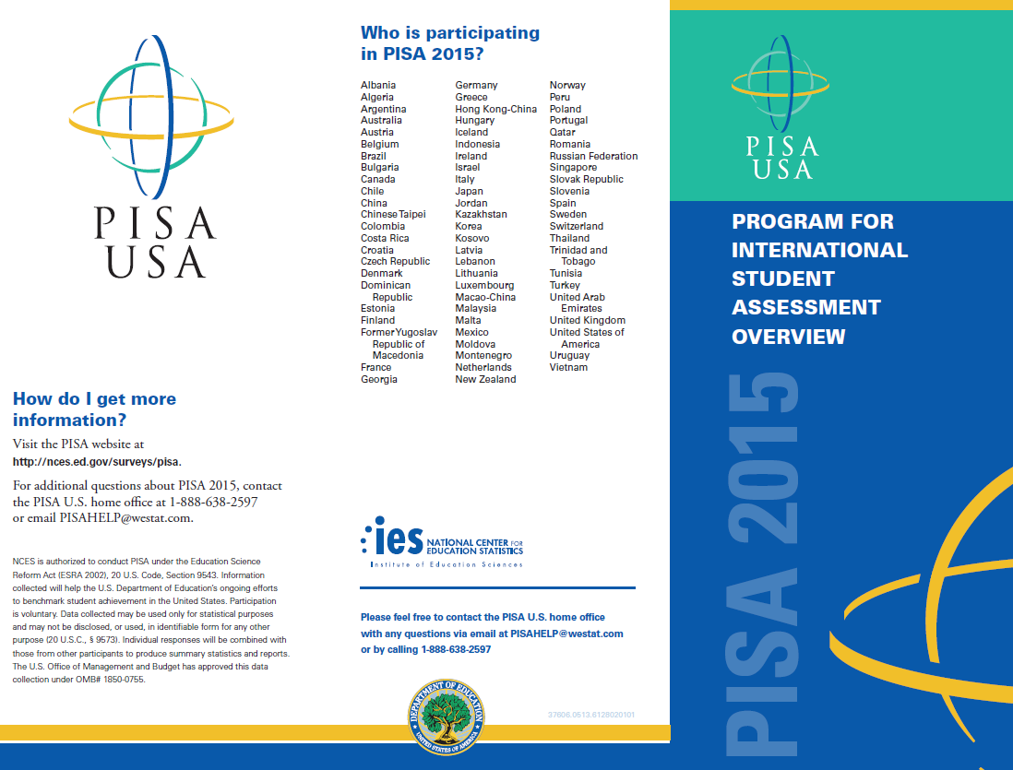

PISA 2015 Study Brochure Inside

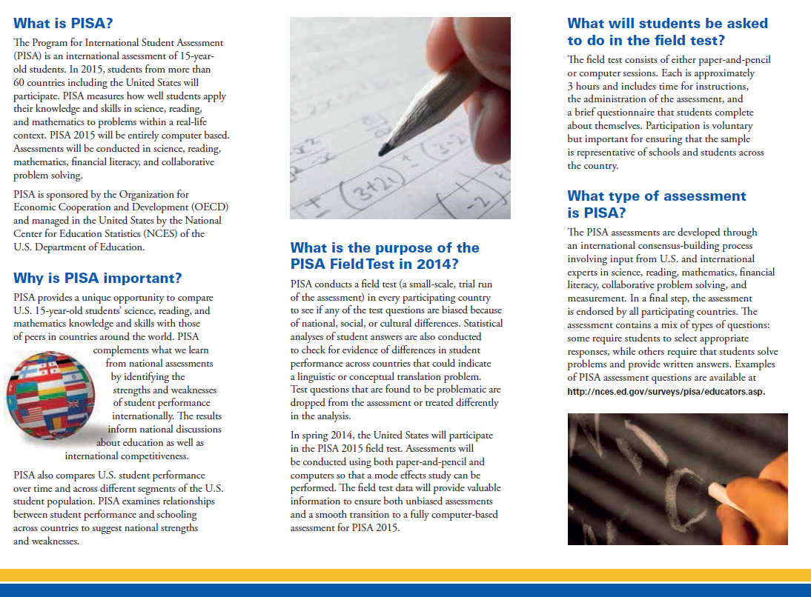
Draft PISA 2015 Field Test FAQ - Front Page

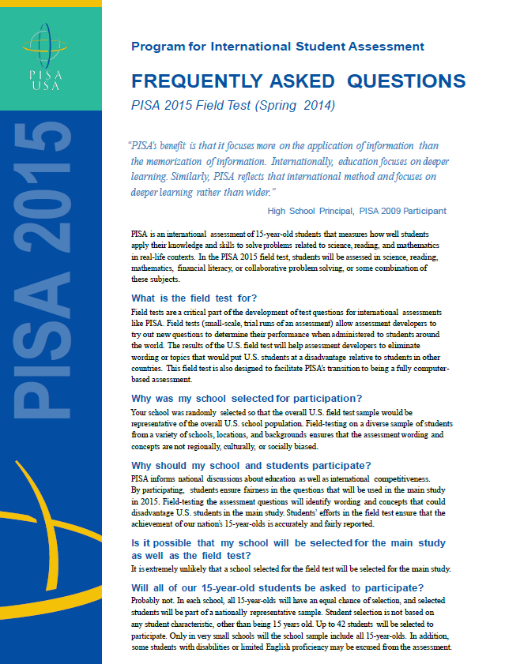

Draft PISA 2015 Field Test FAQ - Back Page

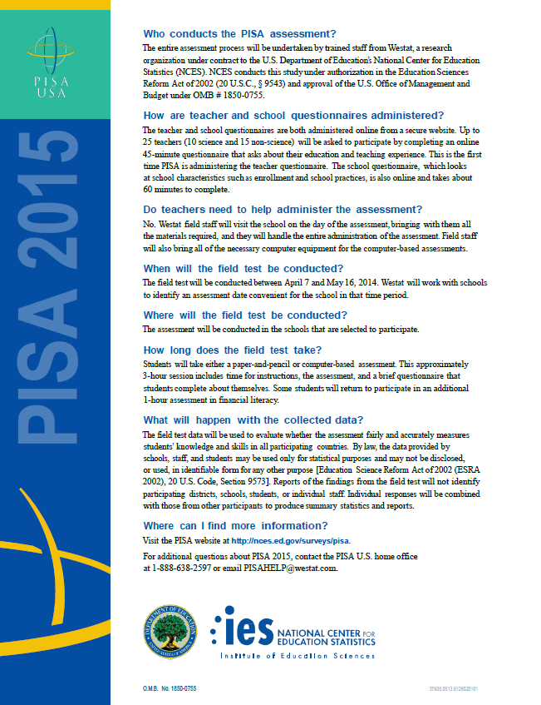

Draft PISA 2015 Field Test Student FAQ

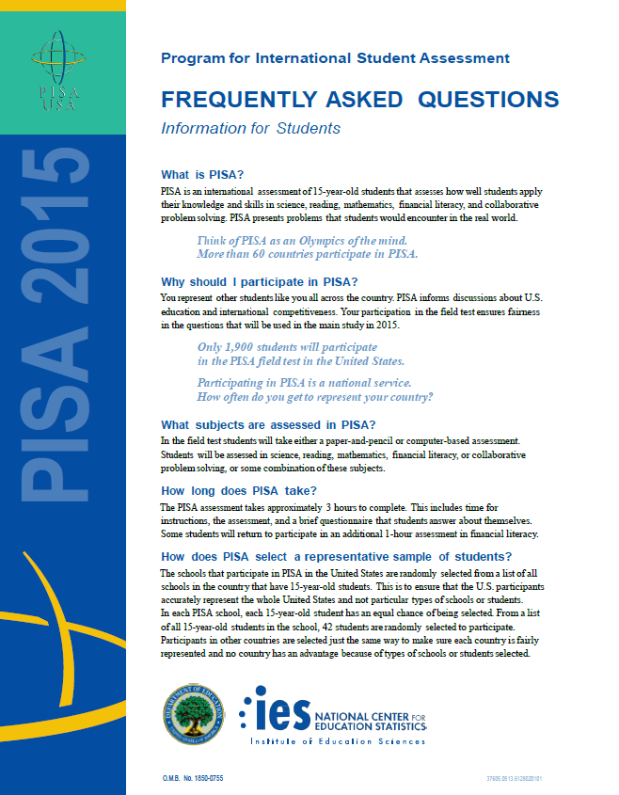

Draft PISA 2015 Timeline of Activities - Outside

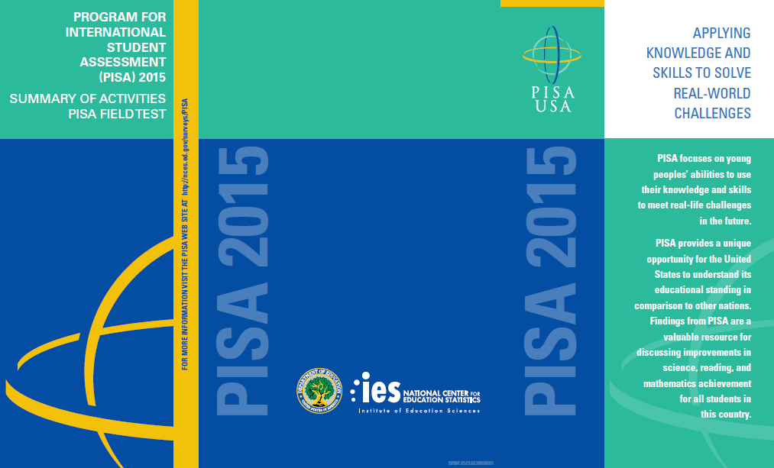
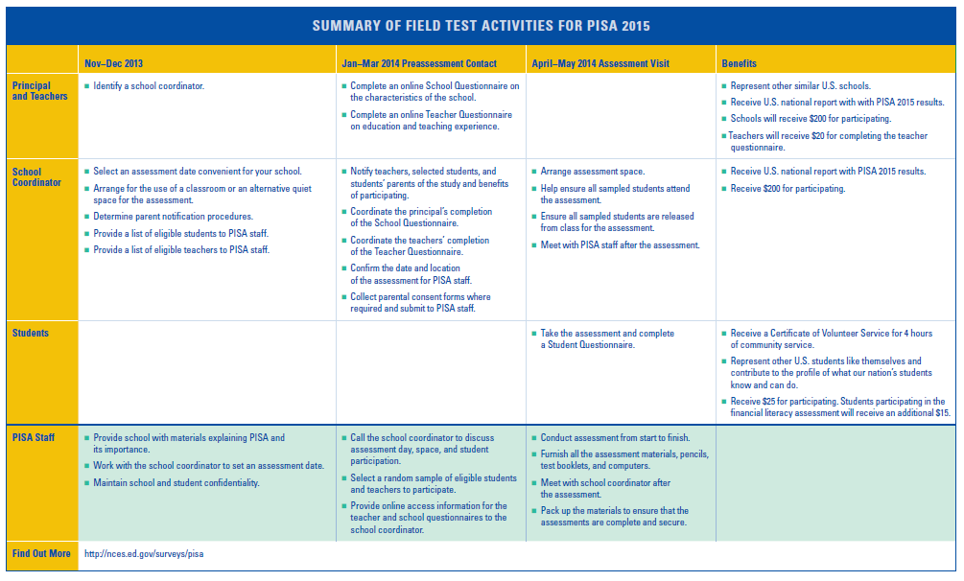
Draft PISA 2015 Timeline of Activities - Inside

Draft Teacher Invite Email

Month, Day, 2014

Dear [Teacher name]:

The United States is participating in an important international study in 2015: the Program for International Student Assessment (PISA). Your school is one of 60 across the United States that is taking part in the PISA field test and you’ve been selected to participate by completing an on-line teacher questionnaire about the courses you teach, your teacher training and education, and your views on teaching. The questionnaire takes about 45 minutes to complete. This information, combined with responses from school principals and students, helps to provide a more complete understanding of student achievement and contexts for learning. You will receive $20 for completing the questionnaire. Use the provided link and unique account information below to complete your questionnaire.

<<link to website>>
Username: **********
Password: **********

PISA is the largest international assessment of education in the world, with more than 70 countries participating in each cycle. It provides comparative information on the performance of U.S. 15-year-old students in science, reading, and mathematics with 15-year-old students in other countries. PISA is sponsored in the United States by the National Center for Education Statistics (NCES) in the U.S. Department of Education and is conducted by Westat in Rockville, Maryland. The U.S. Office of Management and Budget has approved the data collection under OMB #1850-0755. For more detailed information, please see the enclosed FAQ.

If you have any questions, please do not hesitate to call 1-888-638-2597 or send an email to PISAHELP@westat.com. You may also get more information about this study by visiting the PISA website at http://nces.ed.gov/surveys/pisa.

Your participation in the field test for PISA 2015 is vital. Thank you for your time and for supporting this important international study.

Sincerely,
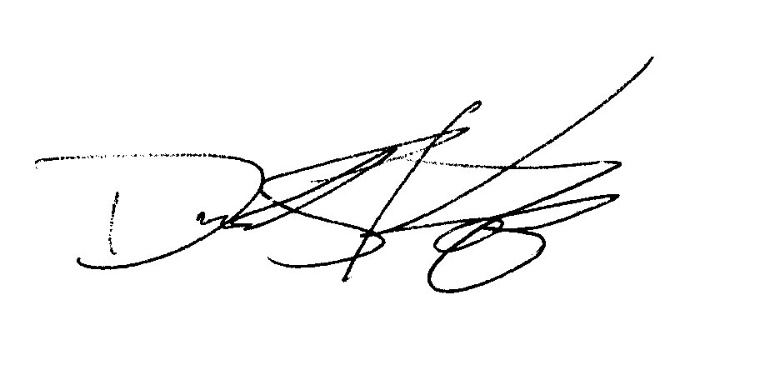
David Kastberg
Project Director, Westat

Appendix B: Draft PISA 2015 Field Test Consent Letters and Supporting Materials
Draft Sample Field Test Notification Letter, PISA 2
Draft Sample Implicit Consent Letter, PISA 3
Draft PISA Implicit Consent Form 4
Draft Sample Explicit Consent Letter, PISA 5
Draft PISA Explicit Consent Form 6
Draft PISA Facts for Parents About the Field Test 7

Draft Sample Field Test Notification Letter, PISA

SCHOOL LETTERHEAD

Dear Parent or Guardian,

This letter is to inform you about an important international study of student learning being conducted in our school this spring. This study is called the Program for International Student Assessment, or PISA. PISA provides important information for internationally benchmarking performance in science, reading, and mathematics of 15-year-old students in the United States against top countries around the world.

Each time the study is done, new test questions need to be developed and tested to ensure that those questions accurately measure the knowledge and skills of students. In spring 2014, new questions will be tested in approximately 60 schools in the United States. This field test will allow test developers to modify or delete questions that are not working effectively.

Our school has accepted an invitation from the National Center for Education Statistics (NCES), U.S. Department of Education, to participate in the PISA field test. A select few of our 15-year-old students, along with your teenager, will take part in this study. The enclosed summary sheet provides some background to PISA, explains what is involved for each student selected to participate in the study, and gives a contact phone number and email address where you can find answers to any questions you might have.

To have an accurate picture of what U.S. 15-year-old students can do, it is important that each student selected take part in the study. Some students will try out questions administered on a computer while other students will try out questions using paper and pencil. Also, students will be asked to complete a brief questionnaire about themselves. I urge you to support this effort by encouraging your teenager to take part; however, participation in this study is entirely voluntary. Previous experience suggests that students enjoy taking part, and all participating students will receive $25 and a certificate from the U.S. Department of Education for 4 hours of volunteer service.

All of the information collected is kept completely confidential, as required by law. NCES is authorized to conduct this study under the Education Sciences Reform Act of 2002 (ESRA, 2002), 20 U.S. Code, Section 9543. Under that law, the data provided by schools, staff, and students may be used only for statistical purposes and may not be disclosed, or used, in identifiable form for any other purpose (20 U.S.C., § 9573). Students and schools are never identified in any reports. All reported statistics refer to the United States as a whole.

Thank you for taking the time to learn about this important study.

Sincerely,

Enclosures:
Facts for Parents about the PISA Field Test

Draft Sample Implicit Consent Letter, PISA

SCHOOL LETTERHEAD

Dear Parent or Guardian,

This letter is to inform you about an important international study of student learning being conducted in our school this spring. This study is called the Program for International Student Assessment, or PISA. PISA provides important information for internationally benchmarking performance in science, reading, and mathematics of 15-year-old students in the United States against top countries around the world.

Each time the study is done, new test questions need to be developed and tested to ensure that those questions accurately measure the knowledge and skills of students. In spring 2014, new questions will be tested in approximately 60 schools in the United States. This field test will allow test developers to modify or delete questions that are not working effectively.

Our school has accepted an invitation from the National Center for Education Statistics (NCES), U.S. Department of Education, to participate in the PISA field test. A select few of our 15-year-old students, along with your teenager, will take part in this study. The enclosed summary sheet provides some background to PISA, explains what is involved for each student selected to participate in the study, and gives a contact phone number and email address where you can find answers to any questions you might have.

To have an accurate picture of what U.S. 15-year-old students can do, it is important that each student selected take part in the study. Some students will try out questions administered on a computer while other students will try out questions using paper and pencil. Also, students will be asked to complete a brief questionnaire about themselves. I urge you to support this effort by encouraging your teenager to take part; however, participation in this study is entirely voluntary. Previous experience suggests that students enjoy taking part, and all participating students will receive $25 and a certificate from the U.S. Department of Education for 4 hours of volunteer service.

All of the information collected is kept completely confidential, as required by law. NCES is authorized to conduct this study under the Education Sciences Reform Act of 2002 (ESRA, 2002), 20 U.S. Code, Section 9543. Under that law, the data provided by schools, staff, and students may be used only for statistical purposes and may not be disclosed, or used, in identifiable form for any other purpose (20 U.S.C., § 9573). Students and schools are never identified in any reports. All reported statistics refer to the United States as a whole.

If you have any objection to your teenager joining in the PISA activities, please let us know by completing the attached consent form and returning it to the school.

Thank you for taking the time to learn about this important study.

Sincerely,

Enclosures:
Facts for Parents About the PISA Field Test
Parent/Guardian Consent Form

Draft PISA Implicit Consent Form

Program for International Student Assessment (PISA)
Field Test
Parent/Guardian Consent Form

Your teenager has been asked to participate in a field test of an international study of student learning called the Program for International Student Assessment (PISA). Each student who participates will receive $25 and a volunteer service certificate of 4 hours from the U.S. Department of Education. This assessment will be conducted by a team of researchers from Westat, who are operating under contract on behalf of the U. S. Department of Education. In spring 2014, new questions will be tested in approximately 60 schools in the United States. This field test will allow test developers to modify or delete questions that are not working effectively.

If you grant permission for your teenager to participate in the PISA field test, you do not need to return this form.

If you do not consent to your teenager’s participation in the PISA field test, please return this form to your teenager’s school as soon as possible.

I do not grant permission for my teenager, _______________________________, to participate in the Program for International Student Assessment Field Test.

__________________________________________________________________
(Signature of parent or guardian)

Date of signature: _______/_______/____________

PLEASE PRINT:

Student name: _____________________________________________

School name: ______________________________________________

FOR OFFICE USE ONLY:

Student ID: ________________________________________________

Draft Sample Explicit Consent Letter, PISA

SCHOOL LETTERHEAD

Dear Parent or Guardian,

This letter is to inform you about an important international study of student learning being conducted in our school this spring. This study is called the Program for International Student Assessment, or PISA. PISA provides important information for internationally benchmarking performance in science, reading, and mathematics of 15-year-old students in the United States against top countries around the world.

Each time the study is done, new test questions need to be developed and tested to ensure that those questions accurately measure the knowledge and skills of students. In spring 2014, new questions will be tested in approximately 60 schools in the United States. This field test will allow test developers to modify or delete questions that are not working effectively.

Our school has accepted an invitation from the National Center for Education Statistics (NCES), U.S. Department of Education, to participate in the PISA field test. A select few of our 15-year-old students, along with your teenager, will take part in this study. The enclosed summary sheet provides some background to PISA, explains what is involved for each student selected to participate in the study, and gives a contact phone number and email address where you can find answers to any questions you might have.

To have an accurate picture of what U.S. 15-year-old students can do, it is important that each student selected take part in the study. Some students will try out questions administered on a computer while other students will try out questions using paper and pencil. Also, students will be asked to complete a brief questionnaire about themselves. I urge you to support this effort by encouraging your teenager to take part; however, participation in this study is entirely voluntary. Previous experience suggests that students enjoy taking part, and all participating students will receive $25 and a certificate from the U.S. Department of Education for 4 hours of volunteer service.

All of the information collected is kept completely confidential, as required by law. NCES is authorized to conduct this study under the Education Sciences Reform Act of 2002 (ESRA, 2002), 20 U.S. Code, Section 9543. Under that law, the data provided by schools, staff, and students may be used only for statistical purposes and may not be disclosed, or used, in identifiable form for any other purpose (20 U.S.C., § 9573). Students and schools are never identified in any reports. All reported statistics refer to the United States as a whole.

Before we can allow your teenager to join in the PISA field test we must have your written consent. Please let us know by completing the attached form and returning it to the school.

Thank you for taking the time to learn about this important study and consider your teenager’s participation in it.

Sincerely,

Enclosures:
Facts for Parents About the PISA Field Test
Parent/Guardian Consent Form

Draft PISA Explicit Consent Form

Program for International Student Assessment (PISA)
Field Test
Parent/Guardian Consent Form

Your teenager has been asked to participate in a field test of an international study of student learning called the Program for International Student Assessment (PISA). Each student who participates will receive $25 and a volunteer service certificate of 4 hours from the U.S. Department of Education. This assessment will be conducted by a team of researchers from Westat who are operating under contract on behalf of the U. S. Department of Education. In spring 2014, new questions will be tested in approximately 60 schools in the United States. This field test will allow test developers to modify or delete questions that are not working effectively.

Yes, I do grant permission for my teenager to participate in the PISA field test.

No, I do not grant permission for my teenager to participate in the PISA field test.

__________________________________________________________________
(Signature of parent or guardian)

Date of signature: _______/_______/____________

PLEASE PRINT:

Student name: _____________________________________________

School name: ______________________________________________

FOR OFFICE USE ONLY:

Student ID: ________________________________________________
Draft PISA Facts for Parents About the Field Test

Facts for Parents
About the PISA Field Test
Between March and May of this year, your teenager’s school will be one of about 60 nationwide taking part in the PISA 2015 Field Test. The schools were selected randomly to represent the nation’s schools and, within each school, about 42 students were selected randomly to take part. Your teenager was among those students selected to take part in the study.
What is PISA?
PISA (the Program for International Student Assessment) is the world’s largest international assessment that measures student learning in science, reading, and mathematics. More than 60 countries representing more than 90 percent of the world’s economy participate in PISA. The assessment occurs every 3 years (2000, 2003, 2006, 2009, 2012, and 2015), and provides information about how students in the U.S. compare in achievement with students in other countries. The National Center for Education Statistics within the U.S. Department of Education sponsors U.S. participation in PISA.
What is the purpose of the PISA Field Test?
Each time the study is done, new assessment questions need to be developed and tested to ensure that those questions accurately measure the knowledge and skills of students. This field test will allow test developers to modify or delete questions that are not working effectively for students in the United States.
What is involved?
PISA staff will visit the school and administer the field test. The field test will take approximately 3 hours; it includes time for instructions, the administration assessment, and a brief questionnaire that students complete about themselves. Some students will be asked to return for an additional 1-hour assessment of financial literacy.
What are the benefits?
The nation as a whole benefits from PISA by having a greater understanding of how the knowledge and skills of U.S. students compare with those of students from other countries. The country benefits from the field test by ensuring that the questions used are fair and appropriate for U.S. students. Schools that participate in PISA will receive $200, and each student who participates will receive $25 and a certificate from the U.S. Department of Education for 4 hours of volunteer service. Students who also participate in the financial literacy assessment will receive an additional $15.

Where can I find out more about PISA?
More information about PISA is available at the PISA website at http://www.nces.ed.gov/surveys/pisa. If you have specific questions you can call PISA staff at 1-888-638-2597 or email us at PISAHelp@westat.com.

