APPENDIX A: DRAFT RECRUITMENT MATERIALS

State PISA Letter 2

School District PISA Letter 3

School PISA Letter 4

PISA 2015 Study Brochure – Front Cover 5

PISA 2015 Study Brochure Inside Text 6

PISA 2015 Study Brochure – Back Cover 7

PISA 2015 State FAQ 8

PISA 2015 School FAQ 10

PISA 2015 Teacher FAQ 12

PISA 2015 Student FAQ 14

Teacher Invite Email 16

[Date]

[Title] [Name First] [Name Last]

# State PISA Letter

[Title/Department]

[State]

[Address 1]

[Address 2]

[City], [State] [Zip code]

Dear [Title] [Name Last]:

The United States is participating in an important international study in 2015: the Program for International Student Assessment (PISA). PISA is the largest international education study in the world. Administered every 3 years since 2000, the United States has participated in each cycle of PISA. More than 70 countries representing approximately 90 percent of the world economy participate in PISA. Results are used by researchers and policymakers to chart national progress against international benchmarks and the educational progress of our economic peers and competitors. Some schools in your state have been randomly selected to participate in PISA in the fall of 2015 and I am writing to ask your agency to support the participation of these schools.

PISA provides comparative information on the performance of U.S. 15-year-old students in science, reading, and mathematics with 15-year-old students in other countries. PISA 2015 will also include assessments of students’ collaborative problem-solving and financial literacy.

PISA is described in more detail in the enclosed materials. PISA is sponsored in the United States by the National Center for Education Statistics (NCES) within the U.S. Department of Education and is conducted by Westat in Rockville, Maryland. The U.S. Office of Management and Budget has approved the data collection under OMB #1850-0755. For information on the confidentiality of the data collected, please see the enclosed FAQ. While participation in this study is voluntary, we ask your agency to support participation by schools in your state so that the United States has a representative sample of schools across the country.

Within the next few weeks, a representative of Westat will contact sampled school districts and schools to discuss participating in PISA. In the meantime, if you have questions about the study, please do not hesitate to call David Kastberg at 1-888-638-2597 or send an email to PISAHELP@westat.com. You may also get more information by contacting Dana Kelly at NCES at 202-219-7101 or dana.kelly@ed.gov or by visiting the PISA website at http://nces.ed.gov/surveys/pisa.

Thank you for your time and support.

Sincerely,

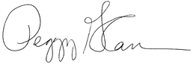

Peggy Carr, Ph.D.

Associate Commissioner

National Center for Education Statistics

cc: [State assessment director]

Enclosures

*NCES is authorized to conduct this study under the Education Sciences Reform Act of 2002 (ESRA 2002), 20 U.S. Code, § 9543. By law, the data provided by your schools, staff, and students may only be used for statistical purposes and may not be disclosed, or used, in identifiable form for any other purpose except as required by law (20 U.S. Code, § 9573).*

# School District PISA Letter

[Date]

[Title] [Name First] [Name Last], [Title/Department]

[School District]

[Address 1]

[City], [State] [Zip code]

Dear [Title] [Name Last]:

The United States is participating in an important international study in 2015: the Program for International Student Assessment (PISA). PISA is the largest international education study in the world. Administered every 3 years since 2000, the United States has participated in each cycle of PISA. More than 70 countries representing approximately 90 percent of the world economy participate in PISA. Results are used by researchers and policymakers to chart national progress against international benchmarks and the educational progress of our economic peers and competitors. Some schools in your district have been randomly selected to participate in PISA in the fall of 2015, and I am writing to ask your agency to support the participation of these schools.

PISA provides comparative information on the performance of U.S. 15-year-old students in science, reading, and mathematics with 15-year-old students in other countries. PISA 2015 will also include assessments of students’ collaborative problem-solving and financial literacy. Participating schools will receive $200, and each school’s PISA school coordinator (school staff person designated to liaise with PISA staff) will receive $200 as compensation for the coordinator’s time and effort. Selected teachers will receive $20 for completing a brief questionnaire about themselves. Each student who participates will receive $25 and a volunteer service certificate of 4 hours from the U.S. Department of Education.

PISA is sponsored in the United States by the National Center for Education Statistics (NCES) within the U.S. Department of Education and is conducted by Westat in Rockville, Maryland. The U.S. Office of Management and Budget has approved the data collection under OMB #1850-0755. For information on the confidentiality of the data collected, please see the enclosed FAQ. While participation in this study is voluntary, we ask your agency to support participation by schools in your district so that the United States has a representative sample of schools across the country.

Within the next few days, a representative of Westat will contact the following school or schools in your district that have been selected for PISA: [LIST SAMPLED SCHOOLS HERE…].

If you have any questions, please do not hesitate to call 1-888-638-2597 or send an email to PISAHELP@westat.com. You may also get more information by contacting Dana Kelly at NCES at 202-219-7101 or dana.kelly@ed.gov or by visiting the PISA website at http://nces.ed.gov/surveys/pisa.

Thank you for your time and support.



Peggy Carr, Ph.D.

Associate Commissioner

National Center for Education Statistics

cc: [State assessment director]

Enclosures

*NCES is authorized to conduct this study under the Education Sciences Reform Act of 2002 (ESRA 2002), 20 U.S. Code, § 9543. By law, the data provided by your schools, staff, and students may only be used for statistical purposes and may not be disclosed, or used, in identifiable form for any other purpose except as required by law (20 U.S. Code, § 9573).*

# School PISA Letter

[Date]

[Title] [Name First] [Name Last], [Title/Department]

[School District]

[Address 1]

[City], [State] [Zip code]

Dear [Title] [Name Last]:

The United States is participating in an important international study in 2015: the Program for International Student Assessment (PISA). Administered every 3 years since 2000, the United States has participated in each cycle of PISA. I am writing to let you know that your school is one of 240 across the United States that has been randomly selected to take part in PISA in the fall of 2015. I hope you will participate in this voluntary study because it is important that the United States has a nationally representative sample of schools.

PISA is world’s largest international education study with more than 70 countries participating, representing approximately 90 percent of the world economy. PISA is sponsored in the United States by the National Center for Education Statistics (NCES) within the U.S. Department of Education and is conducted by Westat in Rockville, Maryland. The U.S. Office of Management and Budget has approved the data collection under OMB #1850-0755.

NCES recognizes the burden of assessments on schools and works to reduce that burden as much as possible both in terms of time and resources. Under contract to NCES, Westat is responsible for all aspects of the assessment administration and will work with you to make PISA a success in your school. PISA takes a relatively small sample of 42 15-year old students and up to 25 teachers in each school, so entire classes and grades are not disrupted. For information on the confidentiality of the data collected and for more general information, please see the enclosed informational materials. Two folders of materials have been enclosed in case you want to share with faculty.

As a token of appreciation for participating in PISA, your school will receive $200. Students who take PISA will receive $25 and a volunteer service certificate of 4 hours from the U.S. Department of Education. Your school’s PISA school coordinator (a staff person you designate to liaise with PISA staff) will receive $200 for his or her time and effort coordinating PISA in the school, and selected teachers will receive $20 for completing a brief questionnaire about themselves. NCES will also sponsor a delegate from your school to attend a 2-day PISA conference in Washington, D.C. during the summer of 2015.

Within the next few days, a representative of Westat will contact you to discuss your participation. If you have any questions, please do not hesitate to call 1-888-638-2597 or send an email to PISAHELP@westat.com. You may also get more information by contacting Dana Kelly at NCES at 202-219-7101 or dana.kelly@ed.gov or by visiting the PISA website at http://nces.ed.gov/surveys/pisa.

Your participation in PISA 2015 is vital to the overall success of the study in the United States. Thank you for your time and for supporting this important international study.



Peggy Carr, Ph.D.

Associate Commissioner

National Center for Education Statistics

cc: [State assessment director]

Enclosures

*NCES is authorized to conduct this study under the Education Sciences Reform Act of 2002 (ESRA 2002), 20 U.S. Code, § 9543. By law, the data provided by your schools, staff, and students may only be used for statistical purposes and may not be disclosed, or used, in identifiable form for any other purpose except as required by law (20 U.S. Code, § 9573)*

PISA 2015 Study Brochure – Front Cover

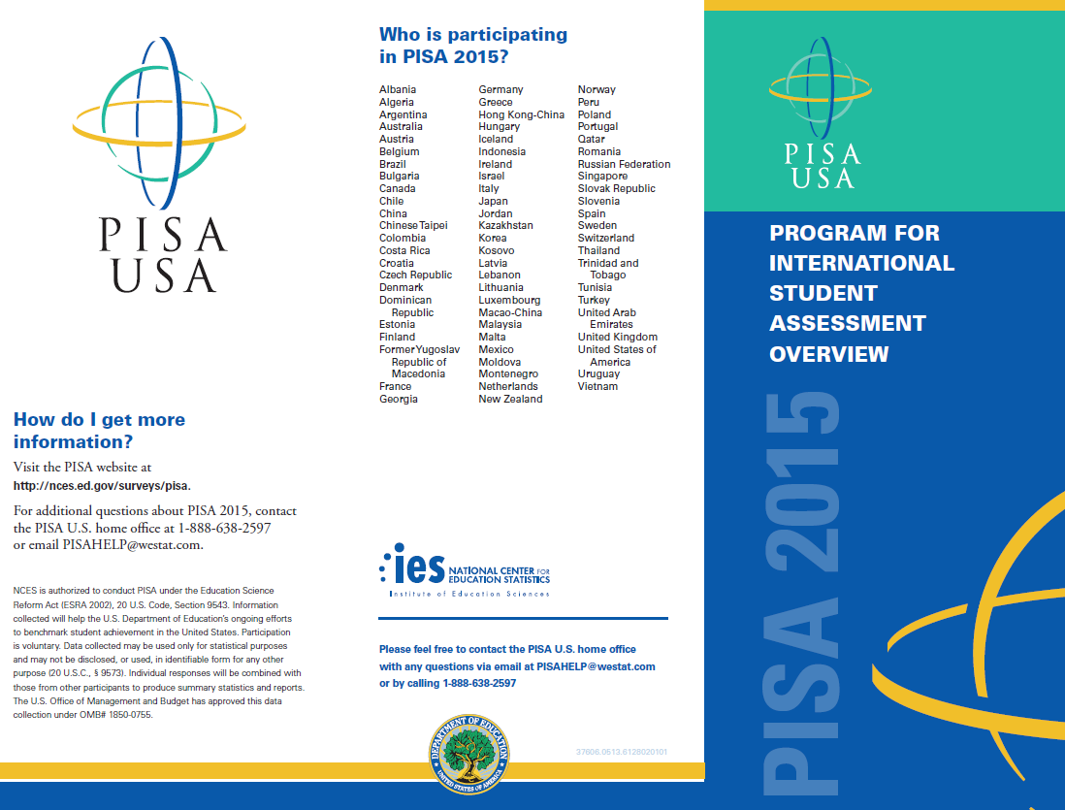

PISA 2015 Study Brochure Inside Text

**What is PISA?**

The Program for International Student Assessment (PISA) is an international assessment of 15-year-old students, conducted every 3 years, that measures how well students apply their knowledge and skills in science, reading, and mathematics to problems in real-life contexts. In 2015, students from more than 70 countries and education systems, including the United States, will participate.

PISA is coordinated by the Organization for Economic Cooperation and Development (OECD) and managed in the United States by the National Center for Education Statistics (NCES) within the U.S. Department of Education.

**Why is PISA important and what are the benefits of participating?**

PISA provides a unique opportunity for the United States to understand its educational standing in comparison to other nations. Through participating in PISA, schools, teachers, and students contribute to the improvement of education.

PISA can help us identify U.S. students’ strengths and weaknesses in these subjects and learn about successful policies and practices that in other countries.

In addition to receiving a U.S. national report with PISA 2015 results, schools may also receive a school-level report. The school report presents comparisons of your school’s average scores with the average scores of participating education systems including the United States. The report also provides comparisons of your school with other similar U.S. schools based on specific school-level characteristics.

PISA offers a modest token of appreciation to schools, the school coordinator, students, and teachers who participate. NCES also sponsors one delegate from each school to attend a summer conference in Washington, D.C. to learn about PISA.

**What will schools, students, and teachers be asked to do in PISA 2015?**

PISA 2015 has four primary components: (1) a core student assessment of science, mathematics, reading, and collaborative problem solving and a student questionnaire, (2) a financial literacy assessment administered to a sub-sample of students who take the core assessment, (3) an online school questionnaire, and (4) an online teacher questionnaire.

Up to 42 students in each school will be selected to participate in the core PISA assessment, which takes about 3 hours, including instructions, breaks, and a questionnaire. A sub-sample of up to 8 students in each school will be asked to return for an additional 1-hour assessment in financial literacy that will be held on the same day as the core assessment.

The principal of each school will also be asked to complete a 30-minute online questionnaire about school and student body characteristics and policies. Up to 25 teachers in each school will be asked to complete a 30-minute online teacher questionnaire about their background, education, and teaching experiences.

**What type of assessment is PISA?**

PISA is developed through an international consensus-building process involving input from U.S. and international experts in science, reading, mathematics, financial literacy, collaborative problem solving, and educational measurement. The PISA assessment materials are thoroughly reviewed by within-country experts to make sure the materials are appropriate for each country’s students. Finally, the resulting assessment materials are endorsed by all participating countries.

**What kinds of questions does PISA include?**

PISA includes a mix of question types: some items require students to select appropriate responses, while others require that students solve problems and provide written answers. Examples of PISA assessment questions are available at <http://nces.ed.gov/surveys/pisa/educators.asp>.

OMB 1850-0755

PISA 2015 Study Brochure – Back Cover

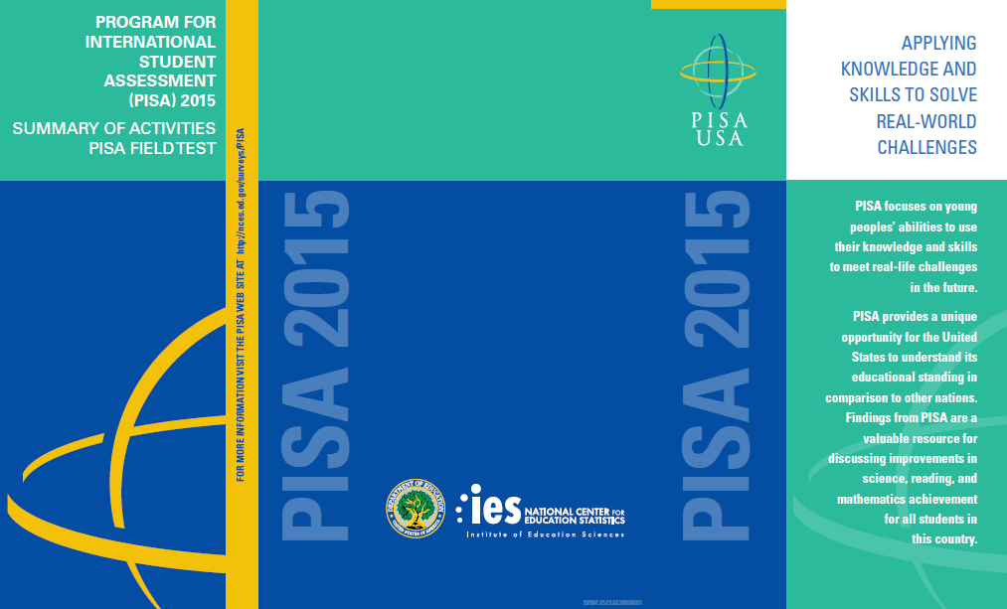

PISA 2015 State FAQ

Program for International Student Assessment

FREQUENTLY ASKED QUESTIONS

*Information for States*

**What is PISA?**

The Program for International Student Assessment (PISA) is an international assessment of 15-year-old students, conducted every three years, that measures how well students apply their knowledge and skills in science, reading, and mathematics to solve problems in real-life contexts. In 2015, students from more than 70 countries and education systems, including the United States, will participate.

PISA is coordinated by the Organization for Economic Cooperation and Development (OECD) and managed in the United States by the National Center for Education Statistics (NCES) within the U.S. Department of Education.

The entire assessment process will be undertaken by trained staff from Westat, a research organization under contract to NCES. NCES is conducting this study under authorization in the Education Sciences Reform Act of 2002 (20 U.S.C., § 9543) and with the approval of the U.S. Office of Management and Budget under OMB # 1850-0755.

**How many districts and schools will be selected in my state?**

Typically, most states have fewer than 10 sampled schools. However, the number of schools and districts sampled in each state varies according to the student population of that state, and not all states have sampled schools. PISA is designed to provide national-level estimates of student achievement rather than state-by-state level estimates. In 2015, approximately 240 schools that enroll 15-year-old students will be selected to participate from across the nation.

**What are schools that participate in PISA asked to do?**

PISA recognizes the burden of assessments on schools and works to reduce that burden as much as possible both in terms of time and resources. Under contract to NCES, Westat is responsible for all aspects of the assessment administration and will bring in laptops and a three-person team of trained professional assessors to administer the assessment. The school will only need to provide a testing location.

Each school is asked to designate a school coordinator to work with Westat and to submit a list of all 15-year-old students and teachers eligible to teach 10th grade (the modal grade of 15 year olds). Up to 42 students from each school will be sampled to participate. In addition, up to 25 teachers will be sampled to complete a teacher questionnaire and the school principal or designee will be asked to complete a school questionnaire. The teacher questionnaire takes approximately 30 minutes to complete, as does the school questionnaire. Both questionnaires will be administered online making it easier for principals and teachers to complete the survey.

**Will the results be reported for my state or for individual schools in my state?**

PISA does not report specific state-level results unless states elect to independently participate in PISA. The PISA data will be used to measure students’ knowledge and skills at the national level only. By law, data provided by schools, staff, and students may be used only for statistical purposes and may not be disclosed, or used, in identifiable form for any other purpose except as required by law [Education Sciences Reform Act of 2002 (ESRA 2002), 20 U.S. Code, Section 9573]. Reports of the findings will not identify participating states, districts, students, or individual staff. Individual responses will be combined with those from other participants to produce summary statistics and reports. For a recent example of how PISA data are reported, please visit <http://nces.ed.gov/pubs2014/2014024rev.pdf>.

**How many students in each school are sampled and how much class time will they miss?**

All 15-year-old students in each sampled school will have an equal chance of selection, but only 42 will be selected to participate. Student eligibility for selection is based solely on a student’s age at the time of the assessment (i.e., 15 years old). Only in very small schools will the school sample include all 15 year olds. While PISA does allow accommodations for students with special educational needs, some students with disabilities or limited English proficiency may be excused from the assessment.

The PISA assessment session is approximately 3 hours for students, including time for instructions, the assessment, and a brief questionnaire that students complete about themselves. Up to eight students will be asked to return in the afternoon to take the additional 1-hour financial literacy assessment.

**When will the assessment take place?**

PISA will be conducted October 6-November 16, 2015. The PISA staff will work with districts and schools to schedule an assessment date that does not interfere with other required school or student responsibilities.

**Which schools in my state are in the PISA sample?**

The confidentiality of the PISA sample is of the upmost importance. To receive your state’s list of sampled schools, please complete and return a notarized Affidavit of Non-Disclosure, enclosed in this package (you may email [PISAHelp@westat.com](mailto:PISAHelp@westat.com) to request additional copies). Once Westat receives the completed and notarized Affidavit, you will receive an encrypted file of the schools in your state that have been selected to participate in PISA.

**Can we make suggestions for replacing schools in my state selected to participate in PISA?**

No. Schools are selected to represent the overall population of 15-year-old students and the schools they attend. The sampling protocol does not allow for states to assist in the selection of schools.

**Where can I find more information?**

If you have any questions, please contact the PISA U.S. home office at 1-888-638-2597 or email [PISAHelp@westat.com](mailto:PISAHelp@westat.com).

For more information on PISA, including results from previous data collections, please visit[**http://nces.ed.gov/surveys/pisa**](http://nces.ed.gov/surveys/pisa)**.**

PISA 2015 School FAQ

Program for International Student Assessment

FREQUENTLY ASKED QUESTIONS

*Information for Schools*

**What is PISA?**

The Program for International Student Assessment (PISA) is an international assessment of 15-year-old students, conducted every three years, that measures how well students apply their knowledge and skills in science, reading, and mathematics to solve problems in real-life contexts. In 2015, students from more than 70 countries and education systems, including the United States, will participate. PISA is coordinated by the Organization for Economic Cooperation and Development (OECD) and managed in the United States by the National Center for Education Statistics (NCES) within the U.S. Department of Education.

The entire assessment process will be undertaken by trained staff from Westat, a research organization under contract to NCES. NCES is conducting this study under authorization of the Education Sciences Reform Act of 2002 (20 U.S.C., § 9543) and with the approval of the U.S. Office of Management and Budget under OMB # 1850-0755.

**What does participating in PISA entail?**

Each school is asked to designate a school coordinator to work with Westat and to submit a list of all 15-year-old students and teachers eligible to teach 10th grade (the modal grade of 15 year olds). Up to 42 students in each school will be sampled to participate in the core PISA assessment, which takes about 3 hours of total time, including instructions, breaks, and a questionnaire. A sub-sample of up to 8 students in each school will be asked to return for an additional 1-hour assessment in financial literacy that will be held on the same day as the core assessment. Up to 25 teachers in each school will be asked to complete a 30-minute online teacher questionnaire about their background, education, and teaching experiences. The principal of each school will also be asked to complete a 30-minute online questionnaire about school and student body characteristics and policies.

**Why should my school participate?**

The participation of selected schools in the United States is vital to ensuring an accurate representation of the overall 15-year-old student population across the country. Although participation is voluntary, we rely on school and student participation to ensure the results are complete and accurate. We cannot do that without the support of schools like yours. By participating in PISA, your school will have the opportunity to impact the bigger picture of education in the United States and across the world.

In addition to receiving a U.S. national report with PISA 2015 results, schools may also receive a school-level report. The school report presents comparisons of your school’s average scores with the average scores of participating education systems including the United States. The report also provides comparisons of your school with other similar U.S. schools based on specific school-level characteristics.

PISA offers a modest token of appreciation for schools, the school coordinator, students, and teachers who participate.

**What school resources are required on assessment day?**

All that is required from a school resource perspective is a space for up to 42 students that can be used for the entire day and that has accessible power outlets. PISA 2015 is completely computer-based, and Westat field staff will bring laptops and all necessary equipment to the school on assessment day. The assessment does not require network or internet access. No IT staff or resources will be needed from your school.

**Will all of our 15-year-old students be asked to participate?**

Probably not. In each school, all 15-year-old students will have an equal chance of selection, but only 42 will be selected to participate. Student selection is not based on any student characteristic other than being 15 years old. Only in very small schools with less than 42 15-year-old students enrolled will the sample include all available students. While PISA does allow accommodations for students with special educational needs, some students with disabilities or limited English proficiency may be excused from the assessment.

**How long does the assessment take?**

The PISA assessment session is approximately 3 hours for students, including time for instructions, the assessment, and a student questionnaire. Up to eight students will be asked to return in the afternoon to take an additional 1-hour financial literacy assessment. In total, the assessment location will be used for about 5 hours for the main assessment, and about 2 hours for the financial literacy assessment, including setup and breakdown by Westat staff. All assessment activities will take place in one day.

**Do teachers need to help administer the assessment?**

No, no teachers or other staff from your school are required to administer PISA. Westat staff will come to your school on the day of the assessment and will bring all materials required including laptops for administering PISA. Westat staff will handle the entire administration from start to finish.

**How are teacher and school questionnaires administered?**

The teacher and school questionnaires are both administered online from a secure website. Up to

25 teachers (10 science and 15 non-science) will be sampled to complete an online 30-minute questionnaire that asks about their education and teaching experience, among other topics. The school questionnaire, which looks at school characteristics, such as enrollment and school practices, is also administered online and takes about 30 minutes to complete. Principals and teachers will receive login and password information via email or from their school’s PISA school coordinator.

**What will happen with the collected data?**

By law, data provided by schools, staff, and students may be used only for statistical purposes and may not be disclosed, or used, in identifiable form for any other purpose except as required by law [Education Sciences Reform Act of 2002 (ESRA 2002), 20 U.S. Code, Section 9573]. Reports of the findings will not identify participating districts, students, or individual staff. Individual responses will be combined with those from other participants to produce summary statistics and reports. For a recent example of how PISA data are reported, please visit <http://nces.ed.gov/pubs2014/2014024rev.pdf>.

**Where can I find more information?**

If you have any questions, please contact the PISA U.S. home office at 1-888-638-2597 or email [PISAHelp@westat.com](mailto:PISAHelp@westat.com).

For more information on PISA, including results from previous data collections, please visit

[**http://nces.ed.gov/surveys/pisa**](http://nces.ed.gov/surveys/pisa)

# PISA 2015 Teacher FAQ

Program for International Student Assessment

FREQUENTLY ASKED QUESTIONS

*Information for Teachers*

**What is PISA?**

The Program for International Student Assessment (PISA) is an international assessment of 15-year-old students, conducted every three years, that measures how well students apply their knowledge and skills in science, reading, and mathematics to solve problems in real-life contexts. In 2015, students from more than 70 countries and education systems, including the United States, will participate. PISA is coordinated by the Organization for Economic Cooperation and Development (OECD) and managed in the United States by the National Center for Education Statistics (NCES) within the U.S. Department of Education.

PISA provides a unique opportunity for the United States to understand its educational standing in comparison to other nations. Through participating in PISA, schools, teachers, and students contribute to the improvement of education.

PISA can help us identify U.S. students’ strengths and weaknesses in these subjects and help us learn about successful policies and practices in other countries.

**What role do teachers have in PISA?**

Beginning with PISA 2015, teachers are asked to complete an online questionnaire. This gives you an opportunity to provide information that is critical to understanding student performance as well as to voice your perspectives on teaching and learning at your school. The teacher questionnaire asks about your background and teaching experience, the student body, and your views on school policies and evaluation.

**How was I selected to take the PISA teacher questionnaire?**

The PISA school coordinator in your school (the person designated by your school principal to communicate with PISA staff) provided a list of all teachers eligible to teach 10th grade students in your school. You are one of about 25 teachers from your school who were selected to participate. Your participation in PISA is vital to reaching a high response rate.

**How long will it take to complete the PISA teacher questionnaire?**

The teacher questionnaire will take approximately 30 minutes to complete online, and you do not have to complete it all in a single session. The online software automatically saves your responses to each question as you navigate through the questionnaire so that if you wish to complete the questionnaire later, you may pick up right where you left off.

**How can I access the PISA teacher questionnaire?**

To access the teacher questionnaire (<https://www.mypisausa.com/teacherquestionnaire>), you will need to have an internet connection, a suitable internet browser (see list below), and your login credentials. You will be emailed a unique hyperlink that you can click on to access the questionnaire directly. The PISA staff are ready to work with you to make access and completion of the teacher questionnaire as easy and efficient as possible.

The following browsers are supported by PISA and can be downloaded for free if you do not already have them installed on the computer:

* *Firefox:* Version 19 and above
* *Internet Explorer*: Version 8 and above
* *Google Chrome*: Version 25 and above
* *Safari (Mac version)*: versions 6 and above

**What is done with the information you collect from me?**

Your responses to the PISA teacher questionnaire will be combined with those from other participating teachers across the United States to produce summary statistics and reports. By law, data provided by schools, staff, and students may be used only for statistical purposes and may not be disclosed, or used, in identifiable form for any other purpose except as required by law [Education Sciences Reform Act of 2002 (ESRA 2002), 20 U.S. Code, Section 9573]. The U.S. Office of Management and Budget has approved this data collection under OMB # 1850-0755. Reports of the findings will not identify participating districts, students, or individual staff. For a recent example of how PISA data are reported, please visit <http://nces.ed.gov/pubs2014/2014024rev.pdf>.

**Where can I go for help or technical support?**

If you have any questions or experience any difficulties, please contact the PISA U.S. home office at

1-888-638-2597 or email [PISAHelp@westat.com](mailto:PISAHelp@westat.com).

For more information on PISA, including results from previous data collections, please visit

[**http://nces.ed.gov/surveys/pisa**](http://nces.ed.gov/surveys/pisa)

PISA 2015 Student FAQ

Program for International Student Assessment

FREQUENTLY ASKED QUESTIONS

*Information for Students*

**What is PISA?**

The Program for International Student Assessment (PISA) is an international assessment of 15-year-old students, conducted every three years, that measures how well students apply their knowledge and skills in solving problems in science, reading, mathematics, financial literacy, and collaborative problem solving. PISA presents problems that students are likely to encounter in the real world. In 2015, students like yourself from more than 70 countries and education systems, including the United States, will participate in PISA.

**Why should I participate in PISA?**

You are one of about 42 students in your school who have been selected to participate in PISA. Because you are one of a select few in your school your participation is very important. If you participate in PISA you will….

* receive a certificate for 4-hours of volunteer service from the U.S. Department of Education, and
* represent students like you across the country.

*Only 5,000 students will have the unique opportunity to participate in PISA 2015 in the United States. How often do you get to represent your country?*

*Participating in PISA is a national service. You can have an impact on the bigger picture of education in the United States and around the world.*

**What subjects are assessed in PISA?**

Each student participating in PISA will be assessed in two or three of the following subjects: science, mathematics, reading, financial literacy, or collaborative problem solving. No student takes every PISA test question, and most students will be assessed in only two of the subjects. PISA is administered on a computer.

**How long does PISA take?**

The PISA assessment takes approximately 3 hours to complete. This includes time for instructions, the assessment, and a brief survey of questions about yourself. Some students will also be selected to participate in an additional 1-hour assessment in financial literacy that is held after the main PISA assessment.

**How did my school get selected to take PISA?**

The schools that participate in PISA in the United States are randomly selected from a list of all schools in the country that enroll 15-year-old students. This is done to ensure that U.S. participants accurately represent the entire population of 15-year-old students in the United States and not just particular types of schools or groups of students.

**How did I get selected to take PISA?**

From a list of all 15-year-old students provided by your school, 42 students are randomly selected to participate. Every 15-year-old student enrolled in a PISA-selected school has an equal chance of being selected. Students in other countries are selected in the same way to make sure each country is fairly represented and no country is advantaged or disadvantaged because of the types of schools or groups of students selected.

**What types of questions will I see on PISA?**

Based on situations you might encounter in real life, PISA questions assess the knowledge and skills students have learned, both in and out of school. Some PISA questions require that you select from a set of provided answers; other PISA questions require that you write out your response.

PISA is administered on computer. Many of the items are interactive, where you manipulate different pieces of information. To try PISA items on your own, please visit: <http://nces.ed.gov/surveys/pisa/items_cba.asp>

**What is done with the information you collect from me?**

Your individual performance on PISA will not be reported. PISA is not designed to produce individual test scores and your individual performance is not shared with your school in any way. Student responses are combined with other student responses and are only used for statistical purposes. By law, data provided by schools, staff, and students may be used only for statistical purposes and may not be disclosed, or used, in identifiable form for any other purpose except as required by law [Education Sciences Reform Act of 2002 (ESRA 2002), 20 U.S. Code, Section 9573].

**Where can I find more information?**

Visit the PISA Website at <http://nces.ed.gov/surveys/pisa>.

For additional questions about PISA, contact the PISA U.S. home office at 1-888-638-2597 or email [PISAHelp@westat.com](mailto:PISAHelp@westat.com)

OMB 1850-0755

# Teacher Invite Email

Month, Day, 2014

Dear [Teacher name]:

You are receiving this email because your school has agreed to participate in the Program for International Student Assessment (PISA) and you’ve been selected to complete the PISA teacher questionnaire. This email contains important information about the study and teacher questionnaire that is part of the PISA data collection. If you need to confirm the authenticity of this email, please feel free to contact Dr. Patrick Gonzales of the U.S. Department of Education for more information. He can be reached at [patrick.gonzales@ed.gov](mailto:patrick.gonzales@ed.gov) or 415-920-9229. Alternatively, please contact the PISA school coordinator in your school, <SC NAME>, who can provide you with more information.

The information you provide will be combined with responses from school principals and students to provide a more complete understanding of student achievement and contexts for learning. The questionnaire takes about 30 minutes to complete. You will receive $20 for completing the questionnaire, if your school’s policy allows it.

Use the provided link and unique account information below to complete your questionnaire. Please do not share your username or password with anyone.

Click here to access your questionnaire:

<<Respondent-specific link to website>>

Username: **********

Password: **********

PISA is sponsored in the United States by the National Center for Education Statistics (NCES) within the U.S. Department of Education and is conducted by Westat, a research organization in Rockville, Maryland, under contract to NCES. The U.S. Office of Management and Budget has approved the data collection under OMB #1850-0755. For more detailed information, please see the attached FAQ.

Please do not hesitate to call the PISA help desk at 1-888-638-2597 or send an email to PISAHELP@westat.com. You may also get more information about this study by visiting the PISA website at <http://nces.ed.gov/surveys/pisa>.

Thank you for your time and for supporting this important international study.

Sincerely,



Peggy Carr, Ph.D.

Associate Commissioner

National Center for Education Statistics

U.S. Department of Education

*NCES is authorized to conduct this study under the Education Sciences Reform Act of 2002 (ESRA 2002), 20 U.S. Code, § 9543. By law, the data provided by your schools, staff, and students may only be used for statistical purposes and may not be disclosed, or used, in identifiable form for any other purpose except as required by law (20 U.S. Code, § 9573)*

Appendix B: Draft PISA 2015 Consent Letters and Supporting Materials

**Draft Sample Notification Letter, PISA** 2

**Draft** **Sample Implicit Consent Letter, PISA** 3

**Draft PISA Implicit Consent Form** 4

**Draft Sample Explicit Consent Letter, PISA** 5

**Draft PISA Explicit Consent Form** 6

**Draft PISA Facts for Parents**  7

**Draft Sample Notification Letter, PISA**

SCHOOL LETTERHEAD

Dear Parent or Guardian,

This letter is to inform you about an important international study of student learning being conducted in our school this spring. This study is called the Program for International Student Assessment, or PISA. PISA provides important information for internationally benchmarking performance in science, reading, and mathematics of 15-year-old students in the United States versus 15-year-olds in other countries around the world.

Our school has accepted an invitation from the National Center for Education Statistics (NCES) within the U.S. Department of Education to participate in PISA. A select number of our 15-year-old students, along with your teenager, will take part in this study. The enclosed summary sheet provides background information about PISA, explains what is involved for each student selected to participate in the study, and gives a contact phone number and email address where you can obtain answers to any questions you might have.

To have an accurate picture of what U.S. 15-year-old students can do, it is important that each student selected take part in the study. Students will complete test items administered on a computer and complete a brief questionnaire about themselves. I urge you to support this effort by encouraging your teenager to take part; however, participation in this study is entirely voluntary. Previous experience suggests that students enjoy taking part, and all participating students will receive $25 plus a certificate from the U.S. Department of Education for 4 hours of volunteer service.

NCES is authorized to conduct this study under the Education Sciences Reform Act of 2002 (ESRA 2002), 20 U.S. Code, § 9543. By law, the data provided by schools, staff, and students may only be used for statistical purposes and may not be disclosed, or used, in identifiable form for any other purpose except as required by law (20 U.S.C., § 9573). The U.S. Office of Management and Budget has approved this data collection under OMB # 1850-0755. Students and schools are never identified in any reports. All reported statistics refer to the United States as a whole.

Thank you for taking the time to learn about this important study.

Sincerely,

Enclosures:

Facts for Parents about PISA

**Draft** **Sample Implicit Consent Letter, PISA**

SCHOOL LETTERHEAD

Dear Parent or Guardian,

This letter is to inform you about an important international study of student learning being conducted in our school this spring. This study is called the Program for International Student Assessment, or PISA. PISA provides important information for internationally benchmarking performance in science, reading, and mathematics of 15-year-old students in the United States versus 15-year-olds in other countries around the world.

Our school has accepted an invitation from the National Center for Education Statistics (NCES) within the U.S. Department of Education to participate in the PISA. A select number of our 15-year-old students, along with your teenager, will take part in this study. The enclosed summary sheet provides background information about PISA, explains what is involved for each student selected to participate in the study, and gives a contact phone number and email address where you can obtain answers to any related questions you might have.

To have an accurate picture of what U.S. 15-year-old students can do, it is important that each student selected take part in the study. Students will complete test items administered on a computer and complete a brief questionnaire about themselves. I urge you to support this effort by encouraging your teenager to take part; however, participation in this study is entirely voluntary. Previous experience suggests that students enjoy taking part, and all participating students will receive $25 plus a certificate from the U.S. Department of Education for 4 hours of volunteer service.

NCES is authorized to conduct this study under the Education Sciences Reform Act of 2002 (ESRA 2002), 20 U.S. Code, § 9543. By law, the data provided by schools, staff, and students may only be used for statistical purposes and may not be disclosed, or used, in identifiable form for any other purpose except as required by law (20 U.S.C., § 9573) Office of Management and Budget has approved this data collection under OMB # 1850-0755. Students and schools are never identified in any reports. All reported statistics refer to the United States as a whole.

If you have any objection to your teenager joining in the PISA activities, please let us know by completing the attached consent form and returning it to the school.

Thank you for taking the time to learn about this important study.

Sincerely,

Enclosures:

Facts for Parents About PISA

Parent/Guardian Consent Form

**Draft PISA Implicit Consent Form**

**Program for International Student Assessment (PISA)**

**Parent/Guardian Consent Form**

Your teenager has been asked to participate in an international study of student learning called the Program for International Student Assessment (PISA). Each student who participates will receive $25 plus a certificate for 4 hours of volunteer service from the U.S. Department of Education. This assessment will be conducted by a team of researchers from Westat, a research organization under contract to the National Center for Education Statistics within the U. S. Department of Education.

**If you grant permission for your teenager to participate in PISA, you do not need to return this form.**

**If you do not consent to your teenager’s participation in the PISA field test, please return this form to your teenager’s school as soon as possible.**

**I do not grant permission** for my teenager, _______________________________, to participate in the Program for International Student Assessment.

**__________________________________________________________________**

(Signature of parent or guardian)

Date of signature: _______/_______/____________

PLEASE PRINT:

**Student name: _____________________________________________**

School name: ______________________________________________

FOR OFFICE USE ONLY:

Student ID: ________________________________________________

**Draft Sample Explicit Consent Letter, PISA**

SCHOOL LETTERHEAD

Dear Parent or Guardian,

This letter is to inform you about an important international study of student learning being conducted in our school this spring. This study is called the Program for International Student Assessment, or PISA. PISA provides important information for internationally benchmarking performance in science, reading, and mathematics of 15-year-old students in the United States against other countries around the world.

Our school has accepted an invitation from the National Center for Education Statistics (NCES) within the U.S. Department of Education to participate in PISA. A select number of our 15-year-old students, along with your teenager, will take part in this study. The enclosed summary sheet provides background information about PISA, explains what is involved for each student selected to participate in the study, and gives a contact phone number and email address where you can obtain answers to any questions you might have.

To have an accurate picture of what U.S. 15-year-old students can do, it is important that each student selected take part in the study. Some students will try out questions administered on a computer while other students will try out questions using paper and pencil. Also, students will be asked to complete a brief questionnaire about themselves. I urge you to support this effort by encouraging your teenager to take part; however, participation in this study is entirely voluntary. Previous experience suggests that students enjoy taking part, and all participating students will receive $25 and a certificate from the U.S. Department of Education for 4 hours of volunteer service.

NCES is authorized to conduct this study under the Education Sciences Reform Act of 2002 (ESRA 2002), 20 U.S. Code, § 9543. By law, the data provided by schools, staff, and students may only be used for statistical purposes and may not be disclosed, or used, in identifiable form for any other purpose except as required by law (20 U.S.C., § 9573). Office of Management and Budget has approved this data collection under OMB # 1850-0755. Students and schools are never identified in any reports. All reported statistics refer to the United States as a whole.

Before we can allow your teenager to participate in PISA we must have your written consent. Please let us know by completing the attached form and returning it to the school.

Thank you for taking the time to learn about this important study and consider your teenager’s participation in it.

Sincerely,

Enclosures:

Facts for Parents About PISA

Parent/Guardian Consent Form

**Draft PISA Explicit Consent Form**

**Program for International Student Assessment (PISA)**

**Parent/Guardian Consent Form**

Your teenager has been asked to participate in a field test of an international study of student learning called the Program for International Student Assessment (PISA). Each student who participates will receive $25 plus a certificate for 4 hours of volunteer service from the U.S. Department of Education. This assessment will be conducted by a team of researchers from Westat, a research organization under contract to the National Center for Education Statistics within the U. S. Department of Education.

Yes, I do grant permission for my teenager to participate in the PISA field test.

No, I do not grant permission for my teenager to participate in the PISA field test.

**__________________________________________________________________**

(Signature of parent or guardian)

Date of signature: _______/_______/____________

PLEASE PRINT:

**Student name: _____________________________________________**

School name: ______________________________________________

FOR OFFICE USE ONLY:

Student ID: ________________________________________________

**Draft PISA Facts for Parents**

**Facts for Parents About PISA**

Between October and November of this year, your teenager’s school will be one of about 240 nationwide taking part in PISA 2015. The schools were randomly selected to represent the nation’s schools and, within each school, about 42 students were selected randomly to take part. Your teenager was among those students selected to take part in the study.

**What is PISA?**

The Program for International Student Assessment (PISA) is the world’s largest international assessment that measures student learning in science, reading, and mathematics. More than 70 countries representing more than 90 percent of the world’s economy will participate in PISA. The assessment occurs every three years (2000, 2003, 2006, 2009, 2012, and 2015), and provides information about how U.S. students’ achievement in these subject areas compares to the achievement of students in other participating countries. The National Center for Education Statistics within the U.S. Department of Education sponsors U.S. participation in PISA. Westat, a research organization based in Rockville, Maryland, is under contract to NCES to conduct the study in U.S. schools.

**What is involved?**

PISA staff will visit the school and administer the assessment. The assessment will take approximately 3 hours, which includes time needed for instructions the assessment and a brief questionnaire that students complete about themselves. Some students will be asked to return for an additional 1-hour assessment of financial literacy.

**What are the benefits?**

The nation as a whole benefits from PISA by having a greater understanding of how the knowledge and skills of U.S. students compare with those of students from other countries. Schools that participate in PISA receive $200, and each student who participates will receive $25 and a certificate from the U.S. Department of Education for 4 hours of volunteer service. Students who are also asked to participate in the financial literacy assessment will receive an additional $15.

**Where can I find out more about PISA?**

Please do not hesitate to call the PISA help desk at 1-888-638-2597 or send an email to [PISAHELP@westat.com](mailto:PISAHELP@westat.com) with any questions you have. You may also get more information about this study by visiting the PISA website at <http://nces.ed.gov/surveys/pisa>.