Applicant's Voluntary
Self-Identiﬁcation Form

Board of Governors
of the Federal Reserve System
OMB No. 7100-0181
Average hours per response 1 minute
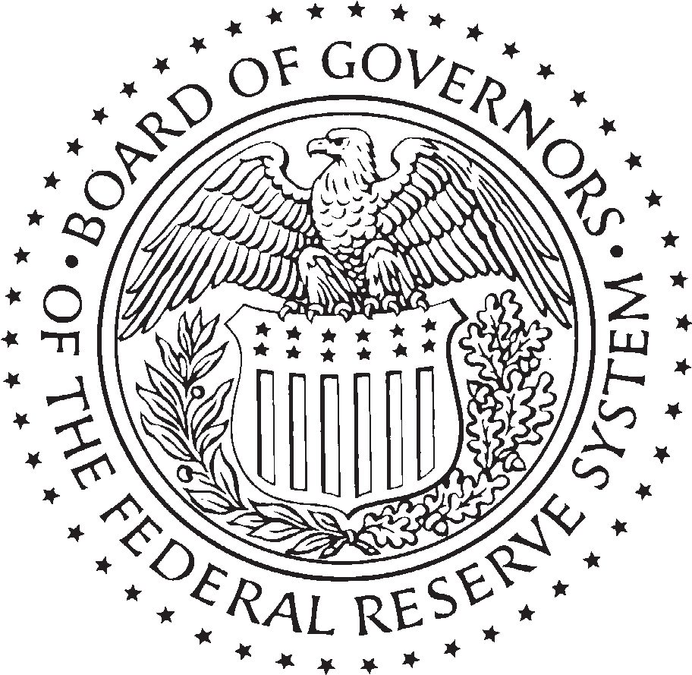
Approval expires February 28, 2011

The Board of Governors of the Federal Reserve System (Board) is requesting that you furnish this information under the authority of 42 U.S.C. 2000e-16, which requires that Federal employment practices be free of discrimination and provide equal employment opportunity for all. Your providing of this information is strictly voluntary. Your failure to do so will have no effect on the decision to hire you or on your employment with the Board. The information you provide on this form
will be kept in a conﬁdential ﬁle separate from your application for employment and will not be shared with the selecting
ofﬁcial or other persons who will make the hiring decision.

GENDER
Female Male

Please respond to the ethnicity question and race identiﬁcation below.

ETHNIC SELF IDENTIFICATION

Are you Hispanic or Latino? Yes No If yes, please select from the following: Cuban South or Central American Mexican Other Spanish Culture
Puerto Rican

RACE SELF-IDENTIFICATION (Mark one or more)

American Indian or Alaskan Native
A person having origins in any of the original peoples of North and South America (including Central America), and who maintains tribal afﬁliation or community attachment.

Asian
A person having origins in any of the original peoples of the Far East, Southeast Asia, or the Indian subcontinent including, for example, Cambodia, China, India, Japan, Korea, Malaysia, Pakistan, the Philippine Islands, Thailand, and Vietnam.

Black or African American
A person having origins in any of the black racial groups of Africa.

Native Hawaiian or Other Paciﬁc Islander
A person having origins in any of the original peoples of Hawaii, Guam, Samoa, or other Paciﬁc Islands.

White
A person having origins in any of the original peoples of Europe, the Middle East, or North Africa.

PRIVACY ACT STATEMENT
Collection of this information is authorized by sections 10 and 11 of the Federal Reserve Act (12 U.S.C. §§ 244 & 248), 42 U.S.C. § 2000e-16, and 12 CFR part 268. The information will be used in planning and monitoring equal employment opportunity programs at the Board, including preparing statistical reports regarding race, gender and national origin of applicants. Providing this information is voluntary and failure to provide the information will have no effect on your application. Disclosure of the information may be made for enforcement, statutory, or regulatoary purposes; to another agency or Federal Reserve Bank; to the Equal Employment Opportunity Commission;
and in accordance with any other routine uses of the records speciﬁed in the Board’s system of records notice
“FRB-Recruiting and Placement Records,,” 73 Federal Register 24984.

Name (Last, First, Middle Initial) Signature Date

Title, Grade, Announcement Number of Position for which you are applying

FR 28s (03/08)

