Equine 2015
Tick Control Products

Code | Established name | Manufacturer | Picture | Type
1 | Barn and Stable Fly Spray | Bonide | 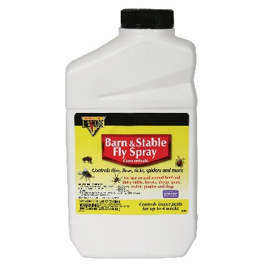 | Spray
2 | Zonk it! Spray | Cut Heal Animal Products | 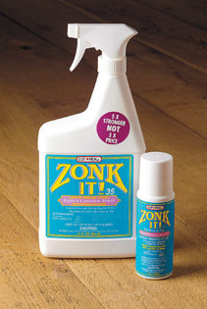 | Spray
3 | Pyranha Aerosol | Equine Direct | 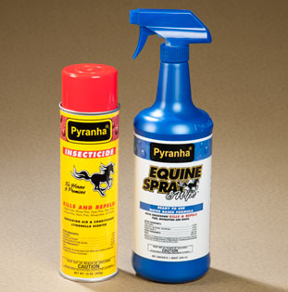 | Spray
4 | Repel-X Concentrate | Farnam | 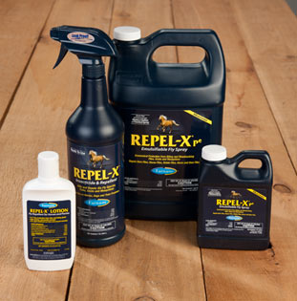 | Spray
5 | Flysect Super 7 | Farnam | 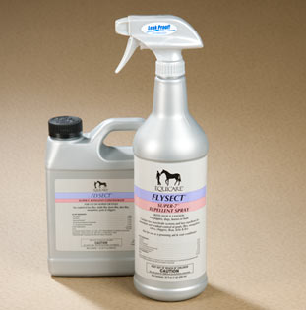 | Spray
6 | Pyranha Spray and Wipe | Equine Direct |  | Spray or Wipe
7 | Bite Free | Farnam | 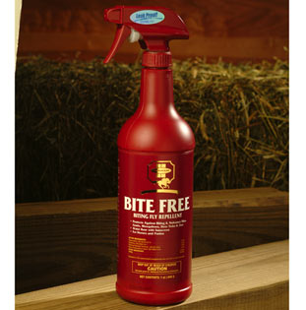 | Spray or wipe
8 | EquiSect | Spray or Wipe | 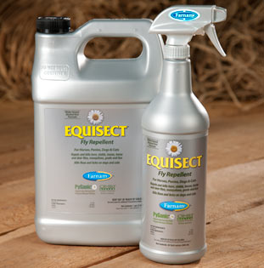 | Spray or wipe
9 | Flysect Super-C Concentrate | Farnam |  | Spray or wipe
10 | Tri-Tec 14 | Farnam | 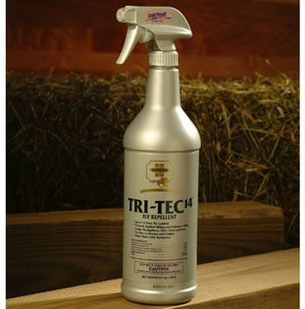 | Spray or wipe
11 | DuraGuard Insecticide and Repellant | Absorbine | 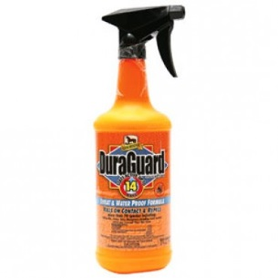 | Spray or wipe
12 | UltraShield Insecticide and Repellant | Absorbine | 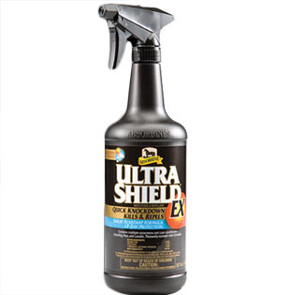 | Spray or wipe
13 | Equi-Spot | Farnam | 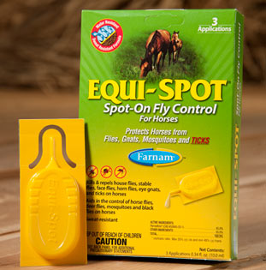 | Spot-On Topical
14 | Endure Roll-On | Farnam | 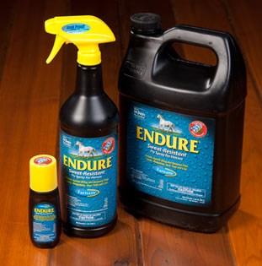 | Roll-On
15 | Zonk It! Roll-On | Cut Heal Animal Products |  | Roll-On
16 | Bug Check | Cut Heal Animal Products | 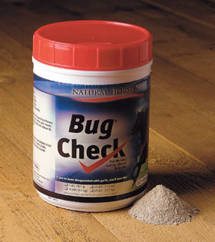 | Edible Powder

