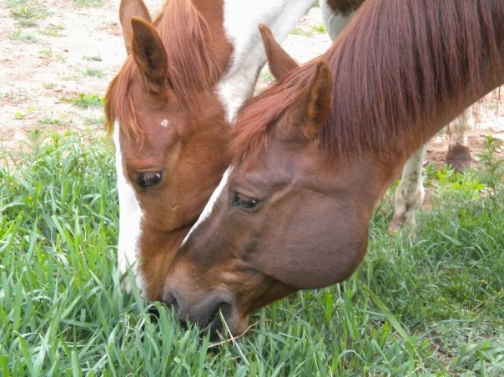
NAHMS Equine 2015

Tick Evaluation and
Data Collection Record
National Animal Health Monitoring System

2150 Centre Ave, Bldg B
Fort Collins, CO 80526

Form Approved
OMB Number 0579-0269
EXP. DATE: XX/20XX

Animal and Plant
Health Inspection
Service

Veterinary Services
Farm ID: (6 digits) | Kit #: | Collector name and phone number: | Date: (mm/dd/yy)

Tick Exam and Collection Instructions

Equids to sample: Sample up to 10 equids on the operation. Select equids that have the greatest chance of tick exposure—
i.e., equids that have access to grass or foliage even if the grass/foliage is located only at the edge(s) of a dirt pen or paddock.
Equids that are not turned out in a pasture or have access to other foliage have a low risk of tick exposure.

Kits: Each kit includes one glass tube prefilled with 70% ethanol and two tick collection tools: one Tick Key and one Pro tick.

- Perform a full-body scratch inspection on the animal with your fingers to locate ticks. Record the location and number of ticks according to the diagram provided on the data collection form. For example, 20 ticks located by the left ear is entered as A-left (20) on the data collection form. Approximately 200 ticks on the right side of the tail is entered as G-right (200).

- Use one of the two tick removal tools (instructions are included with each tool) to remove the tick and place it in the glass tube (prefilled with 70% ethanol).

- From each equid where ticks are observed, collect a representative sample of ticks from each location on that equid. All collected ticks for the operation should be placed in the same tube.

- Ship the tube along with the yellow copy of the Data Collection Record to NVSL, using the enclosed FedEx shipping label.

- Send the original white copy of the Data Collection Record to your NAHMS Coordinator within 3 business days.

Tick Location Diagram
According to the Paperwork Reduction Act of 1995, an agency may not conduct or sponsor, and a person is not required to respond to, a collection of information unless it displays a valid OMB control number. The valid OMB control number for this information collection is 0579-0269. The time required to complete this information collection is estimated to average 2 hours per response, including the time for reviewing instructions, searching existing data sources, gathering and maintaining the data needed, and completing and reviewing the collection of information.

NAHMS-337

JUN 2014

These are common locations of ticks on a horse or other equid. Please use the codes below to indicate on the Data Collection form where ticks are observed on each animal. Specify which side of the animal the ticks are located. If ticks are observed in a location not specified by the codes, mark H. and specify the location and side of the animal.

- Ears
- Mane
- Intermandibular space
- Girth or axilla
- Sheath or udder
- Between hindquarters/thighs
- Tail head or under tail
- Face
- Other (specify on Data Collection Record)

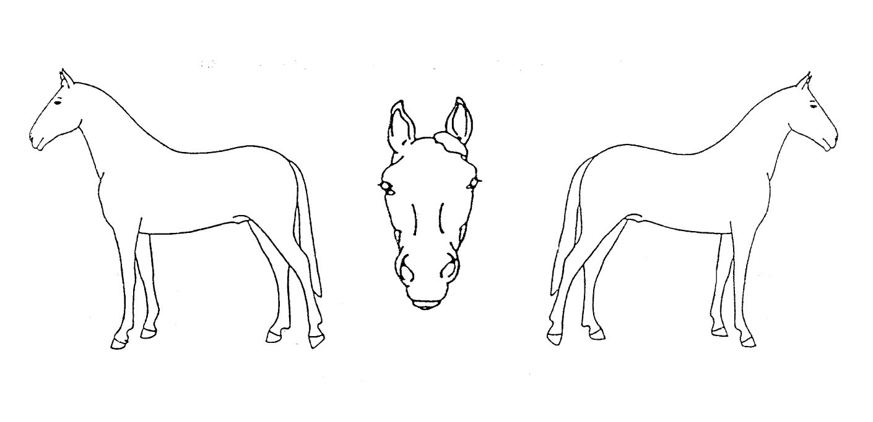
Left
Right
Left
Right
A
B
C
D
E
G
F

H

Reference Codes for Tick Collection

Gender codes
1 = Intact male (stallion or colt) | 3 = Nonpregnant female (mare or filly) | 5 = Spayed female
2 = Castrated male (gelding) | 4 = Pregnant female
Primary use codes
1 = Pleasure | 3 = Breeding | 5 = Farm or ranch work
2 = Show or competition (not betting) | 4 = Racing | 6 = Other (specify in column)
Equine type
1 = Horse | 3 = Donkey | 5 = Miniature
2 = Mule | 4 = Pony | 6 = Other
Breed codes
1 = Appaloosa | 6 = Mustang | 11 = Tennessee Walker
2 = Arabian | 7 = Paint | 12 = Thoroughbred
3 = Draft breed | 8 = Quarter horse | 13 = Warmblood breeds
4 = Miniature horse | 9 = Saddlebred | 14 = Other registered breed  (specify on collection form)
5 = Morgan | 10 = Standardbred | 15 = Other nonregistered breed  (specify on collection form)
Color (color of majority of body)
1 = Red | 4 = White | 7 = Red roan
2 = Brown | 5 = Black | 8 = Blue roan
3 = Gray | 6 = Tan/Buckskin /Palomino | 9 = Other (specify)

Equid # | Equid name or  unique ID | Age  (months  or years) | Gender  (See codes) | Primary use  (see codes) | Equid Type:  (See codes) | Breed  (See codes) | Coat color  (see codes) | In the past  6 months, has this equid had physical contact with pasture or other foliage (bushes, trees, weeds)  (Yes/No) | Treated for ticks in previous 30 days?  (Yes/No) | Code for product used to treat for ticks | Location(s) of ticks  Indicate all locations where ticks were found  Code for area of body,  side (left or right), approximate number of ticks observed  (see horse diagram)
Ex | Daisy | 2yr | 3 | 1 | 1 | 2 | 2 | Yes | Yes | 4 | A-left (5), D-right (50),  H-right (3)
1 |  | ___ mo  ___ yr
2 |  | ___ mo ___ yr
3 |  | ___ mo  ___ yr
4 |  | ___ mo ___ yr
5 |  | ___ mo ___ yr
6 |  | ___ mo ___ yr
7 |  | ___ mo ___ yr
8 |  | ___ mo ___ yr
9 |  | ___ mo ___ yr
10 |  | ___ mo  ___ yr

Tick Prevention/Treatment Product List

