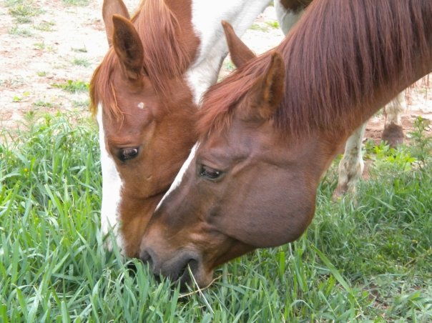
NAHMS Equine 2015

BLOOD
Instructions and
Data Collection Record

National Animal Health Monitoring System

2150 Centre Ave, Bldg B
Fort Collins, CO 80526

Form Approved
OMB Number 0579-0269
EXP. DATE: XX/20XX

Animal and Plant
Health Inspection
Service

Veterinary
Services

Instructions

1. Collect samples from resident equids only and based on the following criteria:
# resident equids # equids to sample
Fewer than 10 All
10–19 10
20–49 15
50 or more 20

2. Randomly select equids that represent the resident equine inventory on the premises in terms of age, sex, breed, and use. Include foals and stallions.

3. Wipe the venopuncture site with alcohol before taking the sample. Wear clean gloves for each
horse.

4. Write the farm ID, horse name/unique ID, and sample number on the label and place it lengthwise on the tube. Complete the attached data collection record.

5. Shipping samples: Keep samples cool and ship overnight on ice within 24 hours of collection using the enclosed FedEx Priority Overnight shipping label.

6. Make sure kit number on form matches kit number on tubes. Be sure to write State/operation# on all pages. Place the yellow and pink copies of the collection record on top of the styrofoam lid before closing the box. Send the white copy to your NAHMS Coordinator within 3 business days.

According to the Paperwork Reduction Act of 1995, an agency may not conduct or sponsor, and a person is not required to respond to, a collection of information unless it displays a valid OMB control number. The valid OMB control number for this information collection is 0579-0269. The time required to complete this information collection is estimated to average 1.5 hours per response, including the time for reviewing instructions, searching existing data sources, gathering and maintaining the data needed, and completing and reviewing the collection of information.

NAHMS-336

JULY 2014

Reference codes for blood collection

G. Direct contact with other equids within last 30 days
Direct physical contact with equids not resident to this premises. This includes the addition of new equids to the herd and through commingling with other equids on or off the premises, such as a horse show on or off the premises.
H.
1 – Colic or other digestive
2 – Respiratory problems
3 – Behavioral problems (unusual demeanor affected use, health, or safety)
4 – Neurologic problems (incoordination, spinal problem, wobbler, seizures, West Nile virus, EHM, EPM)
5 – Lameness
6 – Infectious disease unrelated to specific body condition
7 – Fever (T>101.5°F in adult, T>102.5°F in foal)
8 – Abortion or fetal reabsorption
9 – Other (specify)
J & K. EHV-1 vaccination history
Enter the dates and EHV product used for vaccination against EHV-1 (herpesvirus, also called rhino) in the previous 12 months. Enter NA if never vaccinated and DK if Don’t know.

NAHMS ID #: ____________ Blood Kit Number: ______________ Collection date: ____________________

Collector name: _____________________________ Phone number: ____________________

Number of resident horses on the operation today: (Check one.)

_____ Fewer than 10 resident horses; collect samples from all _____ 20–49 horses; collect 15 samples Total samples submitted: _____
_____ 10–19 horses; collect 10 samples _____ 50+ horses; collect 20 samples

Sample # | A.  Animal name or  unique ID |  | B.  Age  (months  or years) | C.  Gender  code 1–5 |  | D.  Primary use  code 1–6 | E.  Equid type  code 1-6 |  | F.  Breed  code 1–15 | G.  Direct contact w/nonresident equids w/in last  30 days |  | H.  Has this equid had any health issues in last  30 days?  (List all that apply. If none, enter 0.) | I.  # EHV vacc in last  12 mo |  | J.  What was the last date of EHV vacc | K.  EHV vacc product (enter code)
1 |  |  | ___ mo OR  ___ yr |  |  |  |  |  |  | Yes₁ No₃ |  |  |  |  | ___ / ___  mm / yy
2 |  |  | ___ mo OR  ___ yr |  |  |  |  |  |  | Yes₁ No₃ |  |  |  |  | ___ / ___  mm / yy
3 |  |  | ___ mo OR  ___ yr |  |  |  |  |  |  | Yes₁ No₃ |  |  |  |  | ___ / ___  mm / yy
4 |  |  | ___ mo OR  ___ yr |  |  |  |  |  |  | Yes₁ No₃ |  |  |  |  | ___ / ___  mm / yy
5 |  |  | ___ mo OR  ___ yr |  |  |  |  |  |  | Yes₁ No₃ |  |  |  |  | ___ / ___  mm / yy
6 |  |  | ___ mo OR  ___ yr |  |  |  |  |  |  | Yes₁ No₃ |  |  |  |  | ___ / ___  mm / yy
7 |  |  | ___ mo OR  ___ yr |  |  |  |  |  |  | Yes₁ No₃ |  |  |  |  | ___ / ___  mm / yy
8 |  |  | ___ mo OR  ___ yr |  |  |  |  |  |  | Yes₁ No₃ |  |  |  |  | ___ / ___  mm / yy
9 |  |  | ___ mo OR  ___ yr |  |  |  |  |  |  | Yes₁ No₃ |  |  |  |  | ___ / ___  mm / yy
10 |  |  | ___ mo OR  ___ yr |  |  |  |  |  |  | Yes₁ No₃ |  |  |  |  | ___ / ___  mm / yy
Gender:  1 – Intact male  (stallion or colt)  2 – Castrated male (gelding)  3 – Nonpregnant female  (mare or filly)  4 – Pregnant female  5 – Spayed female |  | Primary use of horse:  (if young, intended use)  1 – Pleasure  2 – Show or competition  3 – Breeding  4 – Racing  5 – Farm/ranch work  6 – Other |  |  | Equid type:  1 – Horse  2 – Mule  3 – Donkey  4 – Pony  5 – Miniature horse  6 – Other |  |  | Breed: (if “other,” specify  within column)  1 – Appaloosa  2 – Arabian  3 – Draft breeds  4 – Miniature horse  5 – Morgan  6 – Mustang |  |  | 7 – Paint  8 – Quarter horse  9 – Saddlebred  10 – Standardbred  11 – Tennessee Walker  12 – Thoroughbred |  |  | 13 – Warmblood breeds  14 – Other registered breed (specify)  15 – Other nonregistered breed (specify)
NAHMS ID #: Blood Kit Number: ______________ Collection date: ____________________

Collector name: _____________________________ Phone number: ____________________

Collect 15 samples if there are 20 to 49 resident horses. Collect 20 samples if there are 50+ resident horses.
Sample # | A.  Animal name or  unique ID |  | B.  Age  (months  or years) | C.  Gender  code 1–5 |  | D.  Primary use  code 1–6 | E.  Equid type  code 1-6 |  | F.  Breed  code 1–15 | G.  Direct contact w/nonresident equids w/in last  30 days |  | H.  Has this equid had any health issues in last  30 days?  (List all that apply. If none, enter 0.) | I.  # EHV vacc in last  12 mo |  | J.  What was the last date of EHV vacc | K.  EHV vacc product (enter code)
11 |  |  | ___ mo OR  ___ yr |  |  |  |  |  |  | Yes₁ No₃ |  |  |  |  | ___ / ___  mm / yy
12 |  |  | ___ mo OR  ___ yr |  |  |  |  |  |  | Yes₁ No₃ |  |  |  |  | ___ / ___  mm / yy
13 |  |  | ___ mo OR  ___ yr |  |  |  |  |  |  | Yes₁ No₃ |  |  |  |  | ___ / ___  mm / yy
14 |  |  | ___ mo OR  ___ yr |  |  |  |  |  |  | Yes₁ No₃ |  |  |  |  | ___ / ___  mm / yy
15 |  |  | ___ mo OR  ___ yr |  |  |  |  |  |  | Yes₁ No₃ |  |  |  |  | ___ / ___  mm / yy
16 |  |  | ___ mo OR  ___ yr |  |  |  |  |  |  | Yes₁ No₃ |  |  |  |  | ___ / ___  mm / yy
17 |  |  | ___ mo OR  ___ yr |  |  |  |  |  |  | Yes₁ No₃ |  |  |  |  | ___ / ___  mm / yy
18 |  |  | ___ mo OR  ___ yr |  |  |  |  |  |  | Yes₁ No₃ |  |  |  |  | ___ / ___  mm / yy
19 |  |  | ___ mo OR  ___ yr |  |  |  |  |  |  | Yes₁ No₃ |  |  |  |  | ___ / ___  mm / yy
20 |  |  | ___ mo OR  ___ yr |  |  |  |  |  |  | Yes₁ No₃ |  |  |  |  | ___ / ___  mm / yy
Gender:  1 – Intact male  (stallion or colt)  2 – Castrated male (gelding)  3 – Nonpregnant female  (mare or filly)  4 – Pregnant female  5 – Spayed female |  | Primary use of horse:  (if young, intended use)  1 – Pleasure  2 – Show or competition  3 – Breeding  4 – Racing  5 – Farm/ranch work  6 – Other |  |  | Equid type:  1 – Horse  2 – Mule  3 – Donkey  4 – Pony  5 – Miniature horse  6 – Other |  |  | Breed: (if “other,” specify  within column)  1 – Appaloosa  2 – Arabian  3 – Draft breeds  4 – Miniature horse  5 – Morgan  6 – Mustang |  |  | 7 – Paint  8 – Quarter horse  9 – Saddlebred  10 – Standardbred  11 – Tennessee Walker  12 – Thoroughbred |  |  | 13 – Warmblood breeds  14 – Other registered breed (specify)  15 – Other nonregistered breed (specify)

Code | Est name | True name | Picture | Trade name | Route of admin
1 | Boehringer Ingelheim | Equine Rhinopneumonitis-Influenza Vaccine, Killed Virus |  | Vetera 2xp | Intramuscular
2 | Boehringer Ingelheim | Equine Rhinopneumonitis-Influenza Vaccine, Killed Virus | 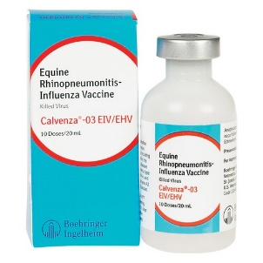 | Calvenza-03 EIV/EHV | Intramuscular
3 | Boehringer Ingelheim | Equine Rhinopneumonitis Vaccine, Modified Live Virus | 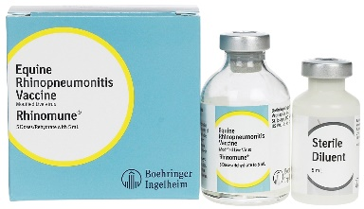 | Rhinomune | Intramuscular
4 | Boehringer Ingelheim | Equine Rhinopneumonitis Vaccine, Killed Virus | 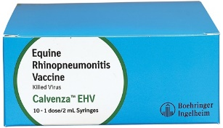 | Calvenza EHV | Intramuscular/Intranasal
5 | Boehringer Ingelheim | Equine Rhinopneumonitis Vaccine, Killed Virus | 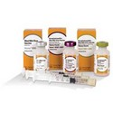 | Vetera EHVxp-1, EHVxp-4 | Intramuscular
6 | Boehringer Ingelheim | Encephalomyelitis-Rhinopneumonitis-Influenza Vaccine, Eastern & Western, Killed Virus, Tetanus Toxoid | 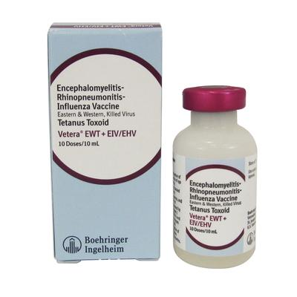 | Vetera EWT + EIV/EHV | Intramuscular

Code | Est name | True name | Picture | Trade name | Route of admin
7 | Boehringer Ingelheim | Encephalomyelitis-Rhinopneumonitis-Influenza Vaccine, Eastern & Western, Killed Virus, Tetanus Toxoid | 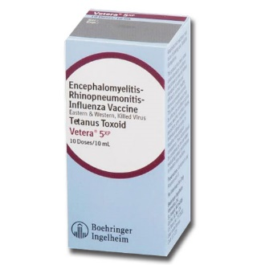 | Vetera 5xp | Intramuscular
8 | Boehringer Ingelheim | Encephalomyelitis-Rhinopneumonitis-Influenza Vaccine, Eastern & Western & Venezuelan, Killed Virus, Tetanus Toxoid | 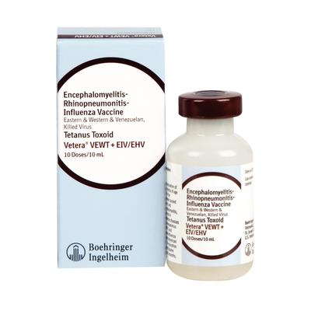 | Vetera VEWT + EIV/EHV | Intramuscular
9 | Boehringer Ingelheim | Encephalomyelitis-Rhinopneumonitis-Influenza Vaccine, Eastern & Western & Venezuelan, Killed Virus, Tetanus Toxoid | 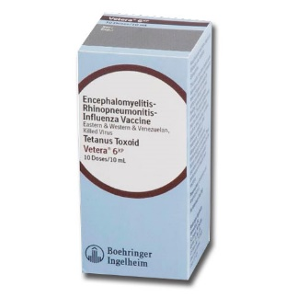 | Vetera 6xp | Intramuscular
10 | Boehringer Ingelheim | Encephalomyelitis-Rhinopneumonitis-Influenza-West Nile Virus Vaccine, Eastern & Western, Killed Virus, Tetanus Toxoid | 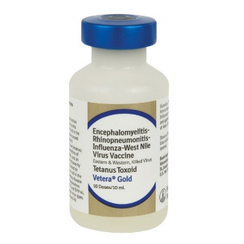 | Vetera Gold | Intramuscular
11 | Boehringer Ingelheim | Encephalomyelitis-Rhinopneumonitis-Influenza-West Nile Virus Vaccine, Eastern & Western, Killed Virus, Tetanus Toxoid | 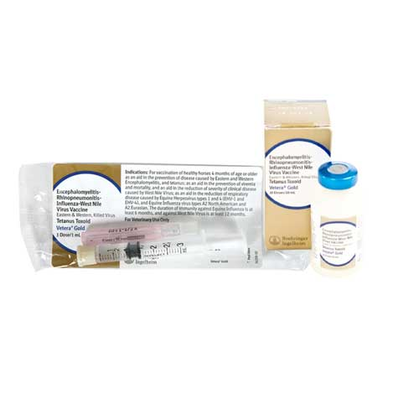 | Vetera Goldxp | Intramuscular

Code | Est name | True name | Picture | Trade name | Route of admin
12 | Boehringer Ingelheim | Encephalomyelitis-Rhinopneumonitis-Influenza-West Nile Virus Vaccine, Eastern & Western & Venezuelan, Killed Virus, Tetanus Toxoid | 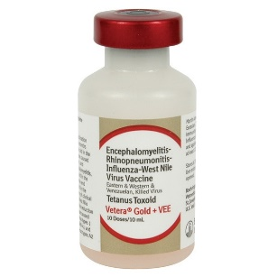 | Vetera Gold + VEE | Intramuscular
13 | Boehringer Ingelheim | Encephalomyelitis-Rhinopneumonitis-Influenza-West Nile Virus Vaccine, Eastern & Western & Venezuelan, Killed Virus, Tetanus Toxoid | 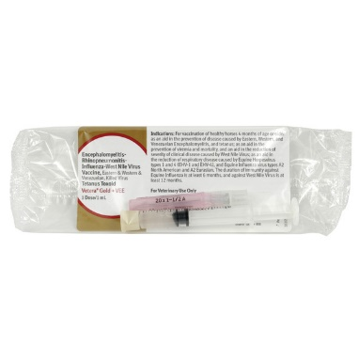 | Vetera Goldxp + VEE | Intramuscular
14 | Merck Animal Health | Equine Rhinopneumonitis-Influenza Vaccine, Killed Virus | 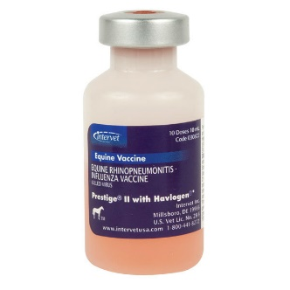 | Prestige II | Intramuscular
15 | Merck Animal Health | Equine Rhinopneumonitis Vaccine, Killed Virus  Prevention of Abortion | 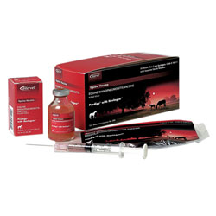 | Prodigy with Havlogen | Intramuscular
16 | Merck Animal Health | Equine Rhinopneumonitis Vaccine, Killed Virus | 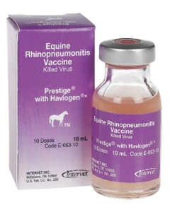 | Prestige with Havlogen | Intramuscular

Code | Est name | True name | Picture | Trade name | Route of admin
17 | Merck Animal Health | Encephalomyelitis-Rhinopneumonitis Vaccine, Eastern & Western, Killed Virus, Tetanus Toxoid | 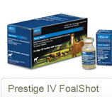 | Prestige IV | Intramuscular
18 | Merck Animal Health | Encephalomyelitis-Rhinopneumonitis-Influenza Vaccine, Eastern & Western, Killed Virus, Tetanus Toxoid | 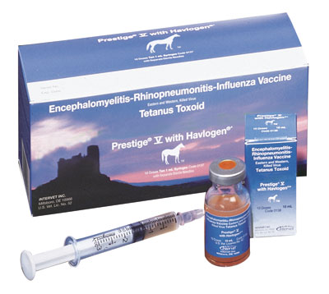 | Prestige V with Havlogen | Intramuscular
19 | Merck Animal Health | Encephalomyelitis-Rhinopneumonitis-Influenza Vaccine, Eastern & Western & Venezuelan, Killed Virus, Tetanus Toxoid | 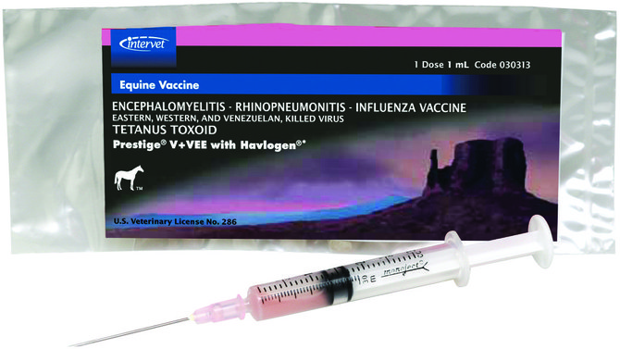 | Prestige V + VEE | Intramuscular
20 | Merck Animal Health | Encephalomyelitis-Rhinopneumonitis-Influenza-West Nile Virus Vaccine, Eastern & Western, Killed Virus, WNV | 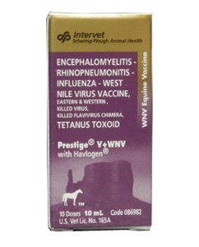 | Prestige V+WNV with Havlogen | Intramuscular
21 | Zoetis Inc. | Equine Rhinopneumonitis-Influenza Vaccine, Killed Virus | 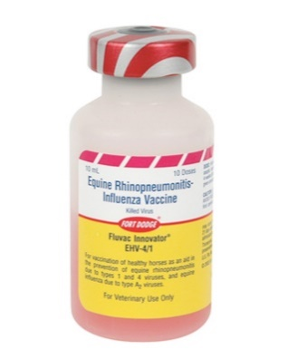 | Fluvac Innovator EHV-4, EHV-1 | Intramuscular

Code | Est name | True name | Picture | Trade name | Route of admin
22 | Zoetis Inc | Equine Rhinopneumonitis Vaccine, Killed Virus  Prevention of Abortion | 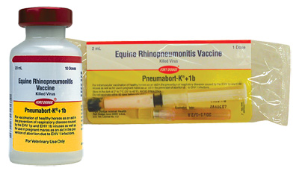 | Pneumabort-K+1b | Intramuscular
23 | Zoetis Inc | Equine Rhinopneumonitis Vaccine, Killed Virus | 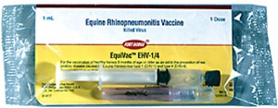 | EquiVac Innovator EHV-1, EHV-4 | Intramuscular
24 | Zoetis Inc | Encephalomyelitis-Rhinopneumonitis-Influenza Vaccine, Eastern & Western, Killed Virus, Tetanus Toxoid | 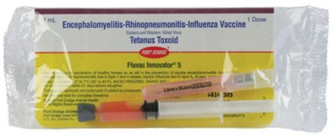 | Fluvac Innovator 5 | Intramuscular
25 | Zoetis Inc | Encephalomyelitis-Rhinopneumonitis-Influenza Vaccine, Eastern & Western & Venezuelan, Killed Virus, Tetanus Toxoid | 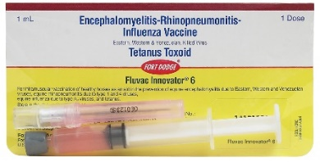 | Fluvac Innovator 6 | Intramuscular
26 | Zoetis Inc | Encephalomyelitis –West Nile Virus Vaccine, Eastern & Western & Venezuelan, Killed Virus, Tetanus Toxoid | 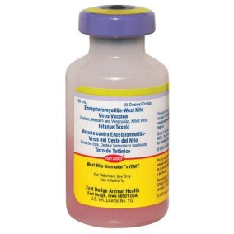 | West Nile Innovator + VEWT | Intramuscular
27 | Other | - | - | - | -

