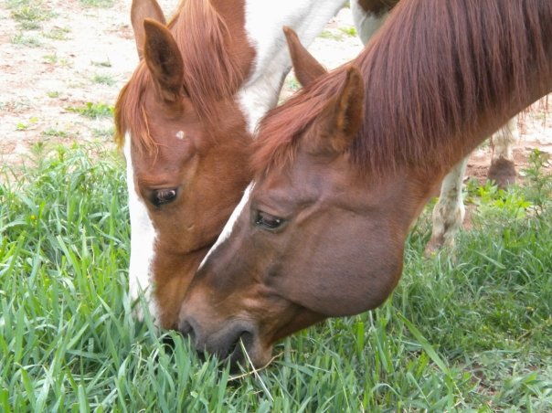
NAHMS Equine 2015

Fecal
Data Collection Record

National Animal Health Monitoring System

2150 Centre Ave, Bldg B
Fort Collins, CO 80526

Form Approved
OMB Number 0579-0269
EXP. DATE: XX/20XX

Animal and Plant
Health Inspection
Service

Veterinary
Services

Farm ID: (6 digits) | Kit #: | Collector’s name and phone # | Date: (mm/dd/yy)

1. How many resident equids are on this premises? _____ head

2. How many samples are being submitted to the lab? _____

# resident horses # horses to sample
Fewer than 10 All
10–19 10
20–49 15
50 or more 20

3. [Interviewer’s assessment. Do not ask this question of the owner.]
What is the overall cleanliness of the equine housing/pasture area compared to other equine operations in your area?
₁ Poor ₂ Average ₃ Excellent

4. Sample collection
- Place labels on whilrpak bags and write farm ID, animal name/unique ID, and sample number on each bag
- Turn a whirlpak bag inside out over your hand (wear gloves provided)
- Pick up a small handfull (golf ball sized) of fecal material from the ground
- Turn the bag right side out, squeeze any extra air out of the bag and close firmly
- Place all the labeled sample bags inside the large ziploc bag and seal the bag
- Keep samples cool (do not freeze the samples) and ship on ice within 24 hours

Paperwork and shipping
- Complete the information on the data collection form for each horse sampled
- Send the original white copy to your NAHMS coordinator within 3 business days
- Include the yellow copy on top of the styrofoam lid and ship with samples
- Ship overnight on Mon-Wed only. No shipping Thr-Sat.
- The lab cannot receive samples Fri-Sun.

According to the Paperwork Reduction Act of 1995, an agency may not conduct or sponsor, and a person is not required to respond to, a collection of information unless it displays a valid OMB control number. The valid OMB control number for this information collection is 0579-0269. The time required to complete this information collection is estimated to average 1 hour per response, including the time for reviewing instructions, searching existing data sources, gathering and maintaining the data needed, and completing and reviewing the collection of information.

NAHMS-339

July 2014

Reference codes for Fecal Collection

Gender codes
1 – Intact male (stallion or colt) | 4 – Pregnant female
2 – Castrated male (gelding) | 5 – Spayed female
3 – Non-pregnant female (mare or filly)
Primary use codes
1 – Pleasure | 4 – Racing
2 – Show or competition (not betting) | 5 – Farm or ranch work
3 – Breeding | 6 – Other (specify in column)
Equine type
1 = horse | 4= pony
2 = mule | 5 = miniature horse
3 = donkey | 6 = other
Breed codes
1 – Appaloosa | 9 – Quarter horse
2 – Arabian | 10 – Standardbred
3 – Draft breed | 11 – Tennessee Walker
4 – Miniature horse | 12 – Thoroughbred
5 – Morgan | 13 – Warmblood breeds
6 – Mustang | 14 – Other registered breed (specify on collection form)
7 – Paint | 15 – Other nonregistered breed (specify on collection form)
8 – Saddlebred
Antibiotics (see separate sheet)
Route of administration of antibiotic
1 = oral | 2 = injected (into muscle or joint, or IV)

Sample # | Animal name or unique ID | A. Age  (months  or years) | B. Gender  (See code sheet.) | C. Primary use  (See code sheet.) | D. Equine Type (See code sheet.) | E. Breed  (See code sheet.) | F. Fecal score  1=normal  2=soft/  cowpie-like  3=watery  4=bloody  5-other, describe | G. Body condition score  1=thin  2=normal  3=fat | H. Did this animal receive an antibiotic in the last  12 months?  (Yes/No)  [If No, SKIP  cols I,J,&K.] | I. Did this animal receive an antibiotic in the last  30 days?  (Yes/No)  [If No, SKIP  cols J&K.] | J. Which antibiotic(s) were given in the last 30 days  (enter code) | K. Route of administration of antibiotic(s) if given in the last 30 days  (enter code)
1 |  | ___ mo OR  ___ yr
2 |  | ___ mo OR  ___ yr
3 |  | ___ mo OR  ___ yr
4 |  | ___ mo OR  ___ yr
5 |  | ___ mo OR  ___ yr
6 |  | ___ mo OR  ___ yr
7 |  | ___ mo OR  ___ yr
8 |  | ___ mo OR  ___ yr
9 |  | ___ mo OR  ___ yr
10 |  | ___ mo OR  ___ yr

Sample # | Animal name or unique ID | A. Age  (months  or years) | B. Gender  (See code sheet.) | C. Primary use  (See code sheet.) | D. Equine Type  (See code sheet.) | E. Breed  (See code sheet.) | F. Fecal score  1=normal  2=soft/  cowpie-like  3=watery  4=bloody  5-other, describe | G. Body condition score  1=thin  2=normal  3=fat | H. Did this animal receive an antibiotic in the last  12 months?  (Yes/No)  [If No, SKIP  cols I,J,&K.] | I. Did this animal receive an antibiotic in the last  30 days?  (Yes/No)  [If No, SKIP  cols J&K.] | J. Which antibiotic(s) were given in the last 30 days  (enter code) | K. Route of administration of antibiotic(s) if given in the last 30 days  (enter code)
11 |  | ___ mo OR  ___ yr
12 |  | ___ mo OR  ___ yr
13 |  | ___ mo OR  ___ yr
14 |  | ___ mo OR  ___ yr
15 |  | ___ mo OR  ___ yr
16 |  | ___ mo OR  ___ yr
17 |  | ___ mo OR  ___ yr
18 |  | ___ mo OR  ___ yr
19 |  | ___ mo OR  ___ yr
20 |  | ___ mo OR  ___ yr

Code | Proprietary name | Established  name | Manufacturer | Picture
1 | Amiglyde-V | Amikacin | Zoetis | 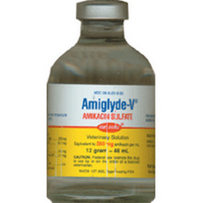
2 | Amoxicillin | Amoxicillin | Ranbaxy | 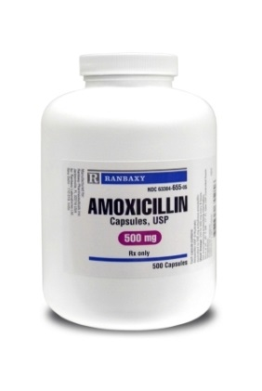
3 | Ampicillin | Ampicillin | Various manufacturers | 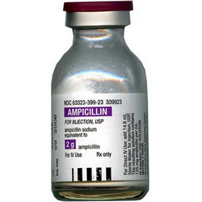
4 | Zithromax | Azithromycin | Pfizer | 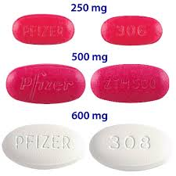  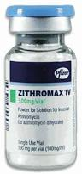
5 | Mefoxin | Cefoxitin | Merck | 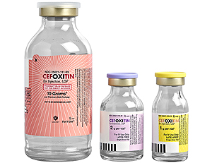
6 | Ceftazidime | Ceftazidime | Various manufacturers | 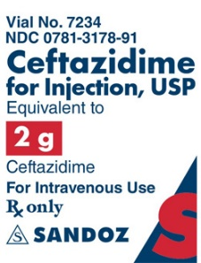
7 | Simplicef | Cefpodoxime | Zoetis | 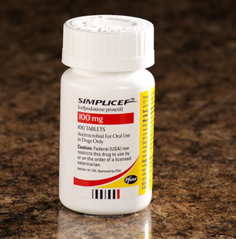
8 | Excede (Ceftiofur Crystalline Free Acid) | Ceftiofur | Zoetis | 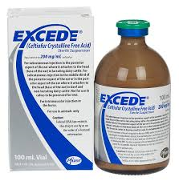
9 | Naxcel (Ceftiofur Sodium) | Ceftiofur | Zoetis | 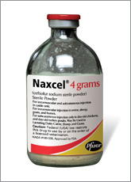
10 | Cefazolin (Injectable and Powder) | Cefazolin | Various manufacturers | 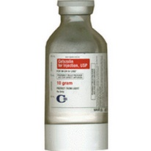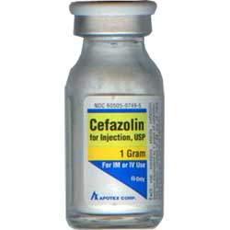
11 | Ceftriaxone | Ceftriaxone | Various manufacturers | 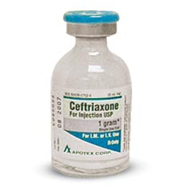
12 | ToDay | Cephapirin | Boehringer Ingelheim | 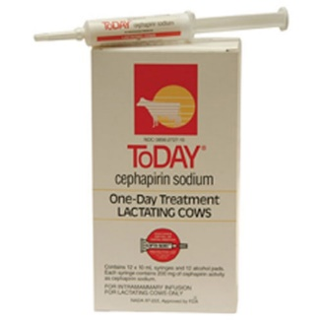
13 | Chloromy-cetin (Human) | Chloramphenicol | Pfizer | 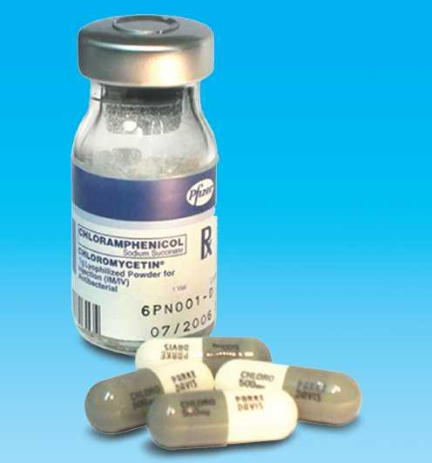
14 | Biaxin | Clarithromycin | Abbott Laboratories | 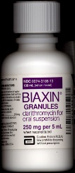
15 | Doxycycline Hyclate (Powder, Tablet and Suspension)  Vibramycin | Doxycycline | Various manufacturers | 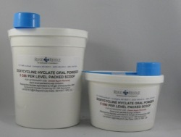  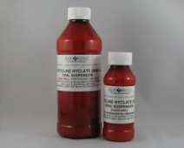  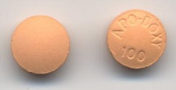
16 | Baytril 100 | Enrofloxacin | Bayer | 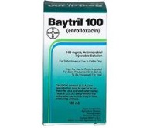
17 | Erygel | Erythromycin | Merz Pharma-ceutical | 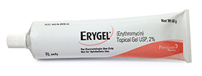
18 | E-Mycin | Erythromycin | Pacific Pharma-ceutical | 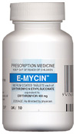  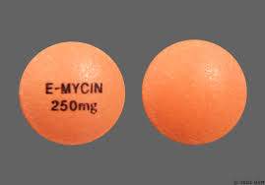
19 | Nuflor | Florfenicol | Merck | 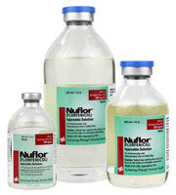
20 | Legacy | Gentamicin | AgriLabs | 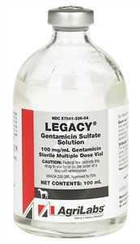
21 | GentaMax | Gentamicin | Phoenix | 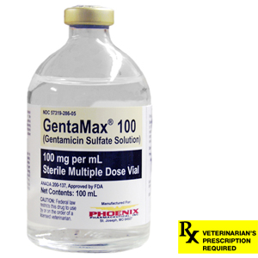
22 | Gentamicin Sulfate | Gentamicin | Vet One
23 | Primaxin IV | Imipenem | Merck | 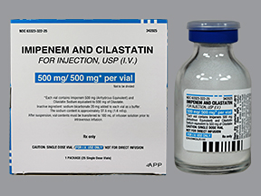
24 | Flagyl (Human form) | Metronidazole | Pfizer | 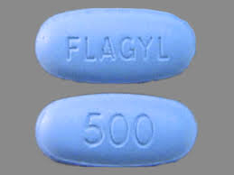
25 | Bio-Mycin | Oxytetracycline | Boehringer Ingelheim | 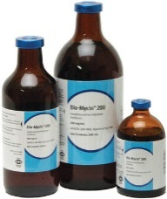
26 | Liquamycin LA-100  Liquamycin LA-200 | Oxytetracycline | Zoetis | 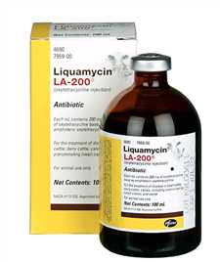
27 | Terra-Vet | Oxytetracycline | Aspen | 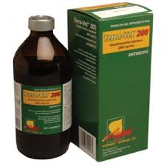
28 | Penicillin G Potassium USP | Penicillin G Potassium | Agri Laboratories, Agripharm | 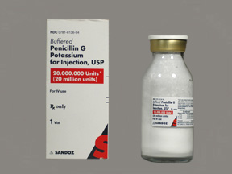
29 | Pen-G | Penicillin G Procaine | Phoenix
30 | Pro-Pen-G | Penicillin G Procaine | Bimeda | 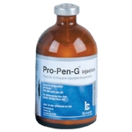
31 | PenOne Pro | Penicillin G Procaine | Vet One | 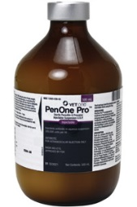
32 | Rifadin | Rifampin | Aventis Pharma-ceuticals | 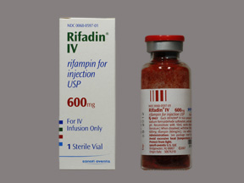
33 | Rimactane | Rifampin | Novartis | 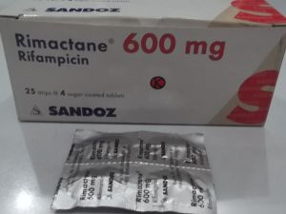
34 | Timentin | Ticarcillin | GlaxoSmith-Kline | 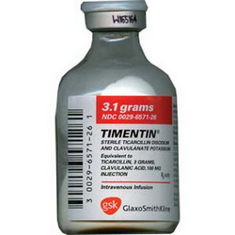
35 | Uniprim | Trimethoprim Sulfadiazine | Neogen | 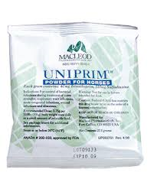
36 | Tucoprim | Trimethoprim Sulfadiazine | Zoetis | 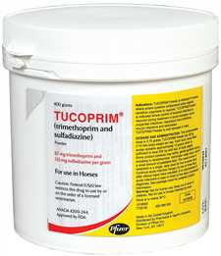
37 | SMZ Tablets | Trimethoprim Sulfadiazine | Various manufacturers | 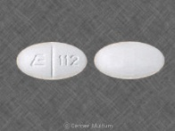
38 | SMZ/TMP | Sulfamethoxazole Trimethoprim | Various manufacturers | 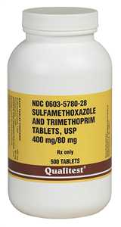
39 | Vanococin | Vancomycin | Baxter Healthcare, ViroPharma, Sandoz | 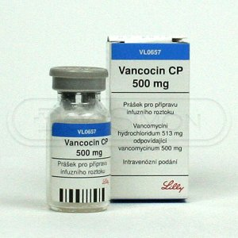
40 | Other | - | - | -

