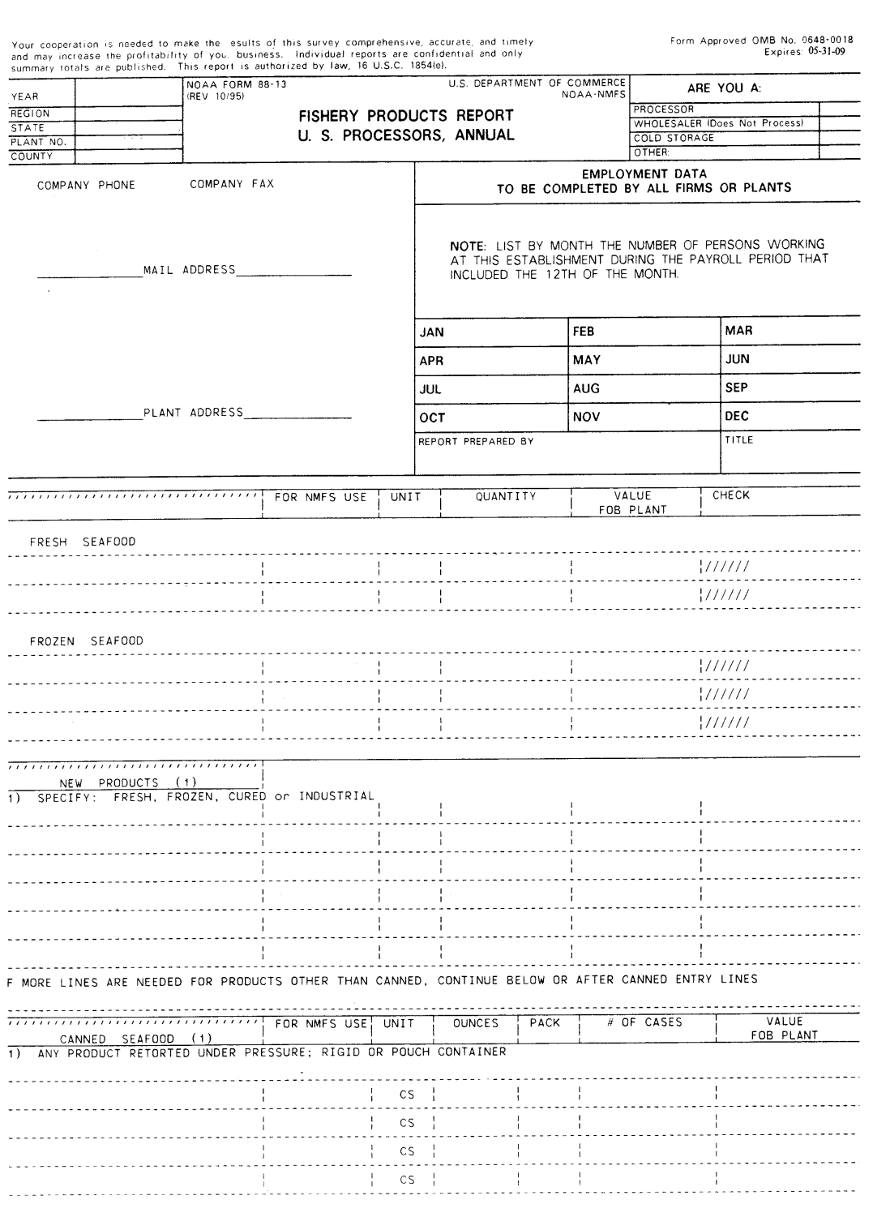

Thank you very much for your participation. We greatly appreciate your co-operation and time. This form summarizes some key points to the survey for quick reference

Please enter monthly employment information here (including administrative staff and yourself) and write your name. Please provide a telephone number or e-mail address as well.

Pre-Printed

Space for company phone and fax number

Please report any new products in this section and provide as much detail as possible, especially in terms of units (lbs, oz, gallons, etc).

* If a product you normally process was not processed in the previous year, it is not included in the pre-printed list. If you started processing it again, please report it here in the new products section.
* If you are new to the survey and there are no products listed already, please list all products you currently process
* Pre-printed items are products that were previously reported. Simply fill in the quantity and value. If you do not process that product anymore, simply cross it out.

If you produce any canned products, please list them under “Canned Seafood” and include the size of can, number of cans in a case and how many cases.

Under quantity please provide the weight of the processed product. Value is the amount of money obtained for the product only, without shipping, retail, etc.

Your company’s name, mailing address, plant address and phone/fax number will be pre-printed on your form. Please check to make sure the information is correct and write in any changes as needed.

Cod Fillet 0820101160 LB

Shrimp Headless 7381201130 LB

Crab King Cooked Legs 7090202033 LB

Plant’s Physical Address

Your Company’s Name

Your Company’s Mailing Address