Instructions for Pacific Transshipment Declaration Form: The owner and operator of any U.S. vessel (“operator” means the master or other individual aboard and in charge of the vessel) used for the following: each transshipment of highly migratory species (HMS) in the Western and Central Pacific Fisheries Convention Area (WCPFC Area), each transshipment of HMS captured in the WCPFC Area and transshipped elsewhere, and transshipments subject to the regulations implementing decisions of the Inter-American Tropical Tuna Commission (IATTC) at 50 CFR Part 300 Subpart C, must ensure the completion and submission of this form. The form must be completed and signed within 24 hours of the completion of the transshipment. Completed forms must be submitted separately by both the offloading vessel and the receiving vessel for each transshipment.

Addresses and Due Dates:

For purse seine vessels holding a license issued under 50 CFR 300.32 for South Pacific Tuna Fisheries, the original form must be submitted to the NMFS American Samoa Field Office, P.O. Box 4150, Pago Pago, AS 96799 or NMFS American Samoa Field Office, Pago Plaza, Suite 201, Pago Pago, AS 96799 for courier service delivery, within 14 days of completion of the transshipment.

For vessels permitted under the requirements of 50 CFR 660.707 (generally, albacore troll vessels), the original form must be submitted to the NMFS Fisheries Resources Division in La Jolla, California within 30 days of the transshipment. Please contact the Fisheries Resources Division at (858) 546-7192 or (858) 546-7000 for the address for submitting the form.

For vessels subject to the receiving vessel requirements of 50 CFR 665.14(c) and 50 CFR 801(e) for receiving fish caught with longline gear, the original form must be submitted to the NMFS Pacific Islands Fisheries Science Center, 2570 Dole Street, Honolulu, HI 96822 within 72 hours of landing.

For offloading vessels subject only to the requirements at 50 CFR Part 300 Subpart C (i.e., for transshipments including fish caught and transshipped only in the IATTC Area), please contact the NMFS Fisheries Resources Division in La Jolla, California at (858) 546-7192 or (858) 546-7000 to find out the due dates and address for submitting the form.

For all other vessels the original form must be submitted to the NMFS Pacific Islands Fisheries Science Center, 2570 Dole Street, Honolulu, HI 96822 within 72 hours after entering port for transshipments at sea and within 72 hours of completion of the transshipment for transshipments in port.

Special Instructions for High Seas and Emergency Transshipments:

For transshipments on the high seas or emergency transshipments that would otherwise be prohibited, a copy of the form with or without signatures must be submitted by fax or email to the NMFS Pacific Islands Regional office (fax: (808) 973-2941; email: pir.wcpfc@noaa.gov) no later than 10 calendar days after completion of the transshipment. The original form with signatures must be submitted no later than 15 calendar days after first entering port or 15 calendar days after completion of the transshipment for emergency transshipments in port to the address where the forms would normally be submitted for a particular vessel (e.g., for a purse seine vessel, the original form would be submitted to the NMFS American Samoa Field Office).

Special Instructions for Sections 5, 6, and 7:

Section 5 is only to be completed by operators of vessels subject to the receiving vessel permit requirements under 50 CFR 665.801(e).

Section 6 is only to be completed by operators of purse seine vessels holding a license issued under 50 CFR 300.32 for South Pacific Tuna Fisheries.

Section 7 is only to be completed for transshipments subject to the regulations implementing decisions of the IATTC at 50 CFR Part 300 Subpart C.

Specific instructions:

Location of Transshipment: Enter the port name where the transshipment took place, including the name of the country for ports outside the United States, or enter the latitude and longitude in decimal form, to the nearest 0.1 degrees, at the start of the transshipment, if the transshipment took place at sea.

Date(s) of Transshipment: Enter the beginning and ending dates for the transshipment as MM/DD/YYYY to MM/DD/YYYY.

Section 1: Offloading Vessel
Enter the current name of the offloading vessel.

Enter the offloading vessel’s official number, which is the documentation number assigned by the U.S. Coast Guard (USCG) or the certificate number issued by a state or the USCG for an undocumented vessel, or any equivalent number if the vessel is registered in a foreign nation.

Enter the full name of the offloading vessel operator. “Operator” means the master or other individual aboard and in charge of the vessel.

Section 2: Receiving Vessel
Enter the current name of the receiving vessel.

Enter the receiving vessel’s official number, which is the documentation number assigned by the USCG or the certificate number issued by a state or the USCG for an undocumented vessel, or any equivalent number if the vessel is registered in a foreign nation.

Enter the full name of the receiving vessel operator. “Operator” means the master or other individual aboard and in charge of the vessel.

If you are subject to the regulations at 50 CFR 300.218(b) (i.e., your transshipment takes place in the WCPFC Area or involves fish caught in the WCPFC Area), enter the estimated quantity of fish product on board the receiving vessel prior to this transshipment, broken down by the area of capture of the product. Enter the unit of measurement for the amount (pounds (lb) or metric tons (mt)). Indicate the amount originating from each tuna Regional Fisheries Management Organization (RFMO) area. WCPFC denotes Western and Central Pacific Fisheries Commission, IATTC denotes Inter-American Tropical Tuna Commission, IOTC denotes Indian Ocean Tuna Commission, ICCAT denotes International Commission for the Conservation for Atlantic Tunas, and CCSBT denotes the Commission for the Conservation of Southern Bluefin Tuna. If any product originated from an area of overlap as indicated on Figure 1 below, indicate the quantity and write in both areas in the same row. If any product originated from an area outside the jurisdiction of a tuna RFMO, please write in “None” after RFMO Area.
Figure 1. Map of Tuna RFMOs
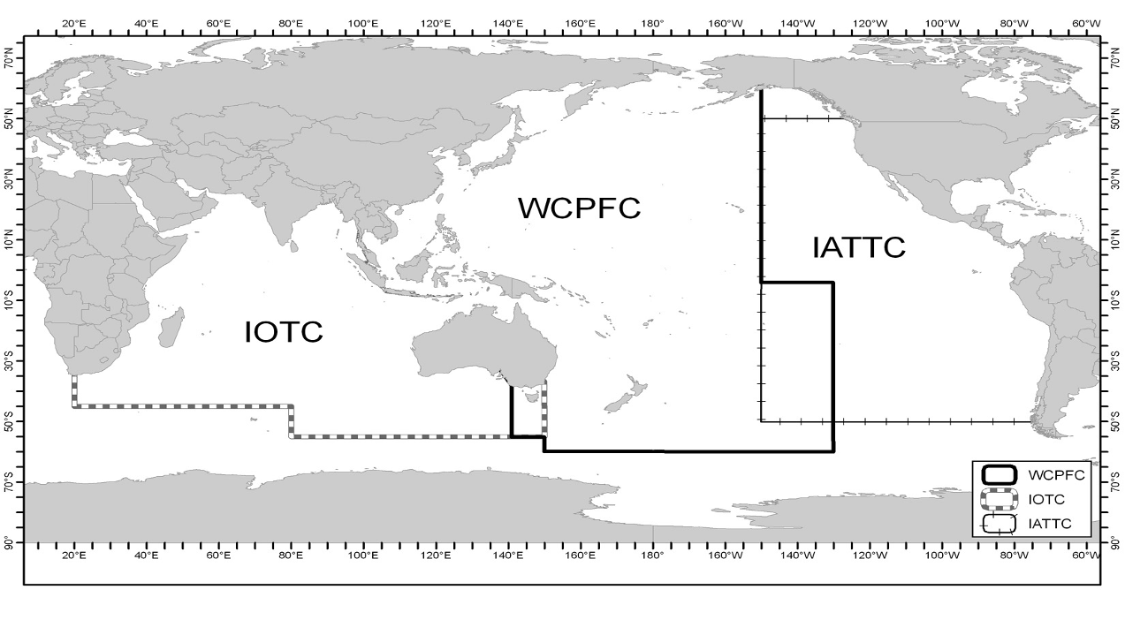
Section 3: Observer (for transshipments at sea only)
If there are one or more observers on board the offloading and/or receiving vessel, the name of at least one of the observer(s) must be included in this section for transshipments at sea. Please place an “O” or an “R” next to each observer name to indicate whether the observer was on board the offloading vessel or the receiving vessel. The operator of the vessel must request the observer to sign and date the form if the observer is on board the vessel. If the observer does not wish to sign the form please write “signature declined” after SIGNATURE (IF ON BOARD). If the observer is on board the other vessel, the request for signature is not required. Please check the appropriate box or boxes to indicate whether the observer is authorized by the WCPFC and/or the IATTC.

Section 4: Species
If a given species was caught in multiple national jurisdictions or in both national jurisdictions and on the high seas, a separate entry, using a separate row, must be made in each instance. If a given species was in more than one condition (e.g., both fresh and frozen) or in more than one product form (e.g., some whole and some gutted and gilled), a separate entry must be made in each instance. If a given species was caught by different gear types, a separate entry must be made for each gear type.

For each entry, identify the processed state of the fish (FR for fresh, FZ for frozen, or DR for dried), the processed state of the product using the weight codes identified on the form, and the estimated weight of the product transshipped and the unit of measurement (pounds (lb), metric tons (mt), or kilograms (kg)). Operators completing Section 7 of the form must use kg as the unit of measurement. For longline-caught fish, also enter the number of fish transshipped.

For each species transshipped, enter the fishing gear used to take the fish using the gear codes identified on the form. If the fishing gear is not included in the list, enter the code for “Other type(s) of gear” (OT) and specify the fishing gear.

For each entry, enter the code to identify the area in which the product was caught:
Indicate I for fish caught inside the WCPFC Area or O for fish caught outside the WCPFC Area. If O, specify if caught in the IATTC Area by writing “IATTC”.
Circle EEZ if the product was caught in waters under national jurisdiction (of any nation).
Circle HS if the product was caught on the high seas (in international waters).
If EEZ is circled, specify the name of the country in whose waters the fish were captured.

If a particular species is not included on the form, write in the name of the species in one of the empty rows at the bottom of the list. Additional forms may be used to accommodate additional species and multiple entries of the same species.

Section 5: Vessels with Receiving Vessel Permits Transshipping Longline-Caught Fish
Only operators of vessels subject to the receiving vessel permit transshipment reporting requirements under 50 CFR 665.801(e) must complete this section:
Enter the broker or shipping agent for the receiving vessel and contact information (name, mailing address, and telephone number or email address).
Enter the intended port of landing.

Section 6: SPTT-Licensed Purse Seine Vessel Information
Only operators of vessels issued licenses under 50 CFR 300.32 must complete this section:
Enter the trip number.
Enter the trip start date in DD/MM/YYYY format.
Enter the intended port of destination of the transshipped fish.
Enter the location where the fish will be processed.

Section 7: For Transshipments in the IATTC Convention Area
This section should be completed for transshipments that are subject to the regulations at 50 CFR Part 300 Subpart C:
Enter the trip start date and time in MM/DD/YYYY/HOUR format.
Enter the location of the departure (port name).
Enter the intended trip end date and time in MM/DD/YYYY/HOUR format (provide the best possible estimate for the hour).
Enter the location of the return (port name).
Enter the dates the transshipment takes place (start date and end date) in MM/DD/YYYY/HOUR format.
Enter the name of the agent (i.e., the broker or shipping agent).
Enter the flag and radio call sign of the offloading vessel.
Enter the flag and radio call sign of the receiving vessel.

Section 8: Signature
The owner or operator of the vessel must print his or her name, sign it, and give the date of signature.
Check one box to indicate whether you are the owner or operator of the OFFLOADING vessel or the owner or operator of the RECEIVING vessel.

Public reporting burden for this collection of information is estimated to average 60 minutes per response, including the time for reviewing instructions, searching existing data sources, gathering and maintaining the data needed, and completing and reviewing the collection of information. Send comments regarding this burden estimate or any other suggestions for reducing this burden to Michael D. Tosatto, Regional Administrator, NMFS Pacific Islands Regional Office, 1601 Kapiolani Blvd., Suite 1110, Honolulu, HI 96814. Information submitted to NMFS will be managed as confidential data consistent with the requirements of NOAA Administrative Order 216-100, Section 506(d) of the WCPFC Implementation Act, and regulations under 50 CFR Part 300. This information might be disclosed to the WCPFC, either through your direct submission or through subsequent disclosure by NMFS. Information submitted or disclosed to the WCPFC will be subject to the procedures, policies, and practices adopted by the WCPFC, but NOAA and NMFS cannot provide any assurance of confidentiality. Notwithstanding any other provisions of the law, no person is required to respond to, nor shall any person be subjected to a penalty for failure to comply with, a collection of information subject to the requirements of the Paperwork Reduction Act, unless that collection of information displays a currently valid OMB Control Number.

