Attachment 8a: Screenshots from PERS
For Attachments 4a, b &c
State Education Agency (SEA) Screenshots

The data will be collected from funded agencies via the Program Evaluation and Reporting System (PERS). Screenshots for the State Education Agency (SEA) questionnaires are provided below in the order presented in the Burden Table (Table A.12-1) in Supporting Statement A. The questionnaires for the Local Education Agencies (LEA) and Non-governmental organizations (NGO) are included in Attachment 8b and 8c, respectively.
The questionnaires in PERS cover the following topics: exemplary sexual health education (ESHE); sexual health services (SHS); and safe and supportive environments (SSE). The burden statement and OMB form approval information are reflected on the initial page of each group of screenshots that correspond to the questionnaires. To view the measures and the list of questions in text format, see Attachments 4a, b &c.
Contents
State Education Agency (SEA) Screenshots 2
SEA ESHE Items 2
SEA SHS Items 17
SEA SSE Items 26
Instruction Slides 35

State Education Agency (SEA) Screenshots

Form Approved
OMB No: 0920-XXXX
Exp. Date: XX/XX/XXXX

“Promoting Adolescent Health through School-Based HIV/STD Prevention”

Att. 4c

SEA ESHE Items

Public reporting burden of this collection of information is estimated to average 4 hours per response, including the time for reviewing instructions, searching existing data sources, gathering and maintaining the data needed, and completing and reviewing the collection of information. An agency may not conduct or sponsor, and a person is not required to respond to a collection of information unless it displays a currently valid OMB control number. Send comments regarding this burden estimate or any other aspect of this collection of information, including suggestions for reducing this burden to CDC/ATSDR Reports Clearance Officer; 1600 Clifton Road NE, MS D-74, Atlanta, Georgia 30333; Attn: OMB-PRA (0920-New)

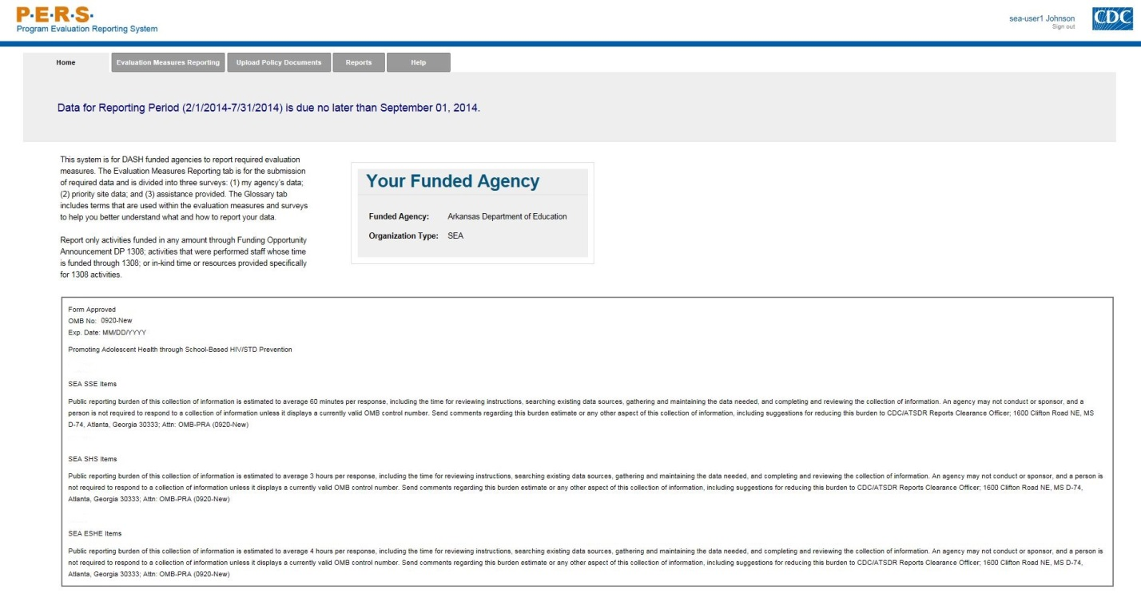

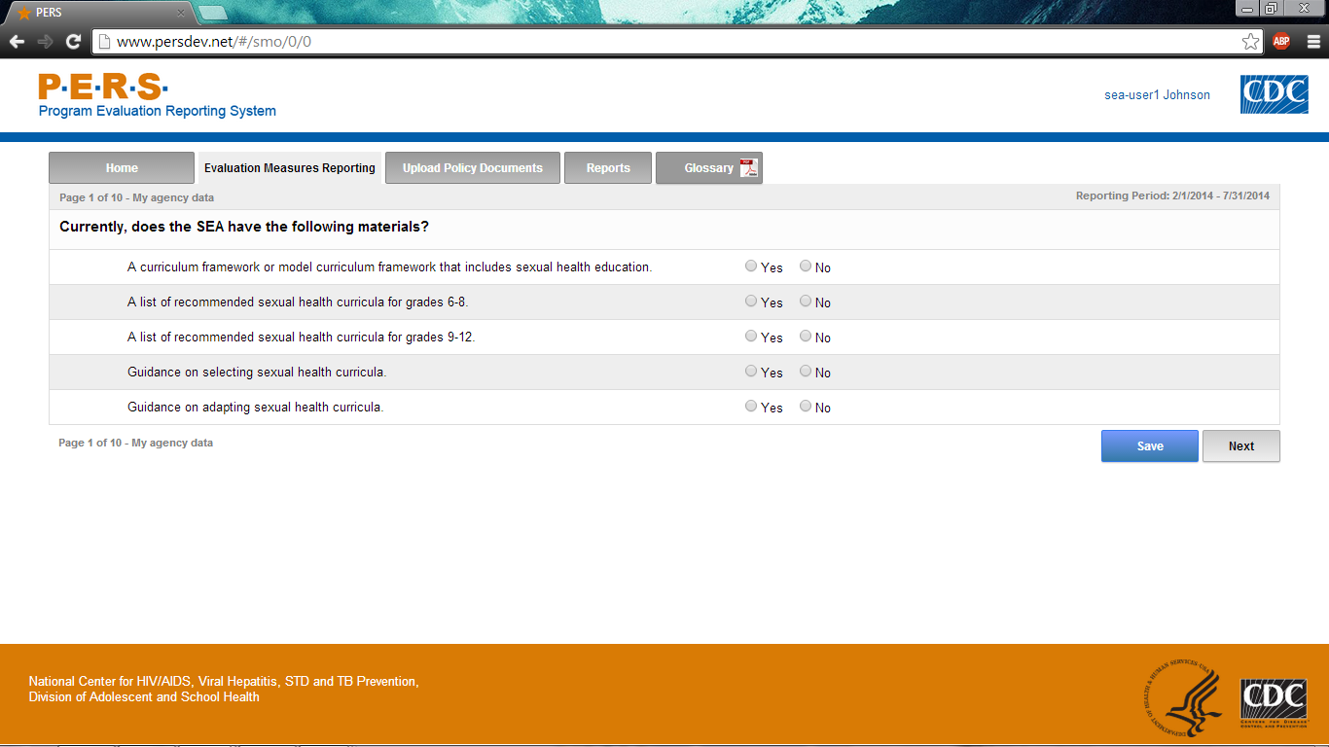

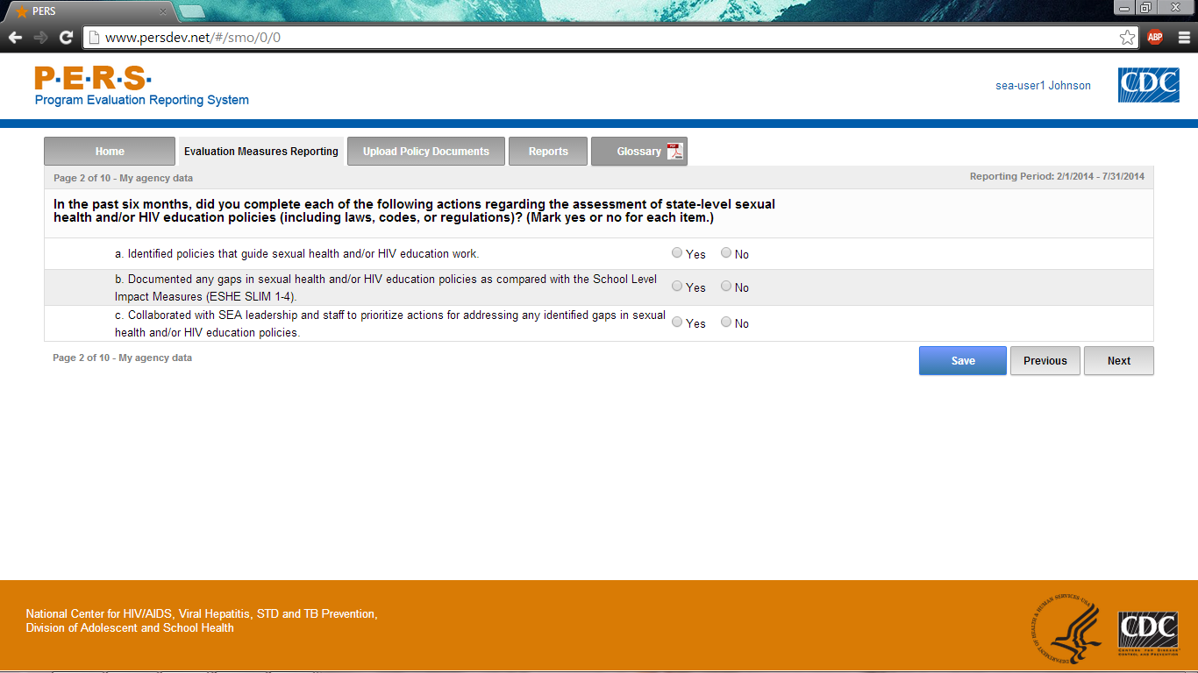
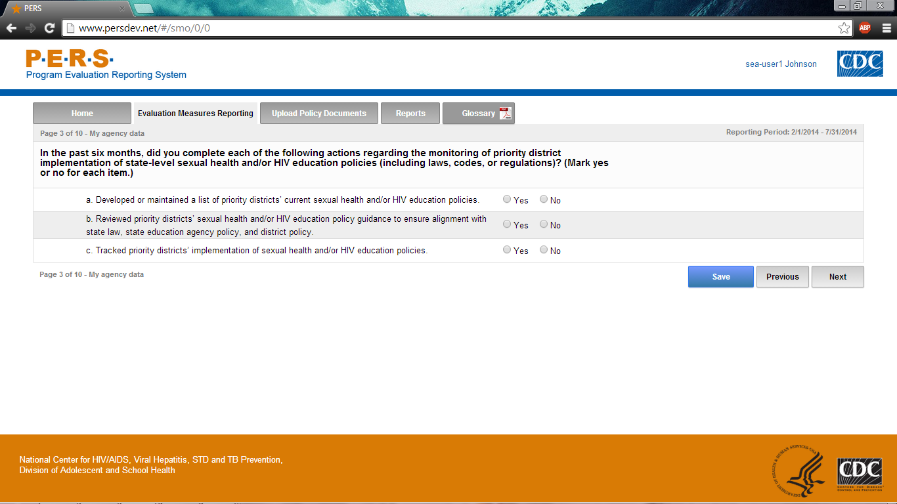

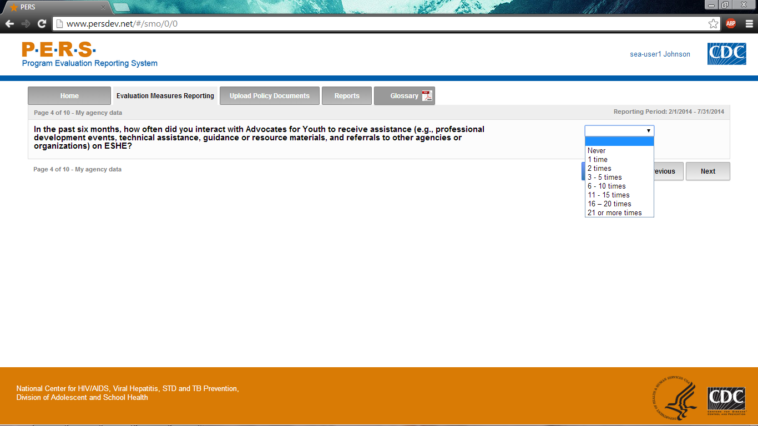

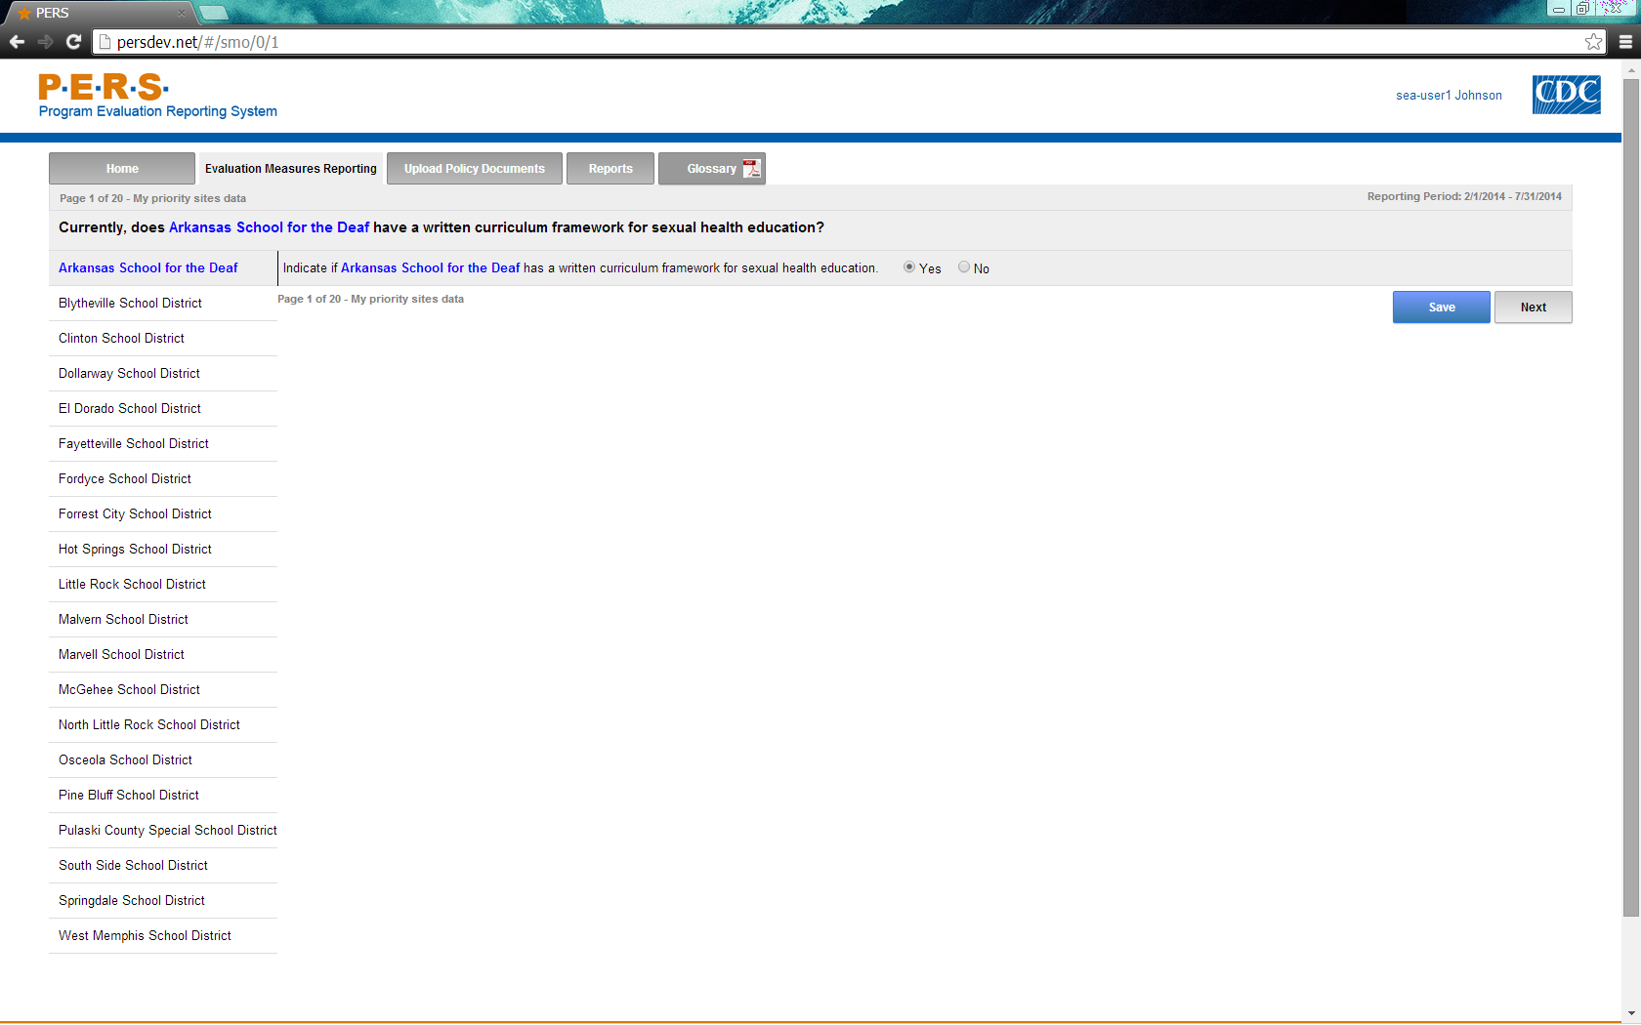
*Note: The highlighted part in the screenshot will be tailored to the Priority District Name of interest for each SEA respondent.
Part A of screenshot. This screen is scrolling enabled.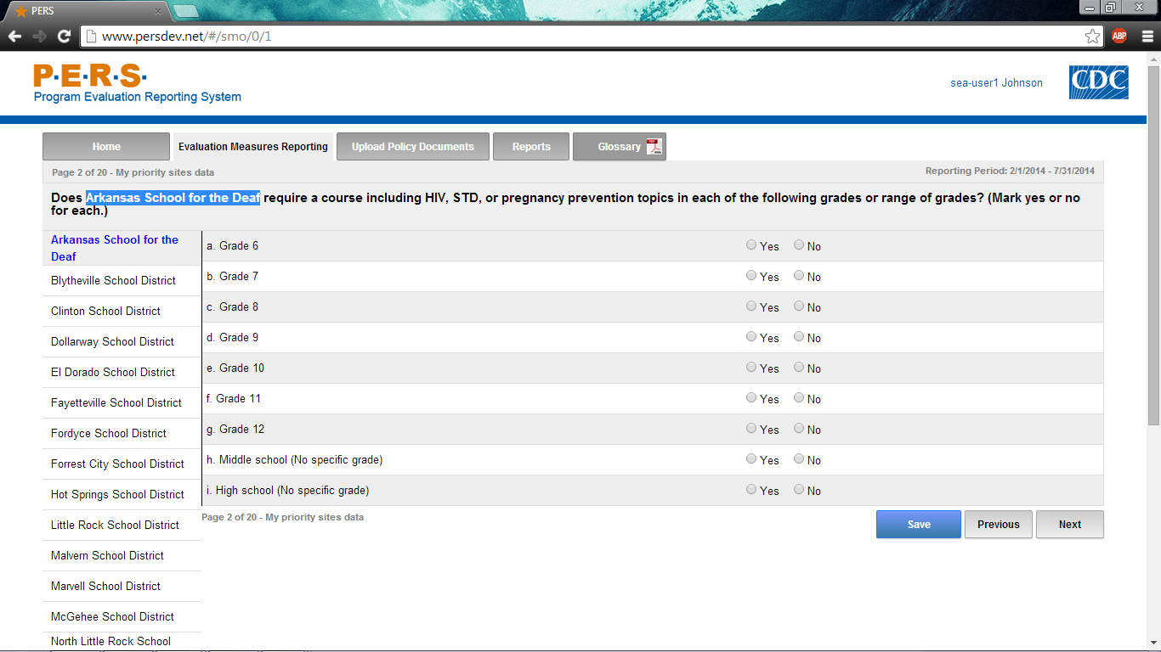
*Note: The highlighted part in the screenshot will be tailored to the Priority District Name of interest for each SEA respondent. The left-hand side of the screenshot shows where the potential Priority Districts will be listed. Each can be selected to answer this question.
Part B of screenshot. This screen is scrolling enabled.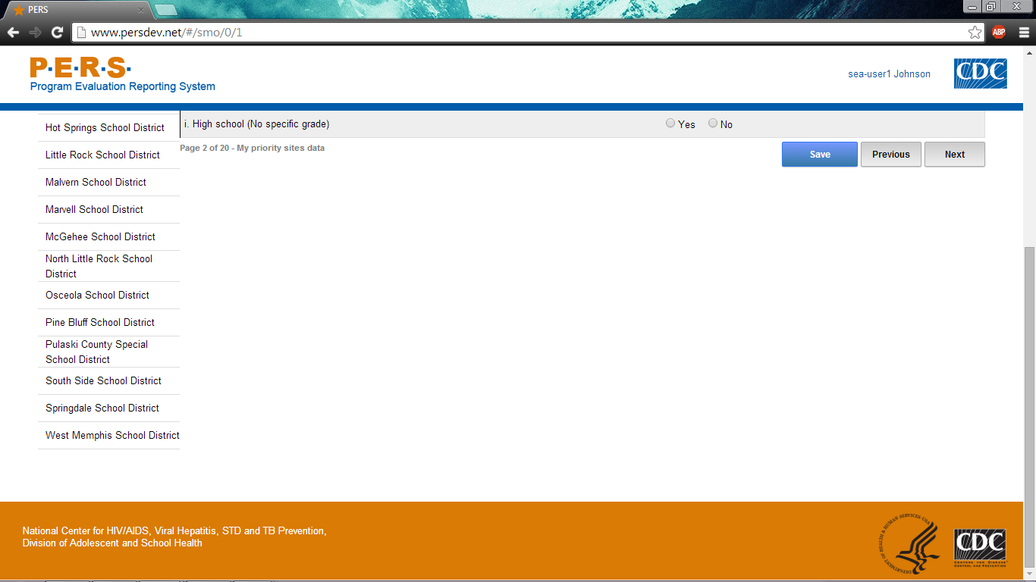
Part A of screenshot. This screen is scrolling enabled.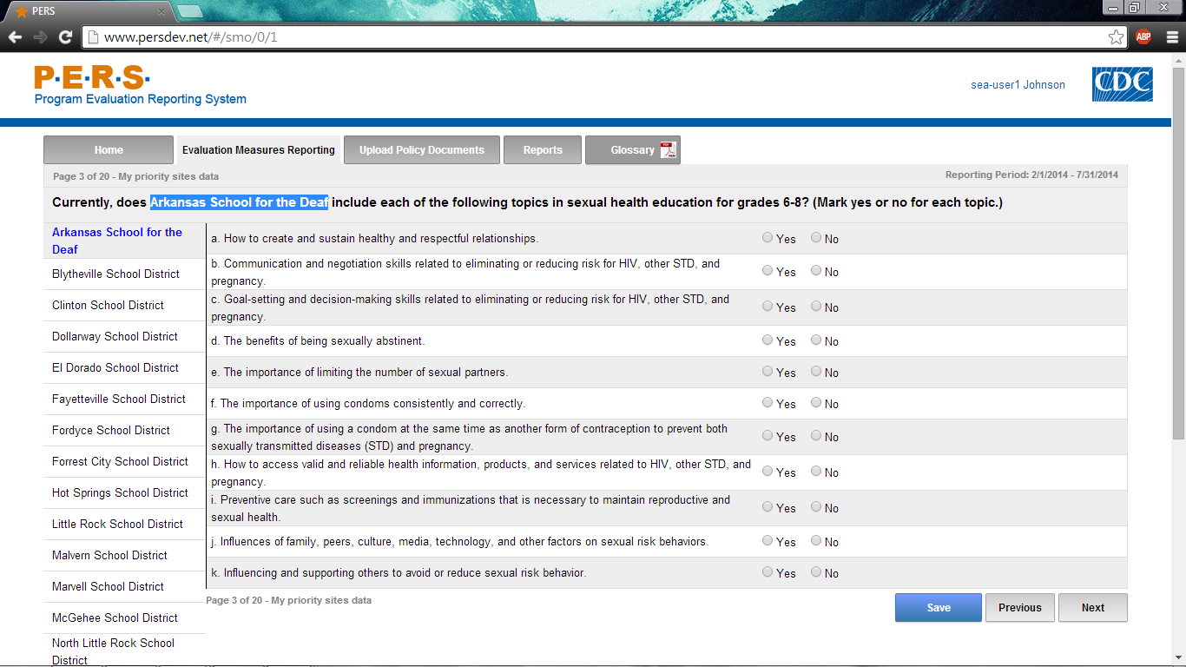
*Note: The highlighted part in the screenshot will be tailored to the Priority District Name of interest for each SEA respondent. The left-hand side of the screenshot shows where the potential Priority Districts will be listed. Each can be selected to answer this question.
Part B of screenshot. This screen is scrolling enabled.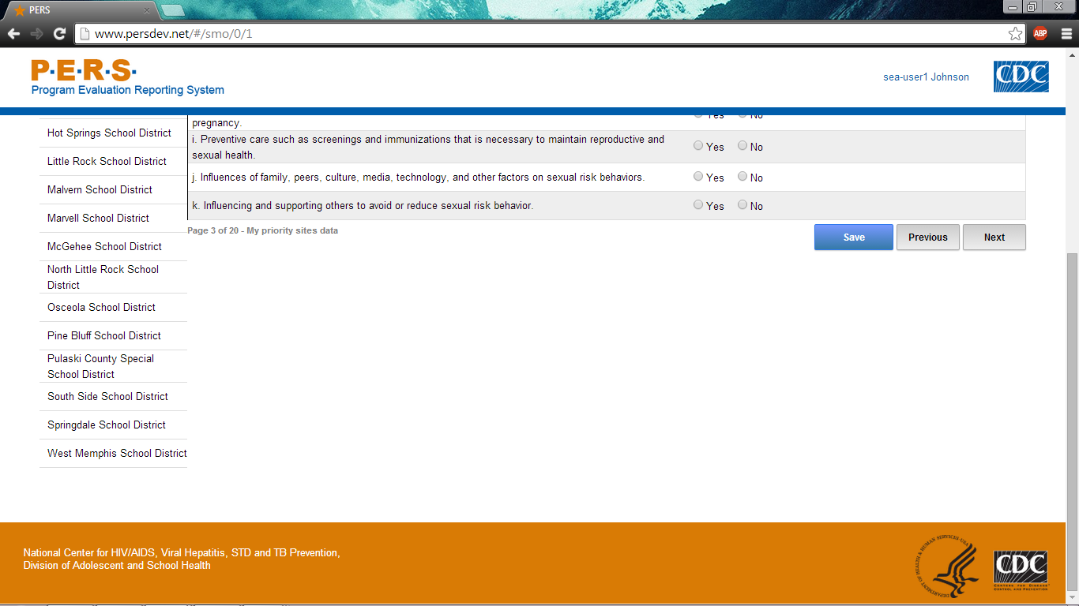
Part A of screenshot. This screen is scrolling enabled.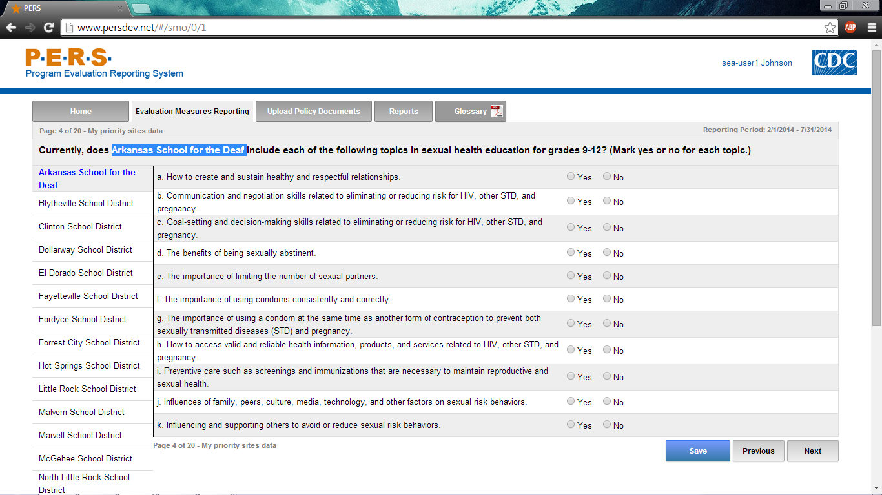
*Note: The highlighted part in the screenshot will be tailored to the Priority District Name of interest for each SEA respondent. The left-hand side of the screenshot shows where the potential Priority Districts will be listed. Each can be selected to answer this question.
Part B of screenshot. This screen is scrolling enabled.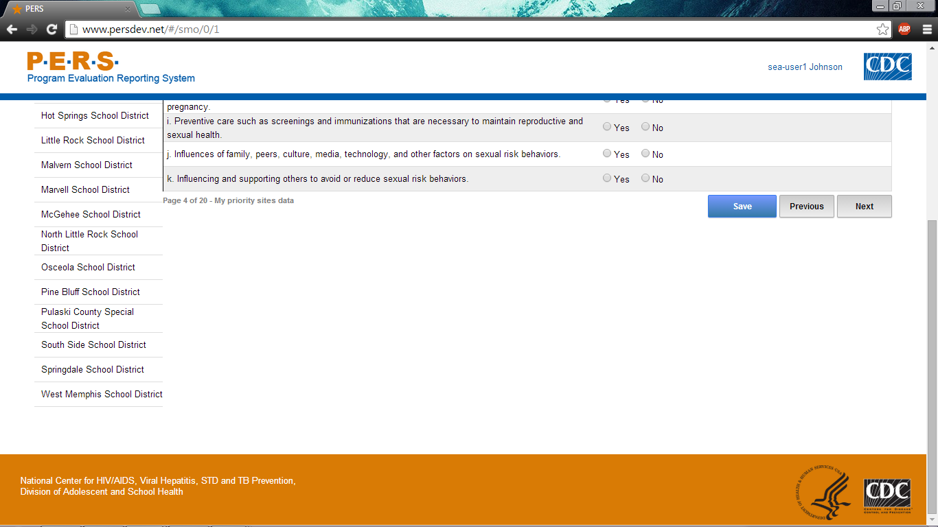
Part A of screenshot. This screen is scrolling enabled.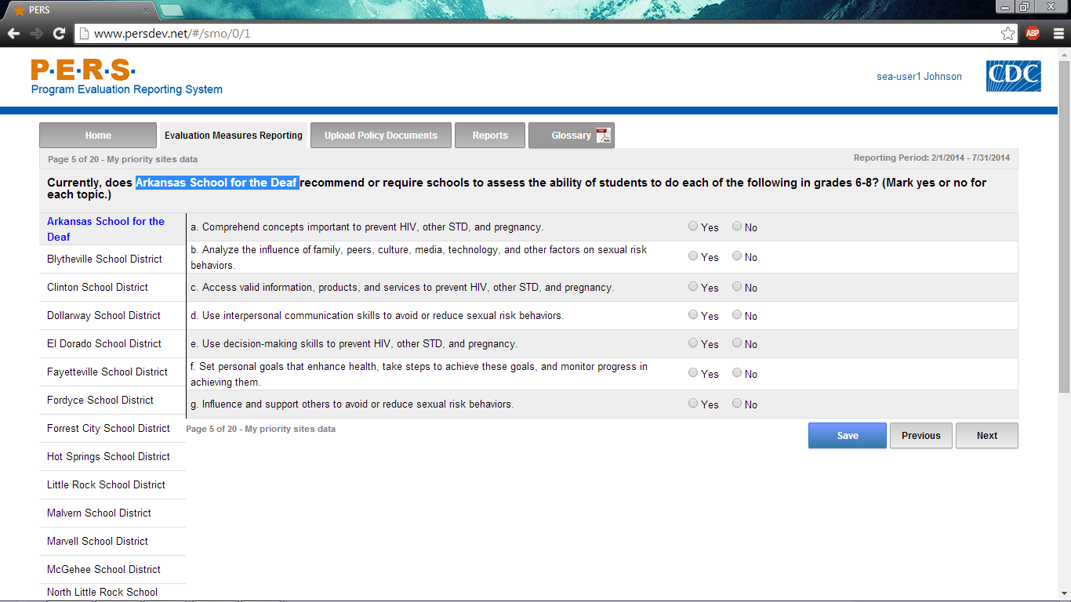
*Note: The highlighted part in the screenshot will be tailored to the Priority District Name of interest for each SEA respondent. The left-hand side of the screenshot shows where the potential Priority Districts will be listed. Each can be selected to answer this question.
Part B of screenshot. This screen is scrolling enabled.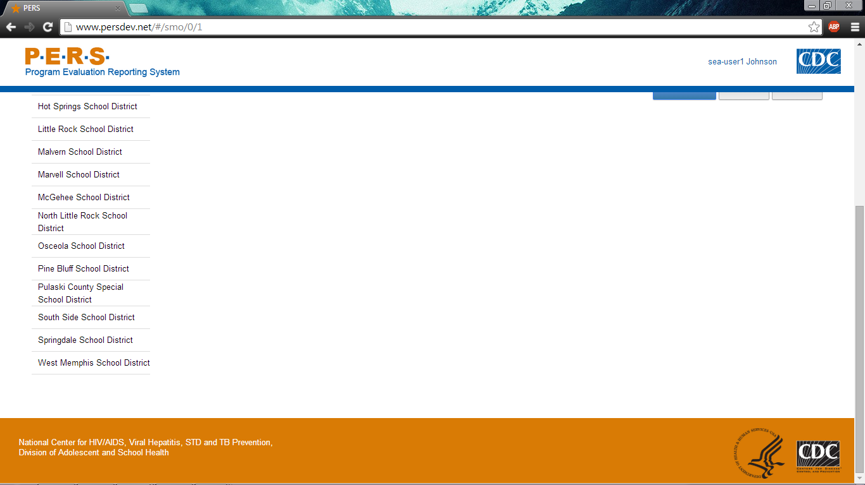
Part A of screenshot. This screen is scrolling enabled.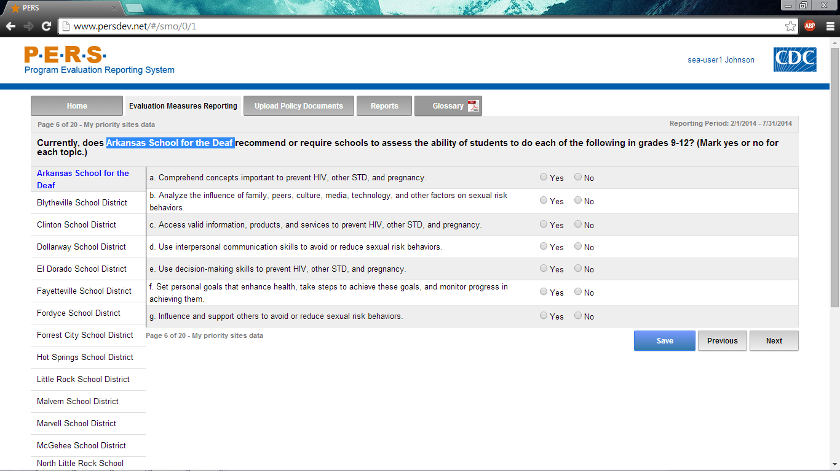
*Note: The highlighted part in the screenshot will be tailored to the Priority District Name of interest for each SEA respondent. The left-hand side of the screenshot shows where the potential Priority Districts will be listed. Each can be selected to answer this question.
Part B of screenshot. This screen is scrolling enabled.
Part A of screenshot. This screen is scrolling enabled.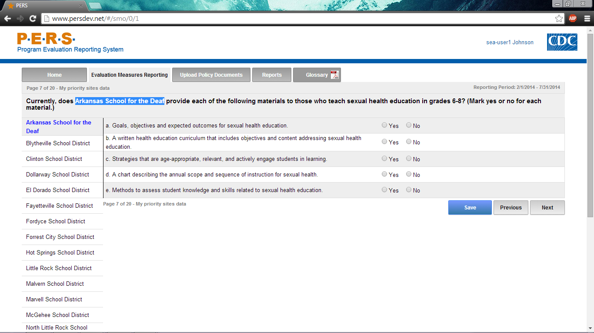
*Note: The highlighted part in the screenshot will be tailored to the Priority District Name of interest for each SEA respondent. The left-hand side of the screenshot shows where the potential Priority Districts will be listed. Each can be selected to answer this question.
Part B of screenshot. This screen is scrolling enabled.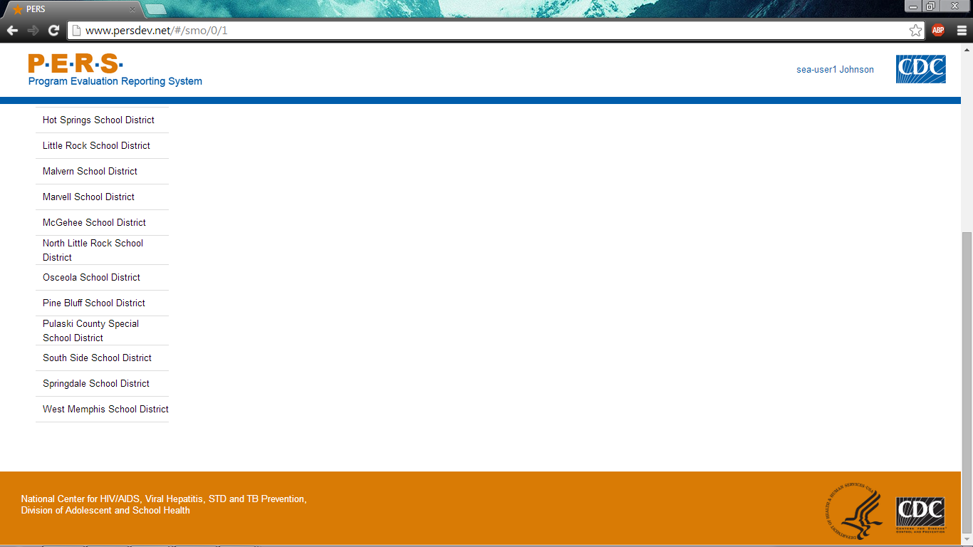
Part A of screenshot. This screen is scrolling enabled.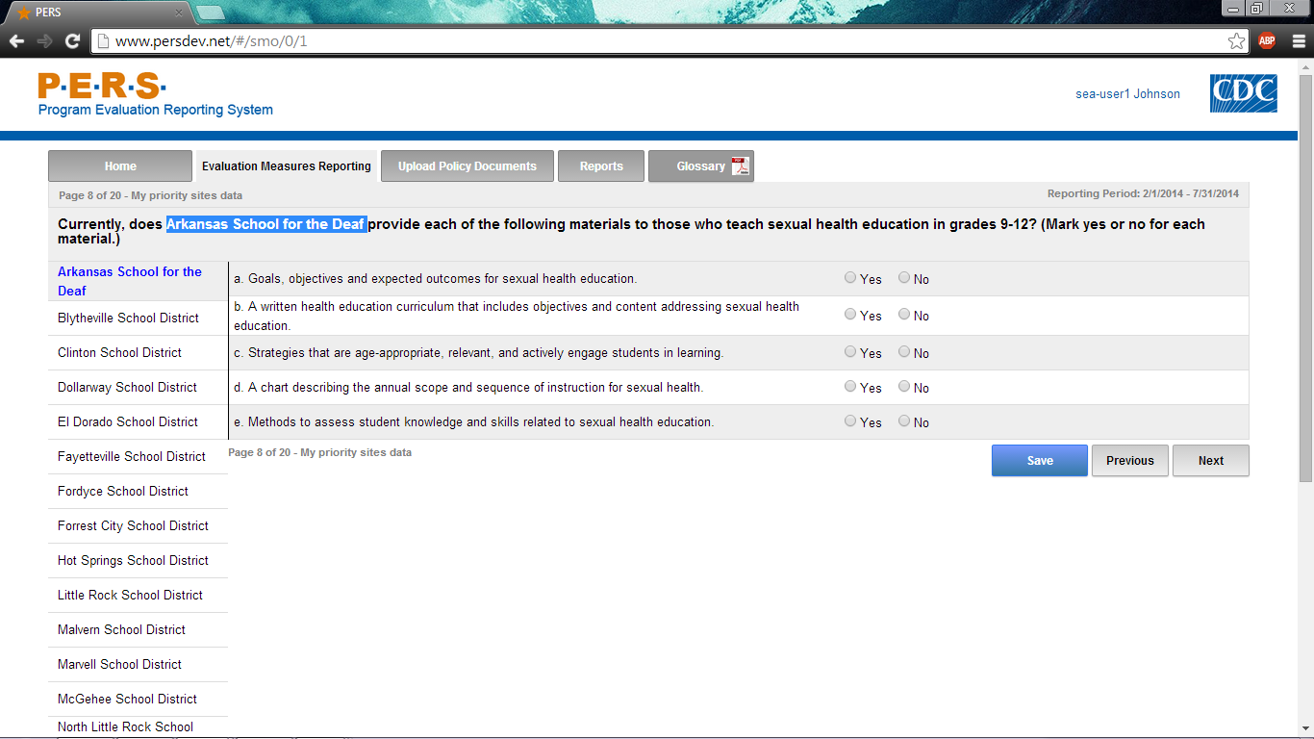
*Note: The highlighted part in the screenshot will be tailored to the Priority District Name of interest for each SEA respondent. The left-hand side of the screenshot shows where the potential Priority Districts will be listed. Each can be selected to answer this question.
Part B of screenshot. This screen is scrolling enabled.
Part A of screenshot. This screen is scrolling enabled.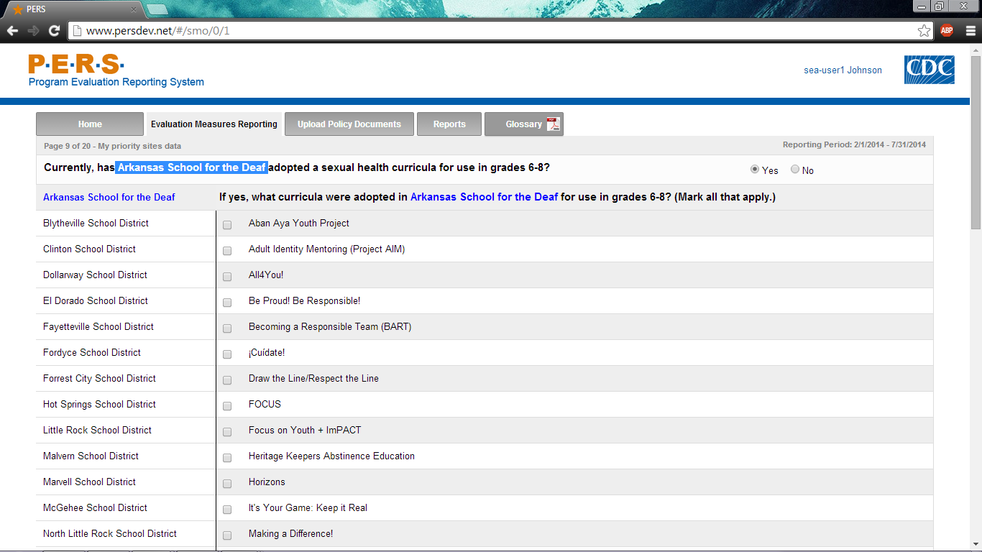
*Note: The highlighted part in the screenshot will be tailored to the Priority District Name of interest for each SEA respondent. The left-hand side of the screenshot shows where the potential Priority Districts will be listed. Each can be selected to answer this question.
Part B of screenshot. This screen is scrolling enabled.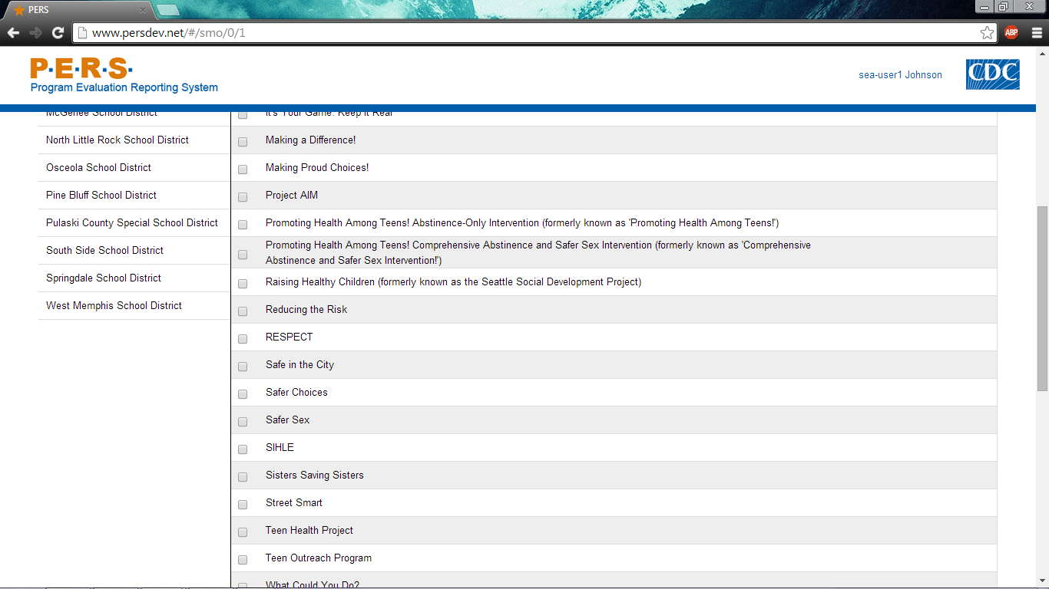
Part C of screenshot. This screen is scrolling enabled.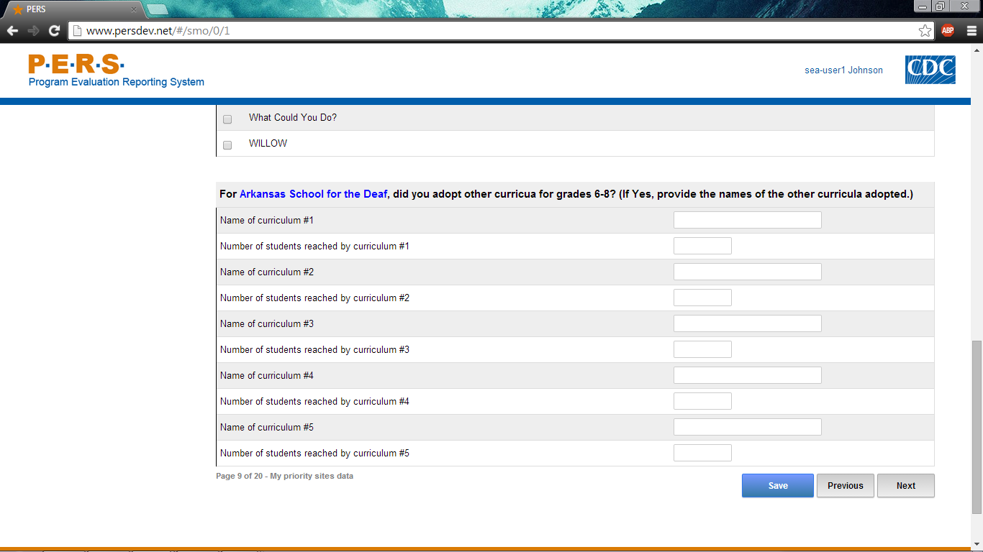
Part A of screenshot. This screen is scrolling enabled.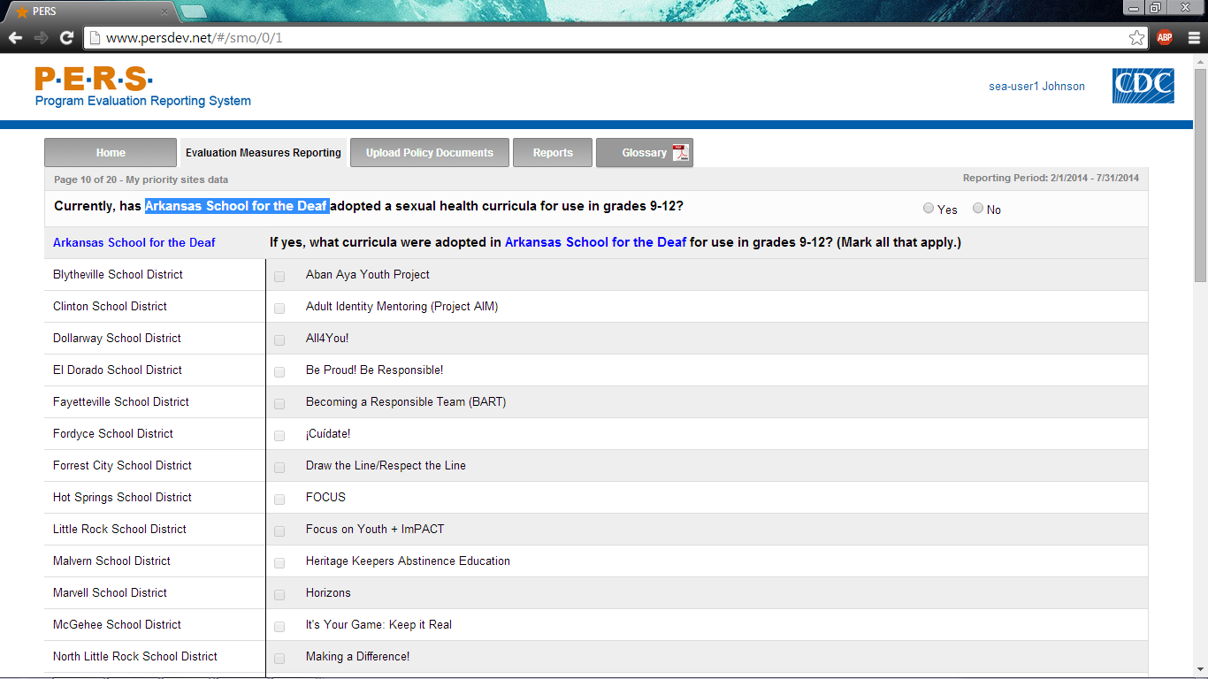
*Note: The highlighted part in the screenshot will be tailored to the Priority District Name of interest for each SEA respondent. The left-hand side of the screenshot shows where the potential Priority Districts will be listed. Each can be selected to answer this question.
Part B of screenshot. This screen is scrolling enabled.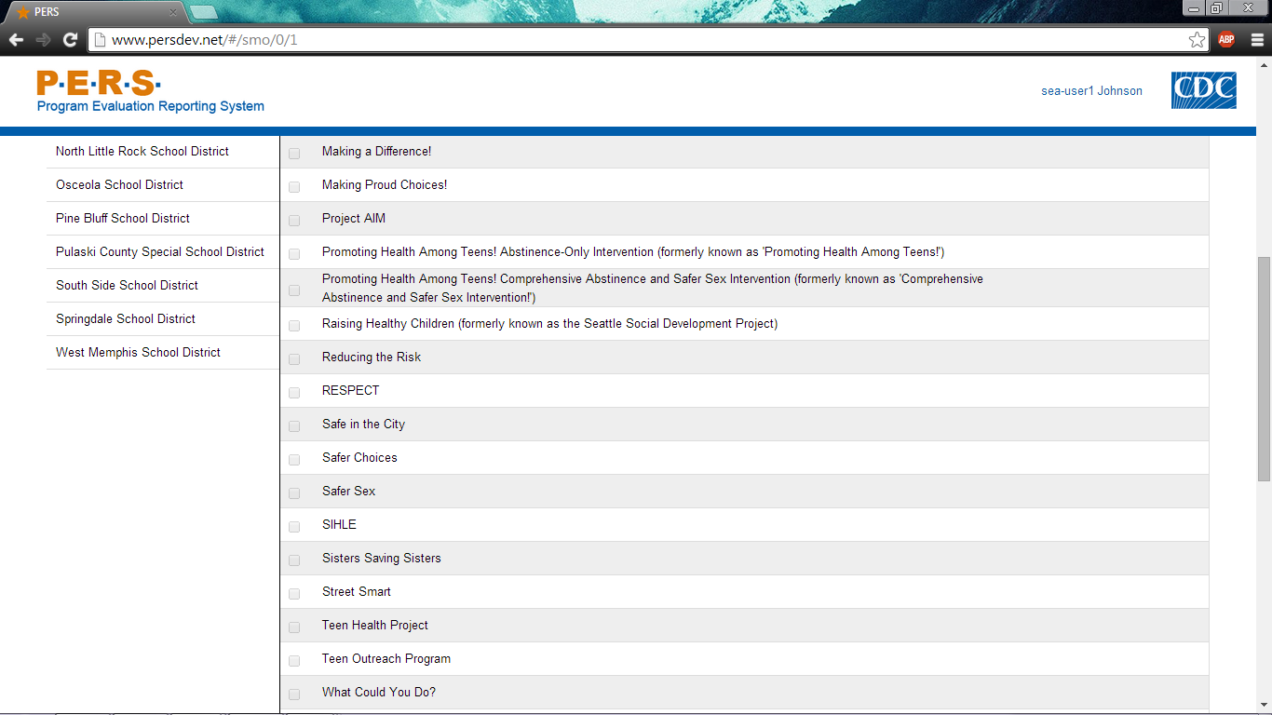
Part C of screenshot. This screen is scrolling enabled.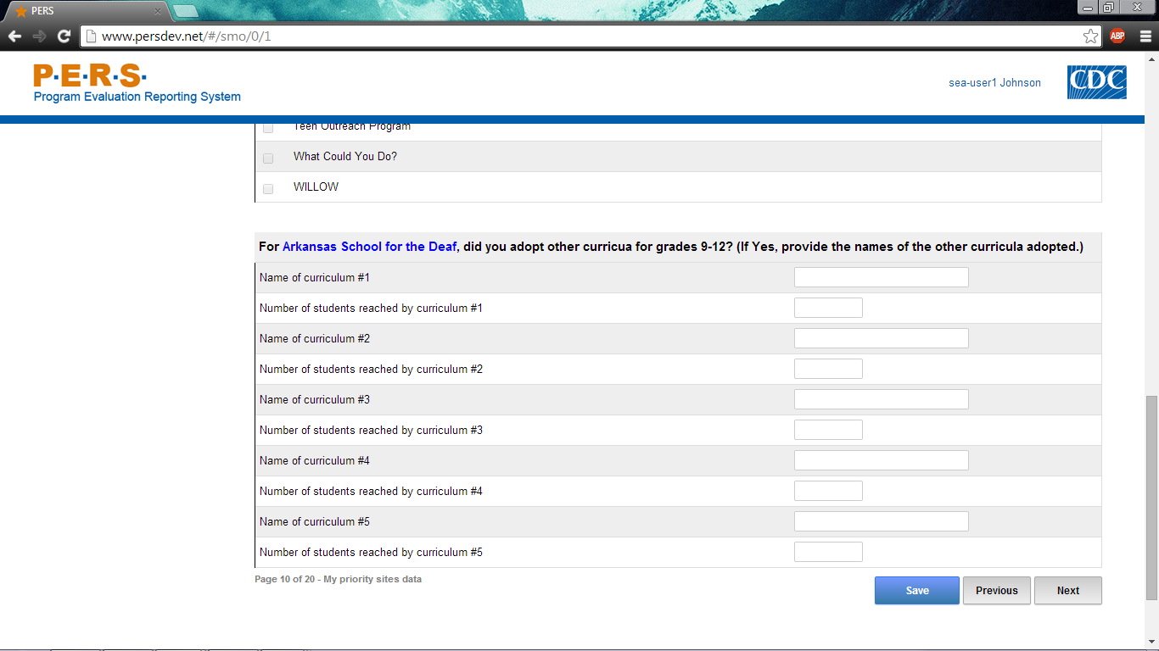

Part A of screenshot. This screen is scrolling enabled.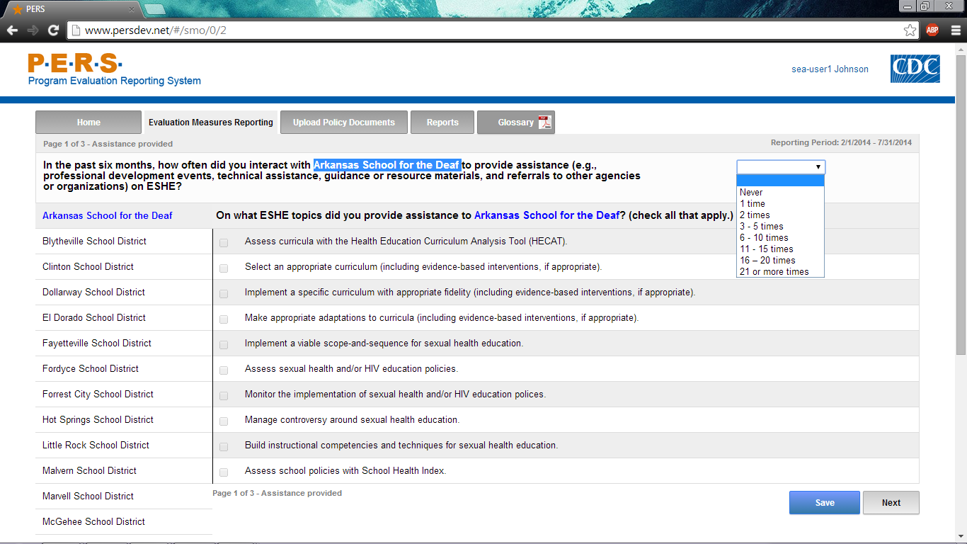
*Note: The highlighted part in the screenshot will be tailored to the Priority District Name of interest for each SEA respondent. The left-hand side of the screenshot shows where the potential Priority Districts will be listed. Each can be selected to answer this question.
Part B of screenshot. This screen is scrolling enabled.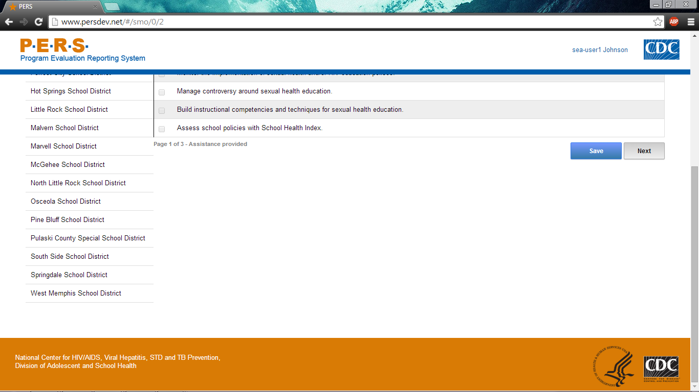

Form Approved
OMB No: 0920-XXXX
Exp. Date: XX/XX/XXXX

“Promoting Adolescent Health through School-Based HIV/STD Prevention”

Att. 4b

SEA SHS Items

Public reporting burden of this collection of information is estimated to average 3 hours per response, including the time for reviewing instructions, searching existing data sources, gathering and maintaining the data needed, and completing and reviewing the collection of information. An agency may not conduct or sponsor, and a person is not required to respond to a collection of information unless it displays a currently valid OMB control number. Send comments regarding this burden estimate or any other aspect of this collection of information, including suggestions for reducing this burden to CDC/ATSDR Reports Clearance Officer; 1600 Clifton Road NE, MS D-74, Atlanta, Georgia 30333; Attn: OMB-PRA (0920-New)

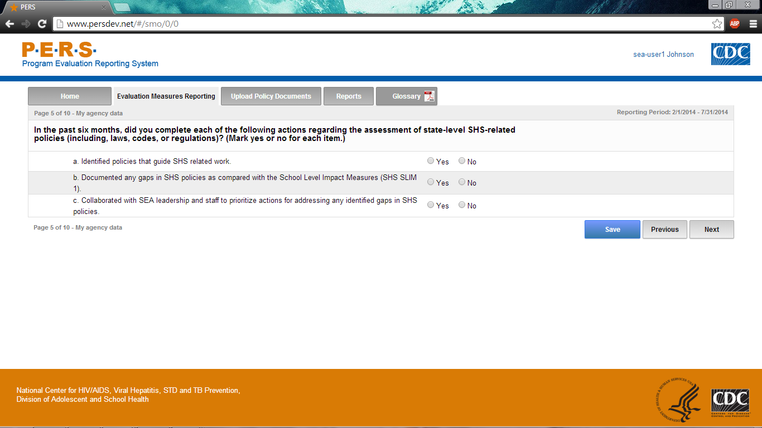

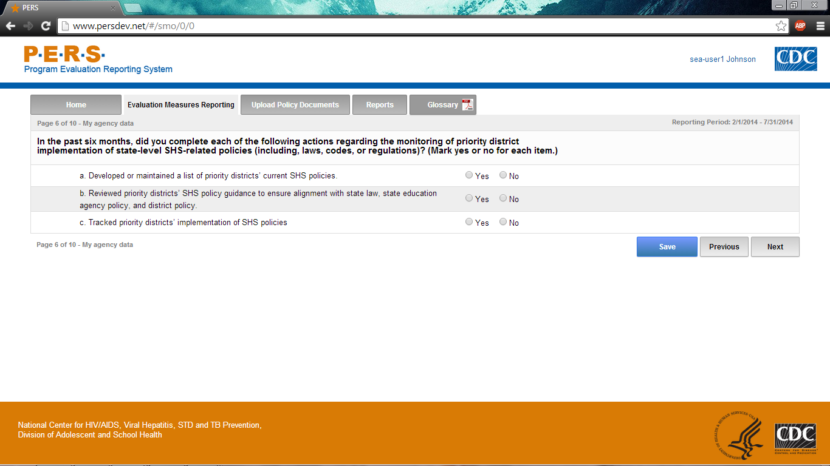

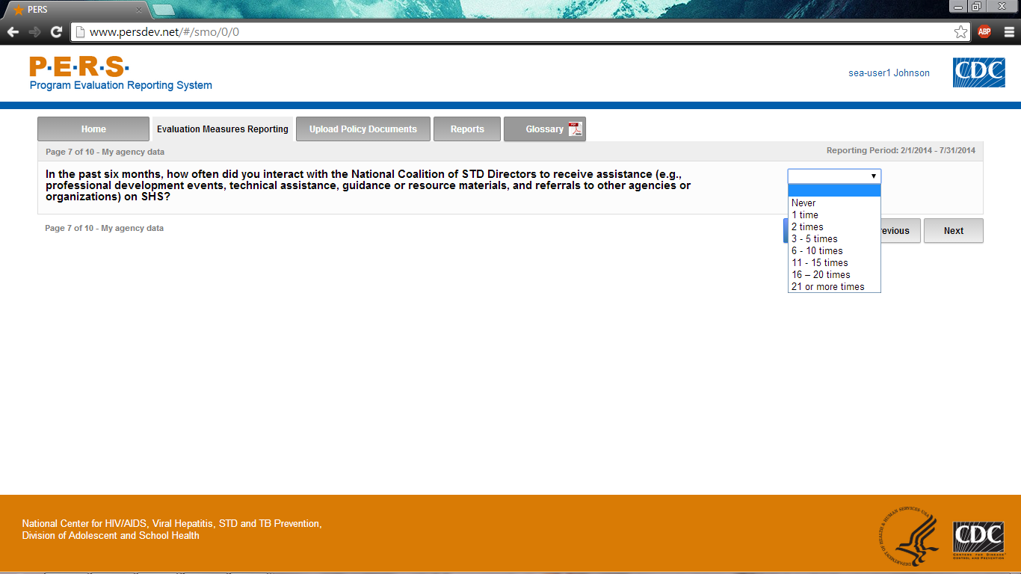
Part A of screenshot. This screen is scrolling enabled.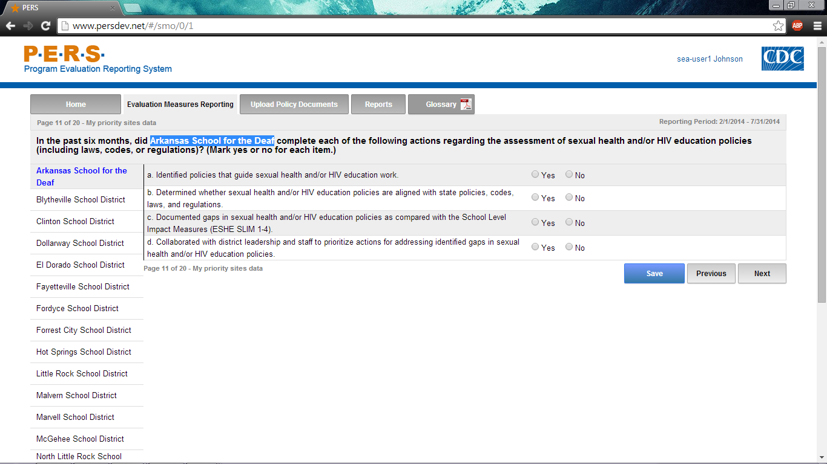
*Note: The highlighted part in the screenshot will be tailored to the Priority District Name of interest for each SEA respondent. The left-hand side of the screenshot shows where the potential Priority Districts will be listed. Each can be selected to answer this question.
Part B of screenshot. This screen is scrolling enabled.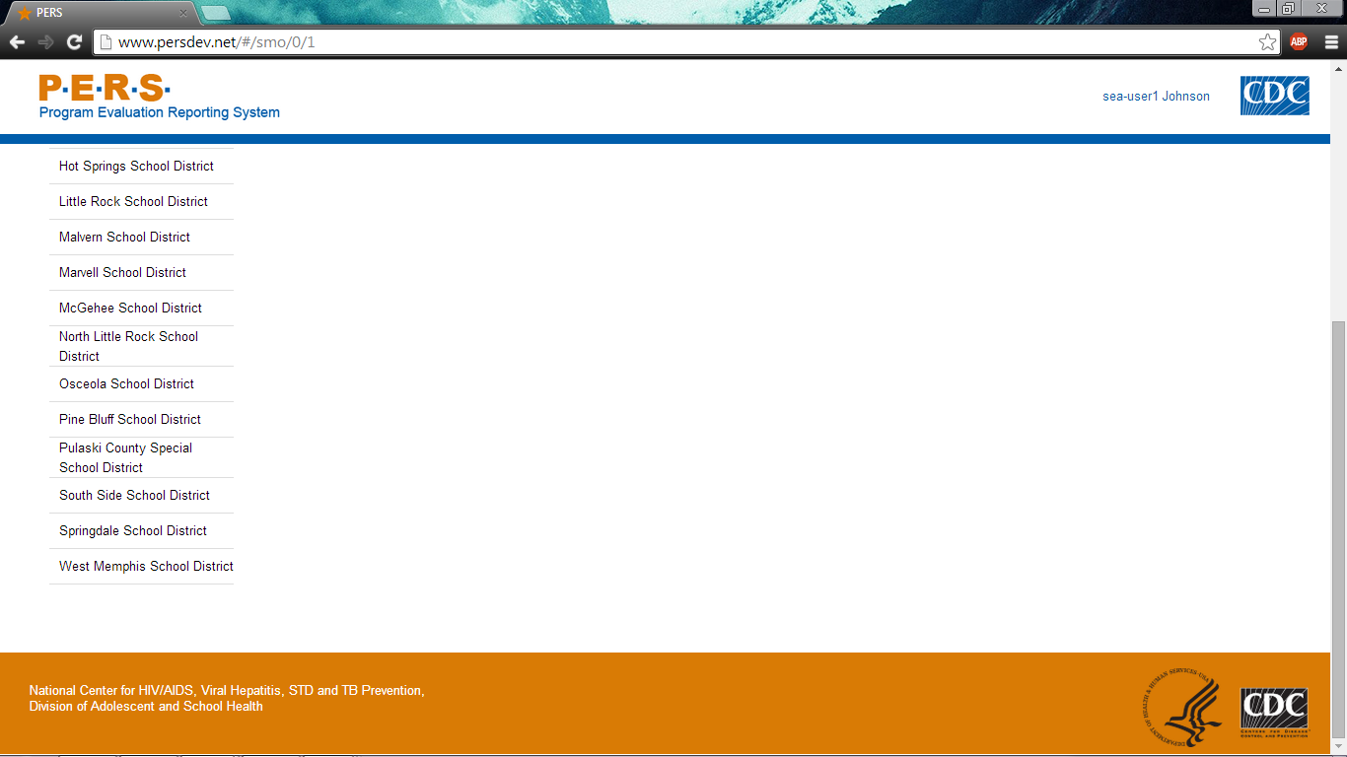
Part A of screenshot. This screen is scrolling enabled.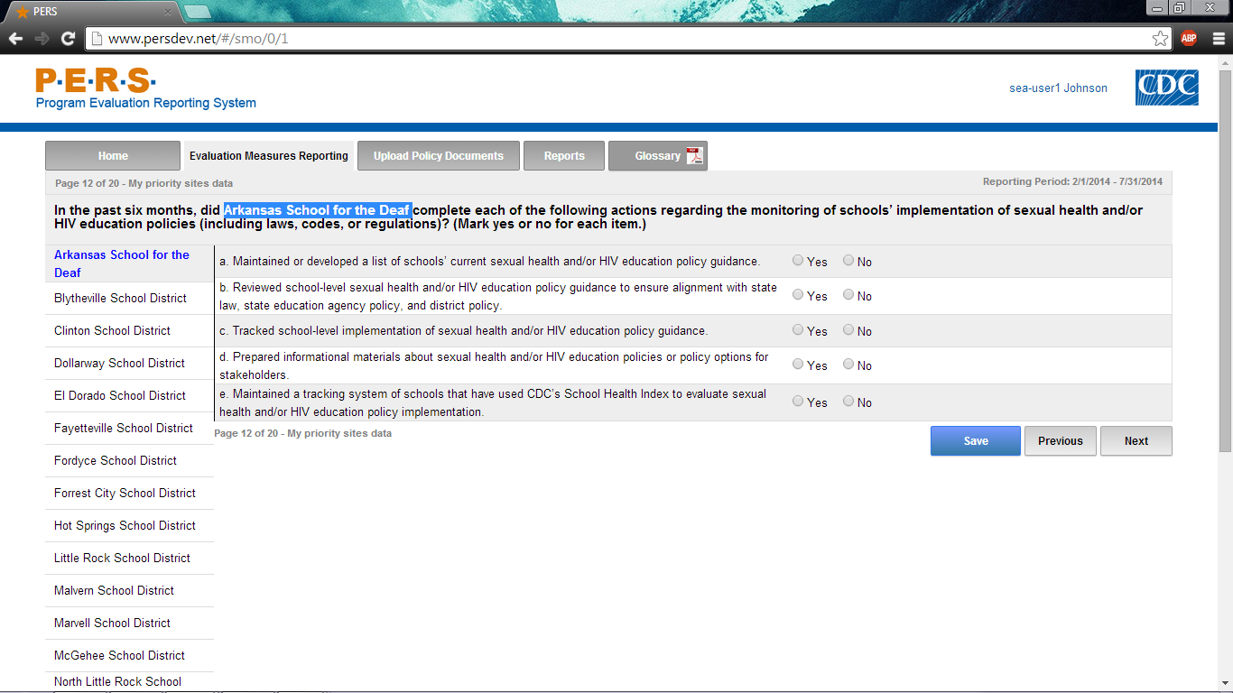
*Note: The highlighted part in the screenshot will be tailored to the Priority District Name of interest for each SEA respondent. The left-hand side of the screenshot shows where the potential Priority Districts will be listed. Each can be selected to answer this question.
Part B of screenshot. This screen is scrolling enabled.
Part A of screenshot. This screen is scrolling enabled.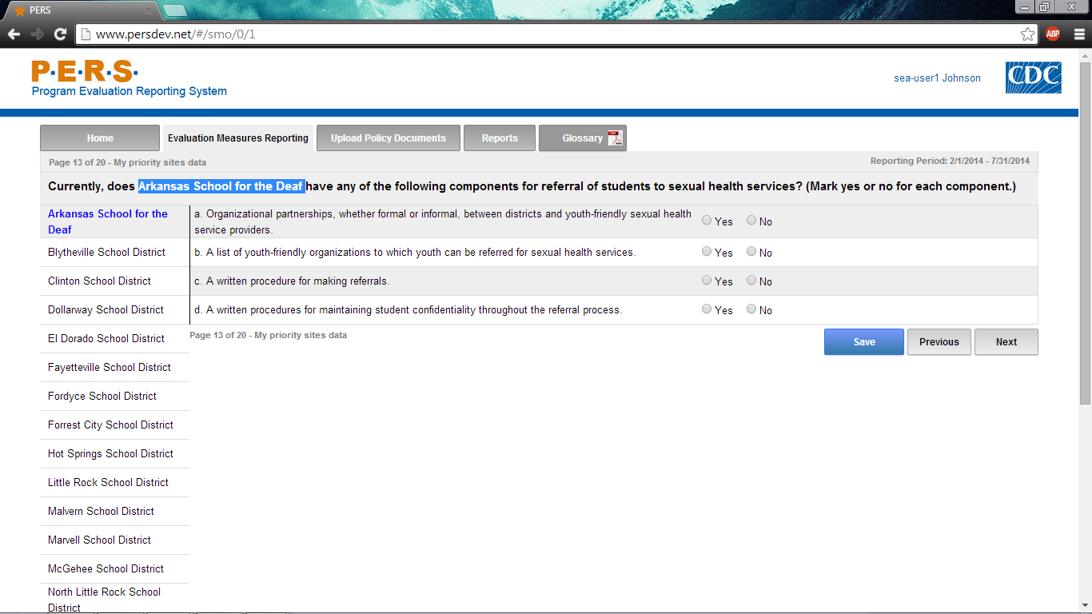
*Note: The highlighted part in the screenshot will be tailored to the Priority District Name of interest for each SEA respondent. The left-hand side of the screenshot shows where the potential Priority Districts will be listed. Each can be selected to answer this question.
Part B of screenshot. This screen is scrolling enabled.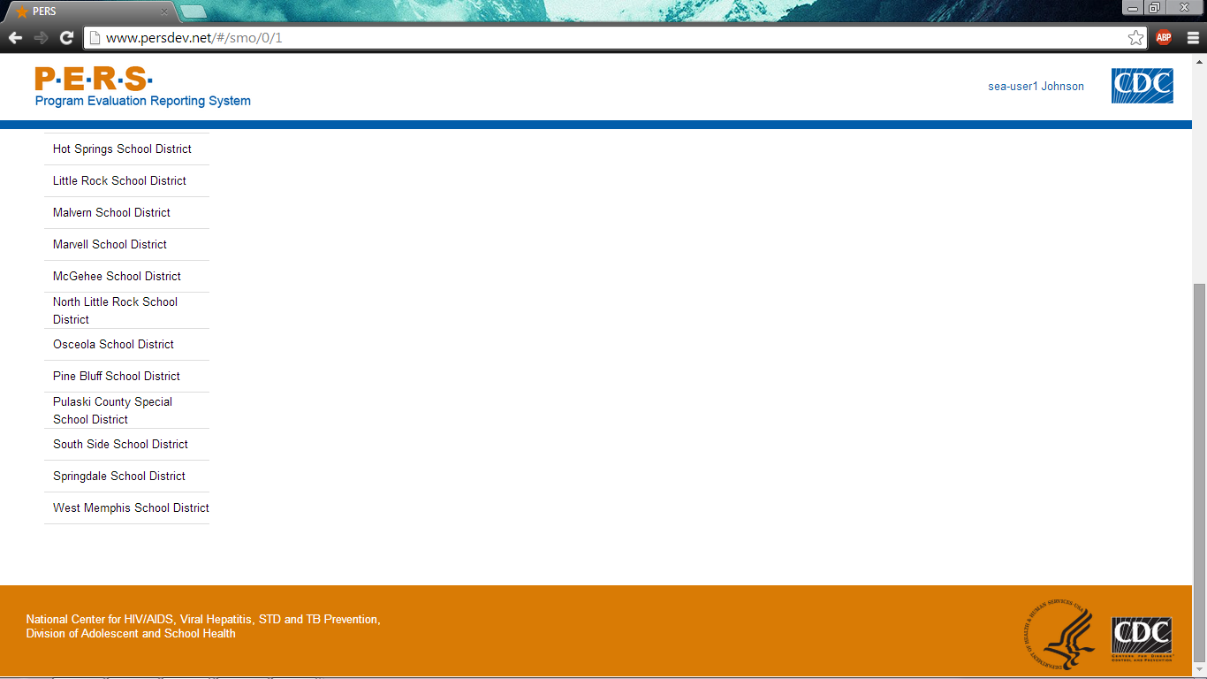
Part A of screenshot. This screen is scrolling enabled.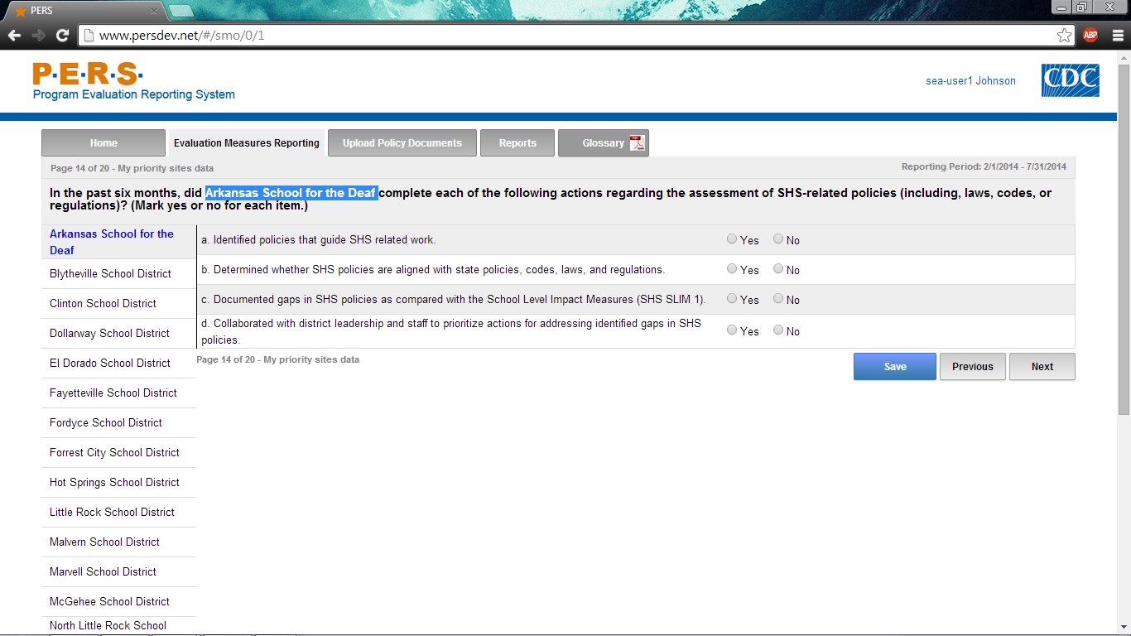
*Note: The highlighted part in the screenshot will be tailored to the Priority District Name of interest for each SEA respondent. The left-hand side of the screenshot shows where the potential Priority Districts will be listed. Each can be selected to answer this question.
Part B of screenshot. This screen is scrolling enabled.
Part A of screenshot. This screen is scrolling enabled.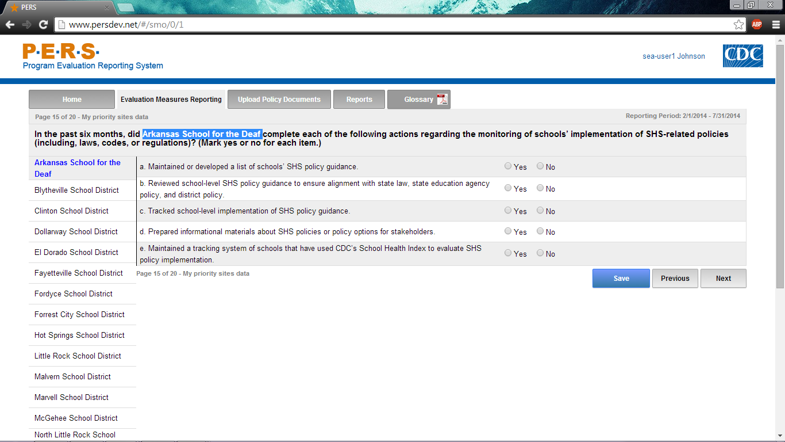
*Note: The highlighted part in the screenshot will be tailored to the Priority District Name of interest for each SEA respondent. The left-hand side of the screenshot shows where the potential Priority Districts will be listed. Each can be selected to answer this question.
Part B of screenshot. This screen is scrolling enabled.
Part A of screenshot. This screen is scrolling enabled.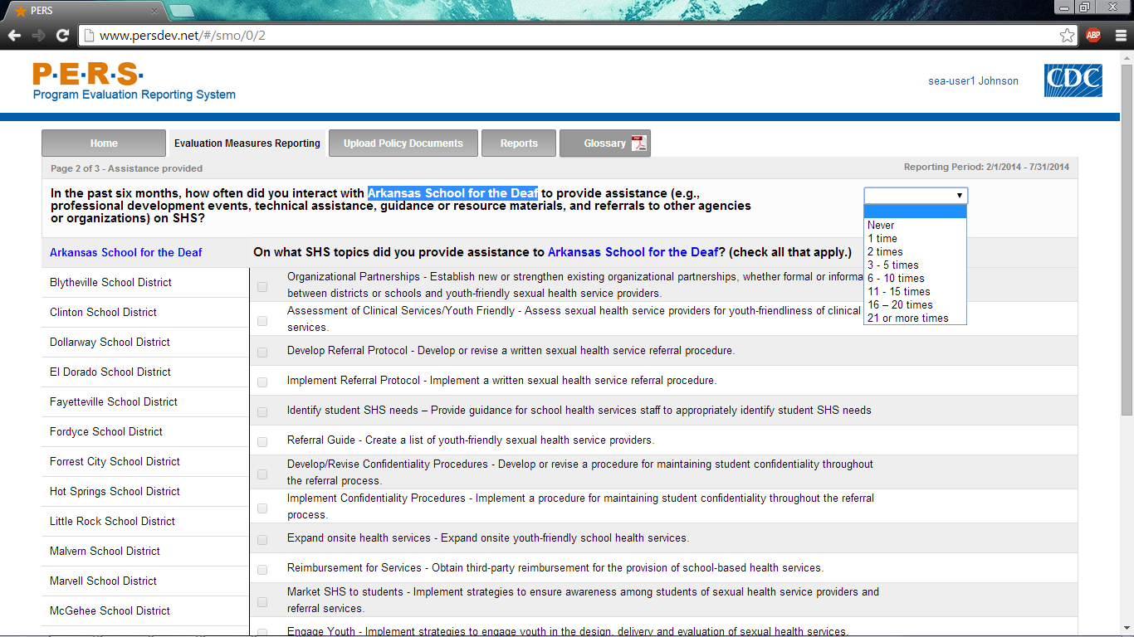
*Note: The highlighted part in the screenshot will be tailored to the Priority District Name of interest for each SEA respondent. The left-hand side of the screenshot shows where the potential Priority Districts will be listed. Each can be selected to answer this question.
Part B of screenshot. This screen is scrolling enabled.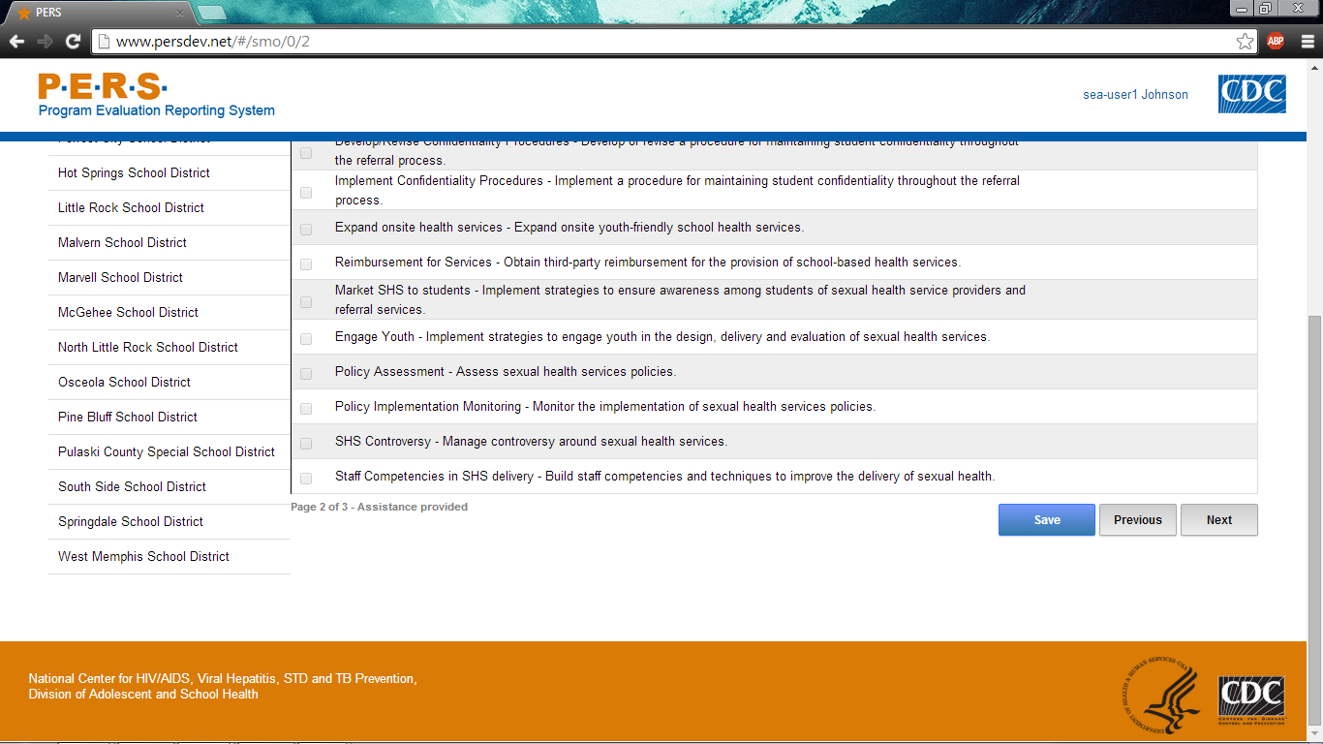

Form Approved
OMB No: 0920-XXXX
Exp. Date: XX/XX/XXXX

“Promoting Adolescent Health through School-Based HIV/STD Prevention”

Att. 4a

SEA SSE Items

Public reporting burden of this collection of information is estimated to average 60 minutes per response, including the time for reviewing instructions, searching existing data sources, gathering and maintaining the data needed, and completing and reviewing the collection of information. An agency may not conduct or sponsor, and a person is not required to respond to a collection of information unless it displays a currently valid OMB control number. Send comments regarding this burden estimate or any other aspect of this collection of information, including suggestions for reducing this burden to CDC/ATSDR Reports Clearance Officer; 1600 Clifton Road NE, MS D-74, Atlanta, Georgia 30333; Attn: OMB-PRA (0920-New)

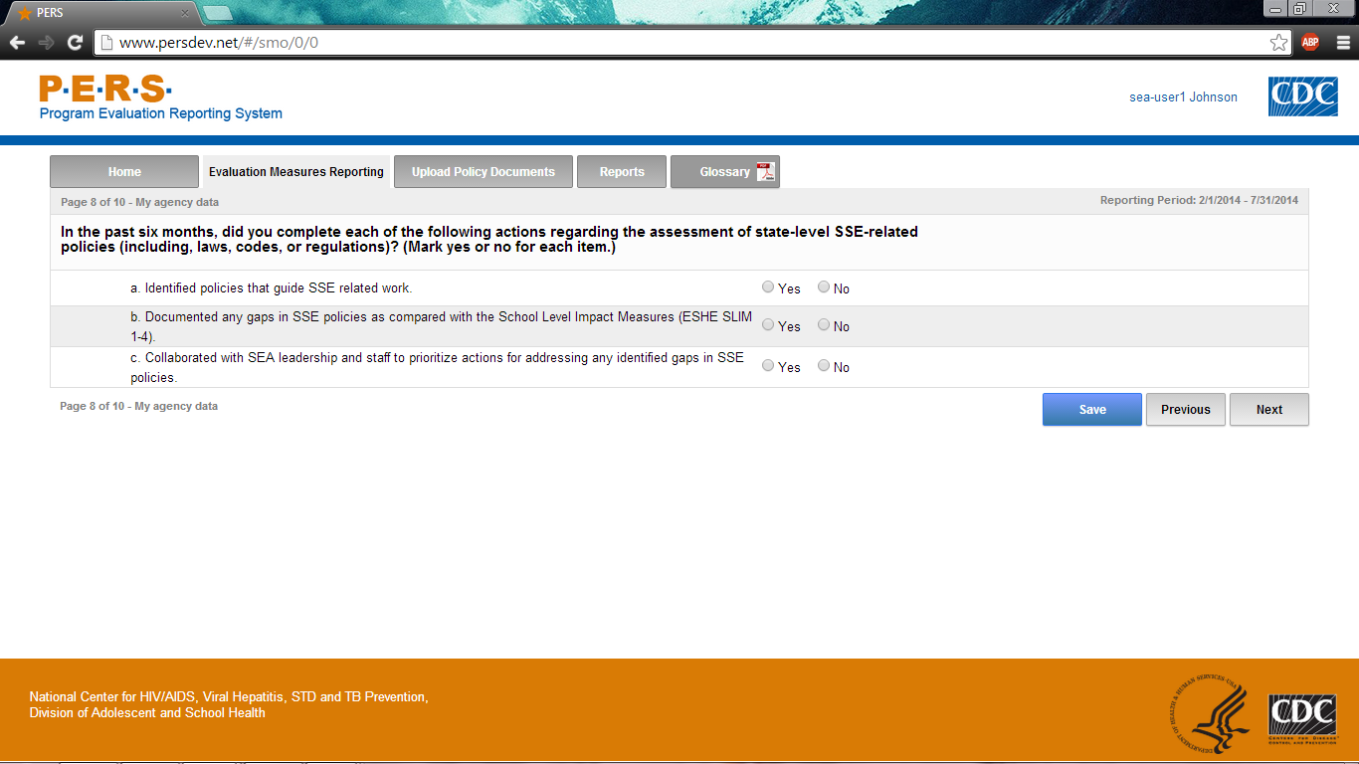

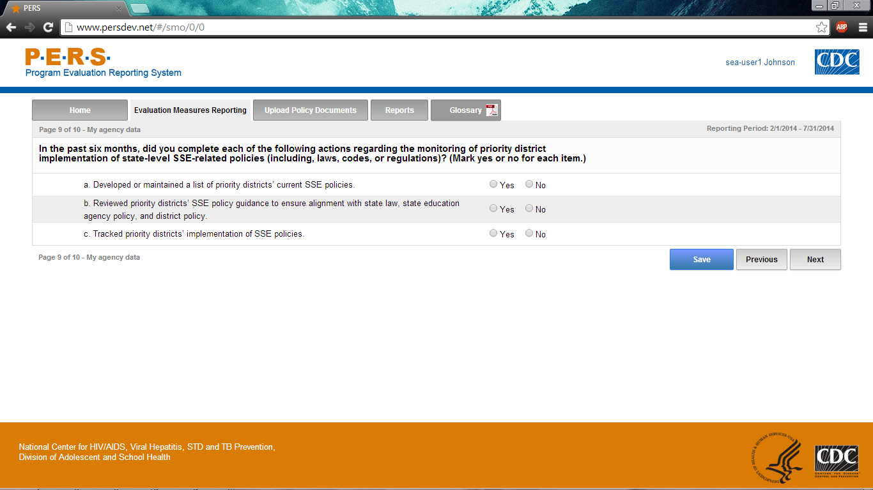

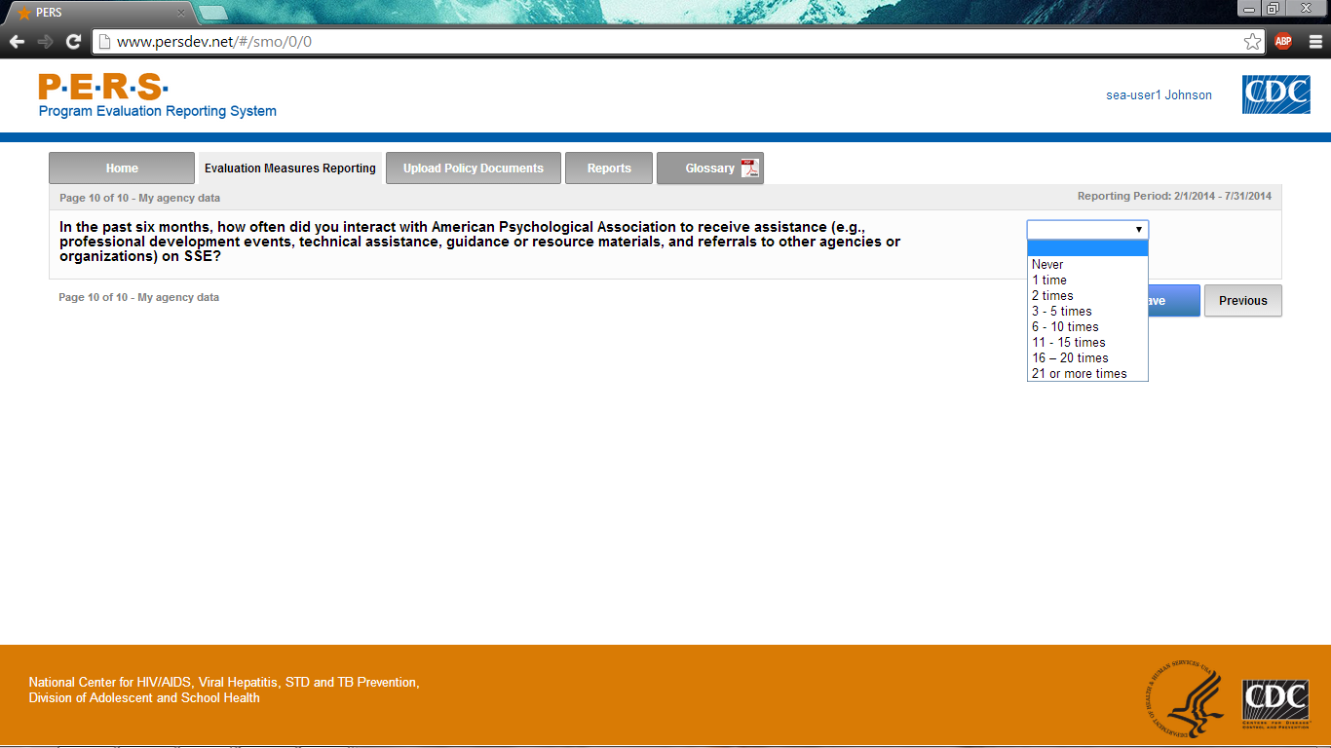
Part A of screenshot. This screen is scrolling enabled.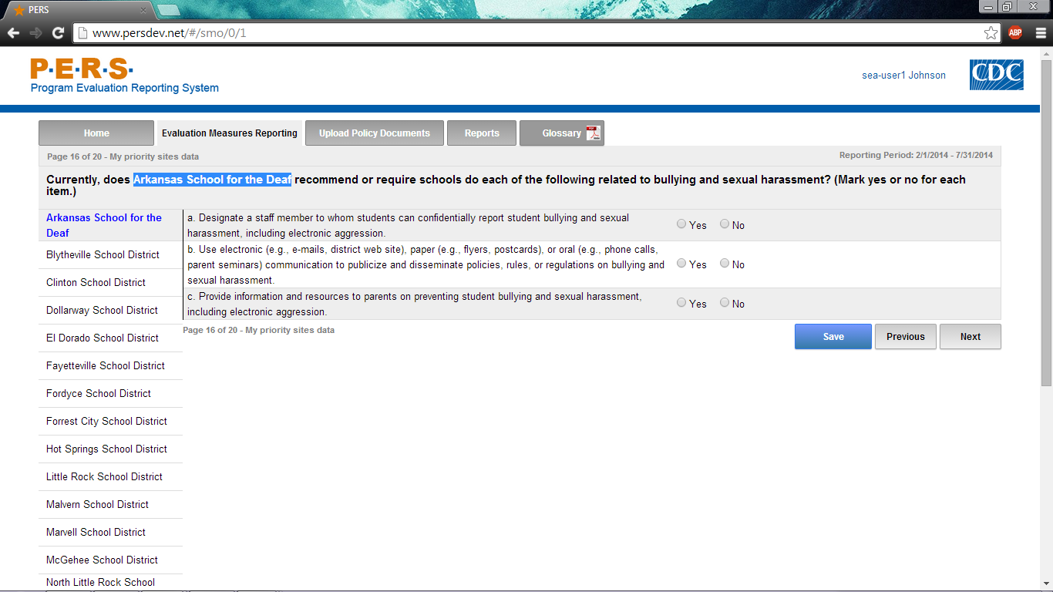
*Note: The highlighted part in the screenshot will be tailored to the Priority District Name of interest for each SEA respondent. The left-hand side of the screenshot shows where the potential Priority Districts will be listed. Each can be selected to answer this question.
Part B of screenshot. This screen is scrolling enabled.
Part A of screenshot. This screen is scrolling enabled.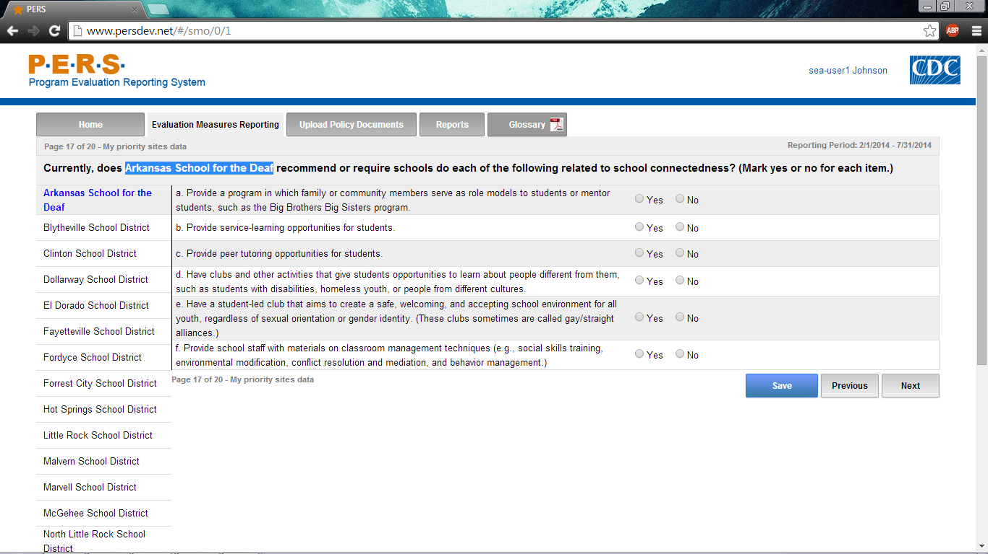
*Note: The highlighted part in the screenshot will be tailored to the Priority District Name of interest for each SEA respondent. The left-hand side of the screenshot shows where the potential Priority Districts will be listed. Each can be selected to answer this question.
Part B of screenshot. This screen is scrolling enabled.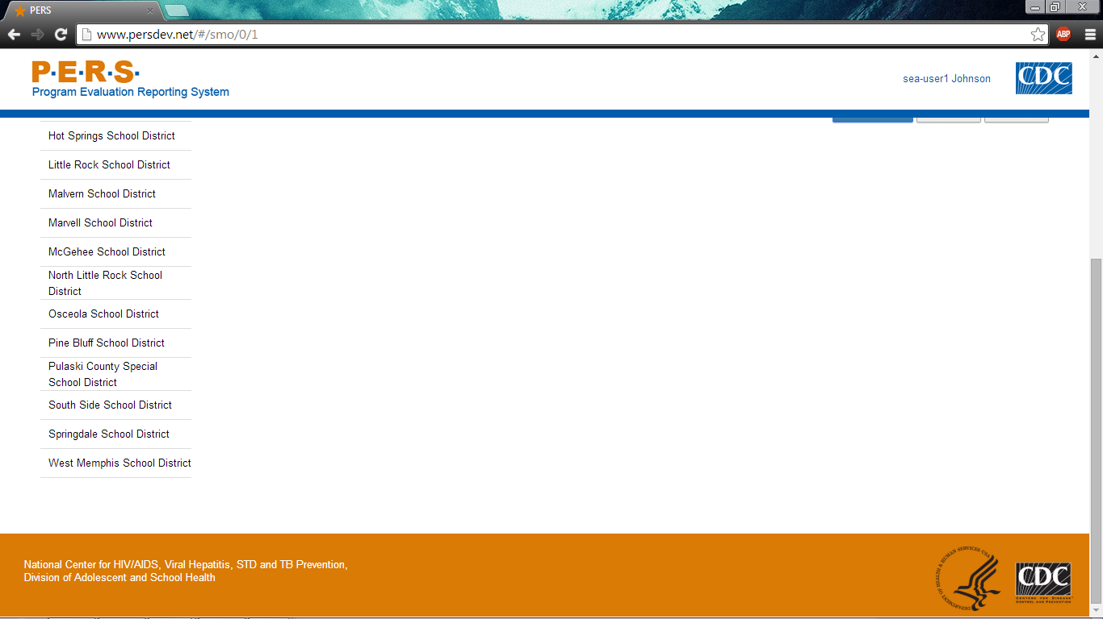
Part A of screenshot. This screen is scrolling enabled.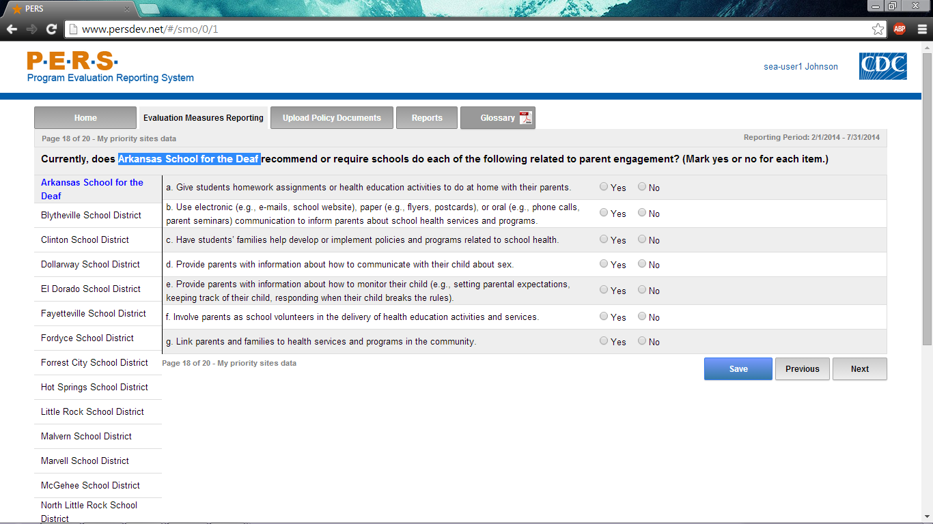
*Note: The highlighted part in the screenshot will be tailored to the Priority District Name of interest for each SEA respondent. The left-hand side of the screenshot shows where the potential Priority Districts will be listed. Each can be selected to answer this question.
Part B of screenshot. This screen is scrolling enabled.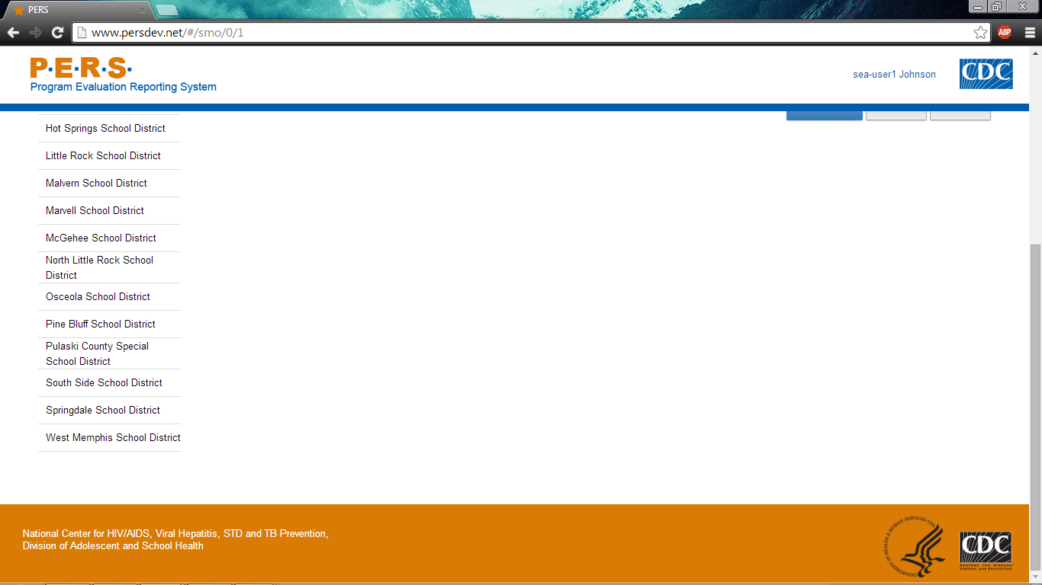
Part A of screenshot. This screen is scrolling enabled.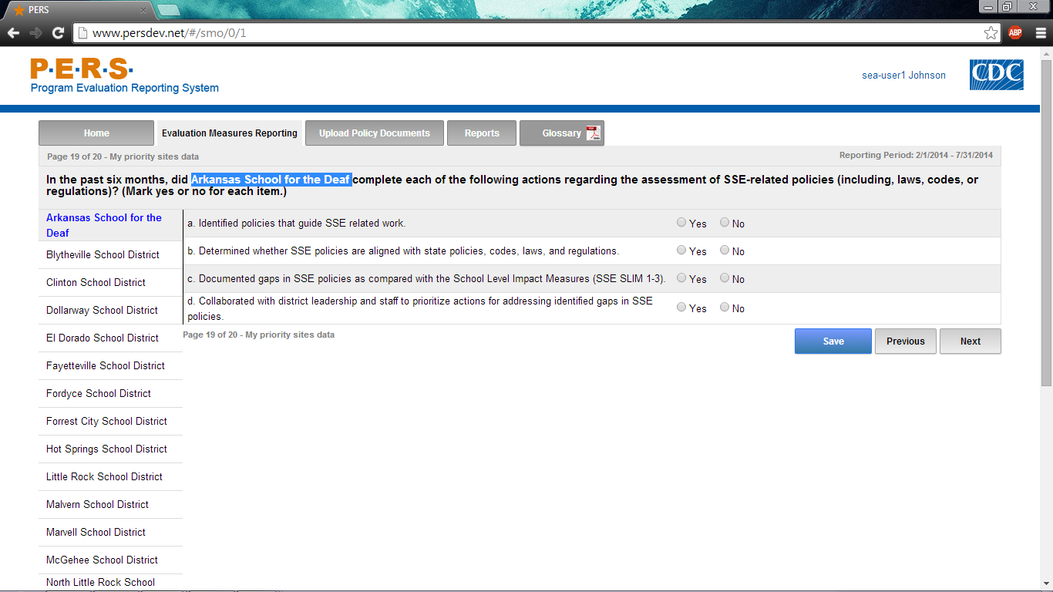
*Note: The highlighted part in the screenshot will be tailored to the Priority District Name of interest for each SEA respondent. The left-hand side of the screenshot shows where the potential Priority Districts will be listed. Each can be selected to answer this question.
Part B of screenshot. This screen is scrolling enabled.
Part A of screenshot. This screen is scrolling enabled.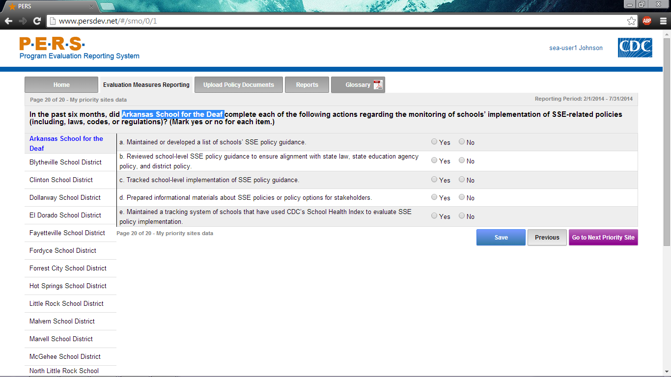
*Note: The highlighted part in the screenshot will be tailored to the Priority District Name of interest for each SEA respondent. The left-hand side of the screenshot shows where the potential Priority Districts will be listed. Each can be selected to answer this question.
Part B of screenshot. This screen is scrolling enabled.
Part A of screenshot. This screen is scrolling enabled.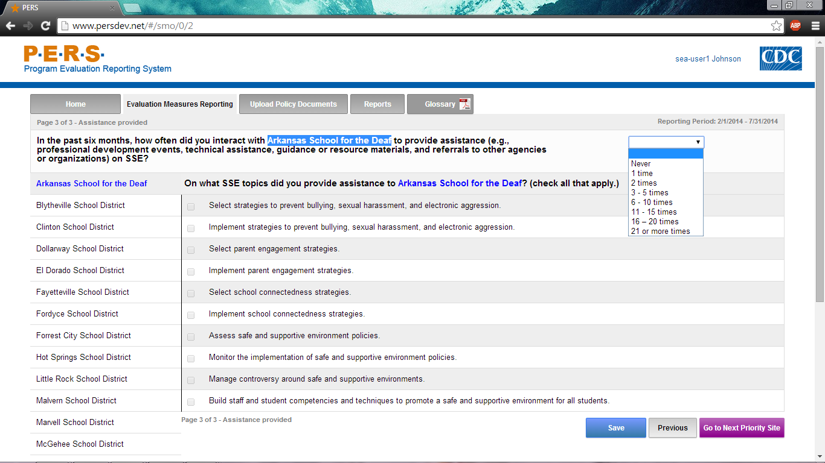
*Note: The highlighted part in the screenshot will be tailored to the Priority District Name of interest for each SEA respondent. The left-hand side of the screenshot shows where the potential Priority Districts will be listed. Each can be selected to answer this question.
Part B of screenshot. This screen is scrolling enabled.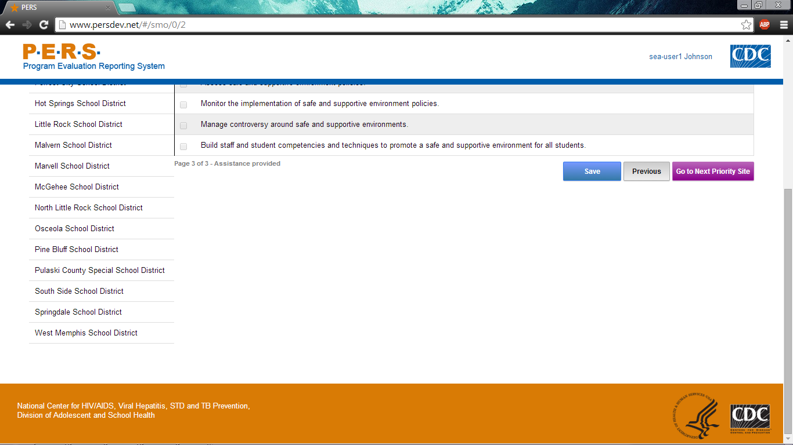

Instruction Slides
Log-in screen
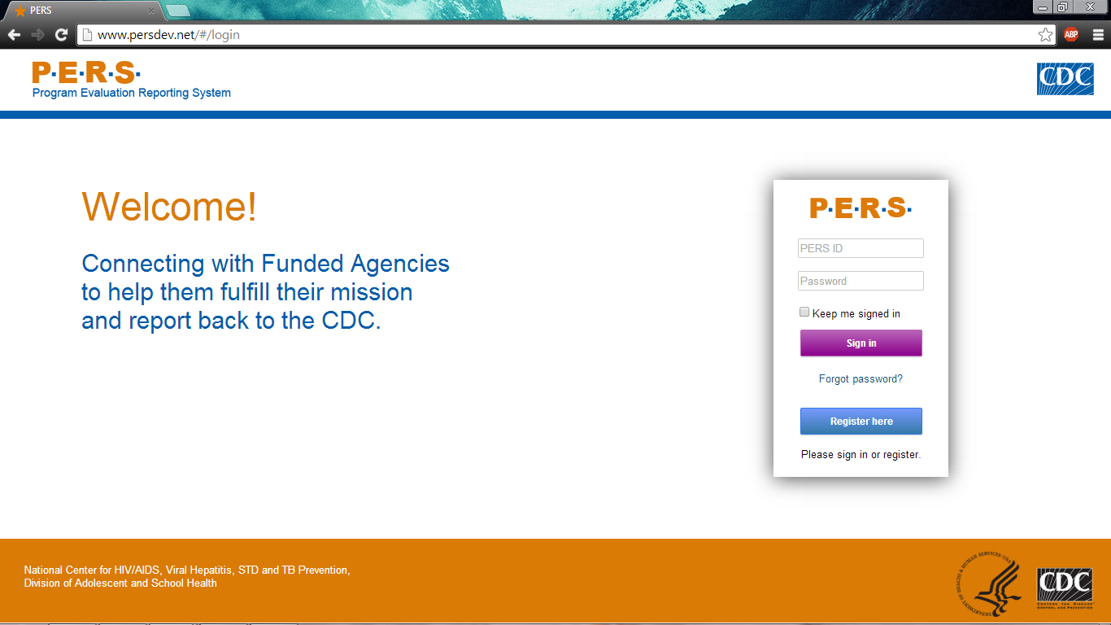
Screen that appears after logging in with username and password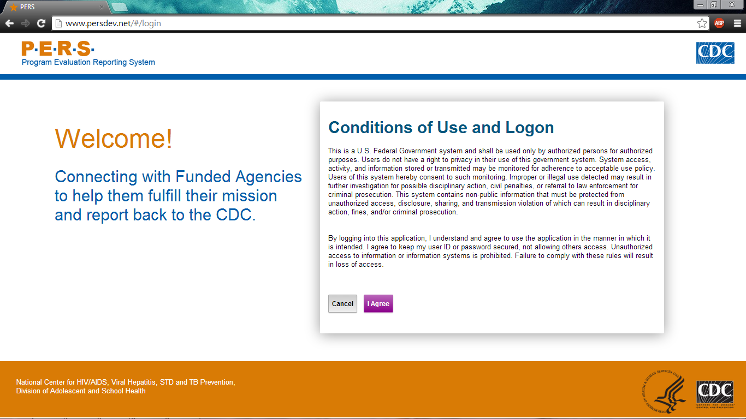
Main page. Questionnaires located in “Evaluation Measures Reporting” tab.
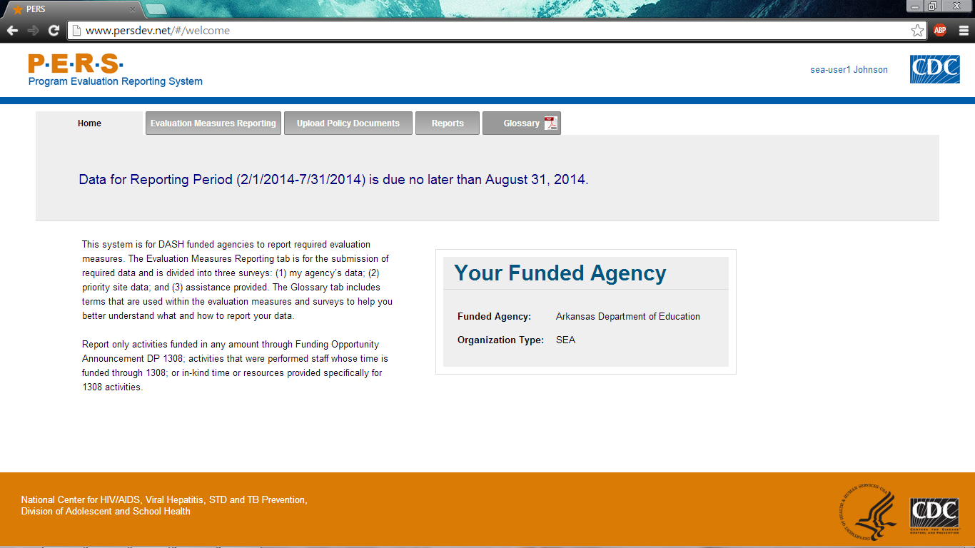
Main screen with links to questionnaires. ESHE, SHS, and SSE questions are organized in the three categories for ease of data entry.

