Attachment 8c: Screenshots from PERS
For Attachments 3a, b &c
Non-governmental Organization (NGO) Screenshots

The data will be collected from funded agencies via the Program Evaluation and Reporting System (PERS). Screenshots for the Non-governmental organization (NGO) questionnaires are provided below in the order presented in the Burden Table (Table A.12-1) in Supporting Statement A. The questionnaires for the State Education Agencies (SEA) and Local Education Agencies (LEA) are included in Attachment 8a and 8b, respectively.
The questionnaires in PERS cover the following topics: exemplary sexual health education (ESHE); sexual health services (SHS); and safe and supportive environments (SSE). The burden statement and OMB form approval information are reflected on the initial page of each group of screenshots that correspond to the questionnaires. To view the measures and the list of questions in text format, see Attachments 3a, b &c.
Contents
Non-governmental Organization (NGO) Screenshots 2
NGO ESHE Items 2
NGO SHS Items 7
NGO SSE Items 12
Instruction Slides 17

Non-governmental Organization (NGO) Screenshots
Form Approved
OMB No: 0920-XXXX
Exp. Date: XX/XX/XXXX

“Promoting Adolescent Health through School-Based HIV/STD Prevention”

Att. 3c

NGO ESHE Items

Public reporting burden of this collection of information is estimated to average 30 minutes per response, including the time for reviewing instructions, searching existing data sources, gathering and maintaining the data needed, and completing and reviewing the collection of information. An agency may not conduct or sponsor, and a person is not required to respond to a collection of information unless it displays a currently valid OMB control number. Send comments regarding this burden estimate or any other aspect of this collection of information, including suggestions for reducing this burden to CDC/ATSDR Reports Clearance Officer; 1600 Clifton Road NE, MS D-74, Atlanta, Georgia 30333; Attn: OMB-PRA (0920-New)

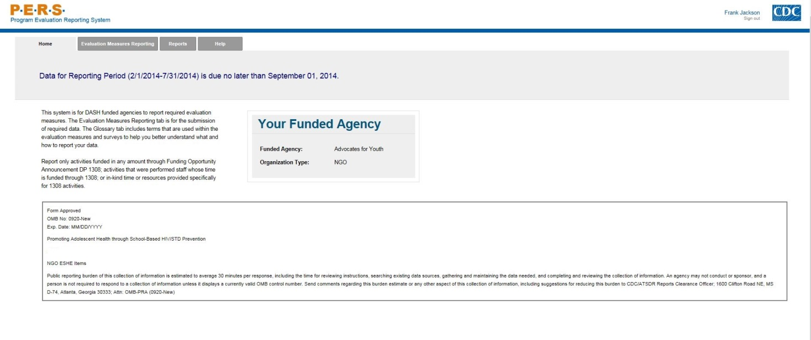
Part A of screenshot for SEAs. This screen is scrolling enabled.

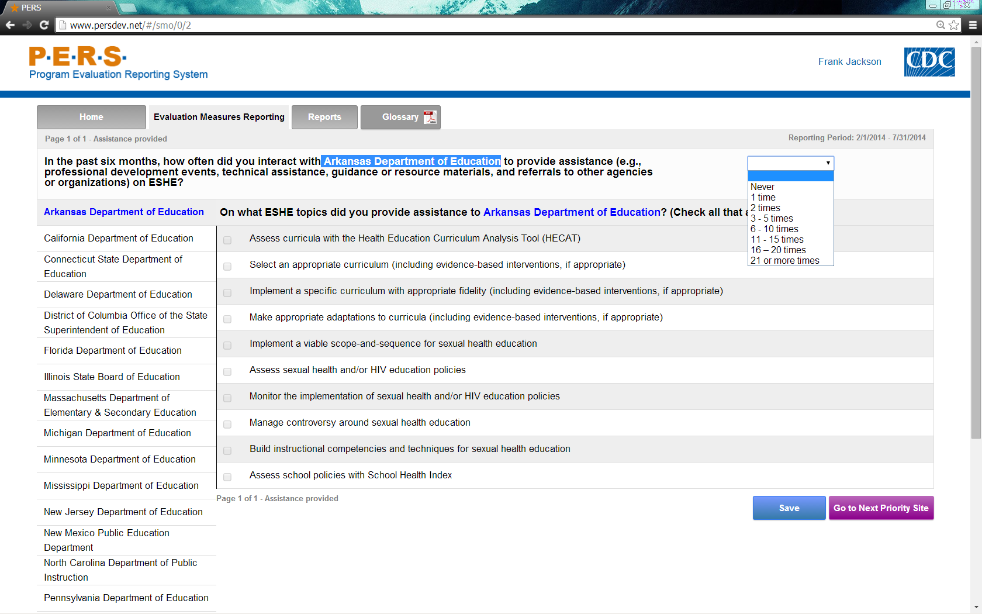
*Note: The highlighted part in the screenshot will be tailored to the State Education Agency of interest for each NGO respondent that provides assistance related to ESHE. The left-hand side of the screenshot shows where the potential State Education Agencies will be listed. Each can be selected to answer this question.
Part B of screenshot for SEAs. This screen is scrolling enabled.

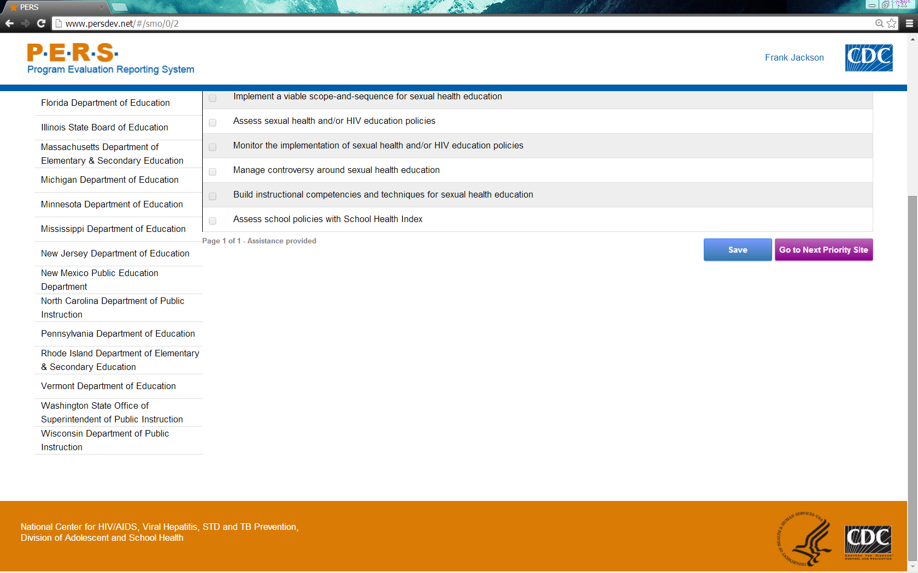

Part A of screenshot for LEAs. This screen is scrolling enabled.
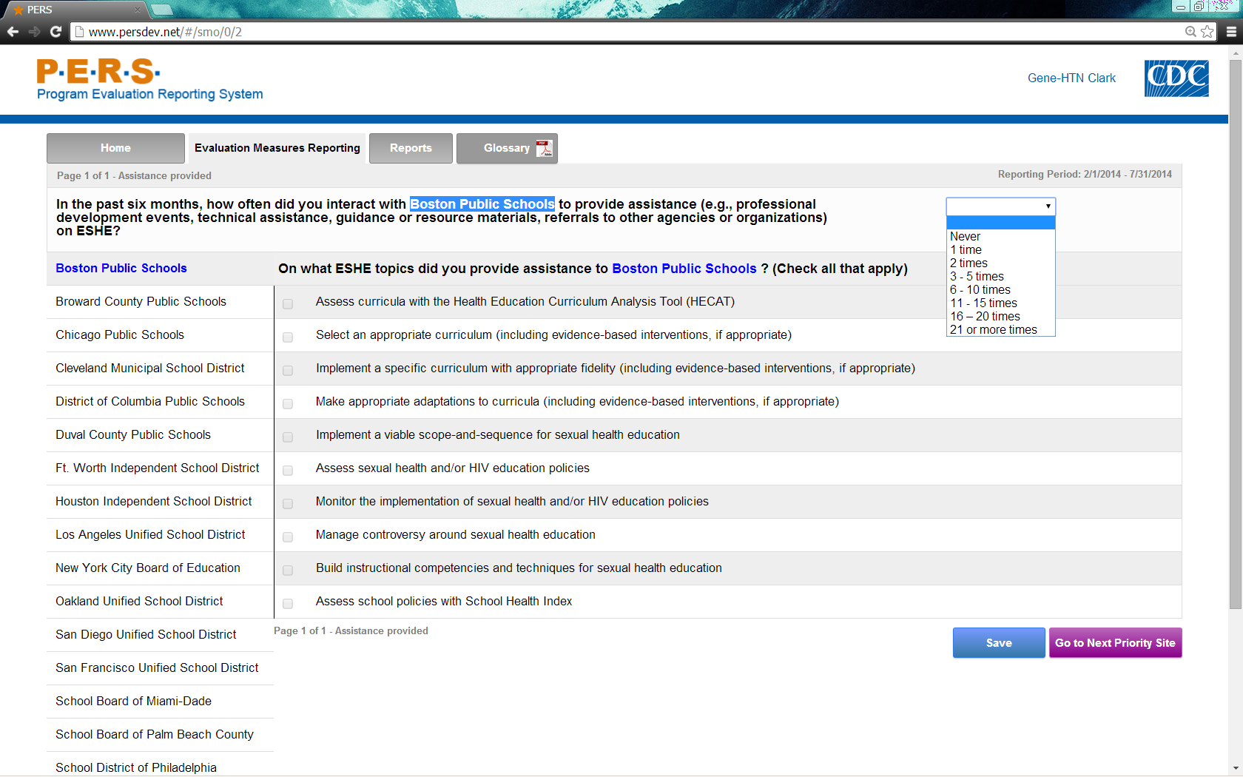
*Note: The highlighted part in the screenshot will be tailored to the Local Education Agency of interest for each NGO respondent that provides assistance related to ESHE. The left-hand side of the screenshot shows where the potential Local Education Agencies will be listed. Each can be selected to answer this question.

Part B of screenshot for LEAs. This screen is scrolling enabled.
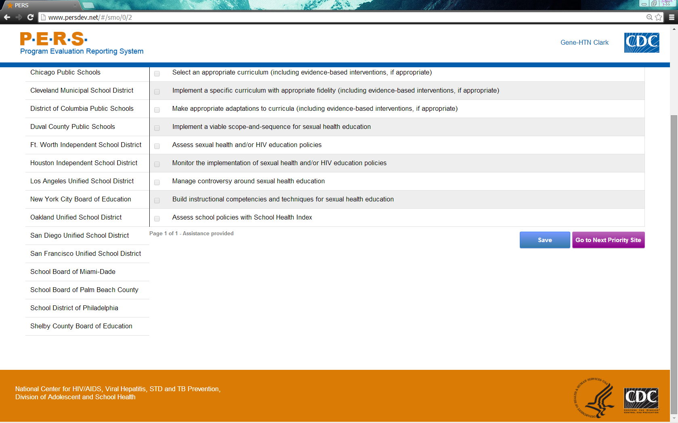

Form Approved
OMB No: 0920-XXXX
Exp. Date: XX/XX/XXXX

“Promoting Adolescent Health through School-Based HIV/STD Prevention”

Att. 3a

NGO SHS Items

Public reporting burden of this collection of information is estimated to average 30 minutes per response, including the time for reviewing instructions, searching existing data sources, gathering and maintaining the data needed, and completing and reviewing the collection of information. An agency may not conduct or sponsor, and a person is not required to respond to a collection of information unless it displays a currently valid OMB control number. Send comments regarding this burden estimate or any other aspect of this collection of information, including suggestions for reducing this burden to CDC/ATSDR Reports Clearance Officer; 1600 Clifton Road NE, MS D-74, Atlanta, Georgia 30333; Attn: OMB-PRA (0920-New)

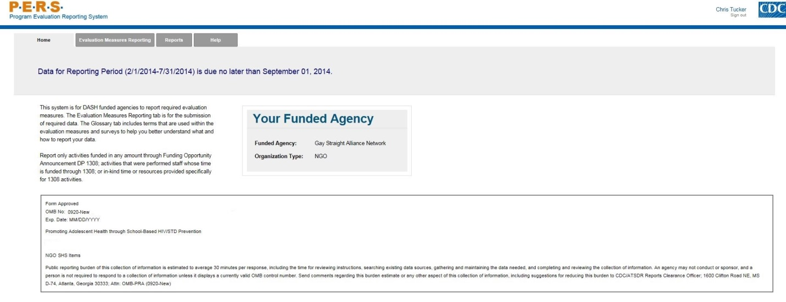
Part A of screenshot for SEAs. This screen is scrolling enabled.

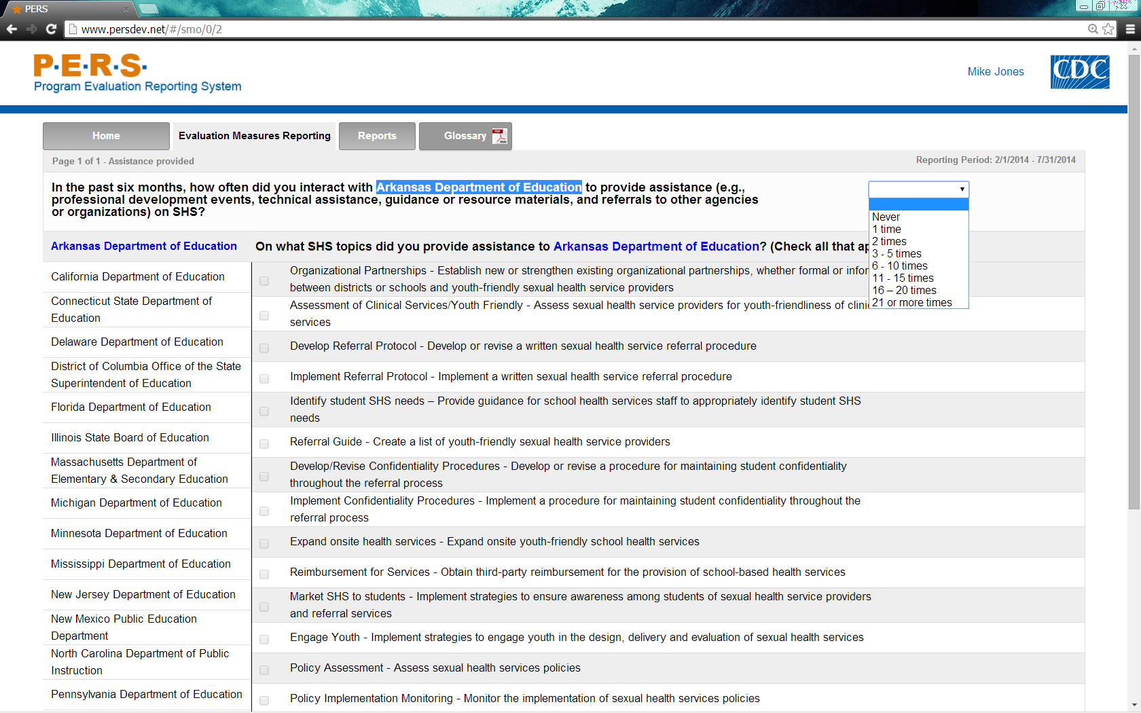
*Note: The highlighted part in the screenshot will be tailored to the State Education Agency of interest for each NGO respondent that provides assistance related to SHS. The left-hand side of the screenshot shows where the potential State Education Agencies will be listed. Each can be selected to answer this question.

Part B of screenshot for SEAs. This screen is scrolling enabled.

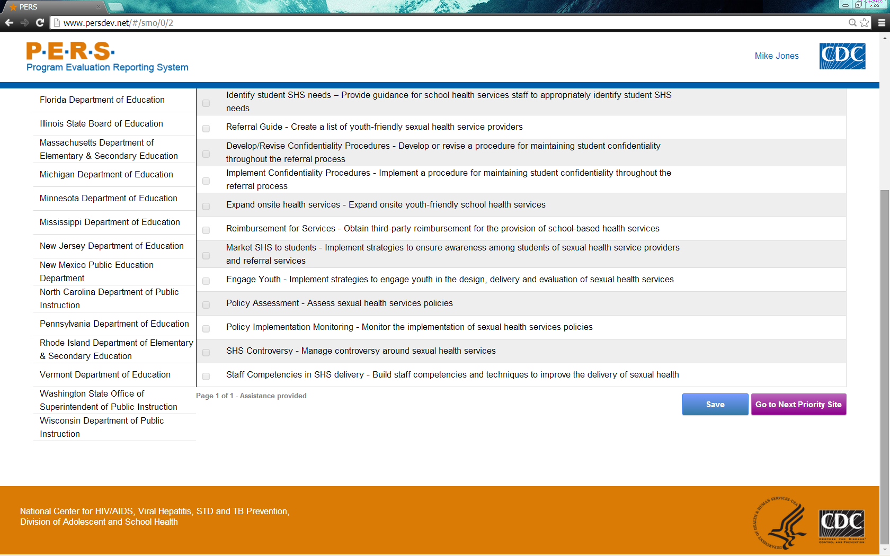

Part A of screenshot for LEAs. This screen is scrolling enabled.
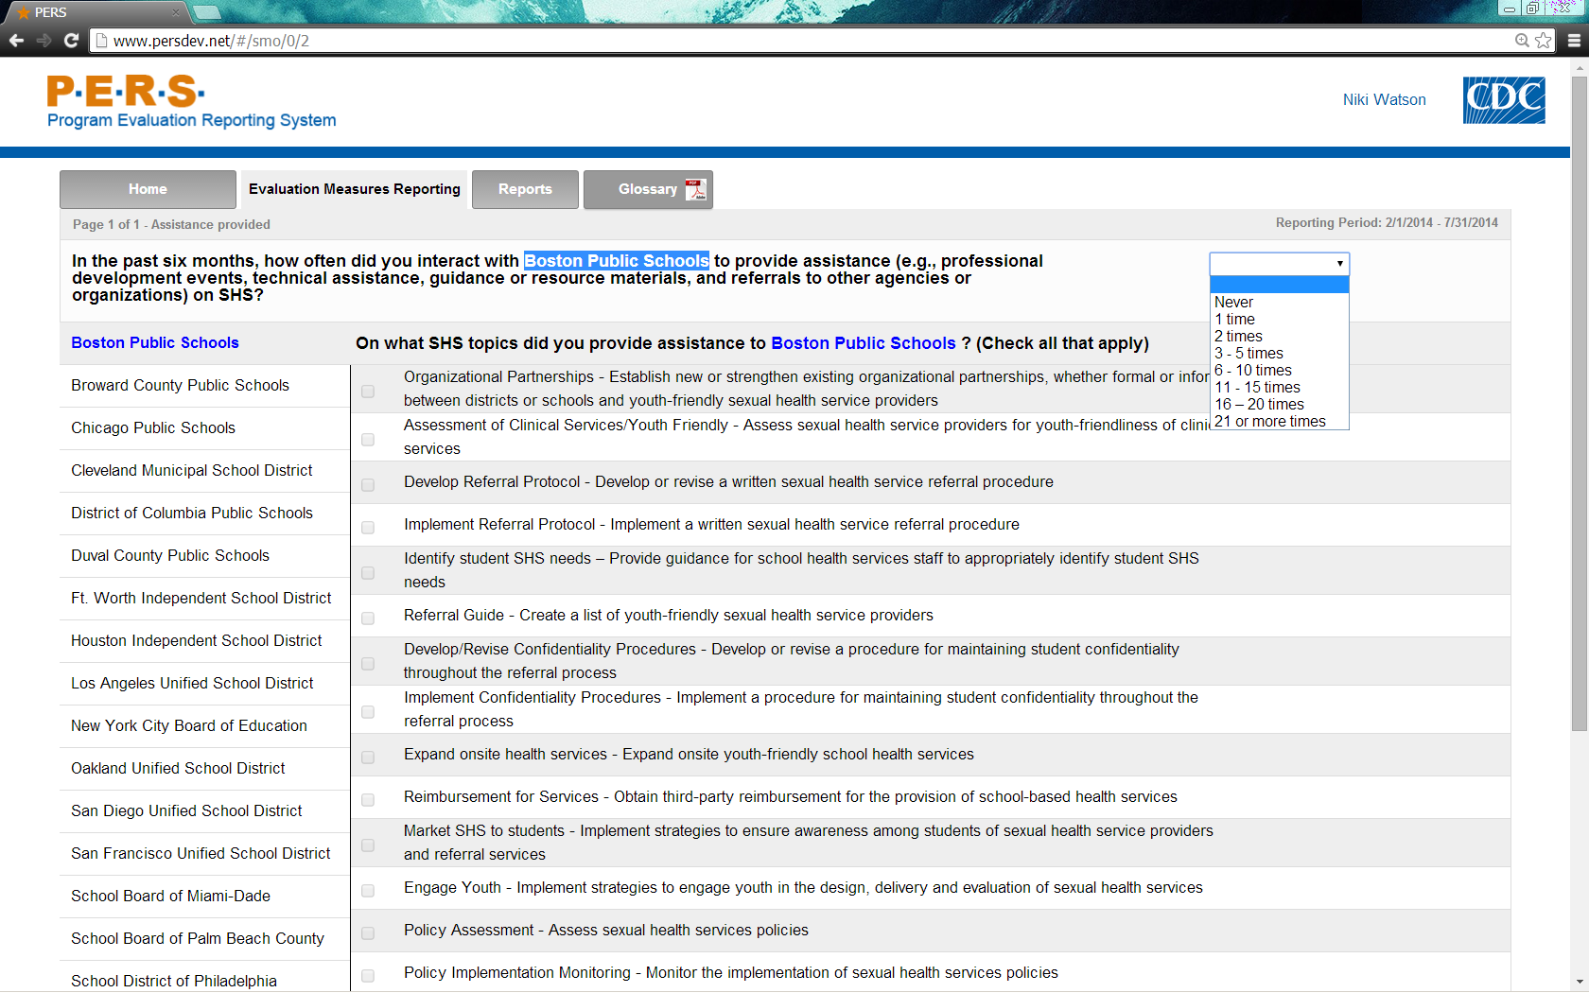
*Note: The highlighted part in the screenshot will be tailored to the Local Education Agency of interest for each NGO respondent that provides assistance related to SHS. The left-hand side of the screenshot shows where the potential Local Education Agencies will be listed. Each can be selected to answer this question.

Part B of screenshot for LEAs. This screen is scrolling enabled.
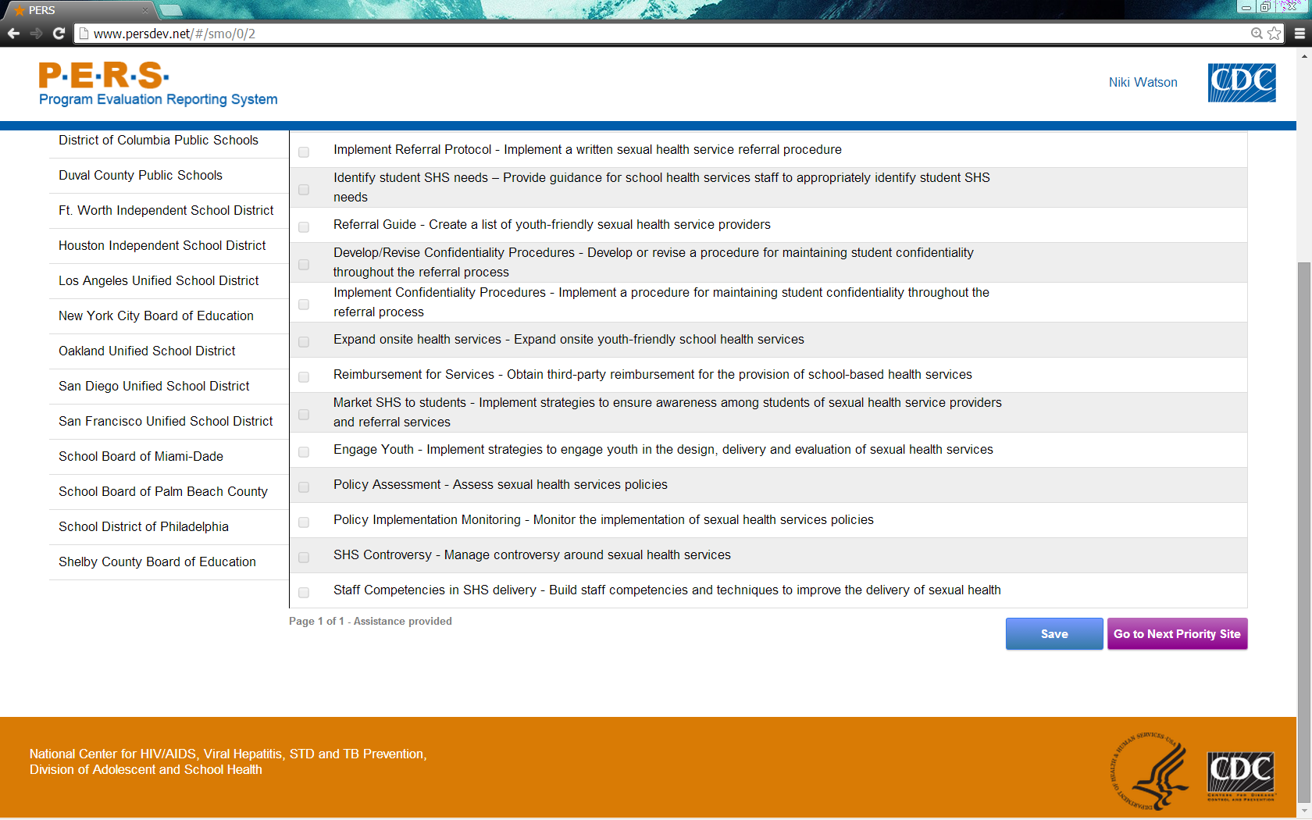

Form Approved
OMB No: 0920-XXXX
Exp. Date: XX/XX/XXXX

“Promoting Adolescent Health through School-Based HIV/STD Prevention”

Attachment 3b

NGO SSE Items

Public reporting burden of this collection of information is estimated to average 30 minutes per response, including the time for reviewing instructions, searching existing data sources, gathering and maintaining the data needed, and completing and reviewing the collection of information. An agency may not conduct or sponsor, and a person is not required to respond to a collection of information unless it displays a currently valid OMB control number. Send comments regarding this burden estimate or any other aspect of this collection of information, including suggestions for reducing this burden to CDC/ATSDR Reports Clearance Officer; 1600 Clifton Road NE, MS D-74, Atlanta, Georgia 30333; Attn: OMB-PRA (0920-New)

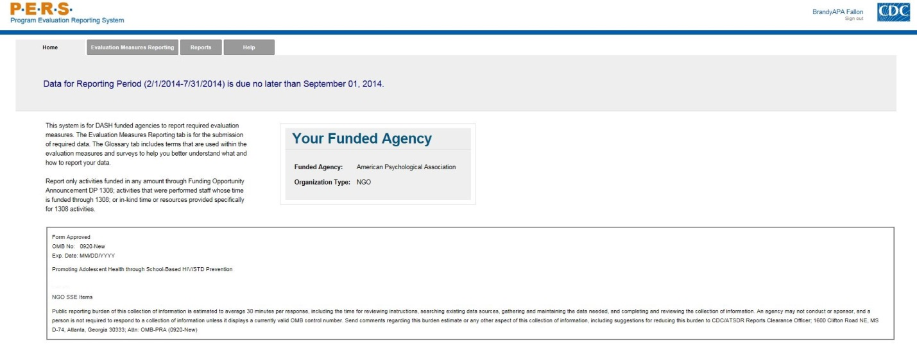

Part A of screenshot for SEAs. This screen is scrolling enabled.
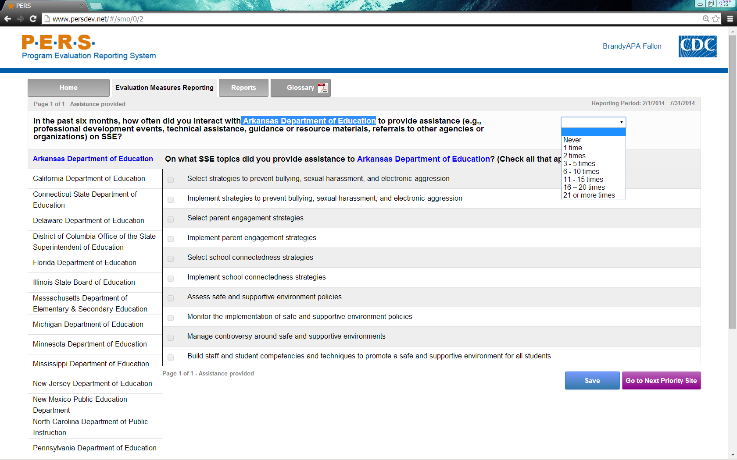
*Note: The highlighted part in the screenshot will be tailored to the State Education Agency of interest for each NGO respondent that provides assistance related to SSE. The left-hand side of the screenshot shows where the potential State Education Agencies will be listed. Each can be selected to answer this question.

Part B of screenshot for SEAs. This screen is scrolling enabled.
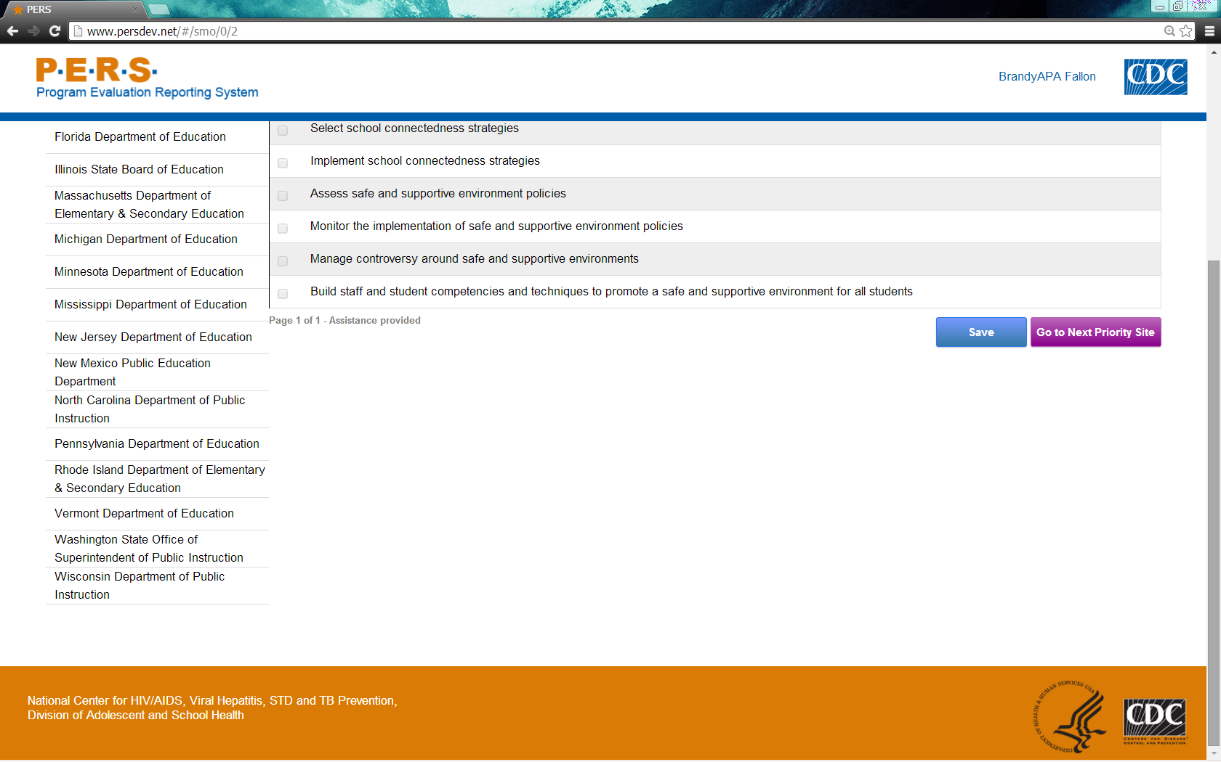

Part A of screenshot for LEAs. This screen is scrolling enabled.
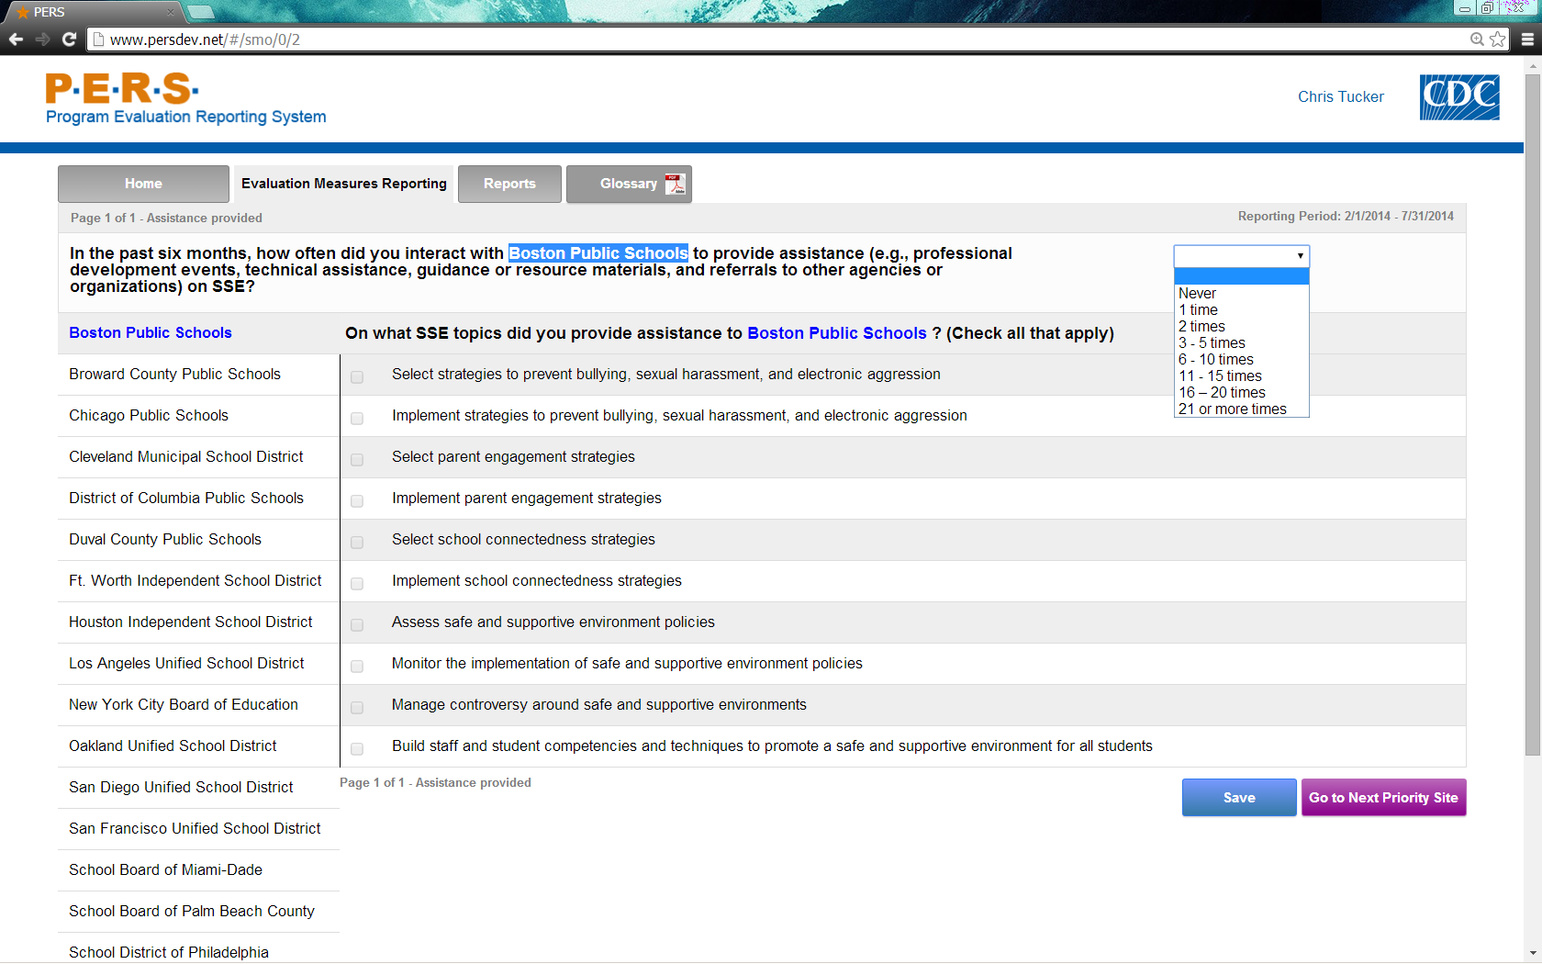
*Note: The highlighted part in the screenshot will be tailored to the Local Education Agency of interest for each NGO respondent that provides assistance related to SSE. The left-hand side of the screenshot shows where the potential Local Education Agencies will be listed. Each can be selected to answer this question.

Part B of screenshot for LEAs. This screen is scrolling enabled.
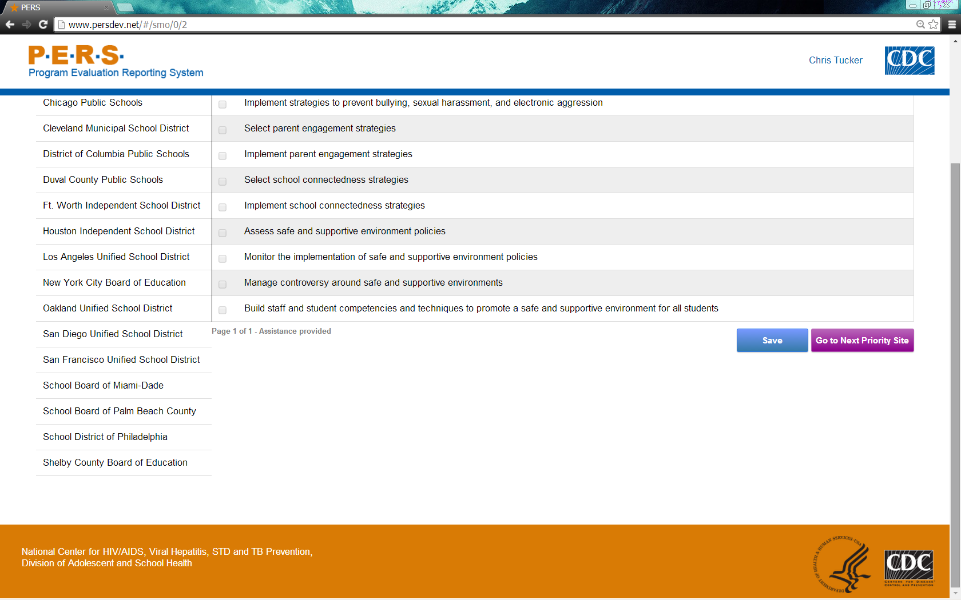

Instruction Slides
Log-in screen
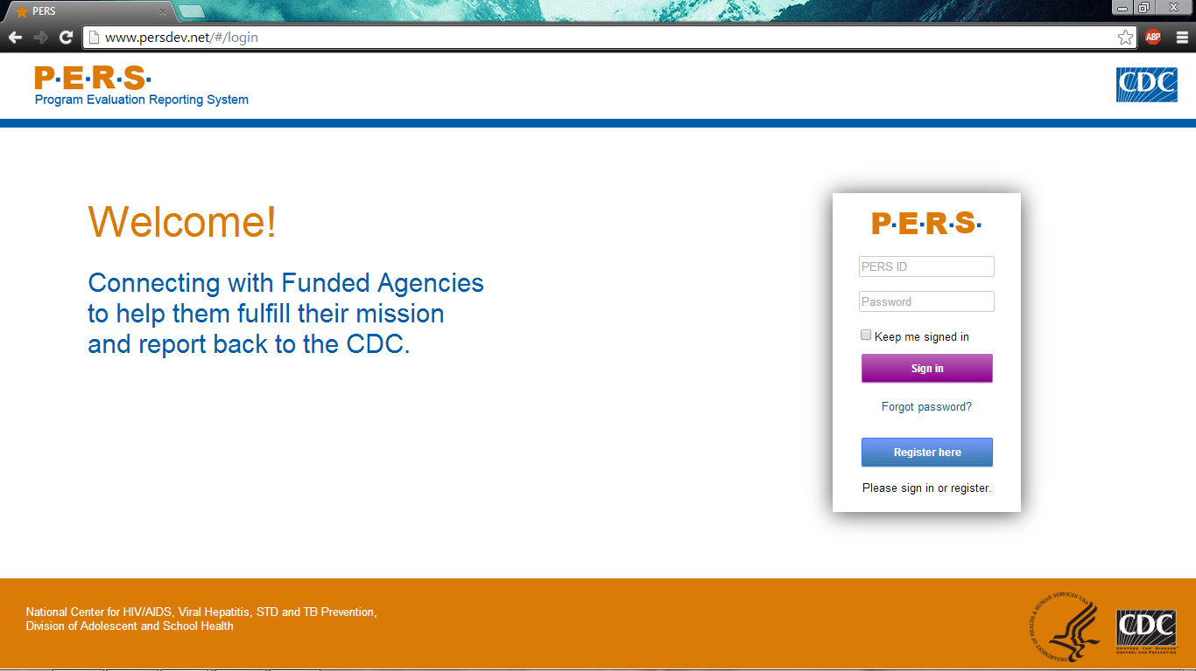
Screen that appears after logging in with username and password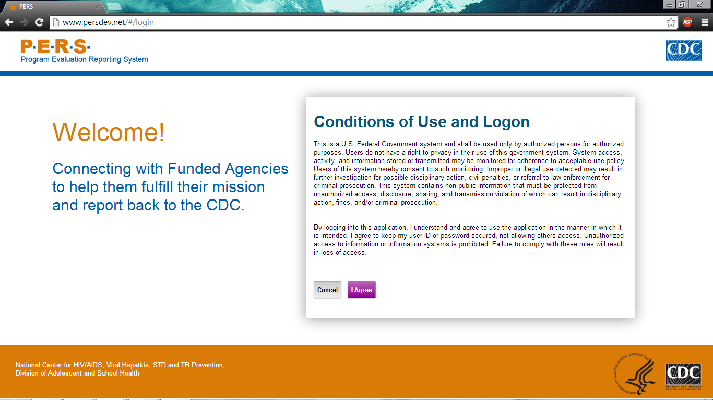
Main page. Questionnaires located in “Evaluation Measures Reporting” tab.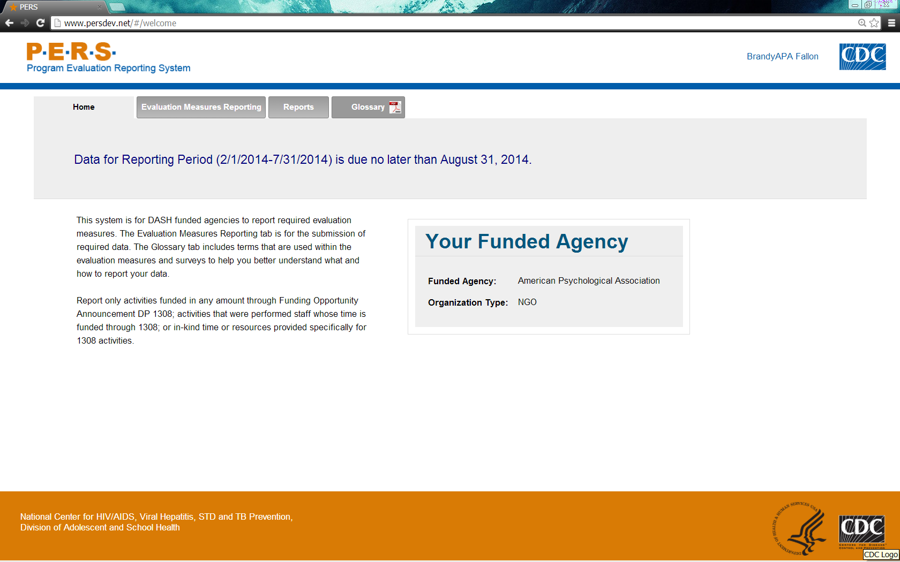Report Measures Menu