Attachment G-3:

Verbal Consent of Photographic Image Release

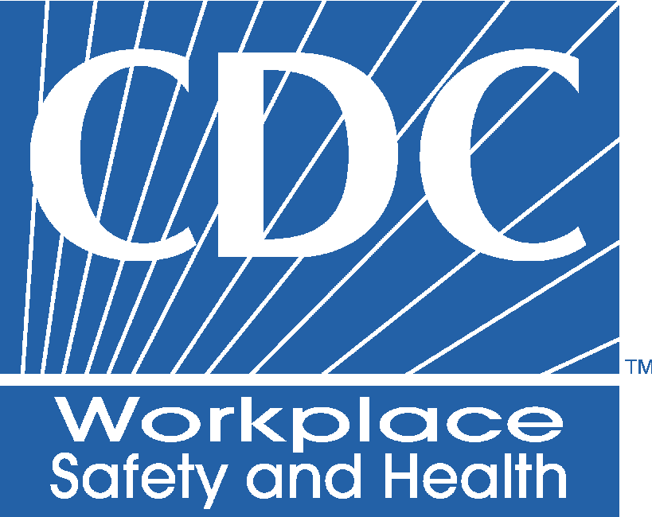

NATIONAL INSTITUTE FOR OCCUPATIONAL SAFETY AND HEALTH (NIOSH)
CENTERS FOR DISEASE CONTROL AND PREVENTION
U.S. PUBLIC HEALTH SERVICE
U.S. DEPARTMENT OF HEALTH AND HUMAN SERVICES

Attention! NIOSH team members:
Prior to videotaping or taking pictures of participants,
please read the following writing to participants.

VERBAL CONSENT OF PHOTOGRAPHIC IMAGE RELEASE

A. I agree to allow the National Institute for Occupational Safety and Health to use my photograph.

I hereby agree to allow my photographic image to be used (without my name, both singly and in conjunction with other persons or objects) by the National Institute for Occupational Safety and Health of the Centers for Disease Control and Prevention, U.S. Department of Health and Human Services.

B. NIOSH will use my photograph in a publication that other persons are free to copy.

I understand that this publication will be printed by the United States Government Printing Office without copyright protection and may be distributed free or sold. I also understand that additional printings may be conducted by the United States Government Printing Office in the future. I understand that other persons will be allowed to make copies of these government publications.

C. No one will ever pay me for the use of this photograph.

I understand that for the use of my photographic image in this publication, I will receive no financial compensation or payment of any kind from the United States Government or from any agency of the Government or from any person making a copy of the government publication now or at any time in the future.

